Accounting Information Systems, 12e (Romney/Steinbart)
Chapter 3 Systems Documentation Techniques

1) Graphical representations of information are often supplemented by
A) product specifications.
B) narrative descriptions.
C) logic charts.
D) oral descriptions from management.
Answer: B
Page Ref: 49
Objective: Learning Objective 1
Difficulty : Easy
AACSB: Analytic

2) The correct label for Shape 1 in the flowchart below is
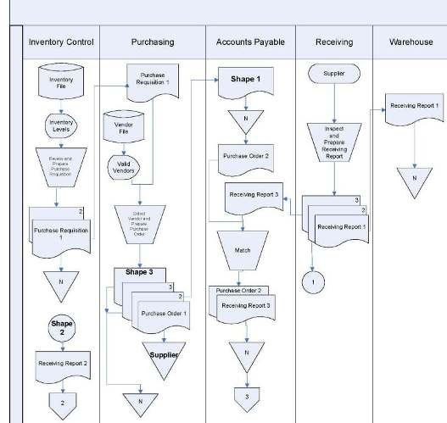

A) Purchase Order 2
B) Purchase Requisition 1
C) Accounts Payable Trial Balance
D) 2
Answer: A
Page Ref: 55-60
Objective: Learning Objective 2
Difficulty : Easy
AACSB: Analytic

3) The correct label for Shape 2 in the flowchart below is

A) 1
B) Purchase Requisition 1
C) Receiving Report 1
D) 2
Answer: A
Page Ref: 55-60
Objective: Learning Objective 2
Difficulty : Easy
AACSB: Analytic
4) The correct label for Shape 3 in the flowchart below is

A) Purchase Order 4
B) Purchase Requisition 1
C) Vendor
D) 4
Answer: B
Page Ref: 55-60
Objective: Learning Objective 2
Difficulty : Difficult
AACSB: Analytic
5) The correct shape for the triangle labeled "Supplier" in the flowchart below is

A) magnetic disk
B) terminal
C) manual process
D) off-page connector
Answer: B
Page Ref: 57
Objective: Learning Objective 2
Difficulty : Moderate
AACSB: Analytic
6) When preparing a document flowchart, the names of organizational departments or job functions should appear in the
A) column headings.
B) right-hand margin.
C) written narrative accompanying the flowchart.
D) title of the flowchart.
Answer: A
Page Ref: 60
Objective: Learning Objective 2
Difficulty : Easy
AACSB: Analytic

7) All of the following are guidelines for preparing data flow diagrams except
A) show the most detail in the highest-level DFD.
B) include all storage files, even if they are only temporary.
C) uniquely name all data flows.
D) sequentially number process bubbles.
Answer: A
Page Ref: 55
Objective: Learning Objective 1
Difficulty : Moderate
AACSB: Analytic

8) Flowchart symbols
A) are divided into four categories.
B) are unique to the organization creating the flowchart.
C) are normally drawn using a flowcharting template.
D) eliminate the need for narrative descriptions or explanations.
Answer: A
Page Ref: 56
Objective: Learning Objective 2
Difficulty : Easy
AACSB: Analytic

9) The Sarbanes-Oxley Act requires independent auditors to
A) create flowcharts using specialized software.
B) establish and maintain adequate controls in the client's information system.
C) understand a client's system of internal controls.
D) prepare and understand all types of system documentation.
Answer: C
Page Ref: 50
Objective: Learning Objective 1
Difficulty : Moderate
AACSB: Analytic
10) The passage of the Sarbanes Oxley Act
A) made documentation skills even more important.
B) requires public companies to prepare an annual internal control report.
C) mandates that auditors must be able to prepare, evaluate and read documentation tools such as flowcharts.
D) all of the above
Answer: D
Page Ref: 50
Objective: Learning Objective 1
Difficulty : Easy
AACSB: Analytic

11) Which of the following is not a true statement?
A) Documentation tools save an organization both time and money.
B) Documentation tools are used extensively in the systems development process.
C) Data flow diagrams and flowcharts are the two most frequently used systems development documentation tools.
D) Data flow diagrams and flowcharts are difficult to prepare and revise using software packages.
Answer: D
Page Ref: 50
Objective: Learning Objective 1
Difficulty : Easy
AACSB: Analytic

12) A data flow diagram
A) is a graphical description of the source and destination of data that shows how data flow within an organization.
B) is a graphical description of the flow of documents and information between departments or areas of responsibility.
C) is a graphical description of the relationship among the input, processing, and output in an information system.
D) is a graphical description of the sequence of logical operations that a computer performs as it executes a program.
Answer: A
Page Ref: 50
Objective: Learning Objective 1
Difficulty : Easy
AACSB: Analytic
13) In a DFD, a "data sink" is also known as a
A) data store.
B) transformation process.
C) data flow.
D) data destination.
Answer: D
Page Ref: 50
Objective: Learning Objective 1
Difficulty : Easy
AACSB: Analytic

14) In preparing a DFD, when data are transformed through a process, the symbol used should be
A) a circle.
B) an arrow.
C) a square.
D) two horizontal lines.
Answer: A
Page Ref: 50-51
Objective: Learning Objective 1
Difficulty : Easy
AACSB: Analytic

15) In general, a data destination will be shown by
A) an arrow pointing away.
B) an arrow pointing in.
C) arrows pointing both ways.
D) no arrows, only two horizontal lines.
Answer: B
Page Ref: 51
Objective: Learning Objective 1
Difficulty : Easy
AACSB: Analytic

16) In a data flow diagram of the customer payment process, "update receivables" will appear above or in
A) a square.
B) a circle.
C) two horizontal lines.
D) none of the above
Answer: B
Page Ref: 51
Objective: Learning Objective 1
Difficulty : Easy
AACSB: Analytic
17) In a data flow diagram of the customer payment process, "Customer" will appear above or in
A) a square.
B) a circle.
C) two horizontal lines.
D) none of the above
Answer: A
Page Ref: 51
Objective: Learning Objective 1
Difficulty : Easy
AACSB: Analytic

18) In a data flow diagram of the customer payment process, "Customer payment" will appear above or in
A) a square.
B) a circle.
C) two horizontal lines.
D) an arrow.
Answer: D
Page Ref: 51
Objective: Learning Objective 1
Difficulty : Easy
AACSB: Analytic

19) Most processes on a DFD can be identified by
A) data in-flows only.
B) data out-flows only.
C) data flows both into or out of a process.
D) always being followed by a data store.
Answer: C
Page Ref: 55
Objective: Learning Objective 1
Difficulty : Easy
AACSB: Analytic

20) More than one arrow is needed between symbols on a DFD if
A) data elements always flow together.
B) data elements flow at different times.
C) data elements flow to different locations.
D) there is no guideline on use of single or multiple arrows.
Answer: B
Page Ref: 55
Objective: Learning Objective 1
Difficulty : Easy
AACSB: Analytic
21) A DFD created at the highest-level or summary view is referred to as a
A) process diagram.
B) overview diagram.
C) content diagram.
D) context diagram.
Answer: D
Page Ref: 52
Objective: Learning Objective 1
Difficulty : Easy
AACSB: Analytic

22) In a payroll processing DFD, the "prepare reports" activity will be represented by ________, the "employee payroll file" will be represented by ________, and the "management" will be represented by ________.
A) a circle; two horizontal lines; a square
B) a circle; two horizontal lines; two horizontal lines
C) a rectangle; a square; a circle
D) a square; two horizontal lines; a circle
Answer: A
Page Ref: 54
Objective: Learning Objective 1
Difficulty : Moderate
AACSB: Analytic

23) Which is a true statement regarding the use of the manual processing symbol in a flowchart?
A) If a document is moved from one column to another, show the document only in the last column.
B) Each manual processing symbol should have an input and an output.
C) Do not connect two documents when moving from one column to another.
D) Use a manual processing symbol to indicate a document being filed.
Answer: B
Page Ref: 60
Objective: Learning Objective 2
Difficulty : Easy
AACSB: Analytic
24) Which is a true statement regarding a document flowchart?
A) A document flowchart illustrates the sequence of logical operations performed by a computer.
B) A document flowchart is particularly useful in analyzing the adequacy of internal control procedures.
C) A document flowchart should ignore control processes and actions.
D) A document flowchart is not normally used in the systems design process.
Answer: B
Page Ref: 57
Objective: Learning Objective 2
Difficulty : Easy
AACSB: Analytic

Use the chart below to answer the following questions regarding flow chart symbols.
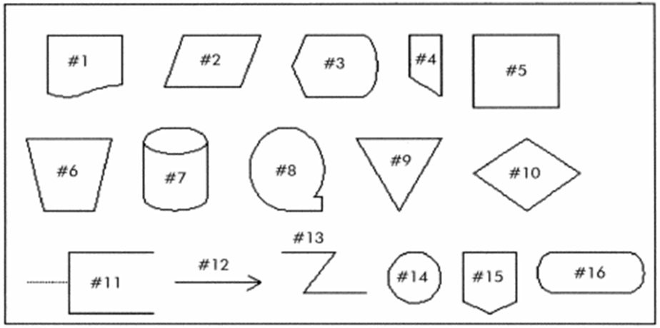

25) Which symbol would be used in a flowchart to represent a computer process?
A) #1
B) #2
C) #5
D) #15
Answer: C
Page Ref: 56-57
Objective: Learning Objective 2
Difficulty : Easy
AACSB: Analytic
26) Which symbol would be used in a flowchart to represent a decision?
A) #10
B) #16
C) #9
D) #6
Answer: A
Page Ref: 56-57
Objective: Learning Objective 2
Difficulty : Easy
AACSB: Analytic

27) Which symbol would be used in a flowchart to represent an invoice sent to a customer?
A) #2
B) #6
C) #1
D) #15
Answer: C
Page Ref: 56-57
Objective: Learning Objective 2
Difficulty : Easy
AACSB: Analytic

28) Which symbol would be used in a flowchart to represent a general ledger?
A) #2
B) #1
C) #3
D) #5
Answer: A
Page Ref: 56-57
Objective: Learning Objective 2
Difficulty : Easy
AACSB: Analytic

29) Which symbol would be used in a flowchart to represent a manual process?
A) #5
B) #6
C) #10
D) #11
Answer: B
Page Ref: 56-57
Objective: Learning Objective 2
Difficulty : Easy
AACSB: Analytic
30) Which symbol would be used in a flowchart to represent a connection to another part of the flowchart on the same page?
A) #4
B) #13
C) #14
D) #15
Answer: C
Page Ref: 56-57
Objective: Learning Objective 2
Difficulty : Easy
AACSB: Analytic

31) Which symbol would be used in a flowchart to represent a connection to another part of the flowchart on a different page?
A) #4
B) #13
C) #14
D) #15
Answer: D
Page Ref: 56-57
Objective: Learning Objective 2
Difficulty : Easy
AACSB: Analytic

32) Which symbol would be used in a flowchart to represent a file of paper documents?
A) #7
B) #8
C) #9
D) #15
Answer: C
Page Ref: 56-57
Objective: Learning Objective 2
Difficulty : Easy
AACSB: Analytic

33) Which symbol would be used in a flowchart to represent a general ledger master file kept on magnetic disk?
A) #2
B) #5
C) #7
D) #8
Answer: C
Page Ref: 56-57
Objective: Learning Objective 2
Difficulty : Easy
AACSB: Analytic
34) Which symbol would be used in a flowchart to represent employee time cards sent by department managers to the payroll department?
A) #1
B) #4
C) #11
D) #16
Answer: A
Page Ref: 56-57
Objective: Learning Objective 2
Difficulty : Easy
AACSB: Analytic

35) Which symbol would be used in a flowchart to represent the display of a report on a computer screen?
A) #1
B) #2
C) #3
D) #11
Answer: C
Page Ref: 56-57
Objective: Learning Objective 2
Difficulty : Easy
AACSB: Analytic

36) Which symbol would be used in a flowchart to represent the addition of information about a step represented in another symbol on the flowchart?
A) #1
B) #5
C) #11
D) #15
Answer: C
Page Ref: 56-57
Objective: Learning Objective 2
Difficulty : Easy
AACSB: Analytic
37) Which symbol would be used in a flowchart to represent a payroll master file kept on magnetic tape?
A) #4
B) #7
C) #8
D) #9
Answer: C
Page Ref: 56-57
Objective: Learning Objective 2
Difficulty : Easy
AACSB: Analytic

38) Which symbol would be used in a flowchart to represent a beginning, an ending, or a connection to another procedure?
A) #9
B) #14
C) #15
D) #16
Answer: D
Page Ref: 56-57
Objective: Learning Objective 2
Difficulty : Moderate
AACSB: Analytic

39) Which symbol would be used in a flowchart to represent a flow of data or documents?
A) #12
B) #13
C) #14
D) #15
Answer: A
Page Ref: 56-57
Objective: Learning Objective 2
Difficulty : Easy
AACSB: Analytic

40) Which symbol would be used in a flowchart to represent a communication link?
A) #12
B) #13
C) #14
D) #15
Answer: B
Page Ref: 56-57
Objective: Learning Objective 2
Difficulty : Easy
AACSB: Analytic
41) In a document flowchart of a manual payroll processing system, "update employee file" will be shown by a(n) ________ symbol, and "prepare payroll check" will be shown by a(n) ________ symbol.
A) input; output
B) input; manual operation
C) manual operation; output
D) manual operation; manual operation
Answer: D
Page Ref: 58
Objective: Learning Objective 2
Difficulty : Easy
AACSB: Analytic

42) A flowchart that depicts the relationships among the input, processing, and output of an AIS is
A) an internal control flowchart.
B) a document flowchart.
C) a system flowchart.
D) a program flowchart.
Answer: C
Page Ref: 60
Objective: Learning Objective 2
Difficulty : Easy
AACSB: Analytic

43) In a program flowchart, branching to alternative paths is represented by
A) a terminal.
B) data/information flow.
C) computer operation.
D) decision diamond.
Answer: D
Page Ref: 57
Objective: Learning Objective 2
Difficulty : Easy
AACSB: Analytic
44) The Union Soup Kitchen is a non-profit organization that collects, stores, prepares and provides food to the homeless in Erie, Pennsylvania. Donations of food are recorded in a database and a receipt is provided to the donor. When food is used, the database is updated so that it always reflects the amounts and types of food that are available. In a data flow diagram, which type of symbol would be used to represent donors?
A)
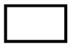
B)

C)

D)
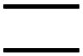
Answer: A
Page Ref: 50
Objective: Learning Objective 1
Difficulty : Easy
AACSB: Analytic

45) The Union Soup Kitchen is a non-profit organization that collects, stores, prepares and provides food to the homeless in Erie, Pennsylvania. Donations of food are recorded in a database and a receipt is provided to the donor. When food is used, the database is updated so that it always reflects the amounts and types of food that are available. In a data flow diagram, which type of symbol would be used to represent the processing of donations?
A)
B)
C)
D)
Answer: B
Page Ref: 50
Objective: Learning Objective 1
Difficulty : Easy
AACSB: Analytic
46) The Union Soup Kitchen is a non-profit organization that collects, stores, prepares and provides food to the homeless in Erie, Pennsylvania. Donations of food are recorded in a database and a receipt is provided to the donor. When food is used, the database is updated so that it always reflects the amounts and types of food that are available. In a data flow diagram, which type of symbol would be used to represent the storage location of data in the system?
A)
B)
C)
D)
Answer: D
Page Ref: 50
Objective: Learning Objective 1
Difficulty : Easy
AACSB: Analytic
47) The Union Soup Kitchen is a non-profit organization that collects, stores, prepares and provides food to the homeless in Erie, Pennsylvania. Donations of food are recorded in a database and a receipt is provided to the donor. When food is used, the database is updated so that it always reflects the amounts and types of food that are available. In a data flow diagram, which type of symbol would be used to represent the process of updating inventory records in the system?
A)
B)
C)
D)
Answer: B
Page Ref: 50
Objective: Learning Objective 1
Difficulty : Easy
AACSB: Analytic
48) The Union Soup Kitchen is a non-profit organization that collects, stores, prepares and provides food to the homeless in Erie, Pennsylvania. Donations of food are recorded in a database and a receipt is provided to the donor. When food is used, the database is updated so that it always reflects the amounts and types of food that are available. In a data flow diagram, which type of symbol would be used to represent the flow of data from the donor into the system?
A)
B)
C)
D)
Answer: C
Page Ref: 50
Objective: Learning Objective 1
Difficulty : Easy
AACSB: Analytic
49) Chuck and Jill Scruggs travel in their motor home six months of the year and buy unique artifacts. Within hours after the Scruggs make a purchase, they have photographed it, written a description of it, and posted it for sale on eBay with a reservation price. Anything that does not sell is shipped back to Austin, Texas, for display in The House of Curiosities, a retail business that the Scruggs operate during the balance of the year. Which symbol should be used to represent eBay in a context diagram of this process?
A)
B)
C)
D)
Answer: A
Page Ref: 50
Objective: Learning Objective 1
Difficulty : Moderate
AACSB: Analytic
50) Chuck and Jill Scruggs travel in their motor home six months of the year and buy unique artifacts. Within hours after the Scruggs make a purchase, they have photographed it, written a description of it, and posted it for sale on eBay with a reservation price. Anything that does not sell is shipped back to Austin, Texas, for display in The House of Curiosities, a retail business that the Scruggs operate during the balance of the year. Which symbol should be used to represent the preparation of data for submission to eBay in a context diagram of this process?
A)
B)
C)
D)
Answer: B
Page Ref: 50
Objective: Learning Objective 1
Difficulty : Moderate
AACSB: Analytic
51) Chuck and Jill Scruggs travel in their motor home six months of the year and buy unique artifacts. Within hours after the Scruggs make a purchase, they have photographed it, written a description of it, and posted it for sale on eBay with a reservation price. Anything that does not sell within a week is shipped back to Austin, Texas, for display in The House of Curiosities, a retail business that the Scruggs operate during the balance of the year. Which symbol should be used to represent the transfer of data to eBay in a context diagram of this process?
A)
B)
C)
D)
Answer: C
Page Ref: 50
Objective: Learning Objective 1
Difficulty : Easy
AACSB: Analytic
52) Chuck and Jill Scruggs travel in their motor home six months of the year and buy unique artifacts. Within hours after the Scruggs make a purchase, they have photographed it, written a description of it, and posted it for sale on eBay with a reservation price. Anything that does not sell is shipped back to Austin, Texas, for display in The House of Curiosities, a retail business that the Scruggs operate during the balance of the year. Which symbol should be used to represent the remote server that is used to store data while the Scruggs are traveling?
A)
B)
C)
D)
Answer: D
Page Ref: 50
Objective: Learning Objective 1
Difficulty : Easy
AACSB: Analytic

53) Chas Mulligan has been hired by Yardley Security as an assistant to the internal auditor. He has been asked to thoroughly document the existing accounting information system in preparation for making recommendations for improvements to internal controls. He decides to begin with a description of the information stored in paper records, their sources, and their destinations. The documentation tool that he should employ for this purpose is a
A) data flow diagram.
B) document flowchart.
C) system flowchart.
D) program flowchart.
Answer: B
Page Ref: 57
Objective: Learning Objective 2
Difficulty : Moderate
AACSB: Reflective Thinking
54) Chas Mulligan has been hired by Yardley Security as an assistant to the internal auditor. He has been asked to document the existing accounting information system, and focus on the activities and flow of data between activities. He decides to begin with a summary description of the sources and uses of data in the organization and how they are processed by the system. The documentation tool that he should employ for this purpose is a
A) data flow diagram.
B) document flowchart.
C) system flowchart.
D) program flowchart.
Answer: A
Page Ref: 50
Objective: Learning Objective 1
Difficulty : Moderate
AACSB: Reflective Thinking

55) Chas Mulligan has been hired by Yardley Security as an assistant to the internal auditor. He has been asked to thoroughly document the existing accounting information system in preparation for making recommendations for improvements. He decides to begin by meeting with the information technology staff in order to develop an understanding of the computer programs used by the system. The documentation tool that he should employ for this purpose is a
A) data flow diagram.
B) document flowchart.
C) system flowchart.
D) program flowchart.
Answer: D
Page Ref: 62
Objective: Learning Objective 2
Difficulty : Easy
AACSB: Reflective Thinking

56) Chas Mulligan has been hired by Yardley Security as an assistant to the internal auditor. He has been asked to thoroughly document the existing accounting information system in preparation for making recommendations for improvements. He decides to begin by meeting with the information technology staff in order to develop an understanding of the overall operation of the AIS, including data entry, storage, and output. The documentation tool that he should employ for this purpose is a
A) data flow diagram.
B) document flowchart.
C) system flowchart.
D) program flowchart.
Answer: C
Page Ref: 60
Objective: Learning Objective 2
Difficulty : Moderate
AACSB: Reflective Thinking
57) When a sale is made, data is captured by a cash register and stored on a floppy disk for later uploading to the accounting system. Which one of the following diagrams represents this activity?
A)
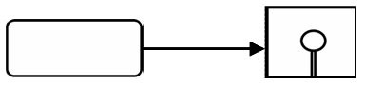
B)
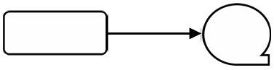
C)
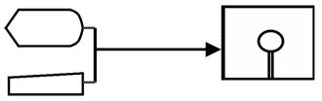
D)
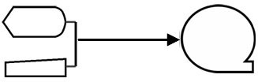
Answer: A
Page Ref: 56
Objective: Learning Objective 2
Difficulty : Moderate
AACSB: Reflective Thinking

58) A materials requisition order document is prepared from the inventory file and the materials file, both of which are stored on disk. Which one of the following diagrams represents this activity?
A)
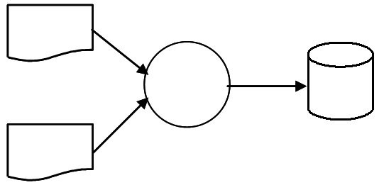
B)
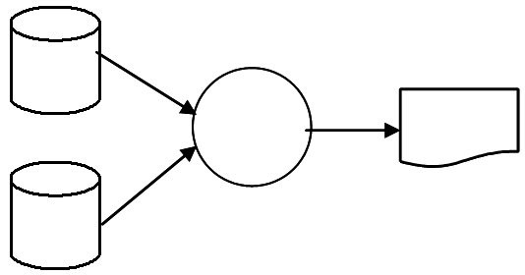
C)
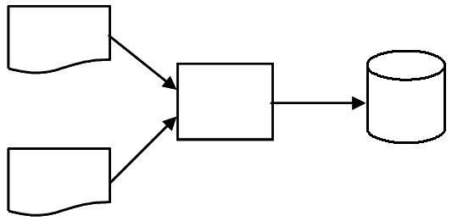
D)
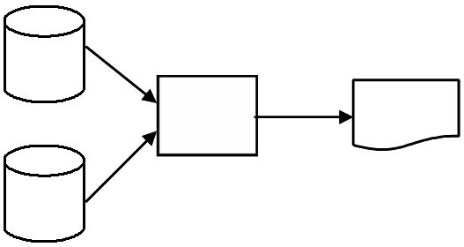
Answer: D
Page Ref: 56-57
Objective: Learning Objective 2
Difficulty : Moderate
AACSB: Reflective Thinking

59) A customer's check is returned for insufficient funds and the accounts receivable file, stored on magnetic disk, is updated. Which one of the following diagrams represents this activity?
A)
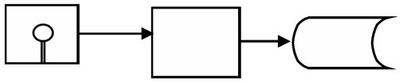
B)
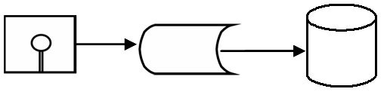
C)
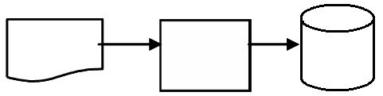
D)
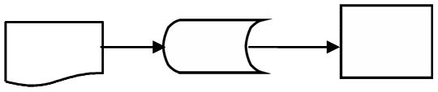
Answer: C
Page Ref: 56-57
Objective: Learning Objective 2
Difficulty : Moderate
AACSB: Reflective Thinking
60) A business simulation game that is used by colleges and universities all over the world has students submit decisions over the Internet. Decisions are stored online, processed on the server, and then the results are stored online. They are then downloaded by students in preparation for the next round. Which one of the following diagrams represents this activity?
A)
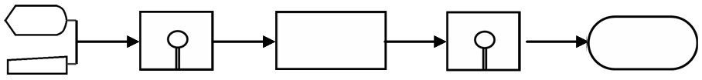
B)
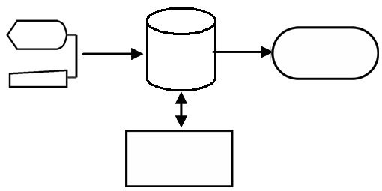
C)
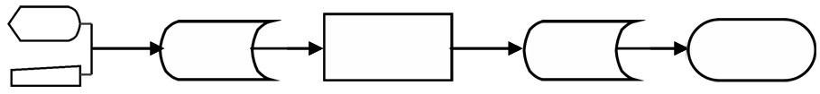
D)
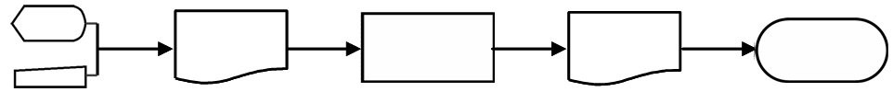
Answer: C
Page Ref: 56-57
Objective: Learning Objective 2
Difficulty : Moderate
AACSB: Reflective Thinking
61) A report is generated from data stored on magnetic disk. Which one of the following diagrams represents this activity?
A)
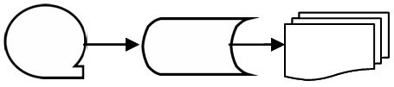
B)
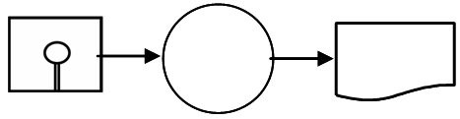
C)
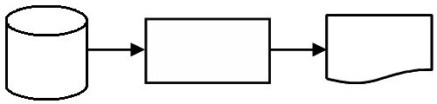
D)
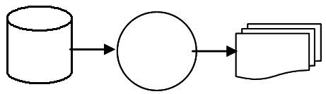
Answer: C
Page Ref: 56-57
Objective: Learning Objective 2
Difficulty : Moderate
AACSB: Reflective Thinking
62) An employee receives a paycheck prepared in the payroll process. Which one of the following diagrams represents this activity?
A)
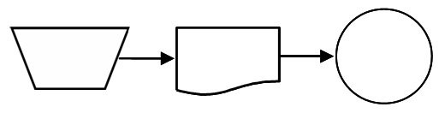
B)
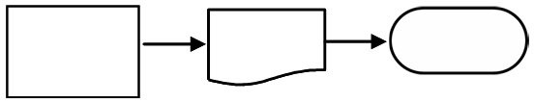
C)
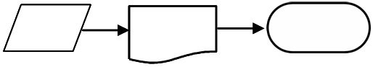
D)
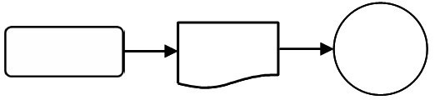
Answer: B
Page Ref: 56-57
Objective: Learning Objective 2
Difficulty : Moderate
AACSB: Reflective Thinking
63) A student manually prepares a homework assignment and then turns it in to her teacher. Which one of the following diagrams represents this activity?
A)
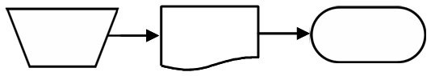
B)
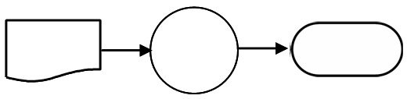
C)
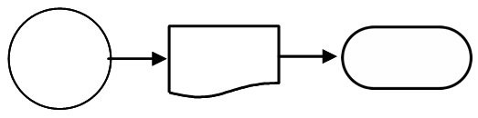
D)
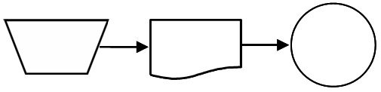
Answer: A
Page Ref: 56-57
Objective: Learning Objective 2
Difficulty : Moderate
AACSB: Reflective Thinking

64) A well-planned and drawn level 0 data flow diagram for the expenditure cycle would show which of the following processes?
A) 0.1 Order Goods; 1.1 Receive and Store Goods; 2.1 Pay for Goods
B) 0.1 Order Goods; 0.2 Receive and Store Goods; 0.3 Pay for Goods
C) 1.0 Order Goods; 2.0 Receive and Store Goods; 3.0 Pay for Goods
D) 1.0 Order Goods; 1.1 Receive and Store Goods; 1.2 Pay for Goods
Answer: C
Page Ref: 52-53
Objective: Learning Objective 1
Difficulty : Moderate
AACSB: Reflective Thinking
65) A well-planned and drawn context data flow diagram will include how many processes?
A) One
B) Between 5 and 7
C) Between 2 and 7, but no more than 7
D) As many as are needed to accurately depict the process being documented
Answer: A
Page Ref: 52
Objective: Learning Objective 1
Difficulty : Moderate
AACSB: Analytic

66) Which of the following is not true about program flowcharts?
A) Program flowcharts are a high-level overview of all business processes.
B) Program flowcharts document the processing logic of computer programs.
C) A program flowchart will exist for every computer process symbol on a system flowchart.
D) Program flowcharts increase computer programmer productivity.
Answer: A
Page Ref: 62
Objective: Learning Objective 2
Difficulty : Moderate
AACSB: Reflective Thinking

67) Data flow diagrams depict
A) processes, but not who is performing the processes.
B) processes, but not the data that flows between processes.
C) who is performing processes, but not how they perform the process.
D) who is performing processes, but not the data that flows between processes.
Answer: A
Page Ref: 50
Objective: Learning Objective 1
Difficulty : Difficult
AACSB: Reflective Thinking

68) Which is the correct label for the blank transformation process circle in the data flow diagram below?
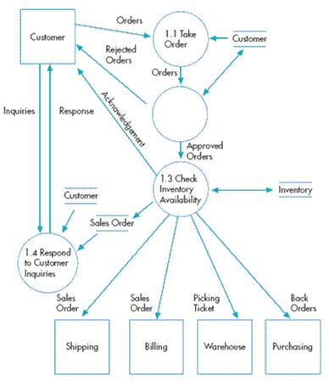
A) 1.2 Check Credit
B) 1.2 Enter Order in Sales Journal
C) 1.2 Does Customer Have Credit?
D) 1.2 Salesperson Approves
Answer: A
Page Ref: 52
Objective: Learning Objective 1
Difficulty : Moderate
AACSB: Analytic
69) In the data flow diagram below, inventory is a
A) data store.
B) data source.
C) data flow.
D) data source and destination.
Answer: A
Page Ref: 52
Objective: Learning Objective 1
Difficulty : Moderate
AACSB: Analytic

70) Discuss the ways in which information professionals interact with documentation tools and the various levels of understanding necessary.
Answer: At a minimum, a professional should be able to read documentation. A professional may also be called upon to evaluate internal control system documentation in order to identify control strengths and weaknesses or recommend improvements. A professional may be engaged to prepare documentation, which requires the greatest amount of skill and understanding of a particular system.
Page Ref: 49
Objective: Learning Objective 1
Difficulty : Moderate
AACSB: Analytic
71) Explain two reasons why it is important to have a working knowledge of DFDs and flowcharting.
Answer: First, SOX requires auditors to evaluate internal control systems. Data flow diagrams and flowcharts are the two most frequently used development and documentation tools used in practice. Second, since systems development is extremely complex, DFDs and flowcharts are tools that are used to create order from chaos and complexity. Third, documentation tools and concepts are covered on the CPA exam.
Page Ref: 50
Objective: Learning Objective 1
Difficulty : Moderate
AACSB: Analytic

72) What does the Sarbanes-Oxley Act require that is relevant to documentation tools?
Answer: The Sarbanes-Oxley Act requires that independent auditors understand the automated and manual procedures an entity uses. One of the best ways to gain this understanding is to use the flowcharts to document the internal control system, as weaknesses and strengths are more easily spotted from such graphic portrayals.
Page Ref: 50
Objective: Learning Objective 1
Difficulty : Easy
AACSB: Analytic

73) Describe a situation in which data flow should be shown with two data flow lines instead of one.
Answer: A data flow may consist of one or more pieces of datum. The determining factor is whether the data elements always flow together at the same time. For example, "customer payment" have both payment and remittance data. Since these elements always flow together, only one data flow line is required. However, data flows between the customer and the payment processes have customer inquiries and cash receipts; these data items do not always flow together at the same time. In such a case, two data flow lines will be shown.
Page Ref: 51
Objective: Learning Objective 1
Difficulty : Moderate
AACSB: Reflective Thinking

74) Describe the different levels of DFDs.
Answer: The highest-level or summary view DFD, which shows major inputs/outputs and a single process is called a context diagram. The DFD itself shows inputs, major processes, and outputs; each process in the DFD can be "exploded" or shown in greater level of detail with the sub-processes and related data flows.
Page Ref: 52
Objective: Learning Objective 1
Difficulty : Moderate
AACSB: Analytic
75) Describe a system flowchart. Describe a program flowchart. How are the two interrelated?
Answer: Systems flowcharts depict the relationships among the input, processing, and output of an AIS. The program flowchart illustrates the sequence of logical operations performed by a computer in executing a program. System flowcharts identify processing areas but do not show how the processing is done. The detailed logic used by the computer to perform the processing is shown on a separate program flowchart.
Page Ref: 60-62
Objective: Learning Objective 2
Difficulty : Moderate
AACSB: Reflective Thinking

76) How is a DFD different from a flowchart?
Answer: The purpose of a DFD is to diagram the origins, flow, transformation, storage, and destination of data. The purpose a flowchart is to present a graphical description of the flow of documents, relationships among input, processing, and output, or the sequence of logical operations in an information system or program. A DFD is limited to basic symbols and lines, and focuses on the flow and use of data. A flowchart will generally be more complex, and more focused on the managerial, AIS, or IS aspects of the organization.
Page Ref: 50,56
Objective: Learning Objective 1
Difficulty : Difficult
AACSB: Reflective Thinking

77) Explain the relevance of the Sarbanes Oxley Act to the documentation tools presented in this chapter.
Answer: The Sarbanes Oxley Act of 2002 requires executives of public companies to document and evaluate internal controls. External auditors must evaluate management's assessment of internal control and attest to its accuracy. Therefore, company executives and the auditors must document and test the internal controls  documentation tools, such as flowcharts, are used to do this.
Page Ref: 50
Objective: Learning Objective 1
Difficulty : Easy
AACSB: Analytic
78) Discuss the idea of a data flow.
Answer: A data flow is a graphic representation of the flow of data between processes, data stores, and data sources and destinations. A data flow is really a form of communication. When the analyst draws a curved or straight line with an arrow at one end, what is represented is a form of communication among the other elements of the data flow process. Consider for example a data source being depicted by a box. The box represents a data source. Data then is sent from the source to a circle, which represents a transformation process. The source of data sends the flow to the transformation process, which will process the data and somehow use the data or turn it into useful information. Note that data flows can represent one or more pieces of datum. Because data flows may have more than one data element, the analyst must determine whether to show one or more lines. Good DFDs and data flow lines in such diagrams eliminate the need for users and analysts to "infer" what type of information is flowing.
Page Ref: 51
Objective: Learning Objective 1
Difficulty : Moderate
AACSB: Analytic

79) What is the value of using a context diagram when working with DFDs?
Answer: In order to create a useful DFD, the analyst must determine system boundarieswhat is to be included or excluded from the system. A context diagram will help to achieve this goal, since it is a good way to depict the boundaries of the system. The analyst first creates a context diagram by placing a circle in the middle of the diagram. The circle represents the system under consideration. On either side of the circle, boxes are created which represent outside entities the system interacts with directly. Data flow lines are drawn to show the direction of the flow of data. After this pictorial representation has been completed, the analyst can then better assess the boundaries of the system and amount of interaction between the system and outside entities.
Page Ref: 52
Objective: Learning Objective 1
Difficulty : Moderate
AACSB: Reflective Thinking
80) Identify five important guidelines for drawing a DFD. Select one from your list and describe why it could be the most important one to consider when preparing a DFD. Support your choice with an example.
Answer: Understand the system. Ignore certain aspects of the system (such as control processes and control actions). Determine system boundaries. Develop a context diagram. Identify data flows. Group data flows. Identify transformation processes. Group transformation processes. Identify all files or data stores. Identify all data sources and destinations. All DFD elements are named. Subdivide the DFD. Give each process a sequential number. Repeat the process. Prepare a final copy. (Student answers will vary depending on the items chosen and the quality of their argument. The text provides various items that could be used to answer this question.)
Page Ref: 55
Objective: Learning Objective 1
Difficulty : Moderate
AACSB: Reflective Thinking
81) Identify five important guidelines for drawing a flowchart. Select one from your list and describe why it could be the most important one to consider when preparing a flowchart. Support your choice with an example.
Answer: Use interviews, questionnaires, or narrative descriptions to understand the system before flowcharting it. Identify the different entities to be flowcharted such as departments, job functions, or external parties. Also identify documents and information flows along with the activities or processes performed on the data. Organize the flowchart using columns when several entities are involved in the process. Focus on the normal operations and include all relevant procedures and processes. Flowcharts should flow from top to bottom and from left to right. The origin and disposition of documents should be clearly identified by a clear beginning and end in the flowcharts. Use standard flowchart symbols. Multiple documents should be identified by numbers shown in the top right-hand corner of the document symbol. Documents do not directly connect with each other, except when moving from one column to another. Use on-page and off-page connectors to organize flowcharts. Use arrowheads to direct the flow of documents. Clearly label the pages, such as 1 of 3, 2 of 3, and 3 of 3. Documents or reports should be first shown in the column in which they originate and then moved to other columns. Use computer processing symbols to show movement of data in and out of the computer system. Filing operations can be directly shown with one line, no manual processing symbol required. Flowcharting is an iterative process. The first attempt should be a rough draft that is refined with each successive pass. Do not clutter flowcharts; redesign the flowchart as necessary. Review the flowchart for accuracy. On the final copy of the flowchart, the name of the flowchart, date, and the preparer's name should be shown. (Student answers will vary depending on the items chosen and the quality of their argument. The text provides various items that could be used to answer this question.)
Page Ref: 60
Objective: Learning Objective 2
Difficulty : Moderate
AACSB: Analytic
82) Following is a context diagram for a current Payroll Processing System. a) Identify the data sources and destinations, data flows, and transformation process marked by question marks. b) What would you need to do to explode this diagram?
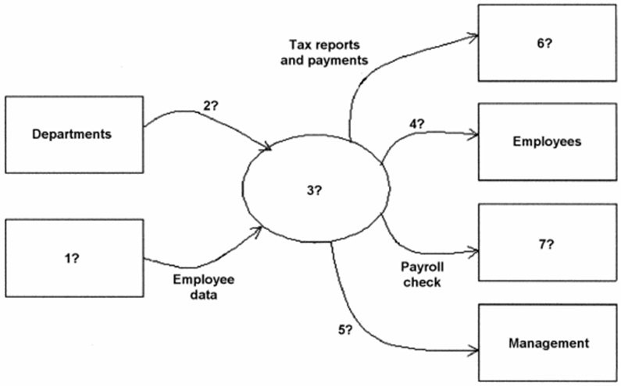
Answer: 1 - Human resources, 2 - Time cards, 3 - Payroll processing system, 4 - Employee paychecks or pay-stubs, 5- Payroll report, 6 - Government agencies, 7- Banks. To explode this diagram, additional information is needed to identify detailed procedures within the payroll processing activity as well as additional inputs and outputs. It would be useful to obtain a comprehensive narrative of the payroll processing procedures for review and identification of these items. If there is no narrative available, interviews are another source of information.
Page Ref: 52
Objective: Learning Objective 1
Difficulty : Difficult
AACSB: Reflective Thinking
83) Identify the mistake(s) in each flowchart segment.
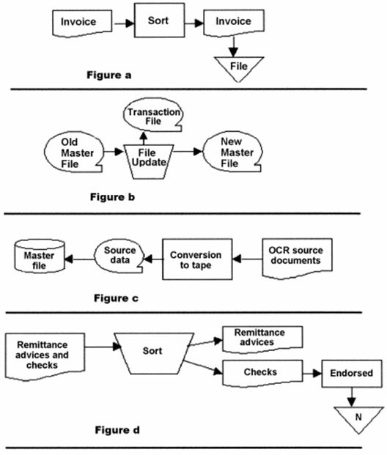
Answer:
a. Figure a - the sort symbol should be a manual operation symbol.
b. Figure b - the file update symbol should be a computer operation symbol, and the arrow from transaction file should flow into file update.
c. Figure c - the arrows should point from left to right and a computer operation symbol is needed between the source data and the master file symbols.
d. Figure d - the symbol for Endorsed should be a manual operation symbol, and endorsed checks are sent to the bank, so the file symbol should be replaced with a terminal symbol.
Page Ref: 56-57, 60
Objective: Learning Objective 2
Difficulty : Difficult
AACSB: Reflective Thinking

