Accounting Information Systems, 12e (Romney/Steinbart)
Chapter 4 Relational Databases

1) Using a file-oriented approach to data and information, data is maintained in
A) a centralized database.
B) many interconnected files.
C) many separate files.
D) a decentralized database.
Answer: C
Page Ref: 88
Objective: Learning Objective 1
Difficulty : Easy
AACSB: Analytic

2) In a well-structured relational database,
A) every table must be related to at least one other table.
B) every table must be related to all other tables.
C) one table must be related to at least one other table.
D) one table must be related to all other tables.
Answer: A
Page Ref: 96-98
Objective: Learning Objective 4
Difficulty : Moderate
AACSB: Reflective Thinking

3) File-oriented approaches create problems for organizations because of
A) multiple transaction files.
B) a lack of sophisticated file maintenance software.
C) multiple users.
D) multiple master files.
Answer: D
Page Ref: 88
Objective: Learning Objective 1
Difficulty : Moderate
AACSB: Analytic

4) Which statement is true regarding file systems?
A) Transaction files are similar to ledgers in a manual AIS.
B) Multiple master files create problems with data consistency.
C) Transaction files are permanent.
D) Individual records are never deleted in a master file.
Answer: B
Page Ref: 88
Objective: Learning Objective 1
Difficulty : Easy
AACSB: Analytic
5) The ________ acts as an interface between the database and the various application programs.
A) data warehouse
B) database administrator
C) database management system
D) database system
Answer: C
Page Ref: 88
Objective: Learning Objective 3
Difficulty : Easy
AACSB: Analytic

6) The combination of the database, the DBMS, and the application programs that access the database through the DBMS is referred to as the
A) data warehouse.
B) database administrator.
C) database system.
D) database manager.
Answer: C
Page Ref: 88
Objective: Learning Objective 3
Difficulty : Easy
AACSB: Analytic

7) The person responsible for the database is the
A) data coordinator.
B) database administrator.
C) database manager.
D) database master.
Answer: B
Page Ref: 88
Objective: Learning Objective 3
Difficulty : Easy
AACSB: Analytic

8) All of the following are benefits of the database approach except:
A) Data integration and sharing
B) Decentralized management of data
C) Minimal data redundancy
D) Cross-functional analysis and reporting
Answer: B
Page Ref: 89
Objective: Learning Objective 1
Difficulty : Easy
AACSB: Analytic
9) The physical view of a database system refers to
A) how a user or programmer conceptually organizes and understands the data.
B) how the DBMS accesses data for a certain application program.
C) how and where the data are physically arranged and stored.
D) how master files store data values used by more than one application program.
Answer: C
Page Ref: 90
Objective: Learning Objective 2
Difficulty : Moderate
AACSB: Analytic

10) The ________ handles the link between the way data are physically stored and each user's logical view of that data.
A) data warehouse
B) data dictionary
C) database management (DBMS) software
D) schema
Answer: C
Page Ref: 90
Objective: Learning Objective 3
Difficulty : Easy
AACSB: Analytic

11) The logical structure of a database is described by the
A) data dictionary.
B) schema.
C) database management system.
D) internal level.
Answer: B
Page Ref: 90
Objective: Learning Objective 3
Difficulty : Easy
AACSB: Analytic

12) The schema that provides an organization-wide view of the entire database is known as the
A) external-level schema.
B) internal-level schema.
C) conceptual-level schema.
D) logical view of the database.
Answer: C
Page Ref: 90
Objective: Learning Objective 3
Difficulty : Easy
AACSB: Analytic
13) A set of individual user views of the database is called the
A) conceptual-level schema.
B) internal-level schema.
C) external-level schema.
D) meta-schema.
Answer: C
Page Ref: 90
Objective: Learning Objective 3
Difficulty : Easy
AACSB: Analytic

14) A low-level view of the database that describes how the data are actually stored and accessed is the
A) conceptual-level schema.
B) subschema.
C) internal-level schema.
D) external-level schema.
Answer: C
Page Ref: 90
Objective: Learning Objective 3
Difficulty : Easy
AACSB: Analytic

15) Record layouts, definitions, addresses, and indexes will be stored at the ________ level schema.
A) external
B) conceptual
C) internal
D) meta
Answer: C
Page Ref: 90
Objective: Learning Objective 3
Difficulty : Easy
AACSB: Analytic

16) The ________ contains information about the structure of the database.
A) data definition language
B) data dictionary
C) data warehouse
D) database management system
Answer: B
Page Ref: 92
Objective: Learning Objective 3
Difficulty : Easy
AACSB: Analytic
17) Which of the following would not be found in a data dictionary entry for a data item?
A) records containing a specific data item
B) physical location of the data
C) source of the data item
D) field type
Answer: B
Page Ref: 93
Objective: Learning Objective 3
Difficulty : Moderate
AACSB: Analytic

18) The data dictionary usually is maintained
A) automatically by the DBMS.
B) by the database administrator.
C) by the database programmers.
D) by top management.
Answer: A
Page Ref: 92
Objective: Learning Objective 3
Difficulty : Easy
AACSB: Analytic

19) Reports produced using the data dictionary could include all of the following except a list of
A) programs where a data item is used.
B) synonyms for the data items in a particular file.
C) outputs where a data element is used.
D) the schemas included in a database.
Answer: D
Page Ref: 92
Objective: Learning Objective 3
Difficulty : Moderate
AACSB: Analytic

20) Which statement below concerning the database management system (DBMS) is false?
A) The DBMS automatically creates application software for users, based on data dictionary parameters.
B) The DBMS automatically maintains the data dictionary.
C) Users' requests for information are transmitted to the DBMS through application software.
D) The DBMS uses special languages to perform specific functions.
Answer: A
Page Ref: 92
Objective: Learning Objective 3
Difficulty : Difficult
AACSB: Analytic
21) Which would not generally be considered a data dictionary output report?
A) A list of cash balances in the organization's bank accounts
B) A list of all programs in which a data element is used
C) A list of all synonyms for the data elements in a particular file
D) A list of all data elements used by a particular user
Answer: A
Page Ref: 92
Objective: Learning Objective 3
Difficulty : Easy
AACSB: Analytic

22) Creating an empty table in a relational database requires use of the ________, and populating that table requires the use of ________.
A) DDL; DML
B) DQL; SQL
C) DDL; DQL
D) DML; DDA
Answer: A
Page Ref: 92
Objective: Learning Objective 3
Difficulty : Moderate
AACSB: Analytic

23) When the human resources manager wants to gather data about vacation and personal day usage by employees and by departments, the manager would use which language?
A) Data Query Language
B) Data Manipulation Language
C) Data Report Language
D) Data Definition Language
Answer: A
Page Ref: 92
Objective: Learning Objective 3
Difficulty : Moderate
AACSB: Analytic

24) If a national sales tax were implemented, which language would be used to add a new field in the sales table to track the sales tax due?
A) Data Definition Language
B) Data Manipulation Language
C) Data Query Language
D) Data Update Language
Answer: A
Page Ref: 92
Objective: Learning Objective 3
Difficulty : Moderate
AACSB: Analytic
25) The feature in many database systems that simplifies the creation of reports by allowing users to specify the data elements desired and the format of the output. is named the
A) report writer.
B) report generator.
C) report creator.
D) report printer.
Answer: A
Page Ref: 92
Objective: Learning Objective 3
Difficulty : Easy
AACSB: Analytic

26) The abstract representation of the contents of a database is called the
A) logical data model.
B) data dictionary.
C) physical view.
D) schema.
Answer: A
Page Ref: 90
Objective: Learning Objective 3
Difficulty : Easy
AACSB: Analytic

27) The problem of changes (or updates) to data values in a database being incorrectly recorded is known as
A) an update anomaly.
B) an insert anomaly.
C) a delete anomaly.
D) a memory anomaly.
Answer: A
Page Ref: 94
Objective: Learning Objective 4
Difficulty : Easy
AACSB: Analytic

28) The potential inconsistency that could occur when there are multiple occurrences of a specific data item in a database is called the
A) update anomaly.
B) insert anomaly.
C) inconsistency anomaly.
D) delete anomaly.
Answer: A
Page Ref: 94
Objective: Learning Objective 4
Difficulty : Easy
AACSB: Analytic
29) Inability to add new data to a database without violating the basic integrity of the database is referred to as the
A) update anomaly.
B) insert anomaly.
C) integrity anomaly.
D) delete anomaly.
Answer: B
Page Ref: 94
Objective: Learning Objective 4
Difficulty : Easy
AACSB: Analytic

30) A relational database in which customer data is not maintained independently of sales invoice data will most likely result in
A) an update anomaly.
B) an insert anomaly.
C) a delete anomaly.
D) an integrity anomaly.
Answer: B
Page Ref: 94
Objective: Learning Objective 4
Difficulty : Moderate
AACSB: Reflective Thinking

31) The problem of losing desired information from a database when an unwanted record is purged from the database is referred to as the ________ anomaly.
A) purge
B) erase
C) delete
D) integrity
Answer: C
Page Ref: 94
Objective: Learning Objective 4
Difficulty : Easy
AACSB: Analytic

32) The delete anomaly
A) may result in unintentional loss of important data.
B) is usually easily detected by users.
C) restricts the addition of new records.
D) prevents users from deleting outdated data from records or tables.
Answer: A
Page Ref: 94
Objective: Learning Objective 4
Difficulty : Moderate
AACSB: Analytic
33) The update anomaly in file-based systems or unnormalized database tables
A) occurs because of data redundancy.
B) restricts addition of new fields or attributes.
C) results in records that cannot be updated.
D) is usually easily detected by users.
Answer: A
Page Ref: 94
Objective: Learning Objective 4
Difficulty : Moderate
AACSB: Analytic

34) In a relational database, requiring that every record in a table have a unique identifier is called the
A) entity integrity rule.
B) referential integrity rule.
C) unique primary key rule.
D) foreign key rule.
Answer: A
Page Ref: 96
Objective: Learning Objective 5
Difficulty : Easy
AACSB: Analytic

35) The database requirement that foreign keys must be null or have a value corresponding to the value of a primary key in another table is formally called the
A) entity integrity rule.
B) referential integrity rule.
C) rule of keys.
D) foreign key rule.
Answer: B
Page Ref: 96
Objective: Learning Objective 5
Difficulty : Easy
AACSB: Analytic

36) In a well-structured database, the constraint that ensures the consistency of the data is known as the
A) entity integrity rule.
B) referential integrity rule.
C) logical view.
D) consistency integrity rule.
Answer: B
Page Ref: 96
Objective: Learning Objective 5
Difficulty : Easy
AACSB: Analytic
37) Which statement below is false regarding the basic requirements of the relational data model?
A) Every column in a row must be single-valued.
B) All non-key attributes in a table should describe a characteristic about the object identified by the primary key.
C) Foreign keys, if not null, must have values that correspond to the value of a primary key in another table.
D) Primary keys can be null.
Answer: D
Page Ref: 96
Objective: Learning Objective 5
Difficulty : Easy
AACSB: Analytic

38) Identify the aspect of a well-structured database that is incorrect.
A) Data is consistent.
B) Redundancy is minimized and controlled.
C) All data is stored in one table or relation.
D) The primary key of any row in a relation cannot be null.
Answer: C
Page Ref: 96
Objective: Learning Objective 5
Difficulty : Easy
AACSB: Analytic

39) In the database design approach known as normalization, the first assumption made about data is
A) there is no redundancy in the data.
B) the delete anomaly will not apply since all customer records will be maintained indefinitely.
C) everything is initially stored in one large table.
D) the data will not be maintained in 3NF tables.
Answer: C
Page Ref: 97
Objective: Learning Objective 5
Difficulty : Moderate
AACSB: Analytic
40) The database design method in which a designer uses knowledge about business processes to create a diagram of the elements to be included in the database is called
A) normalization.
B) decentralization.
C) geometric data modeling.
D) semantic data modeling.
Answer: D
Page Ref: 97
Objective: Learning Objective 5
Difficulty : Easy
AACSB: Analytic

41) Which of the statements below is incorrect?
A) Semantic data modeling facilitates the efficient design of databases.
B) Semantic data modeling facilitates communicating with the intended users of the system.
C) Semantic data modeling allows a database designer to use knowledge about business processes to design the database.
D) Semantic data modeling follows the rules of normalization in the design of a database.
Answer: D
Page Ref: 97
Objective: Learning Objective 5
Difficulty : Moderate
AACSB: Analytic

42) What is one potential drawback in the design and implementation of database systems for accounting?
A) Double-entry accounting relies on redundancy as part of the accounting process but well-designed database systems reduce and attempt to eliminate redundancy.
B) Relational DBMS query languages will allow financial reports to be prepared to cover whatever time periods managers want to examine.
C) Relational DBMS provide the capability of integrating financial and operational data.
D) Relational DBMS can accommodate multiple views of the same underlying data; therefore, tables storing information about assets can include data about both historical and replacement costs.
Answer: A
Page Ref: 104
Objective: Learning Objective 4
Difficulty : Moderate
AACSB: Reflective Thinking
43) Which is probably the most immediate and significant effect of database technology on accounting?
A) replacement of the double entry-system
B) change in the nature of financial reporting
C) elimination of traditional records such as journals and ledgers
D) quicker access to and greater use of accounting information in decision-making
Answer: D
Page Ref: 105
Objective: Learning Objective 1
Difficulty : Moderate
AACSB: Reflective Thinking

44) In a well-designed and normalized database, which of the following attributes would be a foreign key in a cash receipts table?
A) Customer number
B) Cash receipt date
C) Remittance advice number
D) Customer check number
Answer: A
Page Ref: 96
Objective: Learning Objective 3
Difficulty : Moderate
AACSB: Reflective Thinking

45) Dana Halsey is chair of the Purebred Marmoset Society, which maintains a database of registered purebred marmosets and their breeding history. One table will store the name, birth date, and other characteristics of all of the marmosets that have been registered. Each marmoset is uniquely identified by a registration number. A second table will contain data that link each marmoset to its male and female parents by means of their registration numbers. The primary key in the first table is:
A) name
B) birth date
C) a foreign key in the second table.
D) the primary key in the second table.
Answer: C
Page Ref: 96
Objective: Learning Objective 5
Difficulty : Moderate
AACSB: Reflective Thinking
46) Dana Halsey is chair of the Purebred Marmoset Society, which maintains a database of registered purebred marmosets and their breeding history. One table will store the name, birth date, and other characteristics of all of the marmosets that have been registered. Each marmoset is uniquely identified by a registration number. A second table will contain data that link each marmoset to its male and female parents by means of their registration numbers. The primary key in the second table is:
A) name
B) birth date
C) a combination of primary keys in the first table
D) the same as the primary key in the first table
Answer: C
Page Ref: 96
Objective: Learning Objective 5
Difficulty : Difficult
AACSB: Reflective Thinking

47) Dana Halsey is chair of the Purebred Marmoset Society, which maintains a database of registered purebred marmosets and their breeding history. One table will store the name, birth date, and other characteristics of all of the marmosets that have been registered. Each marmoset is uniquely identified by a registration number. A second table will contain data that link each marmoset to its male and female parents by means of their registration numbers. The entities described by the second table are:
A) marmosets
B) parental relationships
C) registration numbers
D) names
Answer: B
Page Ref: 96
Objective: Learning Objective 5
Difficulty : Moderate
AACSB: Reflective Thinking
48) Dana Halsey is chair of the Purebred Marmoset Society, which maintains a database of registered purebred marmosets and their breeding history. One table will store the name, birth date, and other characteristics of all of the marmosets that have been registered. Each marmoset is uniquely identified by a registration number. A second table will contain data that link each marmoset to its male and female parents by means of their registration numbers. The entities described by the first table are:
A) marmosets
B) parental relationships
C) registration numbers
D) names
Answer: A
Page Ref: 96
Objective: Learning Objective 5
Difficulty : Moderate
AACSB: Reflective Thinking

49) Dana Halsey is chair of the Purebred Marmoset Society, which maintains a database of registered purebred marmosets and their breeding history. One table will store the name, birth date, and other characteristics of all of the marmosets that have been registered. Each marmoset is uniquely identified by a registration number. A second table will contain data that link each marmoset to its male and female parents by means of their registration numbers. The primary key in the first table is:
A) name
B) registration number
C) date of birth
D) relationship number
Answer: B
Page Ref: 96
Objective: Learning Objective 5
Difficulty : Moderate
AACSB: Reflective Thinking
50) Dana Halsey is chair of the Purebred Marmoset Society, which maintains a database of registered purebred marmosets and their breeding history. One table will store the name, birth date, and other characteristics of all of the marmosets that have been registered. Each marmoset is uniquely identified by a registration number. A second table will contain data that link each marmoset to its male and female parents by means of their registration numbers. The primary key in the second table is:
A) name
B) registration number
C) date of birth
D) relationship number
Answer: D
Page Ref: 96
Objective: Learning Objective 5
Difficulty : Moderate
AACSB: Reflective Thinking

51) Scuz Bootes has been doing custom choppers, piercings, and tattoos for over thirty years. His home and place of business is a garage in the harbor district of Seattle, Washington. He has meticulous records of every job he has ever done, carefully handwritten with the customer name and address, a description of the job, and an attached picture of the bike or body part before and after customization. His unique style has recently attracted the attention of national media after several celebrities sought him out and showcased his work. Business is booming. Consequently, Scuz has hired you to construct an accounting information system, beginning with the historical records. As you read through the records, you notice that some customer last names have different first names in different records. For example, R. Framington Farnsworth (custom chopper), Bob Farnsworth (tattoo), and Snake Farnsworth (tattoos and piercings) all seem to be the same person. This is an example of what type of problem in the existing records?
A) Entity integrity
B) Referential integrity
C) Update anomaly
D) Insert anomaly
Answer: C
Page Ref: 94
Objective: Learning Objective 4
Difficulty : Moderate
AACSB: Reflective Thinking
52) Scuz Bootes has been doing custom choppers, piercings, and tattoos for over thirty years. His home and place of business is a garage in the harbor district of Seattle, Washington. He has meticulous records of every job he has ever done, carefully handwritten with the customer name and address, a description of the job, and an attached picture of the bike or body part before and after customization. His unique style has recently attracted the attention of national media after several celebrities sought him out and showcased his work. Business is booming. Consequently, Scuz has hired you to construct an accounting information system, beginning with the historical records. As you read through the records, you notice that some describe multiple services. For example, Sheila Yasgur (notation: won lottery) got a custom chopper, multiple tattoos, and piercings in undisclosed locations (no pictures.) You realize that, in these cases, a single written record will have to be translated into multiple sales records. This is an example of what type of problem in the existing records?
A) Entity integrity
B) Referential integrity
C) Update anomaly
D) Insert anomaly
Answer: D
Page Ref: 94
Objective: Learning Objective 4
Difficulty : Moderate
AACSB: Reflective Thinking

53) Scuz Bootes has been doing custom choppers, piercings, and tattoos for over thirty years. His home and place of business is a garage in the harbor district of Seattle, Washington. He has meticulous records of every job he has ever done, carefully handwritten with the customer name and address, a description of the job, and an attached picture of the bike or body part before and after customization. His unique style has recently attracted the attention of national media after several celebrities sought him out and showcased his work. Business is booming. Consequently, Scuz has hired you to construct an accounting information system, beginning with the historical records. As you read through the records, you notice that some customer last names have different first names in different records. For example, R. Framington Farnsworth (custom chopper), Bob Farnsworth (tattoo), and Snake Farnsworth (tattoos and piercings) all seem to be the same person. You explain to Scuz that every customer must be identified by a unique customer number in the AIS. You are referring to the
A) entity integrity rule.
B) referential integrity rule.
C) update anomaly.
D) insert anomaly.
Answer: A
Page Ref: 96
Objective: Learning Objective 4
Difficulty : Moderate
AACSB: Reflective Thinking
54) Scuz Bootes has been doing custom choppers, piercings, and tattoos for over thirty years. His home and place of business is a garage in the harbor district of Seattle, Washington. He has meticulous records of every job he has ever done, carefully handwritten with the customer name and address, a description of the job, and an attached picture of the bike or body part before and after customization. His unique style has recently attracted the attention of national media after several celebrities sought him out and showcased his work. Business is booming. Consequently, Scuz has hired you to construct an accounting information system, beginning with the historical records. You begin development of the relational database that will form the core of the AIS by envisioning the record stored in a single table with a column that represents each attribute. You then begin to break this table down into smaller tables. This process is called
A) integration.
B) optimization.
C) minimization.
D) normalization.
Answer: D
Page Ref: 97
Objective: Learning Objective 5
Difficulty : Easy
AACSB: Reflective Thinking

55) Chelsana Washington is a medical equipment sales representative. Her company has provided her with a laptop computer that uses wireless connectivity to access the accounting information system from virtually anywhere in the country. She, and the other sales reps, have access to view customer and product information. They have access that allows them to enter and cancel customer orders. The permissions for Chelsana define a(an) ________ in the company's database management system.
A) conceptual-level schema
B) subschema
C) data dictionary
D) physical view
Answer: B
Page Ref: 90
Objective: Learning Objective 3
Difficulty : Moderate
AACSB: Reflective Thinking
56) Chelsana Washington is a medical equipment sales representative. Her company has provided her with a laptop computer that uses wireless connectivity to access the accounting information system from virtually anywhere in the country. She, and the other sales reps, have access to view customer and product information. They have access that allows them to enter and cancel customer orders. The permissions for the sales reps define a(an) ________ in the company's database management system.
A) conceptual-level schema
B) external-level schema
C) data dictionary
D) physical view
Answer: B
Page Ref: 90
Objective: Learning Objective 3
Difficulty : Moderate
AACSB: Reflective Thinking

57) Shandra Bundawi is a new graduate who has been hired by an old-line, family-owned furniture manufacturing company in the northeast. She has been asked to analyze the company's accounting information system and to recommend cost-effective improvements. After noting that the production and sales departments use database systems that are entirely separated, she recommends that they be combined. Implementation of her recommendation would benefit the company by contributing to data
A) independence.
B) integration.
C) redundancy.
D) qualifications.
Answer: B
Page Ref: 89
Objective: Learning Objective 1
Difficulty : Easy
AACSB: Reflective Thinking
58) Scuz Bootes has been doing custom choppers, piercings, and tattoos for over thirty years. His home and place of business is a garage in the harbor district of Seattle, Washington. He has meticulous records of every job he has ever done. These have been entered into a computerized accounting information system that his accountant refers to as a "data warehouse." Scuz is considering an expansion of his business into scarification, and has asked his accountant to identify past customers who might be likely candidates for this service. Scuz wants his accountant to engage in
A) customer auditing.
B) customer resource management.
C) data mining.
D) enterprise resource planning.
Answer: C
Page Ref: 89
Objective: Learning Objective 1
Difficulty : Moderate
AACSB: Reflective Thinking

59) Heidi Holloway is a headhunter with Career Funnel in Boca Raton, Florida. Heidi is proud of the company's motto: We funnel workers into jobs. The foundation of CF's success is its accounting information system. When a client is placed with an employer, a record is created that identifies the employment relationship. CF follows up on placements by surveying both employers and clients about the employment experience and then entering the results into the AIS. Clients are uniquely identified by social security number. In records that contain client survey data,the social security number number is likely to be
A) the primary key.
B) a foreign key.
C) combined with other data fields to form a primary key.
D) null.
Answer: B
Page Ref: 96
Objective: Learning Objective 5
Difficulty : Moderate
AACSB: Reflective Thinking
60) The data on this sales invoice would be generated from how many well-structured tables in a well-designed relational database?
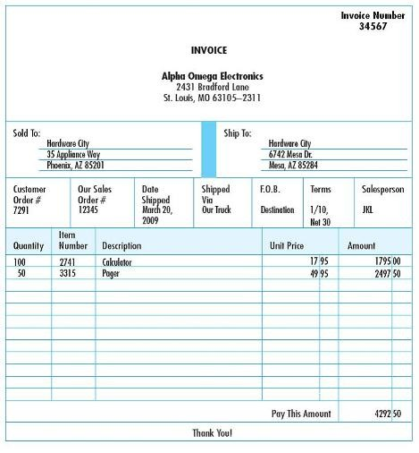
A) 6
B) 5
C) 4
D) 7
Answer: A
Page Ref: 96
Objective: Learning Objective 5
Difficulty : Difficult
AACSB: Reflective Thinking
61) Which of the following would not be one of the well-structured tables in a well-designed relational database used to generate this sales invoice?
A) Customer Order
B) Customer
C) Sales
D) Sales Order
Answer: A
Page Ref: 96
Objective: Learning Objective 5
Difficulty : Difficult
AACSB: Reflective Thinking
62) Which of the following would not be true about the well-structured tables in a well-designed relational database used to generate this sales invoice?
A) Quantity would be generated from the Sales table.
B) 34567 would be a primary key in the Sales table.
C) Unit Price would be generated from the Inventory table.
D) Hardware City is an example of a non-key data value in the Customer table.
Answer: A
Page Ref: 96
Objective: Learning Objective 5
Difficulty : Difficult
AACSB: Reflective Thinking
63) Which one of the following results corresponds to the query below?
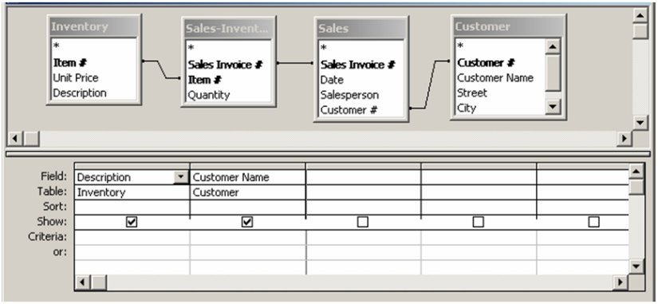
A)
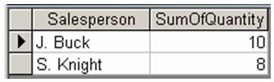
B)
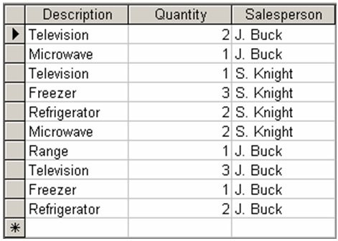
C)
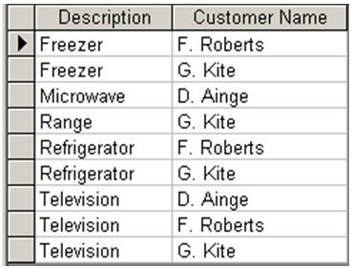
D)
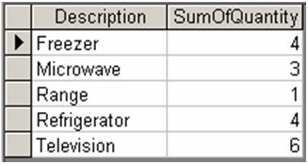
Answer: C
Page Ref: 97-104
Objective: Learning Objective 6
Difficulty : Easy
AACSB: Analytic

64) Which one of the following results corresponds to the query below?
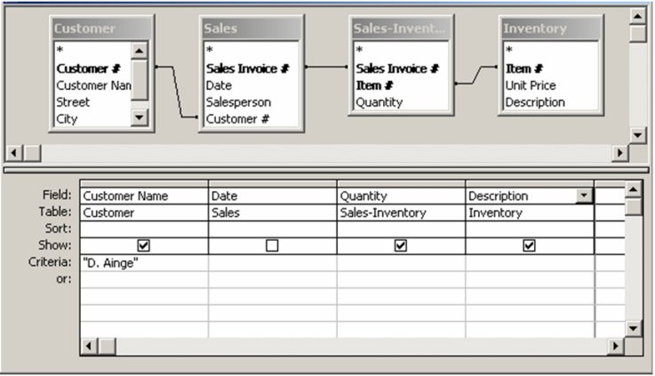
A)
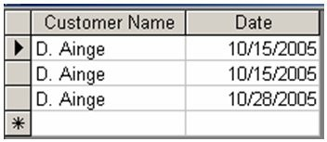
B)
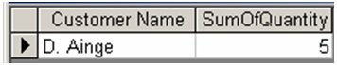
C)
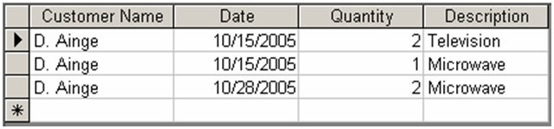
D)
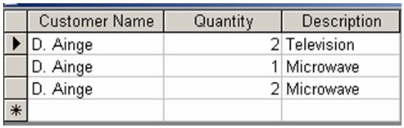
Answer: D
Page Ref: 97-104
Objective: Learning Objective 6
Difficulty : Moderate
AACSB: Reflective Thinking
65) Which one of the following results corresponds to the query below?
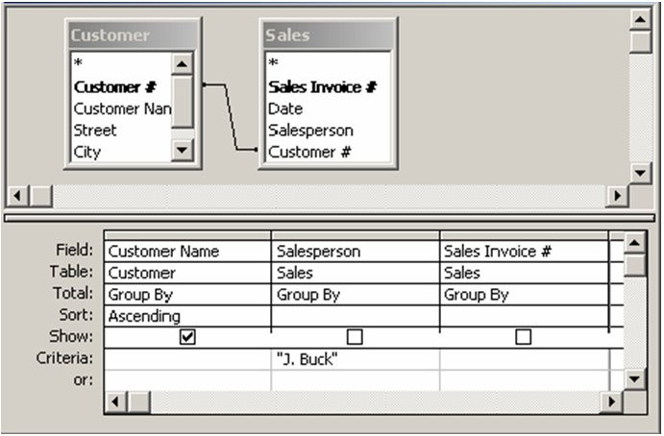
A)
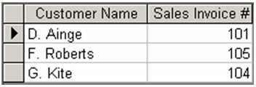
B)
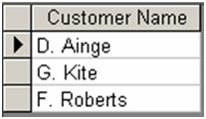
C)
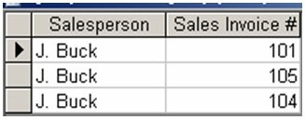
D)
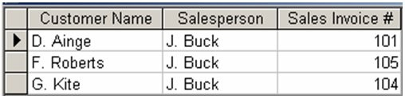
Answer: B
Page Ref: 97-104
Objective: Learning Objective 6
Difficulty : Moderate
AACSB: Reflective Thinking
66) Describe a major advantage of database systems over file-oriented transaction processing systems.
Answer: Database systems separate logical and physical views. This separation is referred to as program-data independence. Such separation facilitates developing new applications because programmers can concentrate on coding the application logic (what the program will do) and do not need to focus on how and where the various data items are stored or accessed. In the file-oriented transaction systems, programmers need to know physical location and layout of records which adds another layer of complexity to programming.
Page Ref: 88-89
Objective: Learning Objective 1
Difficulty : Easy
AACSB: Reflective Thinking

67) What is the difference in logical view and physical view?
Answer: The logical view is how the user or programmer conceptually organizes and understands the data, such as data organized in a table. The physical view, on the other hand, refers to how and where the data are physically arranged and stored in the computer system.
Page Ref: 90
Objective: Learning Objective 2
Difficulty : Easy
AACSB: Analytic

68) Describe the different schemas involved in a database structure. What is the role of accountants in development of schemas?
Answer: A schema describes the logical structure of a database. There are three levels of schemas. First, the conceptual-level schema is an organization-wide view of the entire database listing all data elements and relationships between them. Second, an external-level schema is a set of individual user views of portions of the database, each of which is referred to as a subschema. Finally, an internal-level schema provides a low-level view of the database includes descriptions about pointers, indexes, record lengths, etc. Accountants are primarily involved in the development of conceptual- and external-level schemas; however, database knowledgeable accountants may participate in developing an internal -level schema.
Page Ref: 90
Objective: Learning Objective 3
Difficulty : Moderate
AACSB: Reflective Thinking
69) Describe a data dictionary.
Answer: A data dictionary is a means by which information about the structure of a database is maintained. For each data element stored in the database, there is a corresponding record in the data dictionary that describes it. The DBMS usually maintains the data dictionary. Inputs to the dictionary include various new data, changed data, and deleted data. Output from the data dictionary may include a variety of reports useful to programmers, database designers, and other users of the information system. Accountants have a very good understanding of the data elements that exist in a business organization, so when an organization is developing a database, accountants should be allowed to participate in the development of the data dictionary.
Page Ref: 92
Objective: Learning Objective 3
Difficulty : Easy
AACSB: Analytic

70) Explain the types of attributes that tables possess in a relational database.
Answer: Primary key  the attribute, or combination of attributes, that uniquely identify a specific row in a table. Foreign key  an attribute appearing in one table that is a primary key in another table. Nonkey attributes found in tables  For example, an inventory table may contain information about the description, quantity on hand, and list price of each item a company sells.
Page Ref: 92
Objective: Learning Objective 4
Difficulty : Easy
AACSB: Analytic

71) Explain the two advantages semantic data modeling has over normalization when designing a relational database.
Answer: Semantic data modeling takes advantage of a system designer's knowledge about the business policies and practices of an organization. This is of great benefit in the design of transaction processing databases. Also, since the database model is created around the policies and practices of an organization, communications with the future database users is facilitated. The result is that the system will more closely meet the needs of the intended users.
Page Ref: 97
Objective: Learning Objective 4
Difficulty : Moderate
AACSB: Analytic
72) Explain the difference between file-oriented transaction processing systems and relational database systems. Discuss the advantages and disadvantages of each system.
Answer: In file-oriented approaches, different users (or departments, units, etc.) maintain their own data and use different application programs. This results in a significant increase in number of master files stored by an organization. The various disadvantages of file-oriented organization include data redundancy, data inconsistencies, lack of data integration, a large number of data files, substantial program-data dependence, lack of compatibility, and lack of data sharing. The database approach views data as an organizational resource that should be used and managed for the entire organization. The program that manages and controls the data and the interfaces between data and application programs is called the database management system (DBMS). The various advantages of database approach include the following: minimal data redundancy, fewer data inconsistencies, data integration, data sharing, reporting flexibility, central management of data, cross-functional analysis, and data independence.
Page Ref: 87-88
Objective: Learning Objective 1
Difficulty : Moderate
AACSB: Reflective Thinking

73) Discuss redundancy as it applies to database design.
Answer: Redundancy has been called an enemy of relational databases. There are several problems that may occur when redundant data is stored in a database. First, the database becomes larger than it needs to be, since duplicate facts are being stored within it. Second, a situation may occur where only one instance of redundant data is updated or purged. The result is that the accuracy and integrity of the database suffers, since users may be relying on such inaccurate or incorrect redundant data. Redundancy can also make file maintenance unnecessarily time consuming and error-prone when human intervention is required. The problems discussed above have been identified as anomalies of a relational database. There are three specific anomalies connected with redundancy: the update anomaly, the insert anomaly, and the delete anomaly. A well-designed relational database will attempt to reduce or eliminate the number of instances of redundant data. The best way to achieve such a goal is proper design of the database for the needs of a specific organization.
Page Ref: 94
Objective: Learning Objective 4
Difficulty : Difficult
AACSB: Reflective Thinking
74) Discuss the ways in which a well-designed DBMS will facilitate the three basic functions of creating, changing, and querying data.
Answer: A DBMS will use data definition, data manipulation, and data query languages in order to perform the three basic, essential data functions. Data definition is achieved using DDL (data definition language); data manipulation is achieved using DML (data manipulation language) which includes operations such as updating, inserting, and deleting portions of the database. DQL (data query language) is used to retrieve, sort, order, and present subsets of data in response to user queries. A DBMS will probably also include a report writer, which is a language that simplifies report creation.
Page Ref: 92
Objective: Learning Objective 3
Difficulty : Moderate
AACSB: Analytic

75) List the four DBMS "languages" and describe who uses each and for what purpose.
Answer: DDL is the data definition language used by the DBA (database administrator) to create, initialize, describe logical views, and specify security limits. The DML is the data manipulation used by application programmers who embed these action commands into applications to access data in the database. The DQL is the data query language used by IT professionals and users to interrogate the database by retrieving and presenting data in novel ways often on an ad hoc basis. The report writer is a language used by IT professionals and users that simplifies report creation so reports can be created according to user-specified format.
Page Ref: 92
Objective: Learning Objective 3
Difficulty : Moderate
AACSB: Analytic

76) Describe the information that is contained in the data dictionary.
Answer: The data dictionary contains information about the structure of the database. For each data element stored in the database, the data dictionary contains all the descriptive information about it, such as its name, description, where it is recorded, its source, field length, type of field, programs it is used in, outputs that contain it, and authorized users.
Page Ref: 92
Objective: Learning Objective 3
Difficulty : Easy
AACSB: Analytic
77) Explain the relational database data model.
Answer: A data model is an abstract representation of the contents of a database. The majority of new DMBS use what is called the relational data model, developed by Dr. E. F. Codd in 1970. Using this model, everything in the database is stored in the form of tables, known as relations. Keep in mind that this is the conceptual- and external-level schemas (which describes the logical structure of a database), not the actual physical structure of the database itself. In the concept of relations, both rows and columns comprise the database tables. Each row in a relation (table) is called a tuple. Tuples contain data about a specific occurrence of the type of entity represented by that table. For example, in a sales table, each tuple may contain all of the information about a specific customer. Each column in a relation contains information about one specific attribute of that entity. Using the sales example again, the columns in such a table may represent specific characteristics about each sales transaction.
Page Ref: 92
Objective: Learning Objective 4
Difficulty : Moderate
AACSB: Analytic

78) What are the basic requirements when logically designing a relational database model?
Answer: Every row in every table must have a unique key known as a primary key. Tables may also have a key known as a foreign key; such a key will have a value corresponding to the primary key in another table. Each column in a table must be single-valued (the same data type) and describe an attribute of the entity identified by the primary key; neither column nor row order is significant in the relational model. Keep in mind that the relational model is a logical model, and the physical model may have a different structure to it to facilitate the storage and access to data.
Page Ref: 96
Objective: Learning Objective 4
Difficulty : Moderate
AACSB: Analytic
79) Describe what you think will be the main impact of database technology in your career.
Answer: Answers to this question could cover a wide range. Most likely the following items will be discussed or mentioned:
 the probable demise of the double-entry system as the need for such redundancy is much less in a database system.
 financial reporting may become more of accessing a database of corporate data in the format desired by the user than relying on financial reports prepared by accountants.
 accountants will no longer need to be the filter for accounting data as users will be able to do this themselves, thus the accountants may become more decision makers and managers.
 the whole notion of internal controls will become more important in the future if the accountants' role changes in relation to financial reporting.
Page Ref: 104-105
Objective: Learning Objective 1
Difficulty : Difficult
AACSB: Reflective Thinking

80) Chagall Curtain Company is changing from a file-oriented system to a relational database system. Design at least three tables that would be needed to capture data for a sales transaction. Each table should include a primary key, three non-key attributes, and foreign keys as necessary. Make up data values for two records within each table.
Answer: Customer table; ID (primary key), name, street address, city, state, zip code, phone number, credit limit, salesperson ID (foreign key)
Salesperson table; ID (primary key), name, street address, city, state, zip code, phone number, hire date, commission rate, base salary
Sales table; sales invoice number (primary key), date, amount, sales tax, shipping charge, shipping method, customer ID (foreign key), salesperson ID (foreign key)
Inventory table; item ID (primary key), description, size, color, warehouse location, list price, quantity on hand
Sales-Inventory table; sales invoice number and item ID (concatenated primary key), quantity sold, sales price, extended amount

Students should also make up data values for two separate records for each table.
Page Ref: 94-96
Objective: Learning Objective 5
Difficulty : Difficult
AACSB: Reflective Thinking

