

Criminal Investigation System

A Project Report submitted in partial fulfillment of the requirements for the award of the degree of
Bachelor of Technology
in
Computer Science and Engineering
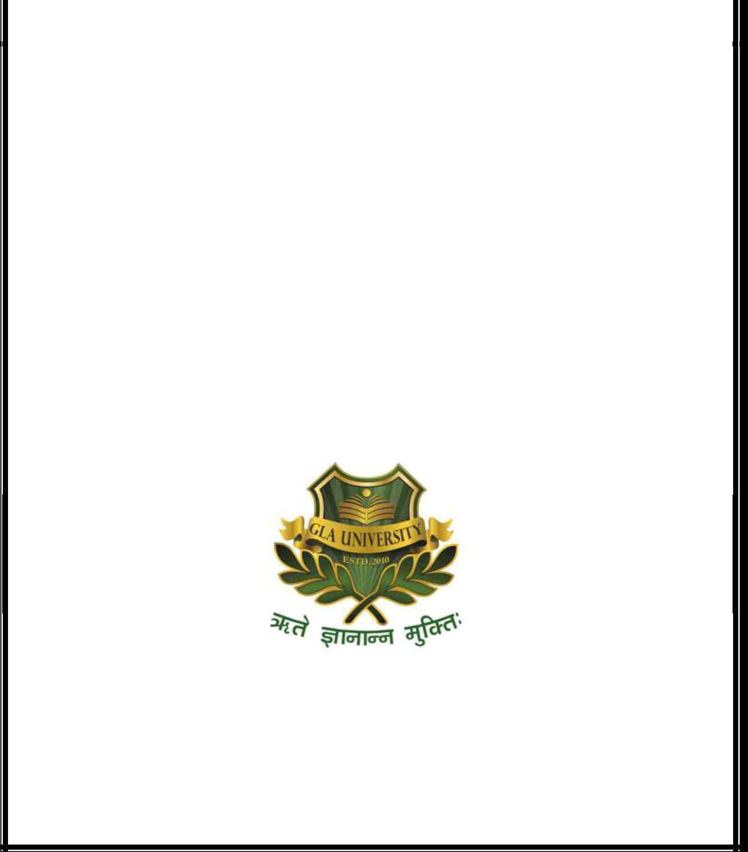
By

Taru Chaudhary (131500330)
Parul (131500210)
Ravi Shankar Dubey (131200272)

Under the Guidance of

Mr. K. Susheel Kumar

Department of Computer Engineering & Applications

Institute of Engineering & Technology

GLA University

Mathura- 281406, INDIA

May, 2017
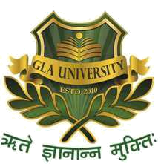
Department of Computer Engineering and Applications

GLA University, Mathura

17km Stone, NH-2, Mathura-Delhi Road, P.O.–Chaumuhan, Mathura–281406(U.P.), India

Declaration

We hereby declare that the work which is being presented in the B.Tech Project “Criminal Investigation System”, in partial fulfillment of the requirements for the award of the Bachelor of Technology in Computer Science and Engineering and submitted to the Department of Computer Engineering and Applications of GLA University, Mathura, is an authentic record of our own work carried under the supervision of Mr. K. Susheel Kumar, Assistant Prof., Dept. of CEA.
The contents of this project report, in full or in parts, have not been submitted to any other Institute or University for the award of any degree.

Sign ______________________ Sign ______________________
Taru Chaudhary Parul
University Roll No.: 131500330 University Roll No.: 131500210

Sign ______________________
Ravi Shankar Dubey
University Roll No.: 131200272

Certificate

This is to certify that the above statements made by the candidate are correct to the best of my/our knowledge and belief.

_______________________
Supervisor
Mr. Saurabh Singhal
Assistant Prof., Dept. of CEA

____________________ ____________________________

Project Coordinator Head of Department

(Mr. Mayank Srivastava) (Prof. Anand Singh Jalal)

Date: ii

