Chapter-3

SOFTWARE DESIGN

__________________________________________

In this chapter we first define what software design is? Then we describe the use case diagrams,data flow diagrams followed by flow chart. In the end database design is given in the form of E-R diagrams and database table.

3. Software Design

Software design is the process by which an agent creates a specification of a software artefact, intended to accomplish goals, using a set of primitive components and subject to constraints.Software design may refer to either "all the activity following requirements specification and before programming,a stylized software engineering process." Software design usually involves problem solving and planning a software solution. This includes both a low-level component and algorithm design and a high-level, architecture design.

3.1 Use Case

Login

Database/image select

Search Database

New Record

User

Enhance Image

Figure 3.1: Use Case

3.2 Analysis Models

3.2.1 Data Flow Diagrams (DFD)

A data flow diagram (DFD) is a graphical represntation of the “flow” of data through an information system,modelling its pprocess aspects. A DFD is often used as a preliminary step to create an overview of the system, which can be later be eleborated.

DFDs can also be used for the visualization of data processing (structured design). A DFD sows what kind of information will be input to and output from the system where the data will come from and go to, and where the data will be stored.

0 level DFD

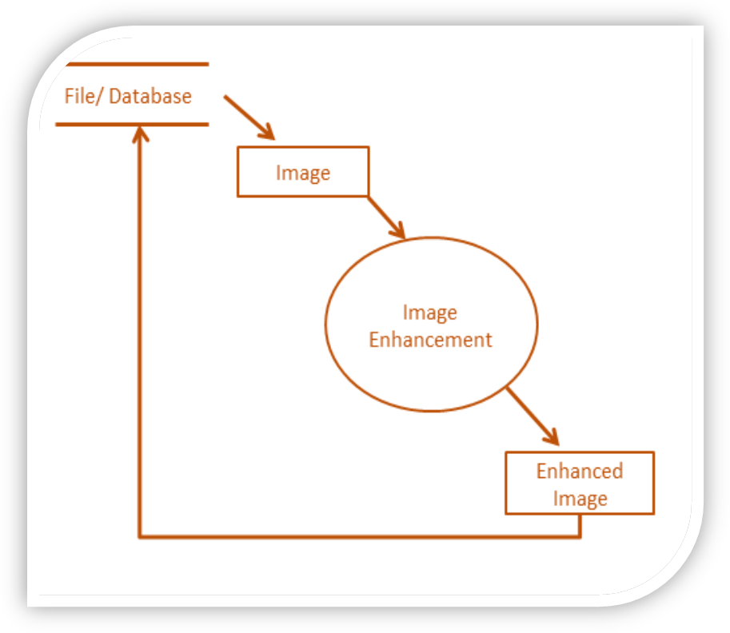

Figure 3.2: Level 0 DFD

3.2 Flow Chart

A flowchart is a type of diagram that represents an algorithm, workflow or process, showing the steps as boxes of various kinds, and their order by connecting them wwith arrorws. This diagrammatic representation illustrates a solution model to agiven problem. Flowcharts are used in analyzing, designing, documenting or managing a process or program in various fields.

Flowcharts are used in designing nad documenting simple processes or programs. Like other types of diagrams, they help visualize what is going or therby help undersatnd a process, and perhaps also find flaws, bottlencks and other less-obvious features within it. There are many different types of flowcharts.

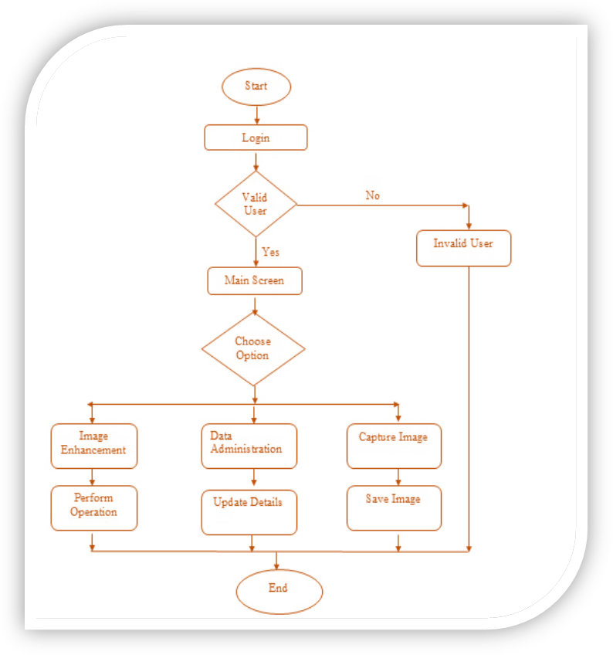
Figure 3.3 Flow Chart

3.3 E-R Diagram

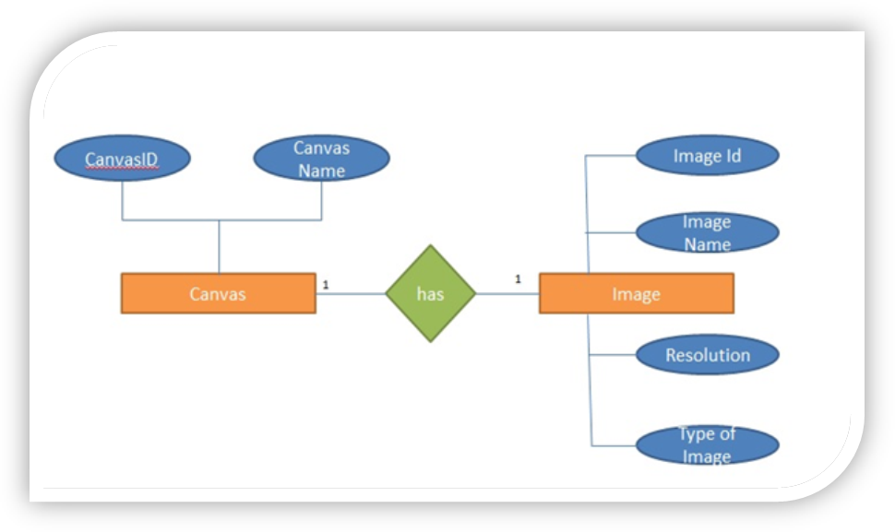Figure 3.4 ER-Diagram 1

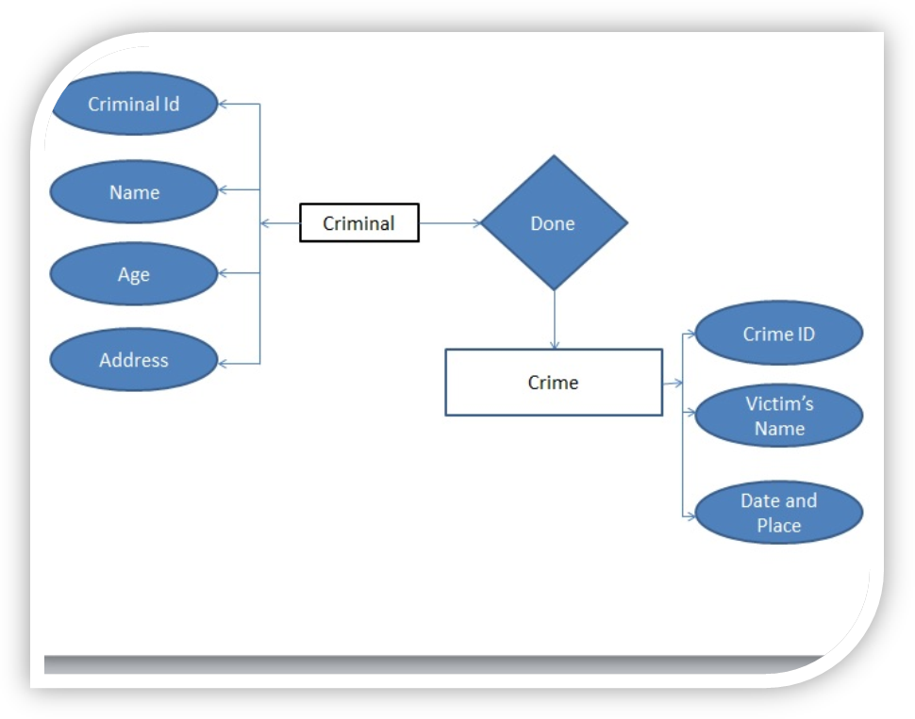
Figure 3.5 ER-Diagram 2

3.4 Database Diagrams

Table 3.1: This table shows records of user.

Table 3.1: user details
Id | User_name | password
01 | admin | 12345

Table 3.2: This table shows records of criminals.

Table 3.2: criminal record

Id | Name | Sex | Dob | Address | Accused of
01 | Prabhakaran | Male | 1885-10-19 | Chitranjan | Murder
02 | Nirbhay | Male | 1965-10-18 | Chinhat | Robbery

