Whitewater Rafing Site Plan

# LOGO

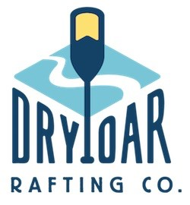

# COLOR #465E73, #84A9BF, #BDE3F2, #8C6316, #BF5934

COLOR URL

# https://coolors.co/palette/ef476f-ffd166-06d6a0-118ab2-073b4c

# TYPOGRAPHY

Roboto

Raleway