**Database and Management System Lab**

**Lab Experiment – 10**

Name: Nancy Gumanta

Roll No: R2142230041

Sap_ID: 500121761

B.Tech CSE, SEM-III, B-1

**Title: Create the following views in SQL on the COMPANY database schema presented in Experiment 2**

**1. A view that has the department name, manager name, and manager salary for every department.**

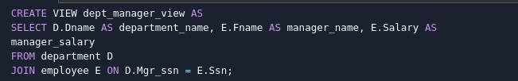

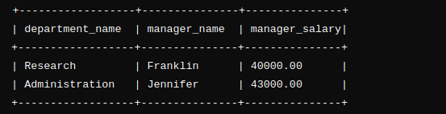

**2. A view that has the employee name, supervisor name, and employee salary for each employee who works in the ‘Research’ department**

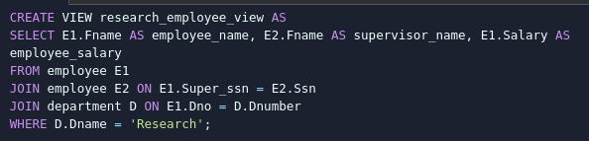

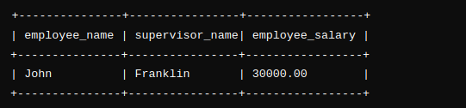

**3. A view that has the project name, controlling department name, number of employees, and total hours worked per week on the project for each project.**

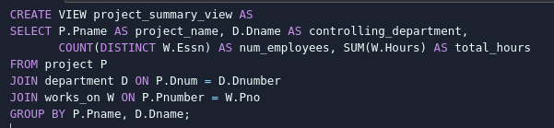

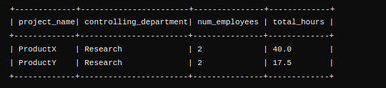

**4. A view that has the project name, controlling department name, number of employees, and total hours worked per week on the project for each project with more than one employee working on it.**

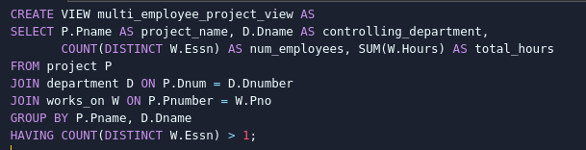

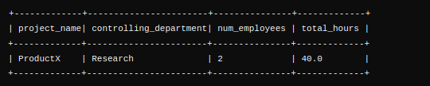

**Database and Management System Lab**

**Lab Experiment – 11**

Name: Nancy Gumanta

Roll No: R2142230041

Sap_ID: 500121761

B.Tech CSE, SEM-III, B-1

**Title: To understand the concepts of Index.**

**Objective:** Students will be able to implement the concept of index

**1. Create EMPLOYEES Table and Insert Sample Data**

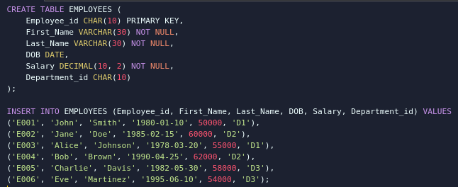

**2. Create an Index on Last_Name and Department_id**



**3. Find the ROWID and Create a Unique Index on Employee_id**



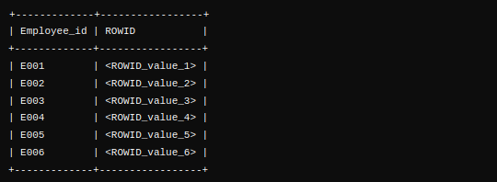

**4. Create a Reverse Index on Employee_id**



**5. Create a Unique Composite Index on Employee_id to Check Duplicates**



**6. Create Function-Based Index for Case-Insensitive Search on Last_Name**



**7. Drop the Function-Based Index on Last_Name**

