**Database and Management System Lab**

**Lab Experiment – 12**

Name: Nancy Gumanta

Roll No: R2142230041

Sap_ID: 500121761

B.Tech CSE, SEM-III, B-1

**Title: To understand the concepts of Sequence.**

**Objective:** Students will be able to implement the concept of sequence.

**1. Create a sequence by name EMPID_SEQ starting with value 100 with an interval of 1.**



**2. Write a SQL command for finding the current and the next status of EMPID_SEQ.**



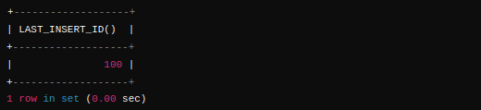

**3. Change the Cache value of the sequence EMPID_SEQ to 20 and maxvalue to 1000.**



**4. Insert values in the EMPLOYEES table using sequences for the Employee_id column.**



**5. Drop sequence EMPID_SEQ.**



**Database and Management System Lab**

**Lab Experiment – 13**

Name: Nancy Gumanta

Roll No: R2142230041

Sap_ID: 500121761

B.Tech CSE, SEM-III, B-1

**Title: To understand the concepts of PL/SQL programming.**

**Objective:** Students will be able to implement the basic concepts of Pl/SQL.

**1. Write a PL/SQL code to accept the value of A, B & C and display which is greater.**

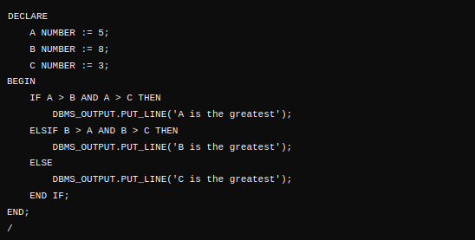



**2. Using PL/SQL Statements create a simple loop that displays the message “Welcome to PL/SQL Programming” 20 times.**

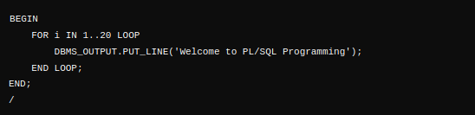

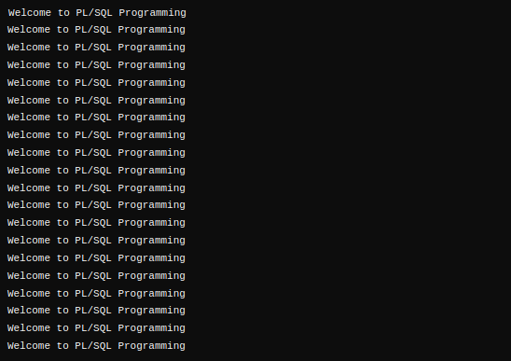

**3. PL/SQL Code to Find the Factorial of a Number**

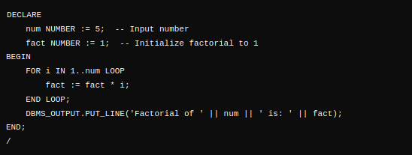



**4. PL/SQL Program to Generate Fibonacci Series**

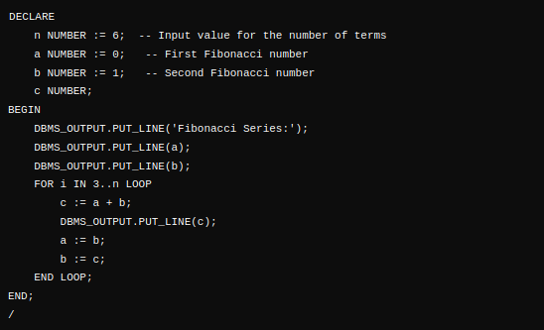

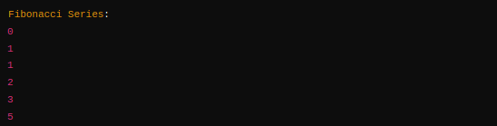

**5. PL/SQL Code to Find the Sum of First N Numbers**



