**Database and Management System Lab**

**Lab Experiment – 8**

Name: Nancy Gumanta

Roll No: R2142230041

Sap_ID: 500121761

B.Tech CSE, SEM-III, B-1

**Title: Use of different SQL clauses and join**

**Objective:** To understand the use of group by and having clause and execute the

SQL commands using JOIN

**1. Consider the following schema:**

**Student (sid, sname, age)**

**Match (mid, mname, venue)**

**Play (sid, mid, day(date))**

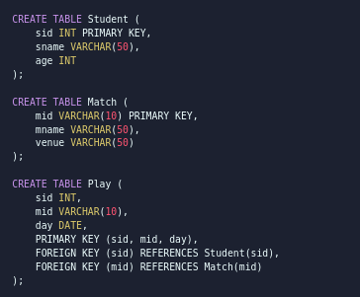

**2. Populate all the tables.**

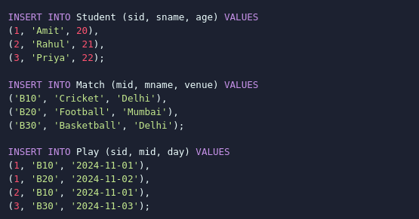

**3. Find all information of students who have played match number B10.**

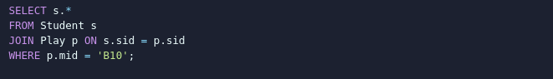

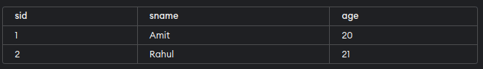

**4. Find the name of matches played by Amit.**

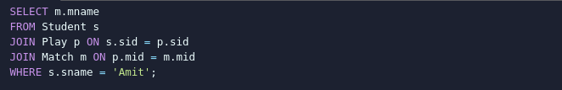

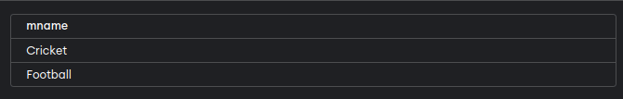

**5. Find the names of students who have played a match in Delhi.**

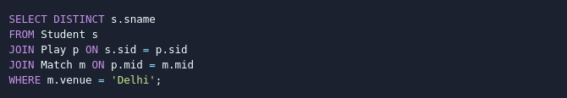

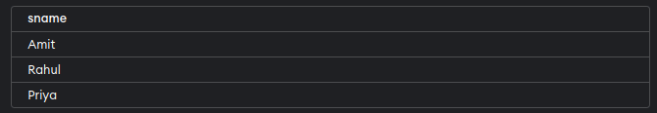

**6. Find the names of students who have played at least one match.**

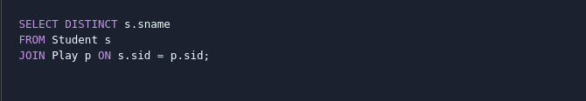

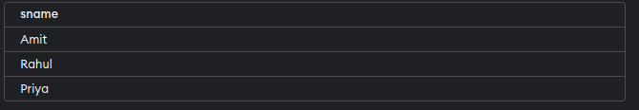

**7. Find the ids and names of students who have played two different matches on the same day.**

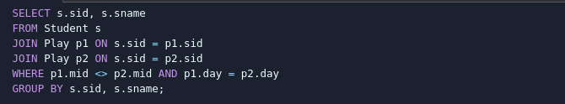



**8. Find the ids of students who have played a match in Delhi or Mumbai.**

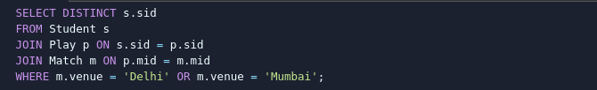

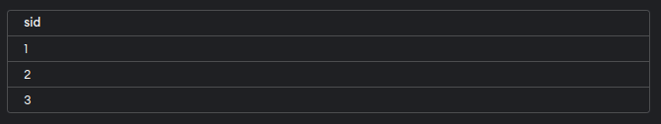

**9. Find the average age of students.**



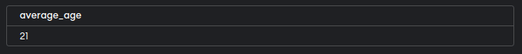

**Database and Management System Lab**

**Lab Experiment – 9**

Name: Nancy Gumanta

Roll No: R2142230041

Sap_ID: 500121761

B.Tech CSE, SEM-III, B-1

**Title: To understand the concepts of Views.**

**Objective:** Students will be able to implement the concept of views

**1. Create table of table name: EMPLOYEES and add 6 rows**

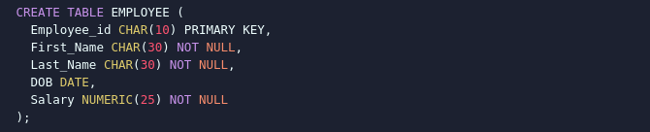

**2. Create a View emp_view with Specific Columns**



**3. Insert Values into the View (emp_view)**



**4. Modify, delete and drop operations are performed on view**







**5. Creates a view named salary_view. The view shows the employees in department 20 and their annual salary**

