Employee dashboard

~~*can you change annual leave as below. Calculation no need to be changed.~~

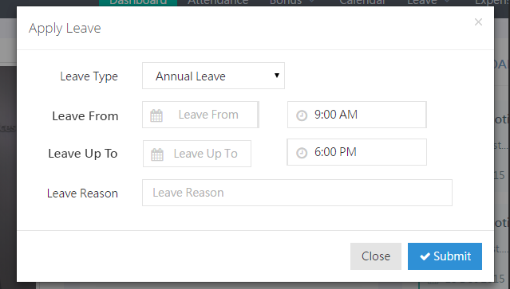

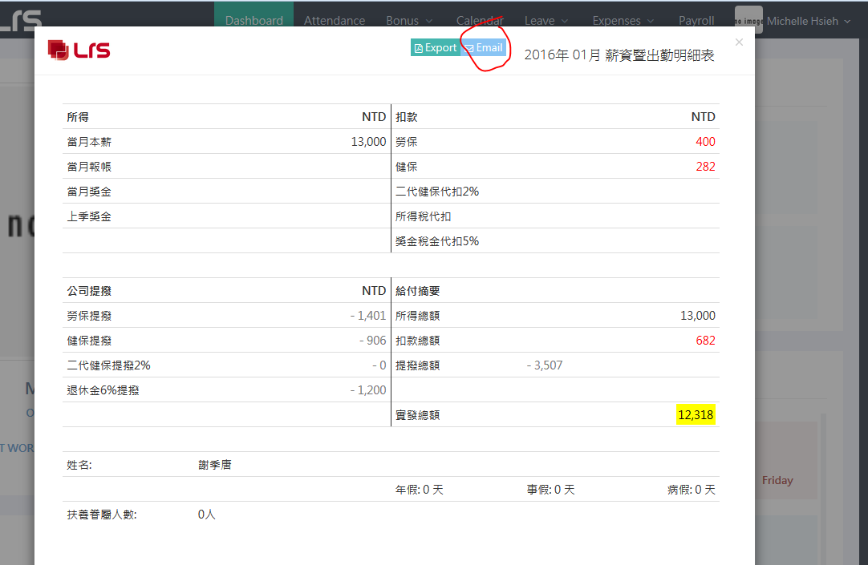

~~*”email” payroll after clicking nothing happened, pls display some successful sent text.~~

~~add sub menu “Manage Employee Expenses” for dept manager and admins?~~

~~Can you use these URL?~~ [~~http://inleadingrs.com/index.php/expenses/manage~~](http://inleadingrs.com/index.php/expenses/manage)

~~Leave need to add as well. “Manage Employee Leaves .~~

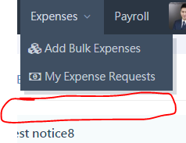

Do you know why when I added a new account and enter to test payroll, display php error?

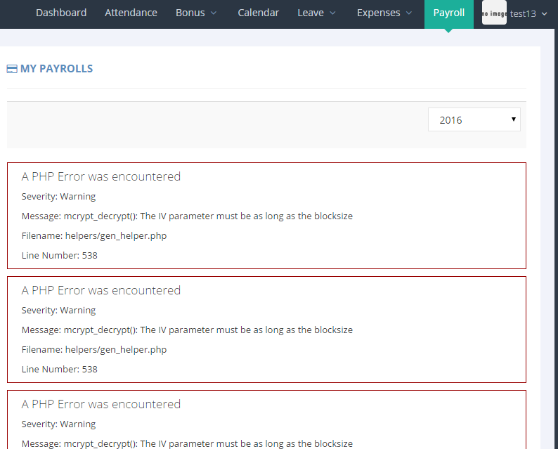

Manager dashboard

1. ~~JK Chen and Han Change expense not need to be approved, directly turn to “approved” status.~~
2. ~~Dept. managers expense and leave request, go to Han Chang request approval. (but JK no need, so pls hardcode skip JK)~~

~~**email and notification box, can you setup Han Chang’s notification box only display dept manager submit request?~~

~~**for JK Chen email and notification box, only display “FMCG&Retail” and “Internet” these two dept employee’s request~~

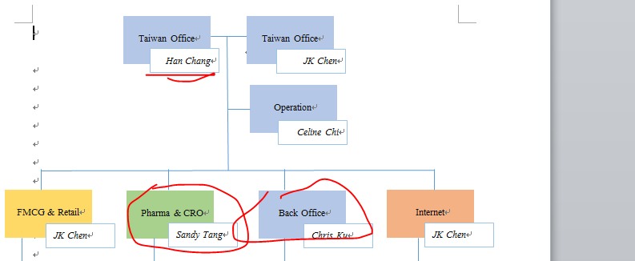

<http://www.leadingrs.com/employee/index.php/leave_applications/employeeLeaveList/15>

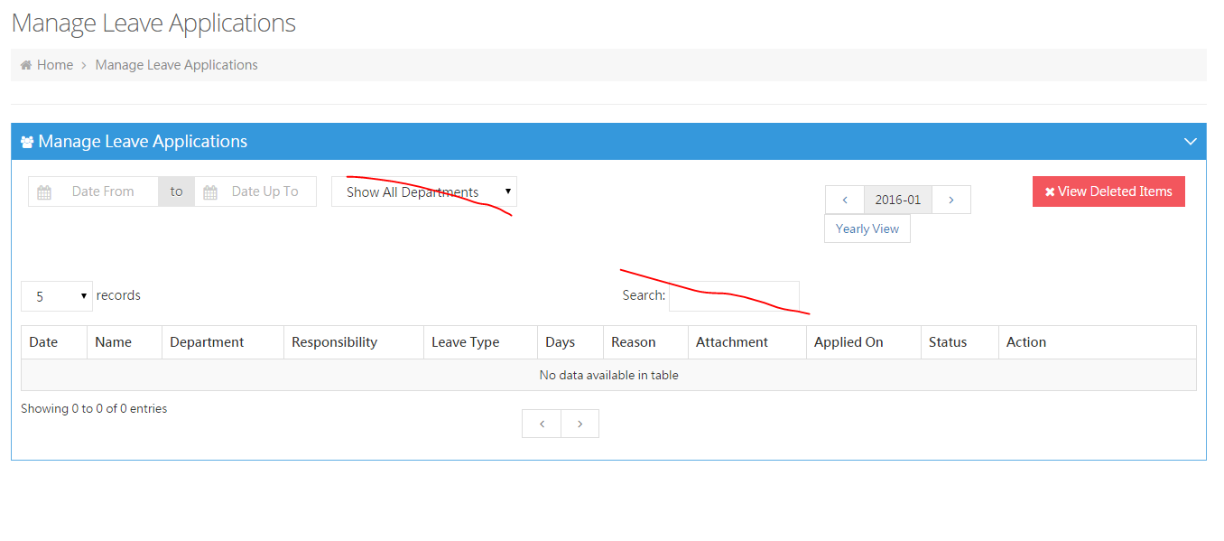 hide these two.

<http://www.leadingrs.com/employee/index.php/payrolls>

2015 Dec missing the employee who left company in the middle of the month data again.

*Pls add the rule, and it’s related with tax counting.

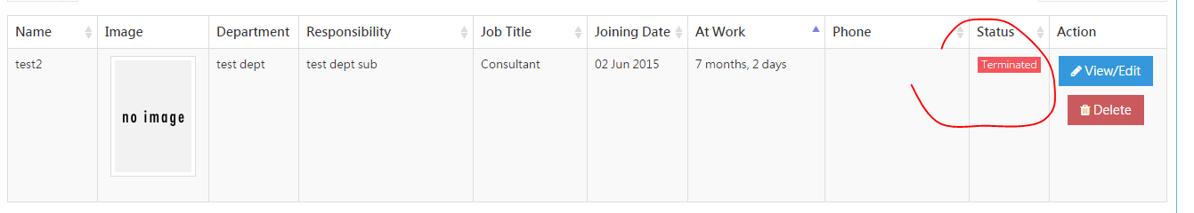

* When adding new employee, it auto got the “terminated” status. I need to click “edit” to change the status.
* Pls make it add new one auto in “probation”

*when employee over 3 months probation, pls do not auto change to active. 🡪 need to add a notice on “notification” (xxx has passed probation period, please change the status.), make it clickable link to edit that certain employee.

I found everytime I click the pagination, and I want to click “delete” button it won’t work,.

<http://www.leadingrs.com/employee/index.php/leave_applications/yearly_status>

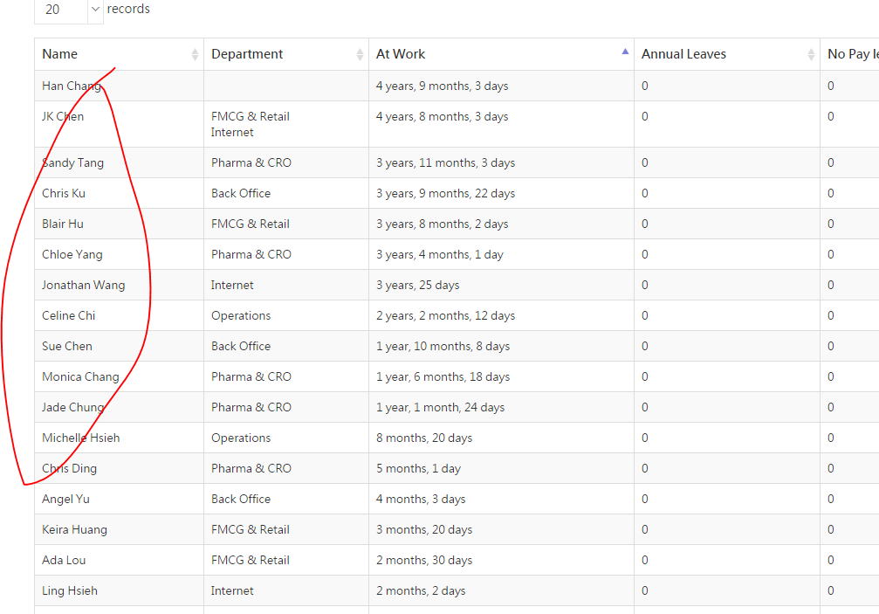

pls make the name clickable and link to certain employee yearly view page

<http://www.leadingrs.com/employee/index.php/leave_applications/employeeLeaveList/15/0/1>

*important!!! 🡪 list order according to employee ID but no need to show employee ID in frondend.

--🡪 2016 you fixed the order but click 2015 still didn’t list by order

As client requested to view the list according to certain order, I’ve changed all employees employee ID. Could you list below page order by employee ID? (but no need to display employee ID in fronend.)

<http://inleadingrs.com/index.php/payrolls>

<http://inleadingrs.com/index.php/leave_applications/yearly_status>

<http://inleadingrs.com/index.php/leave_applications/showEmployeeList>

<http://inleadingrs.com/index.php/expenses/yearly_status>

<http://inleadingrs.com/index.php/expenses/showEmployeeList>

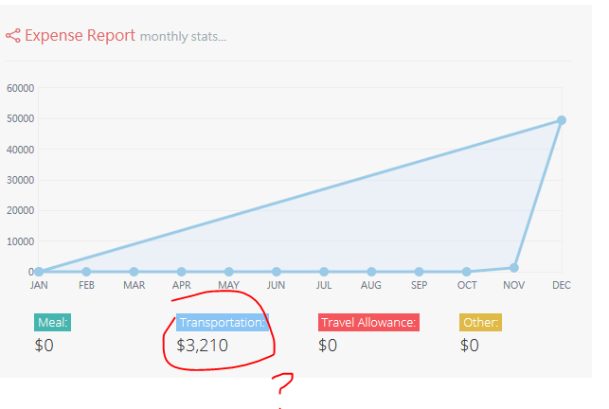 pls make this yearly report, and fix the report.