*login page: teacher/student/admin login

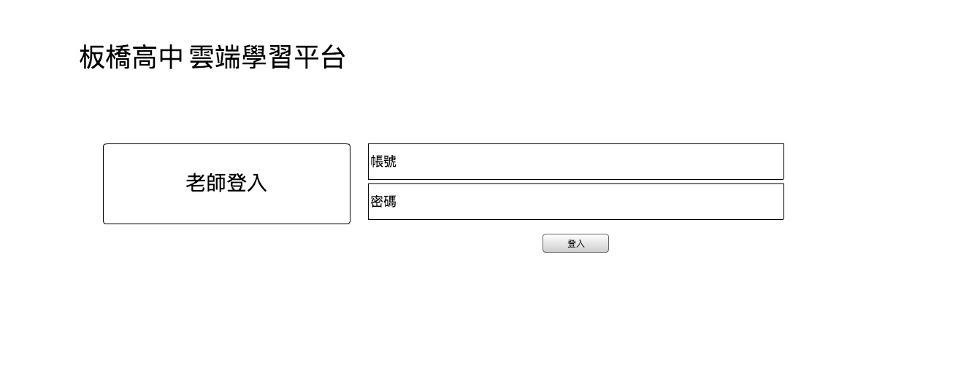

teacher login

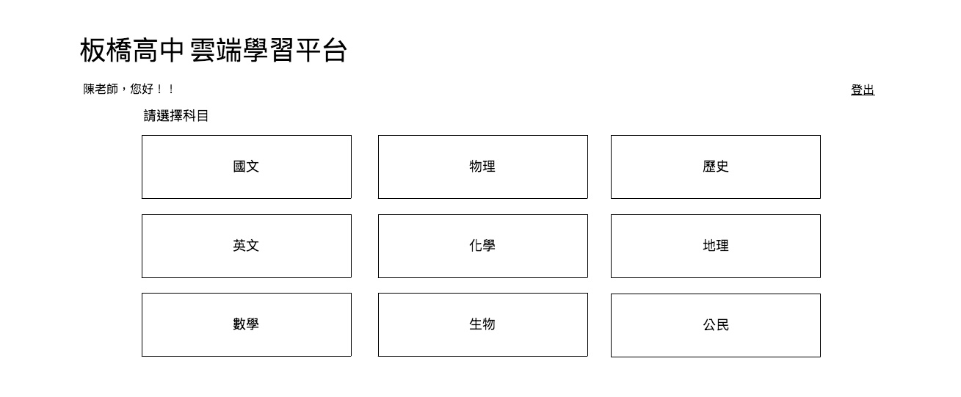

*subject category (button/link): like “Math”, “English”, “Writing”…the subject of classes.

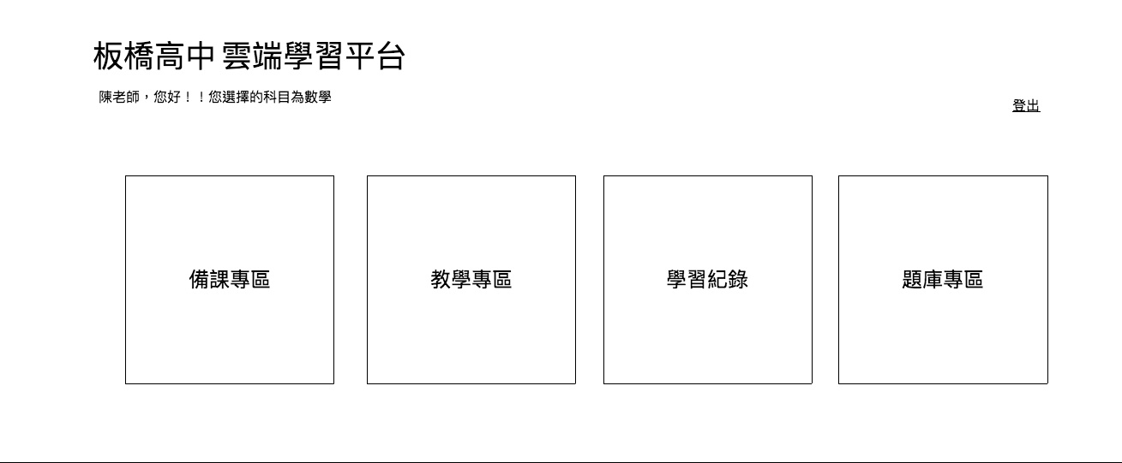

**管理**

[class documents] [class material] [learning history] [manage quiz/exam]

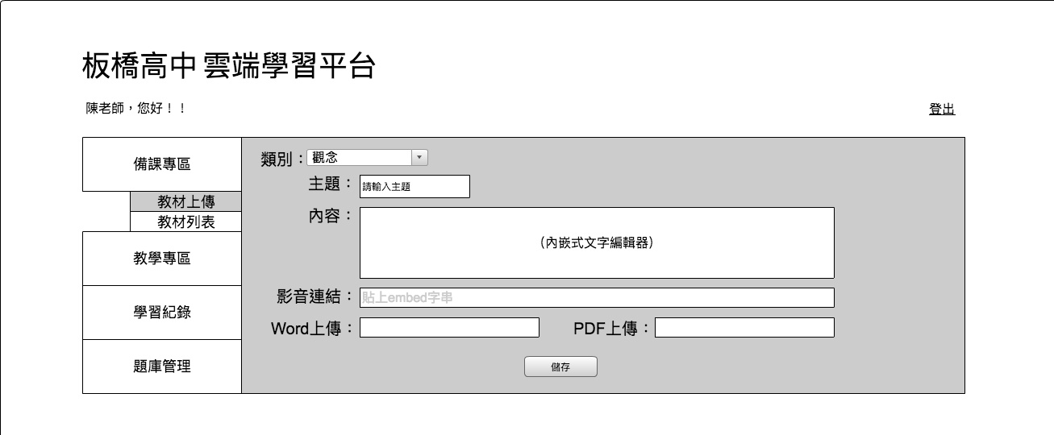

*left menu = same as above [class documents] [class material] [learning history] [manage quiz/exam]

*this is the [class documents] page.submenu: [教材上傳] [教材列表]

*dropdown: 1.觀念(it’s this page) 2.練習 3.批次上傳練習(this one need word/pdf upload for bulk data)

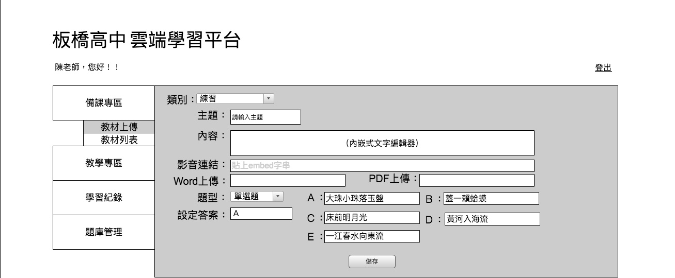

*this is dropdown [ 2.練習] page.

*another dropdown inside this page is : 1.單選題(single answer) 2.複選題(muti answer) 3.填充題(fill in) 4.問答題(long answers)

*1.單選題(single answer) and 2.複選題(muti answer) UI are the same, just add the correct answer on this input box.-🡪 these two can be review by code and count the result. And save it on [class material]

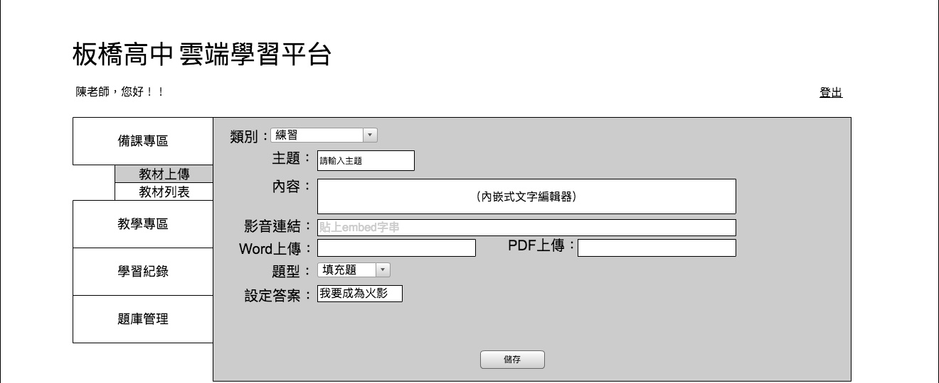

*3.填充題(fill in)🡪 the correct answer box are text input box, but cannot review by code. -🡪save as [class material]

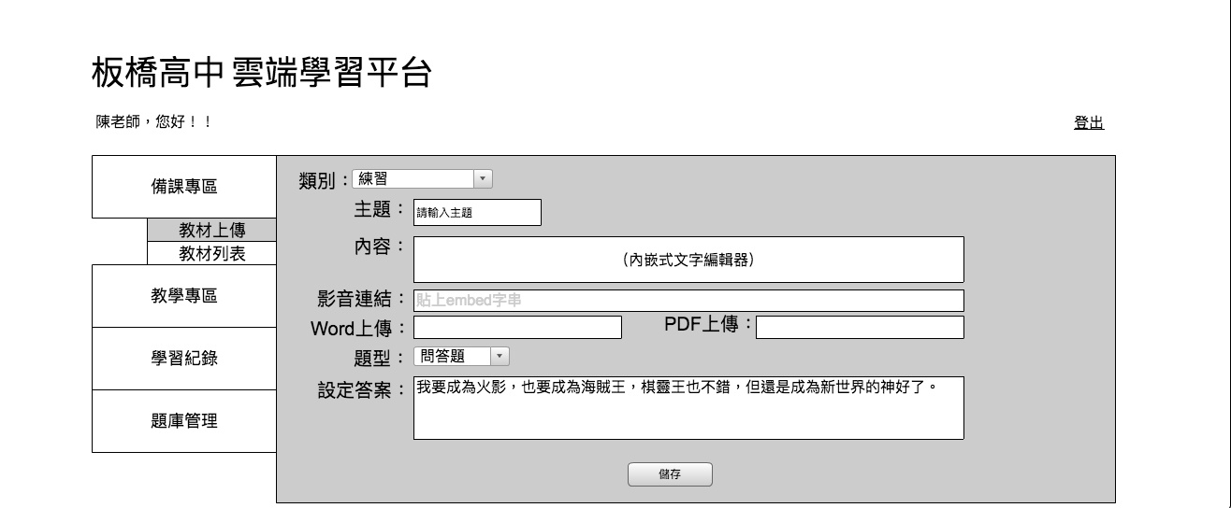

*4.問答題(long answers) 🡪 make “text area” as correct answer column. But cannot be review by code. 🡪save as [class material]

*need to add “upload” image function as one of correct answers.

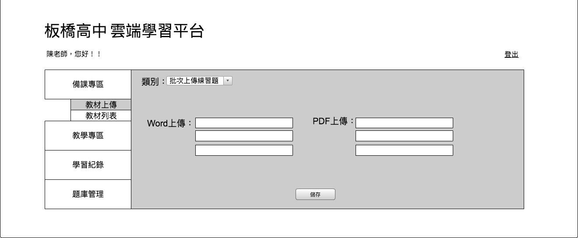

*this is 3.批次上傳練習(this one need word/pdf upload for bulk data) page.

*left: word upload / right: pdf upload -🡪 save as [class material]