~~*important!!!~~

~~Pls update the tax numbers according to excel forms. Keep 2015 approved payroll the same. But change the counting from 2016~~

~~*important!!! 🡪 list order according to employee ID but no need to show employee ID in frondend.~~

~~As client requested to view the list according to certain order, I’ve changed all employees employee ID. Could you list below page order by employee ID? (but no need to display employee ID in fronend.)~~

~~<http://inleadingrs.com/index.php/payrolls>~~

[~~http://inleadingrs.com/index.php/leave_applications/yearly_status~~](http://inleadingrs.com/index.php/leave_applications/yearly_status)

[~~http://inleadingrs.com/index.php/leave_applications/showEmployeeList~~](http://inleadingrs.com/index.php/leave_applications/showEmployeeList)

[~~http://inleadingrs.com/index.php/expenses/yearly_status~~](http://inleadingrs.com/index.php/expenses/yearly_status) ~~🡪 pls also change the display name to English name~~

[~~http://inleadingrs.com/index.php/expenses/showEmployeeList~~](http://inleadingrs.com/index.php/expenses/showEmployeeList)

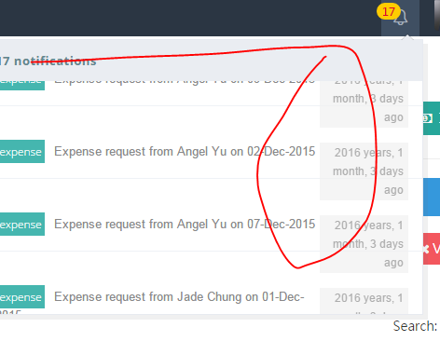

~~*notification still showing the deleted items.~~

<http://inleadingrs.com/index.php/emp_dashboard/my_payrolls>

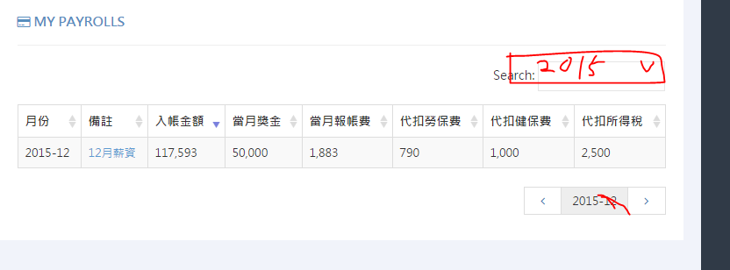

~~Pls make yearly list on “my payrolls” and remove the “search”, add year filter.~~