<http://inleadingrs.com/index.php/leave_applications/yearly_status/2015>

~~name -🡪 pls use English name here.~~

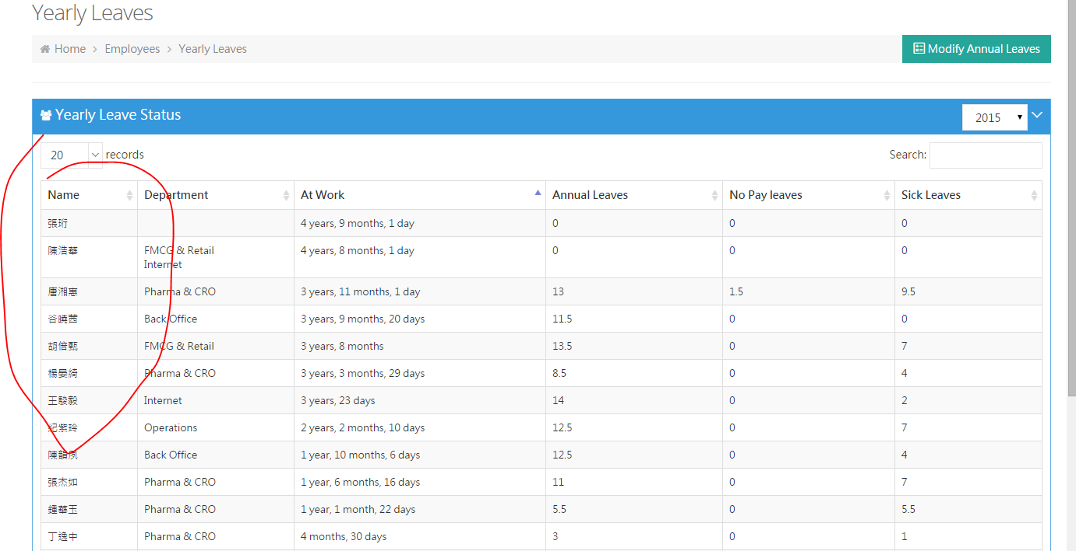

<http://inleadingrs.com/index.php/expenses/showEmployeeList>

~~pls hide terminated employees here. and skip “test department~~”

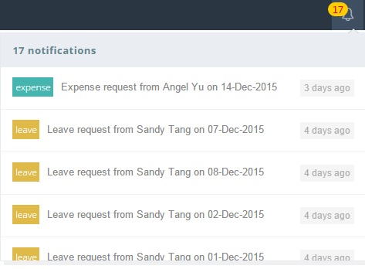

~~when click the notification will go the manage page which is fine, but can you also popup the item at the same time?~~

~~can you help me looking the password login for these three accounts?~~

~~intern@leadingrs.com~~

~~hr@leadingrs.com~~

[~~sandy.tang@leadingrs.com~~](mailto:sandy.tang@leadingrs.com)

~~hide “settings”~~

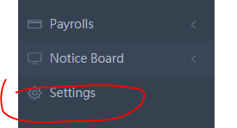

<http://inleadingrs.com/index.php/employee/manage>

~~can you list order by “at work days”?~~

<http://inleadingrs.com/index.php/expenses/yearly_status>

~~pls display “all records” by default”~~

~~and skip “test department”~~

[~~http://inleadingrs.com/index.php/payrolls/yearly/2015~~](http://inleadingrs.com/index.php/payrolls/yearly/2015)

~~*pls delete 2015 nov payroll~~

~~*we are going to change the tax for 2016, is the 2015 Dec payroll numbers will be effected? Is so, pls make the approved payroll fixed.~~

~~I will provide you the new tax and confirmed leaves rule later. Thanks.~~