Celine chi

2015/1/5~1/7 annual leave should be 3 days but it counts 2 days. Pls fix the counting there should be some counting code error.



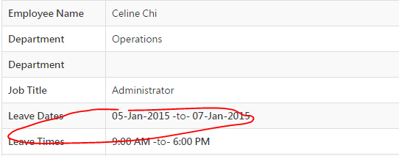

<http://www.leadingrs.com/employee/index.php/leave_applications/yearly_status>

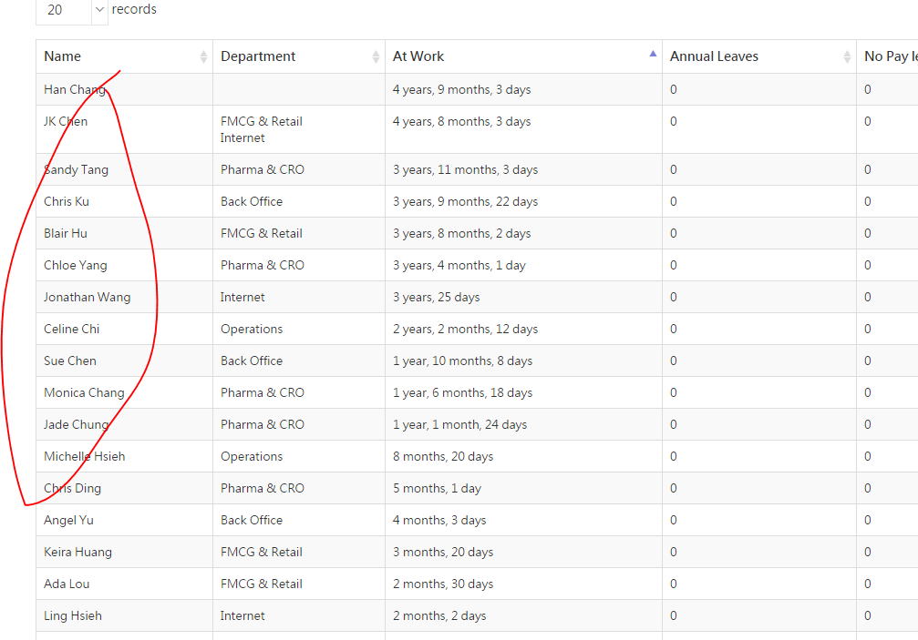

pls make the name clickable and link to certain employee yearly view page

<http://www.leadingrs.com/employee/index.php/leave_applications/employeeLeaveList/15/0/1>