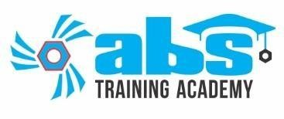

CERTIFICATE

Name of Candidate: username

Photo

Designation: userdesignation

Company **Advanced Bolting Solutions**

Industry **Manufacturing & Service**

Course: **usercourse**

Eligibility Requirements **Safety Training completed**

Theory examination passed Practical skill tested

Results: ABS Training Academy certifies that the above certificate holder Has successfully completed the ABS Bolt Torqueing & tensioning Validation Program with the required criteria.

|  |  |  |  |  |
| --- | --- | --- | --- | --- |
| **Description** | **Subject**  **Marks** | **Marks**  **Obtained** | **Critaria** | **Result** |
| **Safety Awareness** | **15** | **userSAmarks** | **Outstanding** | **95+** |
| **Excellent** | **75-95** |
| **Theory** | **30** | **userthmarks** | **Good** | **55-74** |
| **Average** | **45-54** |
| **Practical** | **55** | **userpmarks** | **Poor/Reject** | **Below 45** |
| **Total Marks** | **100** | **usertotalmarks** |  | |

Date: **01.09.2022**

Valid till: **31.08.2023**

Approved by

(Safety Supervisor) (Trainer) (Manager)

ABS office, Near hotel Alento, Next to JJ MEERA HOSTEL NEAR J.J HOTEL MOTIKHAVDI JAMNAGAR-361 140

This document is valid without signature also, if it is downloaded from QR code.