Test Scheduler
Software Requirement Specification
Version 1.0

Document Control Sheet
Title | Software Requirement Specification
Document Version Number | 1.0
Author(s) | Megha Sahni, Gaurav Suman, Ashwani Singh
Document Review/Approval | Chetan Prakash Sharma

Revision History (in reverse chronological order)
Version | Date | Comments | Author
1.0 | 04 May 2013 – 07 may 2013 | Initial Version | Megha Sahni, Gaurav Suman , Ashwani Singh

1. Introduction 3
2. Functional Requirement 7

Introduction

Overview
This software system will be a Test Scheduler for evaluation of skill on the bases of test result. This system will be designed to assist in automating the designing of test , assigning test, generation of test result, providing feedback and issuing certificates.
The main objective of this system is to provision a web based solution that work seamlessly across locations and also provides user an interface to the system. We want to build new system and also make sure the system will be scalable, robust and can be enhanced in future as we grow the business.

System Requirements

The purpose of this document is to describe the complete scope of the Software Requirements Specifications (SRS), both functional and non-functional for the Test Scheduler.

User characteristics
The proposed system will have the following types of the users and their characteristics:

- Super Admin: Super Admin will be the super user of the system. He will have rights to perform all the activities in the system. All other users will have lesser rights than Super Admin user. He will responsible for managing users, managing tests, and report generations.

- Admin: Admin will have the right for test creation, providing test specifications on the basis of particular test created , issuing test to intended users by providing link to their email id.

- User: User will be able to take tests . The user will be provided a test link by admin and user can take only issued tests.

System Requirement

System Requirement > Client Machine

- Software
- JavaScript enabled browser (IE 7.0, Firefox 3.0, Safari 5.0, Chrome 5.0 and Opera)
- Hardware
- Memory : 1GB RAM

System Requirements: Server

- Software
- Linux
- PHP 5.5
- MySQL 5.3
- Apache 2

- One domain name www.domainname.com is also required to access the Test Scheduler web application.

Test Scheduler Web Server Architecture

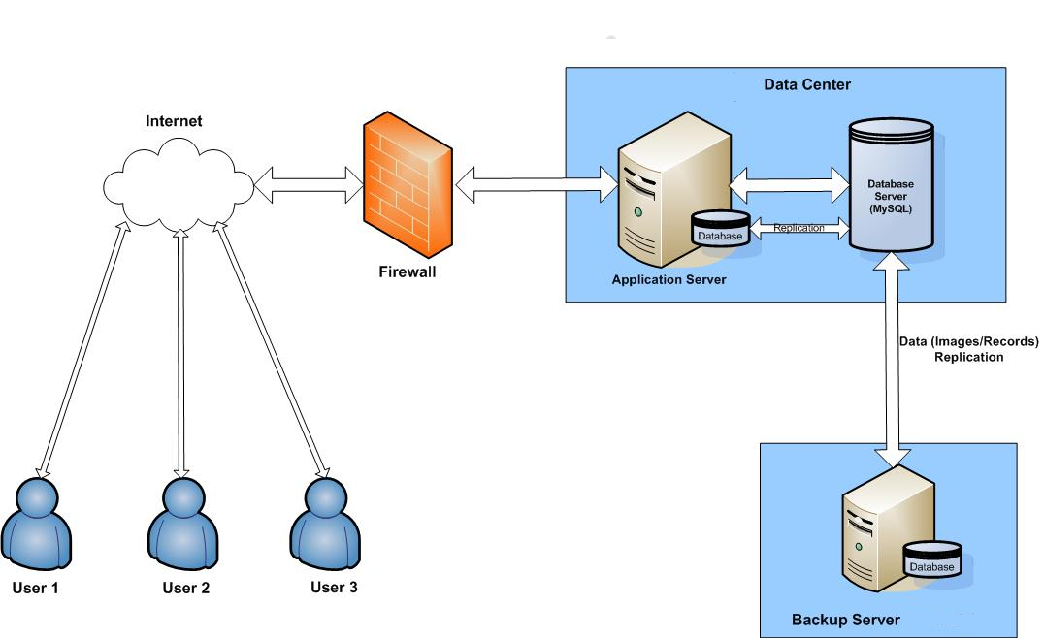

Test Scheduler Web Application Architecture

The following graphic illustrates how data flows throughout the system:
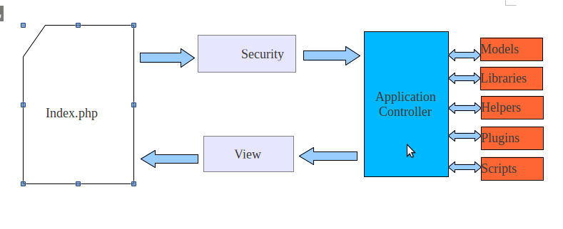

- The index.php serves as the front controller, initializing the base resources needed to run Code.
- Security. Before the application controller is loaded, the HTTP request and any user submitted data is filtered for security.
- The Controller loads the model, core libraries, helpers, and any other resources needed to process the specific request.
- The finalized View is rendered then sent to the web browser to be seen.

Assumptions and dependencies

The development will be based on the following assumptions and dependencies:

- Test Scheduler is a web based application program which will be used via Internet browser.
- There will be a single Administrator i.e Super Admin for the system who will be able to manage all the modules in the system.
- Low-resolution images will be uploaded to the system.

Functional Requirement

Functional Requirement For Admin module:

2.1 Login Screen

- The URL of this page will be http://www.domainname.com
- This option will be available when user click on Sign_in.
- Login page will have two textboxes for entering username (email id) and password respectively.
- After entering username and password and on clicking login button, system will validate username and password with user credential present in the database.
- If username and password are not matching with data present in database then an error message will be shown on login page “Invalid username or password”.
- If username and password both get validated successfully then user will be redirected to the home page.
- Please refer to the following as a sample screenshot for login page:

2.2 Logout

- Logout is a link which will be available post login. Upon click this link, system will destroy the current logged in user’s session and returns the user back to the Login screen.

2.3 Manage Password

Admin can reach to this from Home Page by clicking Manage Password link. This section will be used by user to change his password after login. This screen will have three text box fields:
- Old Password: In this field user has to enter the old password for verification.
- New Password: In this field user has to enter new password.
- Confirm Password: In this field user must enter same password as entered in New Password field.
- After successful change of password the user will be redirected to the home page.
- Please refer to the following as a sample screenshot.

2.4 Registration

This option will be available when user click register link. This section will be used by new users to register on the website. This screen will have six text box fields:
- User Name: In this field the user needs to enter a unique user name . This will be checked for availability when the user register . If available the user name will be allowed if not available an error message will be displayed ”User Name already taken”.
- Password: In this field the user will enter its password which he wants to set.
- Confirm Password: In this field the user will reenter its password which he wants to set. The entry in Password and Confirm Password fields will be checked and will get accepted only when the both are same.
- First Name: In this field the user will enter its First Name.
- Last Name: In this user will enter its Last Name.
- Email: In this user will enter its email id. The email id will get check for its validation and uniqueness bye comparing the email id in the database.
- If all the fields validated successfully then user will be redirected to the home page.
- Please refer to the following as a sample screenshot for registration page:

2.5 Category
- This option will allow the user to enter the type of questions . The default category will be Generic Category. The user is provided with a text field where he can enter the questions category.
- Please refer to the following as a sample screenshot.

2.6 Question Bank
This option will allow the user to add question on the basis of category selected. The user will be provided by two options:
    - Manually :The user will be able to enter all the questions ,options and their respective correct answers one by one.
    - Bulk Import : The user will upload a CSV file containing details of all the questions , options and their respective correct answers.
    - The type of questions can be multiple choice, True/False, textbox. There can be maximum five options in multiple choice questions.
    - Please refer to the following as a sample screenshot.

2.7 Create Test
Selecting this option will allow the user to create a new test. The category in test can be of two types :
  - Random: The user creates a test from a single questions category.
  - Mixed Random : This allows the user to create a test with the power of selecting questions from several different categories.
Please refer to the following as a sample screenshot.

2.8 Assigning Test to user/user group
This option enable Admin to assign already created test to user or a group of user. This option allow certain specifications for the test:
- Collect User Information: This option will allow the admin to store user information when user opens a test. The admin can ask for First Name, Last Name, Email address or Enrollment Number from the user.
- Test availability : It will allow the admin to select when the test will be available to the user whether test will be available all the time or only on a specified day within a specified time limit.
- Select user view after taking test: This option will allow the admin to select what will be displayed to the user after completion of test. The options can be :
    - Only scores
    - Scores and options selected
    - Scores , options selected and correct answers
- Attempts allowed : This option will allow the admin to select total attempts allowed to user for a particular test.The options can be :
    - Only one attempt allowed
    - Unlimited attempts allowed
- Time Limit : This option will be applicable if admin select a time period for which the test will be available to the user.
- Save and finish later : This option will make the admin to decide tom whether give the permission of saving test and completing later to user or not.

- Going back during test: The admin may allow or not allow a user to go back on the previous question during test.
- Must select answer: Selection of this option will make it compulsory for the user to select an answer before going to next question.
- Must select correct answer: selection of this option will allow the user to go on the next page only when the selected answer is the correct answer.
- Print test : This option will give the user the privilege to print the test .
- Set pass marks and feedback : This option will allow the admin to set the minimum marks required for qualifying the test. The admin can also set the default feedback on the basis of marks.
- Negative marking : This option will allow the admin to set if negative marking will be allowed or not and if allowed marks to be deducted from the scores earned on the basis of wrong answers given.
- The admin after setting all the test specifications will get an auto-generated link for test which admin will be able to send to intended users on their emails.
- Please refer to the following as a sample screenshot.

2.9 Delete Test
- This option will allow the user to delete the selected test. The confirmation message will be shown so as to confirm the deletion of respective test.
- Please refer to the following as a sample screenshot.

2.10 Generate Certificate
- This option when provided by admin will generate a certificate to the users if he/she fulfill the minimum requirements for test passing test.
- Please refer to the following as a sample screenshot.

Functional Requirement For User module:

2.11Taking test using URL

This url will allow the user to to take a test when he click on the test link send on his email. This screen will have three text box fields:
- First Name : The user will enter his First Name.
- Last Name : The user will enter his Last Name.
- Email : The user will enter his Email.
- Enrollment Number: The user if belong to an educational institute/college/school will enter his Enrollment Number.
- The details entered by user will get validated with user specifications and test specifications and if validated the user will be directed on the test questions screen.
- Please refer to the following as a sample screenshot.
- After completing the test the user will get the output as specified by the admin.
- Please refer to the following as a sample screenshot.

Functional Requirement For Super Admin module:

2.12 Management of Database and report generation
  - There will be only one super admin. It will be his responsibility to manage user database and test database.
  - Super admin can generate reports on the basis of requirements. The reports can be on the basis of the following:
- Number of tests attempted by a particular user.
- Filtering for high ranking.
- Numbers of users assigned a particular test.
- Number of tests created.
- Number of users attempted a particular test.

