|  |  |  |
| --- | --- | --- |
| 个人简历  {{ name }} |  | |
| 出生年月：{{ birthday }} | 性 | 别：{{ gender }} |
| 住 址：{{ address }} | 电 | 话：{{ phone }}(微信同号) |

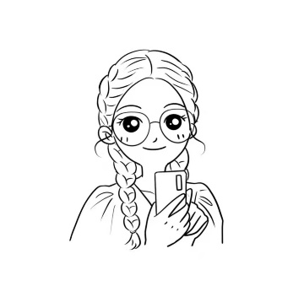

|  |  |  |
| --- | --- | --- |
|  | **教育背景** |  |
|  | **{{start_time1}}-{{end_time1}} {{university}} {{major}}**   * GPA：{{gpa}} * 所获证书：{{certificate}} * 主修课程： {{course}} | |
|  | **主要经历** |  |
|  | **{{start_time2}}-{{end_time2}} {{campus_job}}**   * {{campus_work}}   **{{start_time3}}-{{end_time3}} {{internship_job}}**   * {{internship_work}} | |
|  | **技能特长** |  |
|  | * {{skill}} | |
|  | **自我评价** |  |
|  | * {{self_assessment}} | |