Titles:

Medicare beneficiaries’ telehealth: state-level variations in 2016-2017

Medicare beneficiaries’ telehealth by states in 2016-2017

State-level variations of telehealth use among Medicare fee-for-service beneficiaries, 2016-2017

Target journals: Health Affiars – Data Watch (2000 words)

Bian Liu, PhD; Ruya Zhang; ….

**Abstract**

Telemedicine use among fee-for-service (FFS) Medicare beneficiaries varied … across states during …. State-level variations of telemedicine use Analysis of the

**Study data and methods**

The study used two data sets to calculate the two outcomes of interest: telehealth services density and providers’ density, respectively, defined as the number of services and providers per Medicare FFS beneficiaries. The numerator, total number of telehealth services or total number of providers, was from the Medicare Provider Utilization and Payment Data: Physician and Other Supplier public use file (PUF); while the denominator, total number of FFS beneficiaries, were from the Medicare FFS enrollment PUF data for the calendar year 2016 and 2017. The provider PUF includes summaries of service and procedures provided by physicians and other health-care professionals to the Medicare FFS beneficiaries only, not beneficiaries enrolled in Medicare Advantage plans. Services were coded with healthcare common procedure coding system (HCPCS) codes and summarized by individual provider. Data with less than eleven services per provider were suppressed for privacy concerns. Additional information in PUF file included providers’ unique national provider identifier (NPI), addresses, specialty type, and payment amount. The enrollment PUF provides data on Medicare enrollment, such as the counts of Medicare FFS beneficiaries aggregated at varied geographic scales.

We extracted from the provider PUF all data lines with HCPCS codes indicative of telehealth services published by CMS for calendar years 2016-2017, and aggregated all services and all providers, respectively, at the state level. They were subsequently divided by the total number of Medicare FFS beneficiaries at the state level. We then summarized and mapped the state-level telehealth services density and provider density.

This study had several limitations. First, we rely on HCPCS codes to define telehealth services which do not …

**Study results**

Exhibit 1. Telehealth services per Medicare FFS beneficiaries by state, 2016-2017.

Exhibit 2. Providers with telehealth services per Medicare FFS beneficiaries by state, 2016-2017.

Exhibit 3. Changes in telehealth services utilization among Medicare FFS beneficiaries in 2016-2017. --- scatter plot (X-Y, x= changes in services density, y=changes in provider density )…

Exhibit 4. Services by provider specialties and sex.

Exhibit 5. Characteristics of telehealth use among Medicare FFS beneficiaries in 2016-2017.

**Discussion**

Levels at state level

Levels by provider

Changes by …

Implications:

In the largest safety-Net System, the NYC Health + Hospitals, the use of telehealth increased from 500 visits per month to 83,000 billable televisits and more than 30,000 behavioral health encounters via telephone and video between March and April. (Lau et al., 2020)

**Conclusion**

Utilization of telehealth services among Medicare FFS beneficiaries is growing at a slow/ fast? pace between 2016 and 2017. With the on-going COVID-19 pandemic, there has been an growth … The expansion of telehealth is … . Howe and to what scale telehealth uses are expanding for the older population in the US is still unclear, but this analysis of existing data, most recent data, can help guide the assessment of the current telehealth use and future policy …

**Exhibit X.** State-level variations in telehealth services and providers with telehealth services per Medicare FFS beneficiaries, and telehealth services per provider, by state, 2017.

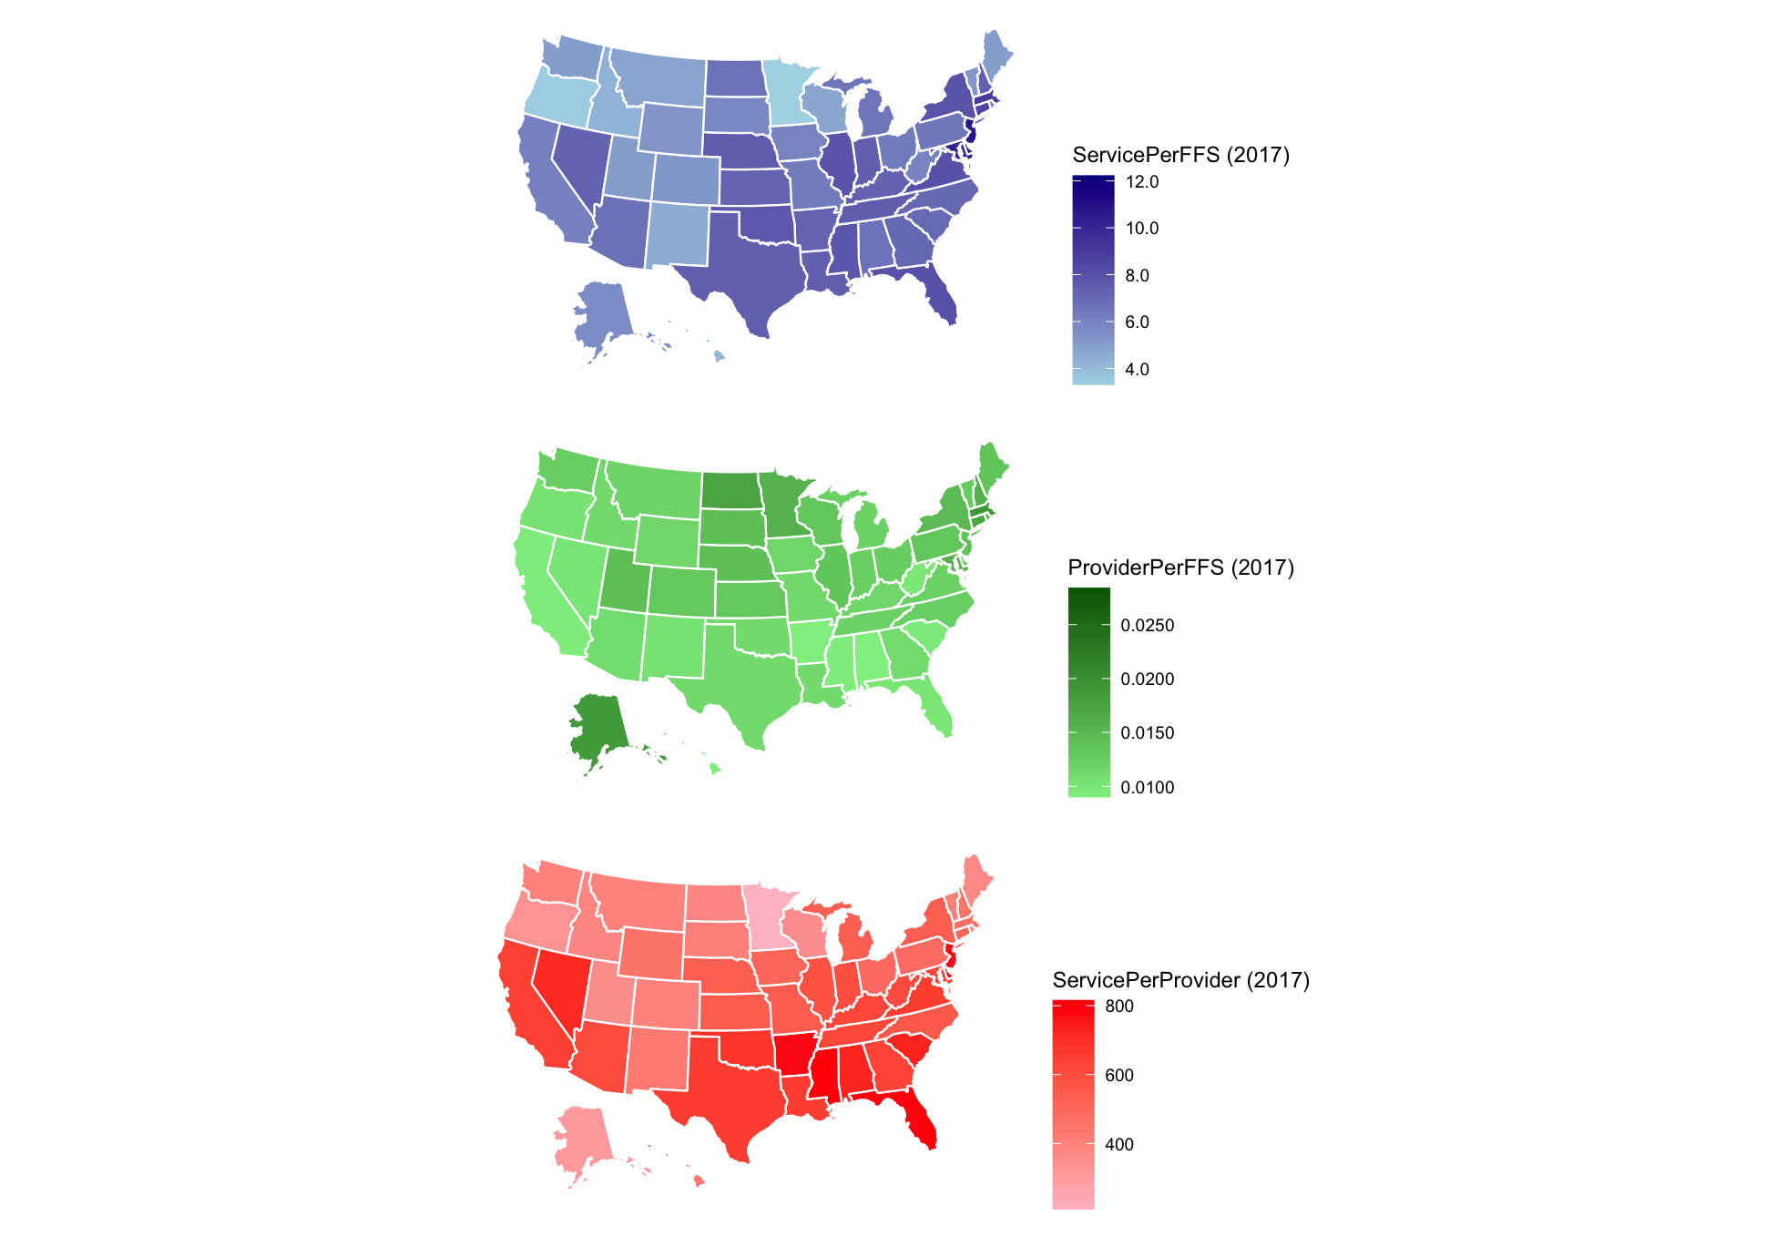

**Exhibit X.** Changes in in telehealth services and providers with telehealth services per Medicare FFS beneficiaries, and telehealth services per provider by state, by state, between 2016 and 2017.

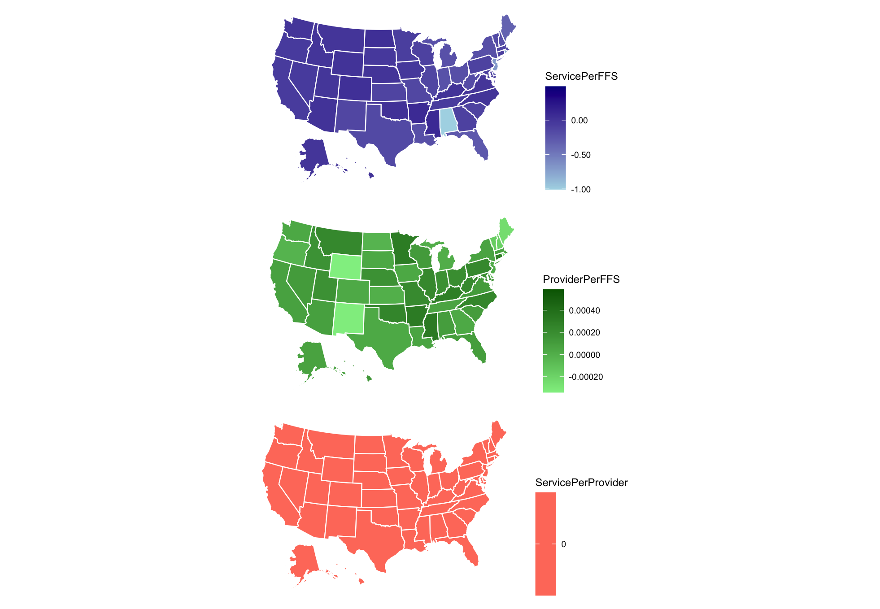

**Exhibit X.** Summary statistics of the utilizations of Medicare covered telehealth services, 2016-2017.

|  |  |  |  |  |
| --- | --- | --- | --- | --- |
| **Variables** | | **Mean (SD)** | **Median (IQR)** | **Min (state) –**  **Max (state)** |
| **2016** | Telehealth services per state | 7,347,169 (7,942,885) | 5,019,948 (1,759,580- 9,805,007) | 448,172 (AK)- 33,477,504 (FL) |
| Medicare FFS beneficiaries per state | 1,033,114(1,073,560) | 761,400(302,172- 1,190,729) | 74,097(DC)- 5,338,224(CA) |
| Telehealth services per Medicare FFS beneficiaries | 6.845(1.794945) | 7.057(5.544-7.598) | 3.381(MN)- 11.736(DC) |
| Providers with telehealth service per state | 12,468 (11,989.34) | 8,682(4,008-15,214) | 1,120(WY)-49,987(CA) |
| Providers with telehealth service per Medicare FFS beneficiaries | 0.012870(0.003245681) | 0.012243(0.011033- 0.013965) | 0.008909(AL)- 0.027815(DC) |
| Telehealth services per provider | 534.7(146.3568) | 531.3(407.5- 638.2) | 208.5(MN)-815.8(MS) |
| **2017** | Telehealth services per state | 7,372,401 (7,954,465) | 5,048,504(1,794,121- 9,967,211) | 468,479(AK)- 33,290,068(FL) |
| Medicare FFS beneficiaries per state | 5,338,224(1,101,445) | 789,379(309,536- 1,222,558) | 76,084(DC)- 5,478,663(CA) |
| Telehealth services per Medicare FFS beneficiaries | 6.724(1.780606) | 11.736(5.466- 7.541) | 3.301(MN)- 12.227(DC) |
| Providers with telehealth service per state | 12,898(12,387.63) | 8,932(4,122- 15,695) | 1,130(WY)- 51,721(CA) |
| Providers with telehealth service per Medicare FFS beneficiaries | 0.012962(0.00327835) | 0.012425(0.011188- 0.014041) | 0.009008(AL)- 0.028403(DC) |
| Telehealth services per provider | 534.7(146.3568) | 531.3(407.5- 638.2) | 208.5(MN)- 815.8(MS) |
| **Changes**  **between**  **2016**  **and**  **2017** | Telehealth services per state | 25,232(208,384) | 28,556(-236- 109,681) | -846,136-525,233 |
| Medicare FFS beneficiaries per state | 26,108(28873.86) | 17,644(7,810- 32,618) | 1,987-140,439 |
| Telehealth services per Medicare FFS beneficiaries | -0.120968(0.2224947) | -0.093759(-0.178926 to -0.004035) | -1.008068-0.490446 |
| Providers with telehealth service per state | 429.4(415.7144) | 305.0(135.5- 531.5) | 7.0- 1734.0 |
| Providers with telehealth service per Medicare FFS beneficiaries | 9.170e-05(0.0001739584) | 9.872e-05(3.183e-05 to 2.063e-04) | -3.431e-04 to 5.879e-04 |
| Telehealth services per provider | 0(0) | 0(0-0) | 0-0 |

**Note:** The summary statistics were based on data from the Medicare Provider Utilization and Payment Data: Physician and Other Supplier Public Use File (PUF) file and the Medicare Fee-For-Service Enrollment PUF data for calendar years 2016-2017. We aggregated data at the state level. The provider PUF includes summaries of service and procedures provided by physicians and other healthcare professionals to FFS Medicare beneficiaries, thus the data are at individual provider level instead of individual patient level. Only providers with more than 11 services were available from the provider PUF data. Data were based on claims for fee-for-service (FFS) Medicare enrollees only.

**Exhibit X.** Distribution of telehealth services by provider specialties.

C:\Users\liub07\AppData\Local\Microsoft\Windows\INetCache\Content.Word\Fig1_prvBar.tiff

**Exhibit X.** Top 20 most utilized telehealth service types in 2016 and 2017.

|  |  |  |  |
| --- | --- | --- | --- |
| 2017 HCPCS | Services | 2016 HCPCS | Services |
| 99214 | 101141006.50 | 99214 | 98994700.60 |
| 99213 | 96481965.00 | 99213 | 98723975.70 |
| 99232 | 46704036.70 | 99232 | 47974607.70 |
| 99233 | 22561443.00 | 99233 | 21965658.60 |
| 99212 | 11713275.30 | 99212 | 12833447.10 |
| 99308 | 10591861.00 | 99308 | 10640502.70 |
| 99203 | 10343285.80 | 99203 | 10339198.70 |
| 99204 | 9325962.00 | 99204 | 9163039.10 |
| 99215 | 9215312.80 | 99215 | 9059238.80 |
| 99309 | 8970790.10 | 99309 | 8650501.80 |
| 99231 | 7181337.00 | 99231 | 7847586.60 |
| G0439 | 6345786.10 | G0439 | 5293073.20 |
| 90837 | 3966304.30 | 90834 | 4093684.20 |
| 90834 | 3919373.10 | 99211 | 3834516.70 |
| 99211 | 3338467.70 | 90837 | 3642459.20 |
| 99307 | 2542086.00 | 99307 | 2771038.10 |
| 99205 | 2423521.00 | 99205 | 2477134.50 |
| 99202 | 2247385.20 | 99202 | 2392354.40 |
| 90960 | 2235180.00 | 90960 | 2242005.10 |
| 90832 | 2203897.70 | 90832 | 2130485.30 |