**Summary**

Analysis: Using linear regression to study the relationship between state-level mortality and four indicators of number of gun circulation, respectively.

Data set: StLevelData dataset, when states have multiple year values, the average was used.

Four crude models: predictor = each of the four continuous variables (ATFRegWeapon, ATFFirearmLicense, GiffordsRank, GOwnerRates) and outcome = age-adjusted mortality rate (AllMortAdj).

Four adjusted model: adding covariates (Poverty, Unemploy, PoorMHO, PoorMH14ls, PoorMH14gt, StPoP) into the crude models, and selected a reduced model with most relevant covariates based on the statistical significant level (p<0.05).

**Results:**

ATFRegWeapon was not linear correlated with mortality in the crude model, but was a significant predictor in the full model and reduced model.

ATFFirearmLicense was not linear correlated with mortality in the crude model, and was not a significant predictor in the full model or reduced model.

GiffordsRank was linear correlated with mortality in the crude model, and was a significant predictor in the full model.

GOwnerRates was linear correlated with mortality in the crude model, and was a significant predictor in the full model.

**Result summary - Crude model:**

Significant positive linear correlation was found between age-adjusted mortality and both Giffords Center Rankings (R-squared:  0.502; p-value: 8.53e-09 significant) and Gun Ownership rates (R-squared: 0.469; p-value: 4.005e-08 significant).

No linear relationship was found between age-adjusted mortality and ATFRegWeapon (R-squared: 0.006; p-value: 0.590) or ATFFirearmLicense (R-squared: 0.001; p-value: 0.813).

**Result summary - Adjusted model:**

Mort=f (ATFRegWeapon, Poverty, StPoP) (R-squared: 0.568; p-value: 1.74e-08). All three variables were significant predictors of mortality p-value= 0.00138, 8.44e-08, and 3.42e-05, respectively.

Mort=f (GiffordsRank, Poverty, Unemploy, PoorMH0, PoorMH14ls, PoorMH14gt, StPoP) explained 64.83% of the variability in All Firearm Mortality, however, none of the predictor is significant.

Mort=f (GOwnerRates, Poverty, Unemploy, PoorMH0, PoorMH14ls, PoorMH14gt, StPoP) explained 65.94% of the variability in All Firearm Mortality, however, there is no significant covariate values.

**Beta coefficients from different models.**

|  |  |  |  |
| --- | --- | --- | --- |
| **Exposure variable** | Beta coefficient | p-value | Model |
| ATFRegWeapon | 4.484e-06 | 0.59 | Crude |
| ATFRegWeapon | 3.471e-05 | 0.001894 | Full |
| ATFRegWeapon | 3.324e-05 | 0.00138 | Reduced |
|  |  |  |  |
| ATFFirearmLicense | -0.0000694 | 0.813 | Crude |
| ATFFirearmLicense | 6.471e-04 | 0.189378 | Full |
| ATFFirearmLicense | 6.922e-04 | 0.13783 | Reduced |
|  |  |  |  |
| GiffordsRank | 0.19662 | 8.53e-09 | Crude |
| GiffordsRank | 1.607e-01 | 4e-05 | Full |
| GiffordsRank | 0.19662 | v 8.53e-09 | Reduced (Crude) |
|  |  |  |  |
| GOwnerRates | 0.20328 | 4.01e-08 | Crude |
| GOwnerRates | 1.578e-01 | 1.98e-05 | Full |
| GOwnerRates | 0.20328 | 4.01e-08 | Reduced (Crude) |
|  |  |  |  |

|  |  |  |  |
| --- | --- | --- | --- |
| Description | **Variable Name** |  |  |
| **All Firearm Mortality - Age Adjusted Rate (per 100,000)** | **AllMortAdj** | **Outcome** | **Y** |
| ATF Registered Weapons | **ATFRegWeapon** | Exposure 1 | X |
| % Poverty | **Poverty** | **Covariates** |  |
| % Unemployment | **Unemploy** |  |
| % Poor mental health (0 days) | **PoorMH0** |  |
| % Poor mental health (1-14 days) | **PoorMH14ls** |  |
| % Poor mental health (> 14 days) | **PoorMH14gt** |  |
| Statewide population | **StPoP** |  |

1. **Crude model: Mort=f(ATFRegWeapon)**

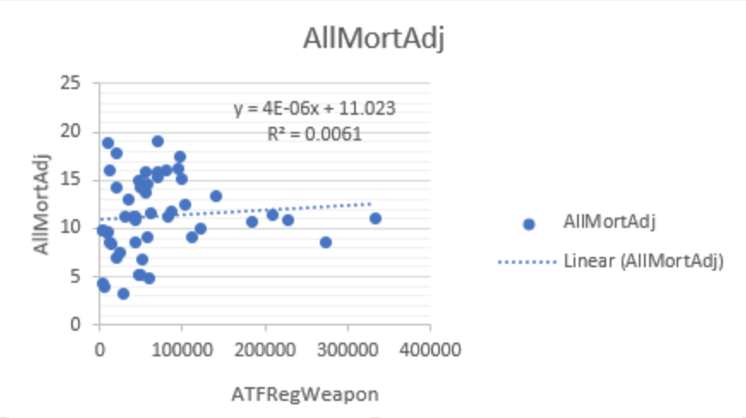

**All firearm mortality- Age Adjusted Rate (per 100,000) and ATF Registered Weapons**

* **R-squared:  0.006; p-value: 0.5903 not significant. We do not reject the null hypothesis.**
* **There is no linear association between All firearm mortality- Age Adjusted Rate (per 100,000) and ATF Registered Weapons.**

1. **Adjusted model: Mort=f (ATFRegWeapon, Poverty, Unemploy, PoorMH0, PoorMH14ls, PoorMH14gt, StPoP)**

|  |
| --- |
|  |
| Residuals: |
|  | Min     1Q  Median      3Q     Max |
|  | -7.1602 -1.4565 -0.0834  0.9936 10.1491 |
|  |  |
|  | Coefficients: |
|  | Estimate Std. Error t value Pr(>|t|) |
|  | (Intercept)  -7.498e+03  8.313e+03  -0.902 0.372207 |
|  | ATFRegWeapon  3.471e-05  1.047e-05   3.315 0.001894 ** |
|  | Poverty       8.438e-01  2.000e-01   4.220 0.000128 *** |
|  | Unemploy      7.654e-02  4.168e-01   0.184 0.855184 |
|  | PoorMH0       7.493e+01  8.312e+01   0.901 0.372465 |
|  | PoorMH14ls    7.513e+01  8.317e+01   0.903 0.371533 |
|  | PoorMH14gt    7.500e+01  8.312e+01   0.902 0.372058 |
|  | StPoP        -4.724e-07  1.115e-07  -4.236 0.000121 *** |
|  | --- |
|  | Signif. codes:  0 ‘***’ 0.001 ‘**’ 0.01 ‘*’ 0.05 ‘.’ 0.1 ‘ ’ 1 |
|  |  |
|  | Residual standard error: 2.805 on 42 degrees of freedom |
|  | Multiple R-squared:  0.5815, Adjusted R-squared:  0.5118 |
|  | F-statistic: 8.339 on 7 and 42 DF,  p-value: 2.356e-06 |
|  |  |

**Global Null Hypothesis**

* **When testing the null hypothesis that there is a linear association between All Firearm Mortality- Age Adjusted Rate (per 100,000), ATF Registered Weapons, poverty, unemployment, Poor Mental Health 0 days, poor mental health 1-14 days, poor mental health >14 days, statewide population.**
* **Explained 58.15% (R-squared) of the variability in All Firearm Mortality.**
* **Significant p-value: ATFRegWeapon (p-value = 0.189), Poverty (p-value = 0.013), StPop (p-value = 0.012)**

1. **Reduced model: Mort=f (ATFRegWeapon, Poverty, StPoP)**

|  |
| --- |
| Residuals: |
|  | Min     1Q  Median      3Q     Max |
|  | -6.7416 -1.4802 -0.2369  1.1582 10.4254 |
|  |  |
|  | Coefficients: |
|  | Estimate Std. Error t value Pr(>|t|) |
|  | (Intercept)  -7.856e-02  1.867e+00  -0.042  0.96662 |
|  | ATFRegWeapon  3.324e-05  9.762e-06   3.405  0.00138 ** |
|  | Poverty       8.287e-01  1.304e-01   6.357 8.44e-08 *** |
|  | StPoP        -4.457e-07  9.709e-08  -4.590 3.42e-05 *** |
|  | --- |
|  | Signif. codes:  0 ‘***’ 0.001 ‘**’ 0.01 ‘*’ 0.05 ‘.’ 0.1 ‘ ’ 1 |
|  |  |
|  | Residual standard error: 2.723 on 46 degrees of freedom |
|  | Multiple R-squared:  0.568, Adjusted R-squared:  0.5398 |
|  | F-statistic: 20.16 on 3 and 46 DF,  p-value: 1.74e-08 |
|  |  |

**Global Null Hypothesis**

* **When testing the null hypothesis that there is a linear association between All Firearm Mortality- Age Adjusted Rate (per 100,000), ATF Registered Weapons, Poverty, and statewide population. ATF Registered weapons, poverty, and statewide population explain 56.8% of the variability in All Firearm Mortality.**

**Main Effects Hypothesis**

* **When testing the null hypothesis that there is a linear association between All Firearm Morality and ATF Registered Weapons after adjusting for poverty and statewide population, we reject the null hypothesis (t = 3.405, df = 46, p-value = 0.00138).**
* **When testing the null hypothesis that there is a linear association between All Firearm Morality and poverty after adjusting for ATF Registered Weapons and statewide population, we reject the null hypothesis (t = 6.357, df = 46, p-value = 8.44e-08).**
* **When testing the null hypothesis that there is a linear association between All Firearm Morality and statewide population after adjusting for poverty and ATF Registered Weapons, we reject the null hypothesis (t = -4.590, df = 46, p-value = 3.42e-05).**
* **For a one unit change in ATF Registered Weapons, on average, the All Firearm Mortality increases by 3.3e-05, after adjusting for poverty and statewide population.**
* **For a one unit change in Poverty, on average, the All Firearm Mortality increases by 8.287e-01, after adjusting for ATFRegWeapon and statewide population.**
* **For a one unit change in StPoP, on average, the All Firearm Mortality decrease by 4.457e-07, after adjusting for ATFRegWeapon and Poverty.**

|  |  |  |  |
| --- | --- | --- | --- |
| Description | **Variable Name** |  |  |
| **All Firearm Mortality - Age Adjusted Rate (per 100,000)** | **AllMortAdj** | **Outcome** | **Y** |
| ATF Federal Firearm Licensees | **ATFFirearmLicense** | Exposure 2 | X |
| % Poverty | **Poverty** | **Covariates** |  |
| % Unemployment | **Unemploy** |  |
| % Poor mental health (0 days) | **PoorMH0** |  |
| % Poor mental health (1-14 days) | **PoorMH14ls** |  |
| % Poor mental health (> 14 days) | **PoorMH14gt** |  |
| Statewide population | **StPoP** |  |

1. **Crude model: Mort=f(ATFFirearmLicense)**

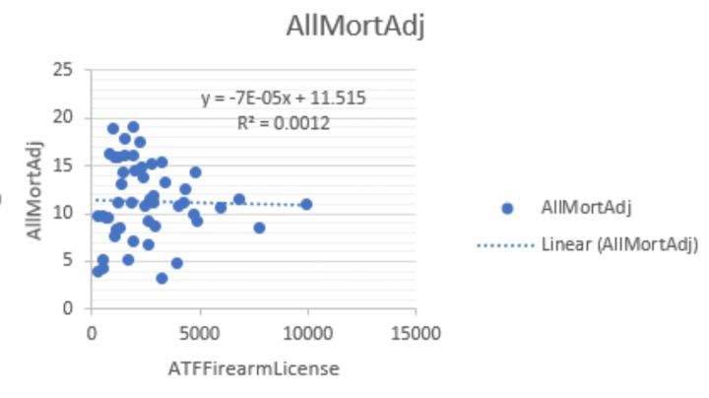

**All firearm mortality- Age Adjusted Rate (per 100,000) and ATF Federal Firearm Licensees**

* **R-squared:  0.001; p-value: 0.8129 not significant. We do not reject the null hypothesis.**
* **There is no linear association between All firearm mortality- Age Adjusted Rate (per 100,000) and ATF Federal Firearm Licensees.**

1. **Adjusted model: Mort=f (ATFFirearmLicense, Poverty, Unemploy, PoorMH0, PoorMH14ls, PoorMH14gt, StPoP)**

|  |
| --- |
| Residuals: |
|  | Min     1Q  Median      3Q     Max |
|  | -7.1004 -1.6484  0.0184  1.0667 10.1337 |
|  |  |
|  | Coefficients: |
|  | Estimate Std. Error t value Pr(>|t|) |
|  | (Intercept)       -7.615e+03  9.175e+03  -0.830 0.411295 |
|  | ATFFirearmLicense  6.471e-04  4.851e-04   1.334 0.189378 |
|  | Poverty            8.250e-01  2.205e-01   3.741 0.000549 *** |
|  | Unemploy           1.549e-04  4.586e-01   0.000 0.999732 |
|  | PoorMH0            7.612e+01  9.174e+01   0.830 0.411363 |
|  | PoorMH14ls         7.620e+01  9.180e+01   0.830 0.411211 |
|  | PoorMH14gt         7.621e+01  9.174e+01   0.831 0.410854 |
|  | StPoP             -3.356e-07  1.428e-07  -2.349 0.023592 * |
|  | --- |
|  | Signif. codes:  0 ‘***’ 0.001 ‘**’ 0.01 ‘*’ 0.05 ‘.’ 0.1 ‘ ’ 1 |
|  |  |
|  | Residual standard error: 3.086 on 42 degrees of freedom |
|  | Multiple R-squared:  0.4935, Adjusted R-squared:  0.4091 |
|  | F-statistic: 5.846 on 7 and 42 DF,  p-value: 8.928e-05 |

* **R-squared: 0.4935; p-value: 8.928e-05 significant.**

**Global Null Hypothesis**

* **When testing the null hypothesis that there is a linear association between All Firearm Mortality- Age Adjusted Rate (per 100,000), ATFFirearmLicense, poverty, unemployment, Poor Mental Health 0 days, poor mental health 1-14 days, poor mental health >14 days, statewide population.**
* **ATFFirearmLicense, poverty, unemployment, Poor Mental Health 0 days, poor mental health 1-14 days, poor mental health >14 days, statewide population explain 49.35%(R-squared)  of the variability in All Firearm Mortality.**

**Main Effects Hypothesis**

* **Significant p-value: Poverty(p-value: 0.000549), StPop(p-value: 0.023592)**

|  |
| --- |
|  |

1. **Reduced model: Mort=f (ATFFirearmLicense, Poverty, StPoP)**

|  |
| --- |
| Residuals: |
|  | Min     1Q  Median      3Q     Max |
|  | -6.9851 -1.6196  0.0009  1.0945 10.1478 |
|  |  |
|  | Coefficients: |
|  | Estimate Std. Error t value Pr(>|t|) |
|  | (Intercept)       -3.184e-01  2.045e+00  -0.156  0.87693 |
|  | ATFFirearmLicense  6.922e-04  4.583e-04   1.510  0.13783 |
|  | Poverty            8.382e-01  1.436e-01   5.837 5.07e-07 *** |
|  | StPoP             -3.477e-07  1.287e-07  -2.702  0.00962 ** |
|  | --- |
|  | Signif. codes:  0 ‘***’ 0.001 ‘**’ 0.01 ‘*’ 0.05 ‘.’ 0.1 ‘ ’ 1 |
|  |  |
|  | Residual standard error: 2.975 on 46 degrees of freedom |
|  | Multiple R-squared:  0.4846, Adjusted R-squared:  0.451 |
|  | F-statistic: 14.42 on 3 and 46 DF,  p-value: 9.347e-07 |

* **R-squared: 0.4846; p-value: 9.347e-07 significant.**

|  |  |  |  |
| --- | --- | --- | --- |
| Description | **Variable Name** |  |  |
| **All Firearm Mortality - Age Adjusted Rate (per 100,000)** | **AllMortAdj** | **Outcome** | **Y** |
| Giffords Center Rankings | **GiffordsRank** | Exposure 3 | X |
| % Poverty | **Poverty** | **Covariates** |  |
| % Unemployment | **Unemploy** |  |
| % Poor mental health (0 days) | **PoorMH0** |  |
| % Poor mental health (1-14 days) | **PoorMH14ls** |  |
| % Poor mental health (> 14 days) | **PoorMH14gt** |  |
| Statewide population | **StPoP** |  |

1. **Crude model: Mort=f(GiffordsRank)**

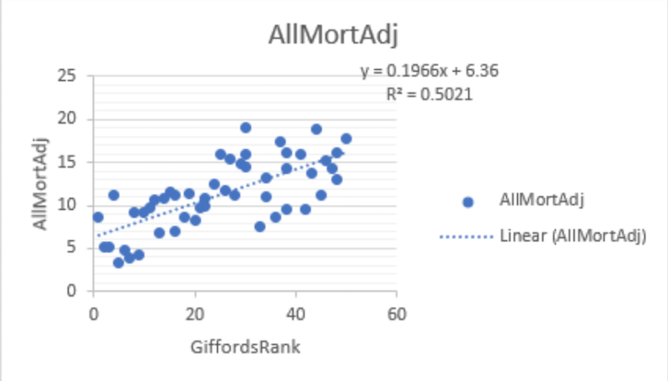

**All firearm mortality- Age Adjusted Rate (per 100,000) and Giffords Center Rankings**

* **R-squared:  0.502; p-value: 8.53e-09 significant.**
* **Giffords Center Rankings explain 50.2% of the variability in All Firearm Mortality. We reject the null hypothesis.**
* **There is a linear association between All firearm mortality- Age Adjusted Rate (per 100,000) and Giffords Center Rankings.**

1. **Adjusted model: Mort=f (GiffordsRank, Poverty, Unemploy, PoorMH0, PoorMH14ls, PoorMH14gt, StPoP)**

|  |
| --- |
| Residuals: |
|  | Min     1Q Median     3Q    Max |
|  | -5.813 -1.426 -0.241  1.654  5.706 |
|  |  |
|  | Coefficients: |
|  | Estimate Std. Error t value Pr(>|t|) |
|  | (Intercept)  -6.163e+03  7.634e+03  -0.807    0.424 |
|  | GiffordsRank  1.607e-01  3.503e-02   4.588    4e-05 *** |
|  | Poverty       3.341e-01  2.145e-01   1.557    0.127 |
|  | Unemploy      4.286e-01  3.949e-01   1.085    0.284 |
|  | PoorMH0       6.159e+01  7.633e+01   0.807    0.424 |
|  | PoorMH14ls    6.166e+01  7.638e+01   0.807    0.424 |
|  | PoorMH14gt    6.181e+01  7.633e+01   0.810    0.423 |
|  | StPoP        -5.192e-08  6.413e-08  -0.810    0.423 |
|  | --- |
|  | Signif. codes:  0 ‘***’ 0.001 ‘**’ 0.01 ‘*’ 0.05 ‘.’ 0.1 ‘ ’ 1 |
|  |  |
|  | Residual standard error: 2.572 on 42 degrees of freedom |
|  | Multiple R-squared:  0.6483, Adjusted R-squared:  0.5897 |
|  | F-statistic: 11.06 on 7 and 42 DF,  p-value: 7.866e-08 |

* **R-squared: 0.6483; p-value: 7.866e-08 significant.**

**Global Null Hypothesis**

* **When testing the null hypothesis that there is a linear association between All Firearm Mortality-Age Adjusted Rate (per 100,000), GiffordsRank, poverty, unemployment, Poor Mental Health 0 days, poor mental health 1-14 days, poor mental health >14 days, statewide population.**
* **GiffordsRank, poverty, unemployment, Poor Mental Health 0 days, poor mental health 1-14 days, poor mental health >14 days, statewide population explain 64.83%(R-squared)  of the variability in All Firearm Mortality.**

**Main Effects Hypothesis**

* **None**

1. **Reduced model:**

* **Did not make reduced model.**

|  |  |  |  |
| --- | --- | --- | --- |
| Description | **Variable Name** |  |  |
| **All Firearm Mortality - Age Adjusted Rate (per 100,000)** | **AllMortAdj** | **Outcome** | **Y** |
| Gun Ownership Rates | **GOwnerRates** | Exposure 4 | X |
| % Poverty | **Poverty** | **Covariates** |  |
| % Unemployment | **Unemploy** |  |
| % Poor mental health (0 days) | **PoorMH0** |  |
| % Poor mental health (1-14 days) | **PoorMH14ls** |  |
| % Poor mental health (> 14 days) | **PoorMH14gt** |  |
| Statewide population | **StPoP** |  |

1. **Crude model: Mort=f(GOwnerRates)**

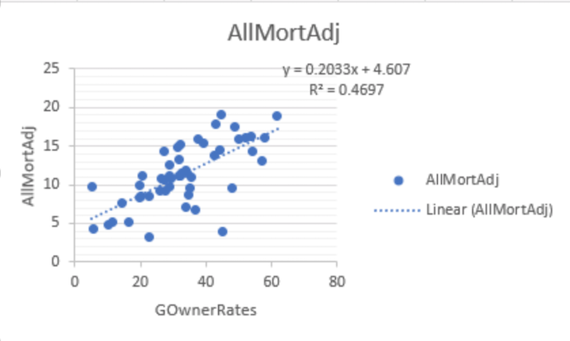

**All firearm mortality- Age Adjusted Rate (per 100,000) and Gun Ownership rates**

* **R-squared:  0.469; p-value: 4.005e-08 significant.**
* **Gun Ownership rates explain 46.97% of the variability in All Firearm Mortality. We reject the null hypothesis.**
* **There is a linear association between All firearm mortality- Age Adjusted Rate (per 100,000) and Gun Ownership rates.**

1. **Adjusted model: Mort=f (GOwnerRates, Poverty, Unemploy, PoorMH0, PoorMH14ls, PoorMH14gt, StPoP)**

|  |
| --- |
| Residuals: |
|  | Min     1Q  Median      3Q     Max |
|  | -7.2809 -1.3044  0.3207  1.6842  4.6360 |
|  |  |
|  | Coefficients: |
|  | Estimate Std. Error t value Pr(>|t|) |
|  | (Intercept) -6.994e+03  7.501e+03  -0.932   0.3564 |
|  | GOwnerRates  1.578e-01  3.283e-02   4.808 1.98e-05 *** |
|  | Poverty      3.719e-01  2.055e-01   1.809   0.0775 . |
|  | Unemploy     3.486e-01  3.837e-01   0.908   0.3688 |
|  | PoorMH0      6.991e+01  7.499e+01   0.932   0.3566 |
|  | PoorMH14ls   6.986e+01  7.505e+01   0.931   0.3573 |
|  | PoorMH14gt   7.019e+01  7.499e+01   0.936   0.3546 |
|  | StPoP       -7.403e-08  6.116e-08  -1.210   0.2329 |
|  | --- |
|  | Signif. codes:  0 ‘***’ 0.001 ‘**’ 0.01 ‘*’ 0.05 ‘.’ 0.1 ‘ ’ 1 |
|  |  |
|  | Residual standard error: 2.531 on 42 degrees of freedom |
|  | Multiple R-squared:  0.6594, Adjusted R-squared:  0.6027 |
|  | F-statistic: 11.62 on 7 and 42 DF,  p-value: 4.167e-08 |

* **R-squared: 0.6594; p-value: 4.167e-08 significant.**

**Global Null Hypothesis**

* **When testing the null hypothesis that there is a linear association between All Firearm Mortality- Age Adjusted Rate (per 100,000), GOwnerRates, poverty, unemployment, Poor Mental Health 0 days, poor mental health 1-14 days, poor mental health >14 days, statewide population.**
* **GOwnerRates, poverty, unemployment, Poor Mental Health 0 days, poor mental health 1-14 days, poor mental health >14 days, statewide population explain 65.94%(R-squared)  of the variability in All Firearm Mortality.**

**Main Effects Hypothesis**

* **None**

1. **Reduced model:**

* **Did not make reduced model.**

**Overview of the data**

|  |  |  |
| --- | --- | --- |
| Description | **Variable Name** |  |
| All firearm mortality | AllMortN | **Y=Outcomes;** multiple years with some missings |
| All Firearm Mortality - Crude Rate (per 100,000) | AllMortCrd |
| **All Firearm Mortality - Age Adjusted Rate (per 100,000)** | **AllMortAdj** |
| Age 0-24 Firearm Mortality | MortN24ls |
| Age 0-24 Mortality Crude Rate (per 100,000) | Mort24lsCrd |
| **Age 0-24 Mortality Age Adjusted Rate (per 100,000)** | **Mort24lsAdj** |
| ATF Registered Weapons | **ATFRegWeapon** | Multiple years |
| ATF Federal Firearm Licensees | **ATFFirearmLicense** |
| Giffords Center Rankings | **GiffordsRank** | 2018 data only |
| Gun Ownership Rates | **GOwnerRates** | 2013 data only |
| Handguns Carry Permit required (0 = No, 1 = Yes) | **HGCPermReq** | 2018 data only |
| Handguns Magazine size restriction (0 = No, 1 = Yes) | **HGMagRestrict** |
| Handguns Open carry allowed (0 = No, 1 = Yes) | **HGOCAllow** |
| Handguns Permit required (0 = No, 1 = Yes) | **HGPermReq** |
| Handguns Purchase permit required (0 = No, 1 = Yes) | **HGPurchPermReq** |
| Handguns Registration of firearm (0 = No, 1 = Yes) | **HGRegFirearm** |
| Background checks on private gun sales required (0 = No, 1 = Yes) | **CheckPGSReq** |
| Long guns Carry Permit required (0 = No, 1 = Yes) | **LGCPermReq** |
| Long guns Magazine size restriction (0 = No, 1 = Yes) | **LGMagRestrict** |
| Long guns Open carry allowed (0 = No, 1 = Yes) | **LGOCAllow** |
| Long guns Permit required (0 = No, 1 = Yes) | **LGPermReq** |
| Long guns Purchase permit required (0 = No, 1 = Yes) | **LGPurchPermReq** |
| Long guns Registration of firearm (0 = No, 1 = Yes) | **LGRegFirearm** |
| % Poverty | **Poverty** | **SES** |
| % Unemployment | **Unemploy** |
| % Poor mental health (0 days) | **PoorMH0** |
| % Poor mental health (1-14 days) | **PoorMH14ls** |
| % Poor mental health (> 14 days) | **PoorMH14gt** |
| Statewide population | **StPoP** |
| % population (age 0-24 years) | **PoP24ls** |
| State | **State** | **50 states** |
| Timeframe | **Year** | **1997-2018** |

**Check on missing data (red=have data; black=missing)**