**Summary**

Analysis: Linear regression

Linear regression was used for finding relationship between the continuous variables in StLevelData dataset.

Four crude model was made: ATFRegWeapon, ATFFirearmLicense, GiffordsRank, GOwnerRates and their relationship to the outcome of AllMortAdj.

Four adjusted model adding covariates (Poverty, Unemploy, PoorMHO, PoorMH14ls, PoorMH14gt, StPoP) to each four main predictors.

Crude model:

There is linear relationship between Giffords Center Rankings and AllMortAdj (R-squared: 0.502; p-value: 8.53e-09 significant).

There is linear relationship between Gun Ownership rates and AllMortAdj (R-squared: 0.469; p-value: 4.005e-08 significant).

No linear relationship between ATFRegWeapon and AllMortAdj (R-squared: 0.006; p-value: 0.590)

No linear relationship between ATFFirearmLicense and AllMortAdj (R-squared: 0.001; p-value: 0.813)

Adjusted model:

Mort=f (ATFRegWeapon, Poverty, StPoP) is the best model (R-squared: 0.568; p-value: 1.74e-08). ATFRegWeapon, Poverty, StPoP each has significant p-values (0.00138, 8.44e-08, and 3.42e-05).

Mort=f (GiffordsRank, Poverty, Unemploy, PoorMH0, PoorMH14ls, PoorMH14gt, StPoP) explained 64.83% of the variability in All Firearm Mortality, however, there is no significant covariate values.

Mort=f (GOwnerRates, Poverty, Unemploy, PoorMH0, PoorMH14ls, PoorMH14gt, StPoP) explained 65.94% of the variability in All Firearm Mortality, however, there is no significant covariate values.

|  |  |  |  |
| --- | --- | --- | --- |
| Description | **Variable Name** |  |  |
| **All Firearm Mortality - Age Adjusted Rate (per 100,000)** | **AllMortAdj** | **Outcome** | **Y** |
| ATF Registered Weapons | **ATFRegWeapon** | Exposure 1 | X |
| % Poverty | **Poverty** | **Covariates** |  |
| % Unemployment | **Unemploy** |  |
| % Poor mental health (0 days) | **PoorMH0** |  |
| % Poor mental health (1-14 days) | **PoorMH14ls** |  |
| % Poor mental health (> 14 days) | **PoorMH14gt** |  |
| Statewide population | **StPoP** |  |

1. **Crude model: Mort=f(ATFRegWeapon)**

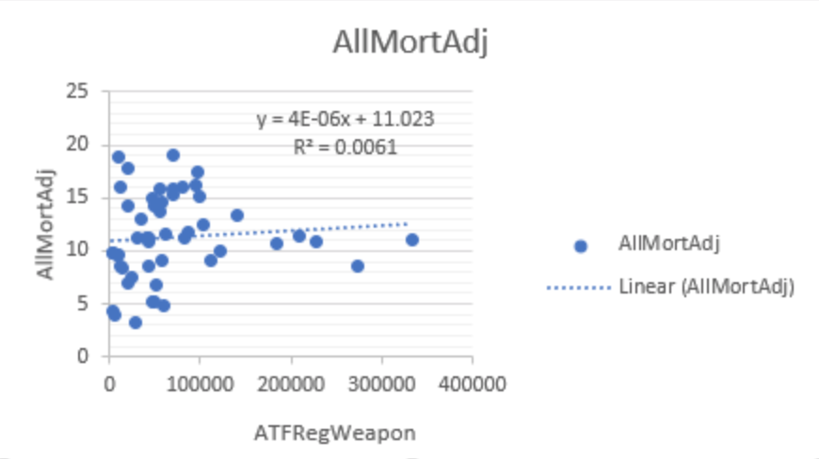

**All firearm mortality- Age Adjusted Rate (per 100,000) and ATF Registered Weapons**

**R-squared: 0.006; p-value: 0.5903 not significant. We do not reject null hypothesis.**

**There is no linear association between All firearm mortality- Age Adjusted Rate (per 100,000) and ATF Registered Weapons.**

1. **Adjusted model: Mort=f (ATFRegWeapon, Poverty, Unemploy, PoorMH0, PoorMH14ls, PoorMH14gt, StPoP)**

|  |
| --- |
|  |
| Residuals: |
|  | Min 1Q Median 3Q Max |
|  | -7.1602 -1.4565 -0.0834 0.9936 10.1491 |
|  |  |
|  | Coefficients: |
|  | Estimate Std. Error t value Pr(>|t|) |
|  | (Intercept) -7.498e+03 8.313e+03 -0.902 0.372207 |
|  | ATFRegWeapon 3.471e-05 1.047e-05 3.315 0.001894 ** |
|  | Poverty 8.438e-01 2.000e-01 4.220 0.000128 *** |
|  | Unemploy 7.654e-02 4.168e-01 0.184 0.855184 |
|  | PoorMH0 7.493e+01 8.312e+01 0.901 0.372465 |
|  | PoorMH14ls 7.513e+01 8.317e+01 0.903 0.371533 |
|  | PoorMH14gt 7.500e+01 8.312e+01 0.902 0.372058 |
|  | StPoP -4.724e-07 1.115e-07 -4.236 0.000121 *** |
|  | --- |
|  | Signif. codes: 0 ‘***’ 0.001 ‘**’ 0.01 ‘*’ 0.05 ‘.’ 0.1 ‘ ’ 1 |
|  |  |
|  | Residual standard error: 2.805 on 42 degrees of freedom |
|  | Multiple R-squared: 0.5815, Adjusted R-squared: 0.5118 |
|  | F-statistic: 8.339 on 7 and 42 DF, p-value: 2.356e-06 |
|  |  |

**Global Null Hypothesis**

**When testing the null hypothesis that there is linear association between All Firearm Mortality- Age Adjusted Rate (per 100,000), ATF Registered Weapons, poverty, unemployment, Poor Mental Health 0 days, poor mental health 1-14 days, poor mental health >14 days, statewide population.**

**Explained 58.15% (R-squared) of the variability in All Firearm Mortality.**

**Significant p-value: ATFRegWeapon (p-value = 0.189), Poverty (p-value = 0.013), StPop (p-value = 0.012)**

1. **Reduced model: Mort=f (ATFRegWeapon, Poverty, StPoP)**

|  |
| --- |
| Residuals: |
|  | Min 1Q Median 3Q Max |
|  | -6.7416 -1.4802 -0.2369 1.1582 10.4254 |
|  |  |
|  | Coefficients: |
|  | Estimate Std. Error t value Pr(>|t|) |
|  | (Intercept) -7.856e-02 1.867e+00 -0.042 0.96662 |
|  | ATFRegWeapon 3.324e-05 9.762e-06 3.405 0.00138 ** |
|  | Poverty 8.287e-01 1.304e-01 6.357 8.44e-08 *** |
|  | StPoP -4.457e-07 9.709e-08 -4.590 3.42e-05 *** |
|  | --- |
|  | Signif. codes: 0 ‘***’ 0.001 ‘**’ 0.01 ‘*’ 0.05 ‘.’ 0.1 ‘ ’ 1 |
|  |  |
|  | Residual standard error: 2.723 on 46 degrees of freedom |
|  | Multiple R-squared: 0.568, Adjusted R-squared: 0.5398 |
|  | F-statistic: 20.16 on 3 and 46 DF, p-value: 1.74e-08 |
|  |  |

**Global Null Hypothesis**

**When testing the null hypothesis that there is linear association between All Firearm Mortality- Age Adjusted Rate (per 100,000), ATF Registered Weapons, Poverty, and statewide population. ATF Registered weapons, poverty, and statewide polulation explain 56.8% of the variability in All Firearm Mortality.**

**Main Effects Hypothesis**

**When testing the null hypothesis that there is linear association between All Firearm Morality and ATF Registered Weapons after adjusting for poverty and statewide population, we reject the null hypothesis (t = 3.405, df = 46, p-value = 0.00138).**

**When testing the null hypothesis that there is linear association between All Firearm Morality and poverty after adjusting for ATF Registered Weapons and statewide population, we reject the null hypothesis (t = 6.357, df = 46, p-value = 8.44e-08).**

**When testing the null hypothesis that there is linear association between All Firearm Morality and statewide population after adjusting for poverty and ATF Registered Weapons, we reject the null hypothesis (t = -4.590, df = 46, p-value = 3.42e-05).**

**For a one unit change in ATF Registered Weapons, on average, the All Firearm Mortality increases by 3.3e-05, after adjusting for poverty and statewide population.**

**For a one unit change in Poverty, on average, the All Firearm Mortality increases by 8.287e-01, after adjusting for ATFRegWeapon and statewide population.**

**For a one unit change in StPoP, on average, the All Firearm Mortality decrease by 4.457e-07, after adjusting for ATFRegWeapon and Poverty.**

|  |  |  |  |
| --- | --- | --- | --- |
| Description | **Variable Name** |  |  |
| **All Firearm Mortality - Age Adjusted Rate (per 100,000)** | **AllMortAdj** | **Outcome** | **Y** |
| ATF Federal Firearm Licensees | **ATFFirearmLicense** | Exposure 2 | X |
| % Poverty | **Poverty** | **Covariates** |  |
| % Unemployment | **Unemploy** |  |
| % Poor mental health (0 days) | **PoorMH0** |  |
| % Poor mental health (1-14 days) | **PoorMH14ls** |  |
| % Poor mental health (> 14 days) | **PoorMH14gt** |  |
| Statewide population | **StPoP** |  |

1. **Crude model: Mort=f(ATFFirearmLicense)**

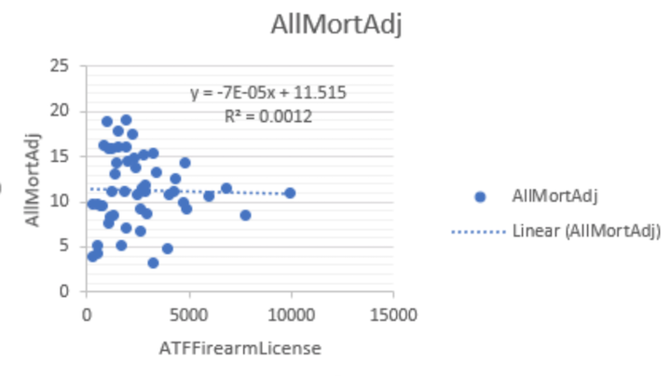

**All firearm mortality- Age Adjusted Rate (per 100,000) and ATF Federal Firearm Licensees**

**R-squared: 0.001; p-value: 0.8129 not significant. We do not reject null hypothesis.**

**There is no linear association between All firearm mortality- Age Adjusted Rate (per 100,000) and ATF Federal Firearm Licensees.**

1. **Adjusted model: Mort=f (ATFFirearmLicense, Poverty, Unemploy, PoorMH0, PoorMH14ls, PoorMH14gt, StPoP)**

|  |
| --- |
| Residuals: |
|  | Min 1Q Median 3Q Max |
|  | -7.1004 -1.6484 0.0184 1.0667 10.1337 |
|  |  |
|  | Coefficients: |
|  | Estimate Std. Error t value Pr(>|t|) |
|  | (Intercept) -7.615e+03 9.175e+03 -0.830 0.411295 |
|  | ATFFirearmLicense 6.471e-04 4.851e-04 1.334 0.189378 |
|  | Poverty 8.250e-01 2.205e-01 3.741 0.000549 *** |
|  | Unemploy 1.549e-04 4.586e-01 0.000 0.999732 |
|  | PoorMH0 7.612e+01 9.174e+01 0.830 0.411363 |
|  | PoorMH14ls 7.620e+01 9.180e+01 0.830 0.411211 |
|  | PoorMH14gt 7.621e+01 9.174e+01 0.831 0.410854 |
|  | StPoP -3.356e-07 1.428e-07 -2.349 0.023592 * |
|  | --- |
|  | Signif. codes: 0 ‘***’ 0.001 ‘**’ 0.01 ‘*’ 0.05 ‘.’ 0.1 ‘ ’ 1 |
|  |  |
|  | Residual standard error: 3.086 on 42 degrees of freedom |
|  | Multiple R-squared: 0.4935, Adjusted R-squared: 0.4091 |
|  | F-statistic: 5.846 on 7 and 42 DF, p-value: 8.928e-05 |

**R-squared: 0.4935; p-value: 8.928e-05 significant.**

**Global Null Hypothesis**

**When testing the null hypothesis that there is linear association between All Firearm Mortality- Age Adjusted Rate (per 100,000), ATFFirearmLicense, poverty, unemployment, Poor Mental Health 0 days, poor mental health 1-14 days, poor mental health >14 days, statewide population.**

**ATFFirearmLicense, poverty, unemployment, Poor Mental Health 0 days, poor mental health 1-14 days, poor mental health >14 days, statewide population explain 49.35%(R-squared) of the variability in All Firearm Mortality.**

**Main Effects Hypothesis**

**Significant p-value: Poverty(p-value: 0.000549), StPop(p-value: 0.023592)**

|  |
| --- |
|  |

1. **Reduced model: Mort=f (ATFFirearmLicense, Poverty, StPoP)**

|  |
| --- |
| Residuals: |
|  | Min 1Q Median 3Q Max |
|  | -6.9851 -1.6196 0.0009 1.0945 10.1478 |
|  |  |
|  | Coefficients: |
|  | Estimate Std. Error t value Pr(>|t|) |
|  | (Intercept) -3.184e-01 2.045e+00 -0.156 0.87693 |
|  | ATFFirearmLicense 6.922e-04 4.583e-04 1.510 0.13783 |
|  | Poverty 8.382e-01 1.436e-01 5.837 5.07e-07 *** |
|  | StPoP -3.477e-07 1.287e-07 -2.702 0.00962 ** |
|  | --- |
|  | Signif. codes: 0 ‘***’ 0.001 ‘**’ 0.01 ‘*’ 0.05 ‘.’ 0.1 ‘ ’ 1 |
|  |  |
|  | Residual standard error: 2.975 on 46 degrees of freedom |
|  | Multiple R-squared: 0.4846, Adjusted R-squared: 0.451 |
|  | F-statistic: 14.42 on 3 and 46 DF, p-value: 9.347e-07 |

**R-squared: 0.4846; p-value: 9.347e-07 significant.**

|  |  |  |  |
| --- | --- | --- | --- |
| Description | **Variable Name** |  |  |
| **All Firearm Mortality - Age Adjusted Rate (per 100,000)** | **AllMortAdj** | **Outcome** | **Y** |
| Giffords Center Rankings | **GiffordsRank** | Exposure 3 | X |
| % Poverty | **Poverty** | **Covariates** |  |
| % Unemployment | **Unemploy** |  |
| % Poor mental health (0 days) | **PoorMH0** |  |
| % Poor mental health (1-14 days) | **PoorMH14ls** |  |
| % Poor mental health (> 14 days) | **PoorMH14gt** |  |
| Statewide population | **StPoP** |  |

1. **Crude model: Mort=f(GiffordsRank)**

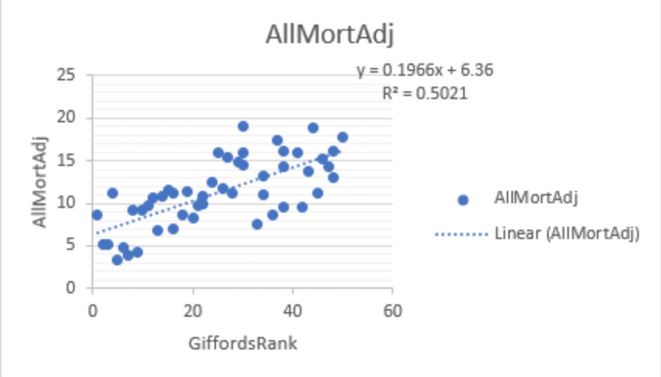

**All firearm mortality- Age Adjusted Rate (per 100,000) and Giffords Center Rankings**

**R-squared: 0.502; p-value: 8.53e-09 significant.**

**Giffords Center Rankings explain 50.2% of the variability in All Firearm Mortality. We reject null hypothesis.**

**There is linear association between All firearm mortality- Age Adjusted Rate (per 100,000) and Giffords Center Rankings.**

1. **Adjusted model: Mort=f (GiffordsRank, Poverty, Unemploy, PoorMH0, PoorMH14ls, PoorMH14gt, StPoP)**

|  |
| --- |
| Residuals: |
|  | Min 1Q Median 3Q Max |
|  | -5.813 -1.426 -0.241 1.654 5.706 |
|  |  |
|  | Coefficients: |
|  | Estimate Std. Error t value Pr(>|t|) |
|  | (Intercept) -6.163e+03 7.634e+03 -0.807 0.424 |
|  | GiffordsRank 1.607e-01 3.503e-02 4.588 4e-05 *** |
|  | Poverty 3.341e-01 2.145e-01 1.557 0.127 |
|  | Unemploy 4.286e-01 3.949e-01 1.085 0.284 |
|  | PoorMH0 6.159e+01 7.633e+01 0.807 0.424 |
|  | PoorMH14ls 6.166e+01 7.638e+01 0.807 0.424 |
|  | PoorMH14gt 6.181e+01 7.633e+01 0.810 0.423 |
|  | StPoP -5.192e-08 6.413e-08 -0.810 0.423 |
|  | --- |
|  | Signif. codes: 0 ‘***’ 0.001 ‘**’ 0.01 ‘*’ 0.05 ‘.’ 0.1 ‘ ’ 1 |
|  |  |
|  | Residual standard error: 2.572 on 42 degrees of freedom |
|  | Multiple R-squared: 0.6483, Adjusted R-squared: 0.5897 |
|  | F-statistic: 11.06 on 7 and 42 DF, p-value: 7.866e-08 |

**R-squared: 0.6483; p-value: 7.866e-08 significant.**

**Global Null Hypothesis**

**When testing the null hypothesis that there is linear association between All Firearm Mortality- Age Adjusted Rate (per 100,000), GiffordsRank, poverty, unemployment, Poor Mental Health 0 days, poor mental health 1-14 days, poor mental health >14 days, statewide population.**

**GiffordsRank, poverty, unemployment, Poor Mental Health 0 days, poor mental health 1-14 days, poor mental health >14 days, statewide population explain 64.83%(R-squared) of the variability in All Firearm Mortality.**

**Main Effects Hypothesis**

**None**

1. **Reduced model:**

**Did not make reduced model.**

|  |  |  |  |
| --- | --- | --- | --- |
| Description | **Variable Name** |  |  |
| **All Firearm Mortality - Age Adjusted Rate (per 100,000)** | **AllMortAdj** | **Outcome** | **Y** |
| Gun Ownership Rates | **GOwnerRates** | Exposure 4 | X |
| % Poverty | **Poverty** | **Covariates** |  |
| % Unemployment | **Unemploy** |  |
| % Poor mental health (0 days) | **PoorMH0** |  |
| % Poor mental health (1-14 days) | **PoorMH14ls** |  |
| % Poor mental health (> 14 days) | **PoorMH14gt** |  |
| Statewide population | **StPoP** |  |

1. **Crude model: Mort=f(GOwnerRates)**

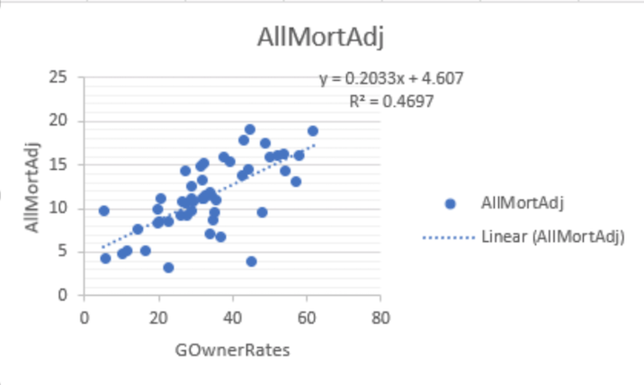

**All firearm mortality- Age Adjusted Rate (per 100,000) and Gun Ownership rates**

**R-squared: 0.469; p-value: 4.005e-08 significant.**

**Gun Ownership rates explain 46.97% of the variability in All Firearm Mortality. We reject null hypothesis.**

**There is linear association between All firearm mortality- Age Adjusted Rate (per 100,000) and Gun Ownership rates.**

1. **Adjusted model: Mort=f (GOwnerRates, Poverty, Unemploy, PoorMH0, PoorMH14ls, PoorMH14gt, StPoP)**

|  |
| --- |
| Residuals: |
|  | Min 1Q Median 3Q Max |
|  | -7.2809 -1.3044 0.3207 1.6842 4.6360 |
|  |  |
|  | Coefficients: |
|  | Estimate Std. Error t value Pr(>|t|) |
|  | (Intercept) -6.994e+03 7.501e+03 -0.932 0.3564 |
|  | GOwnerRates 1.578e-01 3.283e-02 4.808 1.98e-05 *** |
|  | Poverty 3.719e-01 2.055e-01 1.809 0.0775 . |
|  | Unemploy 3.486e-01 3.837e-01 0.908 0.3688 |
|  | PoorMH0 6.991e+01 7.499e+01 0.932 0.3566 |
|  | PoorMH14ls 6.986e+01 7.505e+01 0.931 0.3573 |
|  | PoorMH14gt 7.019e+01 7.499e+01 0.936 0.3546 |
|  | StPoP -7.403e-08 6.116e-08 -1.210 0.2329 |
|  | --- |
|  | Signif. codes: 0 ‘***’ 0.001 ‘**’ 0.01 ‘*’ 0.05 ‘.’ 0.1 ‘ ’ 1 |
|  |  |
|  | Residual standard error: 2.531 on 42 degrees of freedom |
|  | Multiple R-squared: 0.6594, Adjusted R-squared: 0.6027 |
|  | F-statistic: 11.62 on 7 and 42 DF, p-value: 4.167e-08 |

**R-squared: 0.6594; p-value: 4.167e-08 significant.**

**Global Null Hypothesis**

**When testing the null hypothesis that there is linear association between All Firearm Mortality- Age Adjusted Rate (per 100,000), GOwnerRates, poverty, unemployment, Poor Mental Health 0 days, poor mental health 1-14 days, poor mental health >14 days, statewide population.**

**GOwnerRates, poverty, unemployment, Poor Mental Health 0 days, poor mental health 1-14 days, poor mental health >14 days, statewide population explain 65.94%(R-squared) of the variability in All Firearm Mortality.**

**Main Effects Hypothesis**

**None**

1. **Reduced model:**

**Did not make reduced model.**

**Overview of the data**

|  |  |  |
| --- | --- | --- |
| Description | **Variable Name** |  |
| All firearm mortality | AllMortN | **Y=Outcomes;** multiple years with some missings |
| All Firearm Mortality - Crude Rate (per 100,000) | AllMortCrd |
| **All Firearm Mortality - Age Adjusted Rate (per 100,000)** | **AllMortAdj** |
| Age 0-24 Firearm Mortality | MortN24ls |
| Age 0-24 Mortality Crude Rate (per 100,000) | Mort24lsCrd |
| **Age 0-24 Mortality Age Adjusted Rate (per 100,000)** | **Mort24lsAdj** |
| ATF Registered Weapons | **ATFRegWeapon** | Multiple years |
| ATF Federal Firearm Licensees | **ATFFirearmLicense** |
| Giffords Center Rankings | **GiffordsRank** | 2018 data only |
| Gun Ownership Rates | **GOwnerRates** | 2013 data only |
| Handguns Carry Permit required (0 = No, 1 = Yes) | **HGCPermReq** | 2018 data only |
| Handguns Magazine size restriction (0 = No, 1 = Yes) | **HGMagRestrict** |
| Handguns Open carry allowed (0 = No, 1 = Yes) | **HGOCAllow** |
| Handguns Permit required (0 = No, 1 = Yes) | **HGPermReq** |
| Handguns Purchase permit required (0 = No, 1 = Yes) | **HGPurchPermReq** |
| Handguns Registration of firearm (0 = No, 1 = Yes) | **HGRegFirearm** |
| Background checks on private gun sales required (0 = No, 1 = Yes) | **CheckPGSReq** |
| Long guns Carry Permit required (0 = No, 1 = Yes) | **LGCPermReq** |
| Long guns Magazine size restriction (0 = No, 1 = Yes) | **LGMagRestrict** |
| Long guns Open carry allowed (0 = No, 1 = Yes) | **LGOCAllow** |
| Long guns Permit required (0 = No, 1 = Yes) | **LGPermReq** |
| Long guns Purchase permit required (0 = No, 1 = Yes) | **LGPurchPermReq** |
| Long guns Registration of firearm (0 = No, 1 = Yes) | **LGRegFirearm** |
| % Poverty | **Poverty** | **SES** |
| % Unemployment | **Unemploy** |
| % Poor mental health (0 days) | **PoorMH0** |
| % Poor mental health (1-14 days) | **PoorMH14ls** |
| % Poor mental health (> 14 days) | **PoorMH14gt** |
| Statewide population | **StPoP** |
| % population (age 0-24 years) | **PoP24ls** |
| State | **State** | **50 states** |
| Timeframe | **Year** | **1997-2018** |

**Check on missing data (red=have data; black=missing)**