

**Cairo University**

**Faculty of Computers and**

**Information**



CS352 Software Engineering II

Assignment 2

By

[Doaa Ali Hassan] [20160099] [IS 1] [doaaali104@gmail.com]

[Aya Mohamed Abd Alwahab ] [20160079] [IS1]

[Nancy Saeed] [20160259] [IS1]

[9-3-2019]

Department of Computer Science

Faculty of Computers and Information

Cairo University

# **2018**2019

1. Introduction:

The main idea of our system to create a chat room that helps the group of peers to connect with each other without centralized server.

1. Implemented use case: 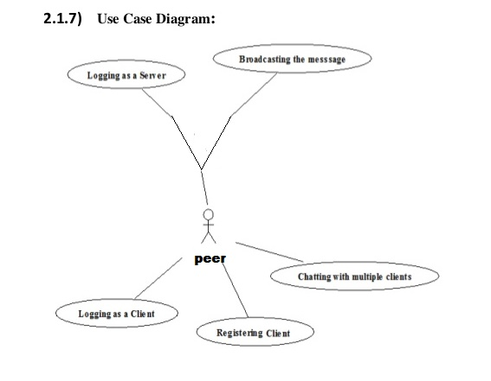
2. System Architecture:

P2p connection between peers without centralized server, as the data can be shared in bidirectional, each nodes can send and receive data from each other, no client and no server it's just peer in connection.

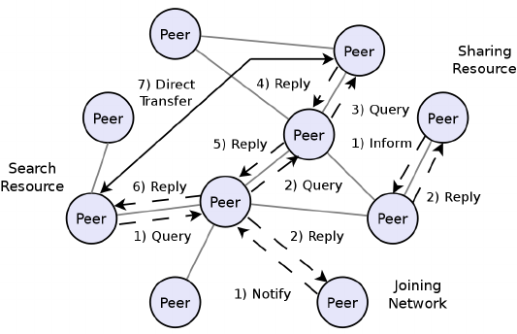

1. System Design:

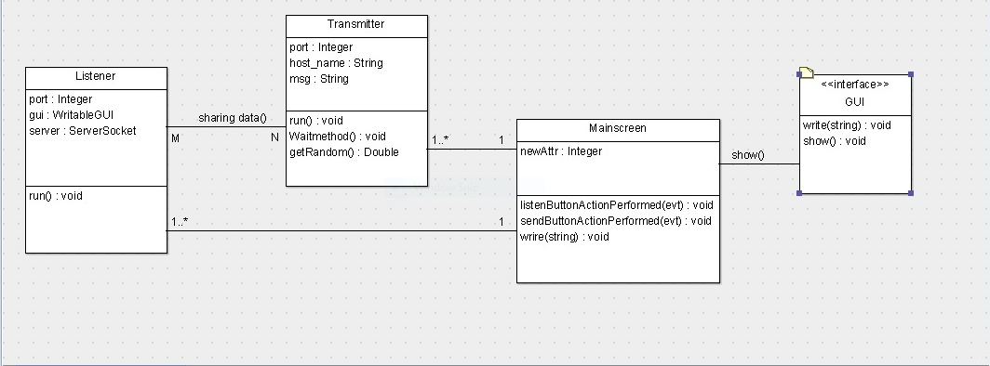

1. Description: Listener : to receive the port number of peer which want to connect in the network .Transmitter:To trnsmiit the messages content from peer to another. Main screen : has some buttons and text space to get the user reactions with system and to get inputs .GUI :to get inputs and show outputs for users.
2. Installation Guide javax.json-1.0.4

1