
Project: MIMIC ICD CODER Data Exploratory and ANALYSIS

April 21, 2026
nancy tanaka
DATA EXPLORATORY AND ANALYSIS

Abstract
Automated ICD coding remains a high-friction problem in clinical operations because diagnosis assignment still depends heavily on manual coder review of long, noisy discharge documentation. This study conducts exploratory data analysis and cohort construction for a multi-label ICD-10 auto-coding pipeline using MIMIC-IV-Note v2.2 discharge summaries joined to MIMIC-IV v3.1 Hosp admissions and diagnoses. The version mismatch is intentional: MIMIC-IV-Note v2.2 is the only public note release as of April 2026, while Hosp v3.1 includes corrections to structured diagnosis tables. Using hadm_id as the stable join key, the cohort is defined as the intersection of discharge summaries, hospital admissions, and ICD-10 diagnosis records, followed by note-length and deduplication checks. The resulting modelable cohort contains 122,288 admissions, roughly 2.6 times the size of the MIMIC-III cohort commonly cited in prior ICD coding work. Label concentration is favorable for benchmarking: the top 50 ICD-10 codes cover 91.04% of admissions despite a long tail of 19,440 distinct codes. Two constraints materially shape the modeling strategy: 44.83% of patients have more than one admission, making patient-level splits mandatory, and discharge summaries are too long for a single BERT window, with median length 1,501 tokens and 90th percentile length 2,447 tokens. De-identification markers account for 3.66% of tokens. These findings support a chunked Bio_ClinicalBERT approach over naive truncation and make Longformer a fallback rather than a first-line choice. For management, the conclusion is simple: the cohort is large enough and concentrated enough to justify immediate baseline training, but only with leakage-safe splits and chunk-aware modeling.
Keywords: clinical NLP; automated ICD coding; ICD-10-CM; multi-label text classification; MIMIC-IV-Note; discharge summaries; transformer models

Introduction
ICD coding is a necessary but inefficient part of the healthcare revenue cycle. Clinical coders must translate long-form physician documentation into standardized diagnosis codes for billing, utilization review, quality reporting, and downstream analytics. That process is expensive, slow, and inconsistent under real-world workload pressure. A coder-assist model that can rank likely codes from discharge summaries has obvious operational value, but only if it is built on a defensible cohort and evaluated with leakage controls.
The benchmark most people still anchor to is Mullenbach et al. (2018), which established the CAML baseline on MIMIC-III for top 50 ICD-9 coding. That paper mattered because it gave the field a common task definition and metric frame, not because the architecture is still state of the art. The field has since moved toward domain-adapted transformers, label-aware attention, and long-context methods, but the core problem has not changed: clinical notes are long, labels are imbalanced, and reported gains often collapse when cohort construction is sloppy.
This study focuses on a more recent benchmark setup: MIMIC-IV-Note v2.2 discharge summaries joined with MIMIC-IV v3.1 hospital diagnoses, filtered to ICD-10 admissions and a top 50 label space. The immediate objective is not to report on model performance. It is to determine whether the available data support a credible auto-coding benchmark and to surface the non-negotiable design constraints before training begins.
The central research question is whether a chunked Bio_ClinicalBERT pipeline can plausibly exceed the historical CAML benchmark when trained on a larger, newer MIMIC-IV cohort with ICD-10 labels. That is only worth asking if the data supports it. This paper therefore contributes the hard part of the weakest project reports skip: cohort construction logic, label-space characterization, note-length analysis, split methodology, and the EDA evidence used to justify the downstream modeling plan.

Literature Review

2.1 Automated Medical Coding
Mullenbach et al. (2018) established the canonical benchmark for automated medical coding using MIMIC-III discharge summaries and the top 50 ICD-9 codes. Their Convolutional Attention for Multi-Label classification (CAML) model became the comparison anchor because it paired an interpretable architecture with standard multi-label metrics, especially Micro F1, Macro F1, and precision at rank. Its continued relevance is mostly historical: it defines the baseline that later work claims to beat. Its limitations are equally clear. It was built on ICD-9 rather than ICD-10, used a pre-transformer architecture, and operated in a regime where long-document context handling was far more primitive.
Subsequent work expanded the design space with label-attention models, transformer encoders, and hierarchical coding systems that better reflect the structure of clinical taxonomies. Retrieval-augmented methods and code-description-aware encoders have also improved label semantics. Even so, many newer papers still depend on benchmark shortcuts that make their gains less convincing than advertised. This project takes a stricter route: establish a clean MIMIC-IV ICD-10 cohort first, then compare a straightforward chunked transformer against a classical baseline before entertaining more elaborate architectures.

2.2 Clinical Language Models
BERT introduced the dominant pretrain-and-finetune paradigm for NLP by using deep bidirectional transformers trained with masked language modeling and next-sentence prediction (Devlin et al., 2019). Its impact on classification tasks was immediate, but the base architecture carries a blunt constraint: a maximum input length of 512 tokens. That limitation is not cosmetic in clinical NLP. It is the core architectural problem when working with discharge summaries.
Bio_ClinicalBERT addressed domain mismatch by continuing pretraining on clinical notes from MIMIC-III, producing embeddings that consistently outperform general-domain BERT on clinical tasks (Alsentzer et al., 2019). For this project, Bio_ClinicalBERT is the correct primary model choice. Anything else would need a strong reason. General BERT is weaker on clinical language, and jumping straight to larger long-context models without proving need is wasteful.
Longformer extends the transformer attention mechanism to support substantially longer contexts through sliding-window attention, making it attractive for long clinical notes (Beltagy et al., 2020). The trade-off is cost. Long-context training is materially slower and more expensive, and in many applied settings that overhead is not justified if chunked BERT already captures enough signal. This paper therefore treats Longformer as a contingency plan, not the default.

2.3 The MIMIC-IV Dataset
MIMIC-IV Hosp v3.1 provides structured EHR data from Beth Israel Deaconess Medical Center and includes admissions, patient demographics, and diagnosis assignments spanning the ICD-9 and ICD-10 transition period (Johnson et al., 2023a). The v3.1 release matters because corrections were made to the diagnoses_icd table. Ignoring those corrections in favor of an older structured release would be lazy and harder to defend.
MIMIC-IV-Note v2.2 provides deidentified free-text clinical notes released separately through PhysioNet (Johnson et al., 2023b). As of April 2026, it remains the only public note release, which creates a forced version mismatch between text and structured hospital tables. That mismatch is acceptable because the join key hadm_id remains stable across releases and because refusing the newer Hosp tables would preserve known structured-data defects for no good reason. The notes are deidentified using Safe Harbor-style redaction and date shifting, which protects privacy but introduces artifacts that matter for analysis.
Relative to MIMIC-III, MIMIC-IV offers a newer cohort, ICD-10-inclusive diagnoses, and post-2015 admissions that capture more contemporary documentation patterns and diagnosis coding behavior, including pandemic-era codes. That makes it a better setting for a modern portfolio-grade ICD coding system, provided the cohort is constructed carefully.

2.4 Responsible Medical AI Documentation
Responsible medical AI is not just a deployment concern. It starts with data documentation. Model Cards provide a standardized way to report intended use, metrics, subgroup performance, and limitations (Mitchell et al., 2019). Data Cards extend that documentation discipline to dataset provenance, coverage, and collection assumptions (Pushkarna et al., 2022). This project treats those artifacts as downstream deliverables informed by the EDA. That is the right order. Writing a model card without first quantifying cohort coverage, split leakage risk, and demographic limitations is performative documentation, not serious model governance.

Methods

3.1 Data Source
This analysis uses two MIMIC resources. The text source is MIMIC-IV-Note v2.2, which contains 331,793 discharge summaries keyed by subject_id and hadm_id and represented with fields including note_id, note_type, note_seq, charttime, and raw text. In this release, the discharge-summary subset is operationally simple because the note type is already restricted to DS.
The structured source is MIMIC-IV Hosp v3.1, which contributes admissions, patient attributes, and diagnosis records. The admissions table contains 546,028 rows, the patients table 364,627 rows, and diagnoses_icd 6,364,488 rows spanning both ICD-9 and ICD-10 coding eras. The decision to join Note v2.2 with Hosp v3.1 is deliberate rather than accidental. The notes release lags with the structured release, but v3.1 corrects diagnosis data and hadm_id remains a stable join key, so the higher-integrity structured table should be preferred.
The source data are identified through patient-level date shifting and capped age reporting, with anchor_age top-coded at 89. That protects patient privacy but distorts temporal interpretation and compresses the oldest age strata. The work assumes MIMIC credentialing and PhysioNet data use compliance and does not attempt any re-identification or reconstruction of true dates.

3.2 Data Preparation and Analysis Strategies
Schema validation was performed before cohort construction to detect type instability and parsing failures early. Timestamp fields were successfully parsed by the Arrow CSV reader with one notable exception: patients.dod, where a high null rate defeated inference and required deferral to a later typed cast stage. Numeric fields remained stable, and no evidence was found that core hospital features had been silently coerced to strings, which matters because that kind of ingestion bug can poison downstream joins and summary statistics.
Cleaning rules were intentionally narrow. The note corpus was restricted to discharge summaries only. De-identification markers were preserved for analysis but collapsed into a measurable artifact class rather than treated as meaningful language. Deduplication by hadm_id was checked but proved to be a no-op because this release is already effectively deduplicated. A minimum length threshold of 100 whitespace tokens was applied to remove clearly non-informative or malformed note bodies.
Cohort construction then applied the actual modeling filter: retain only admissions that appear in all three required sets, namely discharge summaries, hospital admissions, and ICD-10 diagnosis records. The final modelable cohort contains 122,288 admissions. Most attrition is not due to broken joins or missing keys. It is due to design. The structured hospital tables include mixed ICD-9 and ICD-10 eras, so restricting to ICD-10 admissions removes a large share of the text inventory by construction. Version drift between note and structured releases contributes negligibly, at 0.018%, while the ICD-era filter explains 63.14% of the reduction.
Train, validation, and test partitions are defined at the patient level using an 80/10/10 split by subject_id. This is not optional. It is required because 44.83% of patients have more than one admission, and admission-level random splitting would leak patient-specific language patterns across folds. Any evaluation built on admission-level splits would overstate generalization.

3.3 Data Visualization
The note-length distribution is the single most important descriptive result. Figure 3.1 shows a strongly right-skewed distribution with median length 1,501 tokens, 90th percentile length 2,447, and 99th percentile length 3,691. The exceedance curve bends in the 1,000 to 2,000 token range, which is exactly where naive BERT truncation becomes indefensible. This is not a mild inconvenience. It determines the architecture.
The ICD version transition visualization is useful but easy to misread. Figure 6.1 displays ICD-9 and ICD-10 assignments by shifted admission year, but the date-shifting scheme smears the real October 2015 transition across the synthetic timeline. The plot is therefore diagnostic rather than historical. It shows that the version split exists, but it should not be interpreted as an actual temporal trend without date unshifting in a later processing stage.
Figure 7.1 combines a rank-frequency plot and a top K coverage curve for ICD-10 labels. The label space is long-tailed, with 19,440 distinct codes, but the top 50 codes cover 91.04% of admissions. That concentration makes the benchmark tractable. Coverage gains flatten sharply after K = 50, which justifies using a top 50 setting for initial modeling instead of pretending the full long tail is a realistic first target.
The label co-occurrence heatmap in Figure 9.1 reveals clinically coherent clusters, including metabolic comorbidity groupings, behavioral health patterns, and acute complication clusters. The most important sanity check is the near-zero co-occurrence between Z87.891 and F17.210, which represent past and current tobacco use states that should rarely be coded together. That near-zero cell is a good sign. It suggests the diagnosis labels are noisy in the usual way, not catastrophically inconsistent.
Figure 10.1 shows the admissions-per-patient distribution. It is heavily right-skewed, with median 1, mean 2.44, and maximum 238 admissions for a single patient. About 55% of patients appear once, while 11% appear five or more times. This is exactly the distribution that makes patient-level splitting mandatory.

3.4 Algorithms and Modeling Methods

3.4.1 Multi-Label Classification Approach
The task is framed as multi-label classification over 50 binary targets. That is the only coherent formulation because admissions routinely carry many diagnoses. A multi-class setup would force one code per admission and would be structurally wrong. The baseline model is a one-vs-rest logistic regression trained on TF-IDF features using unigram and bigram terms, min_df=5, and a capped vocabulary of 200,000 features with class balancing. This is not glamorous, but it is the correct control. If a transformer cannot clearly outperform this baseline, the transformer setup is probably weak rather than the task being impossible.

3.4.2 Transformer Fine-Tuning Strategy
The primary neural model is Bio_ClinicalBERT with chunk-and-max-pool decoding. The EDA justifies this directly. A single 512-token window would truncate 98.74% of notes and discard on the order of 1,000 tokens even around the median. That is unacceptable. A chunked approach can process several note segments independently and aggregate evidence across them, preserving substantially more signal at lower cost than a full long-context transformer.
Clinical-Longformer is reserved as an escalation path rather than the initial model. That is the right call. Long-context transformers are slower and more expensive, and there is no reason to pay that tax before testing whether chunked Bio_ClinicalBERT already clears the target. The escalation trigger is concrete: if chunked BERT misses the Micro F1 target of 0.70 by more than three points, then re-evaluate the architecture.

3.4.3 Threshold Tuning
Threshold selection is performed per label on the validation set by optimizing F1 rather than using a single global cutoff. The class distribution is too imbalanced for one threshold to work well across all labels. Common codes and low-prevalence codes operate in different score regimes. Ignoring that and using a flat 0.5 threshold would be a weak implementation choice.

3.4.4 Patient-Level Train/Val/Test Splits
The train/validation/test split is performed at the patient level with seed 42 and an 80/10/10 ratio. The logic is straightforward: when 44.83% of patients appear multiple times, random admission-level splits create a high probability that the same patient contributes notes to both train and evaluation sets. For patients with five admissions, the leakage probability under naive random splitting is substantial. That kind of contamination inflates metrics because the model partially memorizes patient-specific phrasing, diagnosis style, and chronic-condition vocabulary.

3.5 EDA Results
The cohort is viable. The final modelable population contains 122,288 admissions, roughly 2.6 times the scale of the MIMIC-III cohort used in the original CAML benchmark. Top 50 coverage reaches 91.04%, which is comfortably above the 80% threshold that would make a top K benchmark worth running. On size and concentration alone, the cohort is strong enough to support both baseline and transformer experiments.
The main constraints are also clear and nontrivial. Note length rules out single-window BERT. Patient overlaps rules out admission-level random splitting. The v3.1 Hosp upgrade improves structured diagnosis integrity, but the ICD-10-only filter eliminates a large share of the note inventory because the older ICD-9 era is intentionally excluded. That is a cohort-definition trade-off, not a data-quality failure.
The analysis also surfaced useful domain signals. The appearance of Z20.822 among the most frequent codes confirms that the cohort includes pandemic-era admissions. Expected cardiometabolic burden is somewhat obscured in the top ranks by ICD-10 sub-code fragmentation rather than absence of disease burden. The near-zero Z87.891 × F17.210 co-occurrence is a small but important validation that label combinations are not obviously nonsensical.

3.6 Model Evaluation
The primary evaluation metrics are Micro F1, Macro F1, and precision at rank, specifically P@5, P@8, and P@15. Micro F1 is the main operational metric because it aggregates global true positives, false positives, and false negatives across labels, which makes it stable under class imbalance. Macro F1 remains necessary because it exposes whether the model collapses on rarer labels. Precision at rank is relevant for coder-assist workflows because ranking quality matters even when binary thresholding is imperfect.
The target performance thresholds are intentionally explicit: Micro F1 at or above 0.70, Macro F1 at or above 0.55, and P@8 at or above 0.65. The minimum acceptable floor is Micro F1 at or above 0.55. Anything below suggests a broken pipeline, poor label handling, or leakage in prior expectations rather than a respectable first baseline.
Results should also be contextualized relative to Mullenbach et al. (2018), but that comparison needs an honesty clause. The move from ICD-9 to ICD-10 introduces additional label fragmentation, so raw delta reporting is informative but not perfectly apples-to-apples. Subgroup reporting by recurrent-admission status, sex, and age bucket should be included in the eventual model card. Temporal subgroup evaluation should wait until date fields are properly normalized beyond the shifted timeline artifact.

4. Conclusion

4.1 Exposition
This EDA establishes that MIMIC-IV can support a serious ICD-10 auto-coding benchmark, but only if the modeling plan respects the structure of the data. The cohort is large, label concentration is high enough for a top 50 benchmark, and the join logic between MIMIC-IV-Note v2.2 and MIMIC-IV Hosp v3.1 is defensible despite the release mismatch. The data are good enough to proceed.
The analysis also kills several weak modeling shortcuts. Single-window BERT is not a credible option because discharge summaries are too long. Admission-level random splitting is not defensible because repeated patients are too common. The problem has evolved since Mullenbach et al. (2018): the cohort is newer, the coding system is ICD-10 rather than ICD-9, the label space is more granular, and the data include pandemic-era admissions. That makes the benchmark harder in some ways and stronger in others.

4.2 Problem Description
The modeling problem exposed by the data is not just “predict codes from text.” It is a constrained long-document, multi-label classification problem with severe right-skew in note length, a fragmented diagnosis space, substantial patient-level leakage risk, and a note corpus that samples only part of the full structured-hospital population. In other words, the task is feasible, but sloppy evaluation or naive architecture choice will produce misleading results.

4.3 Management Recommendations
- Proceed to baseline training immediately. The cohort size and top 50 label coverage are already strong enough to justify a TF-IDF plus logistic regression benchmark.
- Do not waste time on single-window BERT. The note-length distribution makes truncation a losing design from the start.
- Train chunked Bio_ClinicalBERT as the primary neural baseline. It is the best cost-performance choice supported by the EDA.
- Escalate to Clinical-Longformer only if chunked BERT underperforms materially. Use the pre-registered trigger rather than model-chasing.
- Keep patient-level splits fixed and documented. Any admission-level evaluation would contaminate results and weaken the credibility of the entire project.
- Unshift or normalize date logic in the Silver stage before any temporal analysis. Current shifted-year plots are acceptable for diagnostics, not for historical claims.
- Add race and related subgroup fields before model-card finalization. Fairness reporting without demographic coverage is incomplete and would not pass serious review.
- Document the cohort ceiling explicitly in the data card. The modelable population is limited by note availability in MIMIC-IV-Note v2.2, not by this project’s join quality.

5. Acknowledgement
This manuscript was prepared with limited assistance from large language models (Anthropic Claude and OpenAI ChatGPT) used for editorial support, paper organization, and discussion of presentation choices. The code, analyses, computed statistics, cohort definition, methodological decisions, interpretations, and final written content were developed by the author.

References
Alsentzer, E., Murphy, J. R., Boag, W., Weng, W.-H., Jin, D., Naumann, T., & McDermott, M. (2019). Publicly available clinical BERT embeddings. Proceedings of the 2nd Clinical Natural Language Processing Workshop, 72–78. https://doi.org/10.18653/v1/W19-1909
Beltagy, I., Peters, M. E., & Cohan, A. (2020). Longformer: The long-document transformer. arXiv preprint arXiv:2004.05150. https://arxiv.org/abs/2004.05150
Devlin, J., Chang, M.-W., Lee, K., & Toutanova, K. (2019). BERT: Pre-training of deep bidirectional transformers for language understanding. Proceedings of the 2019 Conference of the North American Chapter of the Association for Computational Linguistics, 4171–4186. https://doi.org/10.18653/v1/N19-1423
Johnson, A. E. W., Bulgarelli, L., Shen, L., Gayles, A., Shammout, A., Horng, S., Pollard, T. J., Hao, S., Moody, B., Gow, B., Lehman, L. H., Celi, L. A., & Mark, R. G. (2023). MIMIC-IV, a freely accessible electronic health record dataset. Scientific Data, 10(1), 1. https://doi.org/10.1038/s41597-022-01899-x
Johnson, A. E. W., Pollard, T. J., Horng, S., Celi, L. A., & Mark, R. G. (2023). MIMIC-IV-Note: Deidentified free-text clinical notes (version 2.2) [Data set]. PhysioNet. https://doi.org/10.13026/1n74-ne17
Mitchell, M., Wu, S., Zaldivar, A., Barnes, P., Vasserman, L., Hutchinson, B., Spitzer, E., Raji, I. D., & Gebru, T. (2019). Model cards for model reporting. Proceedings of the Conference on Fairness, Accountability, and Transparency, 220–229. https://doi.org/10.1145/3287560.3287596
Mullenbach, J., Wiegreffe, S., Duke, J., Sun, J., & Eisenstein, J. (2018). Explainable prediction of medical codes from clinical text. Proceedings of the 2018 Conference of the North American Chapter of the Association for Computational Linguistics, 1101–1111. https://doi.org/10.18653/v1/N18-1100
Pushkarna, M., Zaldivar, A., & Kjartansson, O. (2022). Data cards: Purposeful and transparent dataset documentation for responsible AI. Proceedings of the 2022 ACM Conference on Fairness, Accountability, and Transparency, 1776–1826. https://doi.org/10.1145/3531146.3533231

Appendix

Appendix A. Figures
Figures are numbered by the EDA section they support. All figures were generated from the cohort-construction workflow using MIMIC-IV-Note v2.2 and MIMIC-IV Hosp v3.1 after schema validation, discharge-summary filtering, and ICD-10 cohort restriction.
Figure 3.1. Distribution of discharge summary length.
This figure shows the distribution of note lengths measured in whitespace tokens and characters, with reference lines for BERT (512 tokens) and Longformer (4,096 tokens). The distribution is strongly right-skewed, with a median of 1,501 tokens, 90th percentile of 2,447, and 99th percentile of 3,691. This result justifies chunked transformer processing rather than single-window truncation.
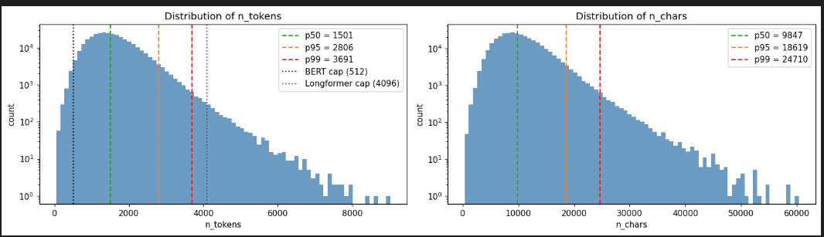
Figure 6.1. ICD version assignments by shifted admission year.
This diagnostic figure displays ICD-9 and ICD-10 diagnosis assignments across shifted admission years. Because MIMIC applies per-patient date shifting, the visual should not be interpreted as a true historical transition plot. Its purpose is only to confirm the presence of the ICD-9 to ICD-10 era split and motivate the ICD-10-only cohort filter.
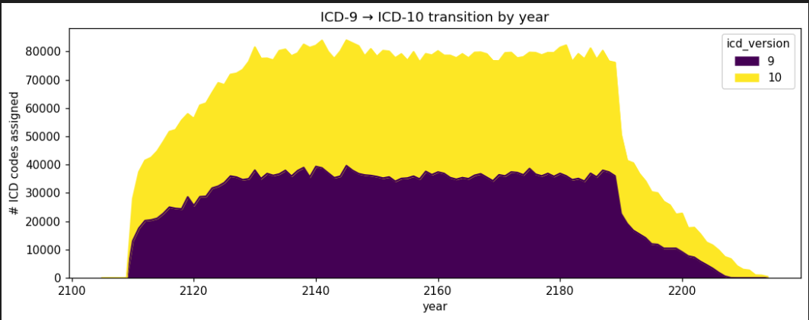
Figure 7.1. ICD-10 code frequency and top-K admission coverage.
The left panel presents the rank-frequency distribution of ICD-10 codes on a log-log scale. The right panel shows the cumulative fraction of admissions covered by the top-K most frequent codes. The top-50 codes cover 91.04% of admissions, supporting the use of a top-50 benchmark for initial modeling.
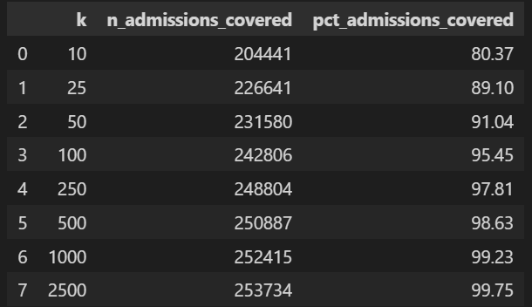
Figure 8.1. Distribution of distinct ICD-10 codes per admission.
This figure summarizes label cardinality at the admission level. It confirms that the task is inherently multi-label and that a multi-class formulation would be structurally wrong.
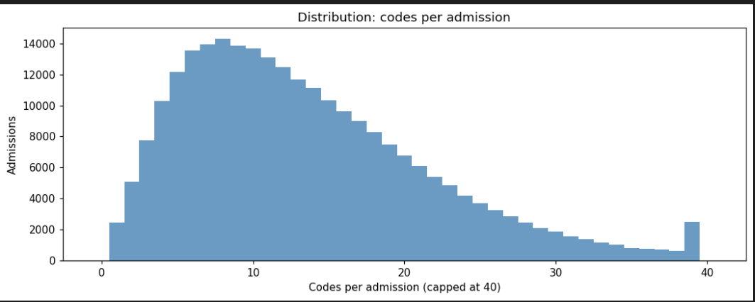
Figure 9.1. Top-20 ICD-10 label co-occurrence heatmap.
This heatmap shows pairwise co-occurrence counts among the most frequent ICD-10 codes. It highlights clinically coherent comorbidity clusters and includes a useful negative-control pattern: the near-zero co-occurrence of Z87.891 and F17.210, which supports coding consistency.
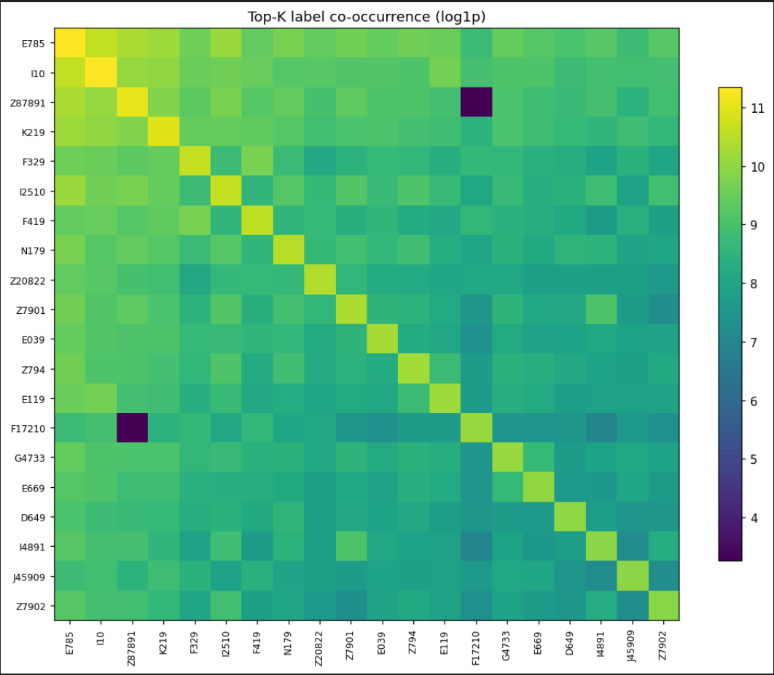
Figure 10.1. Admissions per patient.
This figure displays the distribution of the number of admissions per patient. The distribution is heavily right-skewed, with 44.83% of patients having more than one admission. This finding justifies patient-level train/validation/test splitting to prevent leakage.
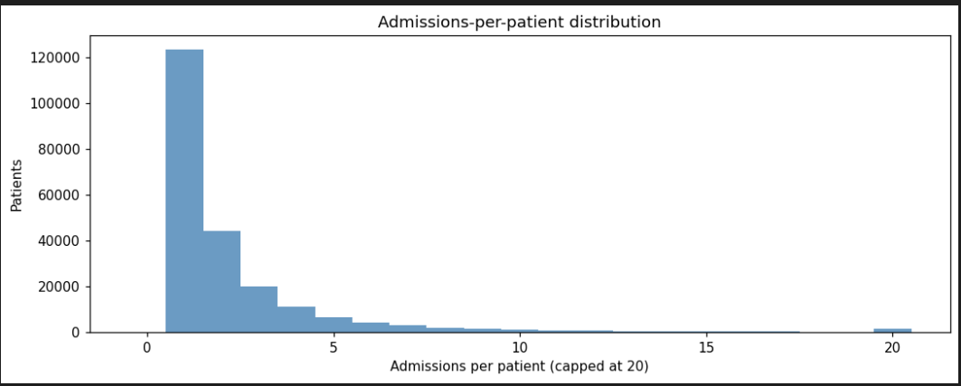

Appendix B. Supplementary Tables
Table B1. Source table volumetrics.
This table reports row counts for the source note, admission, patient, and diagnosis tables used in cohort construction.
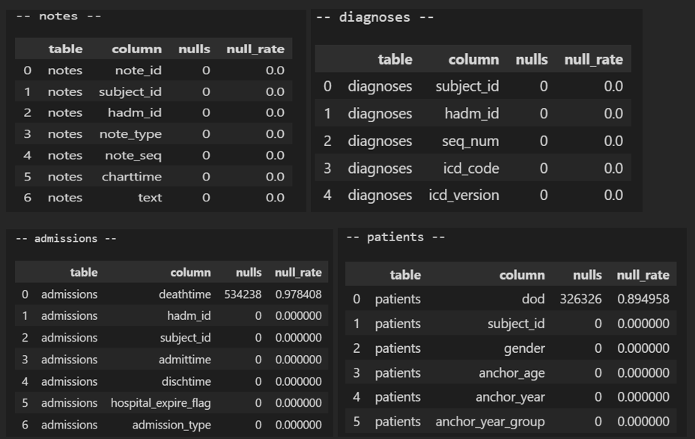
Table B2. Final cohort filtering summary.
This table decomposes the reduction from raw discharge summaries to the final modelable ICD-10 cohort, including the effects of join coverage, diagnosis version restriction, and minimum note-length filtering.
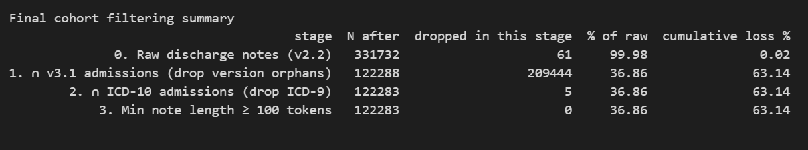
Table B3. Top-50 ICD-10 codes and descriptions.
This table lists the final top-50 ICD-10 codes used for modeling, along with short clinical descriptions and admission frequencies.
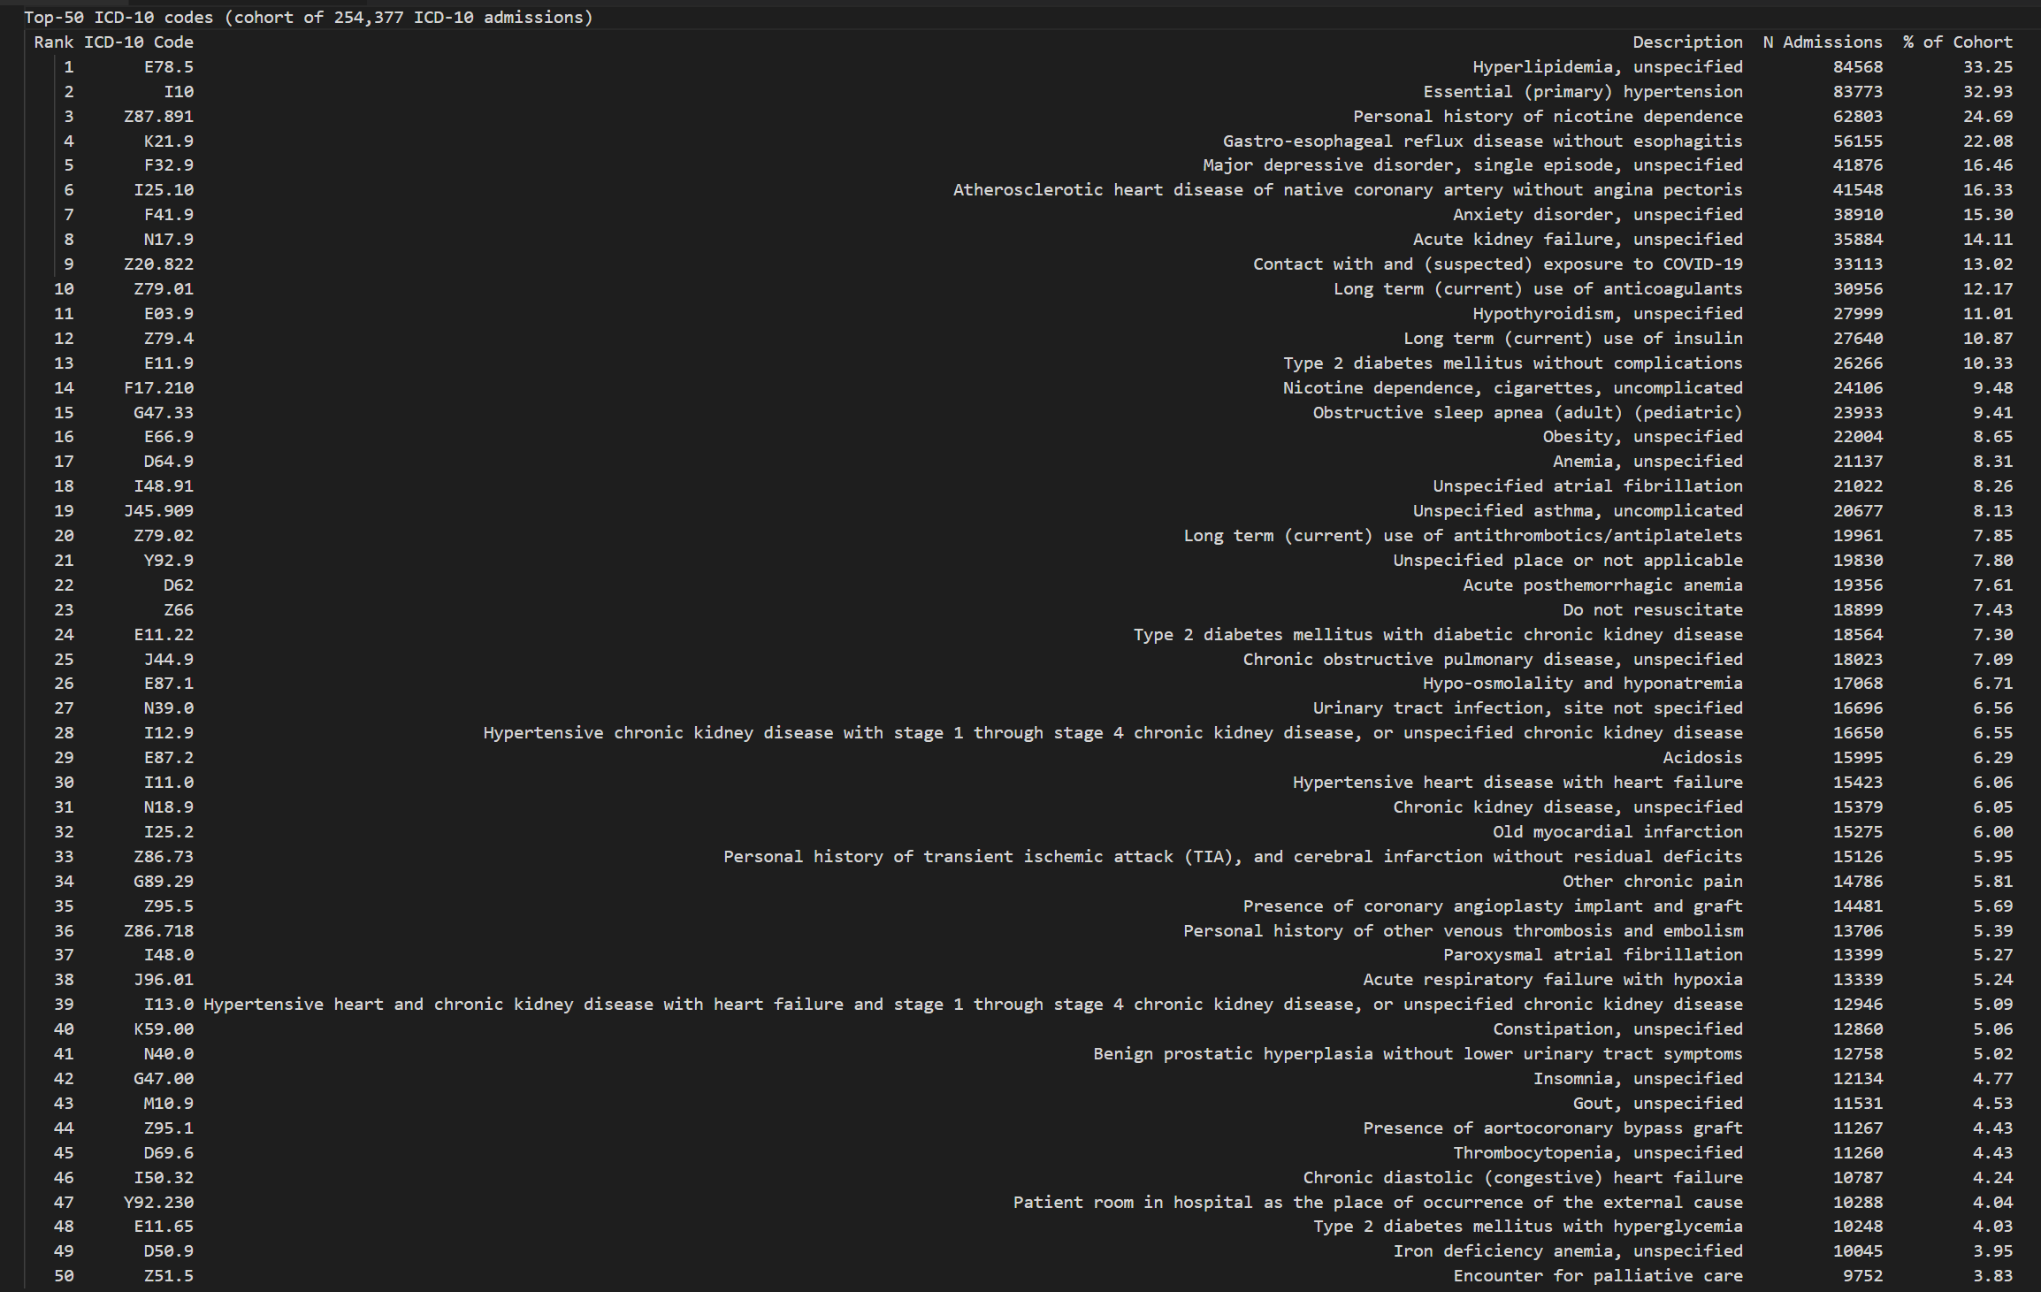
Table B4. Demographic summary of the modelable cohort.
This table reports age, sex, and admission-count characteristics of the final cohort. Any interpretation of the oldest age group should note that anchor_age is capped at 89 in MIMIC.
