Database Development and Class Registration Implementation for the Online Course Enrollment System
Nancy Rivera
CST499: Capstone for Computer Software Technology
Professor: Dr. Butler
Due Date: June 22, 2026

The implementation phase of the software development life cycle (SDLC) transforms system requirements and design specifications into a working software product. During Week 3, the Online Course Enrollment System developed for Rivera Edu-Tech Innovations established the foundation of the application by implementing user registration and authentication capabilities. Based on instructor feedback, additional development activities focused on expanding the database structure and implementing the remaining system requirements associated with course enrollment and schedule management. The Week 4 implementation concentrated on creating database tables, developing pages that support class registration functions, and integrating PHP with a MySQL back-end database. This paper discusses the implementation of the remaining requirements, the database development process, the functionality of the new web pages, and reflections on the experience of developing a database-driven web application.
Database Development
The Online Course Enrollment System uses MySQL as its relational database management system. Relational databases organize information into structured tables and establish relationships between data elements, improving consistency and reducing redundancy (Coronel & Morris, 2019). The existing users table developed during Week 3 was retained and expanded by creating additional tables that support course management and student enrollments.
Three primary tables comprise the application database. The users table stores account information, including a unique user identifier, password, first name, last name, phone number, and email address. The courses table stores information related to available classes, including the course code, course name, semester, and number of credit hours. The enrollments table serves as an associative table that links students and courses by storing enrollment records and corresponding foreign keys. This design follows relational database principles and supports efficient data retrieval while preserving data integrity (Tsui et al., 2018).
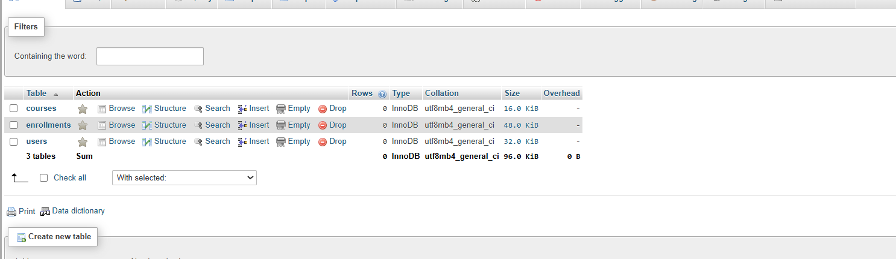
Figure 1: phpMyAdmin Database Showing Users, Courses, and Enrollments Tables.
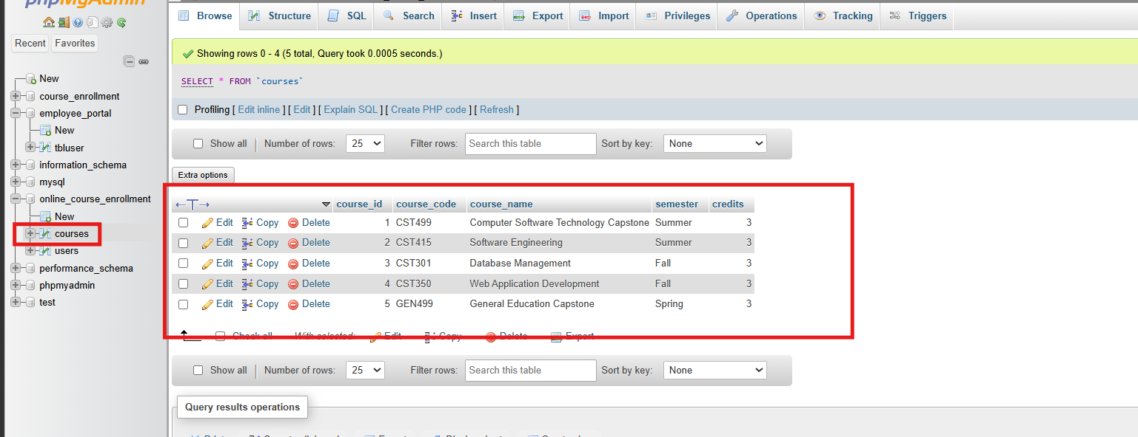
Figure 2: Courses Table Structure and Sample Course Data

Database Connectivity and Web Page Development
The application uses PHP and MySQLi to facilitate communication between the web pages and the MySQL database. A reusable database connection class (db.php) was implemented to centralize connectivity and improve maintainability. The database connection class stores server credentials and returns an active database connection object that can be reused throughout the application. Establishing a single connection mechanism reduces code duplication and simplifies future maintenance activities.
Several additional web pages were developed to satisfy the remaining functional requirements identified during the requirements and design phases. The register_classes.php page displays available courses and allows authenticated users to enroll in classes. The my_classes.php page retrieves and displays all courses associated with the currently logged-in student. The delete_class.php page allows students to remove courses from their schedules. According to Pressman and Maxim (2020), modular implementation promotes maintainability because individual components can be developed, tested, and modified independently without significantly affecting the rest of the system.
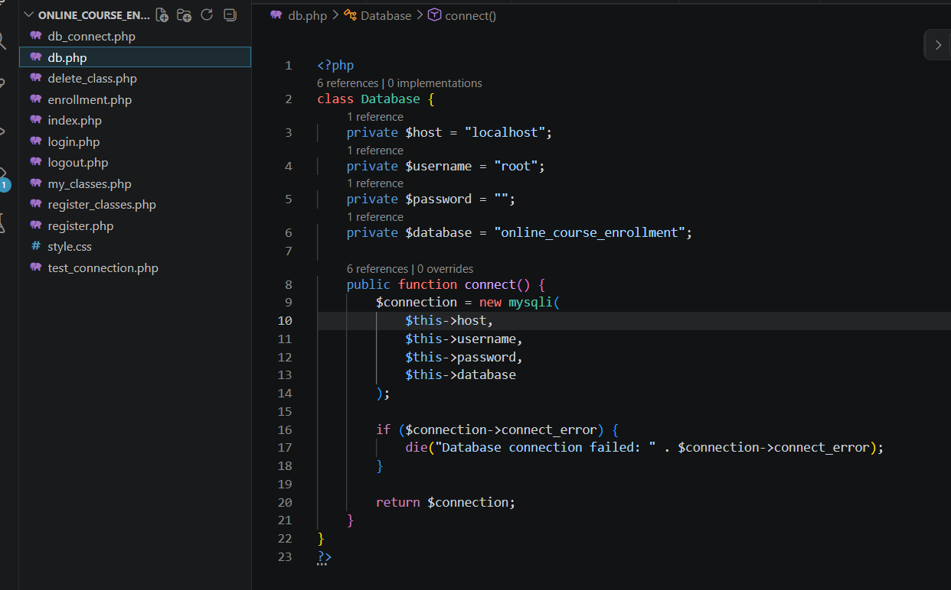
Figure 3: Database Connection Class Source Code (db.php).
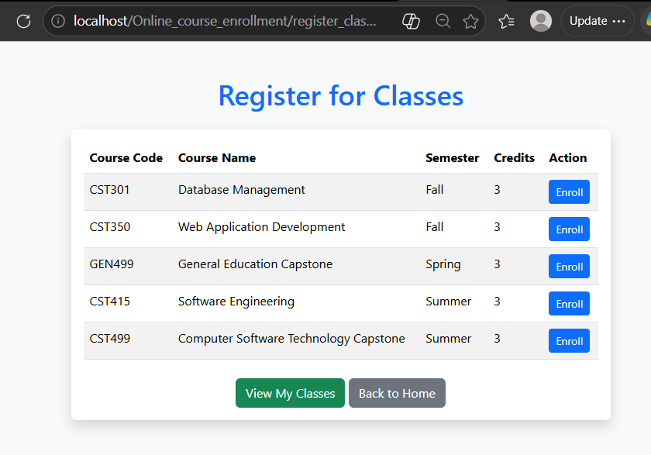
Figure 4: Register for Classes Page

Course Registration and Schedule Management
Course registration functionality was implemented using prepared SQL statements and PHP session management. Prepared statements separate user input from SQL commands and help protect applications against SQL injection vulnerabilities (Sebesta, 2013). After successful authentication, students are redirected to the course registration page, where they can select available courses and enroll in classes.
Before inserting a new enrollment record, the application verifies that the student is not already registered for the selected course. This validation ensures data consistency and prevents duplicate enrollment records from being created. Once validation is complete, the system inserts a new record into the enrollments table and associates the selected course with the logged-in student.
Students can subsequently navigate to the my_classes.php page to review their schedules. The application uses an SQL join operation between the enrollments and courses tables to retrieve and display detailed course information, including the course code, course name, semester, and credit hours. Students may also return to the course registration page to add additional courses or remove existing courses from their schedules. The course deletion functionality removes only the enrollment record associated with the student while preserving course information within the courses table. These operations demonstrate the implementation of Create, Read, and Delete functionality that forms the foundation of many database-driven applications (Pressman & Maxim, 2020).
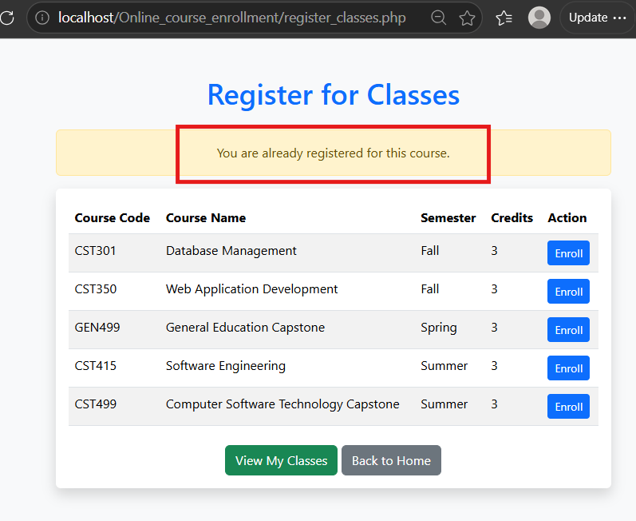
Figure 5: Successful Course Enrollment Message

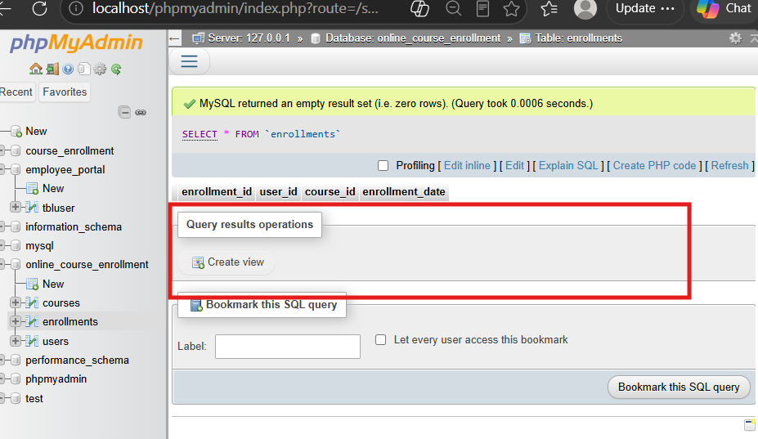
Figure 6: Enrollments Table Before Adding a Course
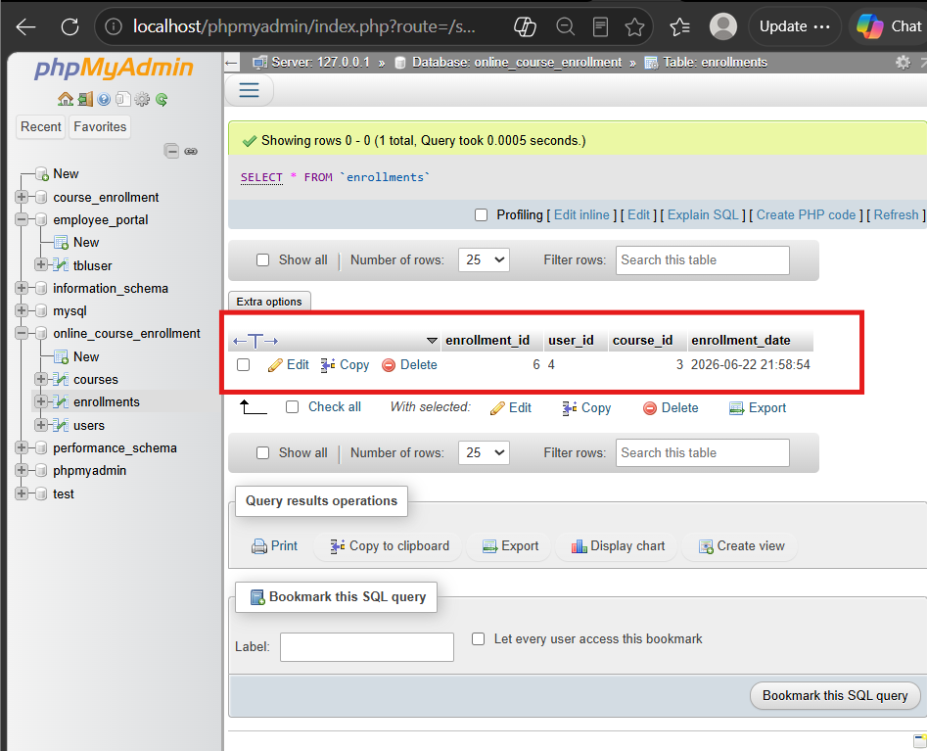
Figure 7: Enrollments Table After Adding a Course
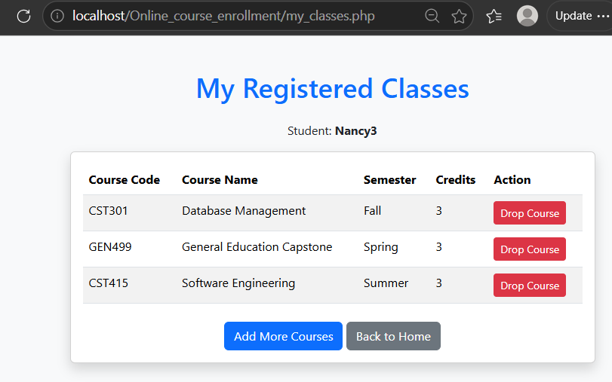
Figure 8: My Registered Classes Page / Schedule Before Deleting a Course
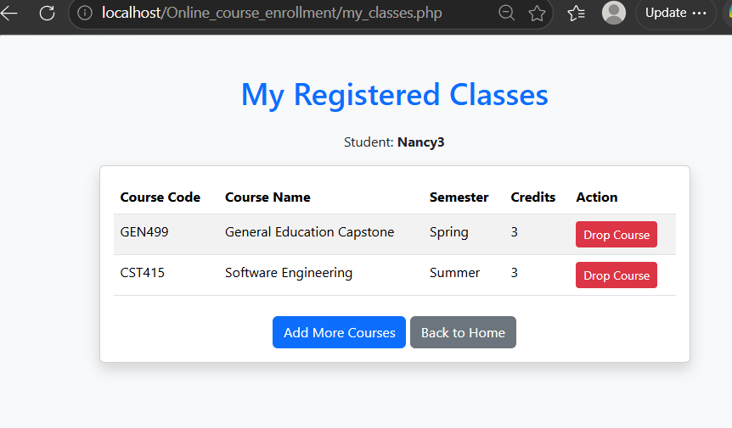
Figure 9: Schedule After Deleting a Course
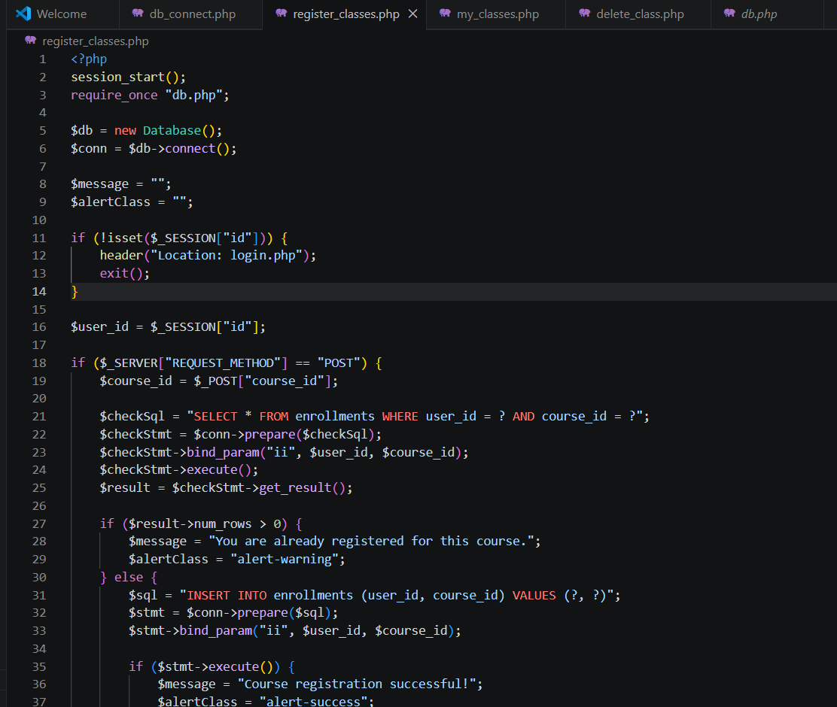
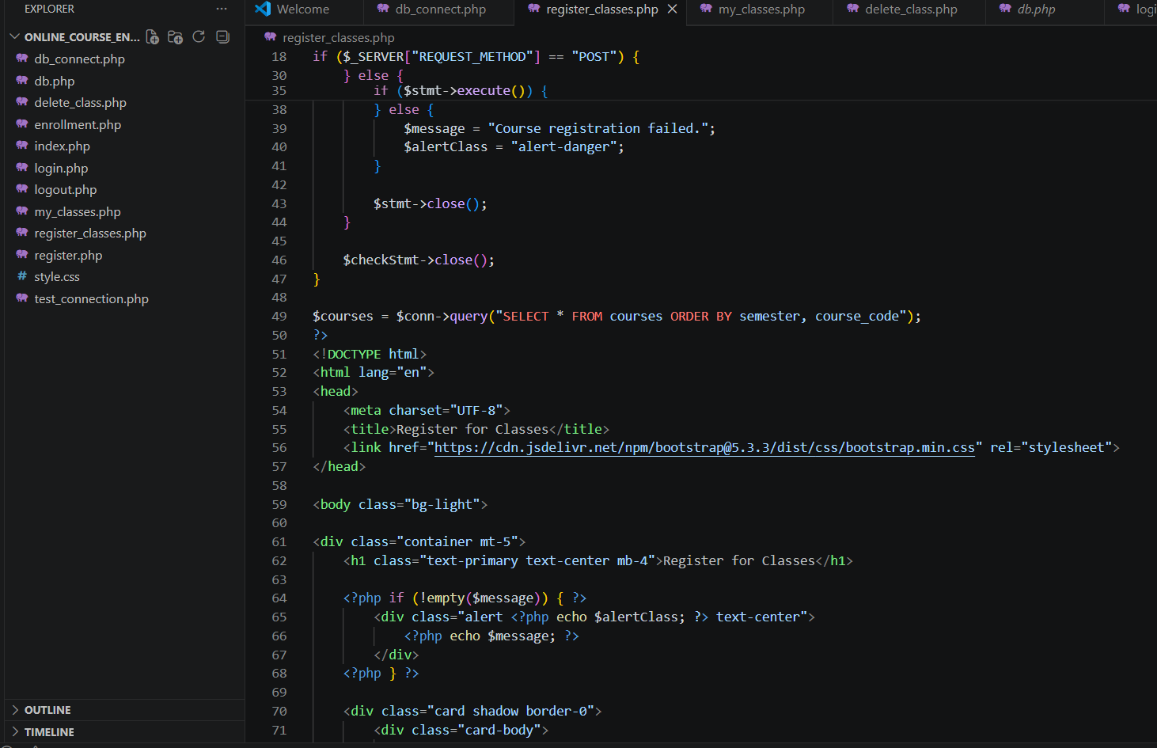
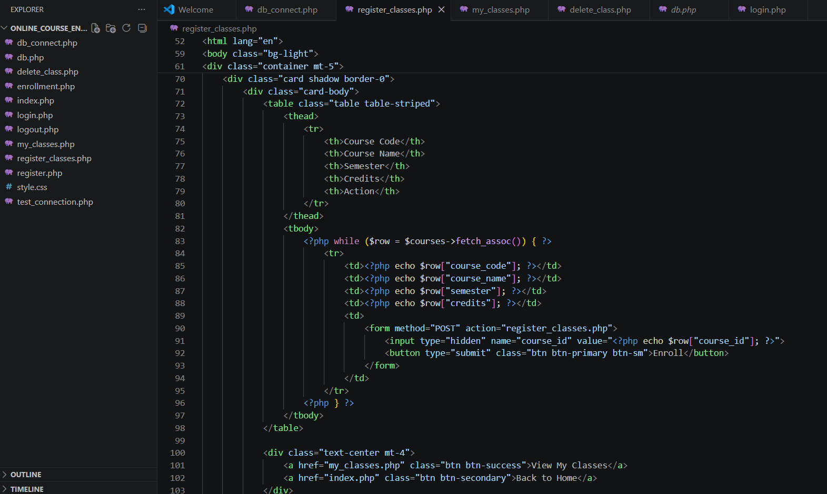
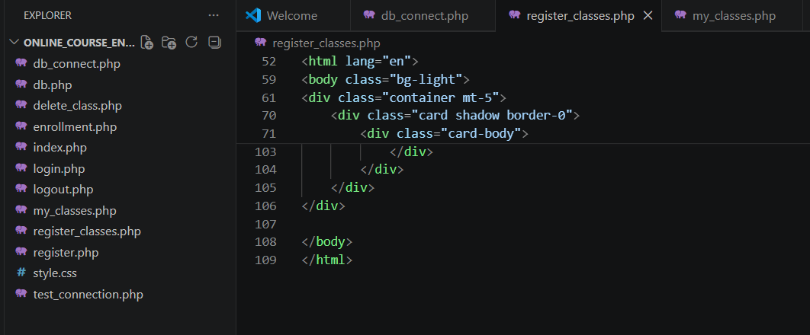
Figure 10-13 PHP Source Code for Course Registration Logic
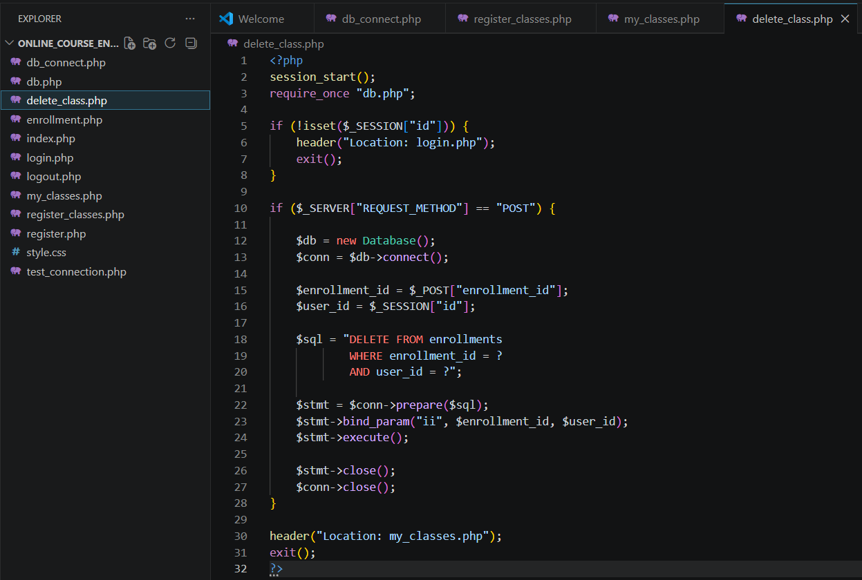
Figure 14-: PHP Source Code for Course Deletion Logic
Reflection on the Implementation Phase
The implementation phase provided valuable practical experience in developing a full-stack, database-driven web application. Integrating PHP with MySQL reinforced the importance of maintaining consistency between application logic and database schemas. The project also demonstrated the significance of relational database design, session management, and secure database interactions through the use of prepared statements.
Several challenges emerged during implementation. Initial issues included database configuration inconsistencies, maintaining proper relationships between users and enrollment records, and ensuring that session variables correctly identified authenticated users throughout the application. Addressing these challenges required iterative testing and troubleshooting of both the front-end pages and the back-end database operations. Successfully implementing user authentication, class registration, schedule management, and course deletion features provided practical insight into software implementation and highlighted the importance of planning activities performed during requirements analysis and system design.
The Week 4 implementation successfully transformed the Online Course Enrollment System from a basic authentication application into a functional course management system. Additional database tables were developed to support course and enrollment information, and several web pages were implemented to provide class registration, schedule viewing, course addition, and course deletion capabilities. The integration of PHP and MySQL demonstrates the practical application of software engineering principles and establishes a scalable foundation for future enhancements, including administrative functions, course prerequisites, and expanded student services. The implementation experience reinforced the importance of sound database design, modular development practices, and iterative testing in the successful development of software systems.

References
Coronel, C., & Morris, S. (2019). Database systems: Design, implementation, & management (13th ed.). Cengage Learning.
Pressman, R. S., & Maxim, B. R. (2020). Software engineering: A practitioner's approach (9th ed.). McGraw-Hill Education.
Sebesta, R. W. (2013). Concepts of programming languages (10th ed.). Pearson.
Tsui, F., Karam, O., & Bernal, B. (2018). Essentials of software engineering (4th ed.). Jones & Bartlett Learning.

