Landing, Login, and Registration Pages Development
CST499: Capstone for Computer Software Technology
Professor: Dr. Butler
Due Date: June 15, 2026

The implementation phase of the software development life cycle transforms system requirements and design specifications into a functioning software application. During this phase, developers build the application components, establish database connectivity, and test system functionality to ensure that requirements are satisfied. For the Online Course Enrollment System proposed by Rivera Edu-Tech Innovations, implementation focused on creating a dynamic web application using PHP, MySQL, XAMPP, and Bootstrap. The initial implementation included developing a landing page, login page, and registration page, as well as establishing a database to store user information. This paper examines the implementation technologies used to develop the Online Course Enrollment System, including the execution of PHP files in XAMPP, the development of the landing, login, and registration pages, the creation of the MySQL database and tables, and the process used to store user information through the registration page.
Running PHP Files in XAMPP
XAMPP was used as the local development environment because it combines Apache, PHP, MySQL, and phpMyAdmin into a single software package. This environment enables developers to build, execute, and test dynamic web applications locally before deploying them to a production environment. To run a PHP file in XAMPP, the Apache and MySQL services must first be started from the XAMPP Control Panel. The project files are then stored in the htdocs directory, which functions as the document root for the Apache web server.
For this project, the application files were saved in the following directory:
C:\xampp\htdocs\online_course_enrollment
After the files were stored in the project folder, the application was executed by entering the following URL into a web browser:
http://localhost/online_course_enrollment/index.php
Executing the application through the local server environment enabled server-side PHP scripts to process requests and exchange data with the MySQL database engine. According to Tsui et al. (2018), implementation activities involve integrating technologies and coding system components to satisfy software requirements.
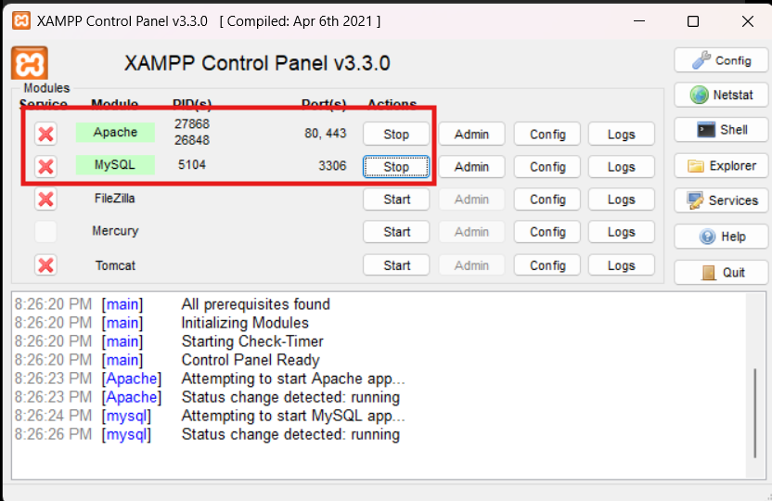
Figure 1. XAMPP Control Panel Running Apache and MySQL
Development of the Landing, Login, and Registration Pages
The implementation process began with the creation of a landing page that serves as the central access point to the Online Course Enrollment System. The page provides a brief overview of the Online Course Enrollment System and introduces users to the services offered by Rivera Edu-Tech Innovations. The page includes navigation links that allow users to access the registration and login pages.
Following the development of the landing page, a login page was created to allow registered users to enter their credentials and access the system. Although the login functionality will be expanded during future development phases, the page currently includes fields for a user ID and password and provides navigation back to the home page.
The final interface component developed during this phase was a registration page that enables prospective students to establish individual system accounts. The page includes fields for a unique user ID, password, first name, last name, phone number, and email address. Bootstrap was incorporated to create a professional and responsive user interface that maintains consistent formatting across different screen sizes. Pressman and Maxim (2020) explain that user interface usedesign should prioritize usability and consistency to improve the user experience.
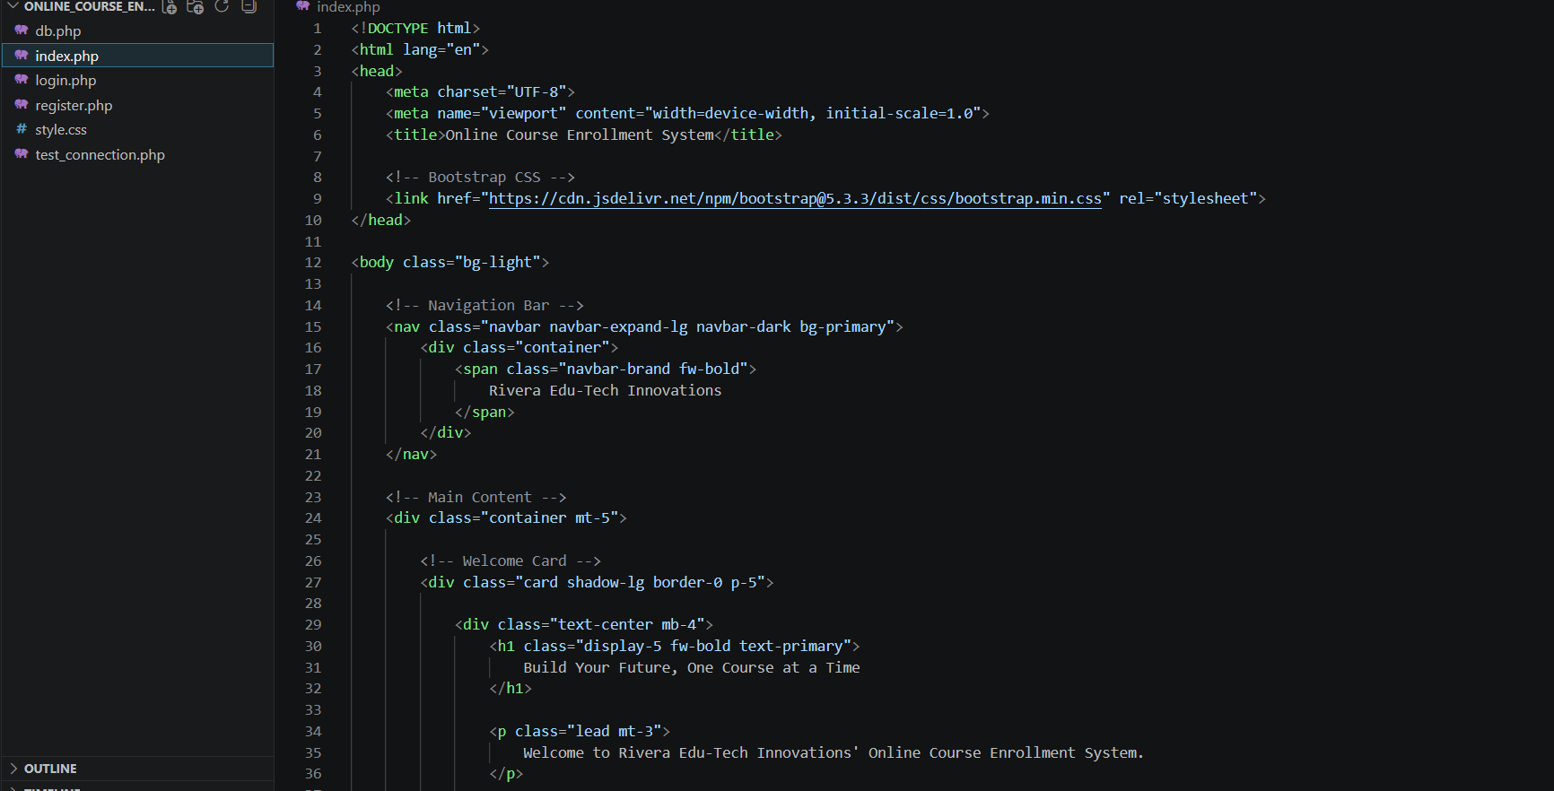
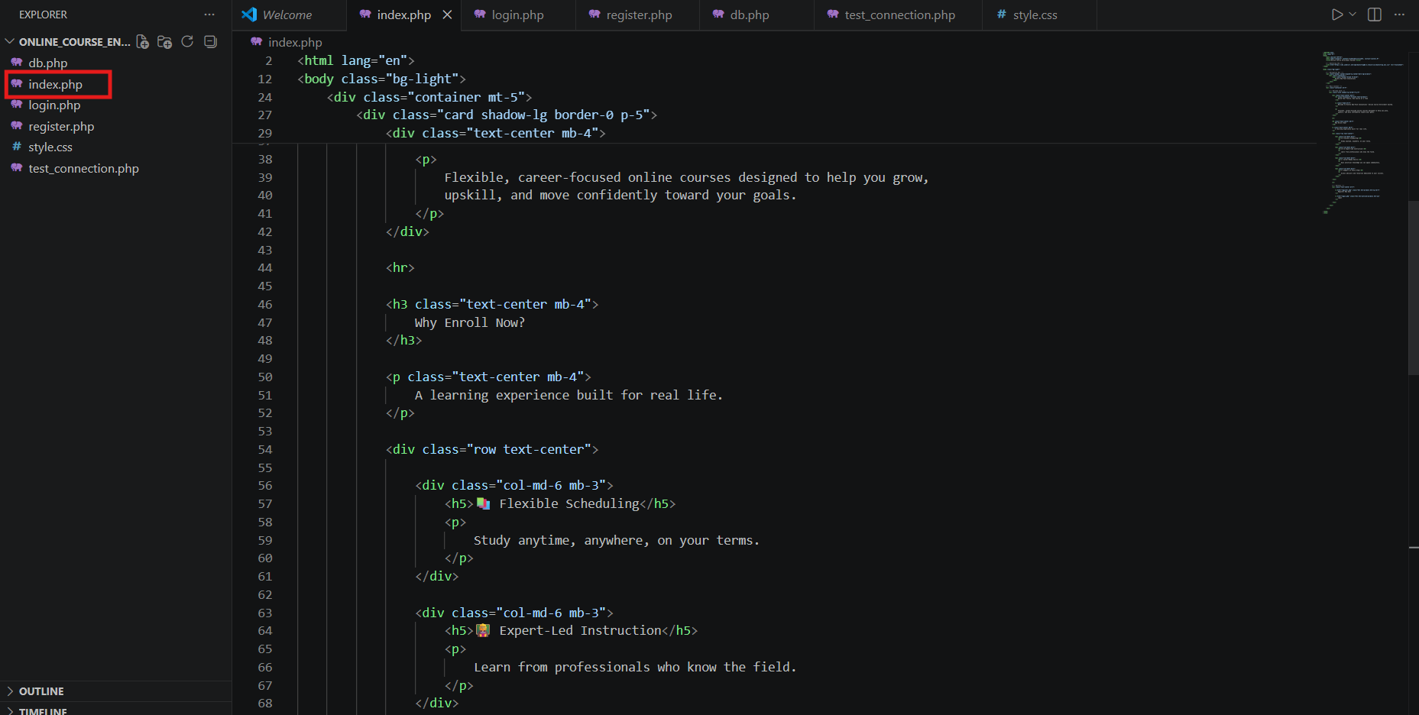
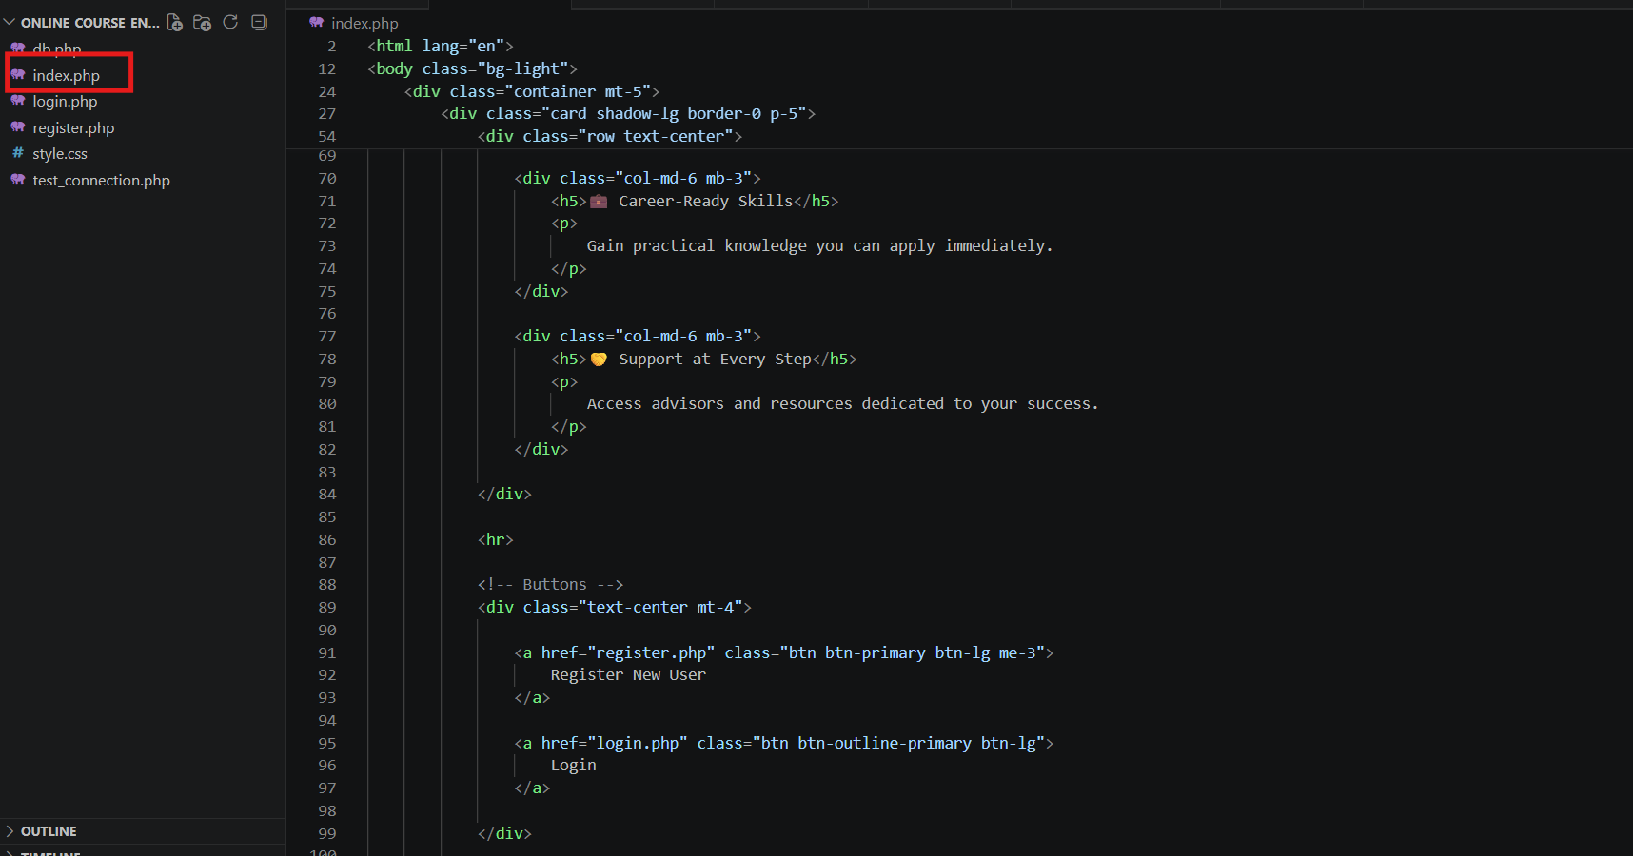
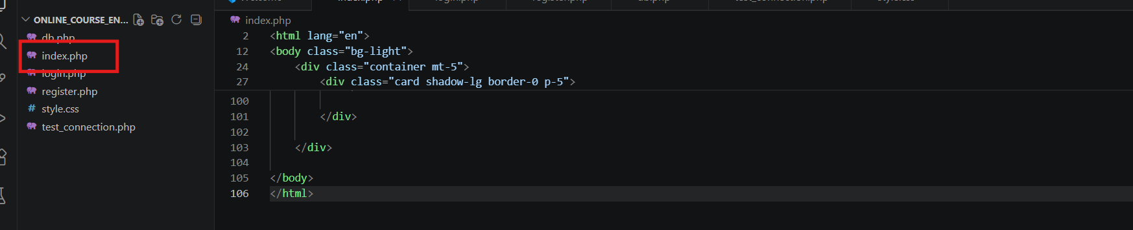
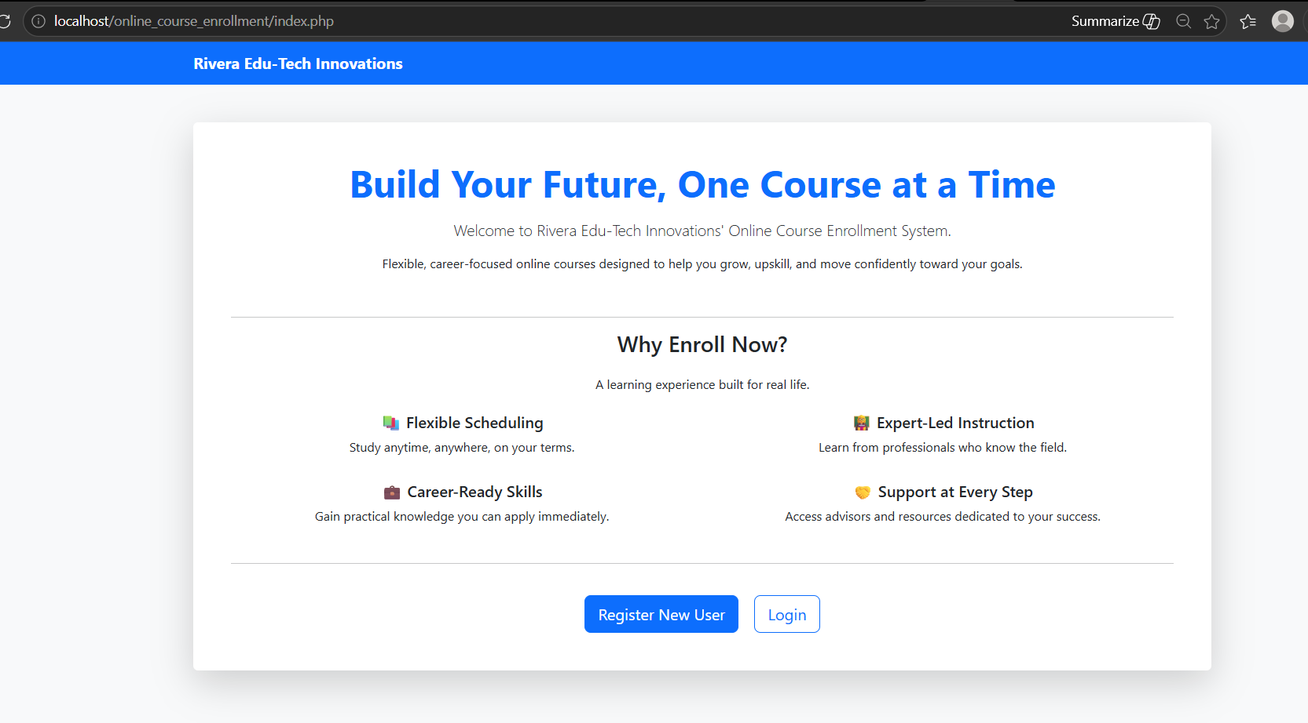
Figure 2-6. Landing Page for the Online Course Enrollment System

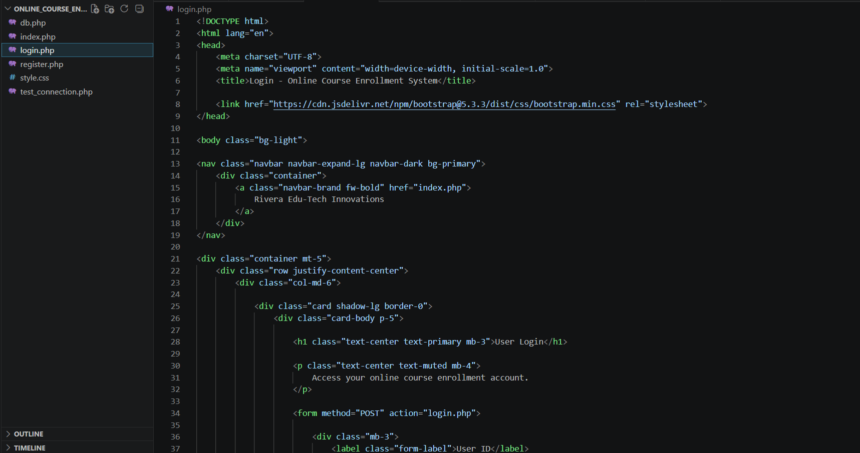
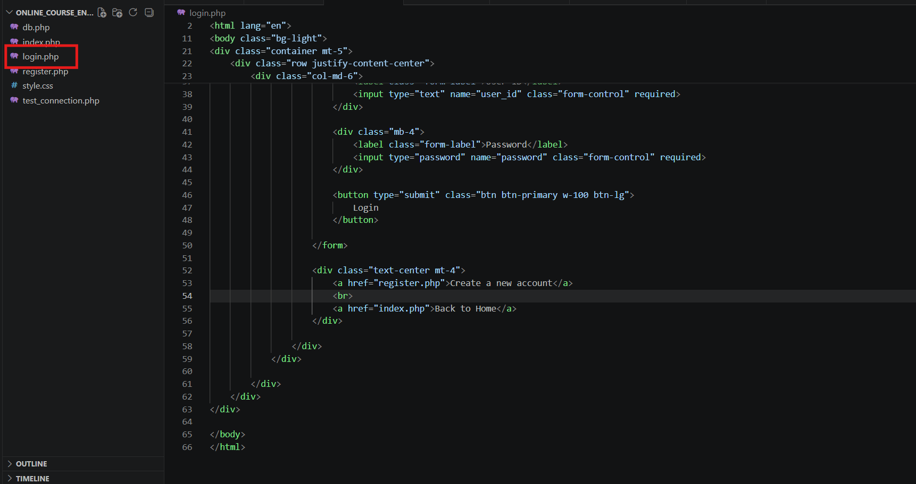
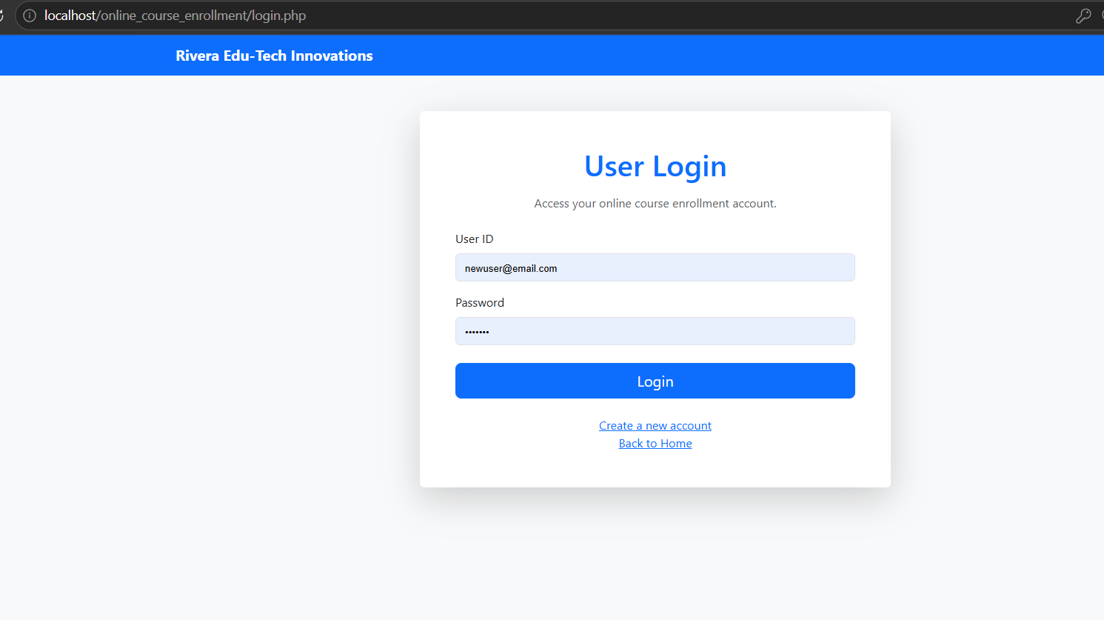
Figure 7-9. Login Page for Registered Users

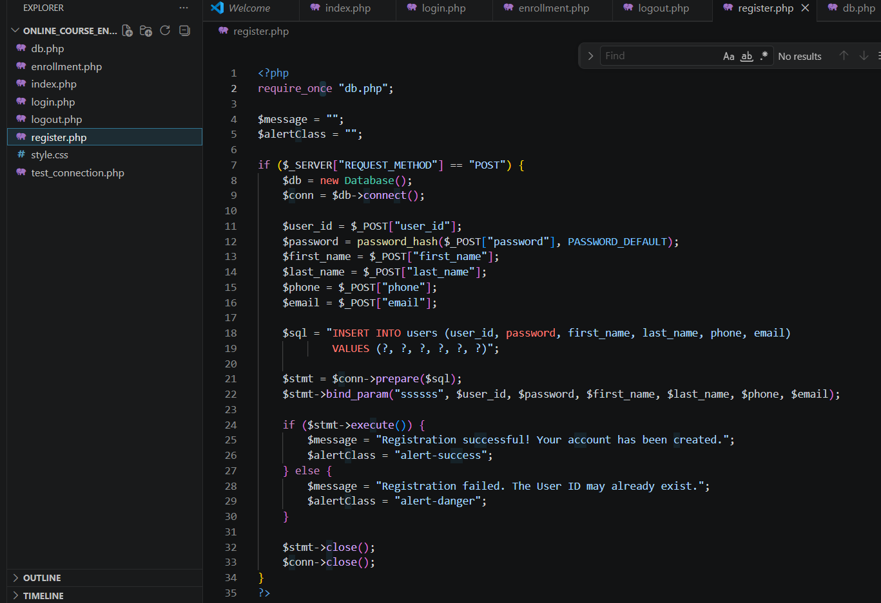
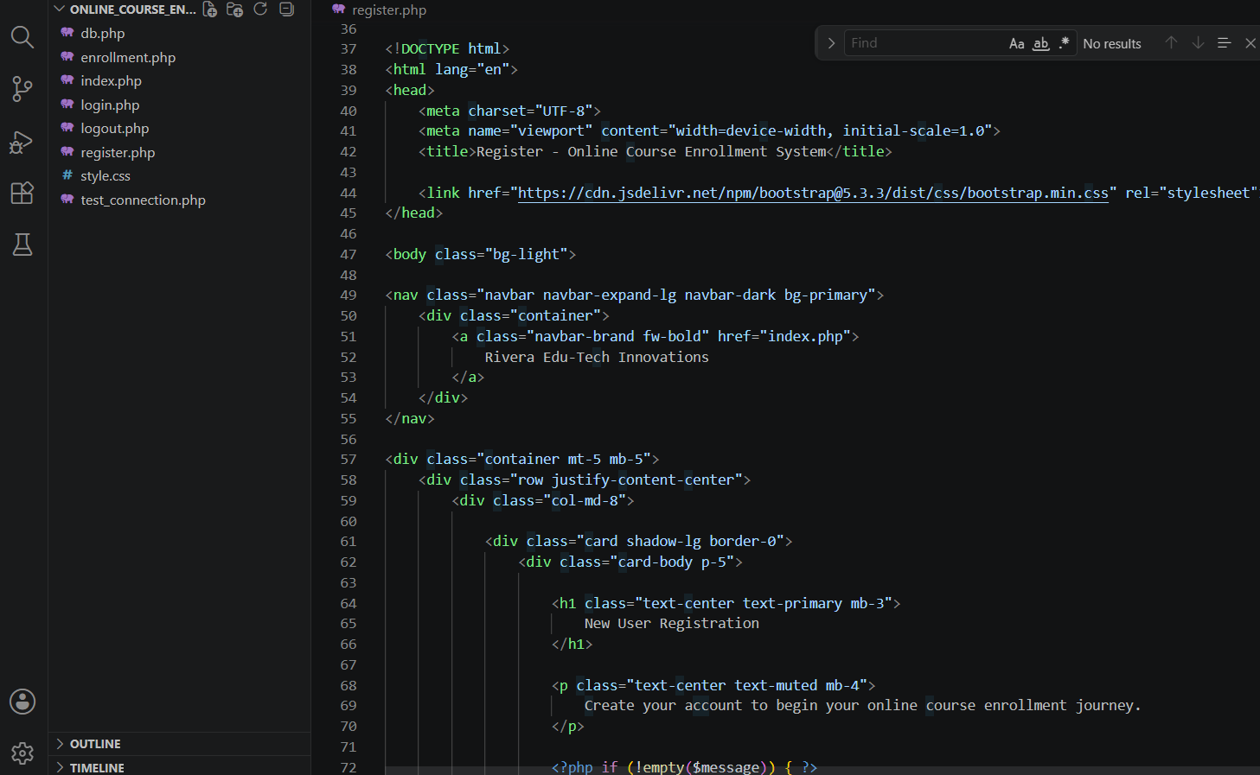
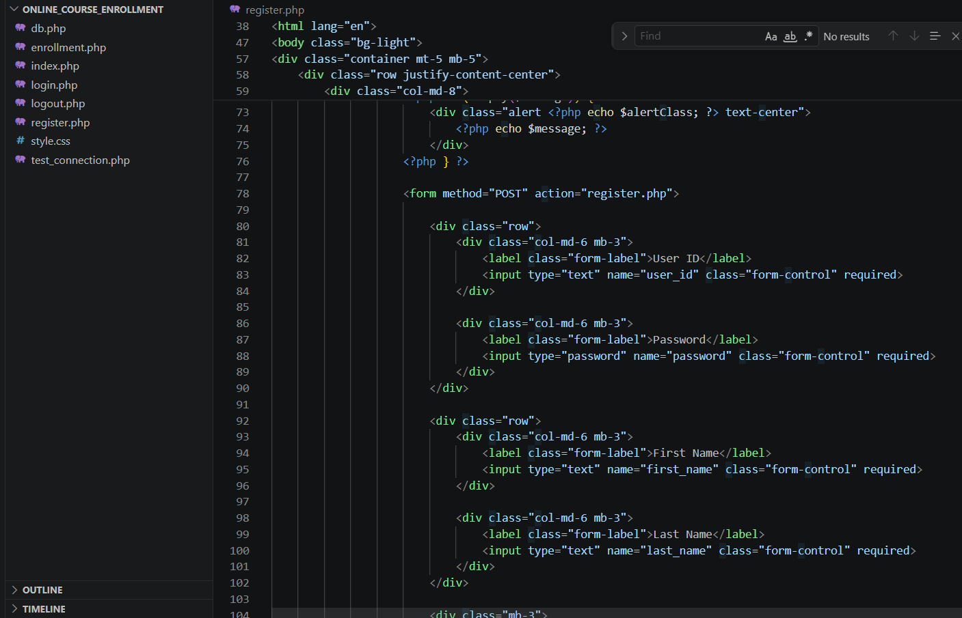
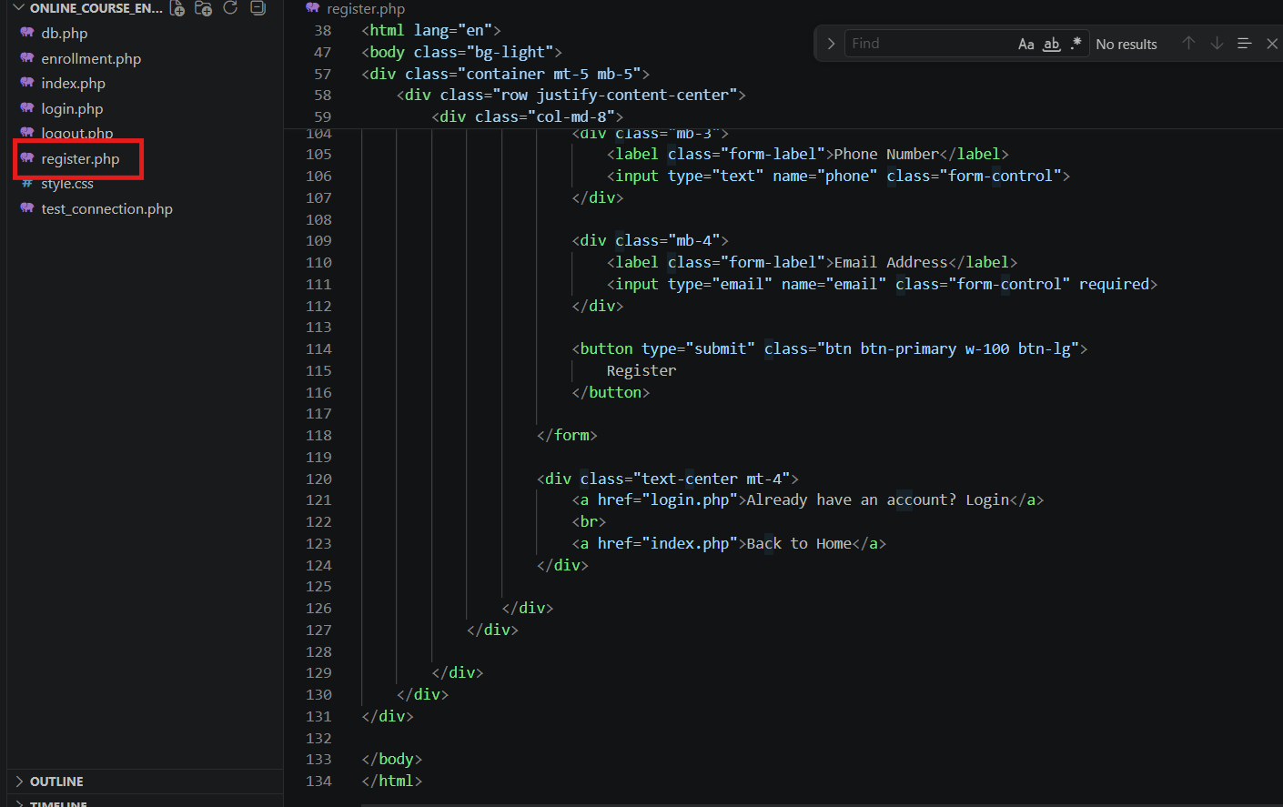
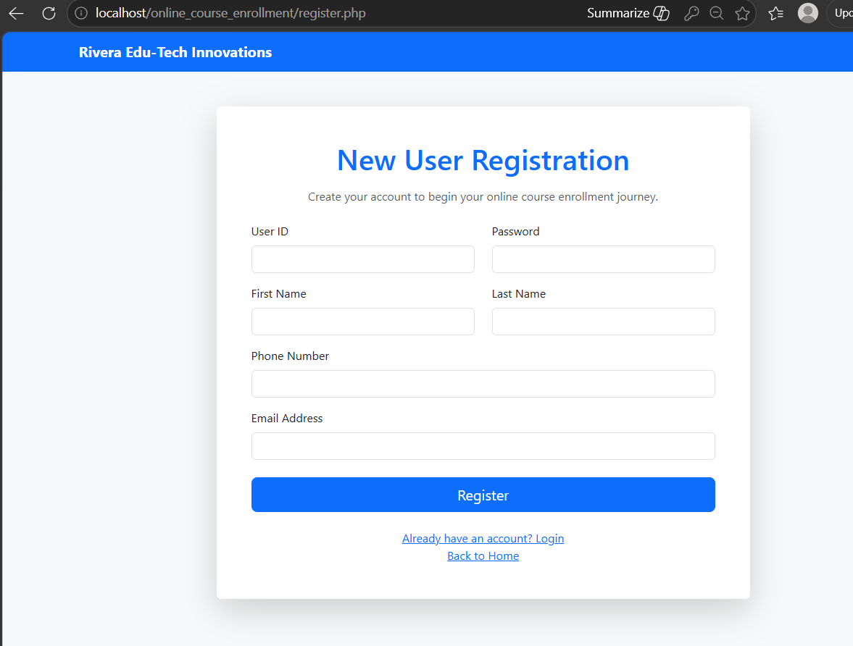
Figure 10-14. Registration Page for New Users
MySQL Database and Table Development
A MySQL database named online_course_enrollment was created using phpMyAdmin. The database was designed to store the information required to support user registration and future course enrollment activities. Within the database, a table named users was developed to store user information.
To support user registration requirements, the database schema incorporates several fields that capture account and profile information.
- Id
- user_id
- password
- first_name
- last_name
- phone
- email
- created_at
The id field was designated as the primary key and configured to increment automatically whenever a new account record is inserted into the table. The user_id field was designated as unique to prevent duplicate accounts from being created. Database constraints such as primary keys and unique fields support data integrity and improve data reliability (Coronel & Morris, 2019).
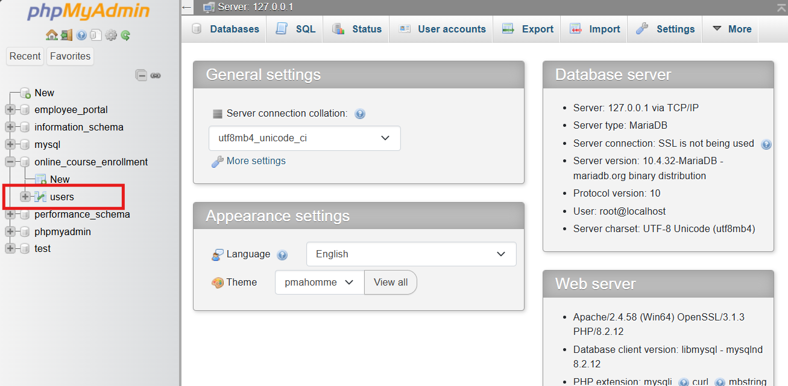
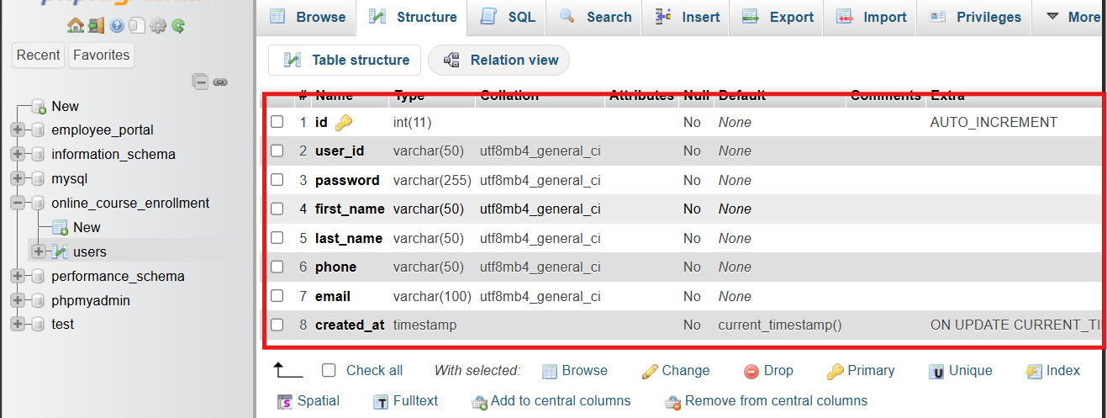
Figure 15-16. MySQL Database Structure

Database Connection Class and Registration Functionality
A custom database connection class was created in the db.php file to centralize the database connection logic. Using PHP's mysqli extension, the class creates a database connection by supplying the required connection parameters, including the server name, database name, username, and password. Creating a separate database connection class improves maintainability because changes to connection settings can be managed in one location.
Several MySQL functions were used during implementation. The new mysqli() function established the database connection. The prepare() function created parameterized SQL statements, while bind_param() associated user-provided values with SQL parameters. The execute() function then executed the SQL statement and inserted user information into the database. Password security was improved by using PHP's password_hash() function to store passwords in an encrypted format rather than as plain text.
The registration process begins when a user enters information into the registration form and submits the form. After the user submits the registration form, PHP processes the form data and establishes a connection to the MySQL database through the custom database class. The application then executes an SQL INSERT statement and stores the user's information within the users table. Upon successful insertion of the data, the application displays a confirmation message indicating that the user's account has been created successfully.

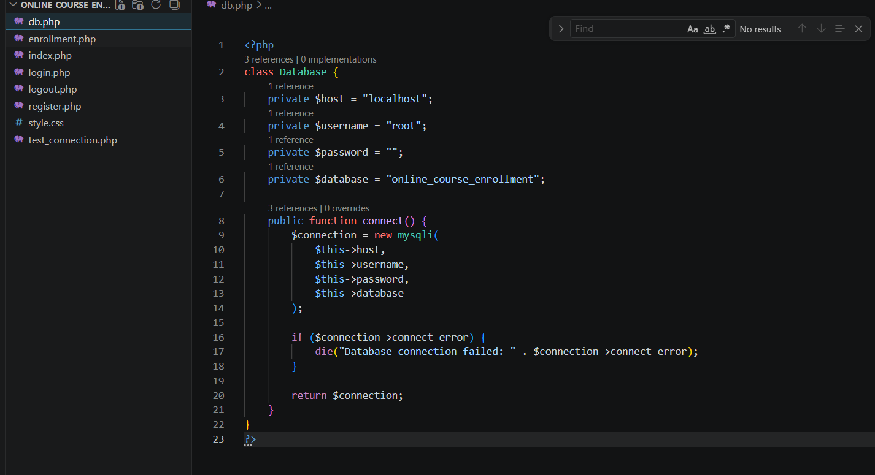
Figure 17. Database Connection Class Source Code

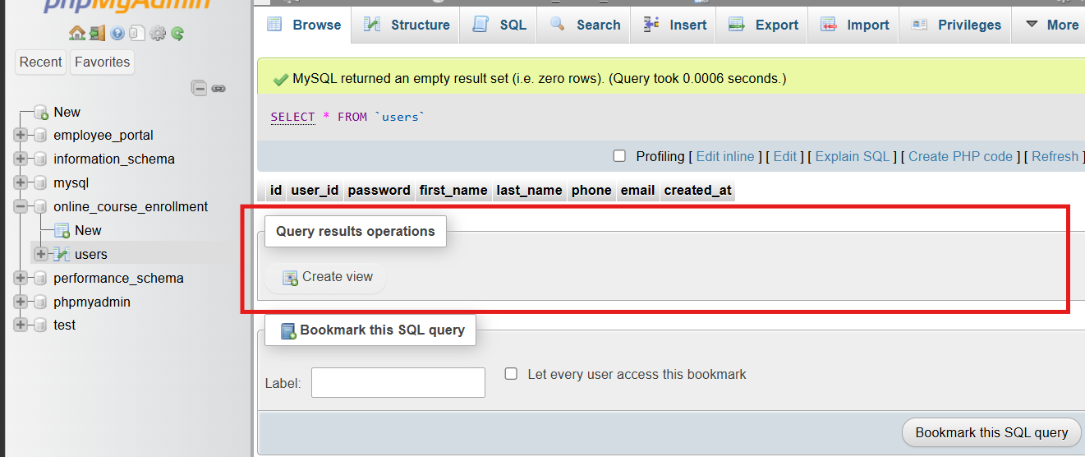
Figure 18. Users Table Before Registration
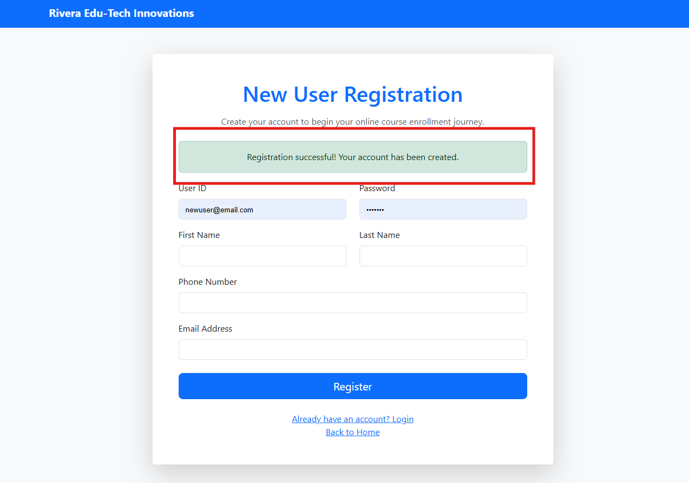
Figure 19. Registration Successful Message

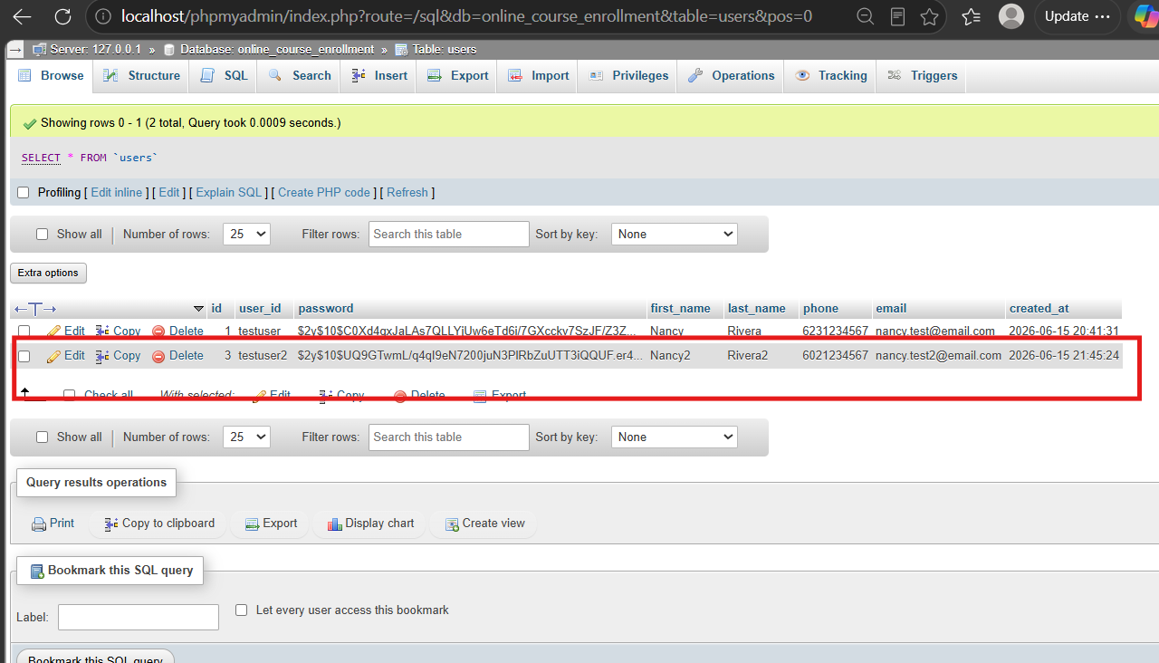
Figure 20. Users Table After Registration
The implementation phase established the foundational components of the Online Course Enrollment System developed by Rivera Edu-Tech Innovations. XAMPP provided the local development environment necessary to execute PHP files and connect to MySQL. The landing page, login page, and registration page were successfully developed and styled using Bootstrap. In addition, a MySQL database and users table were created to store registration information, and a custom database connection class enabled communication between the application and the database. The implemented solution successfully integrated front-end and back-end technologies while creating a flexible framework that can support future enhancements, such as user authentication, course enrollment features, and additional student services.

References
Coronel, C., & Morris, S. (2019). Database systems: Design, implementation, & management (13th ed.). Cengage Learning.
Pressman, R. S., & Maxim, B. R. (2020). Software engineering: A practitioner's approach (9th ed.). McGraw-Hill Education.
Tsui, F. F., Karam, O., & Bernal, B. (2018). Essentials of software engineering (4th ed.). Jones & Bartlett Learning.

