UML Design Modeling and Testing Strategy for the Online Course Enrollment System
CST499: Capstone for Computer Software Technology
Professor: Dr. Butler
Due Date: June 8, 2026

Software design serves as the bridge between requirements analysis and software implementation. Effective design modeling enables stakeholders, developers, and testers to visualize how a system will function before development begins. Unified Modeling Language (UML) provides a standardized approach for representing both the structural and behavioral aspects of software systems. For the Online Course Enrollment System proposed by Rivera Edu-Tech Innovations, UML diagrams provide a comprehensive view of how students and administrators interact with the system and how system components collaborate to support enrollment processes. Additionally, a well-defined testing strategy is essential to ensure the system satisfies both functional and non-functional requirements. This paper describes the UML models developed for the Online Course Enrollment System and discusses how different levels of testing are used to identify defects, verify requirements, and ensure the system is ready for end users.
UML Design Models
The Online Course Enrollment System was designed using several UML models to represent both static and dynamic system characteristics. Collectively, these models contribute to a detailed analysis of the system's structural components and operational workflows. The use case diagram shows the main users of the system and the actions they can perform to meet their enrollment and administrative needs. The two primary actors are students and administrators. Students can register for accounts, authenticate, manage profiles, browse course offerings, enroll in courses, join waitlists, and cancel enrollments. Administrators manage course offerings, monitor enrollment capacities, oversee waitlists, and generate reports. Use case diagrams help ensure that all user requirements identified in the Software Requirements Specification (SRS) are represented within the system design (Tsui et al., 2018).
The class diagram defines the key objects within the system and demonstrates how they are connected. Major classes include User, Student, Administrator, Profile, Course, Enrollment, Waitlist, Semester, and Notification. Relationships among these classes define how data is stored and managed throughout the application. For example, a Student is associated with a Profile and may have multiple Enrollment records. The class diagram serves as the foundation for database design and software implementation.
Several behavioral diagrams were also developed. The sequence diagram illustrates the interactions that occur during course enrollment. When a student selects a course for enrollment, the system verifies available seating, updates the appropriate records, and sends an enrollment confirmation. If the course is already at capacity, the system allows the student to join the waitlist and await an available seat. The activity diagram models the workflow for registration and enrollment. Decision points such as validating user credentials and determining course availability illustrate the flow of control throughout the process. Similarly, the state diagram captures the lifecycle of course enrollment statuses, including Not Enrolled, Waitlisted, Notification Sent, Enrolled, and Canceled. Together, these diagrams provide a comprehensive view of system behavior and support software design decisions (Pressman & Maxim, 2020).
Component Testing
Component testing focuses on validating the functionality of individual software modules in isolation. This testing level ensures that each component satisfies its specified requirements before integration with other modules occurs. For the Online Course Enrollment System, component testing would be applied to critical functions such as registration, authentication, profile management, course enrollment, and waitlist operations.
Component testing is usually conducted during the development phase, allowing developers to identify defects early. Automated testing tools help verify that individual functions produce the expected results and respond appropriately to invalid or unexpected input. Early detection of defects at the component level reduces the cost and complexity of correcting issues later in the development process (Sommerville, 2016).
Integration Testing
Integration testing verifies that multiple software components function correctly when combined. Although individual modules may operate properly during component testing, defects can occur when components exchange data or interact with one another. Within the Online Course Enrollment System, integration testing would validate interactions between the user authentication module, student profile module, enrollment module, database services, and notification services. For example, when a student enrolls in a course, the system must correctly update enrollment records, adjust course capacity counts, and generate confirmation notifications. Integration testing helps identify interface defects and communication failures between modules before the system is released.
System Testing
System testing assesses the application as a whole, after all components have been integrated. Its primary objective is to ensure that the system meets both the functional and nonfunctional requirements outlined in the Software Requirements Specification (SRS). During system testing, the Online Course Enrollment System would be tested using realistic user scenarios that simulate actual operational conditions. Examples include student registration, course enrollment, waitlist management, enrollment cancellation, and administrator course management. Non-functional requirements such as performance, security, scalability, and usability would also be evaluated. System testing ensures that all system components operate together as intended and that the overall solution meets stakeholder expectations (Pressman & Maxim, 2020).
Acceptance Testing
As the last phase of the testing lifecycle, acceptance testing provides stakeholders with an opportunity to assess whether the software meets established business requirements. For the Online Course Enrollment System, university personnel and student representatives would perform structured testing scenarios to determine if the application is suitable for deployment. These scenarios may include registering accounts, enrolling in courses, managing waitlists, and receiving notifications. Successful completion of acceptance testing demonstrates that the system fulfills its intended purpose and supports organizational objectives. Acceptance testing also provides stakeholders with confidence that the software is suitable for operational use (Tsui et al., 2018).
Creating UML models early in the development process helps reduce misunderstandings and provides a clear blueprint for building the system. The diagrams developed for the Online Course Enrollment System illustrate how users interact with the application, how data is organized, and how processes flow throughout the system. However, a successful design alone does not guarantee quality. Thorough testing at the component, integration, system, and acceptance levels is necessary to identify defects and confirm that requirements have been met. Through careful design and validation, the resulting system is better positioned to provide a reliable and efficient enrollment experience.

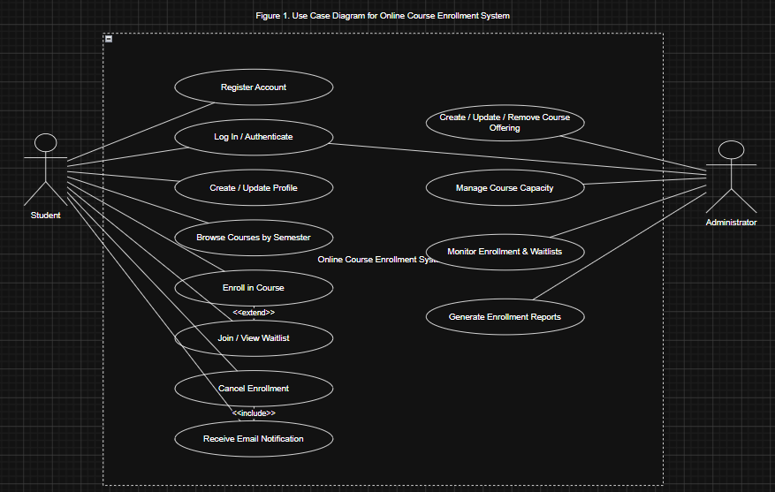

References
Pressman, R. S., & Maxim, B. R. (2020). Software engineering: A practitioner's approach (9th ed.). McGraw-Hill.
Sommerville, I. (2016). Software engineering (10th ed.). Pearson.
Tsui, F., Karam, O., & Bernal, B. (2018). Essentials of software engineering (4th ed.). Jones & Bartlett Learning.

