Software Requirements Specification
for
VendorSetu
Street Vendor Formalization & Micro-Credit Platform
Version 1.1 approved
Prepared by: Nancy Yadav, Vishesh Gupta, Vishal Verma, Purva Joshi, Harshul Saini
B.Tech CSE, Batch 2024 - CSE3005 Software Engineering
BML Munjal University
Submitted to: Dr. Harsh Taneja
04 November 2026

Table of Contents
Table of Contents 2
Revision History 5
1. Introduction 5
1.1 Purpose 5
1.2 Document Conventions 5
1.3 Intended Audience and Reading Suggestions 5
1.4 Product Scope 6
1.5 References 6
2. Overall Description 7
2.1 Product Perspective 7
2.2 Product Functions 7
2.3 User Classes and Characteristics 7
2.4 Operating Environment 8
2.5 Design and Implementation Constraints 8
2.6 User Documentation 8
2.7 Assumptions and Dependencies 8
3. External Interface Requirements 9
3.1 User Interfaces 9
3.2 Hardware Interfaces 9
3.3 Software Interfaces 9
3.4 Communications Interfaces 10
4. System Features 10
4.1 User Registration & Authentication [Implemented] 10
4.2 Vendor Profile & Daily Sales Logging [Implemented] 11
4.3 Alternative Credit (Trust) Scoring Engine [Implemented] 11
4.4 Loan Application & Progressive Lending [Implemented] 12
4.5 Loan Review & Disbursal (Bank / NBFC) [Implemented] 12
4.6 EMI Repayment Tracking [Implemented] 13
4.7 Vending Zone Licensing 13
4.8 Dispute / Eviction Case Logging 14
4.9 Customer: Locate, Pay & Rate Vendors 14
4.10 Peer-Guarantor Group Lending 15
5. Other Nonfunctional Requirements 15
5.1 Performance Requirements 15
5.2 Safety Requirements 15
5.3 Security Requirements 16
5.4 Software Quality Attributes 16
5.5 Business Rules 16
6. Other Requirements 16
6.1 Database Requirements 16
6.2 Legal and Regulatory Requirements 17
6.3 Internationalisation Requirements 17
6.4 Reuse Objectives 17
Appendix A: Glossary 17
Appendix B: Analysis Models 18
B.1 Use Case Diagram 18
B.2 Class Diagram 20
B.3 Sequence Diagrams 21
B.4 State Transition Diagram 24
B.5 Data Flow Diagrams 25
Appendix C: To Be Determined List 28
Appendix D: Implementation (Release 1.0 Prototype) 28
D.1 Development Approach and Technology 28
D.2 Coded Modules 28
D.3 Project Structure 28
D.4 Key Algorithms 29
D.5 How to Run 30
D.6 Coding Standards Followed 30
Appendix E: Test Cases and Results 31
E.1 Test Strategy 31
E.2 User Registration & Login (TC-AUTH-01 to TC-AUTH-06) 32
E.3 Vendor Profile & Daily Sales (TC-SALE-01 to TC-SALE-06) 36
E.4 Trust Score Calculation (TC-TS-01 to TC-TS-06) 40
E.5 Loan Application & Bank Review (TC-LOAN-01 to TC-LOAN-06) 43
E.6 EMI Schedule & Repayment (TC-EMI-01 to TC-EMI-06) 47
E.7 Test Summary 52
E.8 Defects Found by Testing 52

Revision History
Name | Date | Reason For Changes | Version
Nancy Yadav & team | 28-10-2026 | Complete SRS for final evaluation: requirements, analysis models (UML & DFD), prototype implementation of 4 modules and executed test cases | 1.0
Nancy Yadav & team | 04-11-2026 | Test cases rewritten in the course Test Case Template (6 per module); 6 defects found by testing fixed; FR-AUTH-1, FR-VEN-4, FR-VEN-5 and FR-LN-4 made more precise | 1.1

1. Introduction

1.1 Purpose
This Software Requirements Specification (SRS) describes the functional and non-functional requirements of VendorSetu, release 1.0 - a web platform that gives India's street vendors a digital business identity, records their daily sales, converts that history into an alternative credit Trust Score, and uses it to offer progressive micro-loans modelled on the Government of India's PM SVANidhi scheme. The platform also digitises vending-zone licensing for municipal bodies and lets customers find and pay vendors.
The SRS covers the complete system and all five user classes. Features marked [Implemented] are built and tested in the release-1.0 prototype submitted with this document (Appendix D and E); the remaining features are fully specified here and scheduled for the next increment.

1.2 Document Conventions
- Requirement IDs: functional requirements are tagged FR-<feature>-<n> (e.g. FR-LN-3), non-functional requirements NFR-<category>-<n>, and business rules BR-<n>. IDs are referenced in the source code comments.
- Priorities: every feature carries a MoSCoW priority (Must / Should / Could / Won't) and a High / Medium / Low rating. Detailed requirements inherit the priority of their feature unless stated otherwise.
- "shall" marks a mandatory requirement; "should" marks a desirable one.
- [Implemented] marks features coded in the release-1.0 prototype.
- Amounts are in Indian Rupees (₹). Dates are written DD-MM-YYYY.
- Items that are not yet decided are marked TBD-n and tracked in Appendix C.

1.3 Intended Audience and Reading Suggestions
Reader | Interest | Suggested sections
Course faculty / evaluators | Completeness and correctness of the SRS, models and testing | 1, 2, 4, Appendix B, D, E
Developers | What to build and the business rules | 2, 3, 4, 5.5, Appendix B, D
Testers | Verifiable requirements and expected behaviour | 4, 5, Appendix E
Bank / NBFC partners | Loan rules, trust score, repayment and default handling | 1.4, 4.3-4.6, 5.3, 6.2
Municipal (ULB) officials | Licensing and dispute features | 2.3, 4.7, 4.8
Project manager | Scope, priorities, assumptions and open issues | 1.4, 2.7, 4 (MoSCoW), Appendix C

Recommended order: read Section 1 and 2 for the overview, then Section 4 for the features, Appendix B for the diagrams, Section 5 for quality requirements, and Appendix D-E for the prototype and its test results.

1.4 Product Scope
Street vendors are a large part of India's informal economy, yet most have no formal credit history. Banks cannot assess them with a CIBIL score, so vendors depend on informal moneylenders. PM SVANidhi showed that small, progressive working-capital loans work - the restructured scheme (approved by the Union Cabinet in August 2025, extended to March 2030) targets 1.15 crore beneficiaries with an outlay of ₹7,332 crore - but application, verification and repayment tracking are still largely manual.
VendorSetu's objectives are to:
- give every vendor a digital profile and an easy daily sales log (cash or UPI);
- compute a transparent Trust Score (0-100) from sales consistency, repayment history, peer vouching and vending tenure, so lenders can assess vendors without a credit bureau history;
- offer progressive loans of ₹15,000 → ₹25,000 → ₹50,000, where repaying one tier unlocks the next;
- let bank/NBFC officers review, approve, disburse and monitor loans with a generated EMI schedule;
- digitise vending licences and dispute/eviction cases for municipal officers;
- help customers locate nearby vendors, pay digitally and rate hygiene and service.
Benefits: faster and fairer credit decisions, lower default risk through progressive limits, a verifiable business record that helps vendors formalise, and better data for urban local bodies.

1.5 References
# | Document | Author / Source | Version / Date
R1 | IEEE Recommended Practice for Software Requirements Specifications (IEEE Std 830) | IEEE | 1998
R2 | Software Requirements Specification template | Karl E. Wiegers | 1999
R3 | PM SVANidhi scheme portal and guidelines (pmsvanidhi.mohua.gov.in) | Ministry of Housing & Urban Affairs, GoI | Accessed Oct 2026
R4 | Cabinet approves restructuring and extension of PM SVANidhi Scheme till 2030 | Union Cabinet (news reports) | 27-08-2025
R5 | Street Vendors (Protection of Livelihood and Regulation of Street Vending) Act | Government of India | 2014
R6 | Guidelines on Digital Lending | Reserve Bank of India | 02-09-2022
R7 | Digital Personal Data Protection Act | Government of India | 2023
R8 | Software Engineering, 9th edition | Ian Sommerville, Pearson | 2011
R9 | Software Engineering: A Practitioner's Approach, 8th edition | Roger S. Pressman, McGraw Hill | 2014
R10 | CSE3005 Software Engineering - Course Handout | BML Munjal University | 2026-27
R11 | Test Case Template (Doc T_01) | Dr Ghazy Assassa | -

2. Overall Description

2.1 Product Perspective
VendorSetu is a new, self-contained product. It does not replace the PM SVANidhi portal; it complements it by producing the evidence a lender needs (a verified sales record and a Trust Score) and by tracking the loan through its whole life cycle. Today a vendor needs a vending certificate or a Letter of Recommendation from the urban local body, and then bank paperwork; VendorSetu brings the vendor, the municipal officer and the lender onto one platform.
Major components and external interfaces (see the Context Diagram, Figure 6):
- Web client - responsive pages used from a smartphone or PC browser by all user classes.
- Application server - Python/Flask application with four business modules: Authentication, Vendor Profile & Sales, Trust Score Engine, Loan Management.
- Database - relational store for users, profiles, sales, vouches, loans and EMI installments.
- External systems - UPI/payment gateway (EMI and customer payments), SMS/OTP gateway (TBD-4), and the lender's own core banking system, which performs the actual fund transfer.

2.2 Product Functions
- All users: register, log in with mobile number and password, role-based dashboards.
- Street vendor: maintain a business profile; log daily sales; view a 30-day summary and Trust Score with its breakdown; apply for a loan within the eligible tier; view the EMI schedule and pay EMIs; apply for/renew a vending licence; view the vending-zone map.
- Trust Score Engine: compute a 0-100 score and risk band; decide loan eligibility (score ≥ 40).
- Bank / NBFC officer: review applications with Trust Score, approve or reject with remarks, disburse and generate the EMI schedule, track repayments and mark defaults.
- Municipal officer: approve/renew vending licences, log dispute or eviction cases, view the vendor registry.
- Customer: locate vendors by area, pay digitally, rate hygiene and service.
- Peer guarantor: vouch for another vendor (raises their Trust Score) and join group-lending circles.

2.3 User Classes and Characteristics
User class | Characteristics | Usage / privileges | Importance
Street Vendor | Small business owner; basic smartphone skills; may have limited literacy and prefer Hindi or a regional language | Daily (sales log); monthly (EMI). Own data only | Primary - most important
Bank / NBFC Officer | Trained loan officer of a regulated lender; comfortable with web forms | Daily. Reviews and disburses loans; sees vendors' loan data | Primary
Municipal Officer | Urban local body / Town Vending Committee staff | Weekly. Licences and dispute cases within own ward | Secondary
Customer | General public with a smartphone | Occasional. Search, pay, rate | Secondary
Peer Guarantor | A registered vendor who vouches for another vendor | Occasional | Secondary
System Administrator | Technical staff | Maintenance, backups, user unlock | Support

2.4 Operating Environment
- Server: any OS that runs Python 3.11+ (developed on Windows 11; deployable on Linux). Flask 3.1, Werkzeug, Jinja2.
- Database: SQLite 3 in the prototype; PostgreSQL 15 recommended for production.
- Client: current Chrome, Edge, Firefox or Safari; Android 8+ smartphones on 3G/4G networks.
- Network: HTTPS over the public internet.

2.5 Design and Implementation Constraints
- Regulatory: loans must be sanctioned and disbursed by an RBI-regulated entity directly to the borrower's bank account (RBI Digital Lending Guidelines, R6); VendorSetu records decisions but does not hold funds.
- Privacy: personal data must be processed with consent and minimised (DPDP Act 2023, R7); full Aadhaar numbers shall not be stored.
- Devices: pages must work on low-end Android phones and slow networks (see NFR-PERF-3).
- Architecture: business logic is kept in UI-independent modules so it can be unit-tested and reused by a future mobile app or API.
- Technology (prototype): Python 3.11, Flask, SQLite, server-rendered HTML; coding standard PEP 8.
- Process: incremental model - Increment 1 delivers all "Must have" features (Section 4) by the November 2026 evaluation.

2.6 User Documentation
- README with installation, demo accounts and run instructions (delivered).
- In-app guidance: field placeholders, plain-language error messages and Trust Score breakdown (delivered).
- Test report with executed test cases - Appendix E (delivered).
- One-page vendor quick-start guide in Hindi and English (planned, next increment).

2.7 Assumptions and Dependencies
# | Assumption / dependency
A-1 | Loan tiers follow the restructured PM SVANidhi scheme (Aug 2025): ₹15,000 / 12 months, ₹25,000 / 18 months, ₹50,000 / 36 months. The original 2020 scheme used ₹10,000 / ₹20,000 / ₹50,000; tier values are configurable in one place (TIERS in loan.py).
A-2 | An interest rate of 12% p.a. (reducing balance) is assumed for EMI calculation until the partner lender confirms its rate (TBD-2). Government interest subsidy is credited by the lender, outside this system.
A-3 | Vendors own or can borrow a smartphone, or are assisted at a Common Service Centre.
A-4 | Self-reported sales are honest enough to be useful; later increments will cross-check against UPI receipts to limit inflation.
A-5 | Trust Score weights (40/40/10/10) are initial values to be re-calibrated with real repayment data (TBD-5).
D-1 | Availability of a UPI payment gateway (TBD-3) and an SMS/OTP provider (TBD-4).
D-2 | A partner bank/NBFC willing to accept the Trust Score as an input to its credit decision.
D-3 | Municipal bodies providing vending-zone data and licence rules (TBD-1).

3. External Interface Requirements

3.1 User Interfaces
All screens share a top bar (logo, user name and role, Dashboard and Logout links) and show success or error messages in a coloured banner at the top of the page (green for success, red for errors).
Screen | Used by | Main elements
Landing page | Everyone | Short explanation of the 3-step journey; Register and Log in buttons
Register / Login | Everyone | Name, mobile number, role (picked from four cards), password (+confirm); demo accounts that fill the login form in one click
Vendor dashboard | Vendor | Summary cards (Trust Score, 30-day sales, active days, eligible limit / next EMI); Trust Score ring with risk band and a bar per component; 14-day sales chart with the daily-sale form; micro-credit card showing the three tiers, the apply form and the loan list; business profile form
Loan detail | Vendor, Officer | Loan summary; EMI schedule table; Pay button on the next due installment
Officer dashboard | Bank officer | Count cards per status; applications table (pending first) with a colour-coded Trust Score; Approve/Reject with remarks; Disburse; Run default check
Find vendors | Customer | Search by area; vendor cards with business type, zone and UPI ID
Municipal dashboard | Municipal officer | Vendor registry by zone (licence screens in next increment)

- Layout is responsive (single column below 640 px) and uses large touch targets for vendors.
- Loan status is shown as colour-coded pills (Pending, Approved, Disbursed, Rejected, Defaulted, Closed).
- Error messages state what is wrong and how to fix it, e.g. "Amount exceeds Tier 1 limit of Rs 15,000".

3.2 Hardware Interfaces
The system has no direct hardware interface. It runs in a browser on smartphones and PCs. Later increments may use the phone's GPS (vendor location) and camera (scanning a vendor's UPI QR code) through standard browser APIs.

3.3 Software Interfaces
Component | Version | Purpose / data exchanged
Python | 3.11 | Runtime for the application server
Flask (with Werkzeug, Jinja2) | 3.1 | Web framework, routing, sessions, HTML templates, password hashing
SQLite / PostgreSQL | 3.x / 15 | Persistent storage of all entities (Section 6.1)
UPI payment gateway | TBD-3 | Out: payment request (amount, payee UPI ID). In: payment confirmation / failure
SMS / OTP gateway | TBD-4 | Out: OTP, EMI reminders, loan status alerts
Map service (OpenStreetMap / Leaflet) | Future | Display vending zones and nearby vendors
Lender core banking system | Future (REST/JSON) | Out: approved loan details. In: disbursal and repayment confirmation

3.4 Communications Interfaces
- All client-server traffic uses HTTPS (TLS 1.2 or higher) in deployment; forms are submitted with HTTP POST.
- Sessions use a signed, HttpOnly cookie; no sensitive data is placed in URLs.
- Notifications (EMI reminders, loan decisions) will be sent by SMS in the next increment.
- Integration with lenders will use a JSON REST API over HTTPS with API-key authentication (future).

4. System Features
Functional requirements are organised by feature. Priorities use the MoSCoW technique:
Priority | Features | Release
Must have | 4.1 Registration & Authentication; 4.2 Vendor Profile & Daily Sales; 4.3 Trust Scoring Engine; 4.4 Loan Application & Progressive Lending; 4.5 Loan Review & Disbursal; 4.6 EMI Repayment | 1.0 (implemented)
Should have | 4.7 Vending Zone Licensing; 4.9 Customer: Locate & Pay Vendors | 1.1
Could have | 4.8 Dispute / Eviction Case Logging; 4.10 Peer-Guarantor Group Lending; vendor ratings; vending-zone map | 1.2
Won't have (this release) | Aadhaar e-KYC, direct credit-bureau reporting, real fund transfer, voice interface | Later

4.1 User Registration & Authentication [Implemented]

4.1.1 Description and Priority
Lets every user class create an account and log in securely. Priority: Must have / High.

4.1.2 Stimulus/Response Sequences
Stimulus (user action) | System response
User opens Register, fills name, mobile, role, password | Validates input, stores the account with a hashed password, shows "Registration successful"
User enters mobile number and password on Login | Verifies credentials and opens the role's dashboard
User enters a wrong password | Shows "Invalid mobile number or password"; counts the failed attempt
Fifth consecutive wrong password | Locks the account and shows the lock message
User opens a page of another role | Redirects to own dashboard with "You are not allowed to open that page"

4.1.3 Functional Requirements
ID | Requirement
FR-AUTH-1 | The system shall let a new user register with full name, mobile number, password and one role: Vendor, Bank/NBFC Officer, Municipal Officer or Customer. The name shall have at most 50 characters and contain only letters, spaces, dots and apostrophes.
FR-AUTH-2 | The mobile number shall be a valid 10-digit Indian number starting with 6-9 and shall be unique; otherwise the system shall show "Enter a valid 10-digit mobile number" or "Mobile number already registered".
FR-AUTH-3 | The password shall have at least 6 characters including at least one letter and one digit.
FR-AUTH-4 | Passwords shall be stored only as salted one-way hashes.
FR-AUTH-5 | On successful login the system shall start a session and open the dashboard of the user's role.
FR-AUTH-6 | After 5 consecutive failed login attempts the account shall be locked; a successful login resets the counter.
FR-AUTH-7 | Every page except Landing, Register and Login shall require a logged-in user, and role-specific pages shall be accessible only to that role.
FR-AUTH-8 | Mobile-number verification by OTP shall be added when the SMS gateway is available (TBD-4).

4.2 Vendor Profile & Daily Sales Logging [Implemented]

4.2.1 Description and Priority
Creates the vendor's digital business identity and the sales history that feeds the Trust Score. Priority: Must have / High.

4.2.2 Stimulus/Response Sequences
Stimulus (user action) | System response
Vendor fills business type, vending zone, years of vending, UPI ID and saves | Saves or updates the profile; Trust Score card appears
Vendor enters date, amount, payment mode and clicks Log sale | Validates and stores the entry, refreshes the 30-day statistics and Trust Score
Vendor logs a second entry for the same date | Rejects with "Sales already logged for this date"

4.2.3 Functional Requirements
ID | Requirement
FR-VEN-1 | A vendor shall be able to create and update a profile: business type, vending zone, years of vending and optional UPI ID.
FR-VEN-2 | Business type and vending zone are mandatory; years of vending shall be 0-60.
FR-VEN-3 | A vendor shall be able to log one sales entry per day with date, amount and payment mode (Cash or UPI).
FR-VEN-4 | The amount shall be a valid number greater than 0 and not more than ₹1,00,000 per day.
FR-VEN-5 | The sale date shall not be in the future nor more than 90 days old, and only one entry per date is allowed.
FR-VEN-6 | Sales can be logged only after the profile is complete.
FR-VEN-7 | The dashboard shall show active days, total and daily average sales for the last 30 days and the 10 most recent entries.

4.3 Alternative Credit (Trust) Scoring Engine [Implemented]

4.3.1 Description and Priority
Replaces the missing CIBIL score with a transparent score built from data the platform observes. Priority: Must have / High. Detailed processing is shown in the Level-2 DFD (Figure 8).

4.3.2 Stimulus/Response Sequences
Stimulus (user action) | System response
Vendor opens the dashboard | Computes and shows the score, risk band and the four component points
Vendor applies for a loan | Computes the score; blocks the application if the score is below 40

4.3.3 Functional Requirements
ID | Requirement
FR-TS-1 | The system shall compute a Trust Score from 0 to 100 from the vendor's profile, last-30-day sales, EMI history and vouches whenever the dashboard is opened or a loan is applied for.
FR-TS-2 | Score = Sales consistency (active days / 30 × 40) + Repayment history (on-time EMIs / EMIs due × 40) + Peer vouching (min(vouches, 3) / 3 × 10) + Vending tenure (min(years, 5) / 5 × 10), rounded to the nearest integer.
FR-TS-3 | A vendor with no EMI due yet shall receive a neutral 20 repayment points.
FR-TS-4 | Risk band: 70-100 LOW RISK, 40-69 MEDIUM RISK, 0-39 HIGH RISK.
FR-TS-5 | A score of at least 40 is required to apply for a loan.
FR-TS-6 | The vendor shall see the points earned in each component, so the score is explainable.

4.4 Loan Application & Progressive Lending [Implemented]

4.4.1 Description and Priority
Lets an eligible vendor apply for a working-capital loan whose limit grows as earlier loans are repaid. Priority: Must have / High.

4.4.2 Stimulus/Response Sequences
Stimulus (user action) | System response
Vendor enters an amount within the shown tier and clicks Apply | Checks eligibility, stores the application as PENDING with a snapshot of the Trust Score
Vendor enters an amount above the tier limit | Rejects with "Amount exceeds Tier n limit of Rs X"
Vendor with a PENDING application clicks Withdraw | Marks the application WITHDRAWN

4.4.3 Functional Requirements
ID | Requirement
FR-LN-1 | An eligible vendor shall be able to apply for a loan by entering the amount.
FR-LN-2 | Tier limits: Tier 1 up to ₹15,000 for 12 months; Tier 2 up to ₹25,000 for 18 months; Tier 3 up to ₹50,000 for 36 months.
FR-LN-3 | The eligible tier shall be (number of fully repaid loans + 1), at most 3.
FR-LN-4 | The amount shall be a valid number greater than 0 and not more than the tier limit.
FR-LN-5 | A vendor may have only one active loan (Pending, Approved, Disbursed or Defaulted) at a time.
FR-LN-6 | The application shall store the tier, tenure, interest rate and Trust Score at the time of applying, with status PENDING; the vendor may withdraw it while it is PENDING.

4.5 Loan Review & Disbursal (Bank / NBFC) [Implemented]

4.5.1 Description and Priority
Gives the lender a queue of applications with the Trust Score and controls the loan life cycle. Priority: Must have / High. Life cycle: Figure 5.

4.5.2 Stimulus/Response Sequences
Stimulus (user action) | System response
Officer opens the dashboard | Lists applications, PENDING first, with vendor, amount, tier and Trust Score
Officer clicks Approve | Sets status APPROVED
Officer clicks Reject without remarks | Rejects the action: "Remarks are required when rejecting"
Officer clicks Disburse on an APPROVED loan | Sets DISBURSED and generates the EMI schedule
Officer runs the default check | Marks loans with an EMI more than 90 days overdue as DEFAULTED

4.5.3 Functional Requirements
ID | Requirement
FR-BNK-1 | The officer shall see all applications with vendor name, mobile, date, tier, amount, Trust Score and status, with PENDING applications first.
FR-BNK-2 | Only PENDING applications can be approved or rejected.
FR-BNK-3 | Rejection shall require remarks, which are shown to the vendor.
FR-BNK-4 | Only users with the Bank/NBFC Officer role can review or disburse loans.
FR-BNK-5 | Only APPROVED loans can be disbursed; disbursal sets the status to DISBURSED and records the date.
FR-BNK-6 | On disbursal the system shall generate a monthly reducing-balance EMI schedule: EMI = P·r·(1+r)^n / ((1+r)^n − 1), r = annual rate / 12; the last EMI absorbs rounding.
FR-BNK-7 | A DISBURSED loan with any EMI unpaid more than 90 days after its due date shall be marked DEFAULTED.

4.6 EMI Repayment Tracking [Implemented]

4.6.1 Description and Priority
Records repayments, which close the loan, unlock the next tier and raise the Trust Score. Priority: Must have / High.

4.6.2 Stimulus/Response Sequences
Stimulus (user action) | System response
Vendor opens a loan | Shows the schedule with due dates, EMI split and status
Vendor pays the next due EMI | Marks it PAID (on time or late) and refreshes the schedule
Vendor pays the last EMI | Marks the loan CLOSED and shows that the next tier is unlocked

4.6.3 Functional Requirements
ID | Requirement
FR-EMI-1 | The vendor shall see each installment's number, due date, EMI, principal, interest and status.
FR-EMI-2 | Installments shall be paid in order; paying a later one first shows "Pay earlier installment #n first".
FR-EMI-3 | The amount paid shall not be less than the EMI due.
FR-EMI-4 | An installment that is already paid cannot be paid again.
FR-EMI-5 | The system shall record the payment date and whether it was on or before the due date; this feeds the repayment component of the Trust Score.
FR-EMI-6 | When all installments are paid the loan shall become CLOSED and the vendor becomes eligible for the next tier.

4.7 Vending Zone Licensing

4.7.1 Description and Priority
Digitises the vending certificate process of the Street Vendors Act 2014 (R5). Priority: Should have / Medium.

4.7.2 Stimulus/Response Sequences
Stimulus (user action) | System response
Vendor submits a licence application for a zone | Creates the application and notifies the ward's municipal officer
Municipal officer approves | Issues a licence number with issue and expiry dates
Licence is 30 days from expiry | Sends a renewal reminder to the vendor

4.7.3 Functional Requirements
ID | Requirement
FR-LIC-1 | A vendor shall be able to apply for a vending licence for a chosen vending zone.
FR-LIC-2 | The municipal officer of that ward shall approve or reject the application with remarks.
FR-LIC-3 | An approved licence shall have a unique number, issue date and expiry date (validity TBD-1).
FR-LIC-4 | The vendor shall be reminded 30 days before expiry and be able to renew online.
FR-LIC-5 | Vendors shall see a map of permitted vending zones.

4.8 Dispute / Eviction Case Logging

4.8.1 Description and Priority
Gives municipal officers a record of disputes and eviction notices. Priority: Could have / Low.

4.8.2 Stimulus/Response Sequences
Stimulus (user action) | System response
Officer logs a case against a vendor or zone | Creates the case with status OPEN and notifies the vendor
Officer resolves the case | Records the resolution and closes the case

4.8.3 Functional Requirements
ID | Requirement
FR-CASE-1 | A municipal officer shall log a case with type (dispute, eviction notice, relocation), description, vendor and date.
FR-CASE-2 | The affected vendor shall be notified and able to view the case.
FR-CASE-3 | A case shall move OPEN → UNDER REVIEW → RESOLVED, with remarks at each step.
FR-CASE-4 | Eviction cases shall reference the vendor's licence where one exists.

4.9 Customer: Locate, Pay & Rate Vendors

4.9.1 Description and Priority
Brings customers onto the platform and gives vendors a source of digital (verifiable) sales. Priority: Should have / Medium (vendor search by area is already implemented).

4.9.2 Stimulus/Response Sequences
Stimulus (user action) | System response
Customer searches by area | Lists matching vendors with business type, zone and UPI ID
Customer pays a vendor | Initiates a UPI payment and stores the receipt
Customer rates a vendor after paying | Stores hygiene and service ratings

4.9.3 Functional Requirements
ID | Requirement
FR-CUS-1 | A customer shall be able to search vendors by area or vending zone. [Implemented]
FR-CUS-2 | A customer shall be able to view nearby vendors on a map (future).
FR-CUS-3 | A customer shall be able to pay a vendor through UPI; the payment shall also be recorded as a verified sale for the vendor.
FR-CUS-4 | After a payment, a customer may rate hygiene and service from 1 to 5 stars with a comment.

4.10 Peer-Guarantor Group Lending

4.10.1 Description and Priority
Uses the joint-liability model common in Indian microfinance. Priority: Could have / Low.

4.10.2 Stimulus/Response Sequences
Stimulus (user action) | System response
Vendor A vouches for vendor B | Records the vouch; B's peer-vouching points increase
Vendors form a lending circle | Creates a group whose members see each other's repayment status

4.10.3 Functional Requirements
ID | Requirement
FR-PEER-1 | A vendor shall be able to vouch for another vendor once; a vendor cannot vouch for themself.
FR-PEER-2 | At most 3 vouches count toward the Trust Score (FR-TS-2).
FR-PEER-3 | Vendors shall be able to form lending circles of 3-5 members (rules TBD-7).
FR-PEER-4 | If a member's EMI is overdue, the circle's members shall be notified.

5. Other Nonfunctional Requirements

5.1 Performance Requirements
ID | Requirement
NFR-PERF-1 | 95% of page requests shall complete within 2 seconds with 100 concurrent users.
NFR-PERF-2 | Trust Score computation for one vendor shall take less than 0.5 seconds.
NFR-PERF-3 | Each page shall be under 500 KB so it loads within 5 seconds on a 3G connection.
NFR-PERF-4 | The system shall support at least 10,000 registered vendors and 1 million sales records without redesign.

5.2 Safety Requirements
ID | Requirement
NFR-SAFE-1 | No loan shall be disbursed automatically; a human bank officer must approve and disburse (human-in-the-loop). The Trust Score is an input to, not a replacement for, the lender's decision.
NFR-SAFE-2 | Every approval, rejection and disbursal shall record the officer and remarks for audit.
NFR-SAFE-3 | Database backups shall be taken daily and kept for 30 days so financial records are not lost.
NFR-SAFE-4 | Invalid input shall never corrupt stored data; each operation is validated before it is saved.

5.3 Security Requirements
ID | Requirement
NFR-SEC-1 | Passwords shall be stored as salted hashes (Werkzeug scrypt/PBKDF2); plain text is never stored.
NFR-SEC-2 | Accounts shall lock after 5 consecutive failed logins (FR-AUTH-6).
NFR-SEC-3 | Role-based access control shall be enforced on the server for every request (FR-AUTH-7).
NFR-SEC-4 | All database queries shall use parameterised statements to prevent SQL injection.
NFR-SEC-5 | Templates shall auto-escape user input to prevent cross-site scripting.
NFR-SEC-6 | Production deployment shall use HTTPS and a secret key supplied through an environment variable.
NFR-SEC-7 | A vendor shall only see their own sales and loans; officers see only data needed for their role.
NFR-SEC-8 | Personal data handling shall comply with the DPDP Act 2023: consent at registration, purpose limitation and the right to request deletion.

5.4 Software Quality Attributes
ID | Requirement
NFR-USE-1 | A first-time vendor shall be able to log a day's sale in under 30 seconds.
NFR-USE-2 | Every error message shall say what went wrong and how to correct it.
NFR-REL-1 | Loan and EMI state changes shall be atomic (committed together or not at all).
NFR-AVL-1 | The service shall be available 99% of the time, excluding announced maintenance.
NFR-MNT-1 | Business logic shall be separated from the web layer (modules package) and follow PEP 8.
NFR-MNT-2 | Loan tiers, interest rate and score weights shall be defined as constants in one place each.
NFR-TST-1 | Every Must-have feature shall have automated tests; all tests shall pass before a release.
NFR-PRT-1 | The application shall run unchanged on Windows and Linux and in any modern browser.

5.5 Business Rules
ID | Rule
BR-1 | Only a Bank/NBFC Officer may approve, reject, disburse or mark a loan as defaulted.
BR-2 | A vendor may hold only one active loan at a time.
BR-3 | Loan limits grow progressively: a tier is unlocked only after the previous loan is fully repaid.
BR-4 | A vendor needs a Trust Score of at least 40 to apply.
BR-5 | A rejected application must carry the officer's reason.
BR-6 | An EMI unpaid for more than 90 days after its due date makes the loan DEFAULTED.
BR-7 | A municipal officer may act only on licences and cases in their own ward.
BR-8 | A vendor cannot vouch for themself, and only 3 vouches count toward the score.

6. Other Requirements

6.1 Database Requirements
Table | Key columns | Notes
users | user_id, name, phone (unique), password_hash, role, failed_attempts, is_locked | All user classes
vendor_profiles | vendor_id (FK users), business_type, vending_zone, years_vending, upi_id | 1 per vendor
sales | sale_id, vendor_id, sale_date, amount, payment_mode | Unique (vendor_id, sale_date)
vouches | vouch_id, voucher_id, vendor_id | Unique (voucher_id, vendor_id)
loans | loan_id, vendor_id, tier, amount, tenure_months, interest_rate, trust_score, status, officer_id, remarks, applied_on, disbursed_on | Status per Figure 5
emi_installments | emi_id, loan_id, installment_no, due_date, emi_amount, principal_part, interest_part, status, paid_on, paid_on_time | Unique (loan_id, installment_no)
licences, cases, ratings | (next increment) | Classes VendingLicence, DisputeCase, Rating

6.2 Legal and Regulatory Requirements
- Street Vendors (Protection of Livelihood and Regulation of Street Vending) Act, 2014 - licensing and Town Vending Committees.
- RBI Guidelines on Digital Lending (2022) - disbursal and repayment directly between borrower and regulated lender; loan terms shown to the borrower before acceptance.
- Digital Personal Data Protection Act, 2023 - consent, purpose limitation, data minimisation.

6.3 Internationalisation Requirements
The interface shall support English and Hindi in release 1.1, with further regional languages added through translation files (TBD-6). Amounts shall use Indian digit grouping (₹1,00,000).

6.4 Reuse Objectives
The modules package (auth, vendor, credit_score, loan) has no web dependencies, so the same code can serve a future mobile app or lender API.

Appendix A: Glossary
Term | Meaning
CIBIL | TransUnion CIBIL - India's best-known credit bureau; issues credit scores
DFD | Data Flow Diagram - shows how data moves between processes, data stores and external entities
DPDP Act | Digital Personal Data Protection Act, 2023
EMI | Equated Monthly Installment - fixed monthly repayment covering principal and interest
KYC | Know Your Customer - identity verification
MoSCoW | Prioritisation technique: Must have, Should have, Could have, Won't have
NBFC | Non-Banking Financial Company, regulated by the RBI
PM SVANidhi | PM Street Vendor's AtmaNirbhar Nidhi - GoI micro-credit scheme for street vendors
Peer Guarantor | A vendor who vouches for another vendor's reliability
Progressive lending | Loan limits that increase after each successful repayment
Tier | Loan level (1-3) that sets the maximum amount and tenure
Trust Score | VendorSetu's 0-100 alternative credit score
TVC / ULB | Town Vending Committee / Urban Local Body (municipal corporation or council)
UML | Unified Modeling Language
UPI | Unified Payments Interface - India's real-time payment system

Appendix B: Analysis Models
This appendix contains the UML and structured-analysis models of VendorSetu: Use Case, Class, Sequence and State Transition diagrams, and Data Flow Diagrams at Levels 0, 1 and 2.

B.1 Use Case Diagram
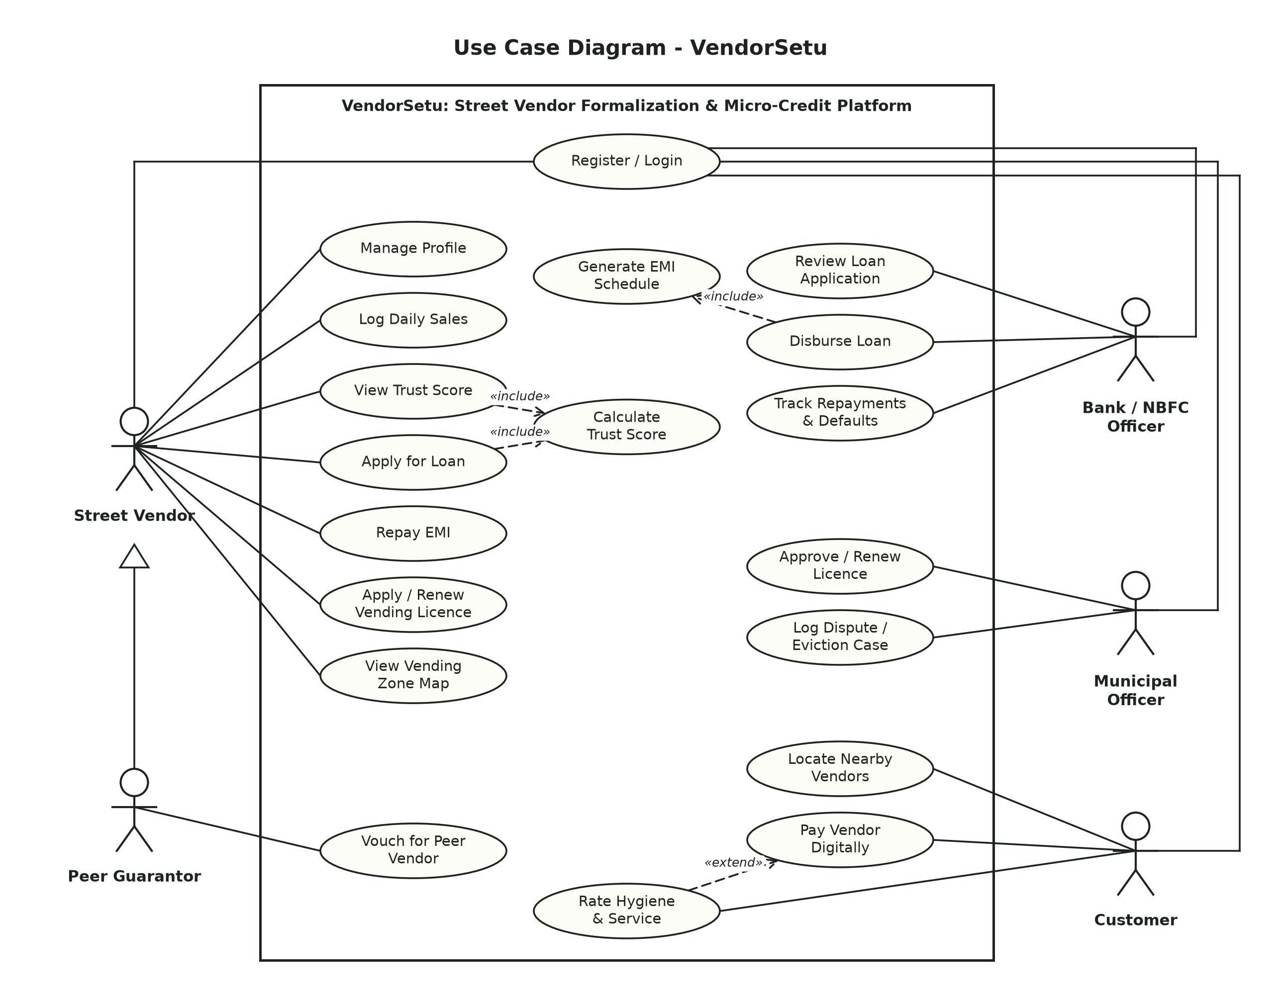
Figure 1: Use Case Diagram
How to read it: stick figures are actors (people or systems outside VendorSetu); ovals are use cases (goals an actor achieves); the rectangle is the system boundary. A solid line means the actor takes part in the use case. «include» (dashed arrow) means the base use case always performs the included one - applying for a loan always calculates the Trust Score. «extend» means optional behaviour - a customer may rate a vendor after paying. The hollow triangle shows that a Peer Guarantor is a specialised Street Vendor.

Use case descriptions
Field | UC-05 Apply for Loan | UC-03 Log Daily Sales
Primary actor | Street Vendor | Street Vendor
Pre-conditions | Logged in; profile complete; no active loan | Logged in; profile complete
Main flow | 1. Vendor opens dashboard and sees eligible tier.  2. Enters amount and clicks Apply.  3. System checks for an active loan.  4. System calculates the Trust Score («include»).  5. System checks score ≥ 40 and amount ≤ tier limit.  6. System saves the application as PENDING and confirms. | 1. Vendor enters date, amount and payment mode.  2. Clicks Log sale.  3. System validates the entry.  4. System saves it and refreshes the 30-day summary and Trust Score.
Alternate flows | 3a. Active loan exists → error, end.  5a. Score < 40 → "not eligible" with score.  5b. Amount > limit → error with the limit. | 3a. Amount ≤ 0 or > ₹1,00,000 → error.  3b. Future date → error.  3c. Date already logged → error.
Post-conditions | Loan record with status PENDING and Trust Score snapshot | One new SALES record
Requirements | FR-LN-1 to FR-LN-6, FR-TS-5 | FR-VEN-3 to FR-VEN-7

B.2 Class Diagram
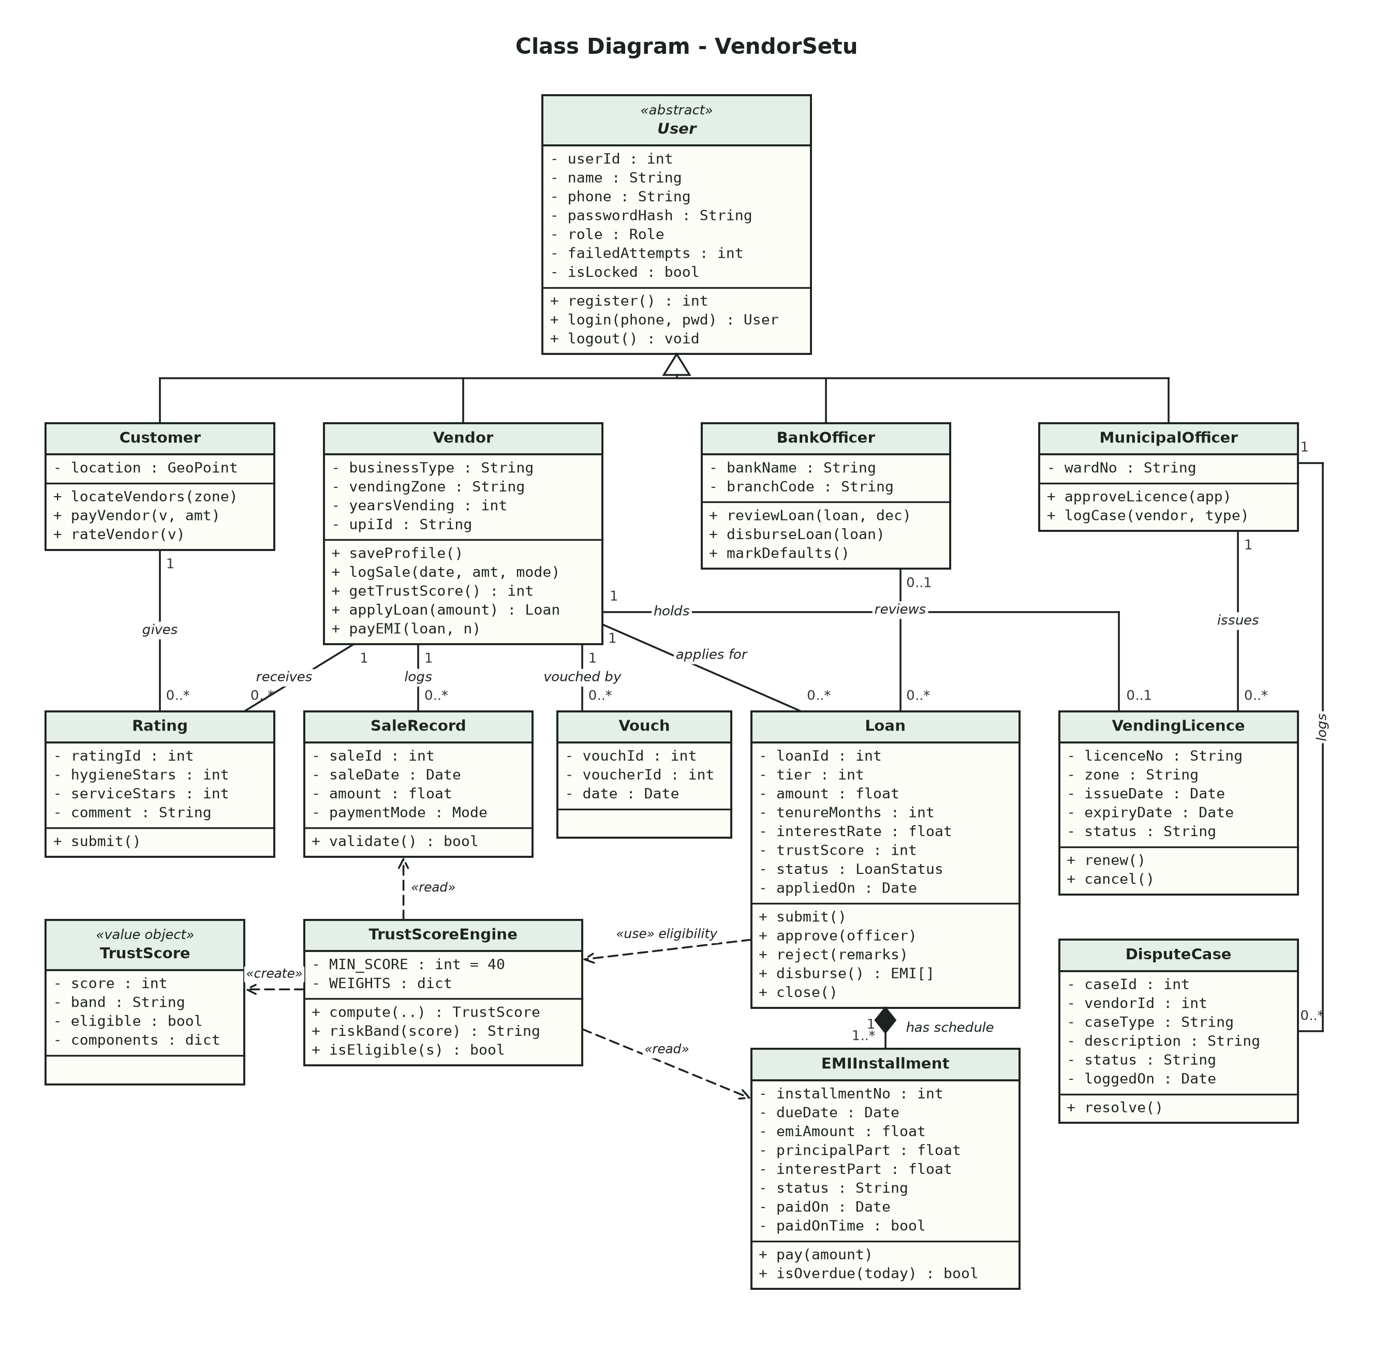
Figure 2: Class Diagram
How to read it: each box is a class with three parts - name, attributes (- private) and operations (+ public). The hollow-triangle tree shows inheritance: Customer, Vendor, BankOfficer and MunicipalOfficer are kinds of the abstract User. Plain lines are associations with multiplicities (1, 0..1, 0..*), e.g. one Vendor applies for zero or more Loans. The filled diamond is composition: EMIInstallments cannot exist without their Loan. Dashed arrows are dependencies - TrustScoreEngine reads SaleRecords and EMIInstallments and creates a TrustScore value object, and Loan uses the engine to check eligibility.

B.3 Sequence Diagrams
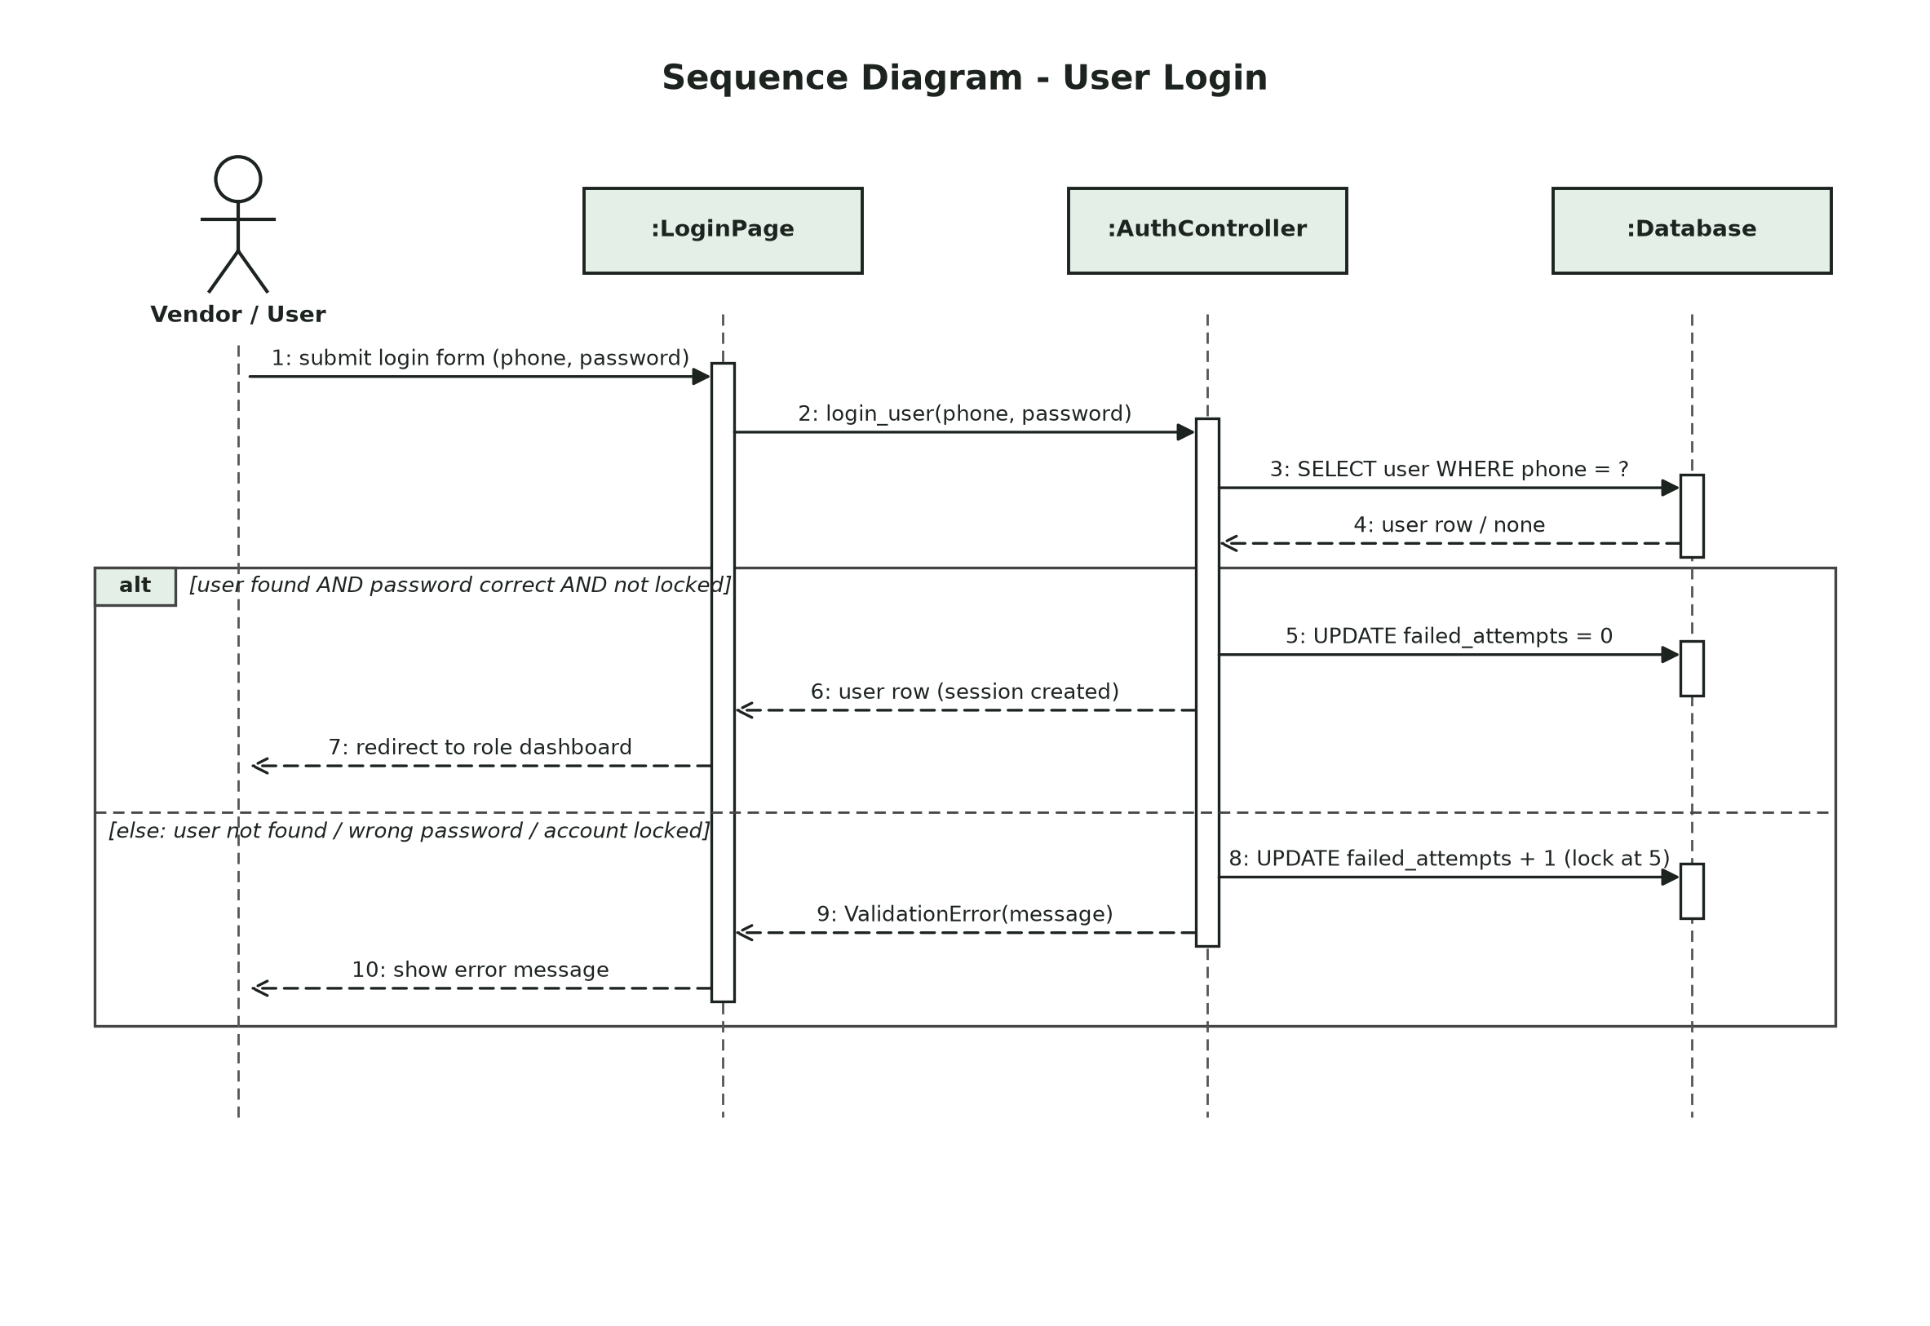
Figure 3: Sequence Diagram - User Login
How to read it: participants are along the top, time flows downward on the dashed lifelines, and the thin rectangles show when an object is active. Solid arrows are calls, dashed arrows are returns. The alt frame shows the two possible outcomes: a valid login opens the dashboard; an invalid one increments the failed-attempt counter (locking the account at 5) and shows an error.

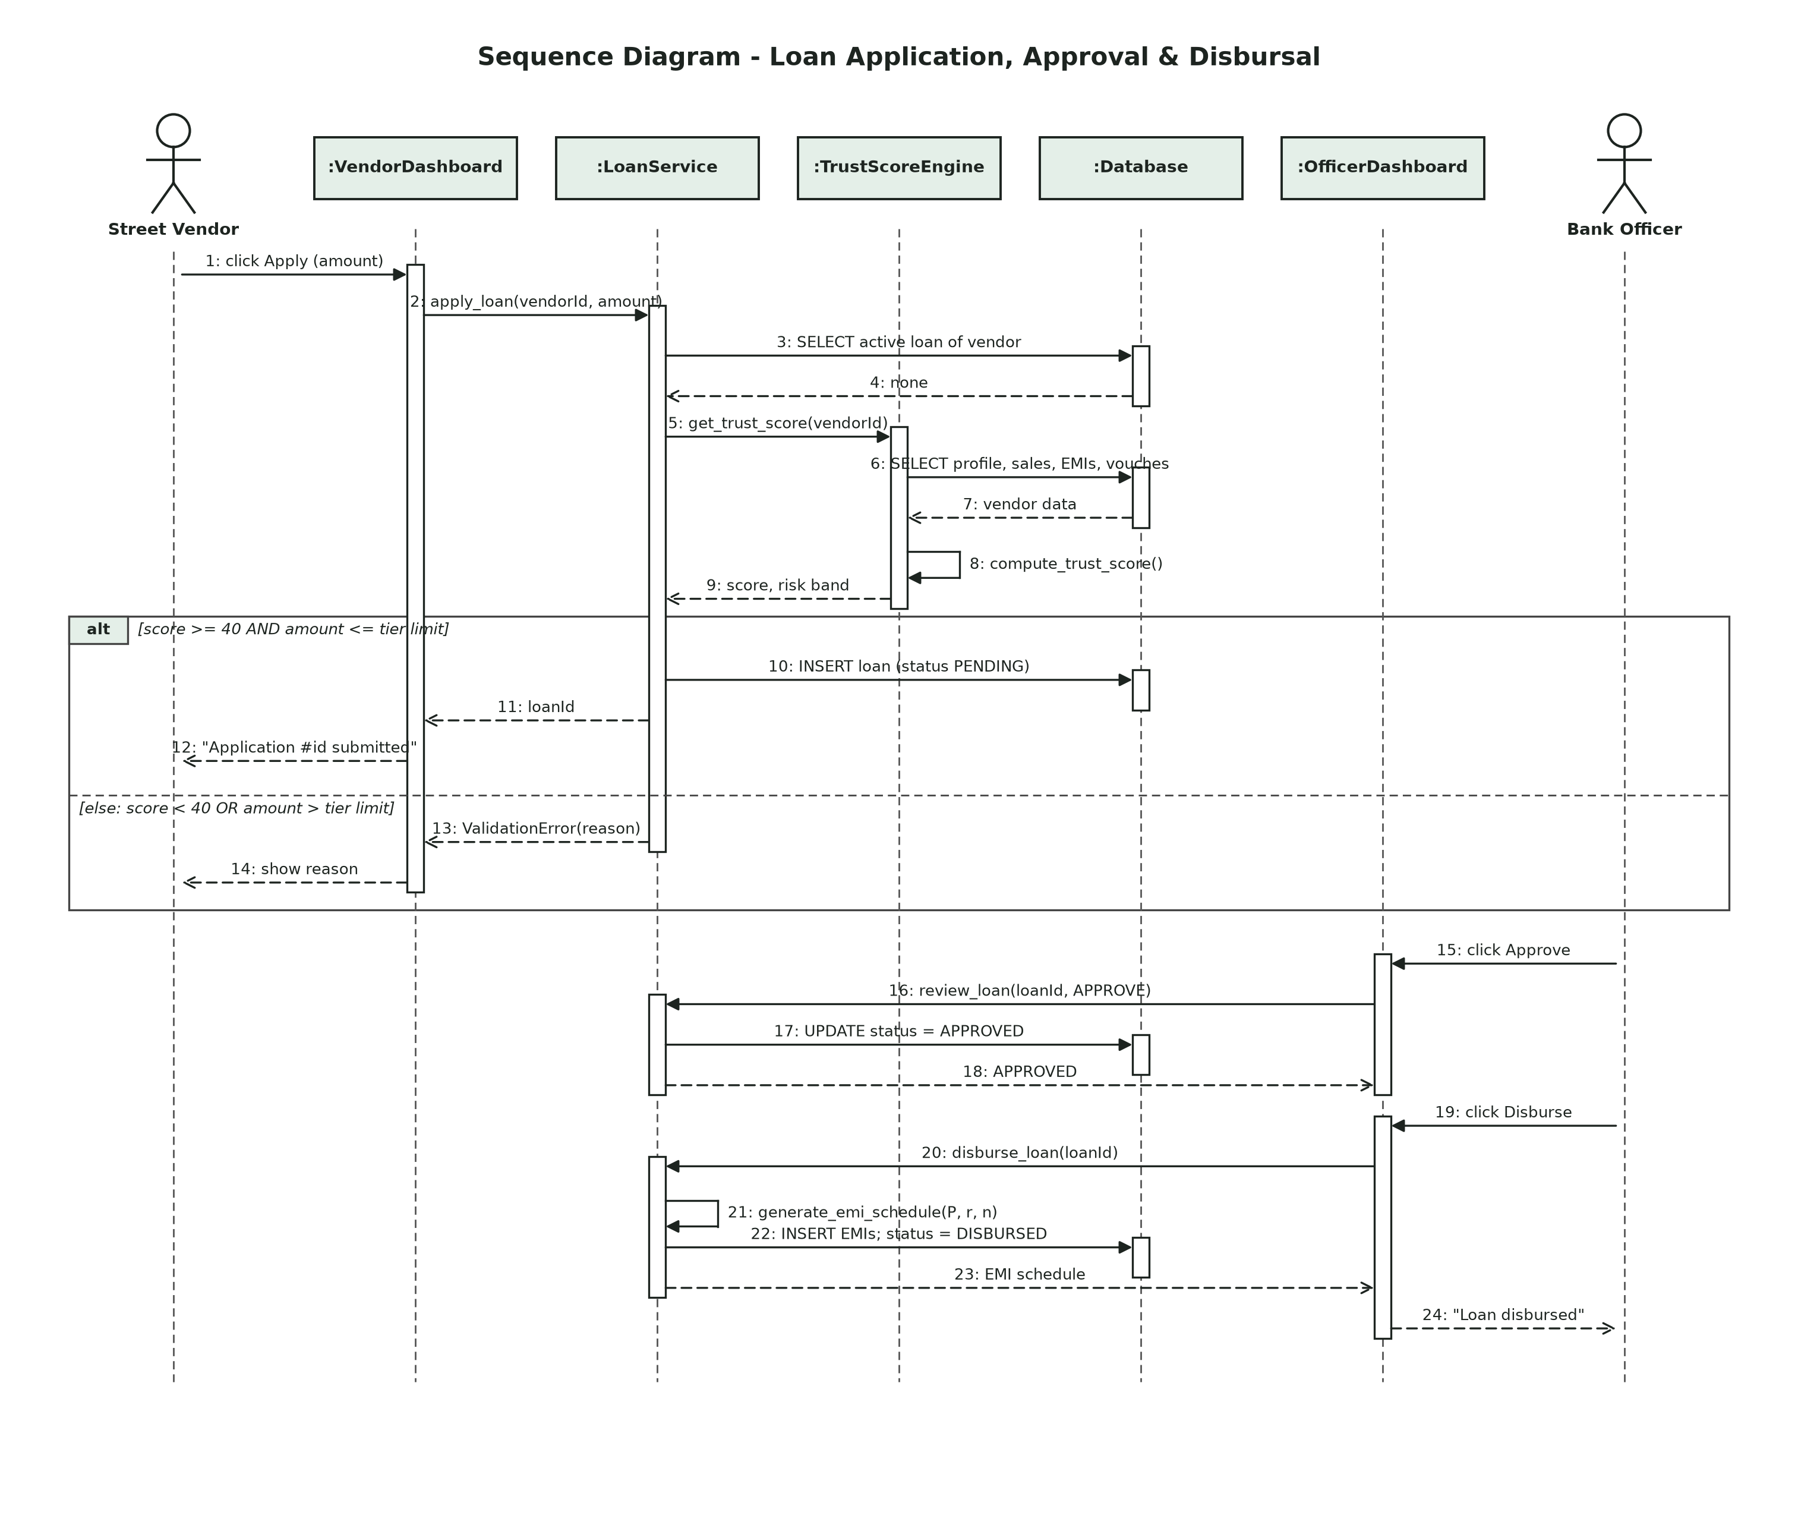
Figure 4: Sequence Diagram - Loan Application, Approval and Disbursal
Messages 1-14 show the vendor's application: the LoanService checks for an active loan, asks the TrustScoreEngine for a score (which reads the database and computes the score itself), and then either saves the PENDING application or returns the reason for refusal. Messages 15-24 show the bank officer approving the loan and disbursing it, which generates and saves the EMI schedule.
Message names are the real function names in the code (login_user in modules/auth.py; apply_loan, review_loan, disburse_loan, generate_emi_schedule in modules/loan.py; get_trust_score, compute_trust_score in modules/credit_score.py). Pages (:LoginPage, :VendorDashboard, :OfficerDashboard) are boundary objects served by app.py; :AuthController, :LoanService and :TrustScoreEngine are the control objects implemented by those modules; the entity classes they read and write are the ones in the Class Diagram (Figure 2).

B.4 State Transition Diagram
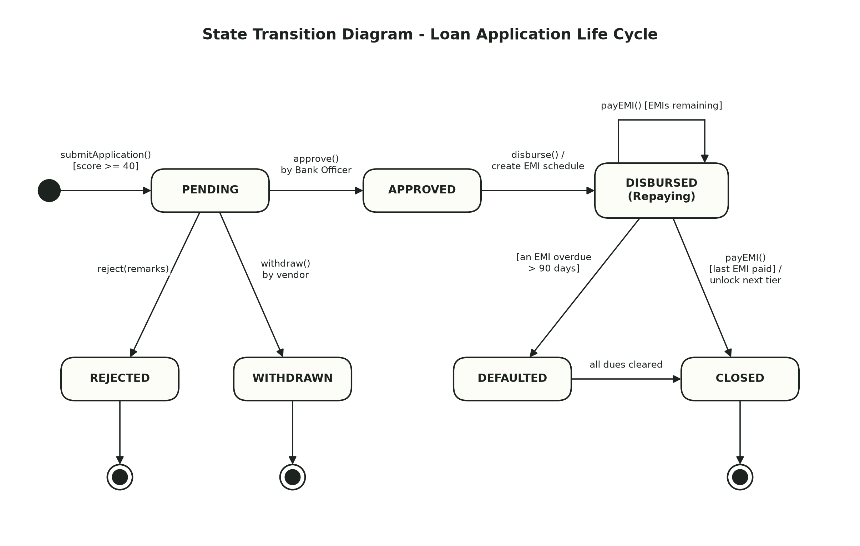
Figure 5: State Transition Diagram - Loan Application Life Cycle
State | Meaning | Leaves the state when
PENDING | Application submitted, waiting for the bank | Officer approves/rejects, or vendor withdraws
APPROVED | Bank has sanctioned the loan | Officer disburses (EMI schedule created)
DISBURSED | Money released; vendor is repaying | Last EMI paid (→ CLOSED) or an EMI is >90 days overdue (→ DEFAULTED)
DEFAULTED | Serious delay in repayment | All dues cleared (→ CLOSED)
REJECTED / WITHDRAWN / CLOSED | Final states | -

B.5 Data Flow Diagrams
Notation (Yourdon-DeMarco): rectangles are external entities, circles are processes, open-ended boxes are data stores, and labelled arrows are data flows.
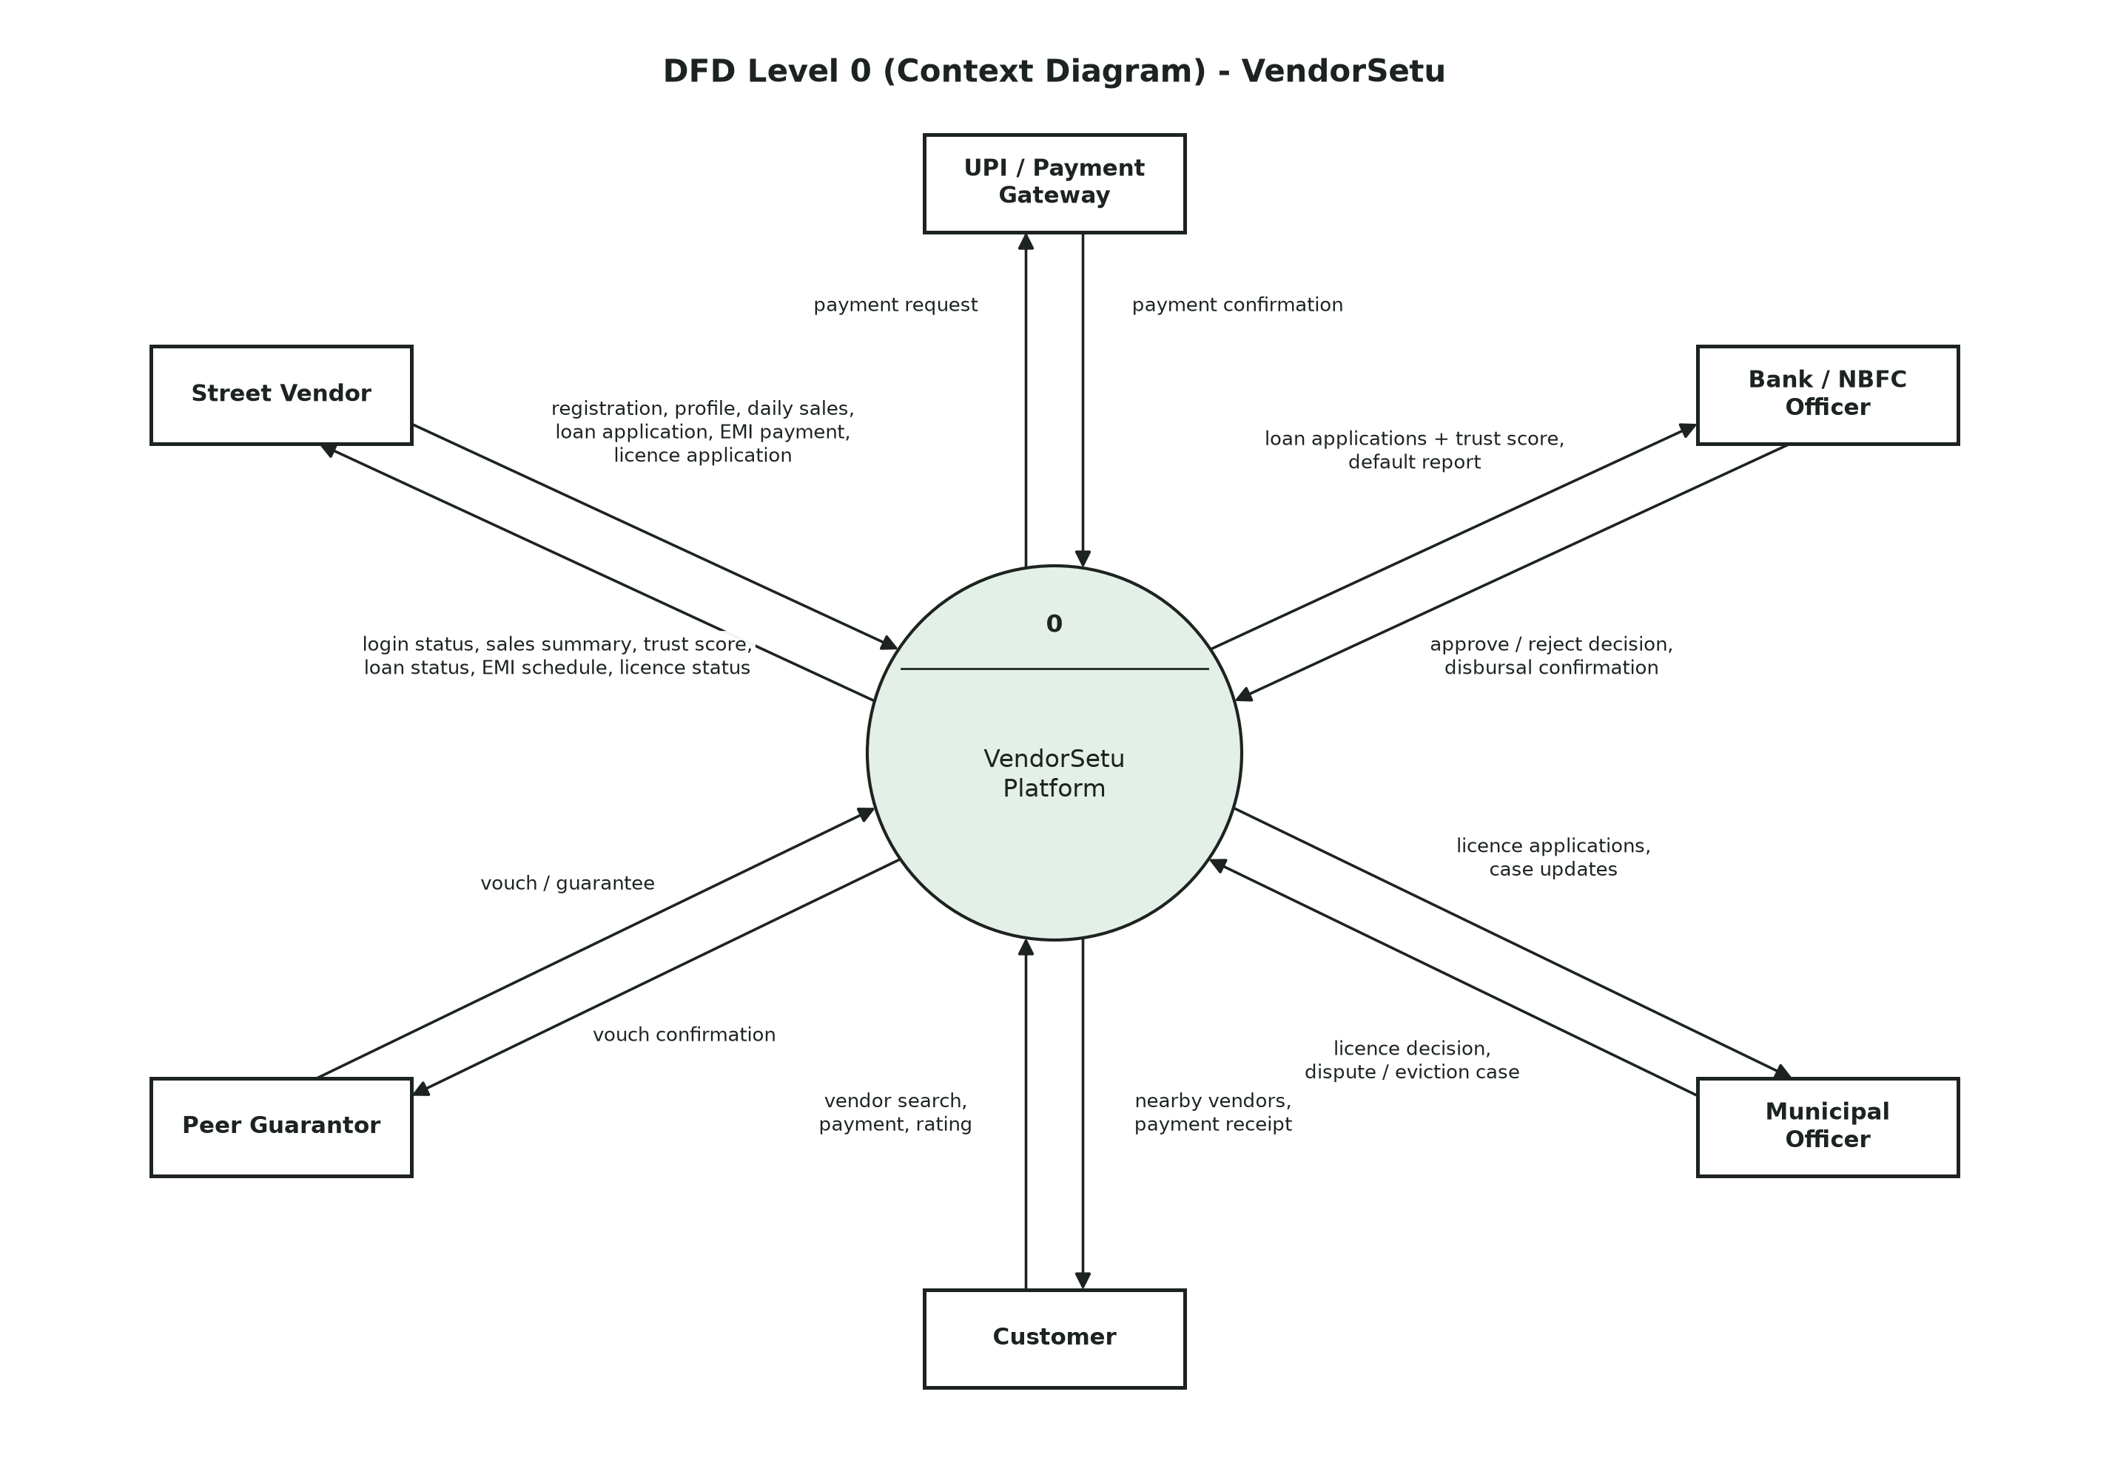
Figure 6: DFD Level 0 (Context Diagram)
The context diagram treats the whole of VendorSetu as one process (0) and shows only the data it exchanges with the six external entities.

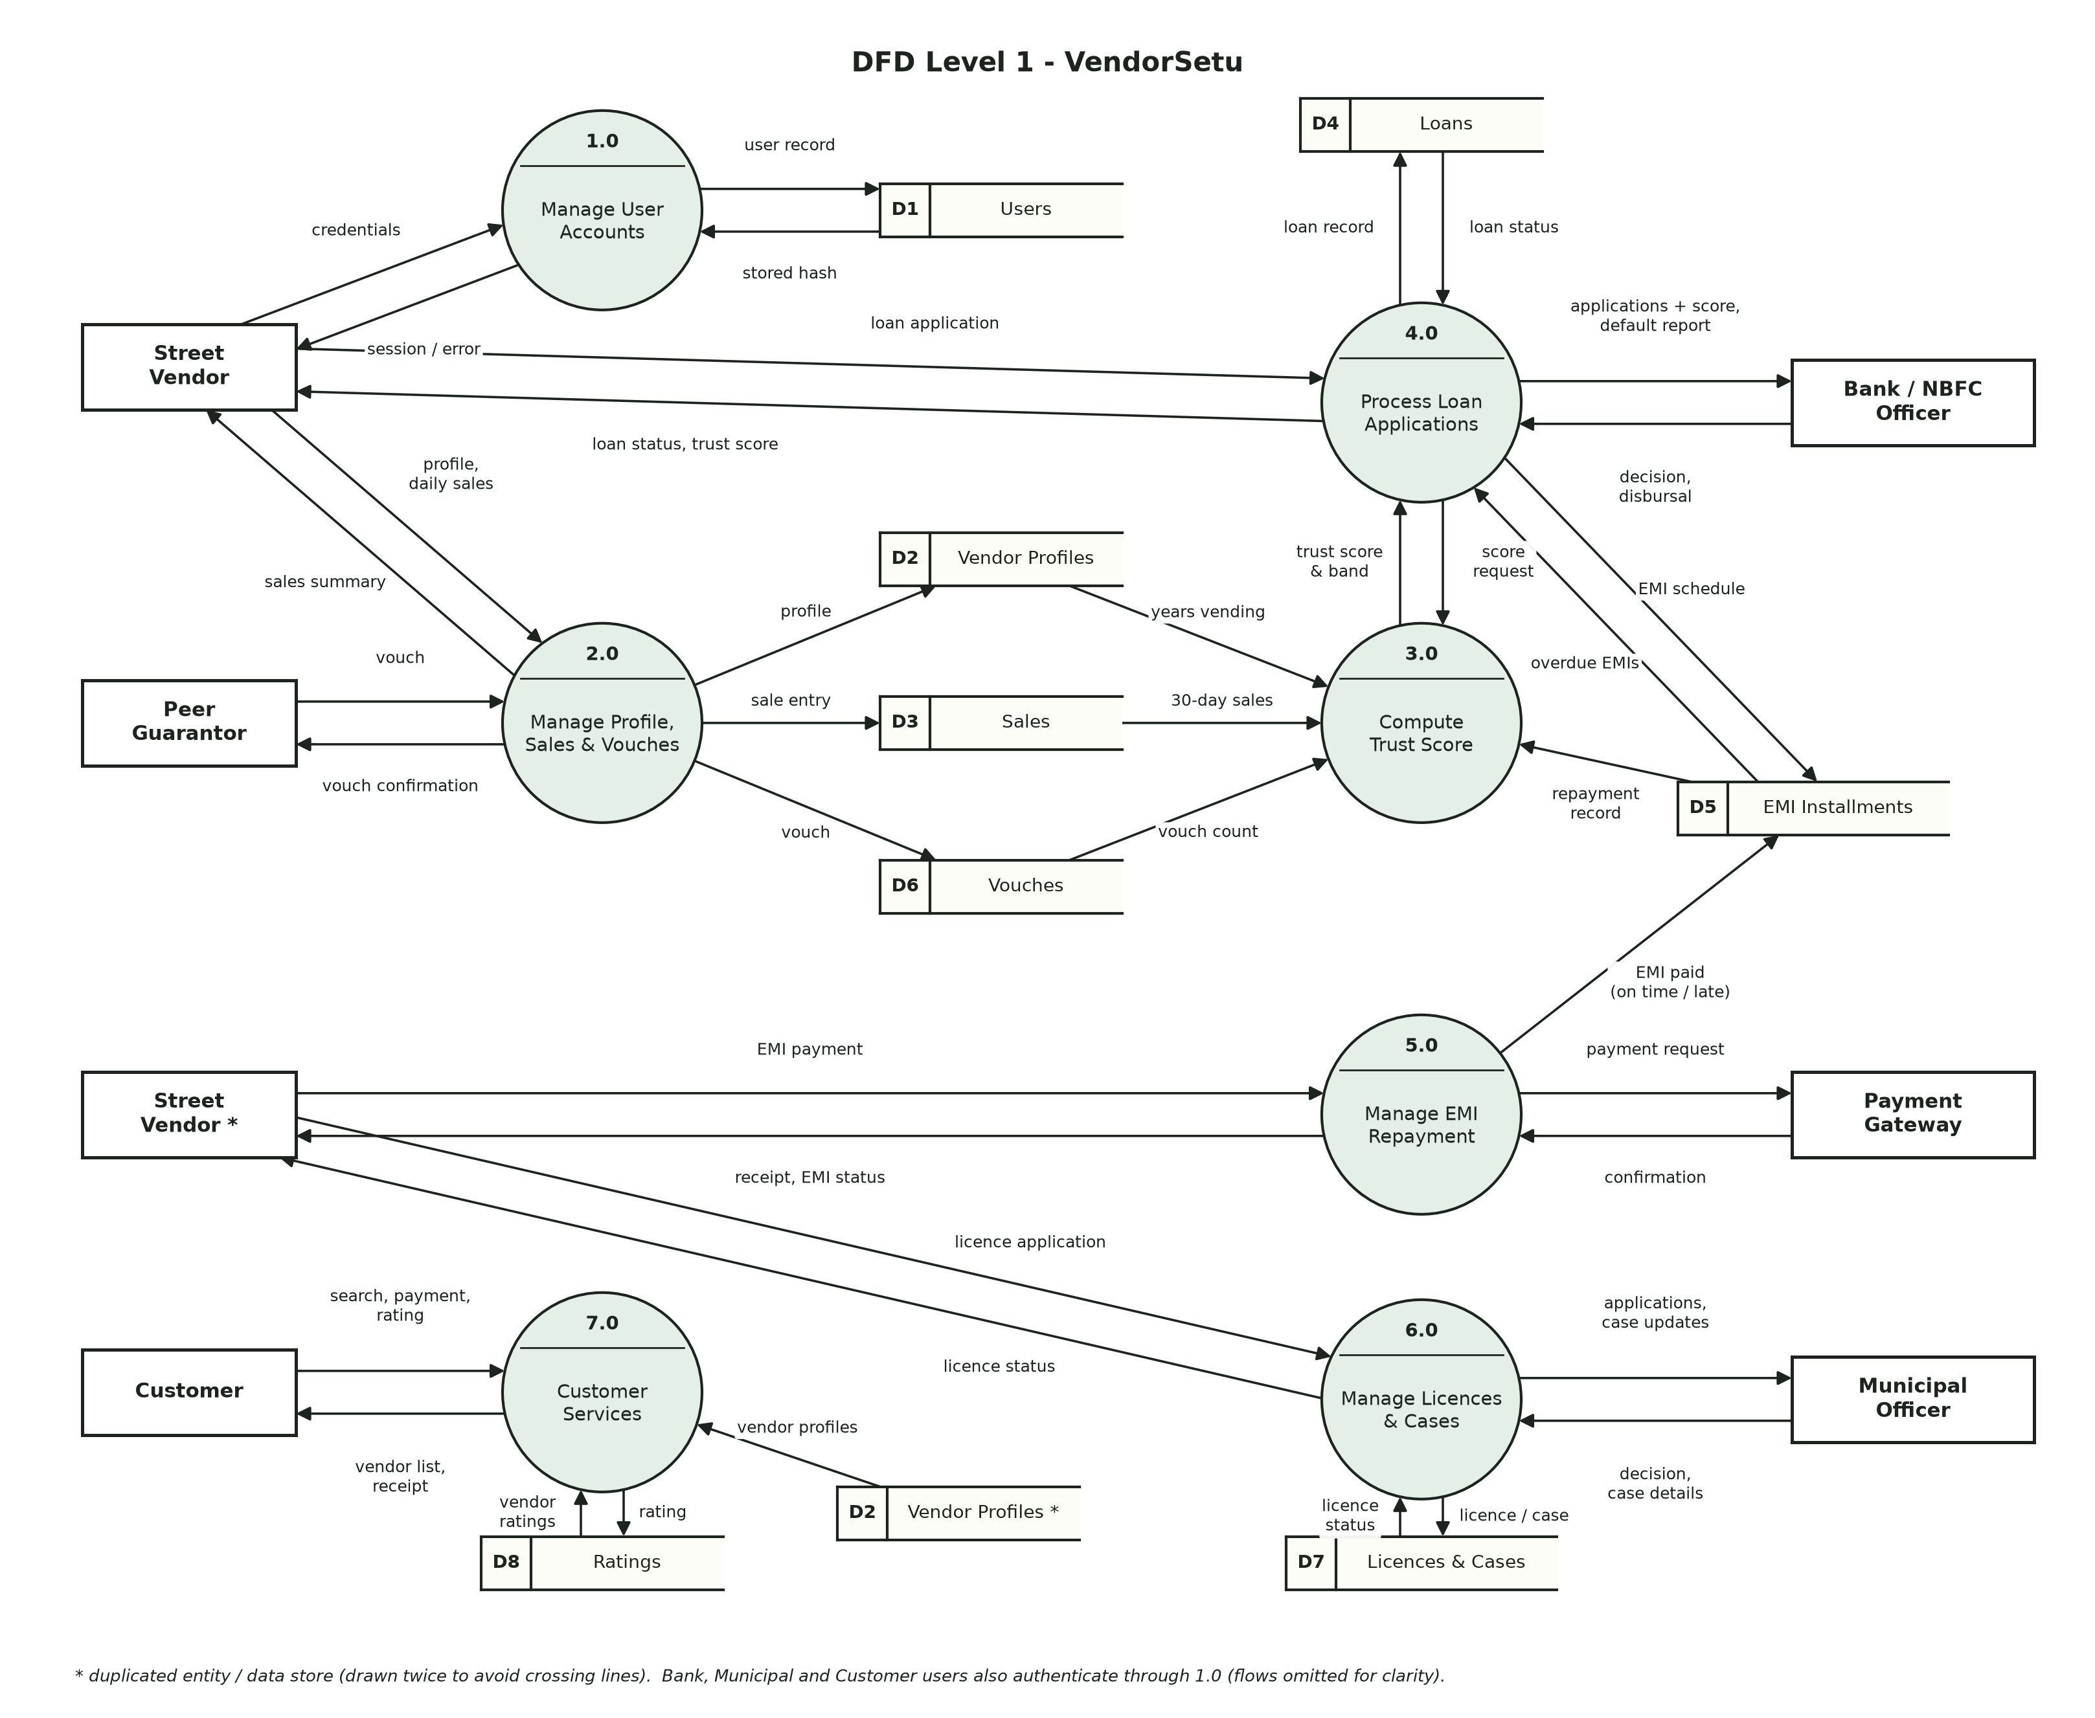
Figure 7: DFD Level 1
Level 1 breaks process 0 into seven processes and shows the data stores D1-D8. Process 3.0 (Trust Score) reads sales, profiles, vouches and EMI records and passes the score to 4.0 (Loans). Entities and stores marked * are drawn twice only to avoid crossing lines.

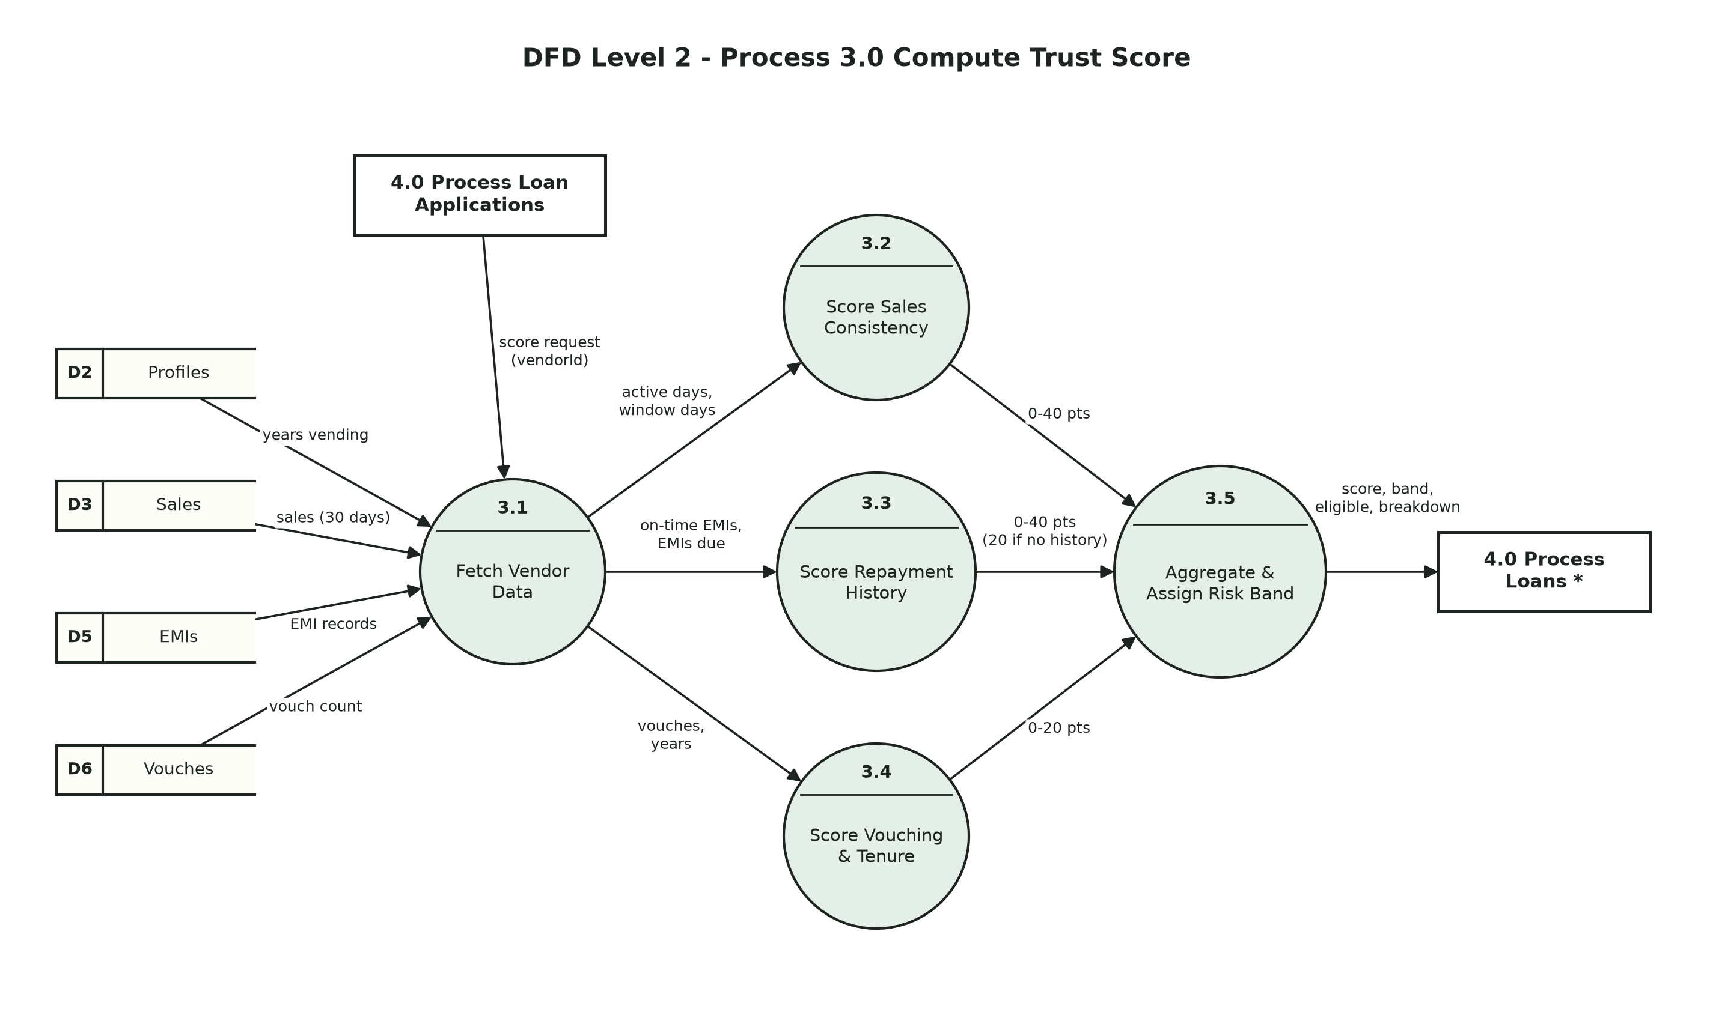
Figure 8: DFD Level 2 - Process 3.0 Compute Trust Score
Level 2 opens process 3.0: on a score request from 4.0, process 3.1 fetches the vendor's data, 3.2-3.4 compute the four score components, and 3.5 adds them (0-100), assigns the risk band and returns the result to 4.0, which shows it to the vendor. This matches compute_trust_score() in Appendix D.
Balancing: every data flow that enters or leaves a process at one level also appears at the next level - e.g. the vendor's "trust score" output in Level 0 is produced by 3.0 → 4.0 → Vendor in Level 1, and the "score request" from 4.0 into 3.0 in Level 1 is the input of process 3.1 in Level 2.

Appendix C: To Be Determined List
# | Item | Section
TBD-1 | Licence validity period and fees - set by each city's Town Vending Committee | 4.7
TBD-2 | Partner lender's actual interest rate (12% p.a. assumed) | 2.7, 4.5
TBD-3 | UPI payment gateway provider | 3.3
TBD-4 | SMS/OTP provider for mobile verification and reminders | 3.3, 4.1
TBD-5 | Re-calibration of Trust Score weights using real repayment data | 4.3
TBD-6 | Regional languages beyond Hindi and English | 6.3
TBD-7 | Lending-circle size and joint-liability rules | 4.10

Appendix D: Implementation (Release 1.0 Prototype)

D.1 Development Approach and Technology
The project follows an incremental model: Increment 1 implements the six "Must have" features end-to-end (four code modules plus the web interface); later increments add the Should/Could features. Technology: Python 3.11, Flask 3.1, SQLite, Jinja2 templates, pytest.

D.2 Coded Modules
Module | Source file | Features / requirements | Key functions
1. Registration & Authentication | app/modules/auth.py | 4.1 - FR-AUTH-1..7 | register_user, login_user
2. Vendor Profile & Daily Sales | app/modules/vendor.py | 4.2 - FR-VEN-1..7 | save_profile, log_daily_sale, sales_summary
3. Trust Scoring Engine | app/modules/credit_score.py | 4.3 - FR-TS-1..6 | compute_trust_score, get_trust_score
4. Loan Management (application, review, disbursal, EMI) | app/modules/loan.py | 4.4-4.6 - FR-LN, FR-BNK, FR-EMI | apply_loan, review_loan, disburse_loan, generate_emi_schedule, pay_emi
Web interface | app/app.py, app/templates/ | 3.1 User Interfaces | Flask routes per role

D.3 Project Structure
SE_Project/
app/
app.py Flask routes (web layer)
database.py SQLite schema + connection helper
seed_demo.py creates demo users and data
modules/
auth.py Module 1 - registration & login
vendor.py Module 2 - profile & daily sales
credit_score.py Module 3 - Trust Score engine
loan.py Module 4 - loans, EMI schedule, repayment
templates/, static/ HTML pages and stylesheet
tests/
test_cases.py the 30 documented test cases (Appendix E)
run_test_cases.py executes them, records every actual output
test_vendorsetu.py pytest wrapper for the same test cases
combinations.py combination testing of every form
test_combinations.py pytest wrapper for combination testing
test_integration.py end-to-end tests through the web routes
diagrams/ diagram source (Python) + PNG output
docs/ this SRS and its generator

D.4 Key Algorithms
Trust Score (FR-TS-2) - excerpt from app/modules/credit_score.py:
def compute_trust_score(active_days, window_days, on_time_emis, emis_due, vouches, years_vending):
"""Pure calculation - returns a dict with the total score, risk band and each component."""
values = (active_days, window_days, on_time_emis, emis_due, vouches, years_vending)
if any(v is None or v < 0 for v in values):
raise ValidationError("Score inputs cannot be negative")
if window_days == 0 or active_days > window_days:
raise ValidationError("Active days cannot exceed the observation window")
if on_time_emis > emis_due:
raise ValidationError("On-time EMIs cannot exceed EMIs due")

consistency = active_days / window_days * 40
repayment = on_time_emis / emis_due * 40 if emis_due else NEUTRAL_REPAYMENT_POINTS
peer = min(vouches, 3) / 3 * 10
tenure = min(years_vending, 5) / 5 * 10

score = round(consistency + repayment + peer + tenure)
...

EMI schedule (FR-BNK-6) - excerpt from app/modules/loan.py:
def generate_emi_schedule(principal, annual_rate, months, start_date):
"""Reducing-balance EMI schedule: EMI = P*r*(1+r)^n / ((1+r)^n - 1)."""
if principal <= 0 or months <= 0:
raise ValidationError("Principal and tenure must be positive")
r = annual_rate / 12 / 100
emi = principal / months if r == 0 else principal * r * (1 + r) ** months / ((1 + r) ** months - 1)
emi = round(emi, 2)

schedule, balance = [], principal
for n in range(1, months + 1):
interest = round(balance * r, 2)
principal_part = round(emi - interest, 2)
amount = emi
if n == months: # last EMI clears any rounding difference
principal_part = round(balance, 2)
amount = round(principal_part + interest, 2)
balance = round(balance - principal_part, 2)
schedule.append({
"installment_no": n,
"due_date": add_months(start_date, n).isoformat(),
"emi_amount": amount,
"principal_part": principal_part,
"interest_part": interest,
})
return schedule

D.5 How to Run
pip install flask pytest
cd app
python seed_demo.py # creates demo data
python app.py # open http://127.0.0.1:5000

Demo logins (mobile / password):
Vendor 9876543210 / ramesh123
Bank officer 9123456780 / bank123
Customer 9988776655 / priya123
Municipal 9090909090 / muni123

python -m pytest tests -v # run all automated tests

D.6 Coding Standards Followed
- PEP 8 naming (snake_case functions, UPPER_CASE constants) and a module docstring naming the SRS section it implements.
- Business rules raise a single ValidationError type with a user-readable message; the web layer only displays it.
- All SQL uses ? parameters (no string concatenation of user input).
- Configuration values (tiers, interest rate, score weights, lock-out limit) are named constants.
- Functions accept an optional 'today' date so time-dependent rules can be tested deterministically.

Appendix E: Test Cases and Results

E.1 Test Strategy
- Format: 6 test cases for each of the 5 tested modules (30 test cases, 162 steps), written in the course Test Case Template (Doc T_01): header, pre-conditions, steps (Action, Input, Expected System Response, Actual Output, Pass/Fail, Comment) and post-conditions. Like the template's Example 2, each test case tests the happy path and its failure conditions; 'Check post-condition' steps look inside the database.
- System testing (25 test cases): every step is performed through the web interface exactly as a user would - fill a form, click a button - and the Expected / Actual Output is the message or value shown on the page, so every step can be repeated by hand in the demo.
- Unit testing (5 test cases): the Trust Score formula is tested directly; the Comment column shows the hand calculation.
- Design techniques: positive testing; equivalence partitioning (every invalid class: empty, wrong format, non-numeric, nan / inf, out of range); boundary-value analysis on both sides of every limit (name 50 / 51, password 5 / 6, amount 1,00,000 / 1,00,000.01, date 90 / 91 days, score 39 / 40 and 69 / 70, tier limit 15,000 / 15,000.01, 90 / 91 days overdue); combination testing; security testing (role check, forged requests, SQL injection).
- Combination testing: 1,894 combinations of valid and invalid values in 7 forms (every value of every field with every value of the others) were submitted; 1,894 gave exactly the result required by the SRS, with no crash and no invalid data stored.
- Defects found and fixed: the first version of the code (commit 0ce1911) failed 7 of these test cases; 6 defects (e.g. 'nan' as an amount crashed the app, customers could open a vendor's loan page) were logged, fixed and re-tested - see E.8. The Comment column marks every step that failed in Run 1.
- Integration testing: two end-to-end scenarios (register → login → profile → sale → apply → approve → disburse → pay EMI; role-based access).
- Test automation: tests/run_test_cases.py executes every case on a fresh, empty database and copies the on-screen result into the Actual Output column; the same cases run under pytest.
- Latest automated run: pytest - 39 passed in 78.99s (0:01:18) (documented cases, combination suites and integration tests). The full step-by-step version of these cases, with a requirements traceability matrix, is in the separate Test Case Document (docs/Test_Cases_VendorSetu.docx).

E.2 User Registration & Login (TC-AUTH-01 to TC-AUTH-06)
Test Case #: | TC-AUTH-01 | Test Case Name: | Register a new account | Page: | 1 of 1
System: | VendorSetu | Subsystem: | Authentication (Module 1 - modules/auth.py) | Type: | System test
Designed by: | Nancy Yadav & team | Design Date: | 04-11-2026 | Requirements: | FR-AUTH-1, FR-AUTH-2, FR-AUTH-4, NFR-SEC-1
Executed by: | Nancy Yadav & team | Execution Date: | 04-11-2026 | Result: | PASS
Short Description: | Test that a new user can register, that the password is stored as a hash and that a mobile number can be registered only once.
Pre-conditions: The application is running with an empty database; The user is on the Register page
Step | Action | Input (Test Data) | Expected System Response | Actual Output | Pass/ Fail | Comment
1 | Fill the Register form and click 'Create account' | Name = Ramesh Kumar, Mobile = 9876543210, Role = Street Vendor, Password = ramesh123, Confirm = ramesh123 | Registration successful. Please log in. -> Log in page is shown | Registration successful. Please log in. -> Log in page is shown | Pass | Positive (happy path)
2 | Check post-condition 1 | - | 1 user stored; password saved as a hash, not as 'ramesh123' | 1 user stored; password saved as a hash, not as 'ramesh123' | Pass
3 | Register again with the same mobile number | Name = Suresh Kumar, Mobile = 9876543210, Password = suresh123 | Mobile number already registered | Mobile number already registered | Pass | Negative - duplicate mobile
4 | Register a bank officer with a new mobile number | Name = Anil Sharma, Mobile = 9123456780, Role = Bank / NBFC Officer, Password = bank123 | Registration successful. Please log in. -> Log in page is shown | Registration successful. Please log in. -> Log in page is shown | Pass | Positive - another role
5 | Check post-condition 2 | - | 2 users stored: Ramesh Kumar (VENDOR), Anil Sharma (BANK_OFFICER) | 2 users stored: Ramesh Kumar (VENDOR), Anil Sharma (BANK_OFFICER) | Pass
Post-conditions: 1. Ramesh's password is stored only as a salted hash 2. Only the two valid registrations are stored; the duplicate mobile number is rejected

Test Case #: | TC-AUTH-02 | Test Case Name: | Registration - name validation | Page: | 1 of 1
System: | VendorSetu | Subsystem: | Authentication (Module 1 - modules/auth.py) | Type: | System test
Designed by: | Nancy Yadav & team | Design Date: | 04-11-2026 | Requirements: | FR-AUTH-1
Executed by: | Nancy Yadav & team | Execution Date: | 04-11-2026 | Result: | Run 1: FAIL → Run 2: PASS
Short Description: | Test the name rules: required, only letters, spaces and dots, at most 50 characters.
Pre-conditions: The application is running with an empty database; The user is on the Register page; Role = Street Vendor and Password = ramesh123 in every step, and a new mobile number in every step
Step | Action | Input (Test Data) | Expected System Response | Actual Output | Pass/ Fail | Comment
1 | Fill the Register form and click 'Create account' | Name = (empty), Mobile = 9876543210 | Name is required | Name is required | Pass | Negative (EP) - empty
2 | Fill the Register form and click 'Create account' | Name = 12345, Mobile = 9876543211 | Name can contain only letters, spaces and dots | Run 1: Registration successful. Please log in.  Run 2 (after fix): Name can contain only letters, spaces and dots | Fail (Run 1)  Pass (Run 2) | Negative (EP) - digits  Run 1 FAILED: defect DEF-04 logged; fixed and re-tested
3 | Fill the Register form and click 'Create account' | Name = 'A' x 51 characters, Mobile = 9876543212 | Name must be at most 50 characters | Run 1: Registration successful. Please log in.  Run 2 (after fix): Name must be at most 50 characters | Fail (Run 1)  Pass (Run 2) | BVA - just above the limit  Run 1 FAILED: defect DEF-04 logged; fixed and re-tested
4 | Fill the Register form and click 'Create account' | Name = 'A' x 50 characters, Mobile = 9876543213 | Registration successful. Please log in. | Registration successful. Please log in. | Pass | BVA - on the limit
5 | Fill the Register form and click 'Create account' | Name = Mohd. Salim, Mobile = 9876543214 | Registration successful. Please log in. | Registration successful. Please log in. | Pass | Positive - name with a dot
6 | Check post-condition 1 | - | 2 users stored: 'A' x 50 (VENDOR), Mohd. Salim (VENDOR) | Run 1: 4 users stored: 12345 (VENDOR), 'A' x 51 (VENDOR), 'A' x 50 (VENDOR), Mohd. Salim (VENDOR)  Run 2 (after fix): 2 users stored: 'A' x 50 (VENDOR), Mohd. Salim (VENDOR) | Fail (Run 1)  Pass (Run 2) | Run 1 FAILED: wrong data stored (defect in the steps above); fixed and re-tested
Post-conditions: 1. Only the two valid names are stored; every rejected name stores nothing

Test Case #: | TC-AUTH-03 | Test Case Name: | Registration - mobile number and role validation | Page: | 1 of 1
System: | VendorSetu | Subsystem: | Authentication (Module 1 - modules/auth.py) | Type: | System test
Designed by: | Nancy Yadav & team | Design Date: | 04-11-2026 | Requirements: | FR-AUTH-1, FR-AUTH-2
Executed by: | Nancy Yadav & team | Execution Date: | 04-11-2026 | Result: | PASS
Short Description: | Test that only a 10-digit Indian mobile number starting with 6-9 and one of the four roles are accepted.
Pre-conditions: The application is running with an empty database; The user is on the Register page; Name = Ramesh Kumar and Password = ramesh123 in every step
Step | Action | Input (Test Data) | Expected System Response | Actual Output | Pass/ Fail | Comment
1 | Fill the Register form and click 'Create account' | Mobile = 987654321 (9 digits) | Enter a valid 10-digit mobile number | Enter a valid 10-digit mobile number | Pass | BVA - 9 digits
2 | Fill the Register form and click 'Create account' | Mobile = 98765432101 (11 digits) | Enter a valid 10-digit mobile number | Enter a valid 10-digit mobile number | Pass | BVA - 11 digits
3 | Fill the Register form and click 'Create account' | Mobile = 5876543210 (starts with 5) | Enter a valid 10-digit mobile number | Enter a valid 10-digit mobile number | Pass | Negative (EP) - must start with 6-9
4 | Fill the Register form and click 'Create account' | Mobile = 98765abcde | Enter a valid 10-digit mobile number | Enter a valid 10-digit mobile number | Pass | Negative (EP) - letters
5 | Fill the Register form and click 'Create account' | Mobile = 9876543210, Role = (not selected) | Invalid role selected | Invalid role selected | Pass | Negative - no role
6 | Send the form with a role that is not offered | Mobile = 9876543210, Role = ADMIN | Invalid role selected | Invalid role selected | Pass | Security - forged request
7 | Check post-condition 1 | - | 0 users stored | 0 users stored | Pass
Post-conditions: 1. No account is created by any of these inputs

Test Case #: | TC-AUTH-04 | Test Case Name: | Registration - password validation | Page: | 1 of 1
System: | VendorSetu | Subsystem: | Authentication (Module 1 - modules/auth.py) | Type: | System test
Designed by: | Nancy Yadav & team | Design Date: | 04-11-2026 | Requirements: | FR-AUTH-1, FR-AUTH-3
Executed by: | Nancy Yadav & team | Execution Date: | 04-11-2026 | Result: | PASS
Short Description: | Test the password rules (at least 6 characters with a letter and a digit, confirmation must match) and the message shown when every field is wrong.
Pre-conditions: The application is running with an empty database; The user is on the Register page; Name = Ramesh Kumar, Mobile = 9876543210, Role = Street Vendor unless the step says otherwise
Step | Action | Input (Test Data) | Expected System Response | Actual Output | Pass/ Fail | Comment
1 | Fill the Register form and click 'Create account' | Password = Confirm = ab123 (5 characters) | Password must be at least 6 characters with letters and digits | Password must be at least 6 characters with letters and digits | Pass | BVA - 5 characters
2 | Fill the Register form and click 'Create account' | Password = Confirm = abcdefgh | Password must be at least 6 characters with letters and digits | Password must be at least 6 characters with letters and digits | Pass | Negative (EP) - no digit
3 | Fill the Register form and click 'Create account' | Password = Confirm = 12345678 | Password must be at least 6 characters with letters and digits | Password must be at least 6 characters with letters and digits | Pass | Negative (EP) - no letter
4 | Fill the Register form and click 'Create account' | Password = ramesh123, Confirm = ramesh124 | Passwords do not match | Passwords do not match | Pass | Negative - confirmation differs
5 | Leave every field empty and click 'Create account' | All fields empty | Name is required | Name is required | Pass | Combination - first broken rule is reported
6 | Fill the Register form and click 'Create account' | Password = Confirm = ab1234 (6 characters) | Registration successful. Please log in. | Registration successful. Please log in. | Pass | BVA - 6 characters
7 | Check post-condition 1 | - | 1 user stored: Ramesh Kumar (VENDOR) | 1 user stored: Ramesh Kumar (VENDOR) | Pass
Post-conditions: 1. Only the registration with a valid password (step 6) is stored

Test Case #: | TC-AUTH-05 | Test Case Name: | Login and logout | Page: | 1 of 1
System: | VendorSetu | Subsystem: | Authentication (Module 1 - modules/auth.py) | Type: | System test
Designed by: | Nancy Yadav & team | Design Date: | 04-11-2026 | Requirements: | FR-AUTH-5, FR-AUTH-7, NFR-SEC-4
Executed by: | Nancy Yadav & team | Execution Date: | 04-11-2026 | Result: | PASS
Short Description: | Test login with correct and wrong credentials, logout, and that pages need a logged-in user.
Pre-conditions: Vendor Ramesh Kumar (9876543210 / ramesh123) is registered; The user is on the Log in page
Step | Action | Input (Test Data) | Expected System Response | Actual Output | Pass/ Fail | Comment
1 | Enter mobile number and password; click 'Log in' | 9876543210 / ramesh123 | Welcome, Ramesh Kumar! -> Vendor dashboard is shown | Welcome, Ramesh Kumar! -> Vendor dashboard is shown | Pass | Positive (happy path)
2 | Click 'Logout' | - | Logged out. -> Log in page is shown | Logged out. -> Log in page is shown | Pass | Positive
3 | Log in with a wrong password | 9876543210 / ramesh124 | Invalid mobile number or password -> Log in page is shown | Invalid mobile number or password -> Log in page is shown | Pass | Negative - wrong password
4 | Log in with a mobile number that is not registered | 9000000001 / ramesh123 | Invalid mobile number or password -> Log in page is shown | Invalid mobile number or password -> Log in page is shown | Pass | Negative - unknown user (same message, so no hint is given)
5 | Type an SQL-injection string in both fields | ' OR '1'='1 / ' OR '1'='1 | Invalid mobile number or password -> Log in page is shown | Invalid mobile number or password -> Log in page is shown | Pass | Security - SQL injection
6 | Type the dashboard address in the browser without logging in | URL = /dashboard | Please log in first. -> Log in page is shown | Please log in first. -> Log in page is shown | Pass | Security - page needs login
Post-conditions: 1. A session exists only after step 1; after a failed login the user stays on the Log in page

Test Case #: | TC-AUTH-06 | Test Case Name: | Account lock after 5 failed attempts | Page: | 1 of 1
System: | VendorSetu | Subsystem: | Authentication (Module 1 - modules/auth.py) | Type: | System test
Designed by: | Nancy Yadav & team | Design Date: | 04-11-2026 | Requirements: | FR-AUTH-6, NFR-SEC-2
Executed by: | Nancy Yadav & team | Execution Date: | 04-11-2026 | Result: | PASS
Short Description: | Test that 5 consecutive wrong passwords lock the account and that a successful login resets the counter.
Pre-conditions: Vendor Ramesh Kumar (9876543210 / ramesh123) is registered and not locked; The user is on the Log in page
Step | Action | Input (Test Data) | Expected System Response | Actual Output | Pass/ Fail | Comment
1 | Log in with a wrong password 4 times | 9876543210 / wrong1 (x4) | Invalid mobile number or password (each time) | Invalid mobile number or password (each time) | Pass | Negative
2 | Log in with the correct password | 9876543210 / ramesh123 | Welcome, Ramesh Kumar! -> Vendor dashboard is shown | Welcome, Ramesh Kumar! -> Vendor dashboard is shown | Pass | Successful login resets the counter
3 | Log in with a wrong password 4 more times | 9876543210 / wrong1 (x4) | Invalid mobile number or password (each time) | Invalid mobile number or password (each time) | Pass | Not locked: the counter was reset
4 | Log in with a wrong password a 5th time | 9876543210 / wrong1 | Account locked after 5 failed attempts. Contact support | Account locked after 5 failed attempts. Contact support | Pass | BVA - 5th attempt locks
5 | Log in with the correct password | 9876543210 / ramesh123 | Account locked after 5 failed attempts. Contact support | Account locked after 5 failed attempts. Contact support | Pass | Locked even with the correct password
6 | Check post-condition 1 | - | is_locked = 1, failed_attempts = 5 | is_locked = 1, failed_attempts = 5 | Pass
Post-conditions: 1. Ramesh's account is locked (is_locked = 1) after 5 consecutive failed attempts

E.3 Vendor Profile & Daily Sales (TC-SALE-01 to TC-SALE-06)
Test Case #: | TC-SALE-01 | Test Case Name: | Save the profile and log a daily sale | Page: | 1 of 1
System: | VendorSetu | Subsystem: | Vendor Profile & Sales (Module 2 - modules/vendor.py) | Type: | System test
Designed by: | Nancy Yadav & team | Design Date: | 04-11-2026 | Requirements: | FR-VEN-1, FR-VEN-3, FR-VEN-5, FR-VEN-6
Executed by: | Nancy Yadav & team | Execution Date: | 04-11-2026 | Result: | PASS
Short Description: | Test that sales can be logged only after the profile is saved, and only once per day.
Pre-conditions: Vendor Ramesh Kumar (9876543210 / ramesh123) is registered and logged in; He has NOT saved his business profile yet and has no sales
Step | Action | Input (Test Data) | Expected System Response | Actual Output | Pass/ Fail | Comment
1 | In 'Daily sales' enter the values and click 'Log sale' | Date = 04-11-2026, Amount = 1500, Mode = UPI | Complete your vendor profile first | Complete your vendor profile first | Pass | Negative - profile missing
2 | In 'Business profile' enter the values and click 'Save profile' | Business = Fruits & vegetables, Zone = Sector 14 Market, Gurugram, Years = 5, UPI = ramesh@upi | Profile saved. | Profile saved. | Pass | Positive
3 | In 'Daily sales' enter the values and click 'Log sale' | Date = 04-11-2026, Amount = 1500, Mode = UPI | Sale logged. Your trust score has been updated. | Sale logged. Your trust score has been updated. | Pass | Positive (happy path)
4 | In 'Daily sales' enter the values and click 'Log sale' | Date = 04-11-2026 (same day), Amount = 900, Mode = Cash | Sales already logged for this date | Sales already logged for this date | Pass | Negative - one entry per day
5 | Check post-condition 1 | - | 1 sale stored: 04-11-2026 Rs 1500 UPI | 1 sale stored: 04-11-2026 Rs 1500 UPI | Pass
Post-conditions: 1. The profile is saved and exactly one sale is stored for today; the duplicate entry is rejected

Test Case #: | TC-SALE-02 | Test Case Name: | Business profile validation | Page: | 1 of 1
System: | VendorSetu | Subsystem: | Vendor Profile & Sales (Module 2 - modules/vendor.py) | Type: | System test
Designed by: | Nancy Yadav & team | Design Date: | 04-11-2026 | Requirements: | FR-VEN-1, FR-VEN-2
Executed by: | Nancy Yadav & team | Execution Date: | 04-11-2026 | Result: | PASS
Short Description: | Test that business type and vending zone are required and years of vending must be 0-60.
Pre-conditions: Vendor Ramesh Kumar (9876543210 / ramesh123) is registered and logged in; He has NOT saved his business profile; in every step the other fields are valid (Business = Fruits & vegetables, Zone = Sector 14 Market, Gurugram, Years = 5)
Step | Action | Input (Test Data) | Expected System Response | Actual Output | Pass/ Fail | Comment
1 | Save the profile | Business type = (empty) | Business type and vending zone are required | Business type and vending zone are required | Pass | Negative - required field
2 | Save the profile | Vending zone = (empty) | Business type and vending zone are required | Business type and vending zone are required | Pass | Negative - required field
3 | Save the profile | Years = abc | Years of vending must be a number | Years of vending must be a number | Pass | Negative (EP) - not a number
4 | Save the profile | Years = 61 | Years of vending must be between 0 and 60 | Years of vending must be between 0 and 60 | Pass | BVA - just above 60
5 | Save the profile | Years = -1 | Years of vending must be between 0 and 60 | Years of vending must be between 0 and 60 | Pass | BVA - just below 0
6 | Save the profile | Years = 60 | Profile saved. | Profile saved. | Pass | BVA - on the limit
7 | Check post-condition 1 | - | Profile stored: Fruits & vegetables, Sector 14 Market, Gurugram, 60 years | Profile stored: Fruits & vegetables, Sector 14 Market, Gurugram, 60 years | Pass
Post-conditions: 1. Only the valid profile (step 6) is stored

Test Case #: | TC-SALE-03 | Test Case Name: | Sale amount - invalid values | Page: | 1 of 1
System: | VendorSetu | Subsystem: | Vendor Profile & Sales (Module 2 - modules/vendor.py) | Type: | System test
Designed by: | Nancy Yadav & team | Design Date: | 04-11-2026 | Requirements: | FR-VEN-4
Executed by: | Nancy Yadav & team | Execution Date: | 04-11-2026 | Result: | Run 1: FAIL → Run 2: PASS
Short Description: | Test that zero, negative, non-numeric and special values (nan, inf) are rejected as the amount.
Pre-conditions: Vendor Ramesh Kumar (9876543210 / ramesh123) is registered and logged in; His profile is saved and he has no sales; Date = today and Mode = UPI in every step
Step | Action | Input (Test Data) | Expected System Response | Actual Output | Pass/ Fail | Comment
1 | In 'Daily sales' enter the values and click 'Log sale' | Amount = 0 | Sale amount must be greater than 0 | Sale amount must be greater than 0 | Pass | BVA - zero
2 | In 'Daily sales' enter the values and click 'Log sale' | Amount = -500 | Sale amount must be greater than 0 | Sale amount must be greater than 0 | Pass | Negative (EP) - negative
3 | In 'Daily sales' enter the values and click 'Log sale' | Amount = abc | Sale amount must be a number | Sale amount must be a number | Pass | Negative (EP) - text
4 | In 'Daily sales' enter the values and click 'Log sale' | Amount = (empty) | Sale amount must be a number | Sale amount must be a number | Pass | Negative (EP) - empty
5 | In 'Daily sales' enter the values and click 'Log sale' | Amount = nan | Sale amount must be a number | Run 1: HTTP 500 Internal Server Error (IntegrityError: NOT NULL constraint failed: sales.amount)  Run 2 (after fix): Sale amount must be a number | Fail (Run 1)  Pass (Run 2) | Negative (EP) - special value  Run 1 FAILED: defect DEF-01 logged; fixed and re-tested
6 | In 'Daily sales' enter the values and click 'Log sale' | Amount = inf | Sale amount must be a number | Run 1: Sale amount cannot exceed Rs 1,00,000 per day  Run 2 (after fix): Sale amount must be a number | Fail (Run 1)  Pass (Run 2) | Negative (EP) - special value  Run 1 FAILED: defect DEF-01 logged; fixed and re-tested
7 | Check post-condition 1 | - | 0 sales stored | 0 sales stored | Pass
Post-conditions: 1. No sale is stored for any invalid amount

Test Case #: | TC-SALE-04 | Test Case Name: | Sale amount - boundary values | Page: | 1 of 1
System: | VendorSetu | Subsystem: | Vendor Profile & Sales (Module 2 - modules/vendor.py) | Type: | System test
Designed by: | Nancy Yadav & team | Design Date: | 04-11-2026 | Requirements: | FR-VEN-4
Executed by: | Nancy Yadav & team | Execution Date: | 04-11-2026 | Result: | PASS
Short Description: | Test the amounts on both sides of the limits: greater than 0 and at most Rs 1,00,000 per day.
Pre-conditions: Vendor Ramesh Kumar (9876543210 / ramesh123) is registered and logged in; His profile is saved and he has no sales; Mode = UPI in every step
Step | Action | Input (Test Data) | Expected System Response | Actual Output | Pass/ Fail | Comment
1 | In 'Daily sales' enter the values and click 'Log sale' | Date = 04-11-2026, Amount = 100000.01 | Sale amount cannot exceed Rs 1,00,000 per day | Sale amount cannot exceed Rs 1,00,000 per day | Pass | BVA - just above the upper limit
2 | In 'Daily sales' enter the values and click 'Log sale' | Date = 04-11-2026, Amount = 100000 | Sale logged. Your trust score has been updated. | Sale logged. Your trust score has been updated. | Pass | BVA - on the upper limit
3 | In 'Daily sales' enter the values and click 'Log sale' | Date = 03-11-2026, Amount = 1 | Sale logged. Your trust score has been updated. | Sale logged. Your trust score has been updated. | Pass | BVA - smallest whole amount
4 | In 'Daily sales' enter the values and click 'Log sale' | Date = 02-11-2026, Amount = -0.01 | Sale amount must be greater than 0 | Sale amount must be greater than 0 | Pass | BVA - just below the lower limit
5 | Check post-condition 1 | - | 2 sales stored: 04-11-2026 Rs 100000 UPI, 03-11-2026 Rs 1 UPI | 2 sales stored: 04-11-2026 Rs 100000 UPI, 03-11-2026 Rs 1 UPI | Pass
Post-conditions: 1. Only the two amounts inside the limits are stored

Test Case #: | TC-SALE-05 | Test Case Name: | Sale date and payment mode validation | Page: | 1 of 1
System: | VendorSetu | Subsystem: | Vendor Profile & Sales (Module 2 - modules/vendor.py) | Type: | System test
Designed by: | Nancy Yadav & team | Design Date: | 04-11-2026 | Requirements: | FR-VEN-3, FR-VEN-4, FR-VEN-5
Executed by: | Nancy Yadav & team | Execution Date: | 04-11-2026 | Result: | Run 1: FAIL → Run 2: PASS
Short Description: | Test the date rules (not in the future, not more than 90 days old, a real date), the payment mode and an entry with several wrong fields.
Pre-conditions: Vendor Ramesh Kumar (9876543210 / ramesh123) is registered and logged in; His profile is saved and he has no sales; Amount = 1500 and Mode = UPI unless the step says otherwise
Step | Action | Input (Test Data) | Expected System Response | Actual Output | Pass/ Fail | Comment
1 | In 'Daily sales' enter the values and click 'Log sale' | Date = 05-11-2026 (tomorrow) | Sale date cannot be in the future | Sale date cannot be in the future | Pass | BVA - tomorrow
2 | In 'Daily sales' enter the values and click 'Log sale' | Date = 2026-02-30 (no such day) | Enter a valid date (YYYY-MM-DD) | Enter a valid date (YYYY-MM-DD) | Pass | Negative (EP) - invalid date
3 | In 'Daily sales' enter the values and click 'Log sale' | Date = 05-08-2026 (91 days ago) | Sale date cannot be more than 90 days old | Run 1: Sale logged. Your trust score has been updated.  Run 2 (after fix): Sale date cannot be more than 90 days old | Fail (Run 1)  Pass (Run 2) | BVA - just outside 90 days  Run 1 FAILED: defect DEF-02 logged; fixed and re-tested
4 | In 'Daily sales' enter the values and click 'Log sale' | Date = 06-08-2026 (90 days ago) | Sale logged. Your trust score has been updated. | Sale logged. Your trust score has been updated. | Pass | BVA - on the 90-day limit
5 | Send the sales form with a payment mode that is not offered | Date = 04-11-2026, Mode = CARD | Payment mode must be CASH or UPI | Payment mode must be CASH or UPI | Pass | Security - forged value
6 | In 'Daily sales' enter the values and click 'Log sale' | Amount = 0, Date = 05-11-2026, Mode = CARD (three fields wrong) | Sale amount must be greater than 0 | Sale amount must be greater than 0 | Pass | Combination - first broken rule is reported
7 | Check post-condition 1 | - | 1 sale stored: 06-08-2026 Rs 1500 UPI | Run 1: 2 sales stored: 06-08-2026 Rs 1500 UPI, 05-08-2026 Rs 1500 UPI  Run 2 (after fix): 1 sale stored: 06-08-2026 Rs 1500 UPI | Fail (Run 1)  Pass (Run 2) | Run 1 FAILED: wrong data stored (defect in the steps above); fixed and re-tested
Post-conditions: 1. Only the entry dated 90 days ago (step 4) is stored

Test Case #: | TC-SALE-06 | Test Case Name: | 30-day sales summary on the dashboard | Page: | 1 of 1
System: | VendorSetu | Subsystem: | Vendor Profile & Sales (Module 2 - modules/vendor.py) | Type: | System test
Designed by: | Nancy Yadav & team | Design Date: | 04-11-2026 | Requirements: | FR-VEN-7, FR-TS-1
Executed by: | Nancy Yadav & team | Execution Date: | 04-11-2026 | Result: | PASS
Short Description: | Test that the dashboard shows the correct 30-day total, active days, daily average and the updated Trust Score.
Pre-conditions: Vendor Ramesh Kumar (9876543210 / ramesh123) is registered and logged in; His profile is saved (5 years of vending) and he has no sales
Step | Action | Input (Test Data) | Expected System Response | Actual Output | Pass/ Fail | Comment
1 | In 'Daily sales' enter the values and click 'Log sale' | Date = 02-11-2026, Amount = 1000, Mode = Cash | Sale logged. Your trust score has been updated. | Sale logged. Your trust score has been updated. | Pass | Positive
2 | In 'Daily sales' enter the values and click 'Log sale' | Date = 03-11-2026, Amount = 2000, Mode = Cash | Sale logged. Your trust score has been updated. | Sale logged. Your trust score has been updated. | Pass | Positive
3 | In 'Daily sales' enter the values and click 'Log sale' | Date = 04-11-2026, Amount = 3000, Mode = Cash | Sale logged. Your trust score has been updated. | Sale logged. Your trust score has been updated. | Pass | Positive
4 | Read the summary cards on the dashboard | - | 30-day sales Rs 6,000; active days 3/30; average Rs 2,000 per active day | 30-day sales Rs 6,000; active days 3/30; average Rs 2,000 per active day | Pass | Hand calculation: 6000 / 3 = 2000
5 | Read the Trust Score card | - | Trust Score 34/100, HIGH RISK | Trust Score 34/100, HIGH RISK | Pass | Hand calculation: 3/30 x 40 + 20 + 0 + 10 = 34
Post-conditions: 1. Three sales are stored and the summary and Trust Score reflect them

E.4 Trust Score Calculation (TC-TS-01 to TC-TS-06)
Test Case #: | TC-TS-01 | Test Case Name: | Trust Score of a new vendor on the dashboard | Page: | 1 of 1
System: | VendorSetu | Subsystem: | Alt-Credit Scoring Engine (Module 3 - modules/credit_score.py) | Type: | System test
Designed by: | Nancy Yadav & team | Design Date: | 04-11-2026 | Requirements: | FR-TS-1, FR-TS-3, FR-TS-4, FR-TS-5, FR-TS-6
Executed by: | Nancy Yadav & team | Execution Date: | 04-11-2026 | Result: | PASS
Short Description: | Test the score, risk band and component points shown to a new vendor, and that the score is updated and used for loan eligibility.
Pre-conditions: Vendor Sunita Devi (9812345670 / sunita123) is registered; her profile shows 0 years of vending; she has no sales, vouches or loans
Step | Action | Input (Test Data) | Expected System Response | Actual Output | Pass/ Fail | Comment
1 | Log in as Sunita and read the Trust Score card | 9812345670 / sunita123 | Trust Score 20/100, HIGH RISK | Trust Score 20/100, HIGH RISK | Pass | Hand calculation: 0 + 20 (no EMI due) + 0 + 0
2 | Read the four component bars | - | Sales consistency 0/40, Repayment history 20/40, Peer vouching 0/10, Vending tenure 0/10 | Sales consistency 0/40, Repayment history 20/40, Peer vouching 0/10, Vending tenure 0/10 | Pass | Explainable score
3 | In 'Daily sales' enter the values and click 'Log sale' | Date = 04-11-2026, Amount = 800, Mode = Cash | Sale logged. Your trust score has been updated. | Sale logged. Your trust score has been updated. | Pass | Positive
4 | Read the Trust Score card again | - | Trust Score 21/100, HIGH RISK | Trust Score 21/100, HIGH RISK | Pass | 1/30 x 40 = 1.3; 1.3 + 20 = 21
5 | In 'Micro-credit' enter the amount and click 'Apply for loan' | Amount = 10000 | Trust score 21 is below 40. Not eligible | Trust score 21 is below 40. Not eligible | Pass | Negative - score below 40
Post-conditions: 1. One sale is stored; no loan is created

Test Case #: | TC-TS-02 | Test Case Name: | Formula - loan eligibility boundary (39 / 40) | Page: | 1 of 1
System: | VendorSetu | Subsystem: | Alt-Credit Scoring Engine (Module 3 - modules/credit_score.py) | Type: | Unit test
Designed by: | Nancy Yadav & team | Design Date: | 04-11-2026 | Requirements: | FR-TS-2, FR-TS-4, FR-TS-5
Executed by: | Nancy Yadav & team | Execution Date: | 04-11-2026 | Result: | PASS
Short Description: | Test the score on both sides of the eligibility cut-off of 40.
Pre-conditions: compute_trust_score() is called directly (unit test); Window = 30 days; no EMI due yet (repayment = 20); Vouches = 0; Years = 0
Step | Action | Input (Test Data) | Expected System Response | Actual Output | Pass/ Fail | Comment
1 | Call compute_trust_score() with the input | Active days = 14 | 18.7 + 20 + 0 + 0 = 39 -> HIGH RISK, not eligible | 18.7 + 20 + 0 + 0 = 39 -> HIGH RISK, not eligible | Pass | BVA - just below 40
2 | Call compute_trust_score() with the input | Active days = 15 | 20 + 20 + 0 + 0 = 40 -> MEDIUM RISK, eligible | 20 + 20 + 0 + 0 = 40 -> MEDIUM RISK, eligible | Pass | BVA - on 40
3 | Call compute_trust_score() with the input | Active days = 16 | 21.3 + 20 + 0 + 0 = 41 -> MEDIUM RISK, eligible | 21.3 + 20 + 0 + 0 = 41 -> MEDIUM RISK, eligible | Pass | BVA - just above 40
Post-conditions: 1. Score, band and eligibility are returned; no stored data changes

Test Case #: | TC-TS-03 | Test Case Name: | Formula - risk band boundary (69 / 70) | Page: | 1 of 1
System: | VendorSetu | Subsystem: | Alt-Credit Scoring Engine (Module 3 - modules/credit_score.py) | Type: | Unit test
Designed by: | Nancy Yadav & team | Design Date: | 04-11-2026 | Requirements: | FR-TS-2, FR-TS-4
Executed by: | Nancy Yadav & team | Execution Date: | 04-11-2026 | Result: | PASS
Short Description: | Test the score on both sides of the MEDIUM / LOW RISK boundary.
Pre-conditions: compute_trust_score() is called directly (unit test); Window = 30 days; no EMI due yet (repayment = 20); Years = 5
Step | Action | Input (Test Data) | Expected System Response | Actual Output | Pass/ Fail | Comment
1 | Call compute_trust_score() with the input | Active days = 29, Vouches = 0 | 38.7 + 20 + 0 + 10 = 69 -> MEDIUM RISK, eligible | 38.7 + 20 + 0 + 10 = 69 -> MEDIUM RISK, eligible | Pass | BVA - just below 70
2 | Call compute_trust_score() with the input | Active days = 30, Vouches = 0 | 40 + 20 + 0 + 10 = 70 -> LOW RISK, eligible | 40 + 20 + 0 + 10 = 70 -> LOW RISK, eligible | Pass | BVA - on 70
3 | Call compute_trust_score() with the input | Active days = 28, Vouches = 1 | 37.3 + 20 + 3.3 + 10 = 71 -> LOW RISK, eligible | 37.3 + 20 + 3.3 + 10 = 71 -> LOW RISK, eligible | Pass | BVA - just above 70
Post-conditions: 1. Score, band and eligibility are returned; no stored data changes

Test Case #: | TC-TS-04 | Test Case Name: | Formula - minimum, maximum and repayment history | Page: | 1 of 1
System: | VendorSetu | Subsystem: | Alt-Credit Scoring Engine (Module 3 - modules/credit_score.py) | Type: | Unit test
Designed by: | Nancy Yadav & team | Design Date: | 04-11-2026 | Requirements: | FR-TS-2, FR-TS-3, FR-TS-4
Executed by: | Nancy Yadav & team | Execution Date: | 04-11-2026 | Result: | PASS
Short Description: | Test the lowest and highest possible scores and the effect of the repayment record.
Pre-conditions: compute_trust_score() is called directly (unit test); Window = 30 days
Step | Action | Input (Test Data) | Expected System Response | Actual Output | Pass/ Fail | Comment
1 | Call compute_trust_score() with the input | Active days = 0, EMIs due = 0, Vouches = 0, Years = 0 | 0 + 20 + 0 + 0 = 20 -> HIGH RISK, not eligible | 0 + 20 + 0 + 0 = 20 -> HIGH RISK, not eligible | Pass | BVA - minimum
2 | Call compute_trust_score() with the input | Active days = 30, On-time EMIs = 12 of 12, Vouches = 3, Years = 5 | 40 + 40 + 10 + 10 = 100 -> LOW RISK, eligible | 40 + 40 + 10 + 10 = 100 -> LOW RISK, eligible | Pass | BVA - maximum
3 | Call compute_trust_score() with the input | Active days = 30, On-time EMIs = 0 of 6, Vouches = 0, Years = 5 | 40 + 0 + 0 + 10 = 50 -> MEDIUM RISK, eligible | 40 + 0 + 0 + 10 = 50 -> MEDIUM RISK, eligible | Pass | No EMI paid on time
4 | Call compute_trust_score() with the input | Active days = 24, On-time EMIs = 6 of 12, Vouches = 1, Years = 2 | 32 + 20 + 3.3 + 4 = 59 -> MEDIUM RISK, eligible | 32 + 20 + 3.3 + 4 = 59 -> MEDIUM RISK, eligible | Pass | Positive - partial record
Post-conditions: 1. Score, band and eligibility are returned; no stored data changes

Test Case #: | TC-TS-05 | Test Case Name: | Formula - caps on vouches and tenure | Page: | 1 of 1
System: | VendorSetu | Subsystem: | Alt-Credit Scoring Engine (Module 3 - modules/credit_score.py) | Type: | Unit test
Designed by: | Nancy Yadav & team | Design Date: | 04-11-2026 | Requirements: | FR-TS-2, BR-8
Executed by: | Nancy Yadav & team | Execution Date: | 04-11-2026 | Result: | PASS
Short Description: | Test that only 3 vouches and 5 years of vending count toward the score.
Pre-conditions: compute_trust_score() is called directly (unit test); Active days = 30 of 30; no EMI due yet (repayment = 20)
Step | Action | Input (Test Data) | Expected System Response | Actual Output | Pass/ Fail | Comment
1 | Call compute_trust_score() with the input | Vouches = 3, Years = 5 | 40 + 20 + 10 + 10 = 80 -> LOW RISK, eligible | 40 + 20 + 10 + 10 = 80 -> LOW RISK, eligible | Pass | BVA - on the caps
2 | Call compute_trust_score() with the input | Vouches = 7, Years = 20 | 40 + 20 + 10 + 10 = 80 -> LOW RISK, eligible | 40 + 20 + 10 + 10 = 80 -> LOW RISK, eligible | Pass | BVA - above the caps (same score)
3 | Call compute_trust_score() with the input | Vouches = 2, Years = 4 | 40 + 20 + 6.7 + 8 = 75 -> LOW RISK, eligible | 40 + 20 + 6.7 + 8 = 75 -> LOW RISK, eligible | Pass | BVA - below the caps
Post-conditions: 1. Score, band and eligibility are returned; no stored data changes

Test Case #: | TC-TS-06 | Test Case Name: | Formula - invalid inputs | Page: | 1 of 1
System: | VendorSetu | Subsystem: | Alt-Credit Scoring Engine (Module 3 - modules/credit_score.py) | Type: | Unit test
Designed by: | Nancy Yadav & team | Design Date: | 04-11-2026 | Requirements: | FR-TS-1
Executed by: | Nancy Yadav & team | Execution Date: | 04-11-2026 | Result: | PASS
Short Description: | Test that impossible input values are rejected with a clear message.
Pre-conditions: compute_trust_score() is called directly (unit test)
Step | Action | Input (Test Data) | Expected System Response | Actual Output | Pass/ Fail | Comment
1 | Call compute_trust_score() with the input | Active days = 35, Window = 30 | Active days cannot exceed the observation window | Active days cannot exceed the observation window | Pass | Negative - more days than the window
2 | Call compute_trust_score() with the input | Active days = 30, Vouches = -1, Years = 5 | Score inputs cannot be negative | Score inputs cannot be negative | Pass | Negative - negative value
3 | Call compute_trust_score() with the input | Active days = 30, On-time EMIs = 5, EMIs due = 3 | On-time EMIs cannot exceed EMIs due | On-time EMIs cannot exceed EMIs due | Pass | Negative - inconsistent values
Post-conditions: 1. No score is returned for invalid input

E.5 Loan Application & Bank Review (TC-LOAN-01 to TC-LOAN-06)
Test Case #: | TC-LOAN-01 | Test Case Name: | Eligible vendor applies for a Tier-1 loan | Page: | 1 of 1
System: | VendorSetu | Subsystem: | Loan Management (Module 4 - modules/loan.py) | Type: | System test
Designed by: | Nancy Yadav & team | Design Date: | 04-11-2026 | Requirements: | FR-LN-1, FR-LN-2, FR-LN-4, FR-LN-5, FR-LN-6
Executed by: | Nancy Yadav & team | Execution Date: | 04-11-2026 | Result: | PASS
Short Description: | Test a loan application at and above the Tier-1 limit and the one-active-loan rule.
Pre-conditions: Vendor Ramesh Kumar (9876543210 / ramesh123) is registered and logged in; His profile shows 5 years of vending and he logged a sale on each of the last 30 days, so his Trust Score is 40 + 20 + 0 + 10 = 70 (LOW RISK); He has no loan
Step | Action | Input (Test Data) | Expected System Response | Actual Output | Pass/ Fail | Comment
1 | Read the Trust Score and the eligible-limit card on the dashboard | - | Trust Score 70/100, LOW RISK; Eligible limit Rs 15,000 (Tier 1) | Trust Score 70/100, LOW RISK; Eligible limit Rs 15,000 (Tier 1) | Pass | Positive
2 | In 'Micro-credit' enter the amount and click 'Apply for loan' | Amount = 15000.01 | Amount exceeds Tier 1 limit of Rs 15,000 | Amount exceeds Tier 1 limit of Rs 15,000 | Pass | BVA - just above the tier limit
3 | In 'Micro-credit' enter the amount and click 'Apply for loan' | Amount = 15000 | Loan application #1 submitted. Status: PENDING. | Loan application #1 submitted. Status: PENDING. | Pass | BVA - on the tier limit
4 | In 'Micro-credit' enter the amount and click 'Apply for loan' | Amount = 5000 | You already have an active loan | You already have an active loan | Pass | Negative - one active loan only
5 | Check post-condition 1 | - | 1 loan stored: #1 Rs 15000, Tier 1, 12 months, 12% p.a., Trust Score 70, PENDING | 1 loan stored: #1 Rs 15000, Tier 1, 12 months, 12% p.a., Trust Score 70, PENDING | Pass
Post-conditions: 1. Application #1 is stored as PENDING with its tier, tenure, interest rate and Trust Score

Test Case #: | TC-LOAN-02 | Test Case Name: | Loan amount - invalid values | Page: | 1 of 1
System: | VendorSetu | Subsystem: | Loan Management (Module 4 - modules/loan.py) | Type: | System test
Designed by: | Nancy Yadav & team | Design Date: | 04-11-2026 | Requirements: | FR-LN-4
Executed by: | Nancy Yadav & team | Execution Date: | 04-11-2026 | Result: | Run 1: FAIL → Run 2: PASS
Short Description: | Test that zero, negative, non-numeric and special values are rejected as the loan amount.
Pre-conditions: Vendor Ramesh Kumar (9876543210 / ramesh123) is registered and logged in; His profile shows 5 years of vending and he logged a sale on each of the last 30 days, so his Trust Score is 40 + 20 + 0 + 10 = 70 (LOW RISK); He has no loan
Step | Action | Input (Test Data) | Expected System Response | Actual Output | Pass/ Fail | Comment
1 | In 'Micro-credit' enter the amount and click 'Apply for loan' | Amount = 0 | Loan amount must be greater than 0 | Loan amount must be greater than 0 | Pass | BVA - zero
2 | In 'Micro-credit' enter the amount and click 'Apply for loan' | Amount = -5000 | Loan amount must be greater than 0 | Loan amount must be greater than 0 | Pass | Negative (EP) - negative
3 | In 'Micro-credit' enter the amount and click 'Apply for loan' | Amount = abc | Loan amount must be a number | Loan amount must be a number | Pass | Negative (EP) - text
4 | In 'Micro-credit' enter the amount and click 'Apply for loan' | Amount = (empty) | Loan amount must be a number | Loan amount must be a number | Pass | Negative (EP) - empty
5 | In 'Micro-credit' enter the amount and click 'Apply for loan' | Amount = nan | Loan amount must be a number | Run 1: HTTP 500 Internal Server Error (IntegrityError: NOT NULL constraint failed: loans.amount)  Run 2 (after fix): Loan amount must be a number | Fail (Run 1)  Pass (Run 2) | Negative (EP) - special value  Run 1 FAILED: defect DEF-01 logged; fixed and re-tested
6 | In 'Micro-credit' enter the amount and click 'Apply for loan' | Amount = inf | Loan amount must be a number | Run 1: Amount exceeds Tier 1 limit of Rs 15,000  Run 2 (after fix): Loan amount must be a number | Fail (Run 1)  Pass (Run 2) | Negative (EP) - special value  Run 1 FAILED: defect DEF-01 logged; fixed and re-tested
7 | Check post-condition 1 | - | 0 loans stored | 0 loans stored | Pass
Post-conditions: 1. No loan application is stored

Test Case #: | TC-LOAN-03 | Test Case Name: | Vendor who is not eligible applies | Page: | 1 of 1
System: | VendorSetu | Subsystem: | Loan Management (Module 4 - modules/loan.py) | Type: | System test
Designed by: | Nancy Yadav & team | Design Date: | 04-11-2026 | Requirements: | FR-TS-5, FR-VEN-6, BR-4
Executed by: | Nancy Yadav & team | Execution Date: | 04-11-2026 | Result: | PASS
Short Description: | Test that a vendor with a Trust Score below 40, or without a profile, cannot apply.
Pre-conditions: Vendor Sunita Devi (9812345670 / sunita123): profile with 0 years of vending, no sales, Trust Score 20; Vendor Mohan Lal (9898989898 / mohan123) is registered but has NOT saved a profile
Step | Action | Input (Test Data) | Expected System Response | Actual Output | Pass/ Fail | Comment
1 | Log in as Sunita. In 'Micro-credit' enter the amount and click 'Apply for loan' | Amount = 10000 | Trust score 20 is below 40. Not eligible | Trust score 20 is below 40. Not eligible | Pass | Negative - score below 40
2 | In 'Micro-credit' enter the amount and click 'Apply for loan' | Amount = 20000 (also above the Tier-1 limit) | Trust score 20 is below 40. Not eligible | Trust score 20 is below 40. Not eligible | Pass | Combination - eligibility is checked first
3 | Log in as Mohan. In 'Micro-credit' enter the amount and click 'Apply for loan' | Amount = 10000 | Complete your vendor profile first | Complete your vendor profile first | Pass | Negative - no profile
4 | Check post-condition 1 | - | 0 loans stored | 0 loans stored | Pass
Post-conditions: 1. No loan application is stored

Test Case #: | TC-LOAN-04 | Test Case Name: | Bank officer approves and disburses a loan | Page: | 1 of 1
System: | VendorSetu | Subsystem: | Loan Management (Module 4 - modules/loan.py) | Type: | System test
Designed by: | Nancy Yadav & team | Design Date: | 04-11-2026 | Requirements: | FR-BNK-2, FR-BNK-5, FR-BNK-6
Executed by: | Nancy Yadav & team | Execution Date: | 04-11-2026 | Result: | PASS
Short Description: | Test approval and disbursal, and that the loan cannot skip or repeat a state.
Pre-conditions: Ramesh's application #1 for Rs 15,000 (Tier 1) is PENDING; Bank officer Anil Sharma (9123456780 / bank123) is logged in
Step | Action | Input (Test Data) | Expected System Response | Actual Output | Pass/ Fail | Comment
1 | Send a Disburse request for #1 (the button appears only after approval) | Loan #1 | Only APPROVED loans can be disbursed | Only APPROVED loans can be disbursed | Pass | Negative - invalid state change
2 | Click 'Approve' on application #1 | Decision = Approve, Remarks = (empty) | Loan #1 APPROVED. | Loan #1 APPROVED. | Pass | Positive
3 | Send an Approve request for #1 again | Decision = Approve | Only PENDING applications can be reviewed | Only PENDING applications can be reviewed | Pass | Negative - invalid state change
4 | Click 'Disburse' on loan #1 | Loan #1 | Loan #1 disbursed. 12 EMIs of Rs 1332.73 scheduled. | Loan #1 disbursed. 12 EMIs of Rs 1332.73 scheduled. | Pass | Positive - EMI from hand calculation
5 | Check post-condition 1 | - | Loan #1 DISBURSED on 04-11-2026; 12 EMIs created | Loan #1 DISBURSED on 04-11-2026; 12 EMIs created | Pass
Post-conditions: 1. Loan #1 is DISBURSED with today's date and 12 EMIs are created

Test Case #: | TC-LOAN-05 | Test Case Name: | Officer rejects; vendor re-applies and withdraws | Page: | 1 of 1
System: | VendorSetu | Subsystem: | Loan Management (Module 4 - modules/loan.py) | Type: | System test
Designed by: | Nancy Yadav & team | Design Date: | 04-11-2026 | Requirements: | FR-BNK-2, FR-BNK-3, FR-LN-5, FR-LN-6, BR-5
Executed by: | Nancy Yadav & team | Execution Date: | 04-11-2026 | Result: | PASS
Short Description: | Test rejection rules (remarks required, valid decision, existing loan), that the vendor sees the remarks, and withdrawal.
Pre-conditions: Ramesh's application #1 for Rs 15,000 is PENDING; Ramesh's Trust Score is 70; Bank officer Anil Sharma (9123456780 / bank123) is logged in
Step | Action | Input (Test Data) | Expected System Response | Actual Output | Pass/ Fail | Comment
1 | Leave Remarks empty and click 'Reject' on #1 | Decision = Reject, Remarks = (empty) | Remarks are required when rejecting | Remarks are required when rejecting | Pass | Negative - remarks required
2 | Send the review form with a decision that is not offered | Decision = DELETE, Remarks = x | Decision must be APPROVE or REJECT | Decision must be APPROVE or REJECT | Pass | Security - forged value
3 | Send an Approve request for application #99 | Loan #99 (does not exist) | Loan not found | Loan not found | Pass | Negative - unknown loan
4 | Enter remarks and click 'Reject' on #1 | Decision = Reject, Remarks = Sales record too short | Loan #1 REJECTED. | Loan #1 REJECTED. | Pass | Positive
5 | Log in as Ramesh and open loan #1 | 9876543210 / ramesh123 | Loan #1 page is shown; Officer remarks: Sales record too short | Loan #1 page is shown; Officer remarks: Sales record too short | Pass | Remarks shown to the vendor
6 | In 'Micro-credit' enter the amount and click 'Apply for loan' | Amount = 12000 | Loan application #2 submitted. Status: PENDING. | Loan application #2 submitted. Status: PENDING. | Pass | Positive - may re-apply after rejection
7 | Click 'Withdraw' on application #2 | Loan #2 | Application #2 withdrawn. | Application #2 withdrawn. | Pass | Positive
8 | Check post-condition 1 | - | Loan #1 REJECTED (remarks: Sales record too short); Loan #2 WITHDRAWN | Loan #1 REJECTED (remarks: Sales record too short); Loan #2 WITHDRAWN | Pass
Post-conditions: 1. Application #1 is REJECTED with the officer's remarks and application #2 is WITHDRAWN

Test Case #: | TC-LOAN-06 | Test Case Name: | Access control on officer and loan pages | Page: | 1 of 1
System: | VendorSetu | Subsystem: | Loan Management (Module 4 - modules/loan.py) | Type: | System test
Designed by: | Nancy Yadav & team | Design Date: | 04-11-2026 | Requirements: | FR-AUTH-7, FR-BNK-4, NFR-SEC-7, BR-1
Executed by: | Nancy Yadav & team | Execution Date: | 04-11-2026 | Result: | Run 1: FAIL → Run 2: PASS
Short Description: | Test that each role can open only the pages allowed to it.
Pre-conditions: Ramesh's application #1 exists; Registered: Sunita Devi (vendor, 9812345670 / sunita123), Priya Mehta (customer, 9988776655 / priya123), R K Verma (municipal officer, 9090909090 / muni123), Anil Sharma (bank officer, 9123456780 / bank123)
Step | Action | Input (Test Data) | Expected System Response | Actual Output | Pass/ Fail | Comment
1 | Log in as Ramesh; type /officer in the browser | URL = /officer | You are not allowed to open that page. | You are not allowed to open that page. | Pass | Security - vendor on officer page
2 | Log in as Priya (customer); type /loan/1 | URL = /loan/1 | You are not allowed to open that page. | Run 1: Loan #1 page is shown  Run 2 (after fix): You are not allowed to open that page. | Fail (Run 1)  Pass (Run 2) | Security - customer  Run 1 FAILED: defect DEF-05 logged; fixed and re-tested
3 | Log in as R K Verma (municipal officer); type /loan/1 | URL = /loan/1 | You are not allowed to open that page. | Run 1: Loan #1 page is shown  Run 2 (after fix): You are not allowed to open that page. | Fail (Run 1)  Pass (Run 2) | Security - municipal officer  Run 1 FAILED: defect DEF-05 logged; fixed and re-tested
4 | Log in as Sunita (another vendor); type /loan/1 | URL = /loan/1 | You can only view your own loans. | You can only view your own loans. | Pass | Security - other vendor
5 | Log in as Anil (bank officer); open /loan/1 | URL = /loan/1 | Loan #1 page is shown | Loan #1 page is shown | Pass | Positive - bank officer
6 | Log in as Ramesh; open /loan/1 | URL = /loan/1 | Loan #1 page is shown | Loan #1 page is shown | Pass | Positive - owner
Post-conditions: 1. Loan data is visible only to its vendor and to bank officers; nothing is changed

E.6 EMI Schedule & Repayment (TC-EMI-01 to TC-EMI-06)
Test Case #: | TC-EMI-01 | Test Case Name: | View the EMI schedule | Page: | 1 of 1
System: | VendorSetu | Subsystem: | Loan Management - Repayment (Module 4 - modules/loan.py) | Type: | System test
Designed by: | Nancy Yadav & team | Design Date: | 04-11-2026 | Requirements: | FR-BNK-6, FR-EMI-1
Executed by: | Nancy Yadav & team | Execution Date: | 04-11-2026 | Result: | PASS
Short Description: | Test the generated reducing-balance EMI schedule against a hand calculation.
Pre-conditions: Vendor Ramesh Kumar (9876543210 / ramesh123) is registered and logged in; His Tier-1 loan #1 of Rs 15,000 at 12% p.a. for 12 months was approved and disbursed today (04-11-2026) by bank officer Anil Sharma; Hand calculation: r = 12% / 12 = 0.01; EMI = 15000 x 0.01 x 1.01^12 / (1.01^12 - 1) = Rs 1,332.73
Step | Action | Input (Test Data) | Expected System Response | Actual Output | Pass/ Fail | Comment
1 | Read the 'Next EMI' card on the dashboard | - | Next EMI Rs 1,332.73 due 2026-12-04 | Next EMI Rs 1,332.73 due 2026-12-04 | Pass | Positive
2 | Click 'View' on loan #1 and read the EMI schedule | Loan #1 | 12 installments; EMI #1 Rs 1,332.73 due 2026-12-04; EMI #12 due 2027-11-04 | 12 installments; EMI #1 Rs 1,332.73 due 2026-12-04; EMI #12 due 2027-11-04 | Pass | Monthly due dates
3 | Read the principal / interest split of EMI #1 | - | EMI #1 = Principal Rs 1,182.73 + Interest Rs 150.00 | EMI #1 = Principal Rs 1,182.73 + Interest Rs 150.00 | Pass | Interest = 15000 x 0.01 = 150
4 | Read the split of EMI #2 | - | EMI #2 = Principal Rs 1,194.56 + Interest Rs 138.17 | EMI #2 = Principal Rs 1,194.56 + Interest Rs 138.17 | Pass | Interest = 13817.27 x 0.01 (reducing balance)
5 | Read the summary cards on the loan page | - | Rs 15,000, Tier 1; 12 months @ 12.0% p.a.; EMIs paid 0/12 | Rs 15,000, Tier 1; 12 months @ 12.0% p.a.; EMIs paid 0/12 | Pass | Positive
Post-conditions: 1. The schedule is displayed; nothing is changed

Test Case #: | TC-EMI-02 | Test Case Name: | Pay EMIs in order | Page: | 1 of 1
System: | VendorSetu | Subsystem: | Loan Management - Repayment (Module 4 - modules/loan.py) | Type: | System test
Designed by: | Nancy Yadav & team | Design Date: | 04-11-2026 | Requirements: | FR-EMI-2, FR-EMI-4, FR-EMI-5
Executed by: | Nancy Yadav & team | Execution Date: | 04-11-2026 | Result: | PASS
Short Description: | Test paying EMIs, and that an installment cannot be paid twice or out of order.
Pre-conditions: Vendor Ramesh Kumar (9876543210 / ramesh123) is registered and logged in; His Tier-1 loan #1 of Rs 15,000 at 12% p.a. for 12 months was approved and disbursed today (04-11-2026) by bank officer Anil Sharma; Hand calculation: r = 12% / 12 = 0.01; EMI = 15000 x 0.01 x 1.01^12 / (1.01^12 - 1) = Rs 1,332.73; No EMI has been paid
Step | Action | Input (Test Data) | Expected System Response | Actual Output | Pass/ Fail | Comment
1 | On loan #1 enter the amount and click 'Pay' on the installment | Installment #1, Amount = 1332.73 | EMI #1 paid on time. | EMI #1 paid on time. | Pass | Positive (happy path)
2 | Send a payment request for #1 again | Installment #1, Amount = 1332.73 | Installment already paid | Installment already paid | Pass | Security - forged request
3 | Send a payment request for #3 (the page offers only #2) | Installment #3, Amount = 1332.73 | Pay earlier installment #2 first | Pay earlier installment #2 first | Pass | Security - out of order
4 | On loan #1 enter the amount and click 'Pay' on the installment | Installment #2, Amount = 1332.73 | EMI #2 paid on time. | EMI #2 paid on time. | Pass | Positive
5 | Check post-condition 1 | - | EMI #1 PAID on time, EMI #2 PAID on time; 10 DUE | EMI #1 PAID on time, EMI #2 PAID on time; 10 DUE | Pass
Post-conditions: 1. EMIs #1 and #2 are PAID (on time); the other 10 are still DUE

Test Case #: | TC-EMI-03 | Test Case Name: | Payment amount - invalid values | Page: | 1 of 1
System: | VendorSetu | Subsystem: | Loan Management - Repayment (Module 4 - modules/loan.py) | Type: | System test
Designed by: | Nancy Yadav & team | Design Date: | 04-11-2026 | Requirements: | FR-EMI-3
Executed by: | Nancy Yadav & team | Execution Date: | 04-11-2026 | Result: | Run 1: FAIL → Run 2: PASS
Short Description: | Test that a payment less than the EMI, or one that is not a number, is rejected.
Pre-conditions: Vendor Ramesh Kumar (9876543210 / ramesh123) is registered and logged in; His Tier-1 loan #1 of Rs 15,000 at 12% p.a. for 12 months was approved and disbursed today (04-11-2026) by bank officer Anil Sharma; Hand calculation: r = 12% / 12 = 0.01; EMI = 15000 x 0.01 x 1.01^12 / (1.01^12 - 1) = Rs 1,332.73; No EMI has been paid; every step pays installment #1
Step | Action | Input (Test Data) | Expected System Response | Actual Output | Pass/ Fail | Comment
1 | On loan #1 enter the amount and click 'Pay' on the installment | Amount = 1332.72 (1 paisa less) | Amount is less than EMI due of Rs 1332.73 | Amount is less than EMI due of Rs 1332.73 | Pass | BVA - just below the EMI
2 | On loan #1 enter the amount and click 'Pay' on the installment | Amount = 0 | Amount is less than EMI due of Rs 1332.73 | Amount is less than EMI due of Rs 1332.73 | Pass | BVA - zero
3 | On loan #1 enter the amount and click 'Pay' on the installment | Amount = abc | Payment amount must be a number | Payment amount must be a number | Pass | Negative (EP) - text
4 | On loan #1 enter the amount and click 'Pay' on the installment | Amount = (empty) | Payment amount must be a number | Payment amount must be a number | Pass | Negative (EP) - empty
5 | On loan #1 enter the amount and click 'Pay' on the installment | Amount = nan | Payment amount must be a number | Run 1: EMI #1 paid on time.  Run 2 (after fix): Payment amount must be a number | Fail (Run 1)  Pass (Run 2) | Negative (EP) - special value  Run 1 FAILED: defect DEF-03 logged; fixed and re-tested
6 | On loan #1 enter the amount and click 'Pay' on the installment | Amount = inf | Payment amount must be a number | Run 1: Installment already paid  Run 2 (after fix): Payment amount must be a number | Fail (Run 1)  Pass (Run 2) | Negative (EP) - special value  Run 1 FAILED: defect DEF-03 logged; fixed and re-tested
7 | Check post-condition 1 | - | 0 installments PAID; 12 DUE | Run 1: EMI #1 PAID on time; 11 DUE  Run 2 (after fix): 0 installments PAID; 12 DUE | Fail (Run 1)  Pass (Run 2) | Run 1 FAILED: wrong data stored (defect in the steps above); fixed and re-tested
Post-conditions: 1. No installment is marked PAID

Test Case #: | TC-EMI-04 | Test Case Name: | Full repayment raises the score and unlocks Tier 2 | Page: | 1 of 1
System: | VendorSetu | Subsystem: | Loan Management - Repayment (Module 4 - modules/loan.py) | Type: | System test
Designed by: | Nancy Yadav & team | Design Date: | 04-11-2026 | Requirements: | FR-EMI-5, FR-EMI-6, FR-LN-3, FR-TS-2
Executed by: | Nancy Yadav & team | Execution Date: | 04-11-2026 | Result: | PASS
Short Description: | Test that on-time payments raise the Trust Score and that paying the last EMI closes the loan and unlocks the next tier (progressive lending).
Pre-conditions: Vendor Ramesh Kumar (9876543210 / ramesh123) is registered and logged in; His Tier-1 loan #1 of Rs 15,000 at 12% p.a. for 12 months was approved and disbursed today (04-11-2026) by bank officer Anil Sharma; Hand calculation: r = 12% / 12 = 0.01; EMI = 15000 x 0.01 x 1.01^12 / (1.01^12 - 1) = Rs 1,332.73; No EMI has been paid; Ramesh's Trust Score is 70
Step | Action | Input (Test Data) | Expected System Response | Actual Output | Pass/ Fail | Comment
1 | Read the Trust Score card | - | Trust Score 70/100, LOW RISK | Trust Score 70/100, LOW RISK | Pass | No EMI due yet: repayment = 20
2 | On loan #1 enter the amount and click 'Pay' on the installment; then read the Trust Score | Installment #1, Amount = 1332.73 | EMI #1 paid on time. -> Trust Score 90/100, LOW RISK | EMI #1 paid on time. -> Trust Score 90/100, LOW RISK | Pass | 1 of 1 on time: repayment = 40
3 | Pay installments #2 to #12 in order, each with the amount shown | 11 payments | EMI #12 paid on time. Loan fully repaid - you are now eligible for the next tier! | EMI #12 paid on time. Loan fully repaid - you are now eligible for the next tier! | Pass | Positive
4 | Open the dashboard and read the eligible-limit card | - | Eligible limit Rs 25,000 (Tier 2) | Eligible limit Rs 25,000 (Tier 2) | Pass | Next tier unlocked
5 | Check post-condition 1 | - | Loan #1 CLOSED; 12 of 12 EMIs PAID | Loan #1 CLOSED; 12 of 12 EMIs PAID | Pass
Post-conditions: 1. Loan #1 is CLOSED, all 12 EMIs are PAID and Ramesh can now borrow up to Rs 25,000

Test Case #: | TC-EMI-05 | Test Case Name: | Invalid payment requests | Page: | 1 of 1
System: | VendorSetu | Subsystem: | Loan Management - Repayment (Module 4 - modules/loan.py) | Type: | System test
Designed by: | Nancy Yadav & team | Design Date: | 04-11-2026 | Requirements: | FR-EMI-1, FR-BNK-5, NFR-SEC-7
Executed by: | Nancy Yadav & team | Execution Date: | 04-11-2026 | Result: | Run 1: FAIL → Run 2: PASS
Short Description: | Test forged payment requests: unknown installment or loan, someone else's loan, a loan not disbursed.
Pre-conditions: Vendor Ramesh Kumar (9876543210 / ramesh123) is registered and logged in; His Tier-1 loan #1 of Rs 15,000 at 12% p.a. for 12 months was approved and disbursed today (04-11-2026) by bank officer Anil Sharma; Hand calculation: r = 12% / 12 = 0.01; EMI = 15000 x 0.01 x 1.01^12 / (1.01^12 - 1) = Rs 1,332.73; Sunita Devi (9812345670 / sunita123) is a registered vendor; Mohd. Salim (9811122233 / salim123) has loan #2 APPROVED but not yet disbursed
Step | Action | Input (Test Data) | Expected System Response | Actual Output | Pass/ Fail | Comment
1 | Send a payment request for installment #13 | Loan #1, Installment #13, Amount = 1332.73 | Installment not found | Installment not found | Pass | Security - no such installment
2 | Send a payment request for installment #0 | Loan #1, Installment #0, Amount = 1332.73 | Installment not found | Installment not found | Pass | BVA - below #1
3 | Send a payment request for loan #99 | Loan #99, Installment #1, Amount = 1332.73 | Loan not found | Run 1: Loan not found | Loan not found  Run 2 (after fix): Loan not found | Fail (Run 1)  Pass (Run 2) | Negative - unknown loan  Run 1 FAILED: defect DEF-06 logged; fixed and re-tested
4 | Log in as Sunita; send a payment for Ramesh's loan #1 | Loan #1, Installment #1 | You can only pay your own loans | Run 1: You can only pay your own loans | You can only view your own loans.  Run 2 (after fix): You can only pay your own loans | Fail (Run 1)  Pass (Run 2) | Security - someone else's loan  Run 1 FAILED: defect DEF-06 logged; fixed and re-tested
5 | Log in as Salim; send a payment for his loan #2 | Loan #2, Installment #1 | Loan is not active for repayment | Loan is not active for repayment | Pass | Negative - loan not disbursed
6 | Check post-condition 1 | - | 0 installments PAID; 12 DUE | 0 installments PAID; 12 DUE | Pass
Post-conditions: 1. No installment is marked PAID

Test Case #: | TC-EMI-06 | Test Case Name: | Late payment and default check (90 / 91 days overdue) | Page: | 1 of 1
System: | VendorSetu | Subsystem: | Loan Management - Repayment (Module 4 - modules/loan.py) | Type: | System test
Designed by: | Nancy Yadav & team | Design Date: | 04-11-2026 | Requirements: | FR-BNK-7, BR-6, FR-EMI-5, FR-TS-2
Executed by: | Nancy Yadav & team | Execution Date: | 04-11-2026 | Result: | PASS
Short Description: | Test that a loan becomes DEFAULTED only when an EMI is MORE than 90 days overdue, that it can still be repaid, and that a late payment lowers the Trust Score.
Pre-conditions: Vendor Ramesh Kumar (9876543210 / ramesh123) is registered; His loan #1 (Rs 15,000) is DISBURSED and no EMI is paid; EMI #1's due date is 06-08-2026 (exactly 90 days ago); Bank officer Anil Sharma (9123456780 / bank123) is logged in
Step | Action | Input (Test Data) | Expected System Response | Actual Output | Pass/ Fail | Comment
1 | Click 'Run default check (90+ days overdue)' | EMI #1 due 06-08-2026 (90 days overdue) | Default check complete: 0 loan(s) marked DEFAULTED. | Default check complete: 0 loan(s) marked DEFAULTED. | Pass | BVA - exactly 90 days: not defaulted
2 | One day later, click 'Run default check' again | EMI #1 due 05-08-2026 (91 days overdue) | Default check complete: 1 loan(s) marked DEFAULTED. | Default check complete: 1 loan(s) marked DEFAULTED. | Pass | BVA - 91 days: defaulted
3 | Check post-condition 1 | - | Loan #1 DEFAULTED | Loan #1 DEFAULTED | Pass
4 | Log in as Ramesh. On loan #1 enter the amount and click 'Pay' on the installment | Installment #1, Amount = 1332.73 | EMI #1 paid late. | EMI #1 paid late. | Pass | A defaulted loan can still be repaid
5 | Read the Trust Score card | - | Trust Score 50/100, MEDIUM RISK | Trust Score 50/100, MEDIUM RISK | Pass | 0 of 1 on time: repayment = 0; 40 + 0 + 0 + 10
Post-conditions: 1. Loan #1 is DEFAULTED; EMI #1 is PAID (late)

E.7 Test Summary
Module | Test cases | Steps | Run 1: cases failed | Run 2: cases passed | Run 2: steps passed
User Registration & Login | 6 | 37 | 1 | 6 | 37 / 37
Vendor Profile & Daily Sales | 6 | 36 | 2 | 6 | 36 / 36
Trust Score Calculation | 6 | 21 | 0 | 6 | 21 / 21
Loan Application & Bank Review | 6 | 35 | 2 | 6 | 35 / 35
EMI Schedule & Repayment | 6 | 33 | 2 | 6 | 33 / 33
Total | 30 | 162 | 7 | 30 | 162 / 162

Integration test (tests/test_integration.py) | What it verifies | Result
test_end_to_end_loan_flow | Register vendor & officer → login → profile → sale → apply ₹15,000 → approve → disburse (12 EMIs of ₹1,332.73) → pay EMI #1 on time | PASS
test_role_based_access | Customer cannot open the officer page; logged-out user is sent to login | PASS

Actual outputs above are recorded by executing the code, not typed by hand; re-running tests/run_test_cases.py and docs/build_srs.py regenerates these tables.

E.8 Defects Found by Testing
Run 1 executed the same cases on the first version of the code (git commit 0ce1911): 7 cases FAILED. Each was logged as a defect, fixed and re-tested (Run 2, results above). The full Run-1 outputs are in Section 7 of the Test Case Document.
Defect | Severity | Found by | What happened in Run 1 | Fix | Re-test
DEF-01 | High | TC-SALE-03 step 5  TC-SALE-03 step 6  TC-LOAN-02 step 5  TC-LOAN-02 step 6 | Typing 'nan' as a sale or loan amount crashed the app (HTTP 500 Internal Server Error); 'inf' gave a misleading message. | New helper parse_number() in database.py rejects values that are not finite numbers. | PASS - closed
DEF-02 | Medium | TC-SALE-05 step 3 | A sale dated 91 days ago (or 01-01-1900) was accepted. | vendor.log_daily_sale() rejects entries more than 90 days old (MAX_BACKDATE_DAYS); FR-VEN-5 updated. | PASS - closed
DEF-03 | High | TC-EMI-03 step 5  TC-EMI-03 step 6 | Paying an EMI with amount 'nan' marked the installment PAID. | loan.pay_emi() uses parse_number(). | PASS - closed
DEF-04 | Low | TC-AUTH-02 step 2  TC-AUTH-02 step 3 | Names such as '12345' or a 51-character string were accepted at registration. | auth.validate_name(): letters, spaces, dots and apostrophes only, at most 50 characters; FR-AUTH-1 updated. | PASS - closed
DEF-05 | High | TC-LOAN-06 step 2  TC-LOAN-06 step 3 | A customer or municipal officer could open any vendor's loan page and see the amount and EMIs. | Only the owning vendor and bank officers may open a loan page (LOAN_VIEW_ROLES in app.py). | PASS - closed
DEF-06 | Low | TC-EMI-05 step 3  TC-EMI-05 step 4 | Paying an EMI of a loan that does not exist, or of another vendor's loan, showed two error messages ('Loan not found | Loan not found'). | The pay_emi route redirects to the dashboard when the loan is missing or not the vendor's own. | PASS - closed

