One Click Test Execution

Nandkumar S Ghatge

Nand.kumar@periscope-tech.com

Contents

1. Introduction 2

2. Need for One Click Test Automation Execution 2

3. Benefits 2

4. Components Required 2

5. Flow Diagram: 3

5.1. How to Install NUnit Console? 3

5.2. How to Install MS Build? 4

5.3. How to Setup One Click Automation in Jenkins? 4

# 1. Introduction

One Click Test Automation Execution is the ability to Trigger Test Automation Script Execution using Single Click.

# 2. Need for One Click Test Automation Execution

When we think of Automation Execution, first thing comes in our mind is bunch of scripts getting executed which Test the Application. This Required visual studio setup, understanding of the code execution etc. This make Automation Execution task difficult for Manual Testers, Product Manager or someone who is not from Technical background.

# 3. Benefits

* Allow Manual Testers to Trigger Test Execution from anywhere and at anytime with just one click.
* Allow Product Owner to Test Application and get results at any given time without depend on manual Test Team for execution.
* Test Execution Task become less painful
* No resource setup requires on local machine just for test execution.
* Reduce Cost as, All Test teams are using same machine for Test Execution.

# 4. Components Required

* GIT (Code Repository)
* Jenkins (Open Source)
* MS Build
* Email Setup to receive Test Execution Result.
* Virtual machine (cloud or On-premises) or desktop to host Jenkins
* 20 GB Storage
* 2 GB RAM
* NUnit Console.exe

# 5. Flow Diagram:

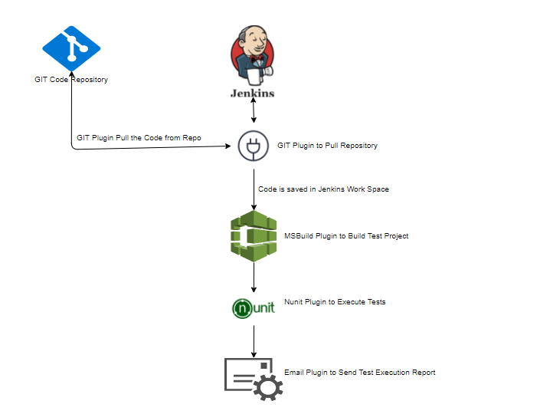

## 5.1. How to Install NUnit Console?

* Go to NUnit Website -> <http://nunit.org/>
* Click on Download -> Click on NUnit.Console

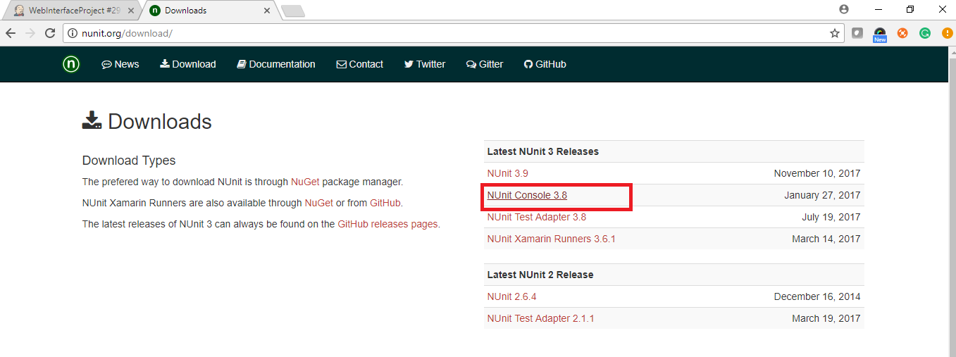

## 5.2. How to Install MS Build?

* Go to Visual Studio Website <https://www.visualstudio.com/downloads/>
* Select Build tools for Visual Studio and click on download

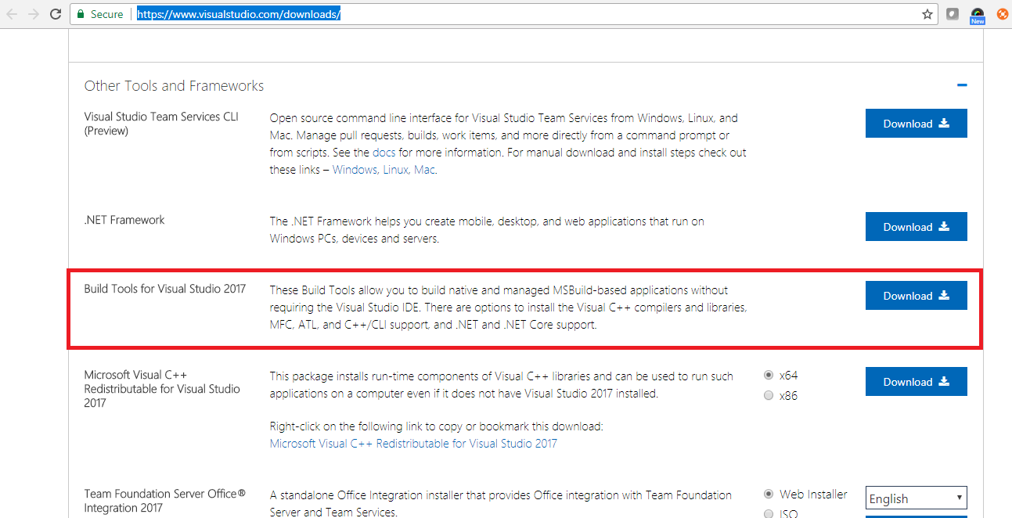

## 5.3. How to Setup One Click Automation in Jenkins?

5.3.1. Install Jenkins on Windows Machine.

* Browse to <https://jenkins.io/download/>

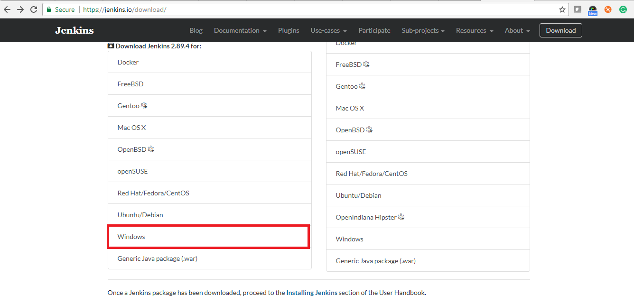

* Select Windows Version -> Download will start in the form of Zip file.
* Unzip Jenkin Folder -> Launch Jenkins.msi, installation window will open

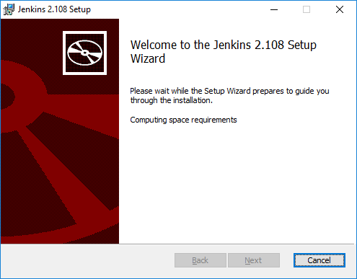

* Click Next-> Complete the installation.
* After Successful installation, hit URL <http://localhost:8080> in Browser.

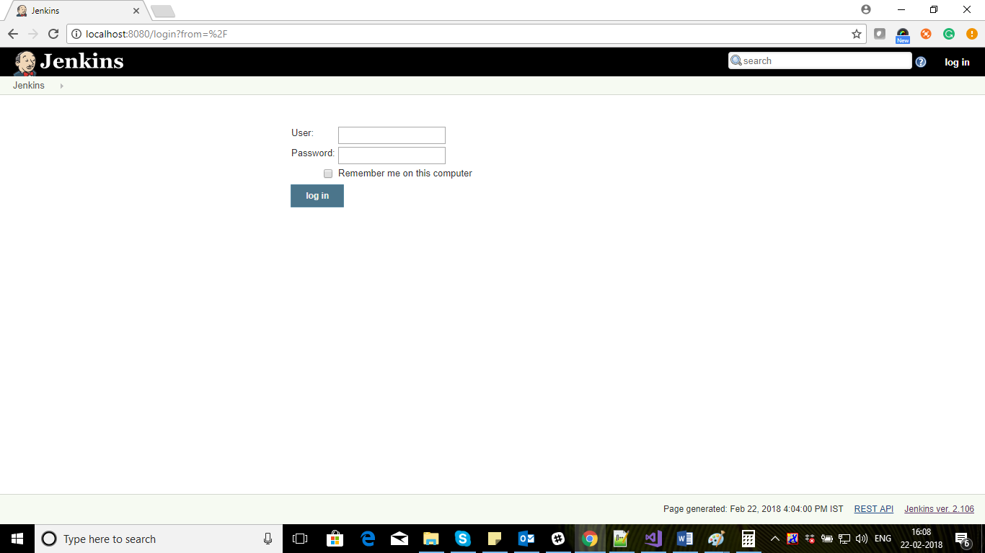

5.3.2. Add GIT, NUnit, MS Build and Email Plugin to Jenkins.

* Login in Jenkins using, Username and Password which you had set.



* Click on [http://localhost:8080/static/3a291c8c/images/24x24/gear2.png](http://localhost:8080/manage) [Manage Jenkins](http://localhost:8080/manage) -> Manage Plugins

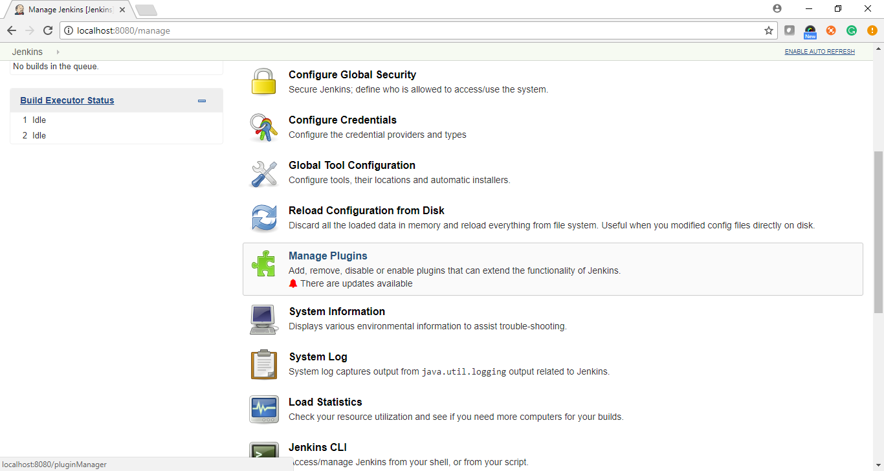

* Select Available Tab-> Search for GIT, MS Build, NUnit and Email Plugin and install
* After successful Installation they will display under installed Tab

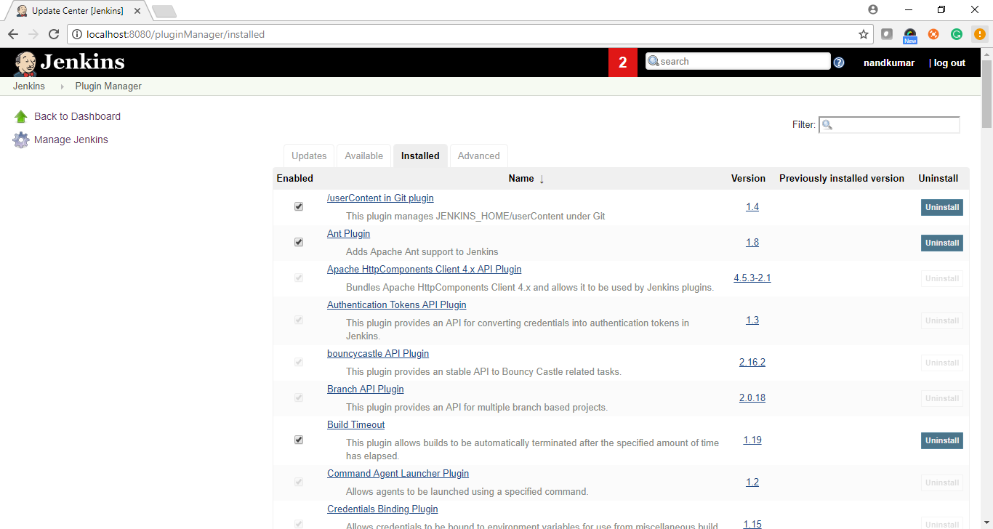

5.3.3. Setup Build Global Configuration in Jenkin.

* Go to [http://localhost:8080/static/3a291c8c/images/24x24/gear2.png](http://localhost:8080/manage) [**Manage Jenkins**](http://localhost:8080/manage) -> Click on Global Configuration Tab

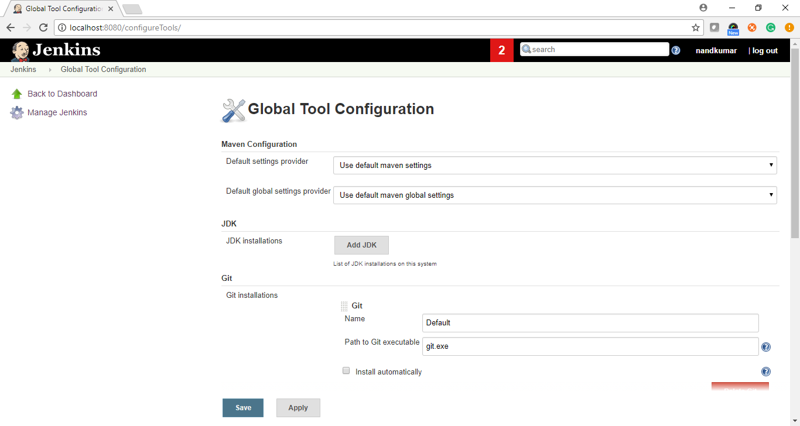

* Click on MS Build Configuration -> Section Will Expand -> Add Name of the Build and Path of the MSBuild.exe file as mentioned Below and Save Changes

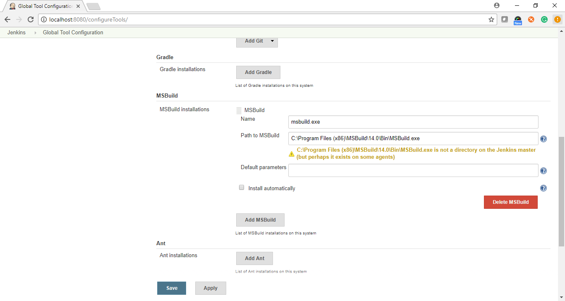

5.3.4. Setup Email Configuration in Jenkins

* Click on [http://localhost:8080/static/3a291c8c/images/24x24/gear2.png](http://localhost:8080/manage) [Manage Jenkins](http://localhost:8080/manage) -> Configure System

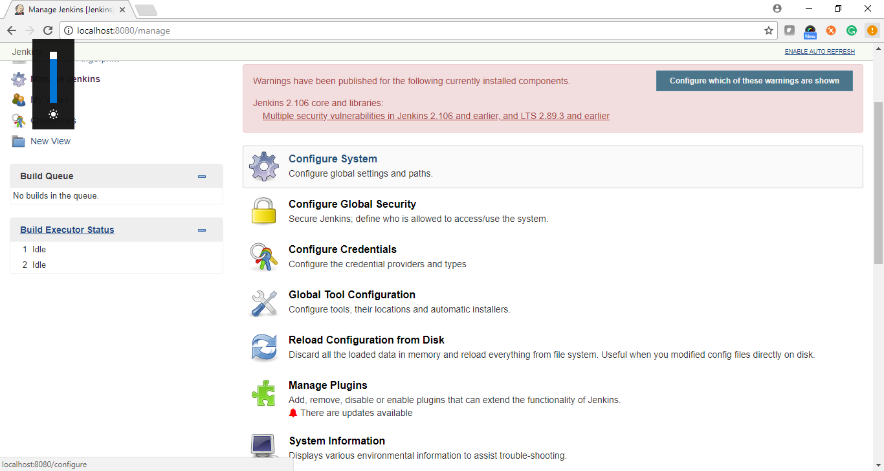

* Select Extended Email Notification -> Add SMTP Server Name, Authentication, Port, Charset as Mentioned Below -> Save Changes

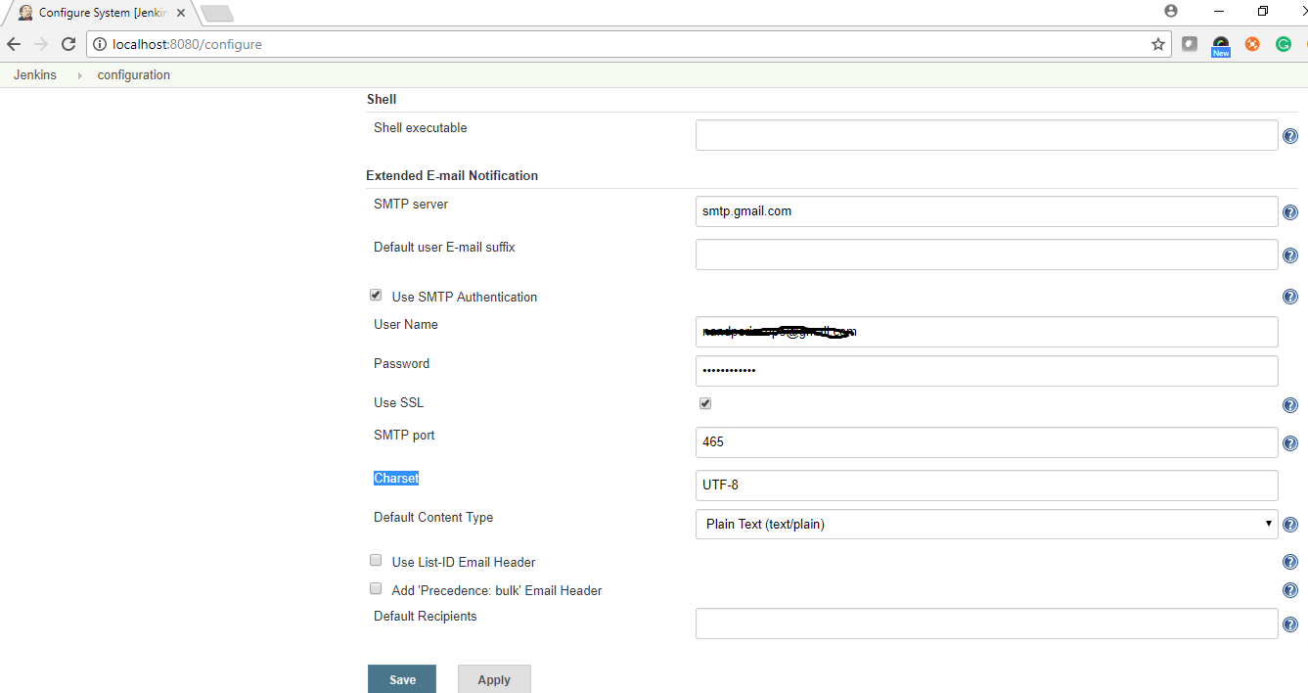

5.3.5. Setup a Build in Jenkins for One Click Automation.

* Click on [http://localhost:8080/static/3a291c8c/images/24x24/new-package.png](http://localhost:8080/view/all/newJob) [New Item](http://localhost:8080/view/all/newJob) -> Enter Project Name -> Select Project “FreeStyle Project”

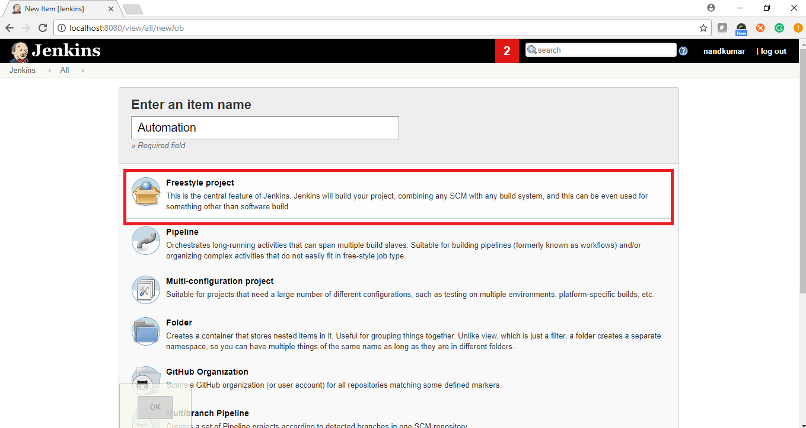

* Setup Source code management to pull the Code from GIT repository to Jenkins Work Space.

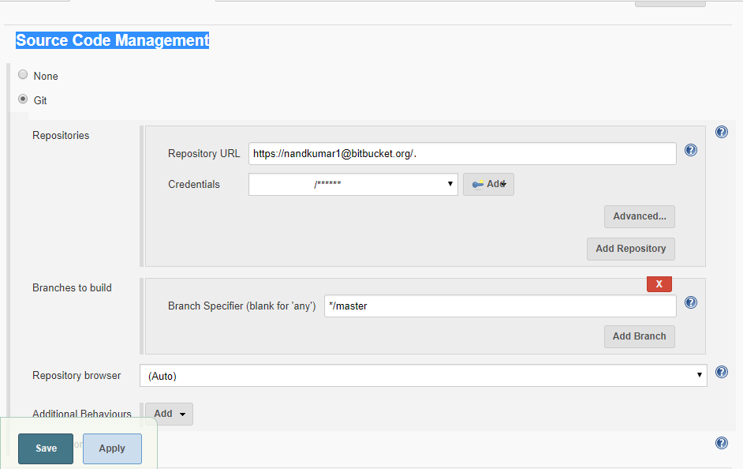

* Setup Build Configuration

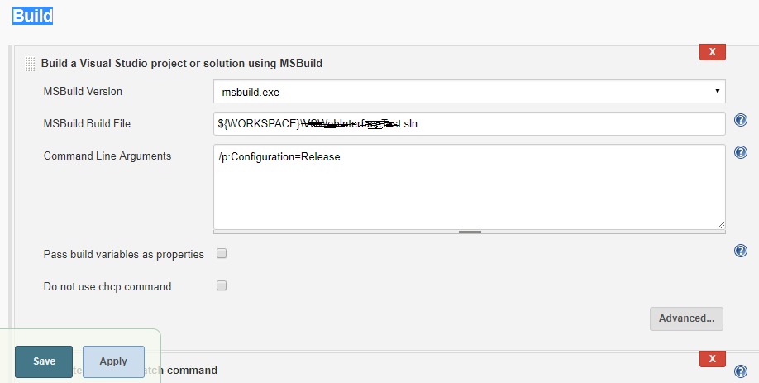

* Add Windows Batch Command under Build section to Download Nuget Package required for Project to build successfully.

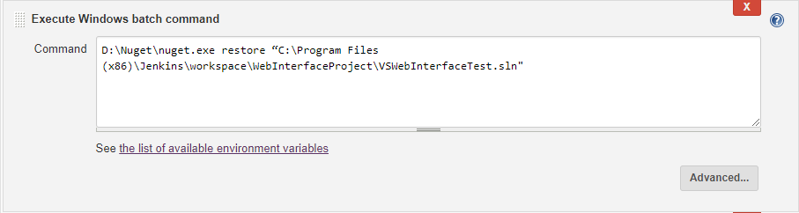

* Add Windows Batch Command to Trigger NUnit Tests after project build successfully.

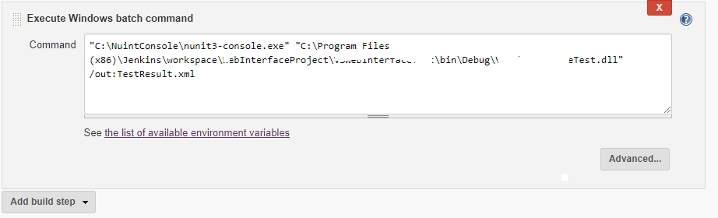

* Add Post- Build Action to Publish the Test Execution Result

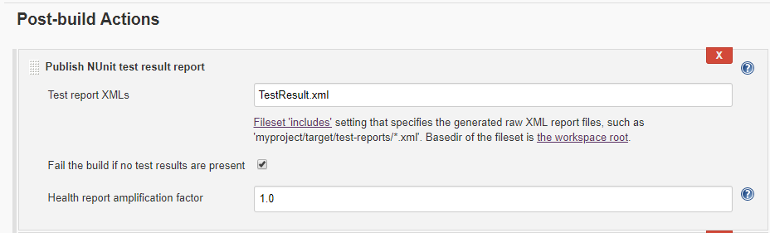

* Add Editable Email Notification under Post Build to Send Execution Result as attachment in notification Email.

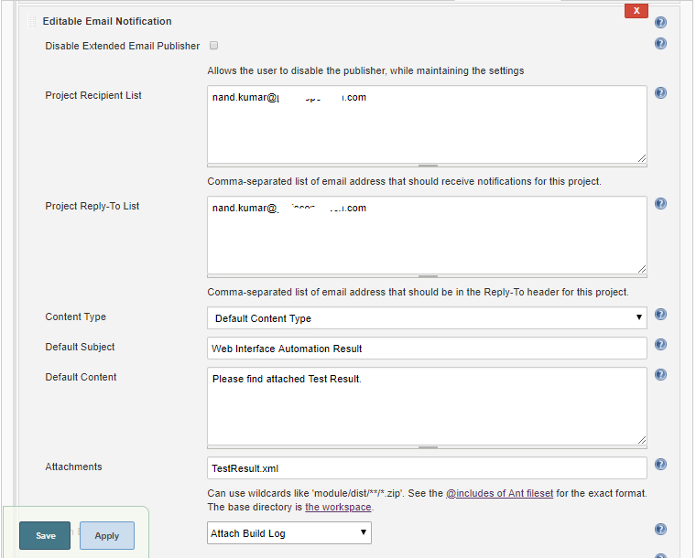

* Save All Changes

5.3.6. Run Build in Jenkins

* Browser Jenkins URL: <http://localhost:8080/>
* Login using Username and Password
* Go to Dashboard -> Select Your Project -> Click on Dropdown Arrow
* Click on Build

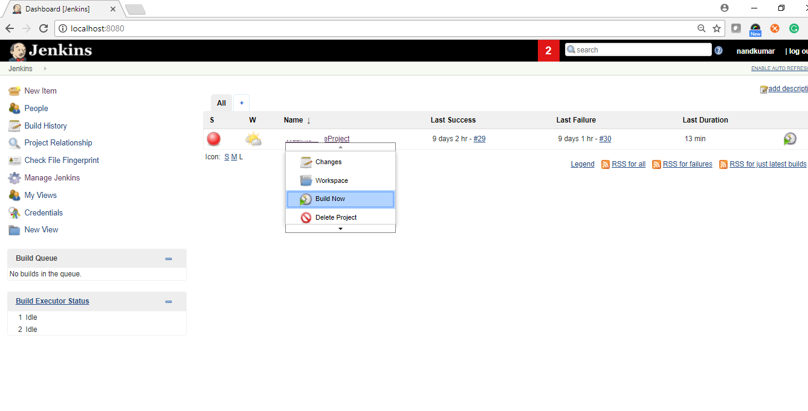

* Build will start, and you can see the Logs in Console

