C program to perform linear search using an array\

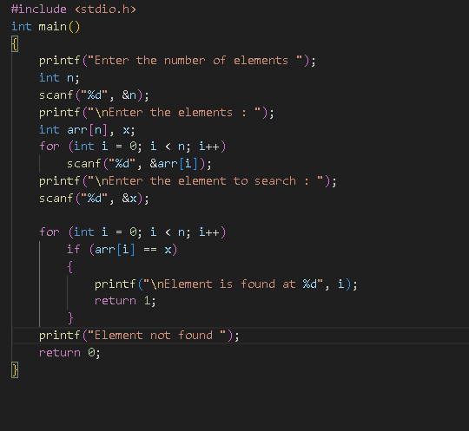

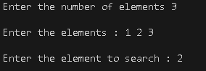



C program to implement binary search using an array

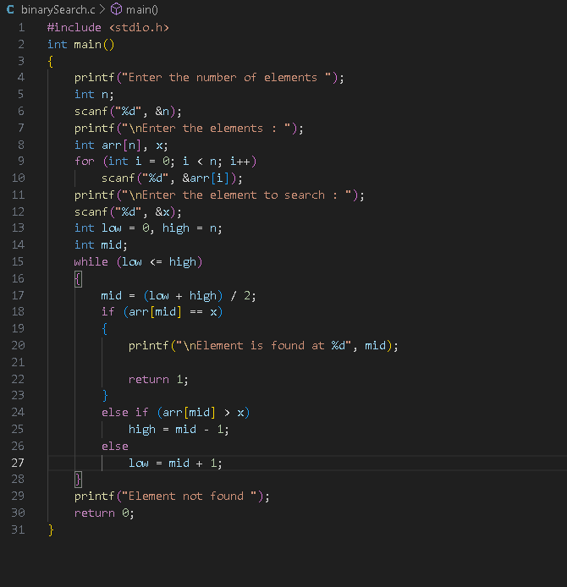

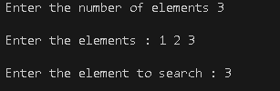



C program to insert element into an array



C program to delete an element from an array



C program to merge two arrays

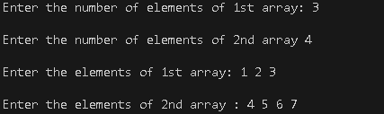



C program to insert an element in a linked list

