INTERNET PROGRAMMING LAB RECORD
PROGRAM 10
STYLEHUB – ONLINE FASHION RETAILER
Name: K.Nanda Kishore Reddy
Register Number: 192411161
Course code:CSA4307

AIM
To design a simple responsive online fashion shopping webpage named StyleHub using HTML, CSS, and JavaScript. The page displays fashion products, allows users to filter products by category, and add items to a shopping cart.

TOOL REQUIRED
HTML5, CSS3, JavaScript, and a web browser (Google Chrome or Microsoft Edge).

ALGORITHM
- Start the program.
- Create the webpage structure using HTML.
- Apply styling and responsive layout using CSS.
- Display fashion products with their names, categories, and prices.
- Use JavaScript to filter products by category.
- When the user clicks Add to Cart, update and display the cart count.
- Open index.html in a browser and test the page.
- Stop the program.

PROGRAM

1. index.html
<!DOCTYPE html>
<html lang="en">
<head>
<meta charset="UTF-8">
<meta name="viewport" content="width=device-width, initial-scale=1.0">
<title>StyleHub - Fashion Store</title>
<link rel="stylesheet" href="style.css">
</head>
<body>
<header>
<h1>StyleHub</h1>
<p>Fashion for Every Day</p>
<div class="cart">Cart: <span id="cart-count">0</span></div>
</header>
<main>
<h2>Explore Fashion</h2>
<label for="category">Filter by category:</label>
<select id="category" onchange="filterProducts()">
<option value="all">All Products</option>
<option value="Men">Men</option>
<option value="Women">Women</option>
<option value="Accessories">Accessories</option>
</select>
<section id="products" class="product-grid">
<article class="product" data-category="Men">
<div class="product-image">👕</div>
<h3>Classic T-Shirt</h3>
<p>Category: Men</p>
<p class="price">₹499</p>
<button onclick="addToCart()">Add to Cart</button>
</article>
<article class="product" data-category="Women">
<div class="product-image">👗</div>
<h3>Summer Dress</h3>
<p>Category: Women</p>
<p class="price">₹999</p>
<button onclick="addToCart()">Add to Cart</button>
</article>
<article class="product" data-category="Accessories">
<div class="product-image">👜</div>
<h3>Everyday Bag</h3>
<p>Category: Accessories</p>
<p class="price">₹799</p>
<button onclick="addToCart()">Add to Cart</button>
</article>
<article class="product" data-category="Men">
<div class="product-image">👟</div>
<h3>Casual Sneakers</h3>
<p>Category: Men</p>
<p class="price">₹1,299</p>
<button onclick="addToCart()">Add to Cart</button>
</article>
</section>
<p id="message" aria-live="polite"></p>
</main>
<footer><p>© 2026 StyleHub Fashion Store</p></footer>
<script src="script.js"></script>
</body>
</html>

2. style.css
* {
box-sizing: border-box;
}
body {
margin: 0;
font-family: Arial, sans-serif;
background: #f7f4f8;
color: #292333;
}
header {
background: #552b63;
color: white;
padding: 20px;
text-align: center;
position: relative;
}
header h1 {
margin: 0;
}
.cart {
margin-top: 8px;
font-weight: bold;
}
main {
max-width: 1000px;
margin: 25px auto;
padding: 0 16px;
}
select {
padding: 8px;
margin: 10px 0 20px;
}
.product-grid {
display: grid;
grid-template-columns: repeat(4, 1fr);
gap: 16px;
}
.product {
background: white;
border-radius: 10px;
padding: 16px;
text-align: center;
box-shadow: 0 2px 8px #ddd;
}
.product-image {
font-size: 48px;
background: #f0e7f3;
border-radius: 8px;
padding: 15px;
}
.price {
color: #552b63;
font-weight: bold;
}
button {
background: #552b63;
color: white;
border: 0;
border-radius: 5px;
padding: 9px 12px;
cursor: pointer;
}
button:hover {
background: #754187;
}
footer {
text-align: center;
padding: 15px;
background: #eee5f1;
}
@media (max-width: 750px) {
.product-grid {
grid-template-columns: repeat(2, 1fr);
}
}
@media (max-width: 450px) {
.product-grid {
grid-template-columns: 1fr;
}
}

3. script.js
let cartCount = 0;
function addToCart() {
cartCount++;
document.getElementById("cart-count").textContent = cartCount;
document.getElementById("message").textContent =
"Product added to cart successfully!";
}
function filterProducts() {
const selectedCategory = document.getElementById("category").value;
const products = document.querySelectorAll(".product");
products.forEach(function(product) {
const productCategory = product.dataset.category;
if (selectedCategory === "all" || productCategory === selectedCategory) {
product.style.display = "block";
} else {
product.style.display = "none";
}
});
}

OUTPUT
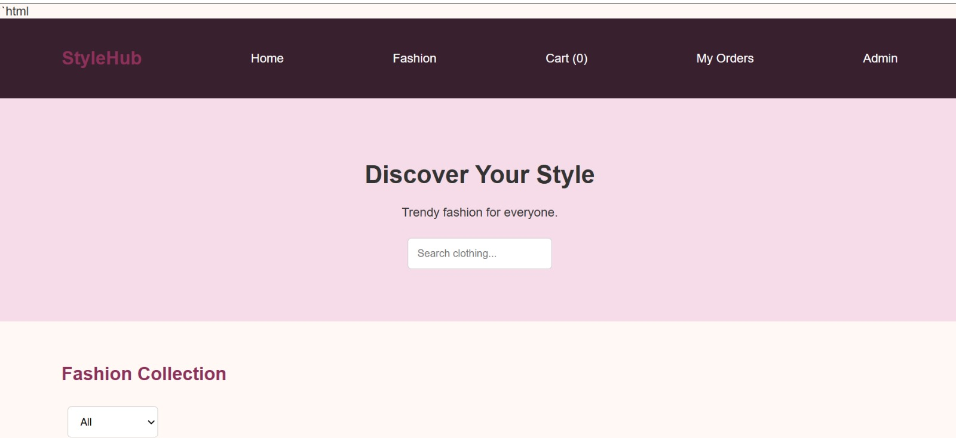

RESULT
Thus, a simple responsive StyleHub online fashion retailer webpage was created using HTML, CSS, and JavaScript. Product category filtering and cart-count updating work on the frontend. This is a demonstration webpage; it does not process real payments or store orders in a backend database.

