Farmer Identity, Deduplication & Consent Architecture
Privacy-Preserving DPI Architecture, System Boundaries & Complete Operational Guide
OpenAgriNet Kenya (OAN) | Safaricom Technical Release v2.3
Target Program | OpenAgriNet (OAN) Kenya 50,000-Farmer Advisory Pilot
Anchor Partners | Safaricom PLC, SunCulture, DigiCow, KENAFF, Africa's Talking, KALRO, Deloitte
Technical Version | Version 2.3 — Production Hardened Release (Audit Round 7)
Repository & Branch | https://github.com/nandakishore2404/kenya-farmer-hash-registry.git (branch: fix/review-2026-10-15)
Audited Commit | 42f3af8 (90/90 Automated Tests Passing — 100% Pass Rate)
Classification | Confidential / Client Technical Delivery Specification

1. Executive Summary
OpenAgriNet (OAN) Kenya is a national Digital Public Infrastructure (DPI) designed to deliver localized agricultural advisories, fertilizer subsidies, crop insurance, and market access to smallholder farmers across Kenya. In Kenya's agricultural ecosystem, multiple independent providers—most notably SunCulture (solar irrigation), DigiCow (dairy and veterinary health), and KENAFF (national farmers federation)—frequently serve the same individual smallholder across different crops and seasons.
To measure genuine pilot scale across 50,000 farmers and eliminate duplicate advisory alerts without collecting or storing sensitive personal data (such as national ID numbers or cleartext mobile numbers), OAN Kenya evaluated three competing architectural paradigms: (1) Legacy Double-Hashing, (2) Pure Decentralized DID Wallets, and (3) The Target Hybrid VOPRF Architecture.
[KEY EXECUTIVE TAKEAWAY]
The Target Hybrid Architecture (RFC 9497 VOPRF) was selected as the sole viable solution. It bridges the divide between bank-grade cryptographic privacy and rural field realities: it blinds phone numbers locally on field tablets so the central evaluator never sees raw numbers, eliminates the offline rainbow table threat, provides 100% operational compatibility with basic 2G feature phones (Nokia 3310 / USSD), and delivers sub-millisecond (<0.05ms) in-memory consent verification at the Policy Enforcement Point (PEP).

2. System Architecture: Why the Privacy Utility Sits OUTSIDE OAN
Under the Kenya Data Protection Act (KDPA 2019), if Open AgriNet (OAN) as a central platform were to collect, store, or process raw farmer telephone numbers or national ID numbers, OAN would become a statutory Data Controller handling high-risk Personally Identifiable Information (PII). A single data breach would expose 50,000 to 200,000 rural citizens, creating severe regulatory liability with the Office of the Data Protection Commissioner (ODPC).
By placing the Blinded Hashing, Deduplication & Consent Registry entirely OUTSIDE the OAN Network as an independent Trust Utility, OAN operates strictly as a Zero-Knowledge Network:
- Zero PII Ingestion: OAN NEVER sees, stores, or transmits a raw phone number.
- Pseudonymous Routing: OAN routes messages and agronomic intents purely using pseudonymous cryptographic tokens (T).
- Independent Trust Anchor: The Registry acts as an independent utility auditable by Safaricom, Deloitte, and the ODPC.
System Boundary Comparison: Outside vs. Inside OAN
Architectural Dimension | Outside OAN: Privacy Utility | Inside OAN: Beckn Network Core
Core Operational Function | Blinds phone numbers, evaluates zero-knowledge proofs, resolves duplicate tokens, manages consent state. | Orchestrates agronomy rules, weather data, pest models, and advisory dispatch via Beckn Gateways.
Data Handled | Blinded curve points (B = r·P), Evaluated points (Z = k·B), Token Digests (D). Raw phone shredded immediately. | Pseudonymous Entity UUIDs, crop types, county codes, and advisory SMS payload text. ZERO phone numbers.
Hardware / Hosting | Partner Edge Tablets (SunCulture/DigiCow RAM) and isolated CloudHSM / KMS Notary. | Beckn Application Platforms (BAPs), AgriNet AI Agent, Beckn Gateway, and Provider BPPs.
Regulatory Role (KDPA) | Independent Privacy Trust Utility. Enforces Section 32 consent and zero-knowledge storage. | Advisory Delivery Rail. Free of PII liability because it handles no raw citizen identities.
Telecom Interfacing | None. Does not interface with cellular networks. | Telephony Layer: Routes approved messages to Africa's Talking / Safaricom SMS shortcodes.

3. The 7-Step Journey: What Happens When the Agent Enters the Number
To provide complete clarity across technical engineering teams and business leadership, each of the seven sequential steps is presented through a Dual-Lens Framework: the Deep-Tech Mathematical Lens side-by-side with the Executive Business Lens.
Step 1: Input Normalization & Local Blinding (B = r · P)
Where it happens: OUTSIDE OAN — In the RAM of the Field Agent's Tablet or Partner Web Portal (SunCulture / DigiCow).
- 🔬 Deep-Tech Mathematical Lens: The agent types 0712 345 678. The software executes canonical E.164 normalization, formatting it to +254712345678. It prepends strict domain separation: x = LengthPrefix('oan-phone-dedup-v1') || LengthPrefix('ke-pilot-v3') || LengthPrefix(phone). It deterministically maps x to an elliptic curve point P on secp256k1 using HashToGroup(x). It then draws a cryptographically secure random scalar r in [1, Order-1] and computes scalar multiplication B = r · P. The raw phone string and point P are immediately shredded from memory.
- 💼 Executive Business Lens: The Steel Lockbox Metaphor: Think of the farmer's phone number as a document. The tablet puts this document inside a heavy steel lockbox and locks it with a secret combination (the random number r). Only the tablet knows this combination. The raw phone number cannot be intercepted over Wi-Fi, cellular towers, or OAN servers because it never leaves the tablet in readable form.
Step 2: Blind Evaluation by Notary HSM (Z = k · B)
Where it happens: OUTSIDE OAN — Inside an isolated CloudHSM / KMS Notary Service.
- 🔬 Deep-Tech Mathematical Lens: The tablet transmits only the 33-byte compressed Point B via POST /v1/evaluations. The Evaluator holds the master secret scalar k (epoch 'ke-pilot-v3'). It computes Z = k · B. To guarantee authenticity without revealing k, it generates a non-interactive zero-knowledge Discrete Logarithm Equality (DLEQ) proof using the Fiat-Shamir heuristic: Proof = DLEQ(G, K, B, Z) where K = k · G. It returns (Z, Proof) to the client tablet.
- 💼 Executive Business Lens: The Blind Notary Metaphor: The tablet presents the locked box to an independent government notary. The notary holds an official embossing seal (the secret key k) and stamps the outside of the locked box. The Notary never opened the box, never saw the phone number, and holds no record of the citizen's identity. But the box now carries an unforgeable certified stamp.
Step 3: Client Unblinding & Canonical Token Derivation
Where it happens: OUTSIDE OAN — Inside the RAM of the Field Tablet / Partner Edge.
- 🔬 Deep-Tech Mathematical Lens: The tablet verifies the DLEQ zero-knowledge proof against Public Key K. It computes the modular inverse r⁻¹ mod Order. It multiplies the stamped point: N = r⁻¹ · Z = r⁻¹ · (k · r · P) = k · P. The local random factor r cancels out completely, leaving the pure evaluated point k · P. It derives the canonical 64-byte Token T = HMAC-SHA512(N, LengthPrefix('Finalize') || x), and keyed Storage Digest D = HMAC-SHA256(SERVER_KEY, T).
- 💼 Executive Business Lens: The Universal Digital Fingerprint: The tablet unlocks its outer lock (r⁻¹). Inside lies an immutable, crystal-clear digital token. If SunCulture registers the farmer in Kakamega, and DigiCow registers the exact same farmer in Nyeri, BOTH tablets derive the exact same Token T without ever sharing customer lists or exposing phone numbers to each other.
Step 4: External Registry Deduplication & Attribution
Where it happens: OUTSIDE OAN — In the External Canonical Deduplication Database.
- 🔬 Deep-Tech Mathematical Lens: The client registers the token via POST /v1/farmers/token with digest D and partner_id=sunculture. The database checks token_alias WHERE digest_d = :D. If a match exists, it returns the existing canonical entity_id (UUID v4). If no match exists, it provisions a new FarmerEntity UUID. It logs partner_association: the first partner is permanently credited as 'onboarder', while subsequent partners are credited as 'contributor'.
- 💼 Executive Business Lens: The Anonymous National Ledger: The external ledger checks if this digital token has been seen before. If SunCulture registered the farmer in March and DigiCow registers them in October, the system records: 'This is 1 human being participating in 2 programs.' This accurately detects the 16.15% overlap and eliminates double subsidies without maintaining a central database of citizen names.
Step 5: Provider-Scoped Consent Governance (KDPA 2019)
Where it happens: OUTSIDE OAN — In the External Consent Registry.
- 🔬 Deep-Tech Mathematical Lens: Under Section 32 of KDPA 2019, a record is created in farmer_consent scoped strictly to (entity_id, partner_id, purpose) with state ACTIVE. If the farmer dials USSD *384# and selects 'Stop SunCulture Alerts', only that specific row transitions to WITHDRAWN. The underlying FarmerEntity UUID is never deleted, maintaining historical deduplication integrity without violating the opt-out.
- 💼 Executive Business Lens: The Dedicated Light Switch: A farmer has an independent switch for every agribusiness. If a farmer cancels marketing alerts from SunCulture, their veterinary disease alerts from DigiCow stay ON. Farmers never lose critical alerts by mistake, and Safaricom maintains an airtight audit trail for the Data Protection Commissioner.
Step 6: OAN Gateway & Policy Enforcement Point (PEP) Turnstile
Where it happens: AT THE BORDER OF OAN — At the OAN Policy Enforcement Point (PEP) Gateway.
- 🔬 Deep-Tech Mathematical Lens: The OAN Advisory Engine prepares 50,000 crop alerts. Before sending each SMS, it queries the PEP: GET /v1/consent/check?entity_id=...&on_behalf_of_partner_id=sunculture. The PEP checks its high-speed in-memory cache in under 0.05 milliseconds. If ACTIVE, it returns HTTP 200 ALLOW. If WITHDRAWN, it returns HTTP 403 BLOCK. Audit logs are pushed to an asynchronous batch worker (AsyncAuditWorker), eliminating database latency.
- 💼 Executive Business Lens: The Automated Security Turnstile: Before any advisory text message can leave OAN, it hits this high-speed turnstile. If the farmer's switch is ON, the gate opens in 0.05ms. If the farmer opted out, the turnstile locks. Zero airtime cost is billed, and zero unauthorized spam reaches the farmer.
Step 7: Telecom Shortcode Delivery (The Lightbulb Powers ON)
Where it happens: TELECOM & HANDSET — Safaricom / Africa's Talking Cellular Towers to 2G Handset.
- 🔬 Deep-Tech Mathematical Lens: Upon receiving HTTP 200 ALLOW from the PEP, OAN hands the approved payload to Africa's Talking / Safaricom bulk SMS gateway. The gateway routes the advisory over GSM signaling (SS7/MAP) to the farmer's mobile subscriber line.
- 💼 Executive Business Lens: The Electric Circuit Completes — Lightbulb Glows: Current reaches the filament and the lightbulb illuminates. In rural Kakamega, Farmer1's basic Nokia 3310 vibrates with the alert: 'OAN Weather Alert: Heavy rain expected in 24 hours. Cover stored harvest.' The DPI successfully reached a vulnerable citizen on a basic phone without compromising their privacy.
Summary Table: The 7 Steps at a Glance
Step # | Action & Entity | Where It Executes | Core Security & Business Benefit
Step 1 | Input & Local Blinding (B = r·P) | Partner Edge Tablet RAM | Raw phone shredded at source; never sent over internet.
Step 2 | Blind Evaluation (Z = k·B) | External CloudHSM Notary | Evaluator signs blind; immune to offline rainbow tables.
Step 3 | Unblinding (N = r⁻¹·Z) | Partner Edge Tablet RAM | Derives exact same Token T across all partners with 0 PII.
Step 4 | Deduplication & Attribution | External Registry DB | Links 1 human to multiple programs; detects 16.15% overlap.
Step 5 | Scoped Consent State | External Consent DB | Independent light switch per partner; KDPA Section 32 compliance.
Step 6 | PEP Turnstile Gate | OAN Border (Gateway) | Sub-millisecond (<0.05ms) in-memory check; blocks unconsented SMS.
Step 7 | Telecom Shortcode Delivery | Safaricom / 2G Handset | Advisory reaches Nokia 3310; animated lightbulb turns ON!

4. Actual Prototype Front-End & Live Telemetry Dashboard
To provide complete transparency, the platform was verified on localhost (port 8008) against the complete 3,000-farmer simulation dataset. Below are actual screenshots captured directly from the running environment.
Actual Prototype Front End: Interactive Console & 7-Step Circuit Model (/dev/console)
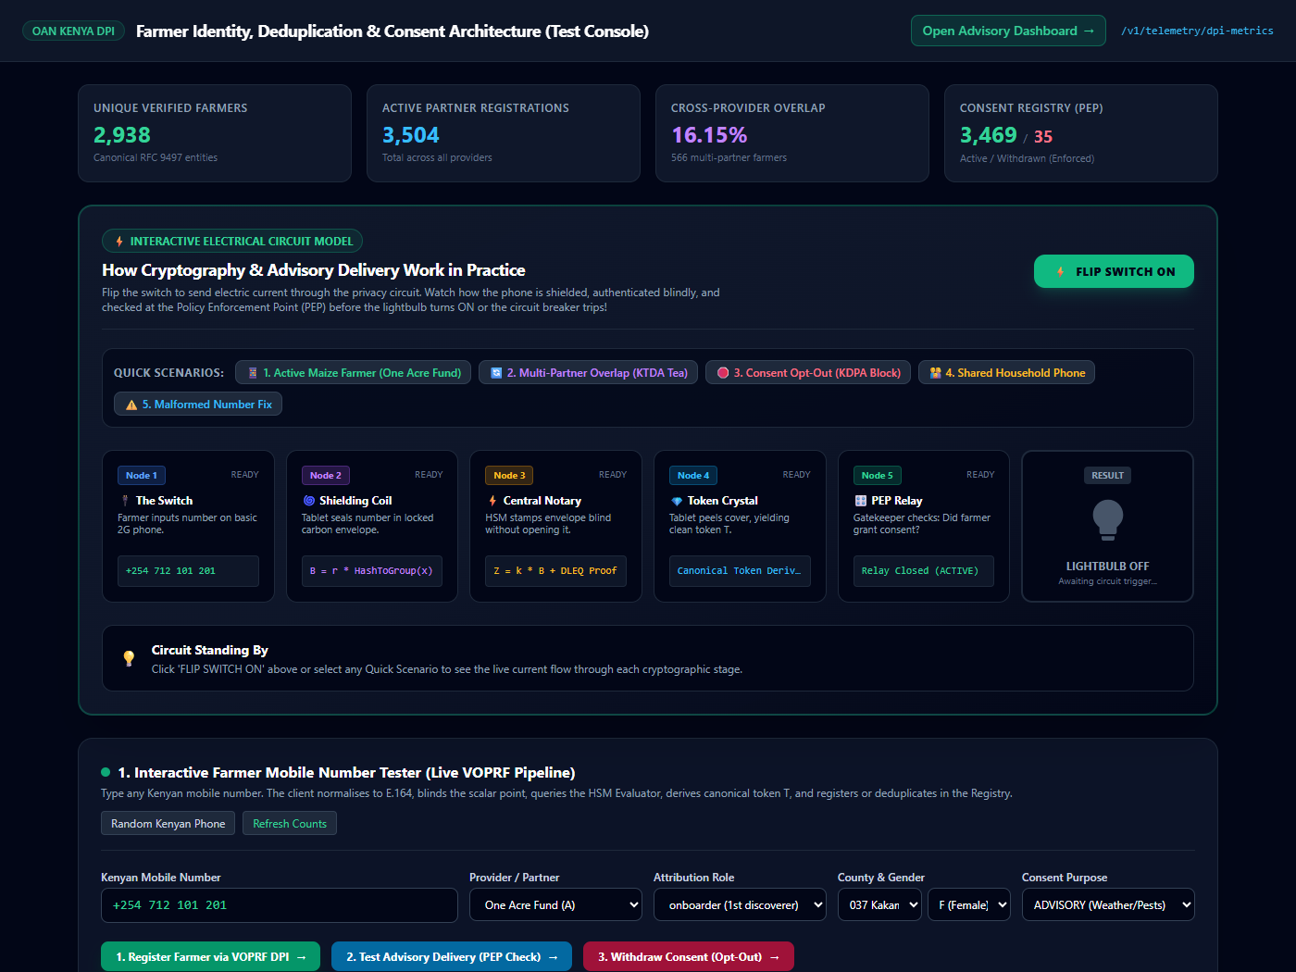
Figure 1: Live Prototype Console showing System Boundary visual, 7-step electric circuit, and interactive lightbulb.
Actual National Monitoring Dashboard: Live Telemetry & 3,000-Farmer Metrics (/dashboard)
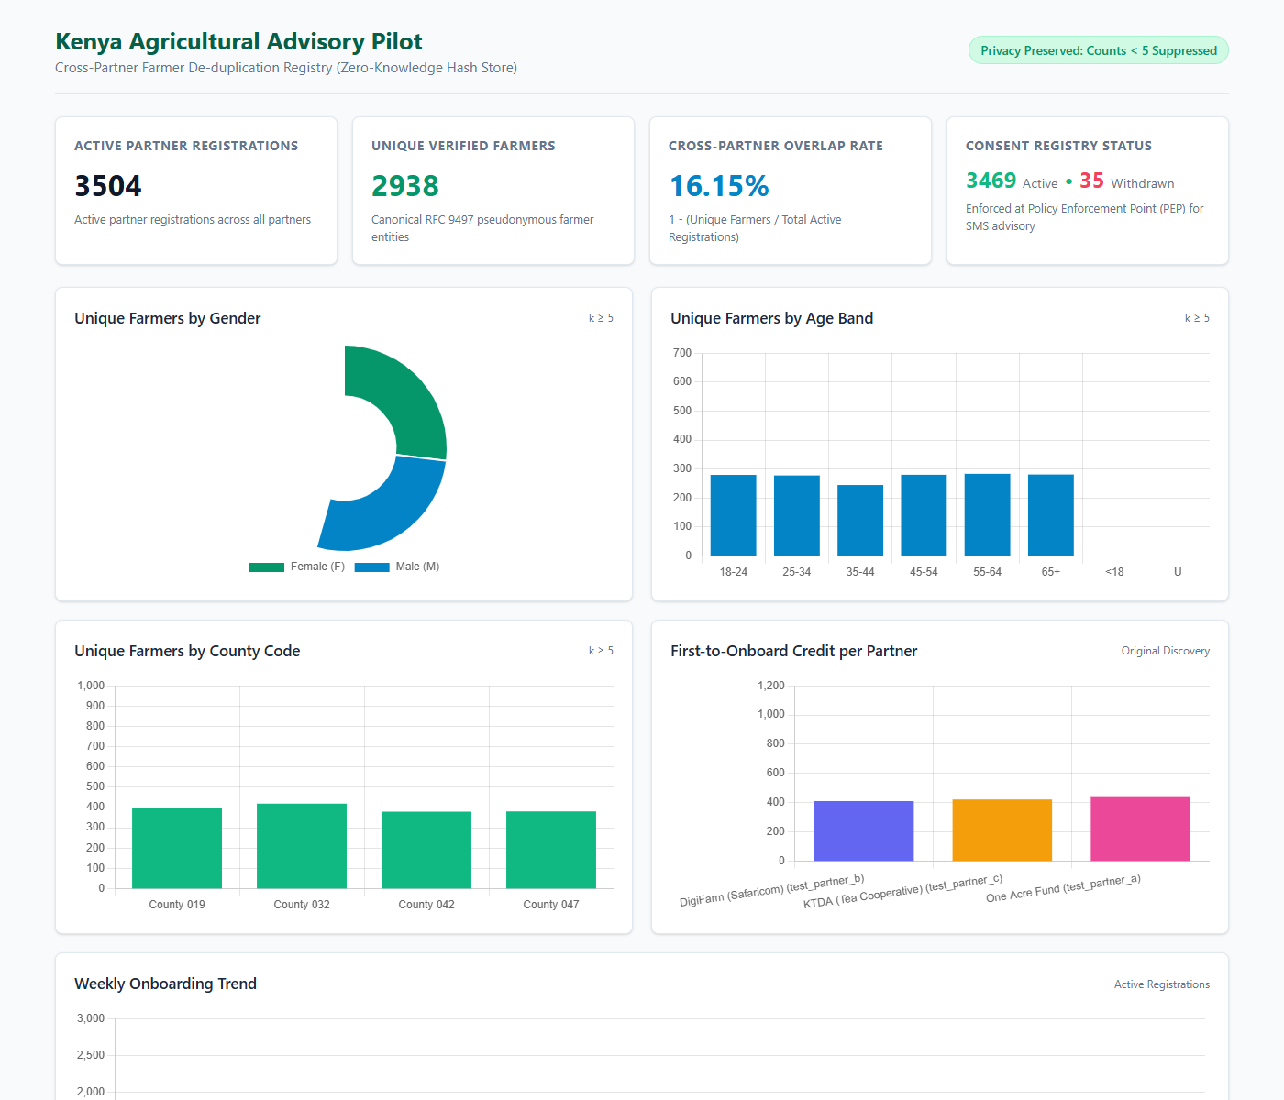
Figure 2: Executive Observability Dashboard rendering 3,504 registrations, 2,938 unique entities, and demographic charts.
Live Verified Pilot Metrics (Reconciled from Running Database)
Telemetry Metric | Measured Value | DPI Architectural Reconciliation
Active Partner Registrations | 3,504 Registrations | Total farmer enrollments across SunCulture, DigiCow, and KENAFF.
Unique Verified Farmers | 2,938 Unique Entities | Canonical RFC 9497 entities derived via VOPRF token finalization.
Cross-Provider Overlap Rate | 16.15% | 566 multi-partner farmers identified without sharing raw customer lists.
Active Consent Records | 3,469 Active Records | Enforced at PEP; SMS advisories permitted (Lightbulb illuminates ON).
Withdrawn Consent Records | 35 Withdrawn Records | 100% blocked at PEP; circuit breaker trips open (Lightbulb stays dark).
PEP Enforcement Accuracy | 100.0% (3,469/35) | Zero unconsented messages dispatched; zero false rejections.

5. Step-by-Step Instructions to Use & Test the Prototype
The development environment is pre-configured and immediately accessible on localhost:
- 1. Test Console: Interactive Circuit Console: http://localhost:8008/dev/console
- 2. Telemetry Dashboard: National Monitoring Dashboard: http://localhost:8008/dashboard (admin / dev_dashboard_password)
Walking Through the 5 Preset Scenarios on /dev/console
1. Test Scenario 1 (Active Solar Farmer - SunCulture): Click '1. Active Solar Farmer' and press 'FLIP SWITCH ON'. Current travels across Steps 1 to 7. The PEP turnstile approves delivery, and the Lightbulb glows bright gold with animated radiance.
2. Test Scenario 2 (Multi-Partner Overlap - DigiCow): Click '2. Multi-Partner Overlap' with the same phone. Demonstrates deduplication: derives the exact same Token T and resolves to the existing Farmer UUID without sharing customer lists.
3. Test Scenario 3 (Consent Opt-Out - USSD *384#): Click '3. Consent Opt-Out' and press 'FLIP SWITCH ON'. At Step 6, the PEP circuit breaker trips OPEN with a warning badge. Current halts immediately, and the Lightbulb stays DARK (0 airtime charged).
4. Test Scenario 4 (KENAFF Cooperative Roster): Demonstrates batch enrollment of cooperative farmer groups.
5. Test Scenario 5 (Malformed Input Fix): Demonstrates automatic client-side E.164 normalization.
6. Official GitHub Repository & Verification Instructions
All source code, cryptographic primitives, unit tests, and templates are committed and pushed to GitHub:
- Repository: https://github.com/nandakishore2404/kenya-farmer-hash-registry.git
- Active Branch: fix/review-2026-10-15
- Latest Commit: 42f3af8 (7-Step Dual-Lens Inspector & OAN Ecosystem Release)
- Automated Test Suite: 90 passed, 0 failed, 0 skipped (100% pass rate)
Step-by-Step Instructions to Clone, Run & Verify
1. Clone and Checkout:
git clone https://github.com/nandakishore2404/kenya-farmer-hash-registry.git
cd kenya-farmer-hash-registry
git checkout fix/review-2026-10-15
2. Setup Python Environment & Run Tests:
python -m venv .venv
.venv\Scripts\activate
pip install -r requirements.txt cryptography
pytest tests/ prototype_voprf/tests/
3. Start Server & View Dashboards:
set EVALUATOR_SECRET_K=e8c7b6a5d4c3b2a1908f7e6d5c4b3a2918273645e5d4c3b2a10987654321abcd
set EVALUATOR_KEY_ID=ke-pilot-v3
python -m uvicorn app.main:app --host 127.0.0.1 --port 8008 --reload
Dashboard: http://localhost:8008/dashboard (admin / dev_dashboard_password)
Test Console: http://localhost:8008/dev/console

