**Linux Programming(Lab-5)**

**Name : G Nanda Kishore**

**Reg No:17MIS1066**

**Exercise 1:**

**Code:**

in the given code there is a compilation error i.e, intmain , we can’t proceed further with this error so cange it to int main.

#include <stdio.h>

/* Print the sum of the integers from 1 to 1000 */

int main(int argc, char **argv)

{

int i;

int sum; sum = 0;

for(i = 0; i -= 1000; i++)

{ sum += i; }

printf("%d\n", sum);

return 0;

}

Output:

1. We got an -ve value which is wrong

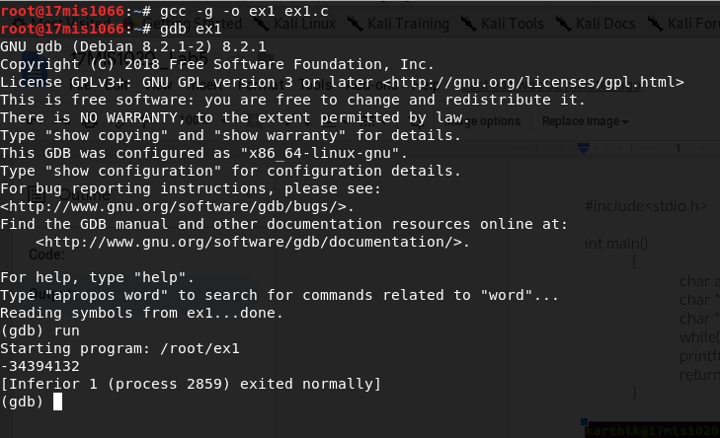

Go set a break point at main function and check for all the lines by giving next. Check the data values each line.

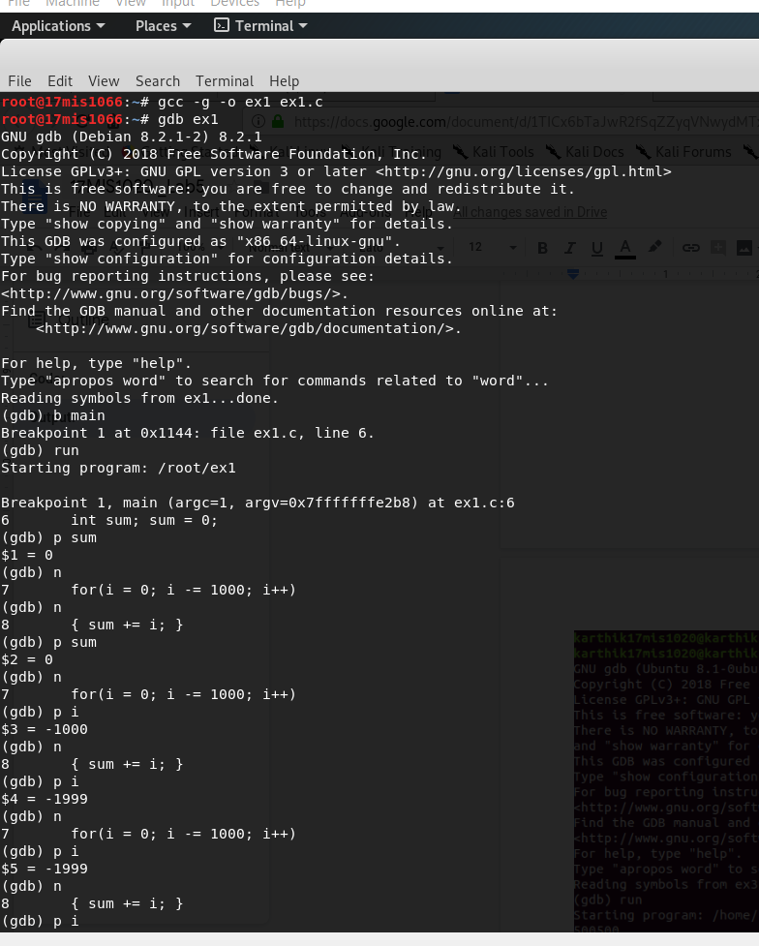

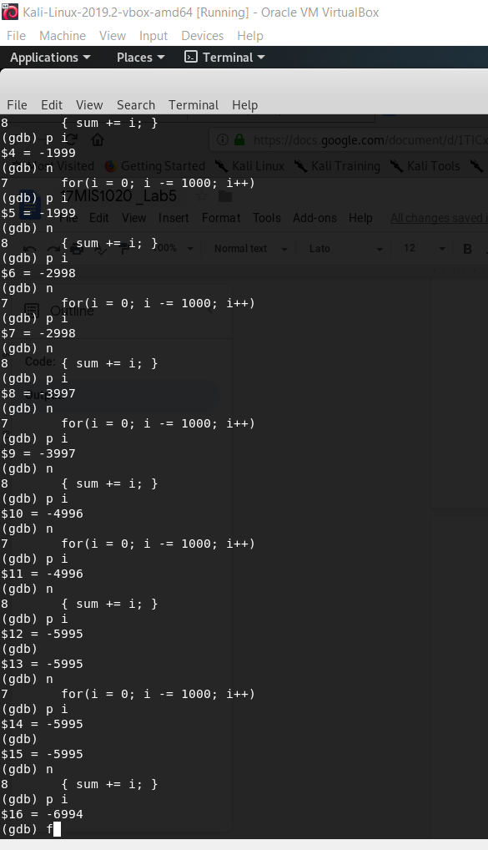

**\*\*Debugging through changing code for(i = 0; i <= 1000; i++) then it works.**

**Debugged Code :**

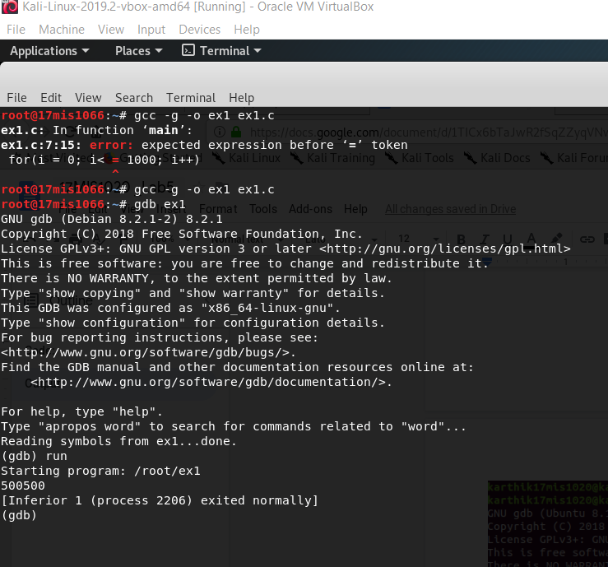

**Exercise 2:**

**Code:**

#include<stdio.h>

int main()

{

char *s = “Goal”;

char *t = “Home”;

while(*s++ = *t++)

printf(*s);

return 0;

**Output:**

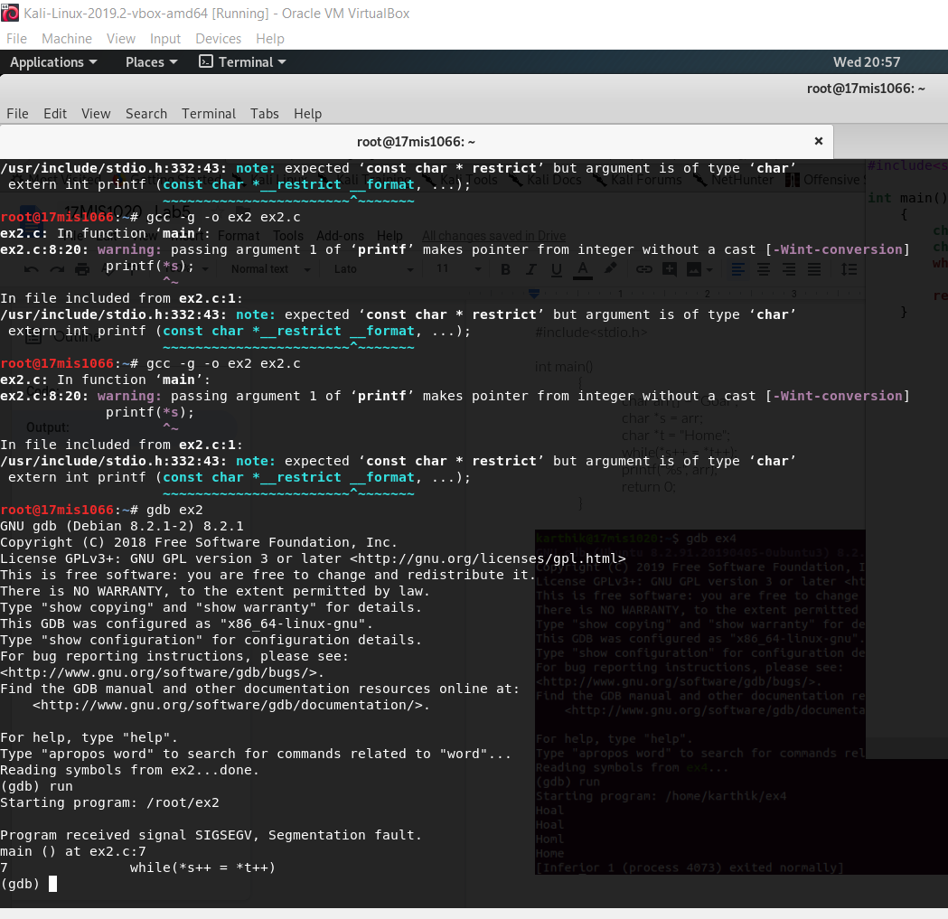

**\*\*We can see segmentation fault due to error in while loop.**

**\*\* Through replacing it with array then the code works.**

char arr[] = "Goal";

char *s = arr;

char *t = "Home";

while(*s++ = *t++);

printf("%s", arr);

**After Debugging:**

