[**http://localhost:8080/hello**](http://localhost:8080/hello)

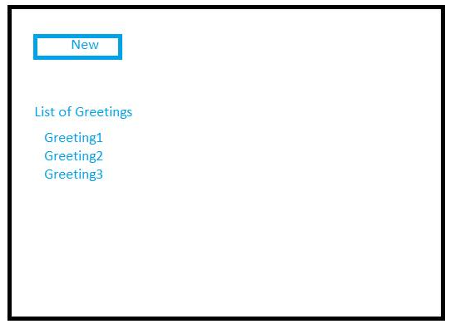

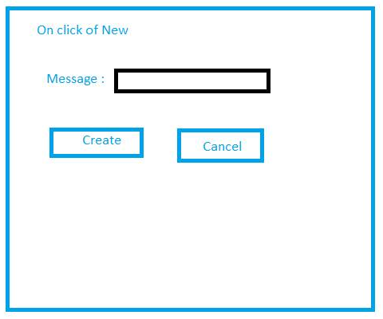 [**http://localhost:8080/hello/{id}**](http://localhost:8080/hello/%7bid%7d)

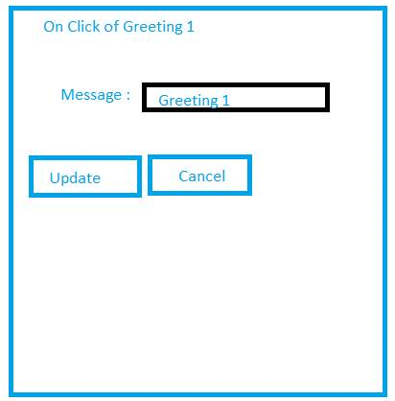  
[**http://localhost:8080/hello/{id}**](http://localhost:8080/hello/%7bid%7d)