1. Navigate to the Debug window of the STM32CubeIDE. Perform a Terminate and Remove of the task shown in the Debug window.

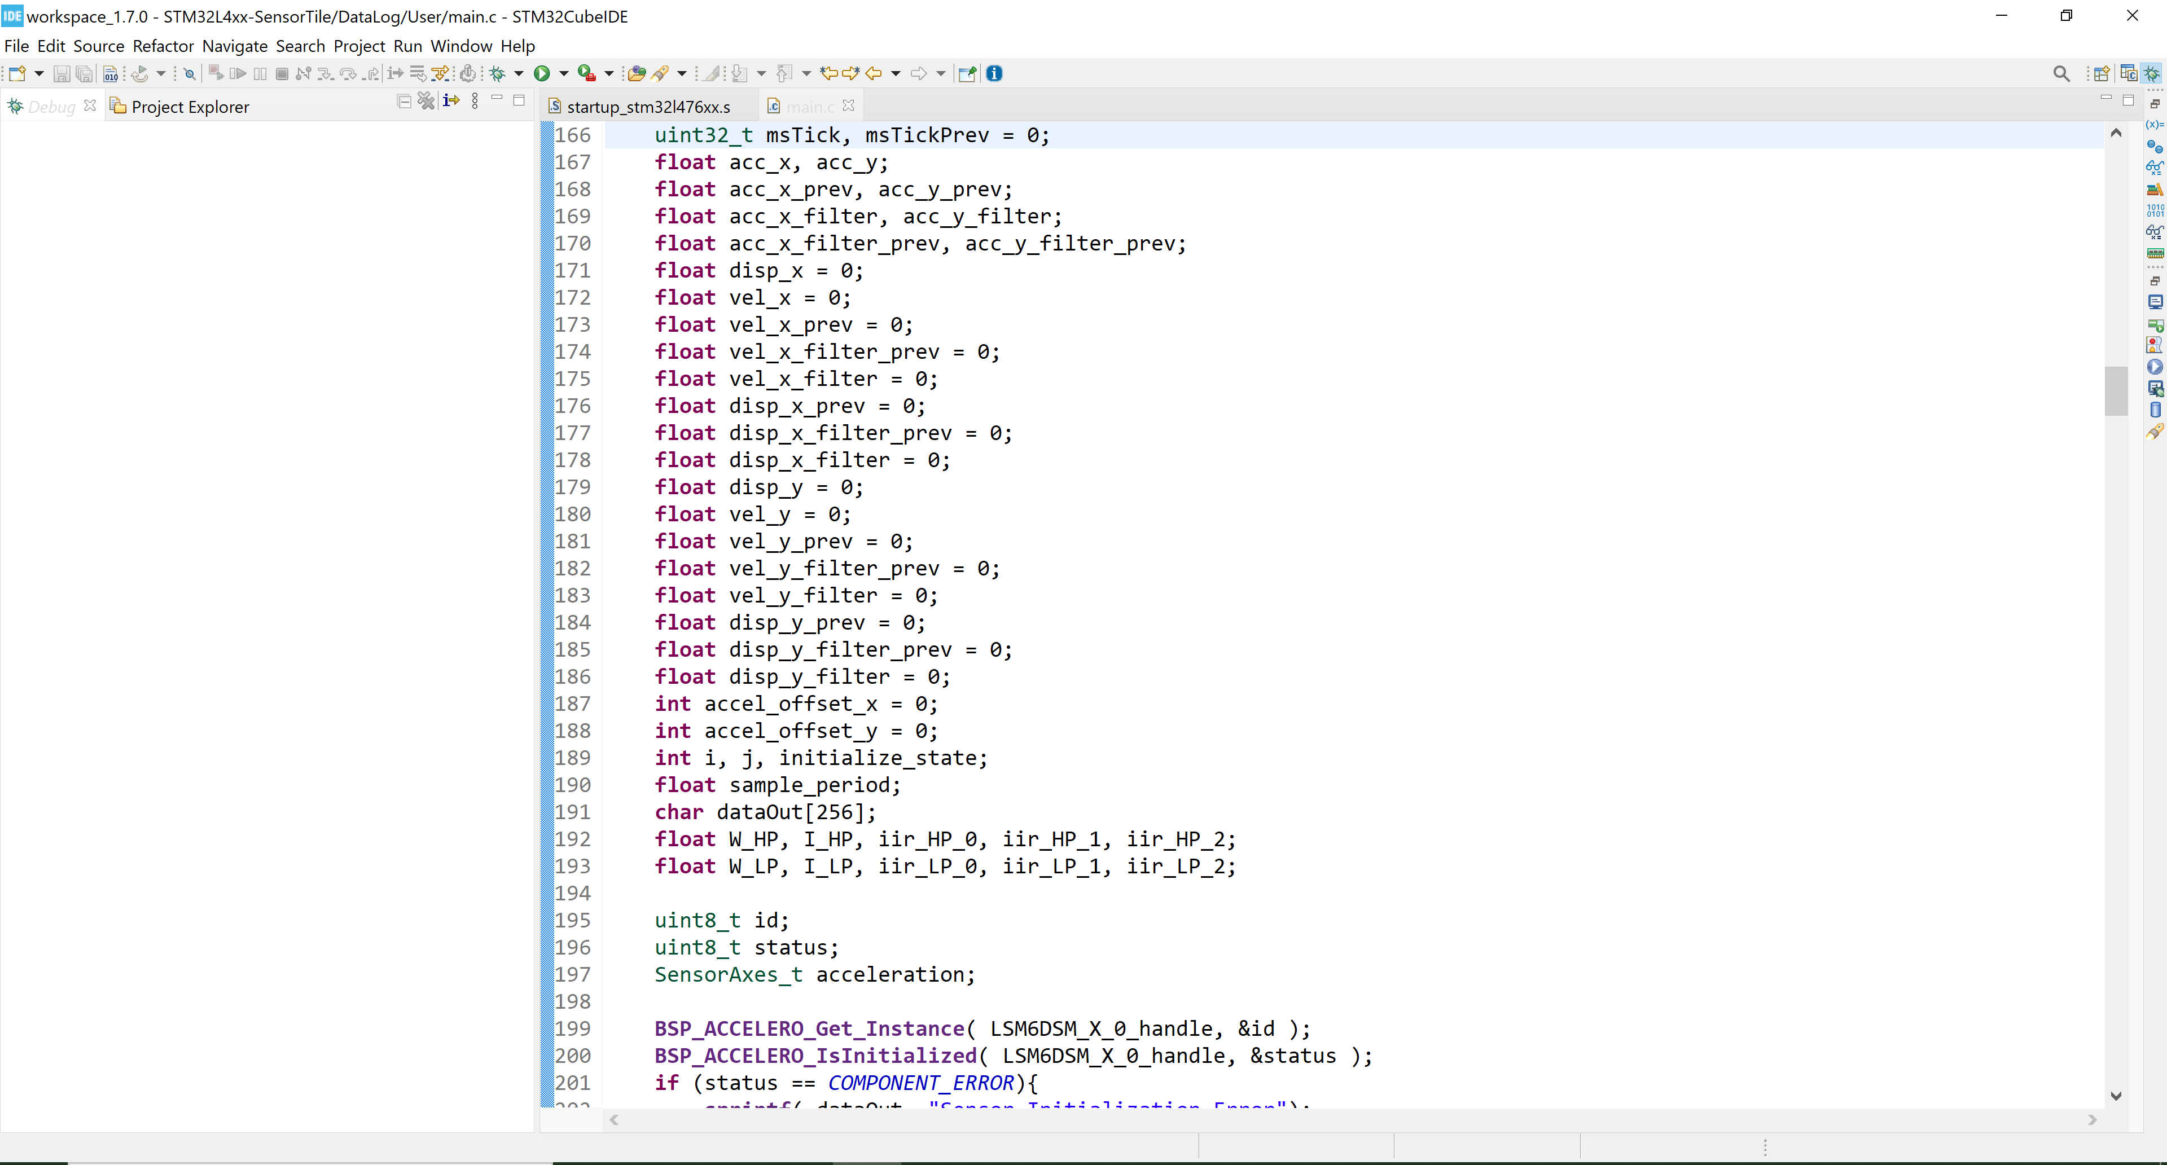

1. Then examine the code in main.c and change the HIGH_PASS_FILTER_FREQUENCY from 0.2 Hz to 0.02 Hz.

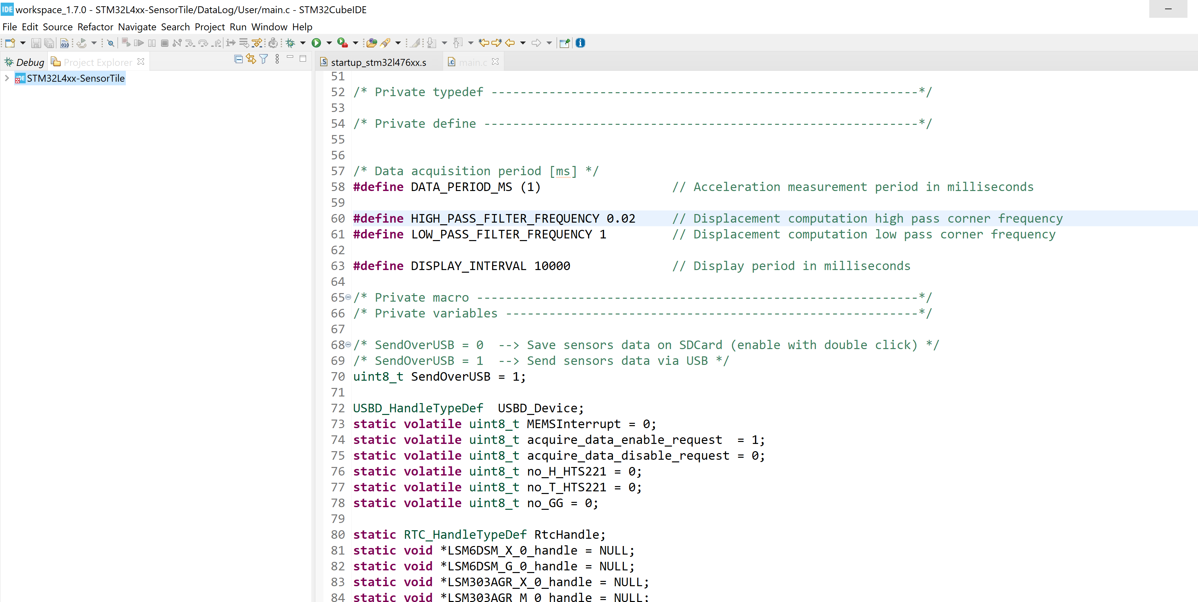

1. Then, with the SensorTile motionless and level, observe the X- an Y-axis acceleration signals. Note the drift in the signals.

Refer to the video attached title, “3 of page 37 high_pass_freq_0pt02_drift_tillt_poor_quality”, show motionless and with motion drift in the signal.

1. Then, perform the same motions you had performed previously. Note that indications of accurate displacement are degraded.

Refer to the video attached title, “3 of page 37 high_pass_freq_0pt02_drift_tillt_poor_quality”, show motionless and with motion drift in the signal.

1. Now change the HIGH_PASS_FILTER_FREQUENCY from 0.02 Hz to 0.002 Hz and evaluate again

Refer to the video attached title, “5 of page 37 high_pass_freq_0pt0002_drift_tillt_poor_quality

”, show motionless and with motion drift in the signal. **Video correction:** I said high corner frequency, I actually is lower high pass corner frequency.