***Show the data using an screenshot as in item 10 page 25 of 28 of this tutorial***

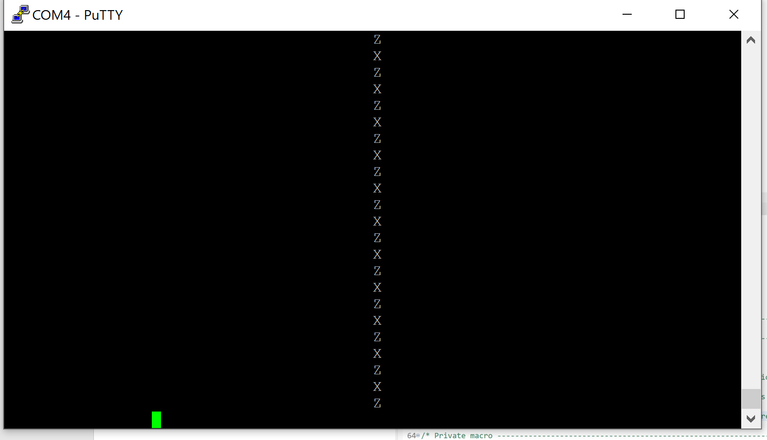

***Submit a demo video testing as described in Real Time Rotation Angle Visualization: Demonstration of Angle Sensing (item 10 page 26 of 28)***

Video attached with file name ‘Item 10 Page 26 of 28 Realtime_Z-axis_And_X-axis_Rotation’

***Make videos to demonstrate: Figure 5. Real time display of computed angle. And Figure 6. Real time display of computed angle. as in page 27 of 28***

Video attached file name ‘Z and X rotation figure 5 and 6 page 27 of 28’

***Item 11 of page 28 of 28***

1.

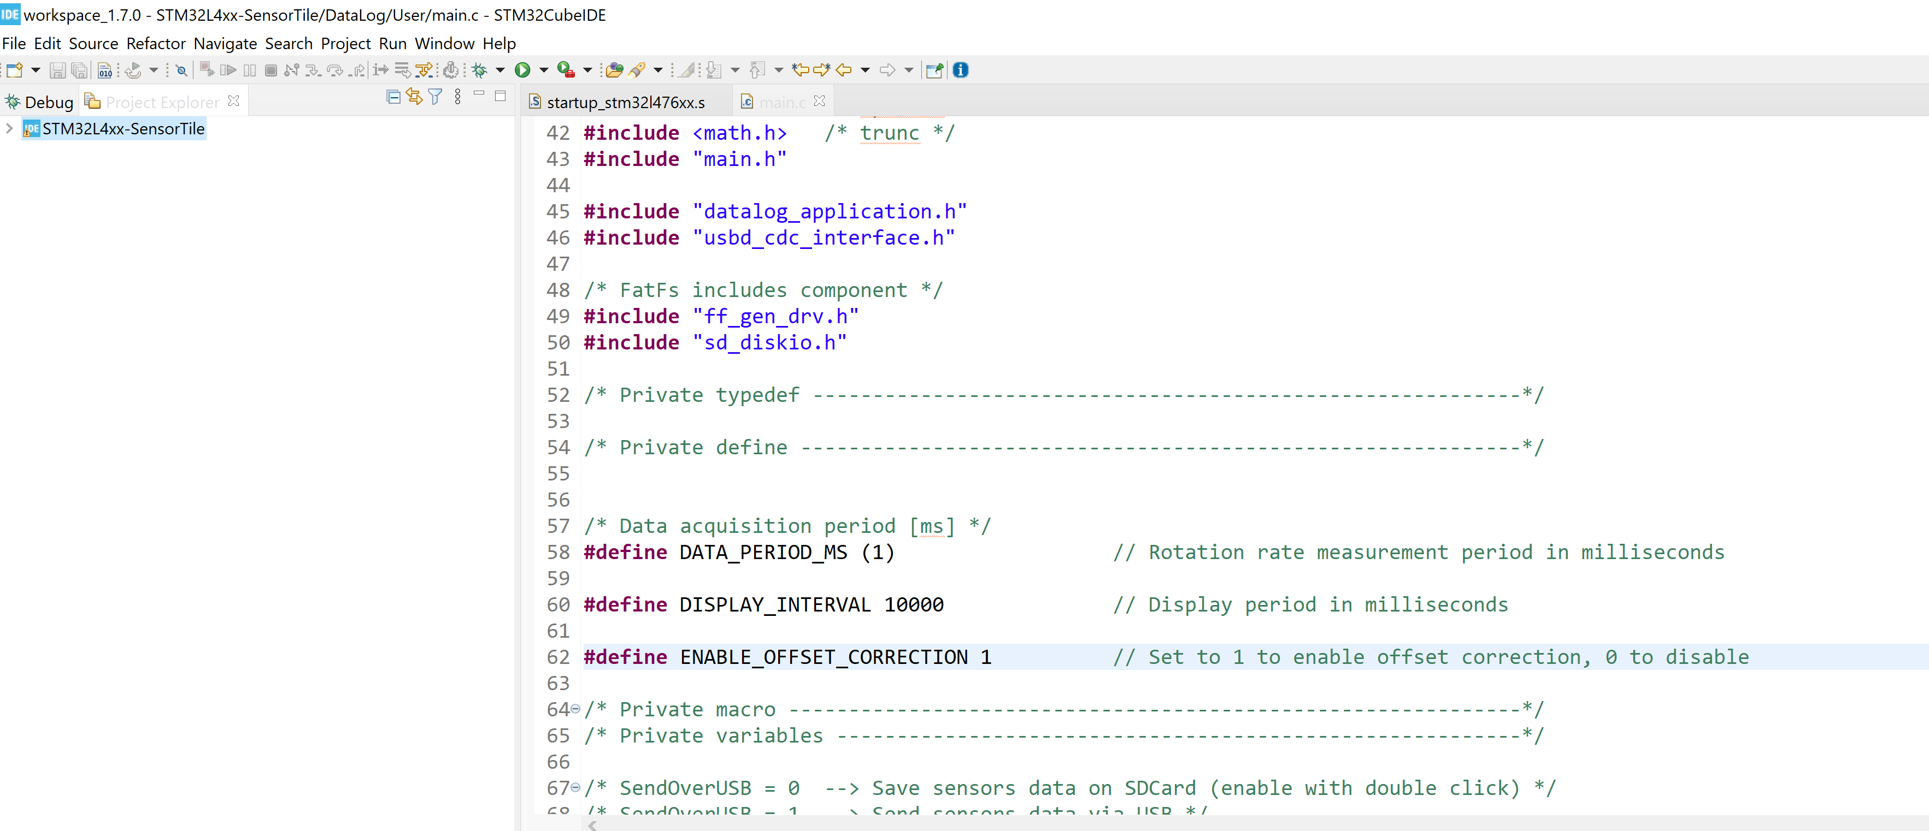

Figure 1. Terminated program as is with ENABLE_OFFSET_CORRECTION = 1

2.

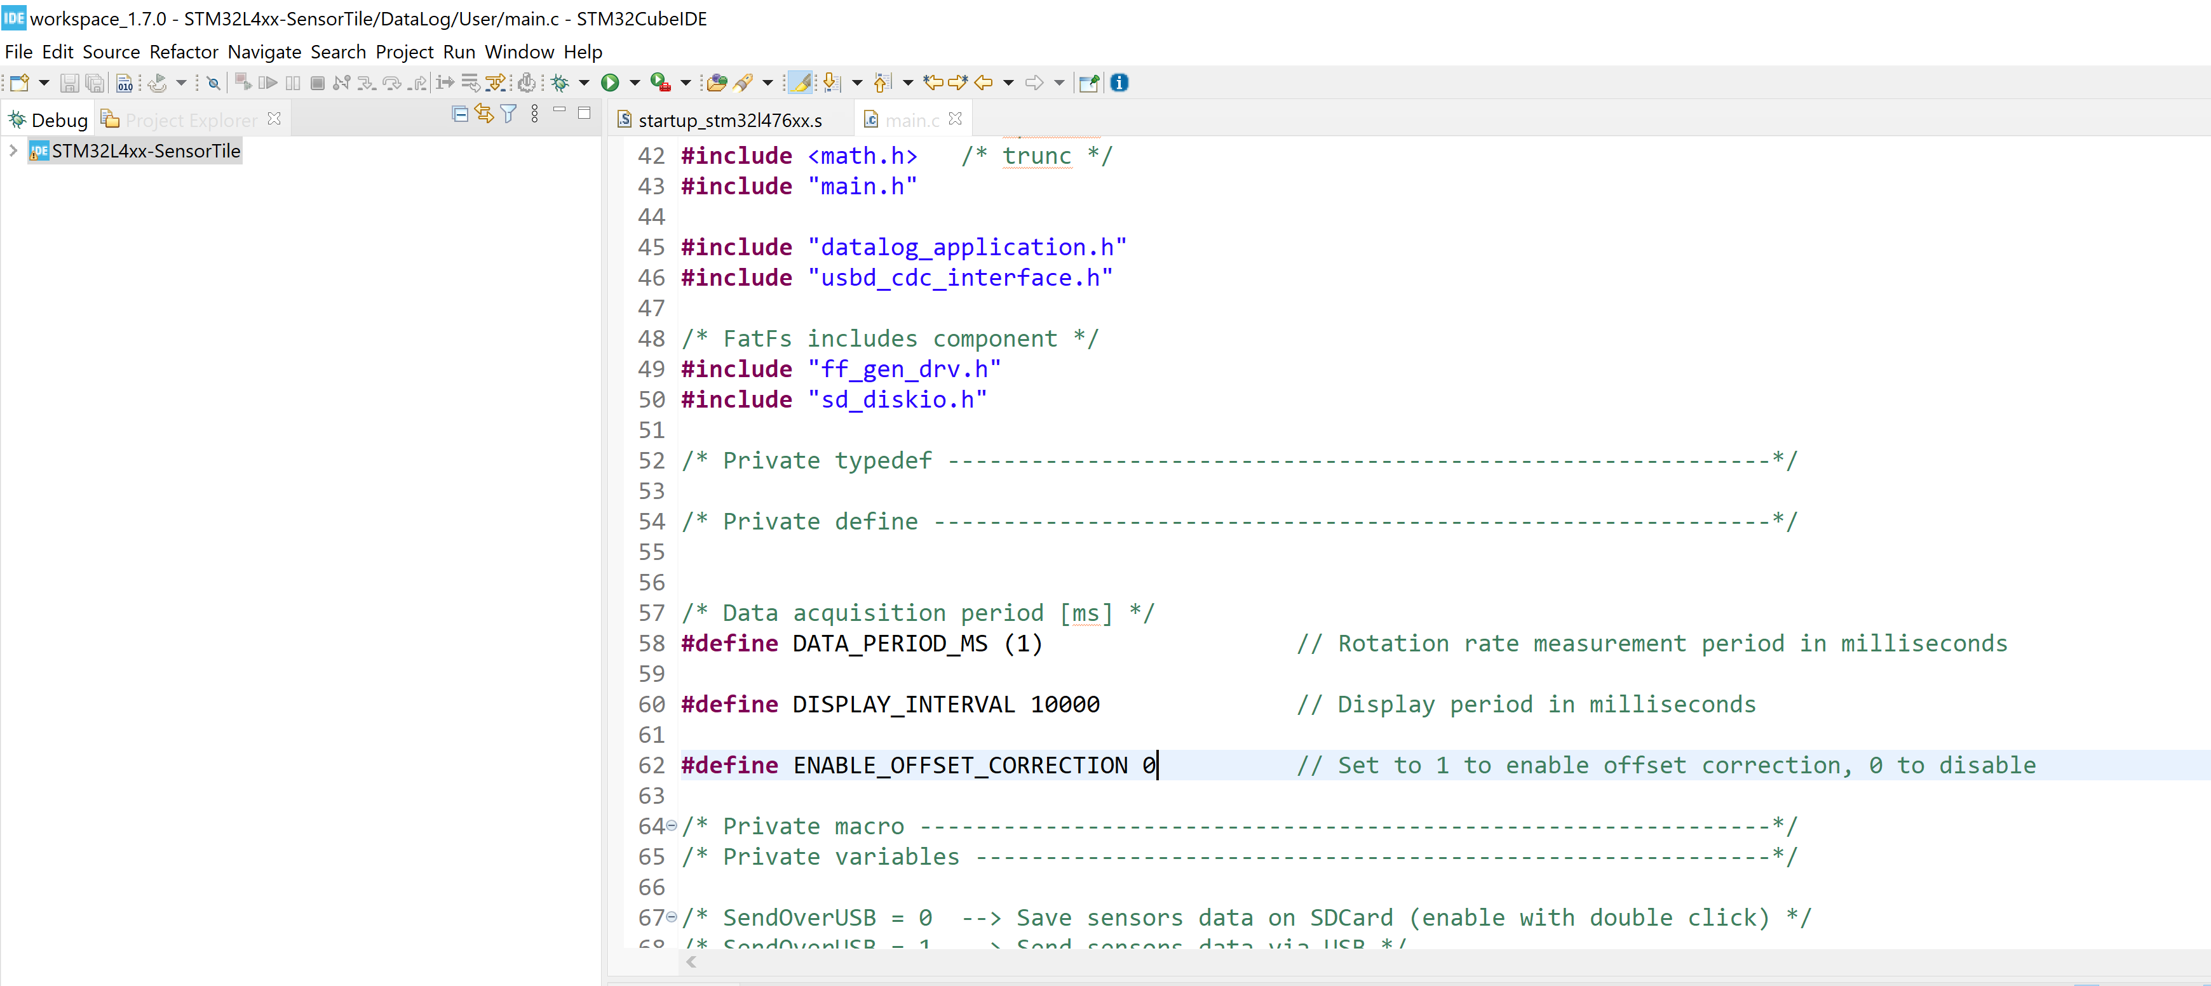

Figure 2. Changed main.c such that ENABLE_OFFSET_CORRECTION = 0

3.

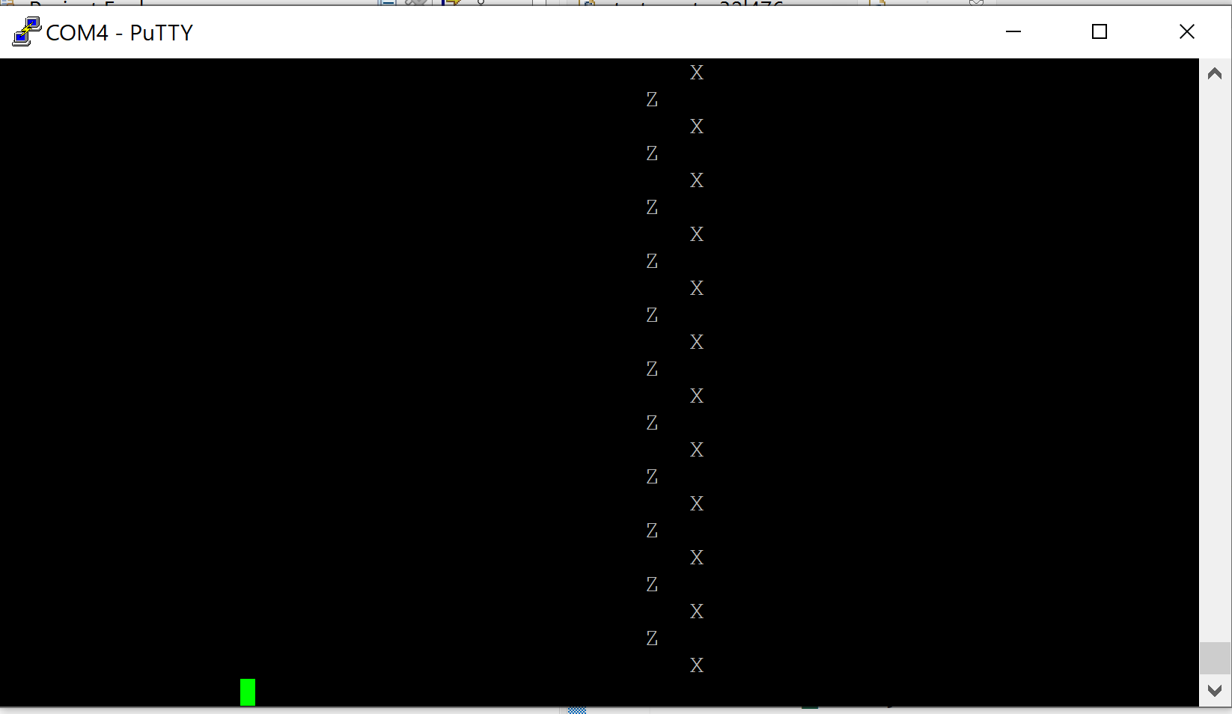

Figure 3. Motionless and level sensortile has drift that can be seen in figure above.

4. See uploaded video file name ‘Step 4 OFFSET_CORRECTION_DISABLE Real_Time_Drift_And_Poor_Quality_Rotation’ for sensor motion behavior

5.

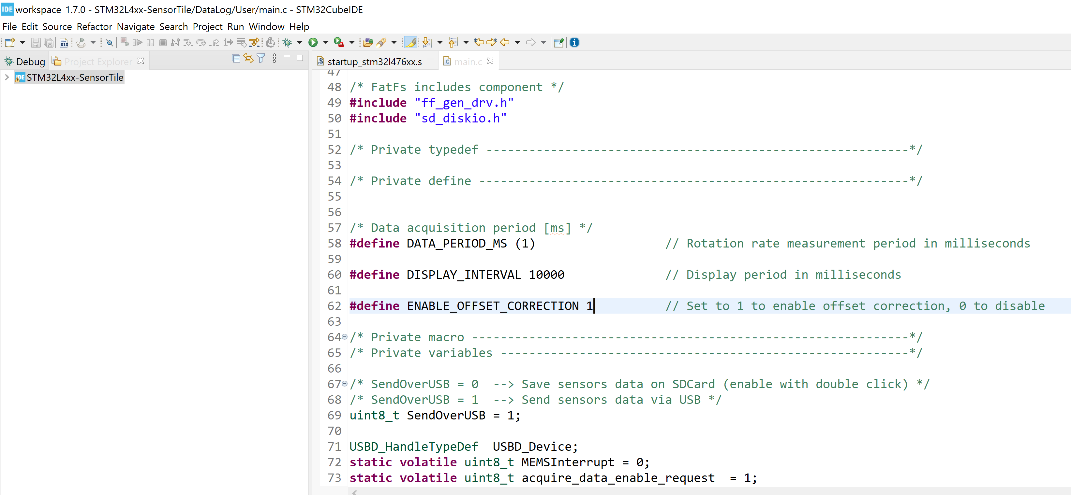

Figure 5 shows ENABLE_OFFSET_CORRECTION = 1

Check out the attached video file name ‘Step 5 OFFSET_CORRECTION_ENABLE Real_Time_Quality_Rotation’