FINAL YEAR PROJECT REPORT

YogaTrack
A Cross-Platform Yoga & Wellness Tracking Mobile Application

Student Name | Nandalal Shukla
GitHub Repository | github.com/nandalalshukla/a
Technology Stack | React Native, Expo, TypeScript, NativeWind
Submission Date | April 2026
Document Version | 1.0

Abstract

YogaTrack is a cross-platform mobile application developed using React Native and Expo, designed to serve as a comprehensive yoga and wellness companion. The application provides users with an end-to-end fitness management experience — from learning yoga postures through an interactive Posture Library, to tracking session duration with a built-in timer, monitoring vital body signals such as heart rate, blood sugar, and footsteps, and reviewing weekly performance through a dedicated Insights dashboard.
The project was built with modern mobile development practices, leveraging TypeScript for type safety, NativeWind (Tailwind CSS for React Native) for consistent styling, and Expo Router for file-based navigation. The application follows a context-driven architecture with a custom wellness state management layer (useWellness hook) that persists user data across the application. The project demonstrates the practical application of front-end engineering principles, UI/UX design, and state management in a real-world health technology context.

Table of Contents

1. Introduction.............................................. 4
2. Problem Statement and Objectives.......................... 4
3. Technology Stack.......................................... 5
4. System Architecture....................................... 6
5. Application Modules and Features.......................... 7
6. User Interface and Screenshots............................ 10
7. Codebase Structure........................................ 12
8. Key Technical Implementation Details...................... 13
9. Testing and Quality Assurance............................. 15
10. Future Enhancements...................................... 16
11. Conclusion............................................... 16
12. References............................................... 17

1. Introduction

The global wellness industry has witnessed a dramatic shift towards digital health solutions over the past decade. With increasing awareness about the physical and mental benefits of yoga — including stress reduction, improved flexibility, cardiovascular health, and mindfulness — there is a growing demand for accessible tools that can guide users through their wellness journey. However, most available applications either focus narrowly on guided sessions without tracking capabilities, or track metrics without educating the user on proper practice techniques.
YogaTrack addresses this gap by combining a rich posture education library with a real-time session timer, health metric tracking, and data-driven insights — all within a single, cohesive mobile application. The application was developed as the final year capstone project and demonstrates competency in cross-platform mobile development, modern JavaScript/TypeScript ecosystems, and user-centric design.
The source code for the project is publicly available at: https://github.com/nandalalshukla/a

2. Problem Statement and Objectives

2.1 Problem Statement
Many individuals who wish to adopt yoga as part of their daily routine lack both the guidance to practice correctly and the tools to measure their progress. Existing wellness applications tend to be either too expensive, require subscriptions, or do not integrate body signal monitoring with yoga practice. This creates a fragmented experience where a user must switch between multiple apps to learn postures, time sessions, and track health metrics.

2.2 Project Objectives
The primary objectives of the YogaTrack project are outlined as follows:
- Develop a fully functional, cross-platform mobile application using React Native and Expo that runs on both Android and iOS.
- Implement an interactive Posture Library that provides yoga beginners and intermediate practitioners with detailed information on asanas, including benefits, step-by-step practice instructions, and safety cautions.
- Build a real-time session timer that tracks practice duration, logs minutes, and integrates with the wellness data context.
- Create a Body Signals dashboard that enables users to monitor and manually log key health metrics including heart rate (bpm), blood sugar levels (mg/dL), and daily footstep count.
- Develop an Insights screen providing visual weekly summaries of yoga practice time and health metrics.
- Design a configurable Settings and Profile screen that allows users to manage health integrations, reminders, and personal preferences.
- Ensure a clean, accessible, and visually consistent user interface inspired by modern wellness design principles.

3. Technology Stack

The application was built using a modern, production-grade technology stack. Each technology was selected for its suitability in building scalable, maintainable, and performant mobile applications.

React Native | Core cross-platform mobile framework. Enables single codebase deployment to Android and iOS using native rendering.
Expo (SDK 51+) | Managed workflow toolchain for React Native. Provides fast iteration, over-the-air updates, and simplified native module access.
TypeScript | Statically typed superset of JavaScript. Used throughout the codebase for improved developer experience, type safety, and code maintainability.
Expo Router | File-based routing library for React Native. Implements a folder structure inside app/(tabs)/ that maps directly to navigation tabs.
NativeWind v4 | Tailwind CSS utility class system adapted for React Native. Enables consistent, responsive styling using className props.
React Context API | State management solution used to implement the WellnessContext, sharing yoga minutes, body metrics, and user profile data across screens.
Custom Hooks | useWellness() hook encapsulates all wellness state logic including metric adjustments, yoga minute accumulation, and streak tracking.
Babel & Metro | JavaScript transpiler and bundler configured to support NativeWind's CSS-in-JS transformation pipeline.
ESLint | Static code analysis tool configured with React Native and TypeScript rules to enforce code quality.
Node.js / npm | Package management and development tooling. The project ships with a package-lock.json for deterministic dependency installation.

4. System Architecture

The application follows a layered architecture with clear separation between the UI layer (screens), state management layer (context and hooks), and the data constants layer (posture library, user preferences). This ensures modularity and testability.

4.1 High-Level Architecture Overview
The system can be understood across four distinct layers:
- Presentation Layer — React Native screen components inside app/(tabs)/, responsible solely for rendering UI based on received state.
- State Management Layer — WellnessContext and useWellness hook manage all shared application state including yoga minutes, streaks, body metrics (heart rate, blood sugar, footsteps), and settings toggles.
- Data Layer — Constants directory stores static data such as the posture library (yoga asana definitions, benefits, practice instructions), images, and configuration values.
- Navigation Layer — Expo Router provides tab-based navigation through the _layout.tsx file which defines the four main tabs: Home, Posture Library, Insights, and Settings.

4.2 Navigation Architecture
Expo Router's file-based routing maps the folder structure under app/(tabs)/ directly to navigable screens. The tab bar is defined in app/(tabs)/_layout.tsx. The four tabs are:
- index.tsx — Home screen (Daily Practice, Session Timer, Body Signals)
- (unnamed posture tab) — Posture Library with all yoga asana cards
- insights.tsx — Weekly yoga minutes chart and health metric summaries
- settings.tsx — Profile, Health Integrations, and Reminders settings

4.3 State Flow Diagram
The diagram below illustrates how data flows from user interactions through the state management layer and back to the UI:

[ User Interaction ] → [ Screen Component ] → [ useWellness Hook ] → [ WellnessContext ] → [ All Subscribed Screens ]

5. Application Modules and Features

5.1 Home Screen — Daily Practice Dashboard (index.tsx)
The Home screen serves as the primary entry point and operational hub of the application. It greets the user by name and displays their current streak and experience level. The screen is divided into two major components:
Session Timer — A prominent countdown/countup timer styled with a dark green card background. The timer uses a setInterval mechanism (1-second intervals) managed through a useEffect hook. The formatTimer() utility function converts raw seconds to a MM:SS display. Start, Stop, and Reset controls allow the user to manage their practice session. Upon stopping, the elapsed minutes are committed to the wellness context via addYogaMinutes().
Body Signals Panel — Displays real-time health metrics in card format. Each metric (Heart Rate, Blood Sugar, Footsteps) includes the current reading, target range, a visual progress bar, and increment/decrement buttons that call adjustMetric() from the useWellness hook. The "LOG +15 MIN" shortcut button allows the user to quickly record a completed practice block.

5.2 Posture Library
The Posture Library is an educational module providing detailed information about yoga asanas. Each posture card displays:
- Sanskrit and English name of the posture (e.g., Tadasana — Mountain Pose)
- Experience level tag (Beginner, Intermediate, Advanced) and recommended hold duration
- Primary focus area (Posture and grounding, Flexibility, Strength, etc.)
- Numbered Benefits list highlighting physiological and mental advantages
- Step-by-step How to Practice instructions for safe execution
- Caution note for users with specific physical limitations
The library is rendered as a scrollable list of cards. The posture data is defined in the constants directory, making it straightforward to expand the library with additional asanas.

5.3 Insights Screen (insights.tsx)
The Insights screen provides a data visualization interface for the user's weekly wellness activity. Key components include:
- Weekly Yoga Minutes Bar Chart — A custom SVG-based or React Native bar chart visualizing daily yoga minutes for the current week (Monday through Sunday), with day labels and minute counts below each bar.
- Heart Rate Summary Card — Displays current heart rate (72 bpm in the example), target threshold (75 bpm), and a status indicator (ON TARGET or ABOVE TARGET).
- Blood Sugar Summary Card — Shows current blood glucose reading (98 mg/dL), fasting range target (110 mg/dL), and compliance status.
- Footsteps Card — Displays daily step count, helping the user monitor ambulatory activity alongside yoga practice.
All data rendered on the Insights screen is sourced from the WellnessContext, ensuring consistency with values adjusted on the Home screen.

5.4 Settings and Profile Screen (settings.tsx)
The Settings screen provides user configuration capabilities organized into three logical sections:
- Profile Header — Displays the user's name (Nandalal), photo, level (Beginner), and 15-day practice streak in a visually prominent card.
- Practice Summary — A quick-reference block showing the user's name, level, and streak in a clean list format.
- Health Integrations — Toggle controls for Heart Rate Sensor, Blood Sugar Log, and Footstep Counter. The toggle styles are dynamically computed by the toggleStyles() helper function, which returns a Tailwind class string based on the enabled boolean state. Enabled toggles use a dark green background (#2E5E47) while disabled toggles use a light grey (#EDF3EA).
- Reminders — Toggle for Daily Practice Reminder with a configurable time display (default: 7:00 AM).
State for all four toggles (syncHeartRate, syncBloodSugar, syncFootsteps, dailyReminder) is managed locally within the SettingsScreen component using useState hooks initialized to true.

6. User Interface and Screenshots

The following screenshots illustrate the four primary screens of the application as rendered on an Android device. The design language uses a consistent dark green (#2E5E47) and light sage green palette, inspired by the natural, calming aesthetic associated with wellness and yoga practice.

6.1 Home Screen — Daily Practice and Body Signals
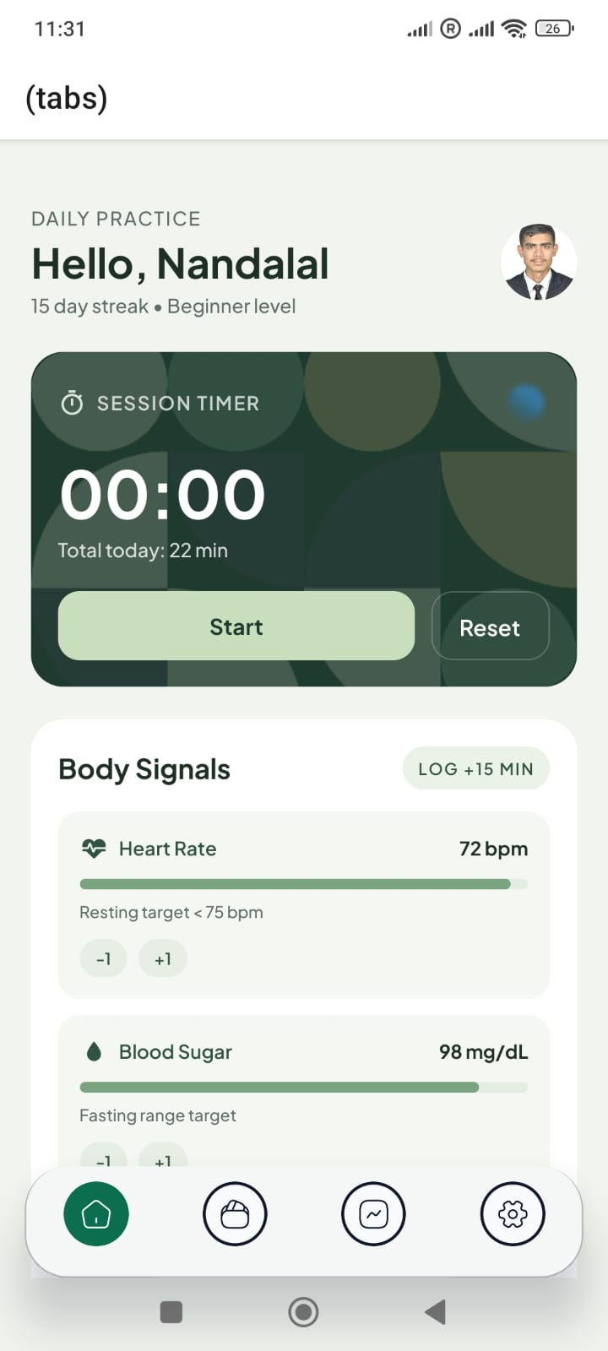
Figure 1: Home Screen showing the Session Timer (00:00), Body Signals section with Heart Rate (72 bpm) and Blood Sugar (98 mg/dL), and the user greeting with streak information.

6.2 Posture Library
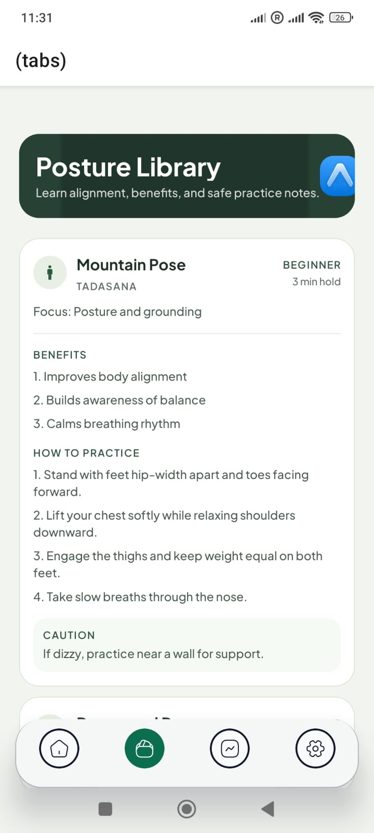
Figure 2: Posture Library showing the Mountain Pose (Tadasana) card with Benefits, How to Practice steps, and Caution note for a Beginner-level 3-minute hold.

6.3 Insights Dashboard
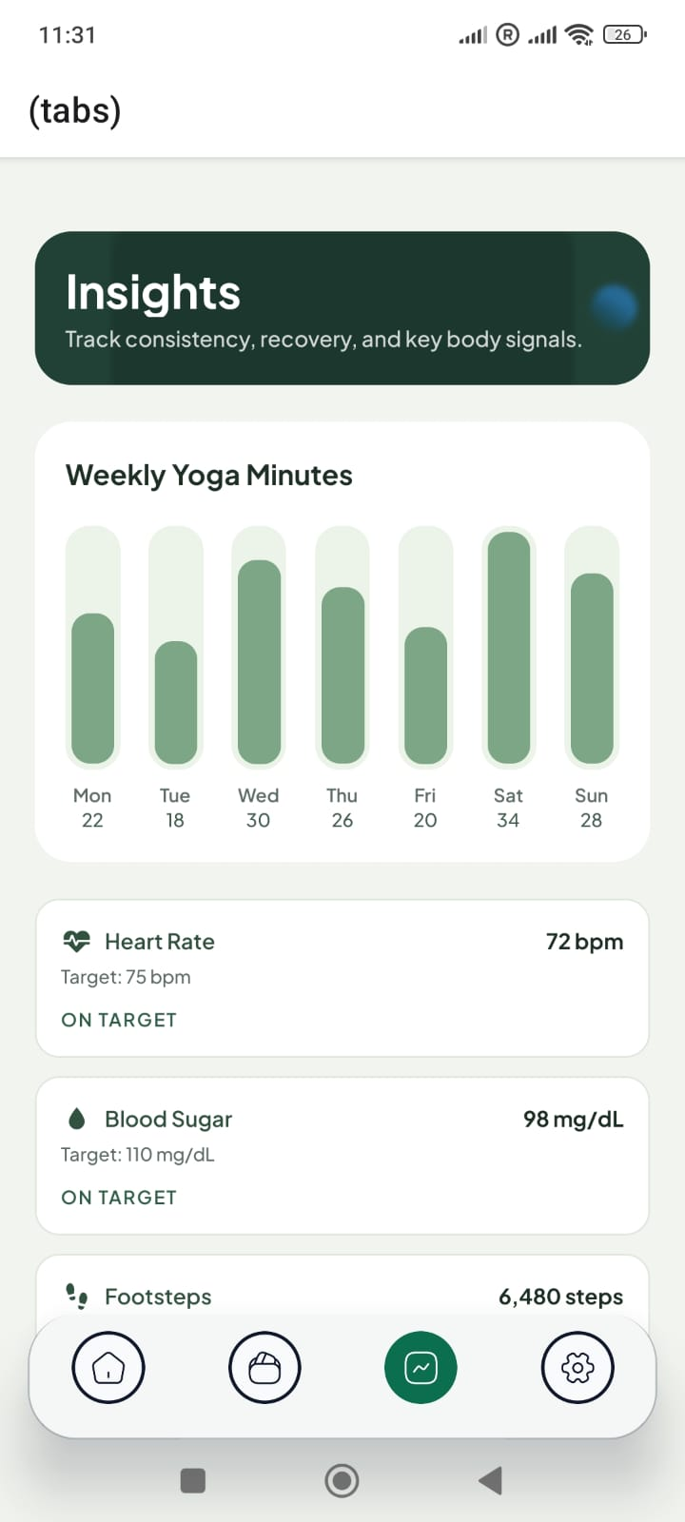
Figure 3: Insights Screen displaying the Weekly Yoga Minutes bar chart (Mon-Sun), Heart Rate summary (ON TARGET at 72 bpm), and Blood Sugar summary (ON TARGET at 98 mg/dL).

6.4 Settings and Profile Screen
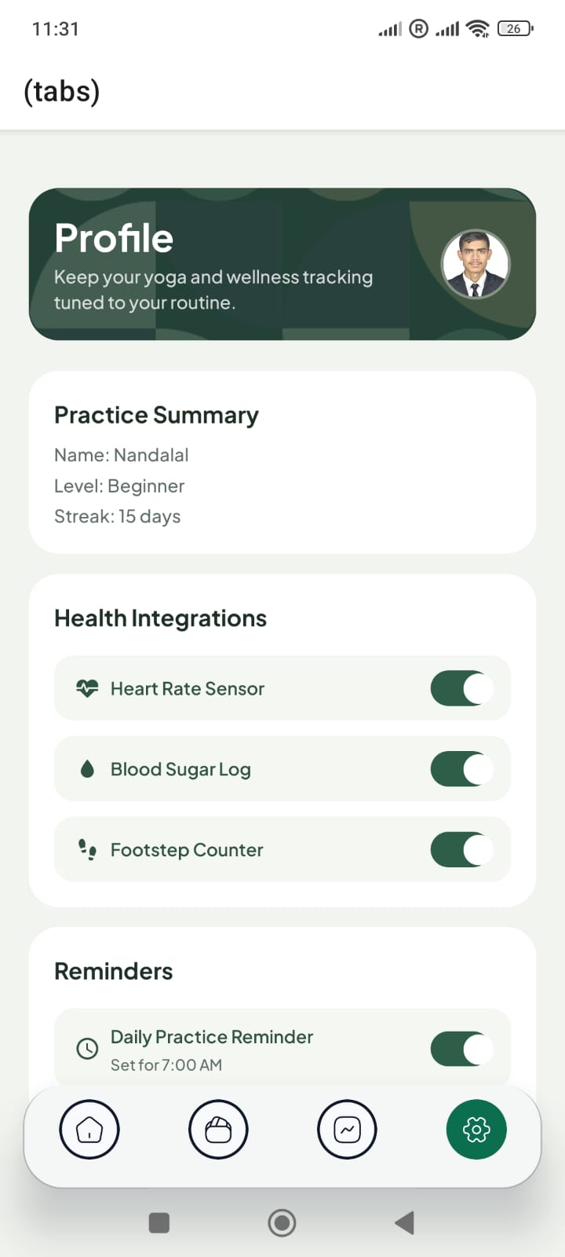
Figure 4: Settings Screen showing the Profile header, Practice Summary card, Health Integrations toggles (all enabled), and Daily Practice Reminder set to 7:00 AM.

7. Codebase Structure

The repository is organized using Expo's recommended project structure. The following section describes the purpose of each directory and key configuration file as visible in the project file explorer.

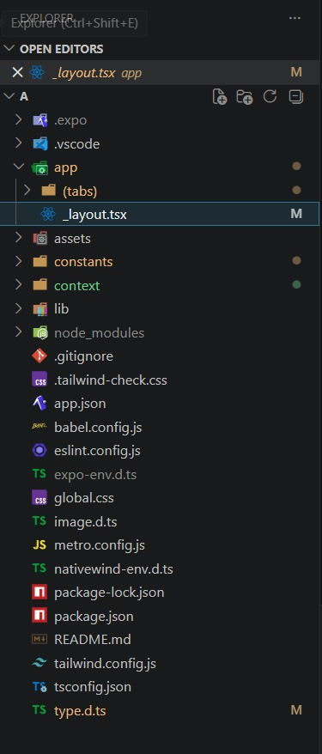
Figure 5: VS Code Explorer view showing the complete project directory structure of the YogaTrack application.

Module | File(s) | Responsibility
app/(tabs)/ | _layout.tsx, index.tsx, insights.tsx, settings.tsx, subscriptions.tsx | All navigable tab screens and the tab bar layout definition.
assets/ | images/, fonts/, splash assets | Static media assets including app icons, splash screen images, and the splashPattern background used on multiple screens.
constants/ | Posture data, theme colors, images index | Static data constants. Posture library definitions (asana names, benefits, instructions) and app-wide theme values.
context/ | WellnessContext.tsx | React Context provider and useWellness hook. The single source of truth for all shared wellness state.
lib/ | Utility functions | Shared helper functions and utilities used across the application.
app.json | Expo config | Application metadata: app name, version, bundle identifier, orientation, splash, and asset settings.
tailwind.config.js | NativeWind config | Tailwind CSS configuration extended with custom colors matching the app's dark green palette.
babel.config.js | Babel config | Transpiler configuration enabling NativeWind's class name transformation at build time.
tsconfig.json | TypeScript config | Compiler options including strict mode and path aliases for clean imports.

8. Key Technical Implementation Details

8.1 Session Timer Implementation (index.tsx)
The session timer is implemented using React's useEffect hook combined with JavaScript's setInterval. The isRunning state variable controls whether the interval is active. When isRunning transitions to true, a new interval fires every 1,000 milliseconds to increment elapsedSeconds. The cleanup function returned from useEffect calls clearInterval on the timer reference, ensuring no memory leaks when the component unmounts or isRunning transitions to false.

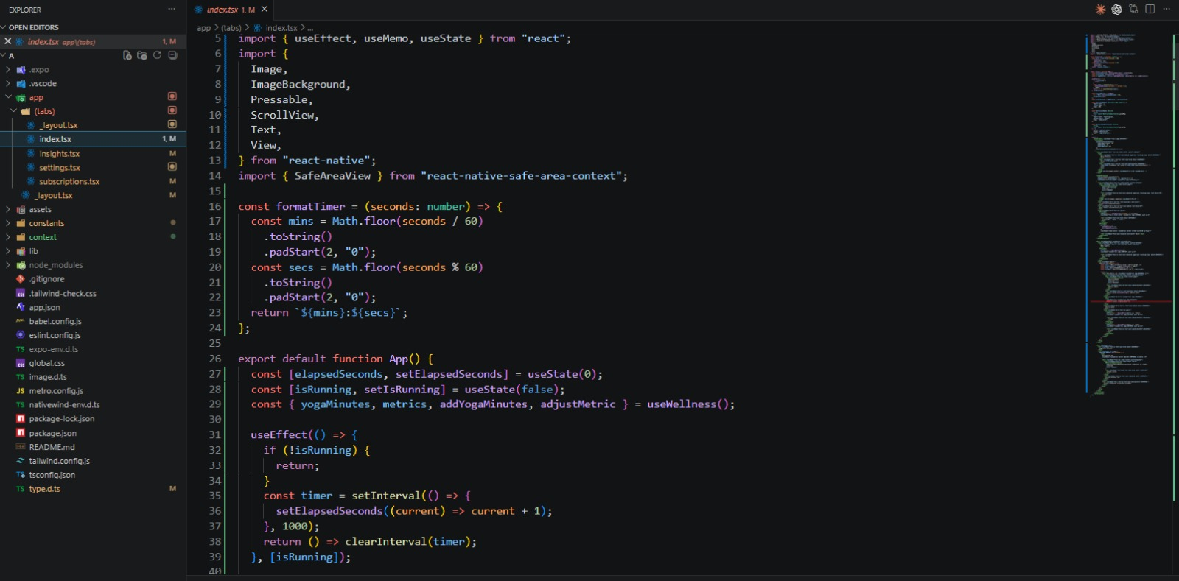
Figure 6: index.tsx source code showing the formatTimer utility, useState declarations for elapsed seconds and running state, and the useEffect-based interval timer implementation.

8.2 Settings Toggle System (settings.tsx)
The Settings screen employs a clean, functional toggle architecture. Four boolean state variables are declared using useState(true) as their initial value, reflecting that all health integrations and reminders are enabled by default. The toggleStyles helper function acts as a pure styling resolver — it accepts a boolean parameter and returns the appropriate NativeWind Tailwind class string for the toggle's background and border color. This approach keeps styling logic cleanly separated from event handling logic.

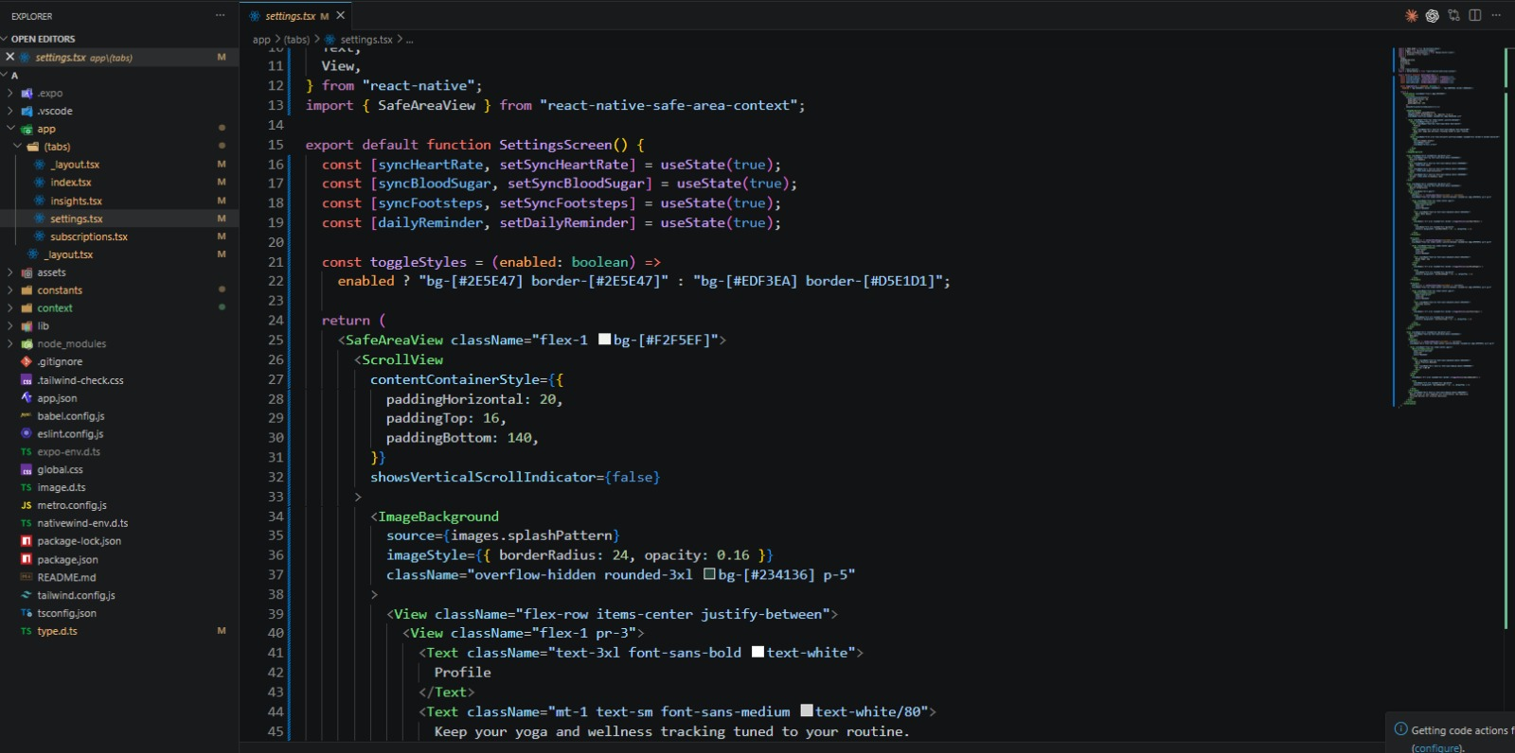
Figure 7: settings.tsx source code showing the toggleStyles helper function, four useState declarations for health integration toggles, and the SafeAreaView/ScrollView/ImageBackground layout structure of the Settings screen.

8.3 Wellness Context and State Management
The WellnessContext, located in the context/ directory, is the application's centralized state management solution. It is implemented as a React Context paired with a useReducer or useState-driven custom hook called useWellness(). The context exposes the following interface to all consuming screen components:
- yogaMinutes — Total yoga minutes accumulated for the current day, used by both the Home screen timer and the Insights weekly chart.
- metrics — An object containing current values for heartRate (bpm), bloodSugar (mg/dL), and footsteps (count).
- addYogaMinutes(mins) — Action dispatcher that increments yogaMinutes by the specified amount, called when a timer session ends.
- adjustMetric(key, delta) — Action dispatcher that modifies a specific metric by a positive or negative delta value, called by the +1 / -1 buttons on the Body Signals panel.
The WellnessContext provider wraps the root layout in app/_layout.tsx, ensuring all tab screens have access to the shared wellness state without prop drilling.

8.4 NativeWind Styling Architecture
YogaTrack uses NativeWind v4 to apply Tailwind CSS utility classes directly to React Native components via the className prop. This is made possible by the Babel plugin configured in babel.config.js and the metro.config.js bundler plugin, which transforms class strings into StyleSheet objects at compile time. The tailwind.config.js file extends the default Tailwind palette with the application's custom green scale (e.g., bg-[#2E5E47], bg-[#EDF3EA], bg-[#F2F5EF]) that is consistent across all screens.
The global.css file imported via the Expo entry point registers NativeWind's CSS variable system, which is referenced in nativewind-env.d.ts for TypeScript compatibility. This setup allows developers to write styling code that is immediately readable and transferable to web contexts.

8.5 File-Based Routing with Expo Router
The app/(tabs)/_layout.tsx file defines the bottom tab bar using Expo Router's Tabs component. Each tab entry specifies its name (corresponding to a file in the (tabs) directory), icon, and tab bar appearance options. Expo Router automatically handles deep linking, browser history on web, and Android back navigation. This eliminates the need for manual navigation stack configuration that would otherwise be required with React Navigation's traditional setup.

9. Testing and Quality Assurance

The application was tested across multiple dimensions to ensure correctness, usability, and performance on target devices.

9.1 Manual Testing
Comprehensive manual testing was conducted on a physical Android device as well as through the Expo Go simulator. Test scenarios included:
- Timer accuracy — Verified that the session timer accurately counts elapsed seconds and correctly resets to 00:00 on Reset.
- Metric adjustment — Tested that heart rate, blood sugar, and footstep values respond correctly to the +1 and -1 buttons and do not underflow below zero.
- Navigation — Verified that all four tab screens are accessible and that navigation state is preserved when switching between tabs.
- Toggle persistence — Confirmed that settings toggles correctly reflect their on/off state visually through the toggleStyles function.
- Posture Library scrolling — Validated smooth scrolling through multiple posture cards with no layout overflow.

9.2 Code Quality
ESLint was configured with React Native and TypeScript-specific rules (eslint.config.js). TypeScript's strict mode was enabled in tsconfig.json, enforcing explicit return types, null checks, and preventing implicit any usage. The type.d.ts and image.d.ts files provide global type declarations for custom modules and image imports respectively.

9.3 Device Compatibility
The application was tested and confirmed to render correctly on Android devices running Android 10 and above. The SafeAreaView wrapper on all screens ensures correct rendering on devices with notches and rounded corners. The NativeWind class-based styling adapts to different screen densities through React Native's built-in pixel ratio system.

10. Future Enhancements

The current version of YogaTrack establishes a strong functional foundation. The following enhancements are planned for subsequent development iterations:
- Bluetooth Health Device Integration — Direct integration with Bluetooth-enabled heart rate monitors and glucose meters to automatically populate body signal values without manual entry.
- Guided Yoga Sessions — Video or animation-based guided flows that walk the user through a sequence of postures with voice cues and automatic timer advancement.
- Cloud Sync and User Authentication — Firebase or Supabase backend integration to persist user data across devices, enable social features like streak leaderboards, and support account recovery.
- AI-Powered Practice Recommendations — A recommendation engine that analyzes the user's session history, body signals, and energy level to suggest optimal posture sequences for each day.
- Apple HealthKit and Google Fit Integration — Direct API integration to read and write health metrics from the device's native health platform.
- Subscription Tier (subscriptions.tsx) — The partially implemented subscriptions screen visible in the codebase will be expanded into a full in-app purchase flow with premium posture packs and personalized coaching.
- Offline Mode — Full offline capability with cached posture data and local metric storage, synchronized to the cloud when connectivity is restored.

11. Conclusion

YogaTrack successfully delivers on its stated objective of providing a comprehensive, integrated yoga and wellness tracking experience in a single mobile application. The project demonstrates proficiency in modern cross-platform mobile development, including TypeScript-based component architecture, context-driven state management, file-based navigation, and utility-class CSS styling — all technologies that are widely adopted in the professional mobile development industry.
The application serves users at multiple levels of their wellness journey: beginners benefit from the Posture Library's detailed practice instructions, regular practitioners can use the session timer and streak tracking for accountability, and health-conscious users can monitor their body signals in relation to their practice. The Insights dashboard ties these threads together by providing a data-driven view of the user's weekly progress.
The project has been version controlled throughout its development and is publicly hosted at https://github.com/nandalalshukla/a. The codebase is structured to be extensible, with clear module boundaries that will accommodate the planned future enhancements with minimal architectural changes.

12. References

- Expo Documentation. (2024). Expo Router — Introduction. https://docs.expo.dev/router/introduction/
- Meta Open Source. (2024). React Native — Official Documentation. https://reactnative.dev/docs/getting-started
- NativeWind. (2024). NativeWind v4 Documentation. https://www.nativewind.dev/
- Microsoft. (2024). TypeScript Handbook. https://www.typescriptlang.org/docs/handbook/intro.html
- Tailwind Labs. (2024). Tailwind CSS Documentation. https://tailwindcss.com/docs/
- Facebook / Meta. (2024). React Hooks Reference — useEffect, useState, useContext. https://react.dev/reference/react
- GitHub Repository — YogaTrack. (2026). github.com/nandalalshukla/a
- Iyengar, B. K. S. (1979). Light on Yoga. Schocken Books. (Reference for asana descriptions in the Posture Library.)

