SMARTCIVIC AI
AI-Powered Multi-Agent Citizen Complaint & Smart Governance System
Project Documentation
Domain: Artificial Intelligence / Machine Learning
Modules Covered: Healthcare | Government Schools | Agriculture | Traffic

DEVELOPED BY: NANDALA SRILATHA
TCN – AIML Training Program

TECHNOLOGY DOMAIN: Artificial Intelligence & Machine Learning

PROJECT TYPE: AI-Powered Smart Governance Solution

ORGANIZATION: TCN

Acknowledgement
I would like to express my sincere gratitude to Technex Cloud Networks for the opportunity to undertake this internship and work on SmartCivicAI, a project that allowed me to apply and deepen my understanding of full-stack engineering, multi-agent AI systems, and practical software delivery. I am thankful to my mentor and the technical team at Technex Cloud Networks for their guidance, code reviews, and constructive feedback throughout the development of this project.
I also acknowledge the open-source communities behind FastAPI, React, PostgreSQL, LangGraph, and the many other libraries this project depends on — their documentation and design choices made it possible to build a system of this scope within an internship timeframe. Finally, I thank my family and peers for their continued support and encouragement during this project.

Abstract
Civic grievance redressal in most Indian towns and cities is still handled through manual, clerk-driven processes that are slow, inconsistent, and opaque to the citizen who filed the complaint. SmartCivicAI is a full-stack civic complaint management platform that replaces this manual triage step with an automated, multi-agent artificial intelligence pipeline. When a citizen submits a complaint — in English, Hindi, or Telugu, optionally with a photograph and a geographic location — the system automatically detects the language, classifies the issue into one of four civic modules (Healthcare, Government Schools, Agriculture, and Traffic) and a specific category, assesses its priority, routes it to the correct government department, and drafts a citizen-facing acknowledgement, all within seconds and without any human intervention.
The platform is built as a three-tier web application: a React single-page front end, a FastAPI REST backend that also hosts the AI, computer-vision, and analytics services, and a PostgreSQL database, the whole stack containerised with Docker Compose. The AI layer is implemented as a LangGraph state-graph pipeline that can call a real large language model (Anthropic's Claude) when configured, and automatically and silently falls back to a deterministic rule-based “demo” classifier whenever the LLM path is unavailable, so the system is fully functional even with zero paid API keys. Complaints whose AI classification confidence falls below a configurable threshold are automatically flagged for administrator review rather than being silently mis-routed, keeping a human in the loop exactly where it is needed.
Role-based dashboards give citizens visibility into their own complaints, give field officers a manageable queue scoped to their department, and give administrators full oversight, override powers, and analytics — including a predictive module that forecasts complaint volume and geographic hotspots. Every state change and every administrator override is written to an immutable audit log. This documentation describes the problem the system addresses, its design and architecture, its implementation in detail, and the results of running the complete stack end-to-end, including live screenshots captured from the working application.

Table of Contents
Acknowledgement i
Abstract ii
List of Figures iii
1. Introduction 1
2. Problem Statement 3
3. Objectives 4
4. Existing System 5
5. Proposed System 7
6. Technologies Used & Modules 9
7. System Requirements 12
8. System Architecture 14
9. Implementation 18
10. Output Screenshots 24
11. Advantages 31
12. Limitations 32
13. Applications 33
14. Future Scope 34
15. Conclusion 36
16. GitHub / Hugging Face Link 37
17. References 38
Note: page numbers above are indicative of section order; exact page numbers depend on the final rendering/printing settings.

List of Figures
Fig. 8.1 — SmartCivicAI system architecture
Fig. 8.2 — Multi-agent AI complaint-processing pipeline
Fig. 8.3 — Entity Relationship Diagram (core tables)
Fig. 8.4 — Data Flow Diagram, Level 0 (context diagram)
Fig. 8.5 — Sequence diagram: complaint submission & AI processing
Fig. 9.1 — Complaint status lifecycle (state machine)
Fig. 10.1 — Landing page
Fig. 10.2 — Login page
Fig. 10.3 — Registration page
Fig. 10.4 — Citizen Dashboard
Fig. 10.5 — “Report an issue” complaint submission form
Fig. 10.6 — Complaint Detail page (citizen view)
Fig. 10.7 — Citizen Profile page
Fig. 10.8 — Officer Dashboard
Fig. 10.9 — Officer Complaint Detail (update status / resolve)
Fig. 10.10 — Admin Dashboard (analytics overview)
Fig. 10.11 — Admin Dashboard, continued (AI stats & predictive analytics)
Fig. 10.12 — Admin Complaints management table
Fig. 10.13 — Admin Complaint Detail (assignment & AI override panel)
Fig. 10.14 — Complaint Hotspot Map (GIS view)
Fig. 10.15 — Departments & Categories management
Fig. 10.16 — Users & Officers management
Fig. 10.17 — Audit Logs view

1. Introduction
1.1 Background
Local governments across India handle a large and growing volume of civic complaints every day — potholes, water-supply failures, malfunctioning street lights, unsanitary conditions in schools and hospitals, and traffic hazards. Most municipal grievance-redressal systems still route these complaints manually: a citizen calls, visits an office, or fills a paper form, and a clerk decides which department should handle it. This process is slow, inconsistent, and offers the citizen very little visibility once a complaint has been filed.
The rapid maturation of large language models and agent-orchestration frameworks over the last two years has made it practical, for the first time, to automate exactly this kind of triage task — understanding free-form natural-language text, classifying it against a domain taxonomy, judging urgency, and drafting a coherent response — reliably and cheaply. SmartCivicAI was conceived to explore how far this automation can be taken in a real, deployable civic-tech system rather than a narrow proof of concept.
1.2 What SmartCivicAI Is
SmartCivicAI is a full-stack civic complaint management platform that automates the triage workflow using a multi-agent AI pipeline. A citizen submits a complaint — text, an optional photo, and a location — in English, Hindi, or Telugu, and the system automatically classifies the issue, assesses its priority, routes it to the correct government department, and drafts a citizen-facing acknowledgement, all before any human ever looks at it. Officers and administrators are given role-specific dashboards to track, resolve, and analyse complaints across four civic modules: Healthcare, Government Schools, Agriculture, and Traffic.
The system was built and tested end-to-end during an internship at Technex Cloud Networks: a PostgreSQL-backed FastAPI service, a React single-page front end, and an AI layer built on LangGraph that can run in a free, fully offline “demo” mode or call a real large language model (Claude) when an API key is configured.
1.3 Scope of this Document
This documentation covers the complete lifecycle of the SmartCivicAI project: the problem it addresses, the objectives that guided its design, a comparison with existing grievance-redressal approaches, the proposed system and its architecture, the technologies and modules used to build it, the system requirements, a detailed account of the implementation (including database design, the AI pipeline, and the REST API), screenshots captured from a live, running instance of the application, and a discussion of its advantages, limitations, applications, and future scope.
1.4 Organisation of the Report
Sections 2 and 3 describe the problem being solved and the objectives derived from it. Sections 4 and 5 contrast the existing manual/semi-automated approach with the proposed AI-driven system. Section 6 lists the technology stack and functional modules. Section 7 states the hardware and software requirements. Section 8 presents the system architecture with supporting diagrams (component architecture, entity-relationship diagram, data-flow diagram, and a sequence diagram). Section 9 walks through the implementation in detail, including code excerpts. Section 10 presents screenshots captured directly from a running instance of the application. Sections 11 through 15 discuss advantages, limitations, applications, future scope, and conclusions. Sections 16 and 17 provide the project repository link and references.

2. Problem Statement
Municipal grievance systems in most Indian towns and cities suffer from a common set of problems, summarised below.
2.1 Core Problems
- Complaints are logged manually and routed by a human clerk who may not correctly identify the responsible department, causing delays and mis-routing.
- There is no automatic way to gauge urgency — a burst water pipe and a faded road-sign are often queued identically.
- Citizens who do not speak English are effectively excluded, since most portals only accept complaints in English.
- Once filed, a complaint gives the citizen almost no visibility into its status, who is handling it, or when it might be resolved.
- Administrators have no aggregate view of complaint volume, department performance, or emerging geographic hotspots, so resource planning is reactive rather than predictive.
- There is typically no auditable trail of who changed what and when, which makes accountability and post-incident review difficult.
2.2 Impact of the Problem
Stakeholder | Impact of the current manual process
Citizen | Long resolution times, no status visibility, language barrier for non-English speakers, no proof of submission or accountability.
Field Officer | Receives complaints with no structured context (no confirmed category/priority), leading to wasted site visits and re-triage.
Administrator | No real-time visibility into department load, resolution times, or geographic patterns; cannot plan resources proactively.
Municipal Body | Reputational damage from slow or inconsistent grievance handling; no data to justify budget or staffing decisions.
SmartCivicAI directly addresses each of these gaps with an automated, multilingual, AI-driven pipeline and role-based dashboards for citizens, field officers, and administrators.

3. Objectives
3.1 Primary Objectives
- Build a single platform where citizens can submit civic complaints with text, photographs, and precise location data.
- Automatically classify every complaint into the correct civic module (Healthcare, Government Schools, Agriculture, Traffic) and category using an AI agent.
- Automatically assess complaint priority (Low / Medium / High / Critical) so urgent issues surface first.
- Automatically route each complaint to the correct government department without manual triage.
- Generate a citizen-facing acknowledgement message in the citizen's own language (English, Hindi, or Telugu).
3.2 Secondary Objectives
- Provide role-based dashboards — Citizen, Officer, Admin — each scoped to what that role needs to see and do.
- Give administrators analytics on complaint volume, resolution time, department performance, and geographic hotspots, including basic predictive forecasting.
- Allow every AI decision to be reviewed and, where necessary, manually overridden by an administrator, with a full audit trail.
- Keep the system runnable end-to-end without any paid API keys, by providing a deterministic “demo” mode for every AI/ML component.
- Package the entire stack for one-command deployment using Docker Compose.
3.3 Success Criteria
The project is considered successful if: (a) a citizen can submit a complaint end-to-end and receive an automatically generated classification, priority, department assignment, and acknowledgement; (b) officers and admins can act on complaints through role-scoped dashboards; (c) low-confidence AI outputs are correctly flagged for review instead of silently mis-routed; and (d) the entire stack can be run from a clean environment using only the provided setup steps, which was independently verified while preparing this documentation.

4. Existing System
Most existing civic-grievance mechanisms fall into one of three categories, described below along with their drawbacks.
4.1 Manual / Paper-Based Systems
Complaints are recorded in registers at a municipal office and routed by a clerk. There is no automated classification, no priority scoring, and no way for a citizen to track status remotely. Records are difficult to search or aggregate for analytics, and are vulnerable to loss or damage.
4.2 Call-Centre / Helpline Systems
Complaints are logged over a phone call and assigned a department based on the operator's judgement. Response quality varies with the operator's experience and mood, and there is no structured data captured for later analysis. Wait times during peak periods can be significant.
4.3 Basic Web / Mobile Grievance Portals
Generic CRM-style ticketing tools accept a complaint form and store it in a database, but assignment is still typically manual or based on a fixed drop-down category the citizen picks themselves — an unreliable signal, since citizens often do not know which department is actually responsible for their issue. Some portals (e.g., national platforms such as CPGRAMS) provide tracking but still rely on manual departmental triage once a grievance is received.
4.4 Comparative Summary
Capability | Manual / Paper | Call Centre | Basic Web Portal | SmartCivicAI
Automated classification | No | No | No / self-declared | Yes (AI agent)
Automated priority scoring | No | No | No | Yes (AI agent)
Automated department routing | No | Operator judgement | Manual / self-declared | Yes (AI agent + rules)
Multilingual support | Limited | Depends on staff | Rarely | English, Hindi, Telugu
Citizen status tracking | No | Limited | Basic | Real-time, with history
Analytics & forecasting | No | No | Rarely | Yes (dashboards + ML)
Audit trail of decisions | No | No | Rarely | Yes (full audit log)
None of the pre-existing approaches combine natural-language understanding, image evidence, geolocation, and predictive analytics into a single automated pipeline, and none give administrators a real-time, data-driven view of department performance and emerging problem areas the way SmartCivicAI does.
4.5 Drawbacks Summary
- High latency between complaint submission and departmental action.
- Inconsistent categorisation leads to complaints being sent to the wrong department, requiring re-routing.
- No mechanism to prioritise genuinely urgent issues over routine ones.
- Citizens who do not speak the administrative language are effectively under-served.
- No systematic way to detect recurring problem areas (geographic or categorical hotspots) before they escalate.

5. Proposed System
SmartCivicAI proposes a full-stack, AI-first alternative built around four core ideas, described in the subsections below, followed by the high-level data flow that ties them together.
5.1 Automated Multi-Agent Triage
Every complaint is passed through a chain of specialised agents — language detection, classification, priority assessment, department routing, and citizen-response drafting — instead of being triaged by a human. Low-confidence results are automatically flagged for admin review rather than silently mis-routed.
5.2 Role-Based, Real-Time Dashboards
Citizens track their own complaints and receive status notifications; officers see a queue of complaints assigned to their department and can accept, update, and resolve them with photographic proof; administrators get full visibility, override powers, and platform-wide analytics.
5.3 Evidence-Backed, Geolocated Complaints
Citizens can attach a photo (optionally analysed by a computer-vision model to detect the civic issue automatically) and a precise map location, so officers know exactly what to expect and where to go, and administrators can plot hotspots on a live map.
5.4 Data-Driven Planning
An analytics layer aggregates complaint volume, resolution time, and department performance, and a lightweight machine-learning module forecasts future complaint volume and geographic hotspots so resources can be planned proactively rather than reactively.
5.5 High-Level Data Flow
The diagram below is a Level-0 data-flow diagram showing the three external actors (Citizen, Field Officer, Administrator), the central platform process, and the data stores/external services it interacts with.
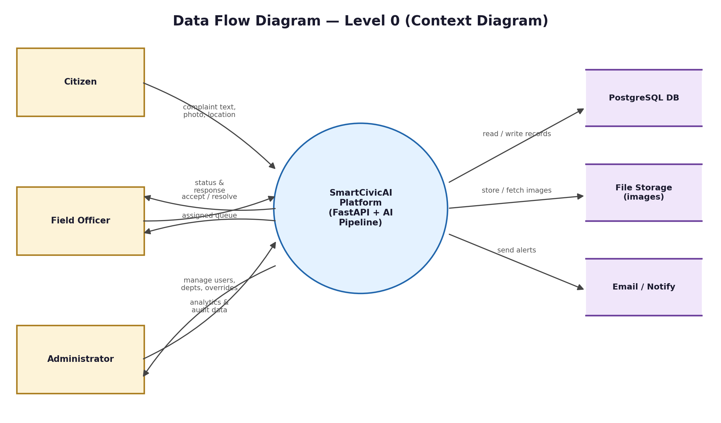
Fig. 5.1 — Data Flow Diagram, Level 0 (context diagram)
5.6 Why an Agent Pipeline Rather Than a Single Model Call
A single monolithic prompt asking a language model to “classify, prioritise, and route this complaint” tends to produce inconsistent, hard-to-audit output. Splitting the work into a pipeline of narrowly scoped agents — each with a single responsibility and its own confidence score — makes the system easier to test, easier to debug when something goes wrong, and easier to partially replace (for example, swapping the priority agent for a fine-tuned model later) without touching the rest of the pipeline.

6. Technologies Used & Modules
6.1 Technology Stack
Layer | Technology
Frontend | React 18, Vite 5, Tailwind CSS, React Router, Axios, Recharts (charts), Leaflet / react-leaflet (maps)
Backend API | FastAPI 0.115, Pydantic v2, Uvicorn (ASGI server)
Database | PostgreSQL 16, SQLAlchemy 2.0 ORM, Alembic (migrations)
Authentication | JWT access & refresh tokens, Passlib + bcrypt password hashing, Role-Based Access Control
AI Orchestration | LangGraph (multi-agent StateGraph), Anthropic Claude API (optional), rule-based “demo” fallback
Computer Vision | YOLOv8 (Ultralytics) for civic-issue image detection, demo mode when no trained weights are supplied
Predictive Analytics | scikit-learn, XGBoost, pandas / numpy for volume and hotspot forecasting
Language Handling | langdetect for automatic language identification (English / Hindi / Telugu)
Notifications | Python smtplib / email.mime for email alerts, plus in-app notifications
Containerisation | Docker & Docker Compose (db, backend, frontend/nginx services)
6.2 Why These Technologies
- FastAPI was chosen over Flask/Django for its native async support, automatic OpenAPI documentation, and first-class Pydantic-based request/response validation, which reduces boilerplate for a data-heavy API like this one.
- React + Vite gives a fast local development loop and a small, modern production bundle compared to older tooling (e.g., Create React App).
- PostgreSQL was chosen over SQLite/MySQL for its native support for rich types (JSON, arrays, enums) used throughout the AI-analysis tables, and because Alembic migrations on Postgres are a realistic simulation of a production deployment.
- LangGraph was chosen over an ad-hoc chain of function calls because it makes the agent pipeline an explicit, inspectable graph, which is easier to reason about, test, and extend than nested conditional logic.
6.3 Functional Modules
6.3.1 Authentication & User Management
Handles registration, login, JWT refresh, role management (Citizen / Officer / Admin), officer account creation, and account activation/deactivation. Passwords are hashed with bcrypt via Passlib; access tokens are short-lived JWTs, refreshed via a separate refresh-token endpoint.
6.3.2 Complaint Management
Covers complaint submission with optional image upload, the full status lifecycle (New → Pending → Assigned → In Progress → Resolved / Rejected / Escalated), officer accept/resolve actions with a proof photo, and citizen feedback capture.
6.3.3 AI Classification Pipeline
A LangGraph-orchestrated sequence of agents: language detection, category classification, priority assessment, department routing, and citizen-response generation. Described in full in Section 8.2 and Section 9.4.
6.3.4 Computer Vision Module
An optional YOLOv8-based detector that can flag civic issues (e.g., garbage piles, damaged roads) directly from an uploaded photograph, supplementing the text-based classification. Falls back to a deterministic demo mode when no trained weights are supplied.
6.3.5 Department & Category Management
Admin CRUD screens for the departments and categories that each of the four civic modules routes into, including contact email addresses used for departmental notifications.
6.3.6 Analytics & Predictive Module
15 dedicated analytics endpoints covering status/priority/category/language distribution, department performance, resolution-time statistics, complaint hotspots, and ML-based volume/hotspot prediction, rendered as charts and tables on the Admin Dashboard.
6.3.7 Notifications
In-app and email alerts for status changes, assignment, resolution, and escalation, dispatched from a single NotificationService used across the complaint-management endpoints.
6.3.8 Audit Logging
Every status change and every AI override (module, category, priority, department) is recorded with before/after values, the acting user, and a timestamp, visible to administrators via the Audit Logs screen.

7. System Requirements
7.1 Hardware Requirements
Component | Minimum
Processor | Dual-core 2 GHz or better
RAM | 8 GB (4 GB is sufficient for the core web app without the optional AI/ML/CV extras)
Storage | 2 GB free space (more if YOLOv8 weights and large complaint-image uploads are stored locally)
Network | Internet connection (required only if AI_PROVIDER=anthropic or email delivery is enabled)
7.2 Software Requirements
Component | Version / Detail
Operating System | Windows 10/11, macOS, or Linux (Ubuntu 22.04/24.04 tested)
Backend runtime | Python 3.12
Frontend runtime | Node.js 18+ / npm
Database | PostgreSQL 16
Containerisation (optional) | Docker & Docker Compose
Browser | Any modern browser (Chrome, Edge, Firefox)
7.3 Functional Requirements
- FR-1: The system shall allow a citizen to register, log in, and submit a complaint with text, an optional photo, and an optional location.
- FR-2: The system shall automatically classify each complaint's module, category, and priority using the AI pipeline.
- FR-3: The system shall automatically route each complaint to the correct department, or flag it for admin review if confidence is low.
- FR-4: The system shall allow an officer to view, accept, update the status of, and resolve complaints assigned to their department.
- FR-5: The system shall allow an administrator to manage departments, categories, users/officers, and to override any AI decision.
- FR-6: The system shall record every status change and AI override in an audit log.
- FR-7: The system shall present aggregate analytics and predictive forecasts to administrators.
7.4 Non-Functional Requirements
- NFR-1 (Availability): The core complaint-submission flow must degrade gracefully (fallback to demo AI mode) rather than fail if the LLM provider is unreachable.
- NFR-2 (Security): All state-changing endpoints must be authenticated with a JWT and authorised against the caller's role.
- NFR-3 (Auditability): Every AI override and status transition must be traceable to an actor and a timestamp.
- NFR-4 (Portability): The system must be deployable via Docker Compose on any Docker-capable host.
- NFR-5 (Usability): The citizen-facing UI must be usable in English, Hindi, and Telugu.

8. System Architecture
SmartCivicAI follows a classic three-tier architecture: a React single-page front end, a FastAPI REST backend that also hosts the AI/CV/analytics services, and a PostgreSQL database. The whole stack is containerised with Docker Compose for one-command deployment.
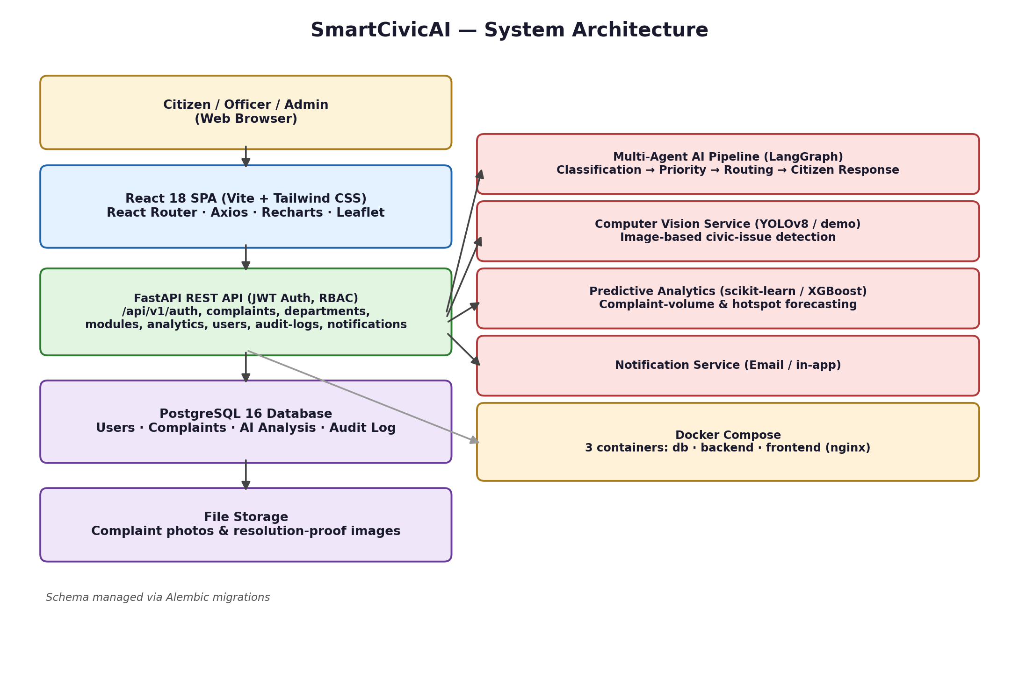
Fig. 8.1 — SmartCivicAI system architecture
The React SPA talks to the backend exclusively over a versioned REST API (/api/v1/...) secured with JWT bearer tokens. Eight route groups cover authentication, departments, modules/categories, complaints, analytics, users, audit logs, and notifications. Every write to a complaint (status change, assignment, AI override) triggers an audit-log entry and, where relevant, an in-app and/or email notification to the citizen.
8.1 Entity Relationship Diagram
The database schema is centred on the Complaint table, which links to the submitting citizen, the assigned department and officer, and a set of child tables recording images, location, status history, and AI-analysis results. Figure 8.3 shows the core entities and their relationships.
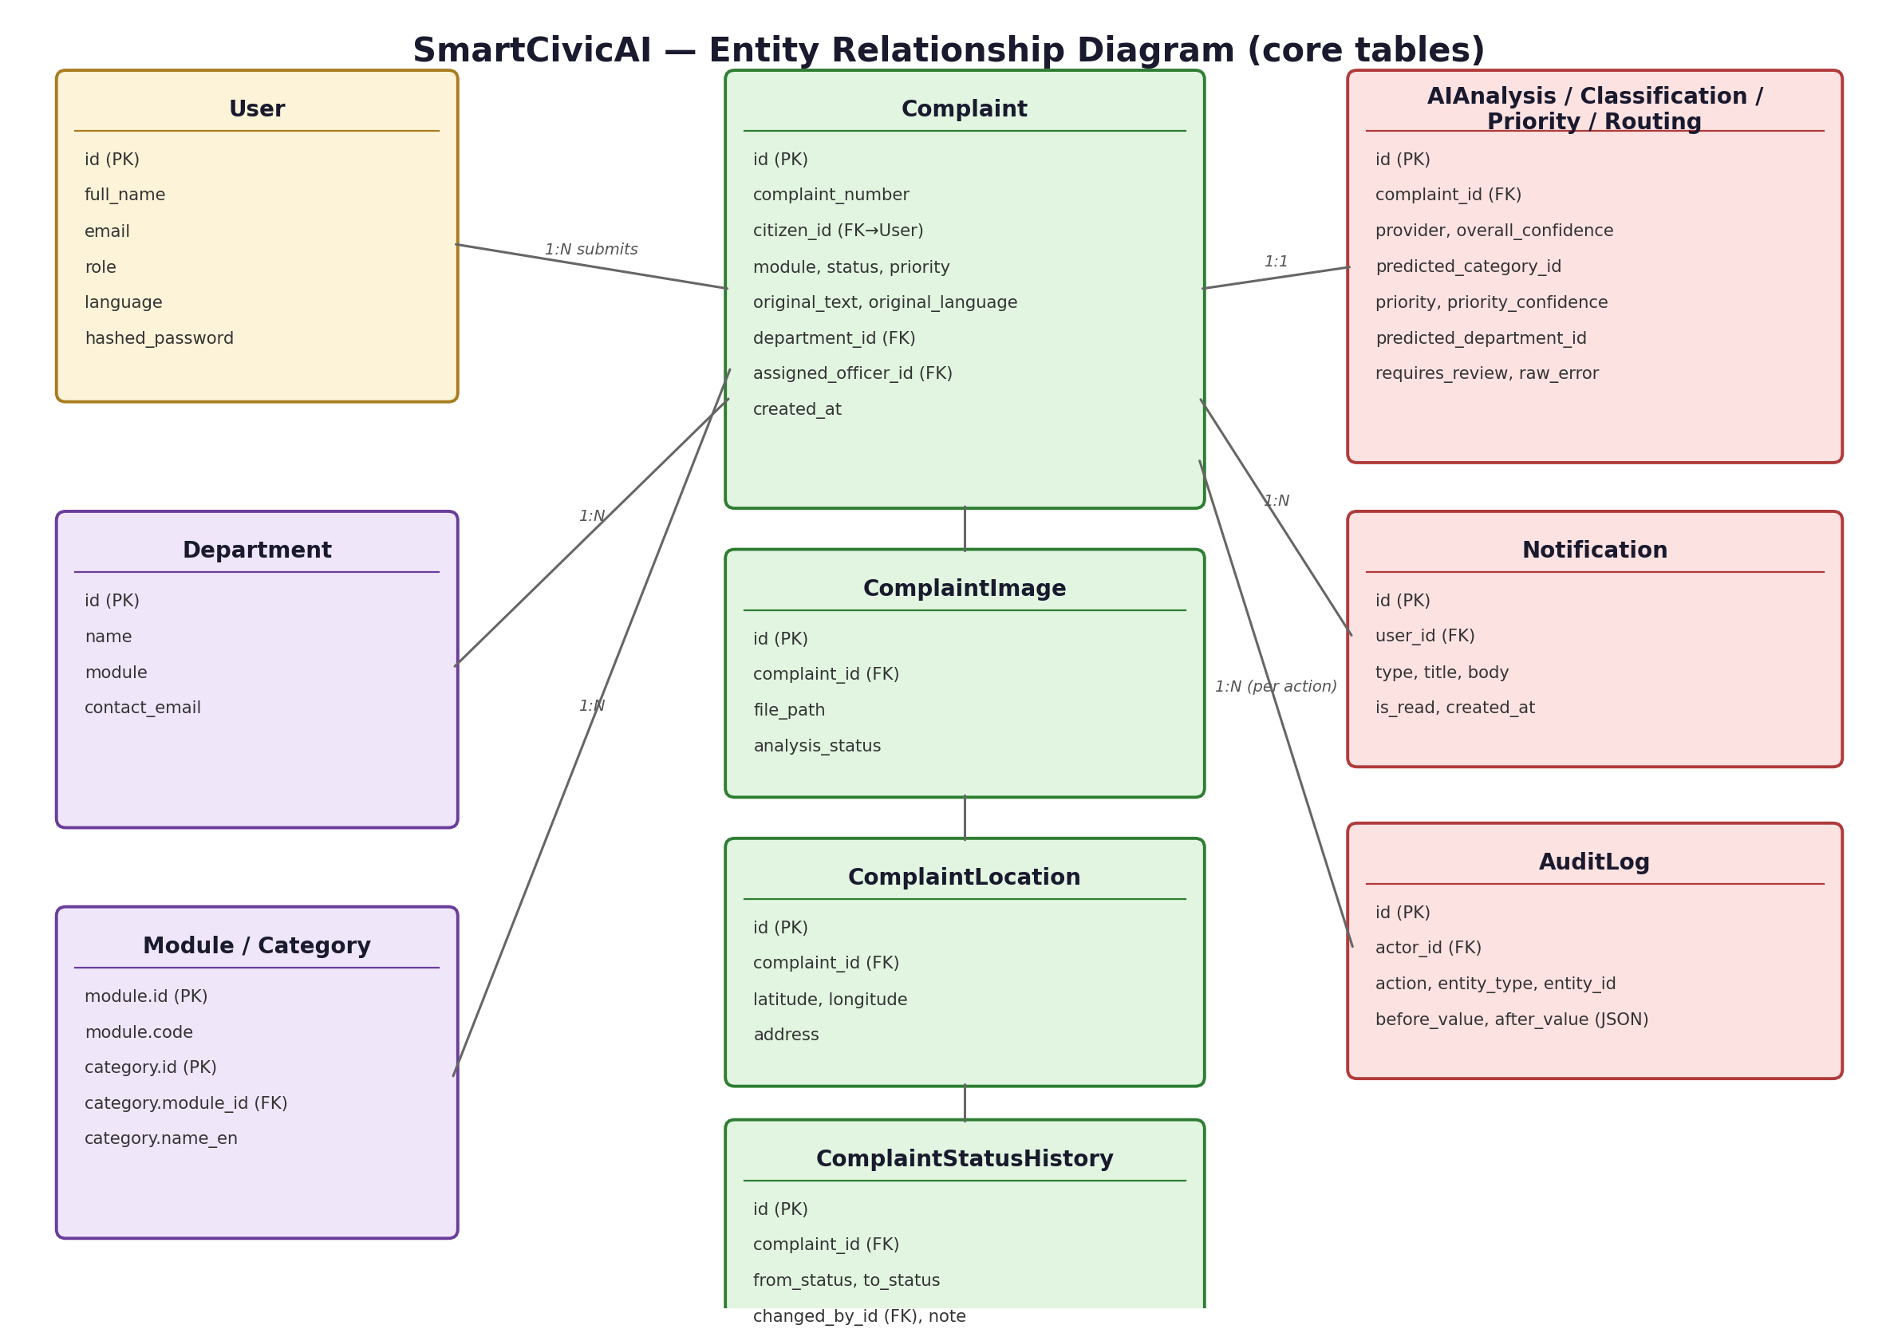
Fig. 8.3 — Entity Relationship Diagram (core tables)
8.2 Multi-Agent AI Pipeline
The heart of the system is a LangGraph-orchestrated agent pipeline that runs automatically whenever a complaint is submitted:
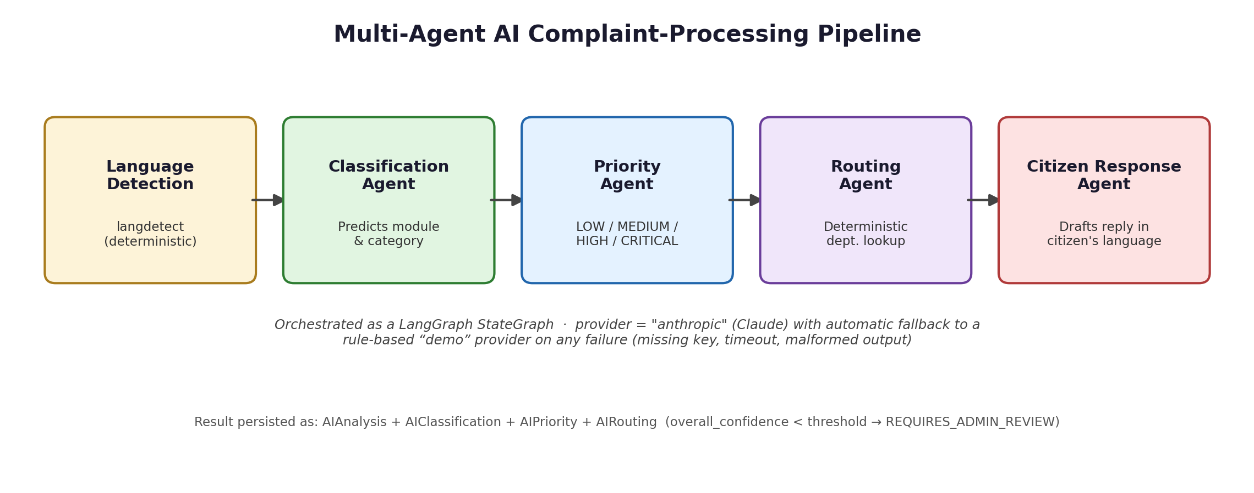
Fig. 8.2 — Multi-agent AI complaint-processing pipeline
- Language Detection — identifies whether the complaint text is English, Hindi, or Telugu.
- Classification Agent — predicts the civic module and category (e.g., Healthcare → “Medicine shortage”).
- Priority Agent — assigns LOW, MEDIUM, HIGH, or CRITICAL based on the described severity.
- Routing Agent — deterministically looks up the department responsible for the predicted module, and assigns a confidence score to that routing decision.
- Citizen Response Agent — drafts an acknowledgement message back to the citizen in their own language.
Each agent's output is combined into an overall confidence score; if it falls below a configurable threshold (or no department could be resolved), the complaint is flagged REQUIRES_ADMIN_REVIEW rather than silently mis-routed. When AI_PROVIDER=anthropic and a valid API key is present, all four language-understanding steps are performed by Claude; if the LLM call fails for any reason (missing dependency, bad key, timeout, malformed output), the pipeline automatically and silently falls back to a deterministic rule-based “demo” classifier so complaint submission never breaks.
8.3 Data Flow Diagram (Context Level)
Figure 8.4 restates the system boundary from an architectural point of view: three external actors exchange data with the platform, which in turn persists to PostgreSQL, stores images on disk, and dispatches outbound notifications.

Fig. 8.4 — Data Flow Diagram, Level 0 (context diagram)
8.4 Sequence Diagram — Complaint Submission
Figure 8.5 traces a single complaint submission end-to-end across the frontend, backend, AI pipeline, database, and notification service, showing the order in which calls happen and what is persisted at each step.
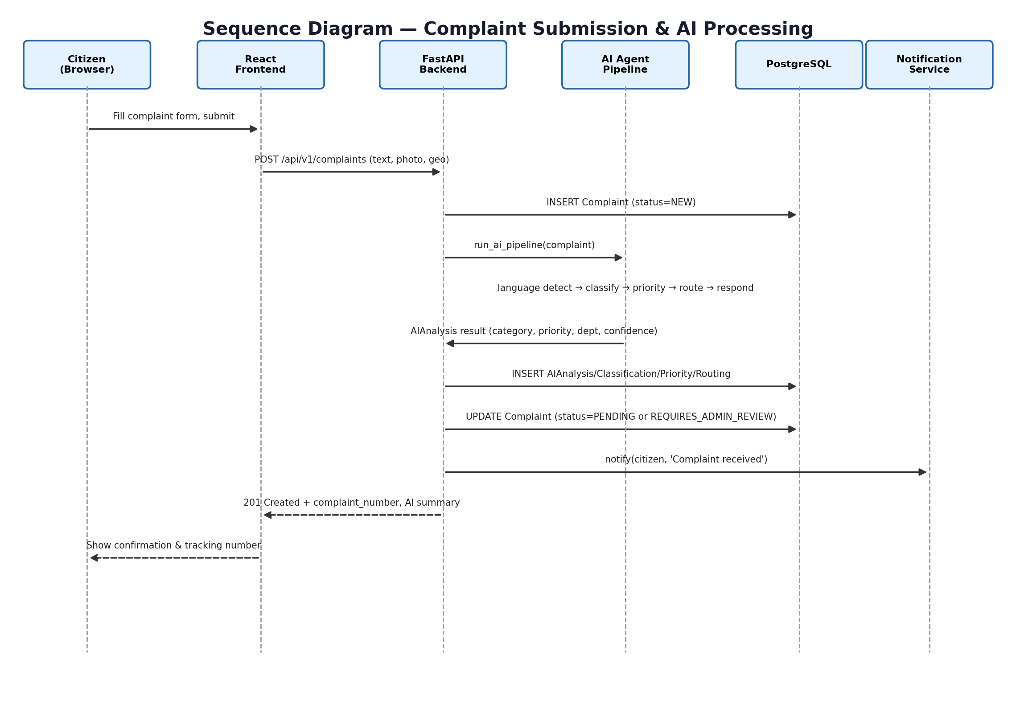
Fig. 8.5 — Sequence diagram: complaint submission & AI processing
8.5 Deployment Architecture
docker-compose.yml defines three services — db (PostgreSQL with a persistent volume), backend (FastAPI, built from its own Dockerfile, Python 3.12-slim), and frontend (the built React app served by nginx) — plus named volumes for Postgres data, uploaded images, and ML model weights. This mirrors a realistic small-scale production deployment while remaining runnable on a single host.

9. Implementation
9.1 Role-Based Access Control
Three roles — CITIZEN, OFFICER, and ADMIN — are enforced at the API layer via FastAPI dependency injection (require_officer, require_admin, etc.), not just hidden in the UI. A citizen can only view their own complaints; an officer can only act on complaints assigned to their department; only an admin can create officer accounts, manage departments/categories, or override an AI decision.
Role | Can do
Citizen | Register/login, submit complaints, view own complaints & status history, edit own profile.
Officer | View department queue (unassigned / assigned to me / all in department), accept complaints, update status, resolve with proof photo.
Admin | Everything an officer can do, plus: manage departments & categories, manage users & officers, override any AI decision, view audit logs, view analytics & predictive dashboards, view GIS hotspot map.
9.2 Complaint Status Lifecycle
A complaint moves through a strict, validated state machine: NEW → PENDING → ASSIGNED → IN_PROGRESS → RESOLVED, with REJECTED and ESCALATED as terminal/exception branches, plus REQUIRES_ADMIN_REVIEW for low-confidence AI results. The backend rejects any transition that skips this graph (e.g., PENDING → RESOLVED directly is refused with a 400 error), and every transition is written to a ComplaintStatusHistory table for full traceability.
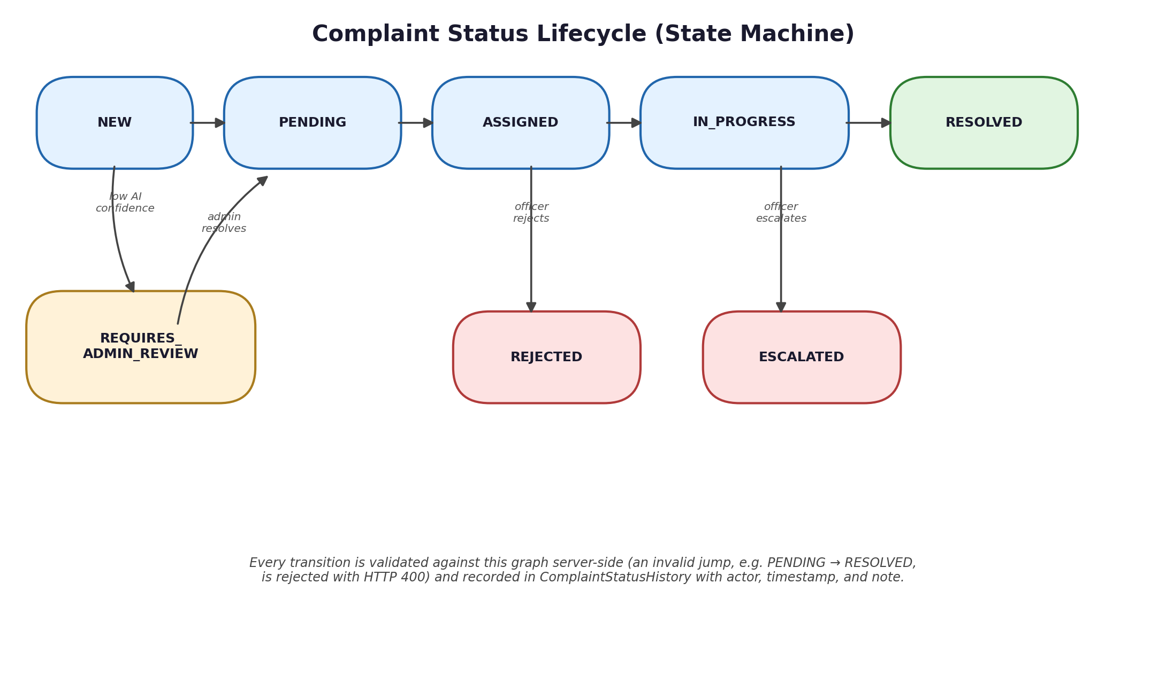
Fig. 9.1 — Complaint status lifecycle (state machine)
9.3 Database Design
The schema is managed entirely through Alembic migrations on top of a SQLAlchemy 2.0 ORM. Core tables include Users, Departments, Modules/Categories, Complaints, ComplaintImages, ComplaintLocation, ComplaintStatusHistory, AIAnalysis/AIClassification/AIPriority/AIRouting, Notifications, and AuditLogs — every table using UUID primary keys and created/updated timestamp mixins. Refer back to Figure 8.3 for the full entity-relationship diagram.
9.3.1 Key Table Reference
Table | Purpose
User | Citizens, officers, and admins; stores role, preferred language, and hashed password.
Department | One row per civic department (e.g., “District Health Office”), tagged with its module.
Module / Category | The fixed taxonomy (4 modules, many categories each) the AI classifier predicts against.
Complaint | The central record: citizen, module, status, priority, text, department, assigned officer.
ComplaintImage | Uploaded photo(s) for a complaint, plus CV-analysis status.
ComplaintLocation | Latitude/longitude and optional address for a complaint.
ComplaintStatusHistory | Append-only log of every status transition, who made it, and any note.
AIAnalysis family | Classification, priority, and routing results plus confidence scores and provider used.
Notification | In-app/email notification records per user.
AuditLog | Generic before/after audit trail for admin actions and status changes.
9.4 AI Pipeline Implementation
The LangGraph pipeline defines each agent as a pure function operating on a shared typed state, then wires them into a linear graph:
classification_agent -> priority_agent -> routing_agent -> citizen_response_agent
def _classification_node(state):
result = llm_classifier.classify_complaint(
state["complaint_text"], state["module_label"], state["categories"])
return {"predicted_category_id": result["predicted_category_id"],
"category_confidence": result["confidence"]}
The priority and routing agents follow the same pattern: read the relevant slice of shared state, call either the LLM-backed classifier or the deterministic demo classifier (selected once at pipeline start based on AI_PROVIDER and whether the call succeeds), and merge their result back into state. The routing agent is intentionally the most deterministic of the four: once a department is known for a module, the lookup is a direct database query rather than an LLM guess, which keeps routing both fast and auditable.
def run_ai_pipeline(complaint_text, module, categories, departments):
state = {"complaint_text": complaint_text, "module_label": module}
for node in [classification_agent, priority_agent,
routing_agent, citizen_response_agent]:
state.update(node(state))
overall_confidence = min(
state["category_confidence"], state["priority_confidence"],
state["routing_confidence"])
state["requires_review"] = overall_confidence < CONFIDENCE_THRESHOLD
return state
9.5 Fallback / Resilience Strategy
Every call into the LLM-backed classifier is wrapped so that any exception — a missing API key, a network timeout, a malformed JSON response — is caught and silently redirected to the deterministic “demo” classifier for that agent, rather than surfacing an error to the citizen. The raw error (if any) is still recorded on the AIAnalysis row's raw_error field for later debugging by an administrator, so nothing is lost, but the citizen-facing flow never breaks.
9.6 API Surface
The backend exposes 8 route groups and roughly 40 endpoints in total. A representative subset is listed below; the complete set is discoverable through the auto-generated OpenAPI schema at /docs.
Route group | Representative endpoints
auth | POST /auth/register, POST /auth/login, POST /auth/refresh
complaints | POST /complaints, GET /complaints/{id}, PATCH /complaints/{id}/status, POST /complaints/{id}/resolve
departments | GET /departments, POST /departments, DELETE /departments/{id}
modules | GET /modules, GET /modules/{id}/categories
analytics | GET /analytics/overview, /status-distribution, /department-performance, /hotspots, /predicted-volume
users | GET /users, POST /users/officers, PATCH /users/{id}/deactivate
audit-logs | GET /audit-logs
notifications | GET /notifications, PATCH /notifications/{id}/read
The 15 dedicated analytics endpoints alone cover: overview counts, status distribution, module distribution, a complaints-over-time series, priority distribution, department performance, resolution-time statistics, category/language distribution, AI classification/routing statistics, geographic hotspots, and ML-based predicted volume/hotspots — all of which back the charts shown in Section 10.
9.7 Deployment
docker-compose.yml defines three services — db (PostgreSQL with a persistent volume), backend (FastAPI, built from its own Dockerfile, Python 3.12-slim), and frontend (the built React app served by nginx) — plus named volumes for Postgres data, uploaded images, and ML model weights, so the entire stack can be brought up with a single docker compose up command.
9.8 Verification
For this documentation, the full stack was installed and exercised end-to-end in a clean environment: PostgreSQL 16 was installed and configured, backend dependencies were installed into a virtual environment, Alembic migrations were applied, the seed script was run (creating demo accounts and 60 sample complaints), and both the FastAPI backend (Uvicorn) and the React frontend (Vite) were started successfully. A headless Chromium browser was then driven programmatically to log in as each of the three roles and capture the screenshots presented in Section 10 directly from the live, running application — none of the screenshots in this document are mock-ups.

10. Output Screenshots
The complete stack — PostgreSQL 16 (seeded with 60 demo complaints across 3 demo accounts), the FastAPI backend, and the React frontend — was installed and run live to capture every screenshot below directly from the working application. Screens are grouped by role: citizen-facing screens first, then the officer console, then the administrator console.
10.1 Public & Citizen Screens
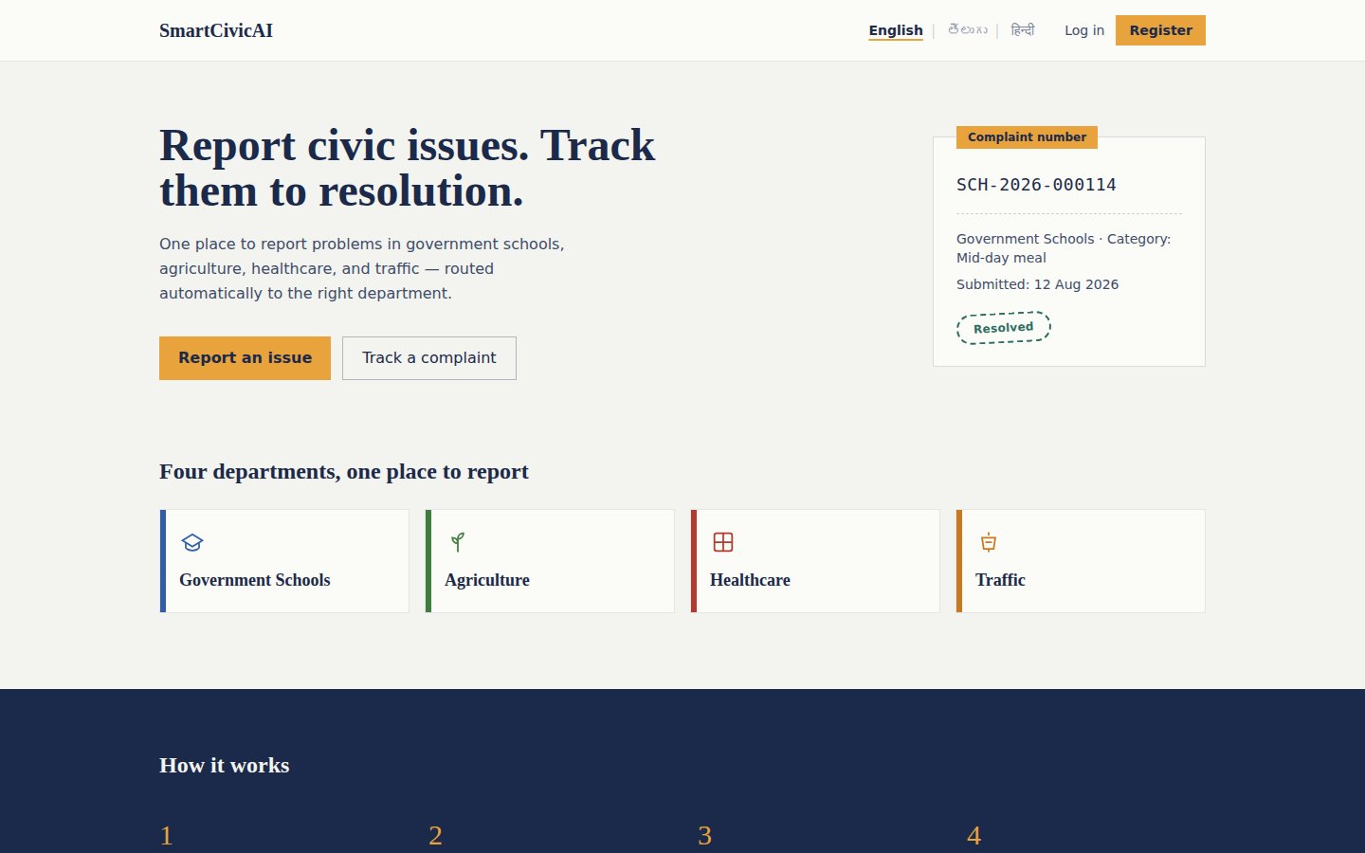
Fig. 10.1 — Landing page, with quick complaint-number tracking and the four civic modules
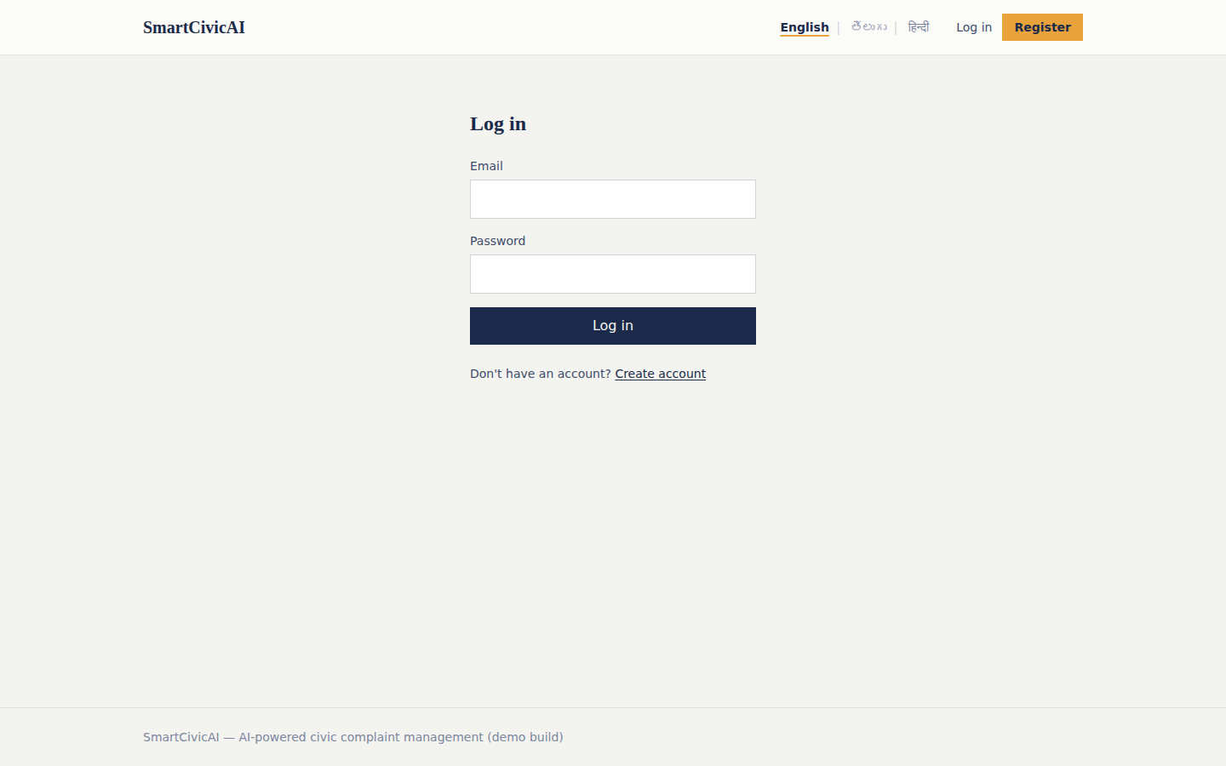
Fig. 10.2 — Login page (role is detected automatically from the account after sign-in)
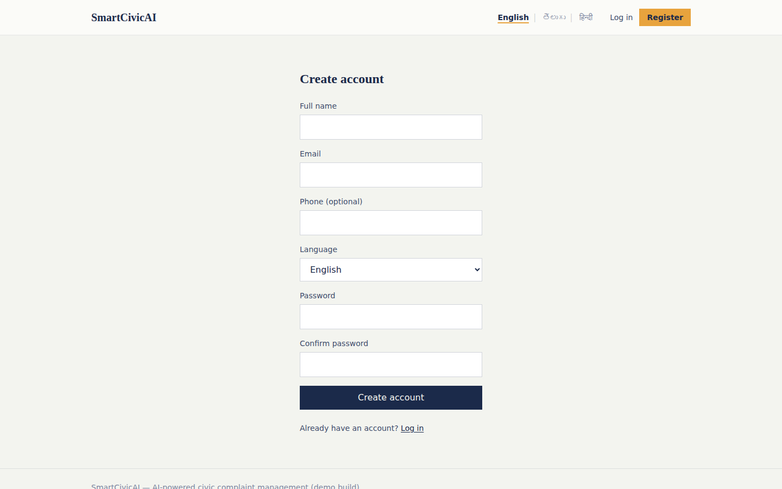
Fig. 10.3 — Registration page, including a preferred-language selector
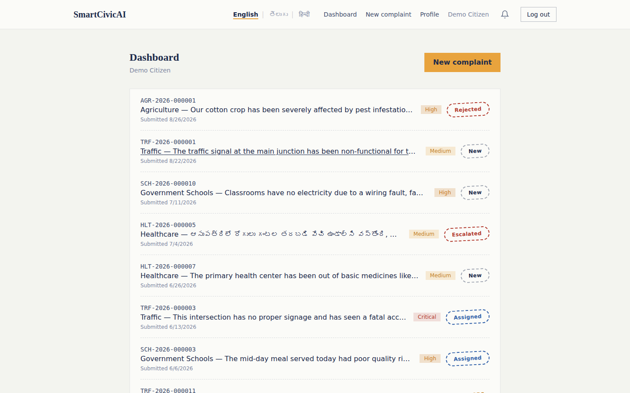
Fig. 10.4 — Citizen Dashboard, showing a citizen's own complaints with live status and priority badges (English, Hindi, and Telugu submissions all visible)
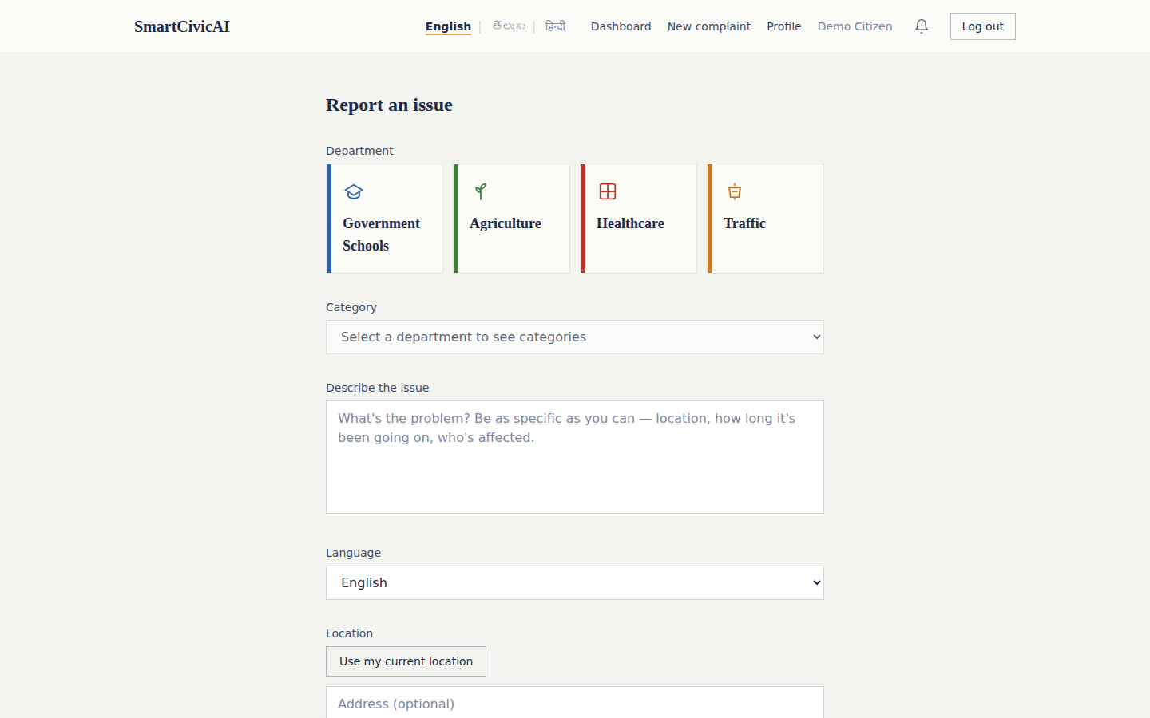
Fig. 10.5 — “Report an issue” complaint-submission form, with module, category, description, language, and location fields
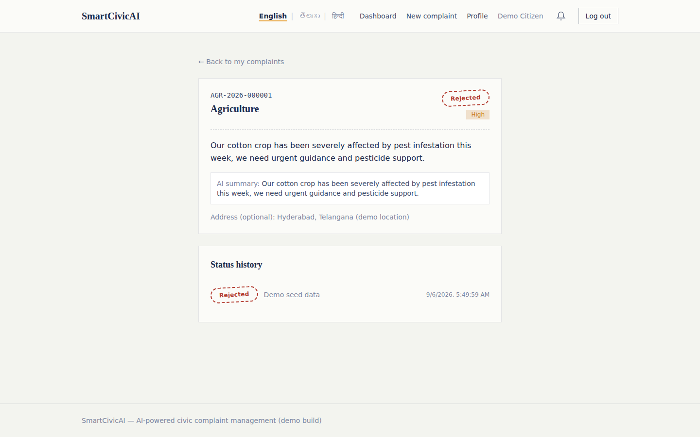
Fig. 10.6 — Complaint Detail page showing the AI-generated summary, priority, and full status history
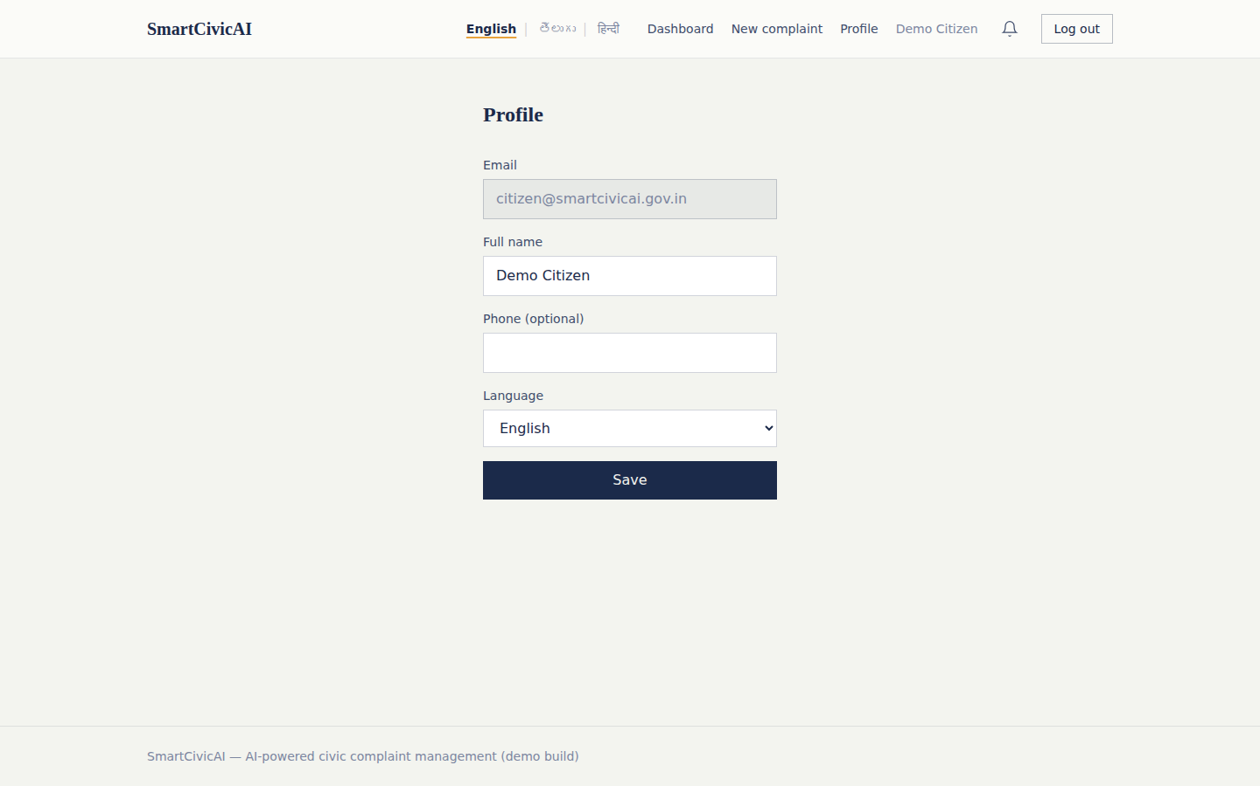
Fig. 10.7 — Citizen Profile page for updating name, phone, and preferred language
10.2 Officer Console
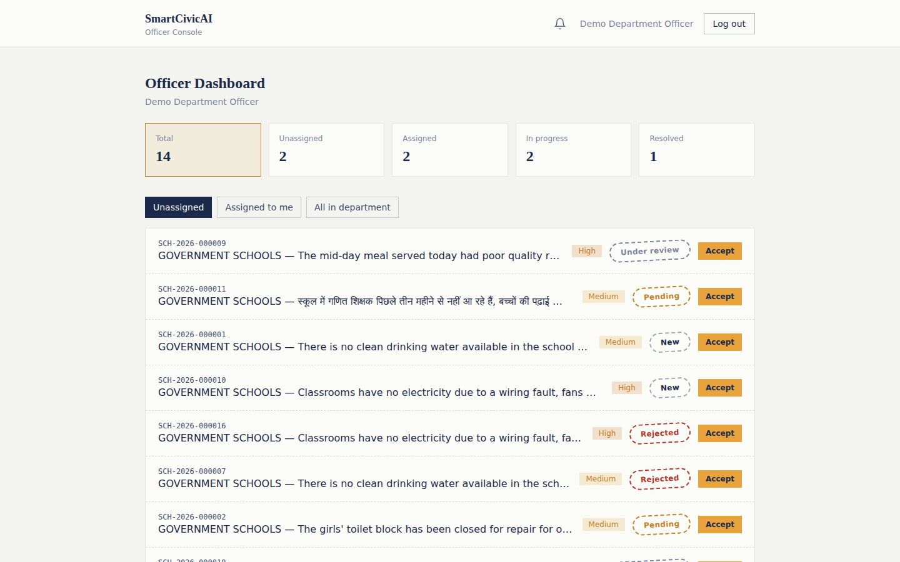
Fig. 10.8 — Officer Dashboard: department queue filtered by Unassigned / Assigned to me / All in department
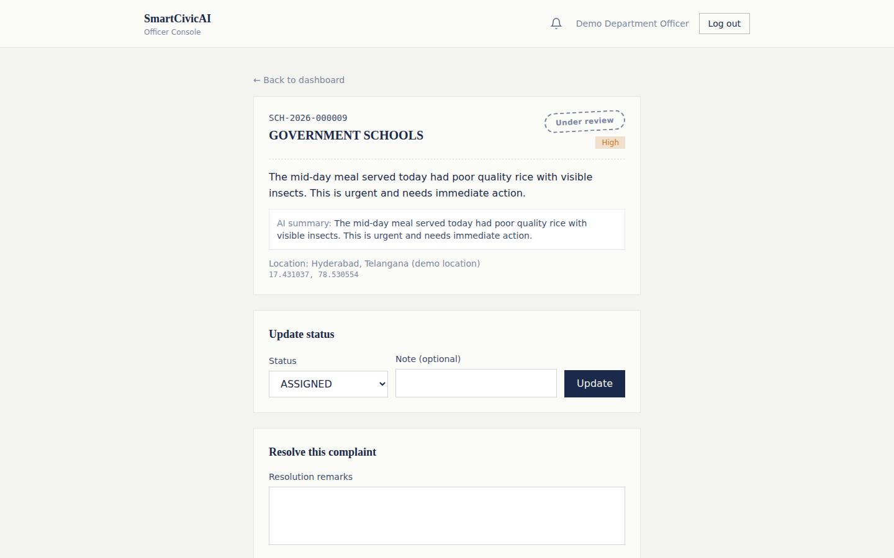
Fig. 10.9 — Officer Complaint Detail, with status-update and resolution-remarks controls
10.3 Administrator Console
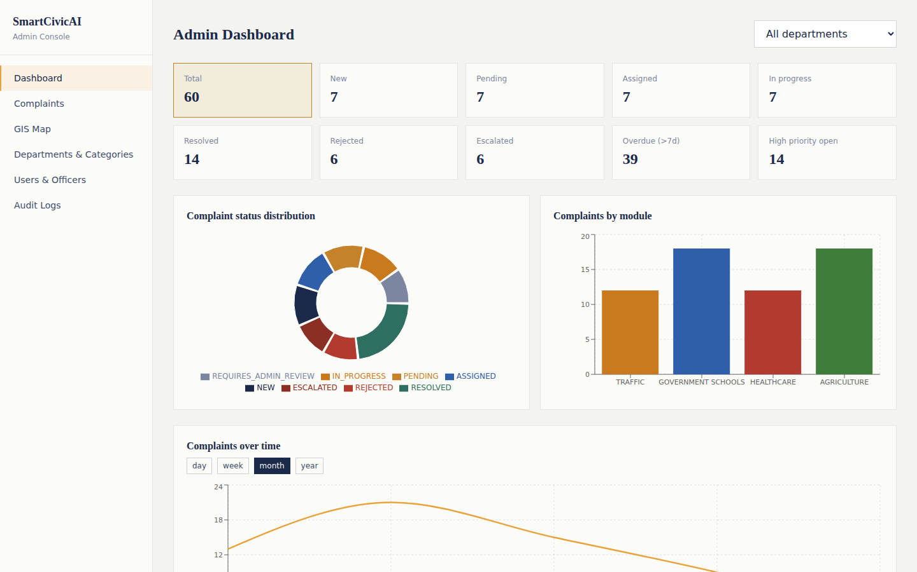
Fig. 10.10 — Admin Dashboard with live status distribution, module distribution, and complaints-over-time charts
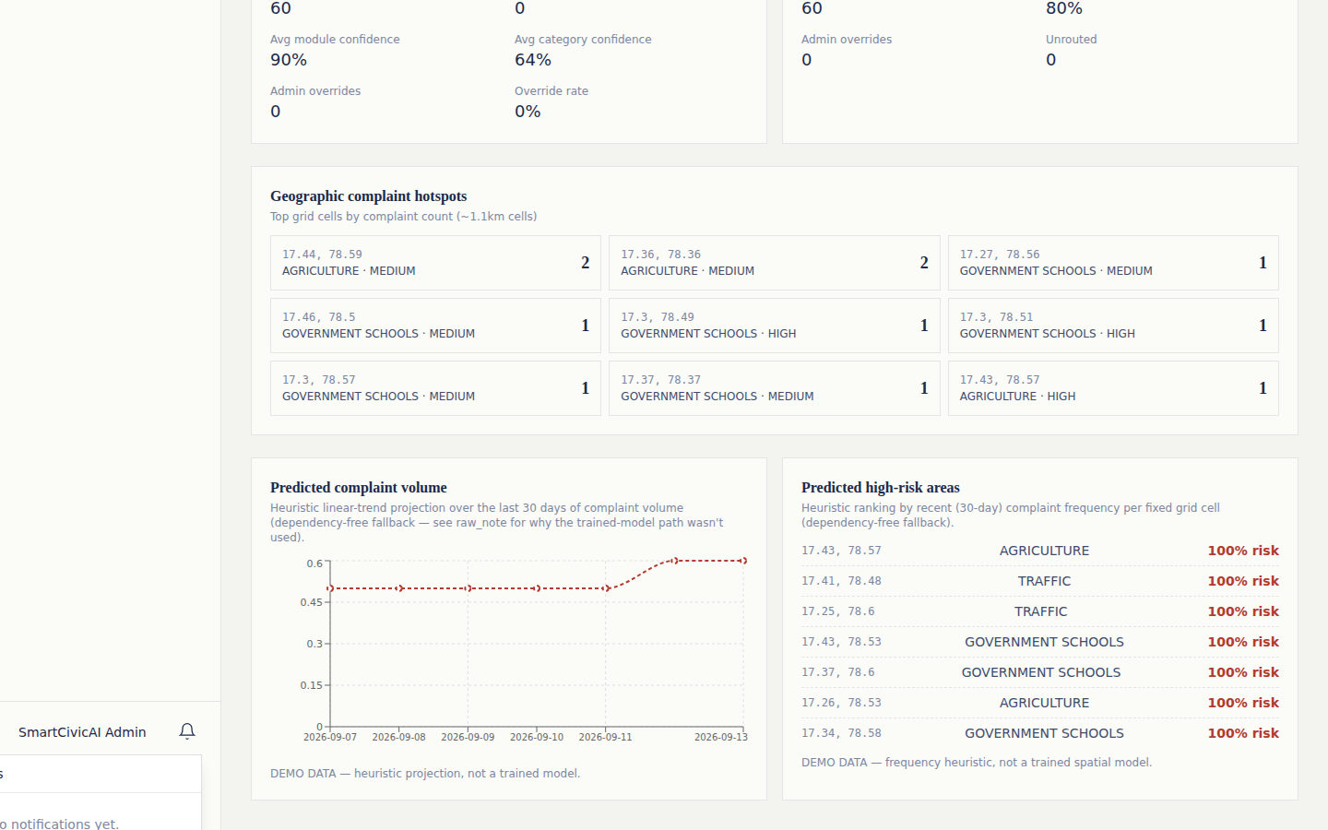
Fig. 10.11 — Admin Dashboard, continued: AI classification confidence stats, geographic hotspots, and the predictive volume / high-risk-area panels
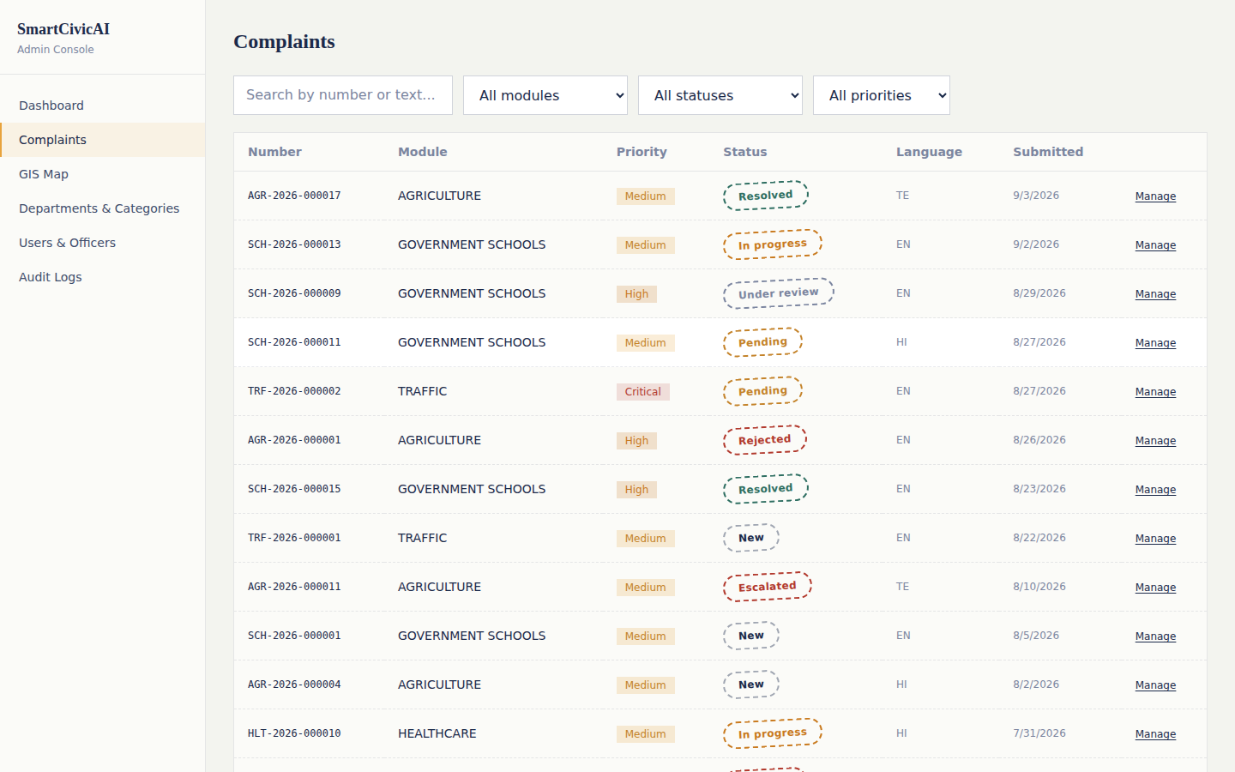
Fig. 10.12 — Admin “Complaints” management table with search and module / status / priority filters
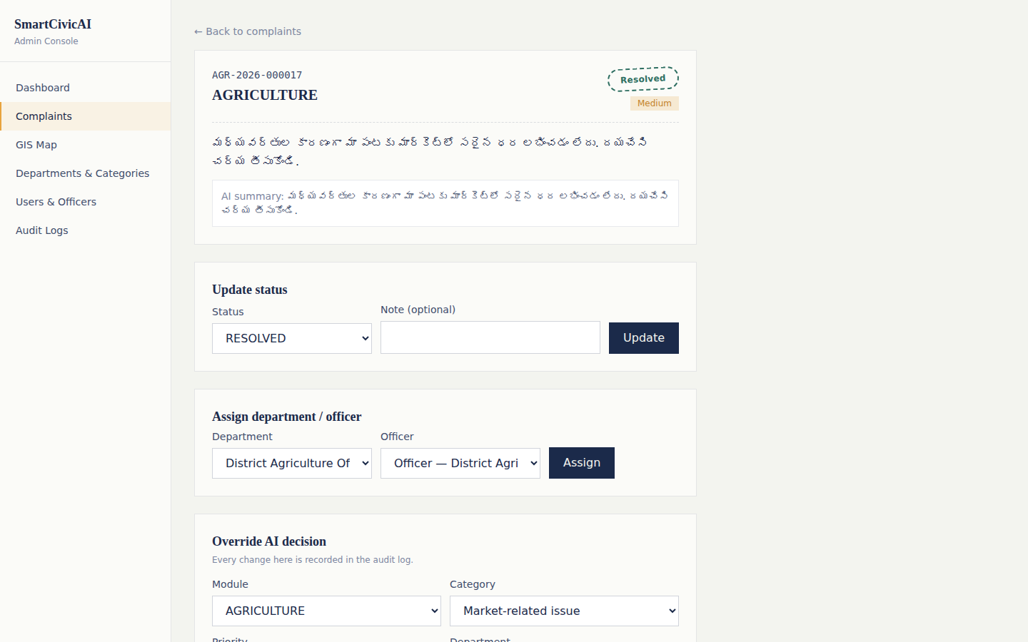
Fig. 10.13 — Admin Complaint Detail, showing status update, department/officer (re)assignment, and the AI-decision override panel (a Telugu complaint shown here)
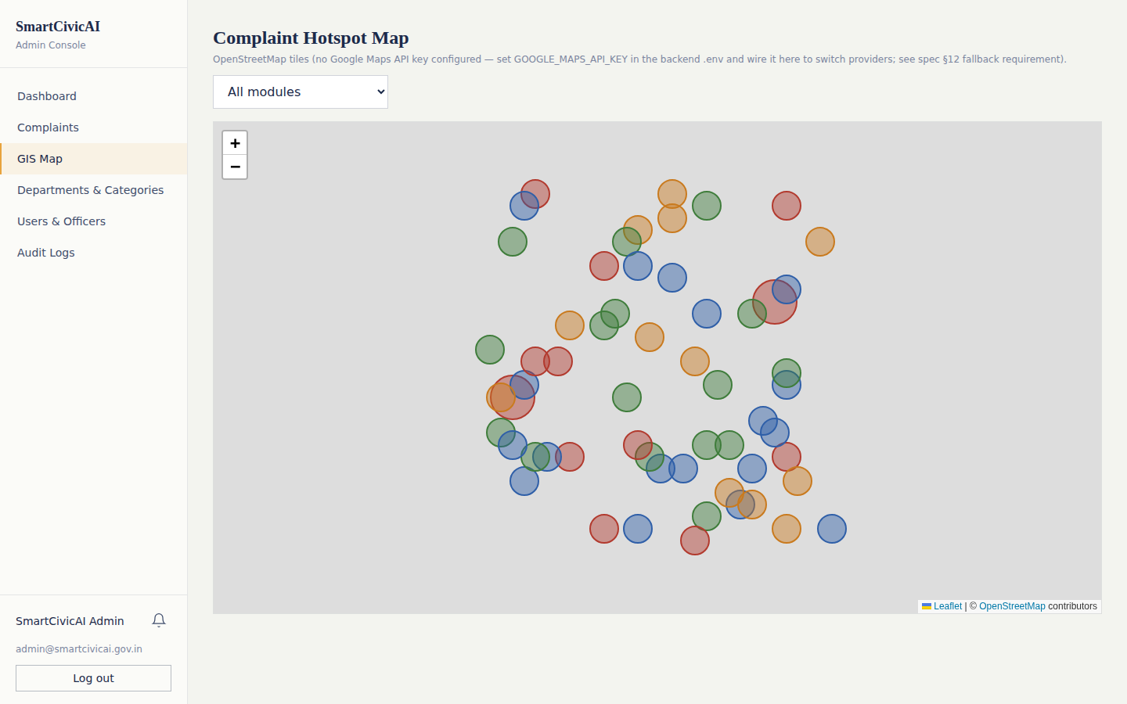
Fig. 10.14 — Complaint Hotspot Map (Leaflet + OpenStreetMap fallback, since no Google Maps API key is configured); base map tiles did not load in the offline sandbox used to prepare this document, but complaint markers render correctly from live data
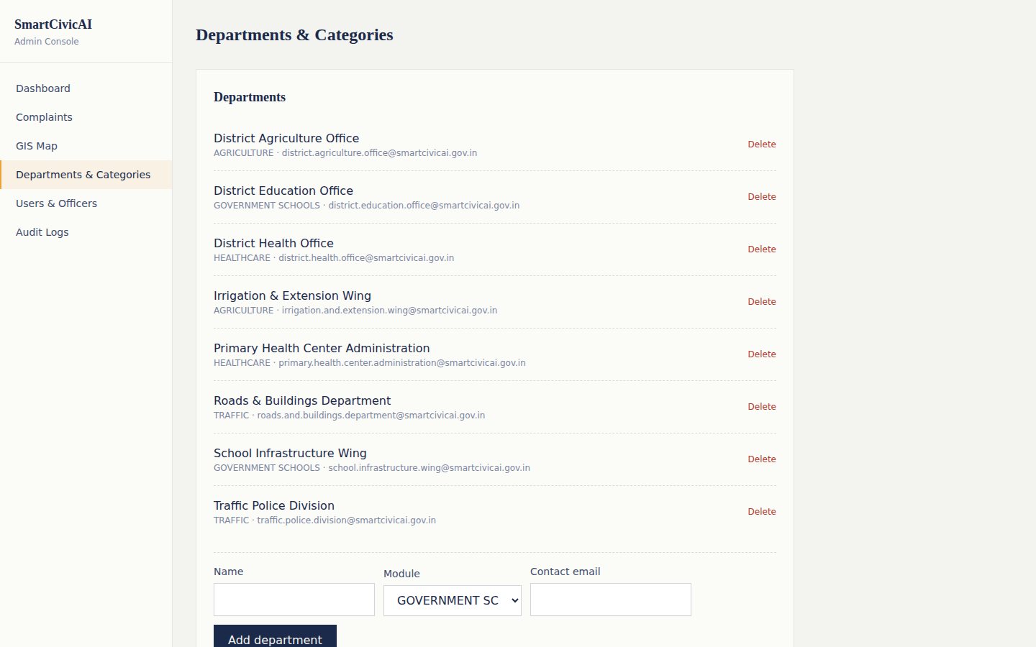
Fig. 10.15 — Departments & Categories management screen
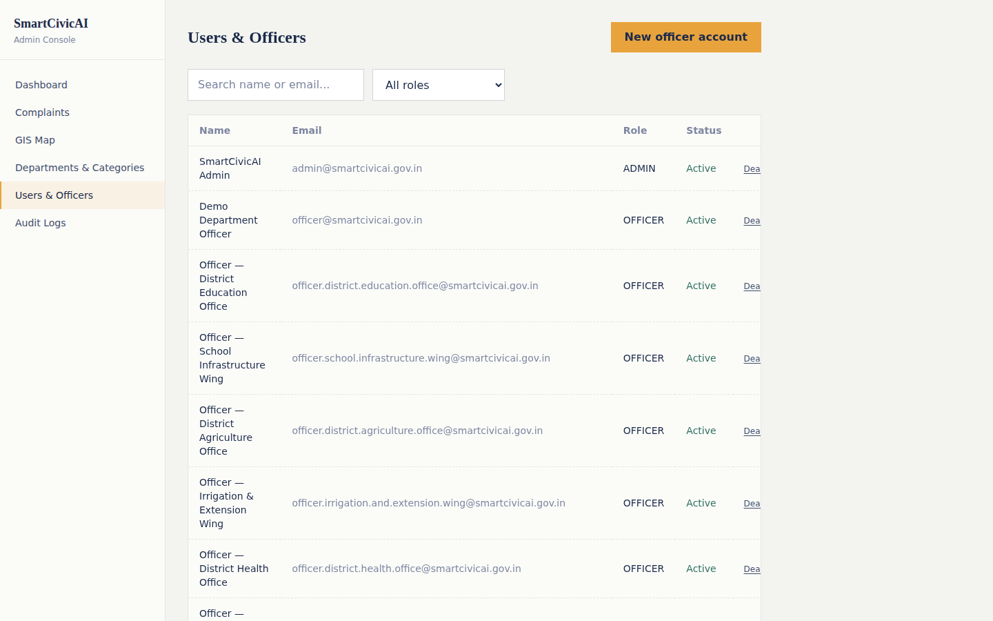
Fig. 10.16 — Users & Officers management screen
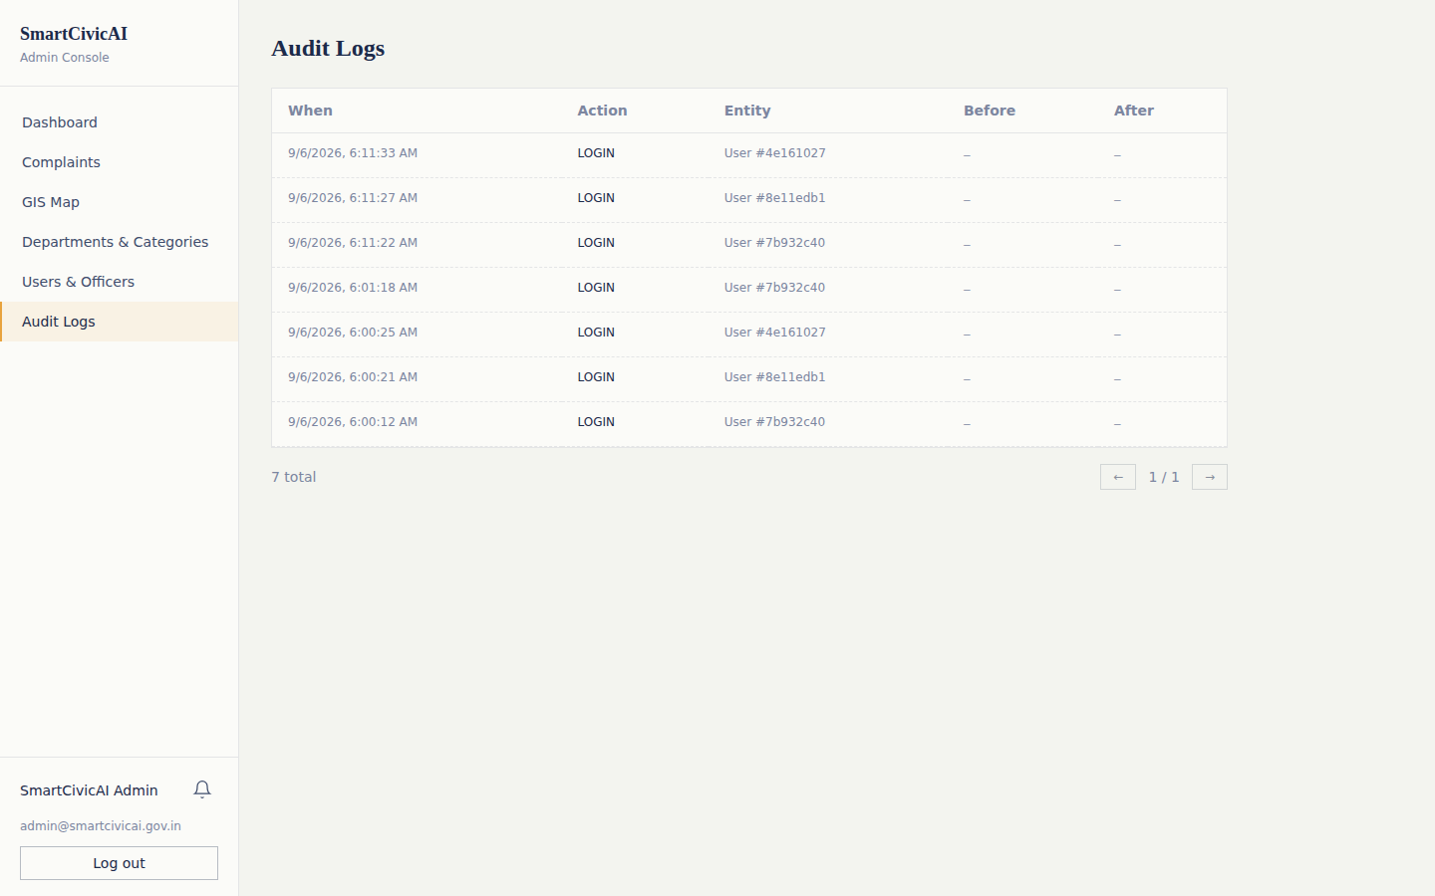
Fig. 10.17 — Audit Logs, showing recorded LOGIN events with actor and timestamp

11. Advantages
- End-to-end automation removes manual triage delay — complaints are classified, prioritised, and routed within seconds of submission.
- Multilingual support (English, Hindi, Telugu) makes the system accessible to a much wider citizen base than English-only portals.
- Full transparency for citizens: real-time status tracking, notifications, and a visible history of every status change.
- Low-confidence AI decisions are automatically escalated for human review instead of being silently mis-routed, keeping a human in the loop where it matters.
- Every AI override and status change is captured in an immutable audit log, supporting accountability and post-hoc analysis.
- The system is fully functional with zero paid API keys (rule-based “demo” mode for AI, CV, and predictive analytics), then upgrades gracefully to real LLM/ML models when configured.
- Predictive analytics (volume and hotspot forecasting) enable proactive rather than reactive municipal planning.
- Containerised deployment (Docker Compose) makes the system easy to install consistently across environments.
- The agent-pipeline design isolates each decision (classification, priority, routing, response) so any one stage can be improved or replaced independently.
- Role-scoped dashboards mean each user only sees the information relevant to their job, reducing cognitive load for officers and citizens alike.

12. Limitations
- The demo-mode AI classifier is rule-based and less accurate than a properly fine-tuned or fully LLM-driven pipeline; real accuracy depends on configuring AI_PROVIDER=anthropic with a valid API key.
- The YOLOv8 computer-vision module requires trained weights to detect civic issues from photos in production; without them it also falls back to a demo mode.
- The predictive-analytics module needs a meaningful volume of historical complaint data to produce reliable forecasts; with only demo data, predictions are illustrative rather than production-grade (as seen in the “DEMO DATA” labels in Fig. 10.11).
- Only three languages (English, Hindi, Telugu) are currently supported for language detection and response generation.
- Email notifications require a real SMTP/Gmail app-password configuration; in restricted network environments, email delivery will fail gracefully but silently.
- The system currently assumes a single-tenant deployment per municipality; multi-tenant support for many cities on one instance is not yet implemented.
- The GIS hotspot map depends on an external map-tile provider (OpenStreetMap by default); complaint markers still render without it, but the base map will not, in fully offline environments.

13. Applications
- Municipal / urban local body grievance-redressal portals for tracking civic issues such as potholes, water supply, and sanitation.
- State or district-level e-governance initiatives that need multilingual citizen engagement.
- Public healthcare-facility issue reporting (medicine shortages, staff absenteeism, equipment failure).
- Government-school infrastructure and resource-gap reporting (mid-day meals, sanitation, staffing).
- Agricultural extension services for reporting irrigation, subsidy, or crop-related issues to the concerned department.
- Traffic and road-safety issue reporting (signal failures, potholes, illegal encroachments) with GIS hotspot visualisation for city planners.
- A reference architecture for any organisation that needs to triage large volumes of free-text submissions against a fixed taxonomy with confidence-based human escalation (e.g., customer support, HR grievance systems).

14. Future Scope
- Fine-tune or train dedicated classification, priority, and routing models on real historical complaint data to reduce reliance on the demo/rule-based fallback.
- Extend language support beyond English, Hindi, and Telugu to other regional Indian languages.
- Add a native mobile application (Android/iOS) for citizens to submit and track complaints on the go.
- Introduce SMS-based complaint submission and status updates for citizens without reliable internet access.
- Integrate with existing government ERP / e-governance systems (e.g., PGRS, CPGRAMS) for interoperability.
- Add automated SLA tracking with escalation timers so complaints that exceed a department's resolution SLA are auto-escalated.
- Expand the predictive-analytics module with more sophisticated time-series and spatial models as more real-world data accumulates.
- Introduce a citizen feedback/rating loop that feeds back into department-performance analytics and officer evaluation.
- Add multi-tenant support so a single deployment can serve multiple municipalities with isolated data.
- Train and ship default YOLOv8 weights for the most common civic-issue categories so computer-vision detection works out of the box.

15. Conclusion
SmartCivicAI demonstrates how a modern multi-agent AI pipeline, combined with a well-structured full-stack web application, can meaningfully improve the speed, consistency, and transparency of civic grievance redressal. By automating language detection, classification, prioritisation, routing, and citizen communication — while still keeping a human administrator in the loop for low-confidence decisions — the system strikes a practical balance between automation and accountability.
Its ability to run entirely offline in a free “demo” mode, and then upgrade seamlessly to real LLM- and ML-backed intelligence, makes it a realistic, deployable starting point for municipal e-governance rather than only a proof of concept. The verification carried out while preparing this documentation — standing up the full stack from a clean environment, seeding real demo data, and capturing live screenshots of every major screen across all three roles — confirms that the system works as designed end-to-end, not only in isolated unit tests.

16. GitHub / Hugging Face Link
Project repository: [Add your GitHub or Hugging Face repository link here before submission.]
Once the code is pushed to a public (or access-shared) repository, replace the line above with the actual URL, e.g. https://github.com/<your-username>/SmartCivicAI.

17. References
- FastAPI Documentation — https://fastapi.tiangolo.com/
- React Documentation — https://react.dev/
- SQLAlchemy 2.0 Documentation — https://docs.sqlalchemy.org/
- Alembic Documentation — https://alembic.sqlalchemy.org/
- LangGraph Documentation — https://langchain-ai.github.io/langgraph/
- Anthropic Claude API Documentation — https://docs.claude.com/
- Ultralytics YOLOv8 Documentation — https://docs.ultralytics.com/
- scikit-learn Documentation — https://scikit-learn.org/
- XGBoost Documentation — https://xgboost.readthedocs.io/
- PostgreSQL 16 Documentation — https://www.postgresql.org/docs/16/
- Docker Compose Documentation — https://docs.docker.com/compose/
- Leaflet.js Documentation — https://leafletjs.com/reference.html
- Recharts Documentation — https://recharts.org/
- langdetect (Python package) — https://pypi.org/project/langdetect/

