1, Unzip the plugin and place the Meetanshi folder in the app/code like below screen shot.

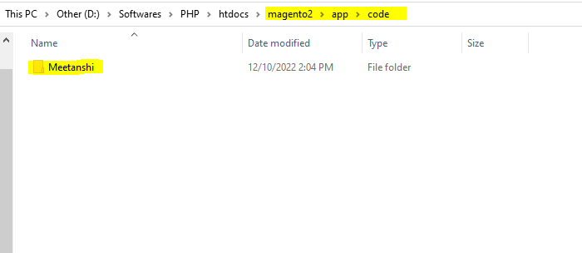

Execute the below command in the magento2 folder :

php bin/magento setup:upgrade

php bin/magento setup:static-content:deploy -f

php bin/magento cache:flush

2,In the Magento admin panel go to

Store->sales->Payment methods->Other payment methods

Select the OAB payment gateway and provide below details and save the configuration.

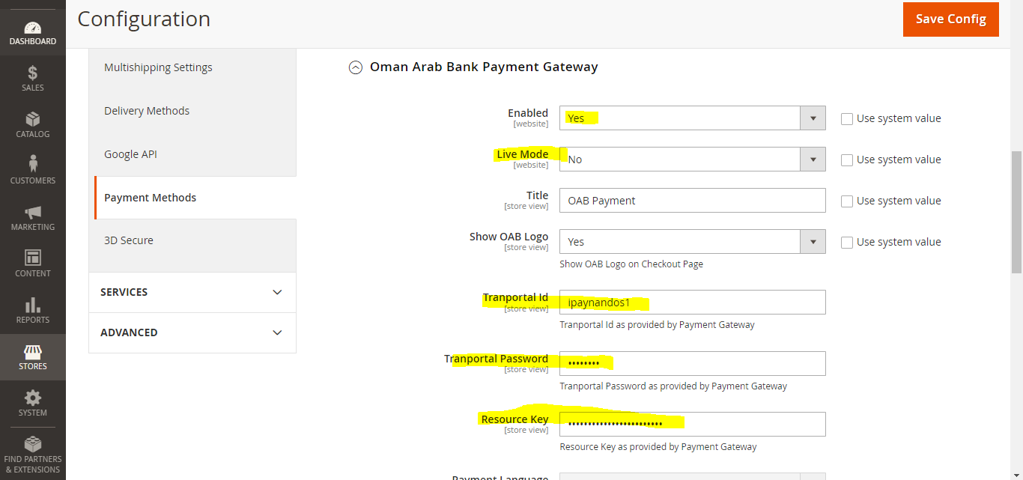

Select Live mode yes only for production.



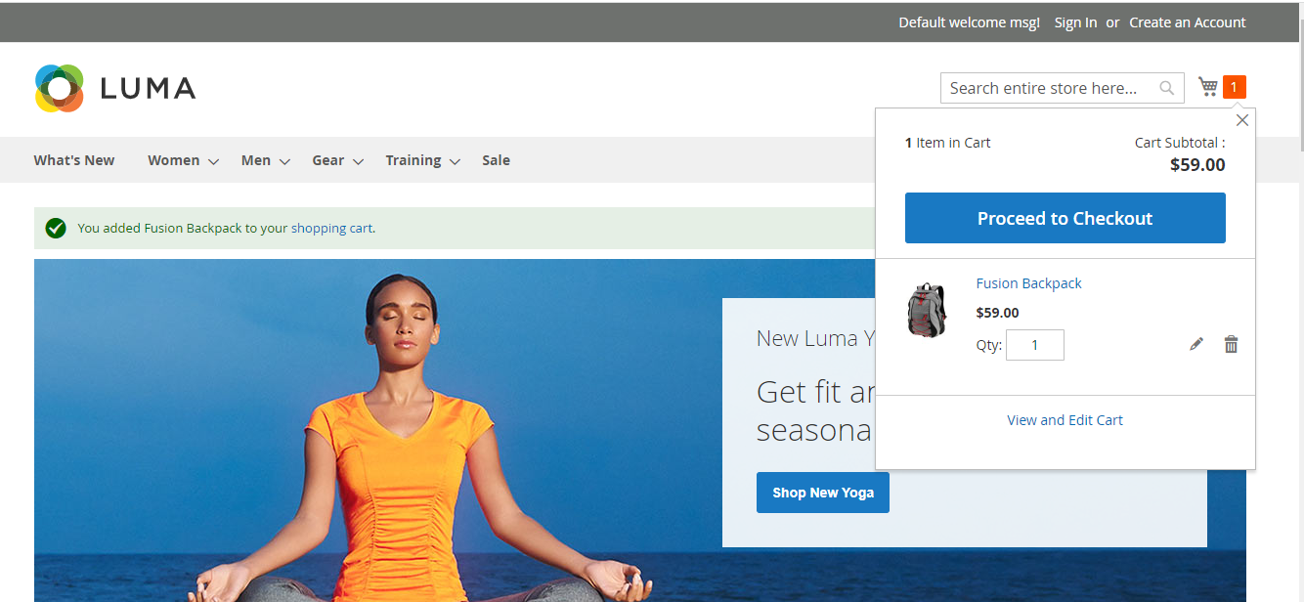

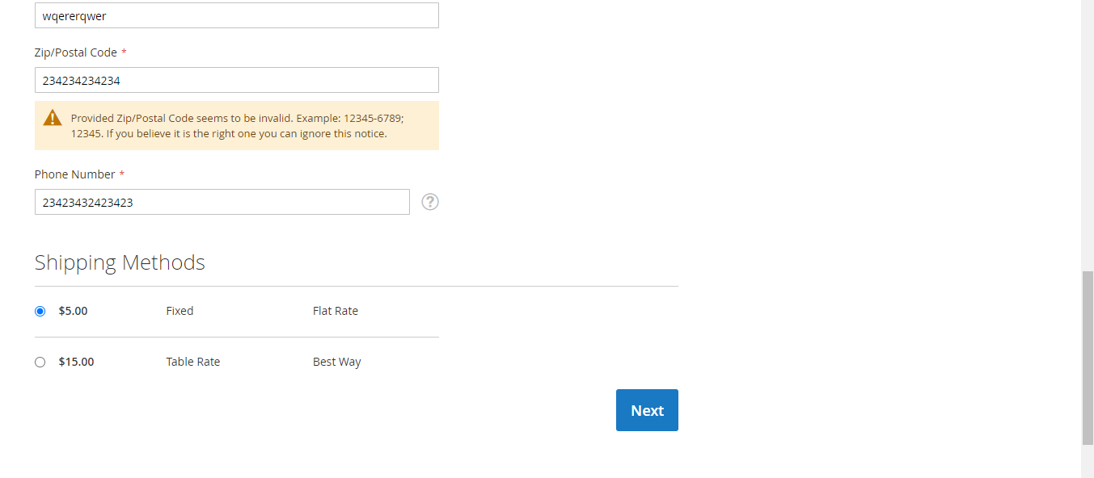

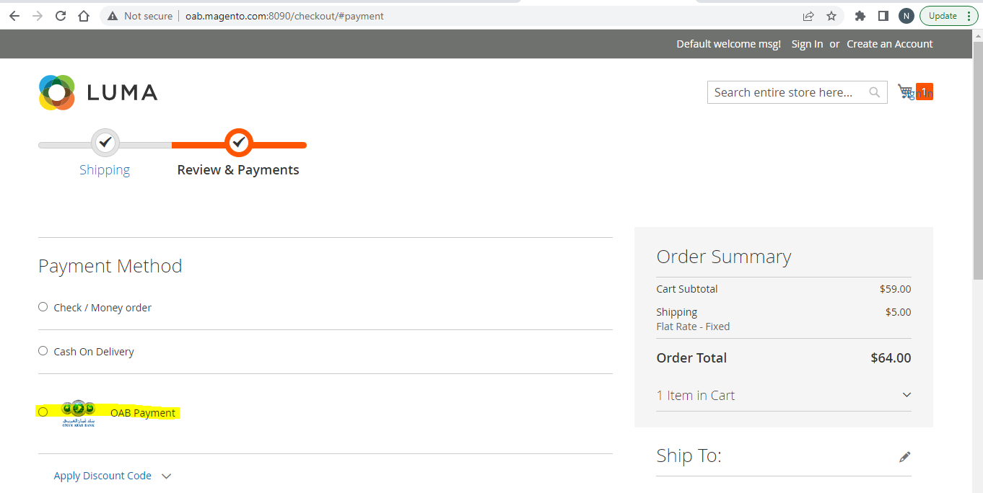

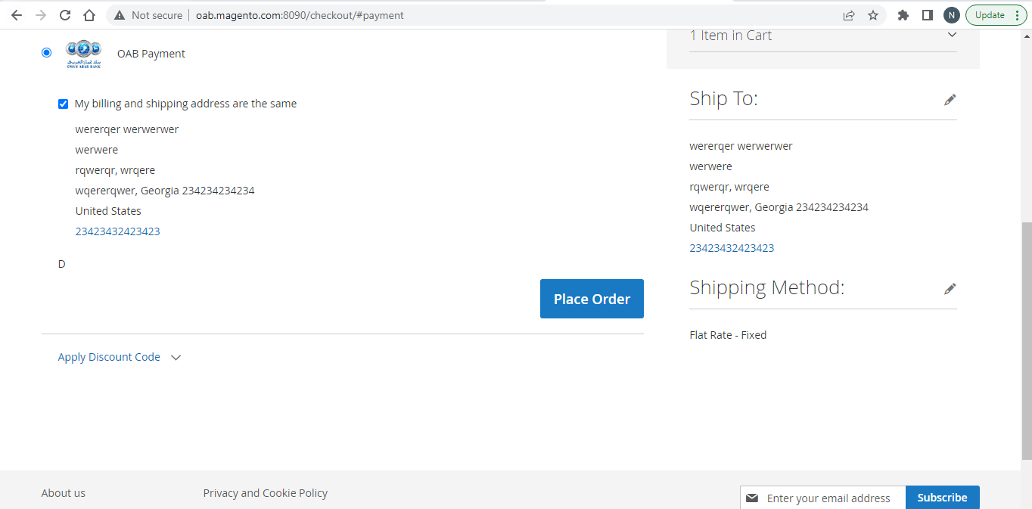

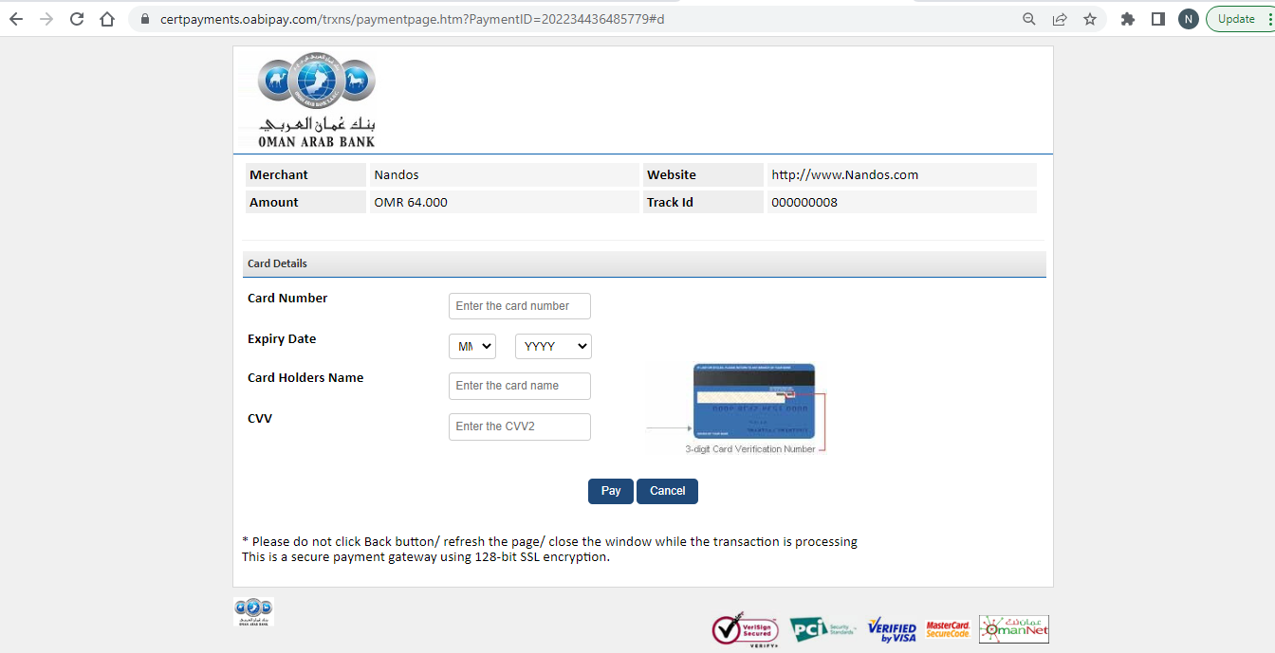

Uat proceed with oab test cards only

