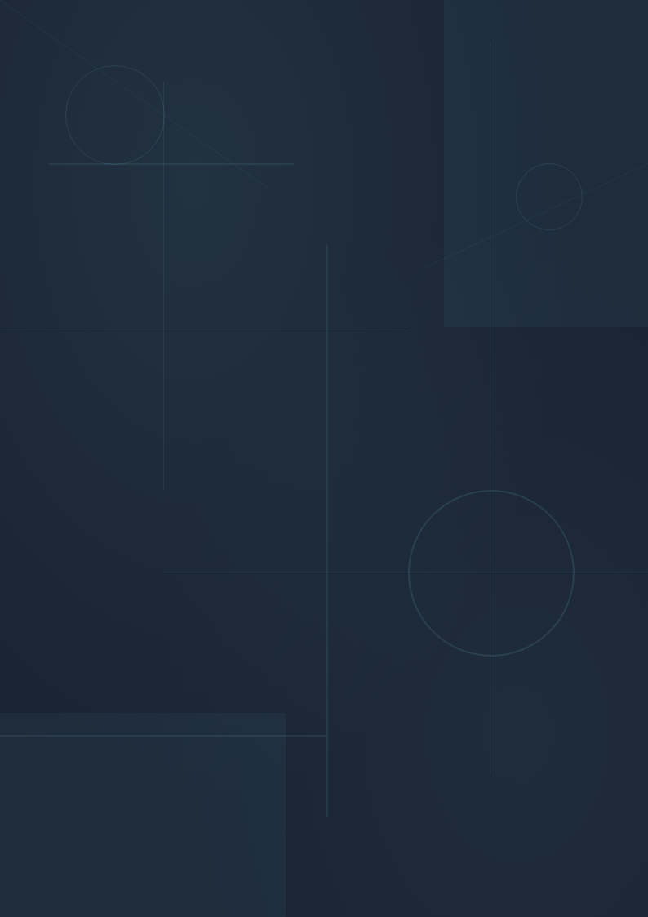

AURA PLATFORM
System Design Document
Audio Upstream Refactor Agent — v1.0
Unified Architecture Specification
Date: May 2026 | Classification: Engineering Internal

Table of Contents

1. Executive Summary 3
2. System Architecture 4
2.1 High-Level Architecture 5
2.2 Subsystem Boundaries 6
3. Multi-Agent Architecture 7
3.1 Agent Taxonomy 8
3.2 Agent Communication Model 9
4. CLI Agent Framework 10
5. Knowledge Architecture 11
6. Dashboard Architecture 12
7. Simulation Architecture 13
8. Governance Architecture 14
9. Deployment Architecture 15
10. Data Flow Architecture 16
11. Failure Recovery Architecture 17
12. Scalability Architecture 18
13. Security Architecture 19
14. Technology Selection 20
15. Implementation Roadmap 21

1. Executive Summary
AURA (Audio Upstream Refactor Agent) is an autonomous multi-agent Linux kernel upstreaming ecosystem specialized in Qualcomm Audio drivers. AURA's mission is not simple code conversion — it is to learn upstreaming patterns, understand architectural intent, infer upstream design philosophy, and autonomously migrate downstream Qualcomm audio stack components into upstream-quality Linux kernel code.
This design document consolidates eleven modular architectural specifications into a unified, implementation-grade platform blueprint. The document follows a mandatory design-first methodology: all architectural decisions are documented, cross-referenced, and validated before any implementation begins.

1.1 Platform Vision
AURA evolves beyond static code translation into an intelligent upstreaming ecosystem that:
• Learns autonomously from already-upstreamed Qualcomm drivers and maintainer review patterns
• Generates upstream-quality patch series with proper bisectability, commit messages, and changelogs
• Simulates runtime subsystem behavior (probe flow, DAPM, SoundWire, runtime PM) before submission
• Maintains persistent knowledge that improves continuously through self-learning
• Operates as a explainable, auditable, governance-controlled engineering platform

1.2 Architectural Philosophy
Ten core design principles govern the entire platform:
# | Principle | Rationale
1 | Learn before migrate | No code generation without prior pattern extraction
2 | Never modify isolated files blindly | Always analyze full dependency graph
3 | Understand subsystem relationships first | Audio drivers are interconnected ecosystems
4 | Respect upstream kernel philosophy | Generated code must feel upstream-native
5 | Respect maintainer expectations | Learn from LKML reviews and rejected patches
6 | Build reusable migration intelligence | Rules persist and improve over time
7 | Validate continuously | Sparse, checkpatch, clang, dtbs_check at every stage
8 | Maintain traceability for every change | Evidence tracking for all decisions
9 | Explain every decision | No black-box behavior — all outputs are explainable
10 | Govern all critical actions | Human approval gates for upstream-ready patches

1.3 Long-Term Evolution
Phase 1 (Audio Focus): AURA masters Qualcomm Audio upstreaming — codecs, macros, machine drivers, LPASS, SoundWire, WCD, HDMI/DP, DSP interfaces. Phase 2 (Plugin Expansion): The generic subsystem plugin architecture enables expansion into camera/ISP, DRM/display, GPU, PCIe, USB, networking, WiFi, Bluetooth, power management, scheduler, multimedia, AI accelerators, storage, thermal, and sensor frameworks. Phase 3 (Platform Maturity): AURA evolves into a full Linux subsystem intelligence platform serving as an autonomous upstream engineering ecosystem.

2. System Architecture
AURA is architected as a layered system with seven architectural tiers. Each layer has well-defined boundaries, interfaces, and dependency relationships. No layer may bypass an intermediate layer.

2.1 High-Level Architecture
The platform follows a seven-layer architecture:
Layer | Component | Responsibility
L0 | Meta-Process Foundation | Design-first governance, iterative execution, CLI mandate
L1 | Core Foundation | 10-agent taxonomy, design principles, learning/execution modes
L2 | Platform Infrastructure | Docker containerization, SQLite persistence, shell execution
L3 | Agent Intelligence | 14 specialized CLI agents with dynamic scaling
L4 | Orchestration & Interaction | Task graphs, live streaming, conversational engineering OS
L5 | Intelligence & Observability | Confidence scoring, evidence tracking, digital twin simulation
L6 | Governance & Security | RBAC, approval pipeline, immutable audit ledger

2.2 Subsystem Boundaries
AURA is NOT tightly coupled only to Qualcomm Audio. The architecture implements a generic subsystem plugin model where each plugin contains: migration rules, maintainer intelligence, subsystem heuristics, architecture patterns, validation pipelines, review heuristics, DTS rules, binding rules, and debugging strategies. The subsystem abstraction layer provides generic interfaces for: migration orchestration, maintainer intelligence, dependency analysis, patch generation, validation, dashboarding, explainability, confidence scoring, and knowledge persistence. Cross-subsystem learning transfers patterns (e.g., runtime PM, regmap, DT binding philosophy, managed resource cleanup) across domains while maintaining strict isolation of subsystem-specific rules.

3. Multi-Agent Architecture
AURA employs 14 specialized agent types organized into a dynamic, adaptive architecture. Every agent is implemented as an independent CLI executable — no in-process pseudo-agents. The orchestrator dynamically determines optimal agent count, creates specialized sub-agents, merges redundant agents, and splits overloaded agents.

3.1 Agent Taxonomy
# | Agent | Responsibility | Execution
1 | Chief Orchestrator | Execution planning, dependency graphs, scheduling, circuit breakers | Singleton
2 | Learning Agent | Discover upstreamed drivers, compare d/s vs u/s, extract patterns | Continuous
3 | Driver Dependency Agent | Map includes, APIs, DT deps, firmware, macro relationships | Per-task
4 | DTS/Bindings Agent | DT cleanup, YAML conversion, binding validation | Per-task
5 | Upstream Philosophy Agent | Learn maintainer expectations, analyze LKML/alsa-devel reviews | Continuous
6 | Refactor Agent | Downstream-to-upstream transformation, API modernization | Per-task
7 | Validation Agent | Sparse, checkpatch, clang, dtbs_check, build testing | Per-patch
8 | Regression Intelligence Agent | Compare output vs upstream refs, detect deviations | Per-patch
9 | Knowledge Base Agent | Persistent learning DB, migration rules, pattern maintenance | Persistent
10 | Dashboard Agent | HTML dashboard generation, metrics, visualizations | Persistent
11 | Maintainer Intelligence Reviewer | Simulate maintainer reviews, critique patches | Per-review
12 | Feature Pruning Agent | Determine upstream suitability, classify features | Per-task
13 | Legal Compliance Agent | Validate DCO, SPDX, licensing, proprietary boundaries | Per-patch
14 | Human Question Agent | Generate targeted architecture clarification questions | On-demand

3.2 Agent Communication Model
All agents communicate through the orchestrator using structured JSON messages over stdin/stdout. The communication model enforces:
• Every agent has a dedicated markdown rule file (skillset + memory) loaded at startup
• Every agent maintains isolated execution context — no shared state
• Every agent supports restart/recovery with idempotent operations
• Every agent reports findings via structured stdout (JSON envelope)
• Every agent is monitored by a watchdog with configurable timeout and circuit breaker
• Agents are spawned as subprocesses with resource limits (CPU, memory, file descriptors)

4. CLI Agent Framework
Every agent MUST be implemented as an independent CLI agent. This is not optional. No in-memory pseudo agents, no lightweight simulated agents, no monolithic orchestration-only agents. Every operational agent must be explicit, isolated, CLI-driven, and independently executable.
Each CLI agent implementation follows a standardized contract:
• Entry: agent-name [command] [arguments] — with --rules path/to/rules.md
• Input: Task specification via stdin (JSON), rules via --rules markdown file
• Output: Structured JSON on stdout with results, evidence, confidence, errors
• Logging: Structured JSON logs on stderr with severity, timestamp, agent-id
• Signals: SIGTERM for graceful shutdown, SIGKILL after watchdog timeout
• Exit codes: 0=success, 1=validation-failed, 2=unrecoverable-error, 3=timeout
• State: Agent maintains local findings in markdown files, not in memory

5. Knowledge Architecture
Knowledge persistence uses a local-first architecture with SQLite as the primary store and JSON/CSV export for portability. The knowledge architecture maintains:

5.1 Knowledge Stores
Store | Technology | Content
Migration Rules DB | SQLite + JSON export | Category-specific upstreaming rules and patterns
Maintainer Intelligence DB | SQLite | Reviewer profiles, preferences, acceptance probabilities
Patch Evolution DB | SQLite | v1/v2/v3 revision history, review feedback, outcomes
DTS Conversion Rules | Markdown + SQLite | DT binding conversion patterns, YAML schemas
SoundWire Topology Patterns | SQLite | Topology rules, endpoint configurations
Evidence Tracker | SQLite + JSON export | Traceability links between patches, references, decisions
Subsystem Heuristics | SQLite | Per-subsystem patterns, anti-patterns, heuristics

5.2 Four-Tier Learning Architecture
Tier | Source | Learning Focus
Tier 1: Kernel Pattern | File #3 | Downstream-vs-upstream comparison, migration rules
Tier 2: Maintainer Intelligence | File #4 | Reviewer personality modeling, acceptance prediction
Tier 3: Cross-Subsystem Transfer | File #6 | Pattern transfer across camera/DRM/GPU/etc.
Tier 4: Upstream Suitability | File #13 | Rejection prediction, philosophy alignment, legal compliance

6. Dashboard Architecture
The dashboard is not a simple status page — it is the mission control center, engineering intelligence platform, AI observability system, and upstreaming operations center. The dashboard serves a team of up to 20 concurrent users with real-time updates via WebSocket.

6.1 Dashboard Pages
Page | Primary Content | Source Spec
Global Command Center | System health, active agents, upstream parity, queue depth | File #5
Driver Migration Center | Per-driver status, dependency trees, confidence scores | File #5
Knowledge Graph Center | Subsystem relationships, codec relationships, DAI topology | File #5
Maintainer Intelligence Center | Reviewer profiles, acceptance probability, patch evolution | File #5
Learning Center | Learned rules, extracted patterns, heuristics | File #5
Live Agent Observability | Agent health, CPU/memory, watchdog state, circuit breakers | File #5
Architecture Lab | Interactive design, DAPM viz, SoundWire simulation | File #5 + #9
Patch Review War Room | Inline diffs, maintainer sim comments, style warnings | File #5
Debugging Center | Logs, traces, IRQ timelines, failure propagation maps | File #5 + #9
Simulation Control Center | Active simulations, state machines, probe ordering graphs | File #9
Approval Operations Center | Pending approvals, escalations, reviewer workload | File #7
Governance Command Center | Audit events, role management, security alerts | File #8

6.2 Technical Stack
Frontend: React with TypeScript, WebSocket for real-time agent streaming, D3.js/ForceGraph for dependency visualizations, CodeMirror for inline diff review, Canvas API for animated DAPM/SoundWire topology diagrams. Backend: FastAPI (Python) with WebSocket endpoints, SQLite for session state, SSE (Server-Sent Events) for dashboard live updates.

7. Simulation Architecture
AURA's simulation subsystem transforms static code intelligence into behavioral subsystem intelligence. The architecture uses a hybrid approach: lightweight behavioral state-machine models are the default (running locally), with optional QEMU-based full kernel emulation on the development compute machine (enabled per-simulation via toggle).

7.1 Simulation Targets
Simulation Type | Default Mode | QEMU Mode | Purpose
Driver Probe Flow | State machine | Optional | Platform registration, deferred probe, component matching
PCM Playback/Capture | Behavioral model | Optional | ALSA interaction, DMA allocation, IRQ generation
DAPM Power Flow | State machine | N/A | Widget activation, route enabling, power optimization
SoundWire Simulation | Behavioral model | Optional | Bus discovery, slave enumeration, stream setup
Runtime PM Simulation | State machine | Optional | Suspend/resume, autosuspend, power collapse
DSP Interaction | Behavioral model | Optional | DSP boot, APR/GPR communication, topology loading
DMA + IRQ Simulation | Trace analysis | Optional | Buffer movement, interrupt timing, underrun/overrun

7.2 Digital Twin Model
The digital twin represents devices, buses, codecs, macros, DAPM widgets, SoundWire endpoints, clocks, regulators, runtime PM states, DSP topology, DMA engines, PCM pipelines, and IRQ relationships. Built from upstream kernel, downstream kernel, DTS, YAML bindings, and DAPM graphs.

8. Governance Architecture
Governance follows a three-pillar model with 5-minute initial setup and incremental expansion. The design prioritizes practical implementation over theoretical completeness.

8.1 Pillar A: Identity & Access
Phase 1 (MVP): Email/password authentication with first-admin bootstrap wizard. Phase 2: GitHub/Google OAuth integration. Phase 3: Enterprise SSO (SAML/LDAP). RBAC roles: Viewer (read-only), Reviewer (review + comment + request rework), Approver (approve/reject patches), Architect (override architecture decisions), Admin (full control). Subsystem-level permissions: ownership per subsystem, patch ownership, DTS ownership, SoundWire ownership.

8.2 Pillar B: Approval Intelligence
A 3-dimensional approval matrix ensures patch quality:
• Dimension A — Lifecycle Gates: Learning → Dependencies → Migration → Validation → Maintainer Sim → Human Review → Approved → Submission-Ready
• Dimension B — Subsystem Review: Architecture → DTS → SoundWire → Runtime PM → Final Subsystem Approval
• Dimension C — Quality Checkpoints: Migration Correctness → Dependency Completeness → Validation → Maintainer Sim → Architecture Consistency → Upstream Philosophy → Regression Risk

8.3 Pillar C: Audit & Compliance
Immutable audit ledger recording: user identity, email ID, role, timestamp, session ID, patch ID, patch hash, subsystem, approval stage, confidence score, review comments, evidence snapshot. Legal Compliance Agent validates DCO sign-off, SPDX identifiers, license compatibility, and proprietary boundary detection before any patch is marked upstream-ready.

9. Deployment Architecture
AURA deploys as a single-tenant Docker Compose stack. The container topology consists of:
Service | Technology | Purpose
aura-core | Python 3.12 + FastAPI | Orchestrator API, agent management, task scheduling
aura-dashboard | React + Vite (nginx) | Interactive engineering dashboard (12 pages)
aura-db | SQLite (volume-mounted) | Knowledge persistence, audit logs, session state
llm-gateway | Python proxy (FastAPI) | Multi-provider LLM routing (OpenAI + Anthropic + local)
ws-server | Python (FastAPI WS) | WebSocket server for live agent streaming
qemu-runner | Docker (optional) | Full kernel emulation on dev compute (toggle-enabled)
Startup experience: first execution requests API credentials, validates model providers, validates CLI tools (sparse, clang, dtbs_check), validates kernel toolchains, initializes knowledge database, and launches the governance bootstrap wizard.

10. Data Flow Architecture
Data flows through the platform via three channels:
• Command Channel: Orchestrator to agents via subprocess stdin/stdout with JSON envelopes for task dispatch, progress reports, and results collection
• Event Channel: Server-Sent Events (SSE) and WebSocket for real-time dashboard updates, agent status changes, and simulation events
• Persistence Channel: SQLite for structured data (rules, audit logs, evidence), filesystem for markdown memory files and kernel source trees, JSON/CSV exports for portability
Inter-agent communication is strictly orchestrator-mediated — agents do not communicate directly. This ensures auditability, replayability, and circuit-breaker isolation.

11. Failure Recovery Architecture
Resilience is built into every layer:
Mechanism | Trigger | Action
Watchdog Timer | Agent exceeds timeout threshold | Kill agent, retry with backoff, alert dashboard
Circuit Breaker | 3 consecutive failures | Open circuit, route to fallback agent, notify human
Retry with Backoff | Transient failure | Exponential backoff: 5s, 15s, 45s, max 3 retries
Rollback Checkpoint | Migration validation fails | Restore previous state, quarantine failed patch
Stalled Agent Recovery | No progress in 10 minutes | Force restart, resume from last checkpoint
Failed Migration Quarantine | Critical validation failure | Isolate patch, block upstream-ready marking
Hallucination Detection | Inconsistent API usage detected | Halt generation, request human review
Dependency Deadlock Detection | Circular dependency in graph | Alert orchestrator, request human resolution

12. Scalability Architecture
Current target: 20 team members, ~200 concurrent agents. The architecture supports this scale through:
• Agent pool management with configurable max concurrency (default 50 parallel agents)
• SQLite with WAL mode for concurrent reads during write operations
• Async FastAPI for non-blocking I/O handling 20 concurrent WebSocket connections
• Lazy loading of dashboard visualizations — graphs computed on-demand, cached for 5 minutes
• Plugin-based subsystem expansion — adding a new subsystem requires only implementing the plugin interface without modifying core platform code
• Recommendation: Design the plugin abstraction from day 1, but implement only Qualcomm Audio initially. This validates the abstraction without over-engineering.

13. Security Architecture
Concern | Implementation
API Credential Isolation | Credentials stored in environment variables, never committed; injected via Docker secrets
Agent Sandboxing | Agents run as unprivileged user, chroot for kernel source access, seccomp-bpf syscall filtering
Secure Execution | No code execution from LLM output — all generated code is reviewed before execution
Audit-Safe Logging | Structured JSON logs, append-only, integrity verification via hash chain
Permission Isolation | RBAC enforces least privilege; subsystem permissions are separate from global roles
Agent Privilege Escalation | Agents cannot spawn other agents or modify orchestrator state

14. Technology Selection
Layer | Technology | Rationale
Backend Framework | FastAPI (Python 3.12) | Async-native, WebSocket support, excellent agent integration
Frontend | React + TypeScript + Vite | Component-based, real-time updates via WebSocket, fast build
Database | SQLite (WAL mode) | Local-first, zero-config, JSON/CSV export, sufficient for 20-user scale
LLM Gateway | Custom FastAPI proxy | Multi-provider routing, token budget management, fallback logic
LLM Providers | OpenAI GPT-4o + Anthropic Claude + Local (Ollama) | Cost optimization, capability matching, offline fallback
Graph Rendering | D3.js + ForceGraph.js | Force-directed dependency graphs, interactive topology
Code Review UI | CodeMirror 6 + diff-match-patch | Syntax highlighting for C/DTS/YAML, inline diff review
Container | Docker + Docker Compose | Single-tenant, reproducible, portable across environments
Simulation | State machines (default) + QEMU (optional) | Fast local simulation with high-fidelity option on dev compute
Auth (Phase 1) | Email/password (bcrypt) | 5-minute setup, incremental OAuth/SSO expansion
Auth (Phase 2) | GitHub + Google OAuth | Familiar login, team onboarding
Auth (Phase 3) | SAML/LDAP | Enterprise integration
Observability | Prometheus metrics endpoint + structured logging | Simple monitoring, 99% availability target

15. Implementation Roadmap
Implementation proceeds in six phases with clear milestones and deliverables. Each phase builds on the previous, with no phase overlap.
Phase | Duration | Deliverables
P0: Infrastructure | Week 1-2 | Docker Compose stack, SQLite schema, LLM gateway, CLI agent runtime, CI pipeline
P1: Core Agents | Week 3-5 | Orchestrator + 8 core agents (CLI executables), task scheduling, dependency graph
P2: Intelligence | Week 6-8 | Learning engine, knowledge persistence, confidence scoring, evidence tracking
P3: Simulation | Week 9-10 | State-machine simulation engine, digital twin model, enable/disable toggle
P4: Governance | Week 11-12 | Auth (email/password), RBAC, approval pipeline (3-dim matrix), audit ledger
P5: Dashboard | Week 13-15 | 12-page dashboard, WebSocket streaming, task graph UI, diff review
P6: Integration | Week 16-18 | End-to-end workflows, load testing (20 users), documentation, deployment guide
After P6, the platform enters continuous improvement: Phase 2 adds maintainer intelligence agents (File #4), feature pruning and legal compliance (File #13), and governance bootstrap wizard (File #11). Phase 3 expands subsystem plugins beyond audio into the full plugin architecture.

