Jenkins Setup
Pre - requesites:
- Download the jenkins.war ( https://updates.jenkins-ci.org/download/war/ )
- Java 8
- apache-maven-3.5.4
- SonarQube 6.7.2
- Tomcat 8
Create Style of the project:

New Item --> Choose Freestyle project / Maven Project

Configuration the application:
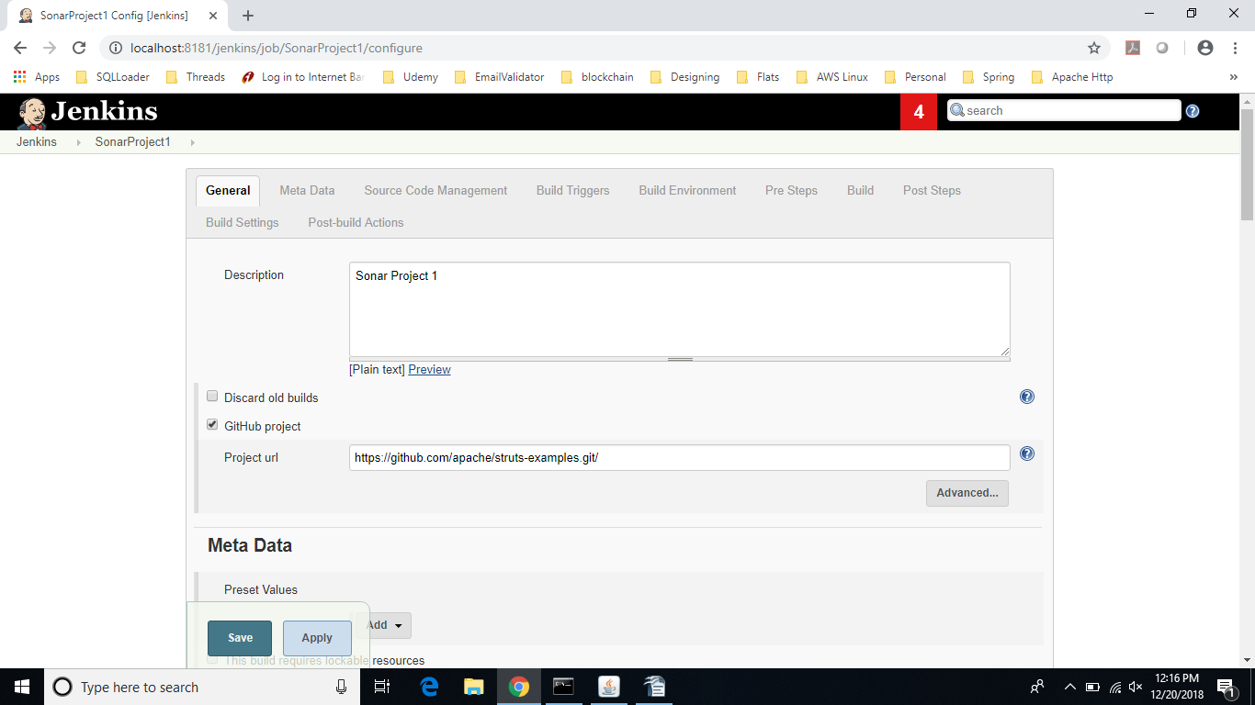

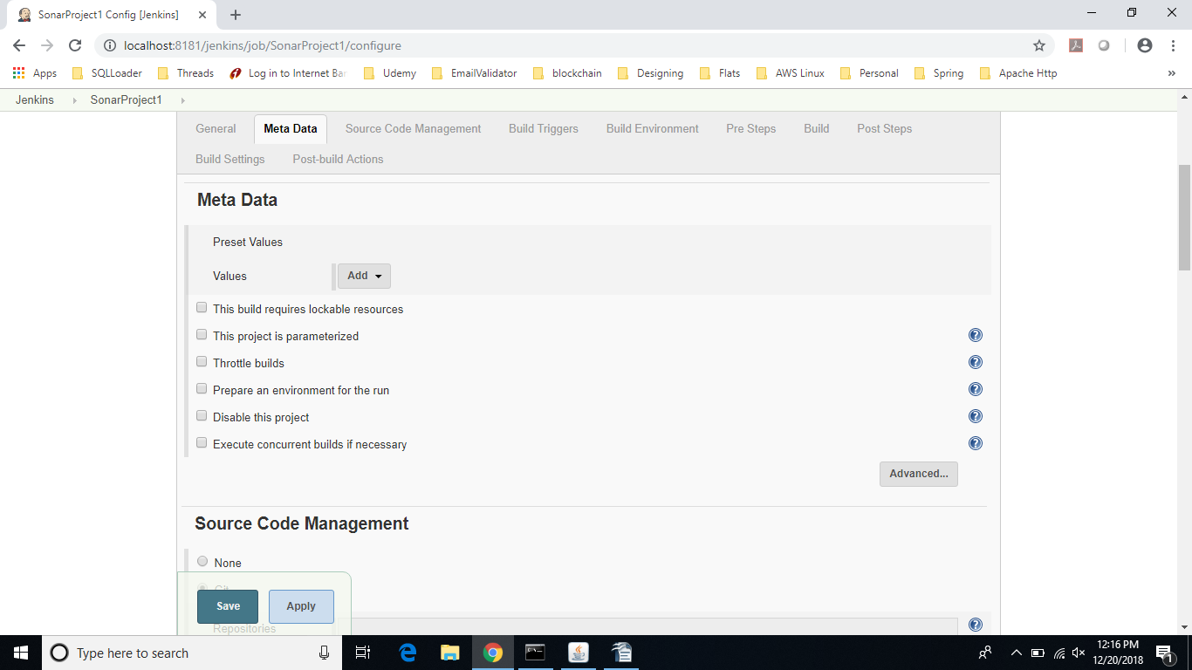
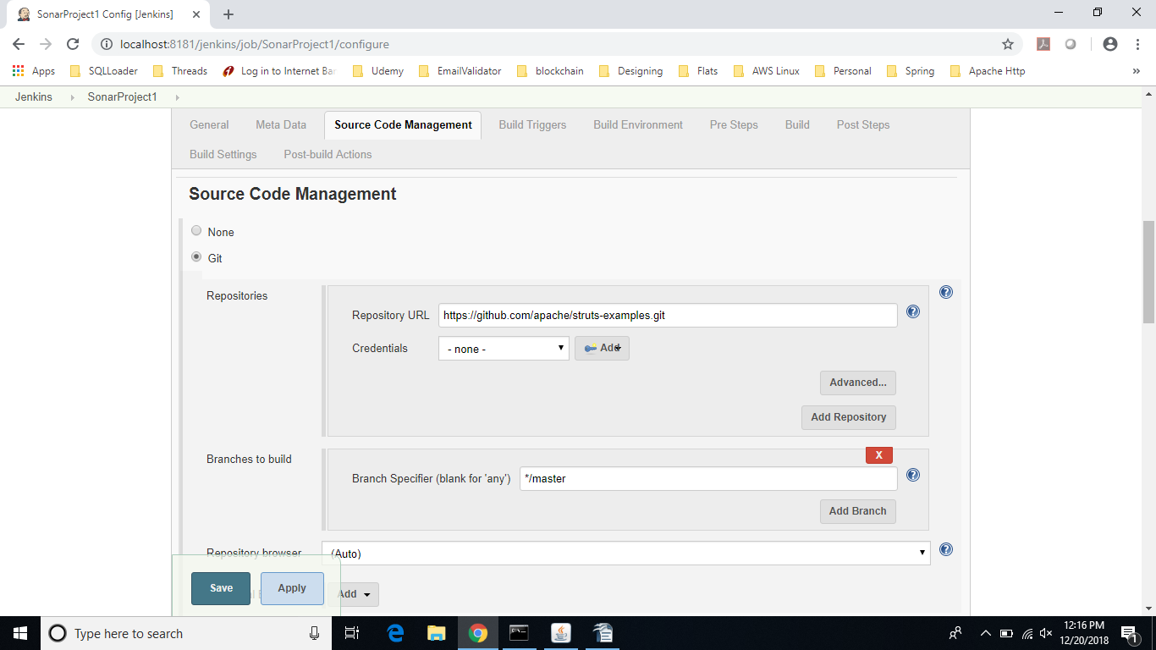

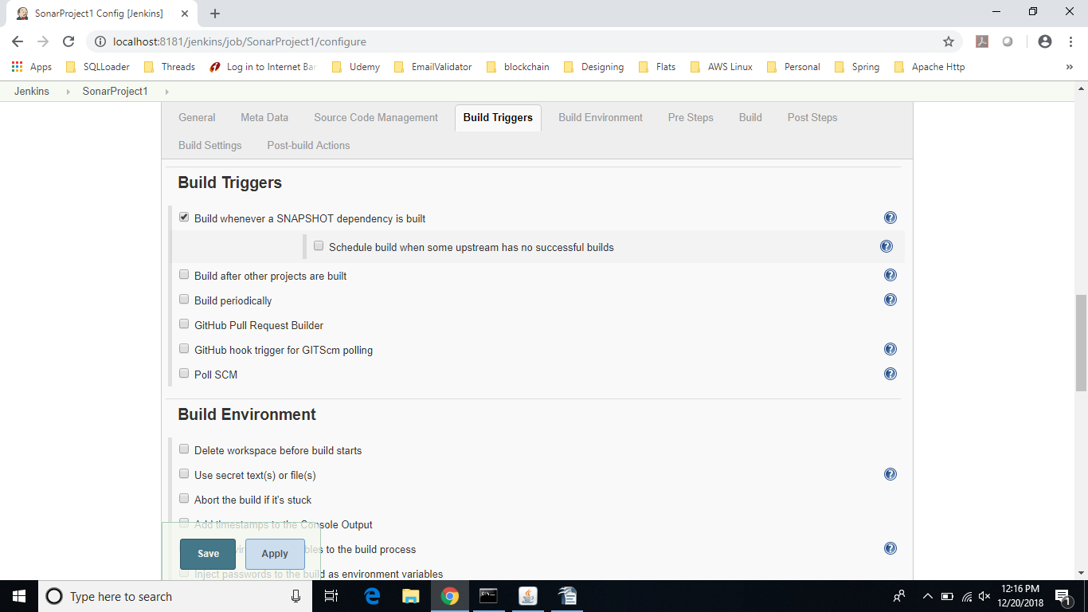
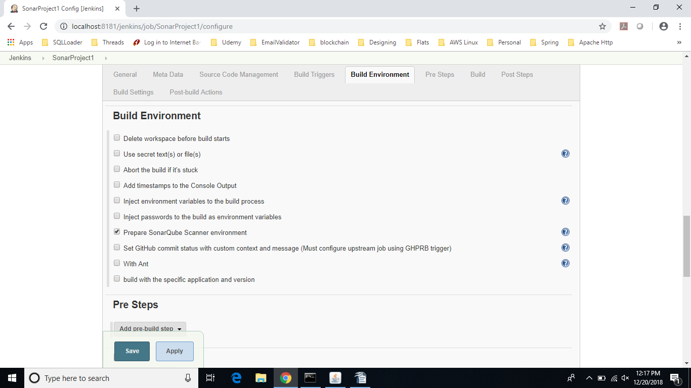

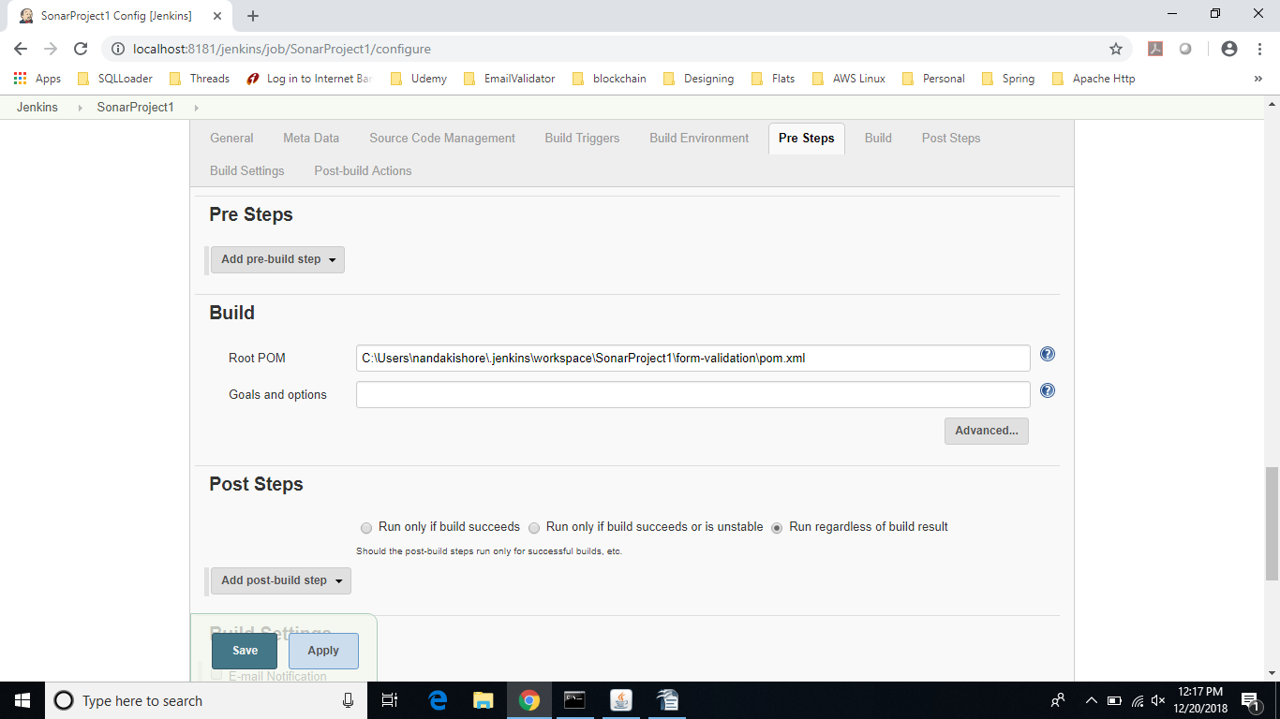
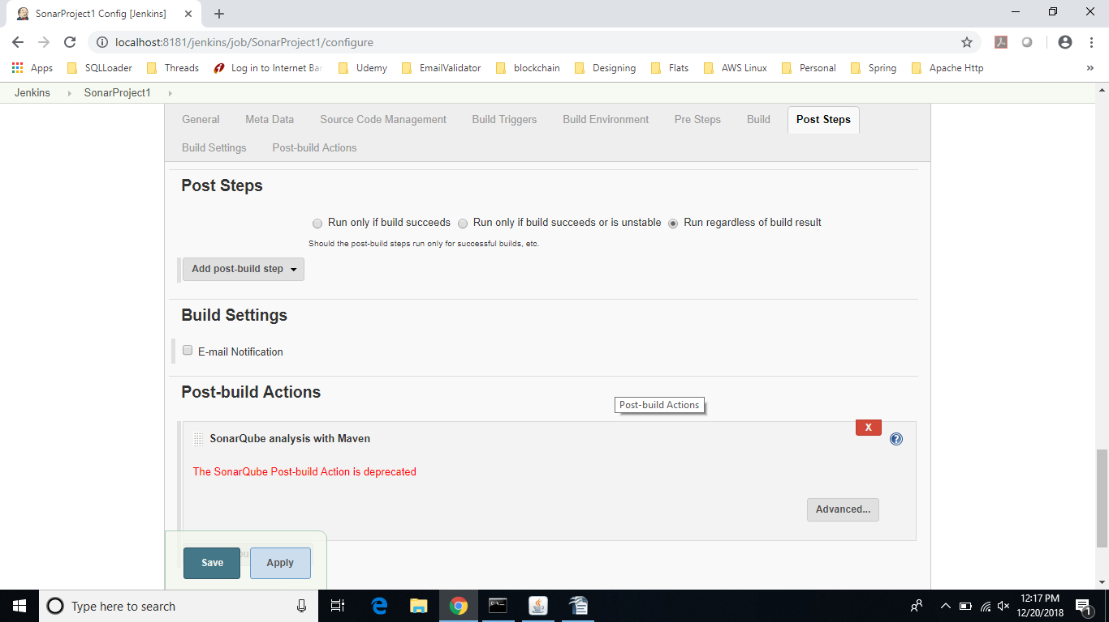

Jenkin Configuration:
SonarQube:
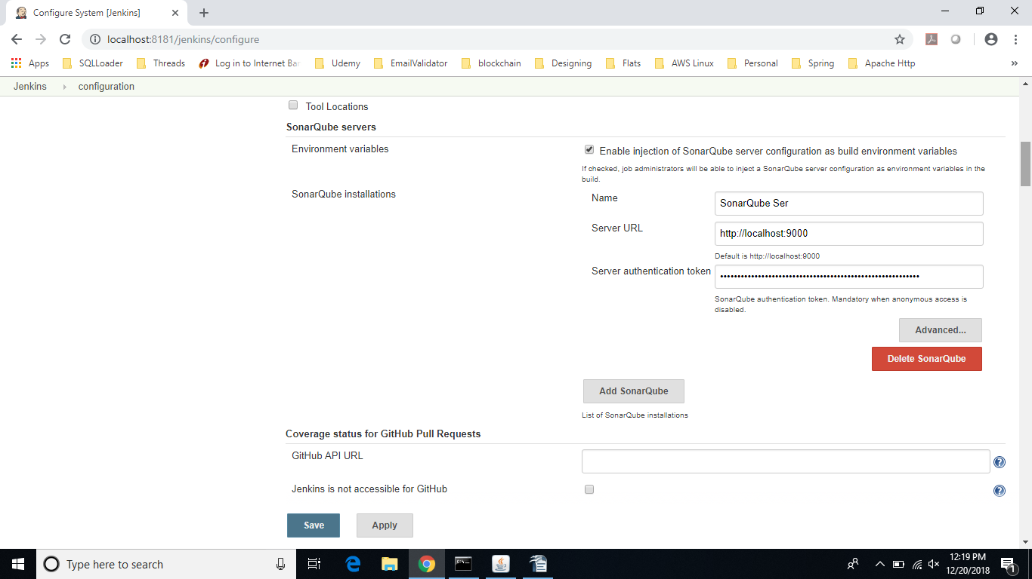
Jenkins Location:
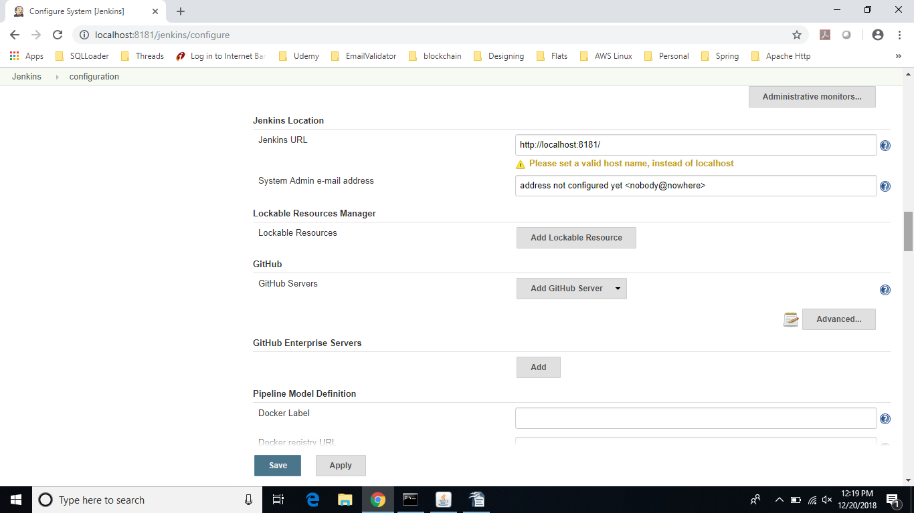
GitHub Confi:
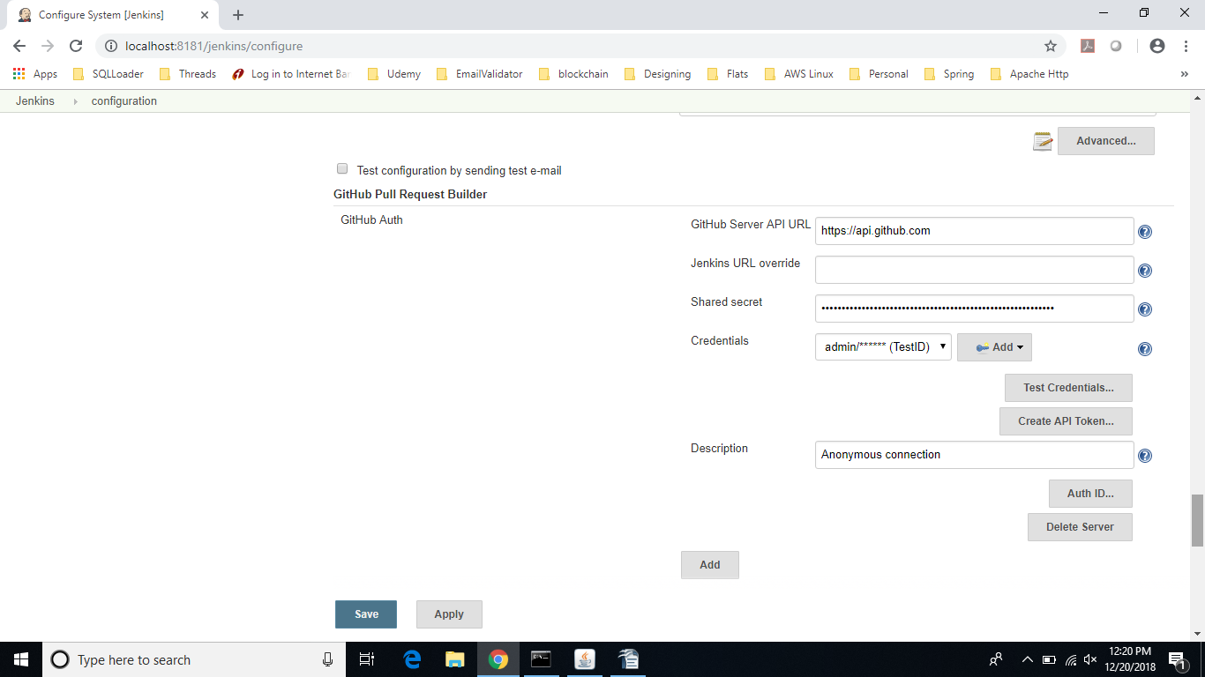
Global Tool Configuration:
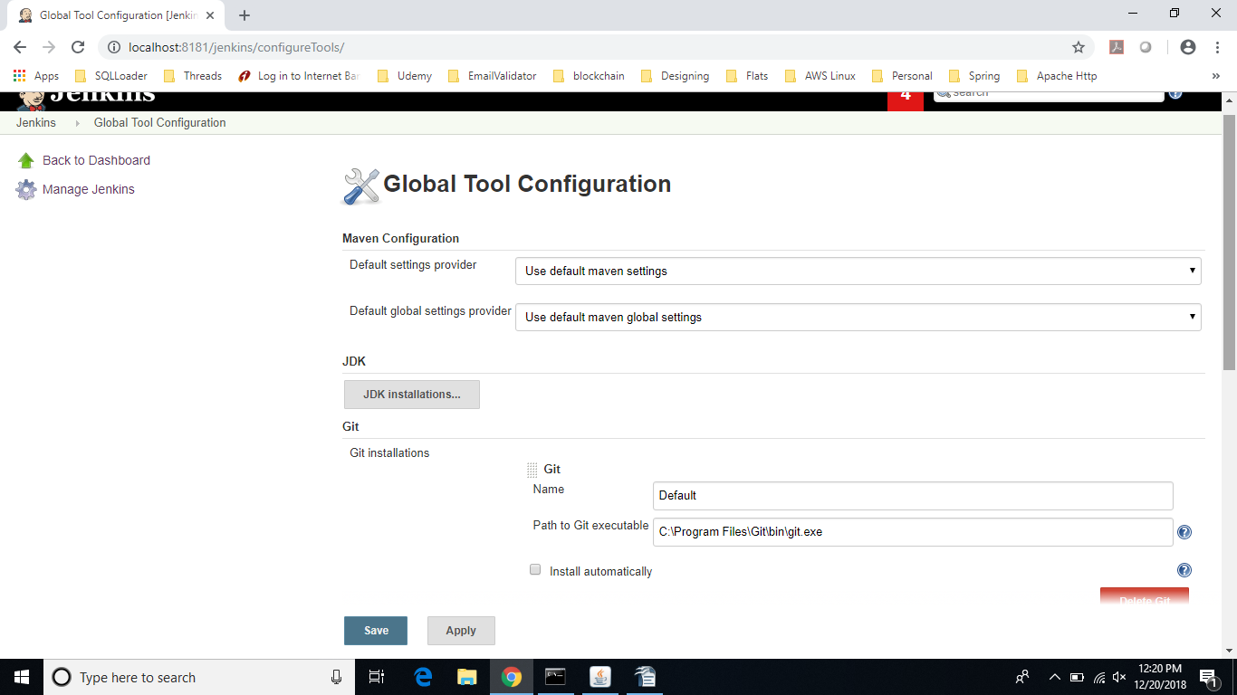

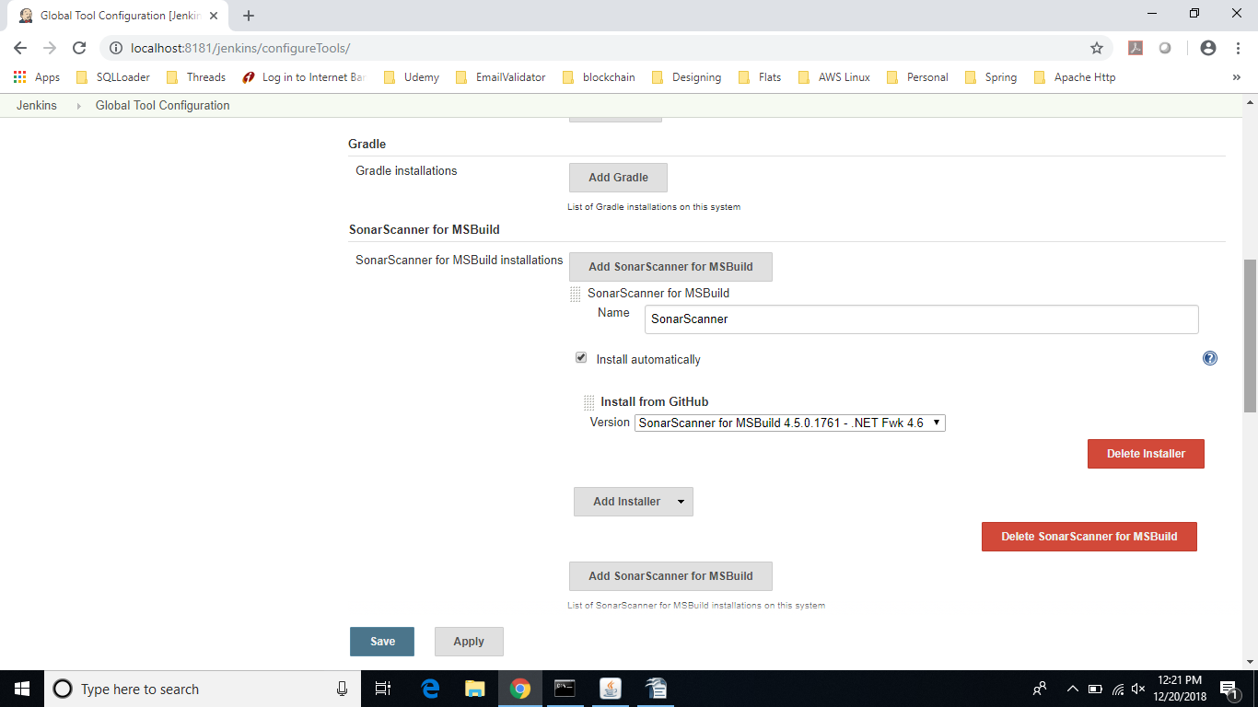
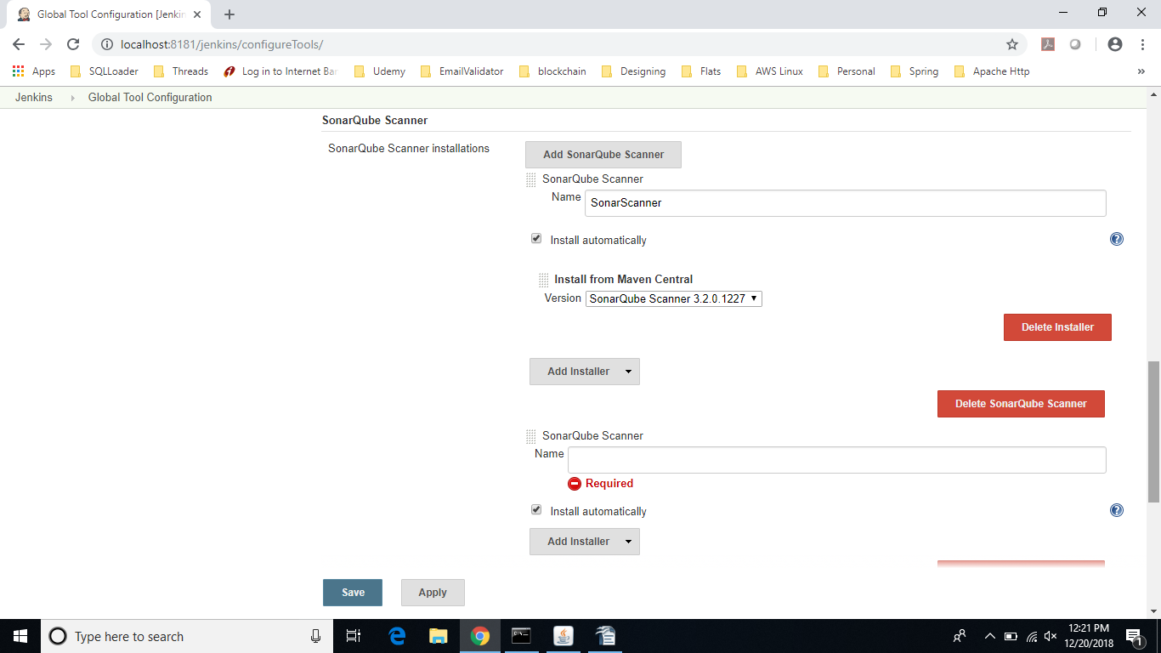

Build the Project:
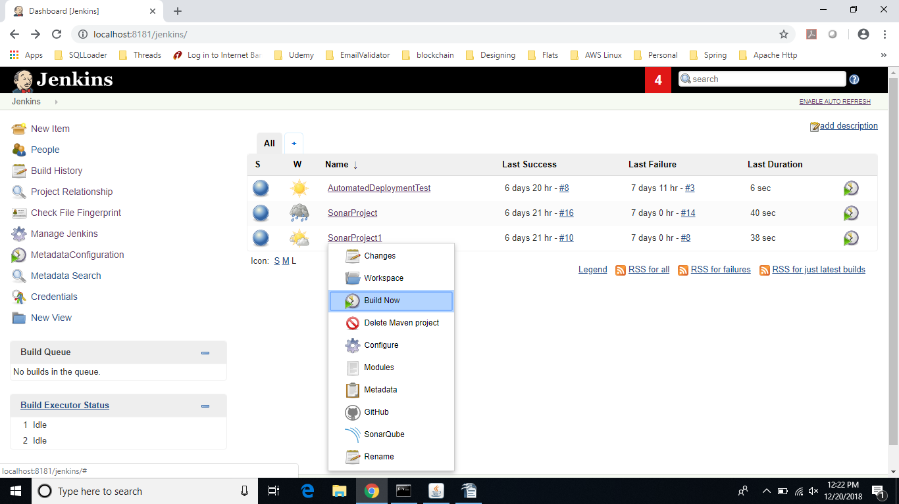
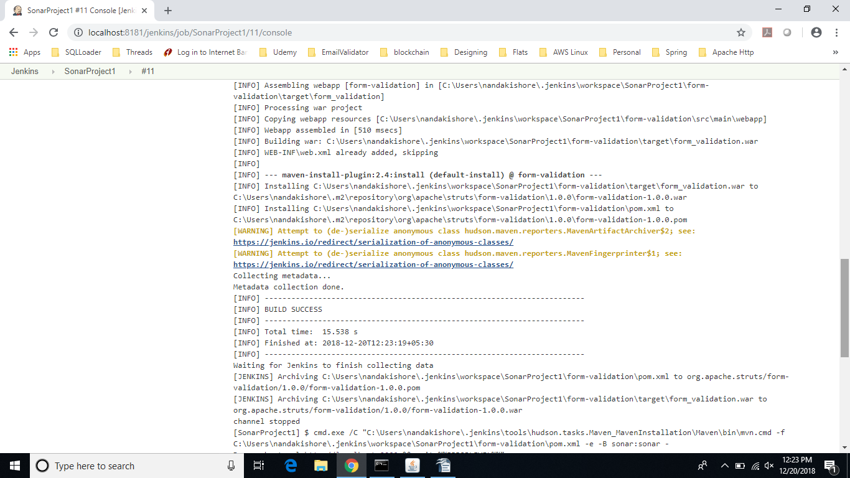

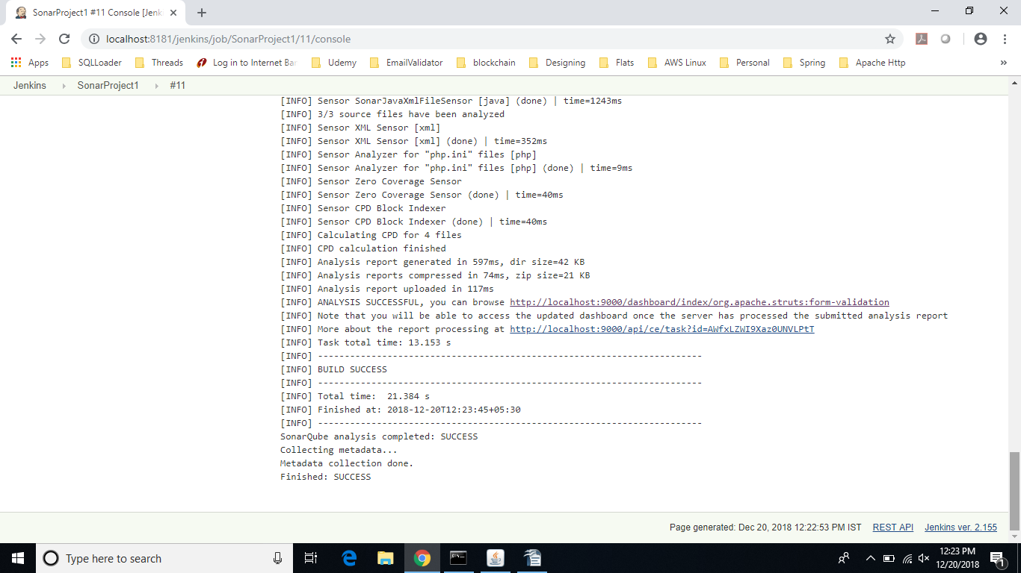
SonarQube Scan Check:
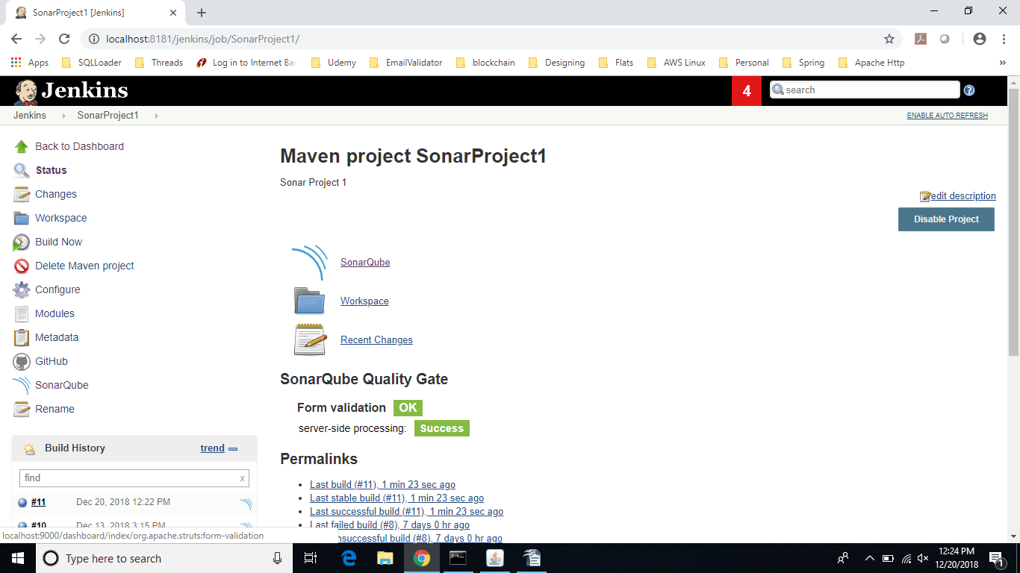

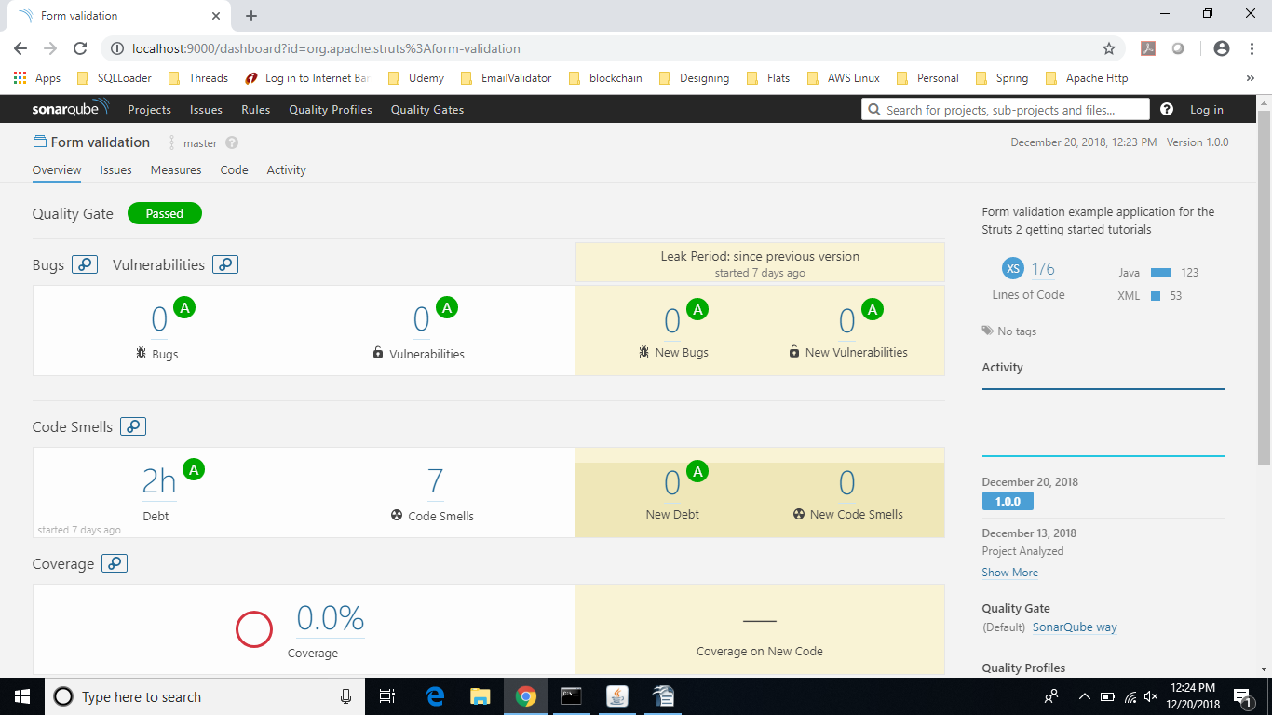
consolidated batch file:

SET JAVA_HOME=C:\Program Files\Java\jdk1.8.0_151
SET CATALINA_HOME=C:\Nandakisgore\Applications\Jenkins\Tomcat8.0
SET PATH=%JAVA_HOME%\bin;%
SET CLASSPATH=%JAVA_HOME%\lib;%
call C:\Nandakisgore\Applications\Jenkins\Tomcat8.0\bin\startup.bat
call C:\Nandakisgore\Applications\Jenkins\sonarqube-6.7.2\bin\windows-x86-64\StartSonar.bat
pause

The above batch will start the all the services up and running.

