NANDAN NAYAK

191047014

Assignment 1

**SHARE MARKET MONITORING**

**Table of Contents**

1. Abstract.
2. Libraries Used.
3. What is Log4j?

* Introduction
* Installation and Configuring

1. Example Code
2. Output

**ABSTRACT**

Share Market Monitoring Application is used to Add the Information about the company along with its share value into the share markets listing or to Update the existing information of the company. Stand Alone Application has been designed using Java Swing with the database connection ( MYSQL/MSSQL ) to store the information. Share Market authorities can also delete the company from its listing. The Application also keeps Log of every action which is performed on the Database using Log4j Library.

**LIBRARIES USED**

* Java Swings
* Log4j For Java
* Mysql Connector for JAVA (MySQL DB)
* SQLJDBC connector for JAVA (MSSQL DB)

**WHAT IS LOG4J**

**Introduction**

Apache Log4j is java based logging utility which provides an easier way to generate/produce the Logs of the events which took place while executing the program .The events can be errors, warnings , success messages which occurs during the execution of the program can be stored in the log file as the messages.

Log4j provides multiple types of logging such as logging on the console , logging on the file etc.

**Installation and Configuration**

* Download the compressed zip file and extract it
* Add the Jar File obtained after extracting to the project.
* Create a File called *log4j.properties*  and specify properties required for the project ( if log needs to be stored in the file specify the destination file name In this file).
* If log needs to be saved in the file, the file extensions should be .log .

**EXAMPLE CODE :**

Connecting MySQL With Java:

classname="com.mysql.jdbc.Driver";

Class.*forName*(classname);

String connectionstring="jdbc:mysql://localhost:3307/"+DB_NAME;

Connection conn = DriverManager.*getConnection*(connectionstring,USER,PASS);

Statement stmt=conn.createStatement();

Connecting MSSQL With Java:

classname="com.microsoft.sqlserver.jdbc.SQLServerDriver";

Class.*forName*(classname);

String connectionstring="jdbc:sqlserver://localhost;databaseName="+DB_NAME;

Connection conn = DriverManager.*getConnection*(connectionstring,USER,PASS);

Statement stmt=conn.createStatement();

Sample Example:

*Import org.apache.log4J.*;*

*PropertyConfigurator.configure(“path-of-the-log-properties-file”);*

*Logger logger = Logger.getLogger(ClassName.class.getName());*

*logger.info(“info message”);*

*logger.warn(“warning message”)*

**OUTPUT**

LOG4J LOG File :

2020-01-01 16:45:07 INFO Brew:90 - Default Database connection successfull

2020-01-01 16:45:07 INFO Brew:147 - database Not Found ... creating new database

2020-01-01 16:45:07 INFO Brew:174 - successfully connected to database

2020-01-01 16:45:07 INFO Brew:218 - Table company not found .... creating a new table

2020-01-01 16:45:07 INFO Brew:226 - new company table created

2020-01-01 16:45:26 INFO Brew:266 - Inserted Data Successfully

2020-01-01 16:45:48 INFO Brew:266 - Inserted Data Successfully

2020-01-01 16:46:04 INFO Brew:332 - Updated Successfull

2020-01-01 16:46:15 INFO Brew:467 - company found and deleted

2020-01-01 16:46:19 WARN Brew:479 - ERROR IN DELETING...

2020-01-01 16:46:19 WARN Brew:480 - Illegal operation on empty result set.

2020-01-01 16:46:23 INFO Brew:467 - company found and deleted

2020-01-01 16:46:59 INFO Brew:90 - Default Database connection successfull

2020-01-01 16:46:59 INFO Brew:137 - database is already present .... Connecting to database...

2020-01-01 16:46:59 INFO Brew:174 - successfully connected to database

2020-01-01 16:46:59 WARN Brew:236 - ERROR in Creating Table

2020-01-01 16:46:59 WARN Brew:237 - Could not find stored procedure 'show'.

2020-01-01 16:51:01 INFO Brew:90 - Default Database connection successfull

2020-01-01 16:51:02 INFO Brew:137 - database is already present .... Connecting to database...

2020-01-01 16:51:02 INFO Brew:174 - successfully connected to database

2020-01-01 16:51:02 INFO Brew:225 - Table company not found .... creating a new table

2020-01-01 16:51:02 WARN Brew:243 - ERROR in Creating Table

2020-01-01 16:51:02 WARN Brew:244 - There is already an object named 'company' in the database.

2020-01-01 16:52:27 INFO Brew:90 - Default Database connection successfull

2020-01-01 16:52:27 INFO Brew:137 - database is already present .... Connecting to database...

2020-01-01 16:52:27 INFO Brew:174 - successfully connected to database

2020-01-01 16:52:27 INFO Brew:225 - Table company not found .... creating a new table

SCREENSHOTS :

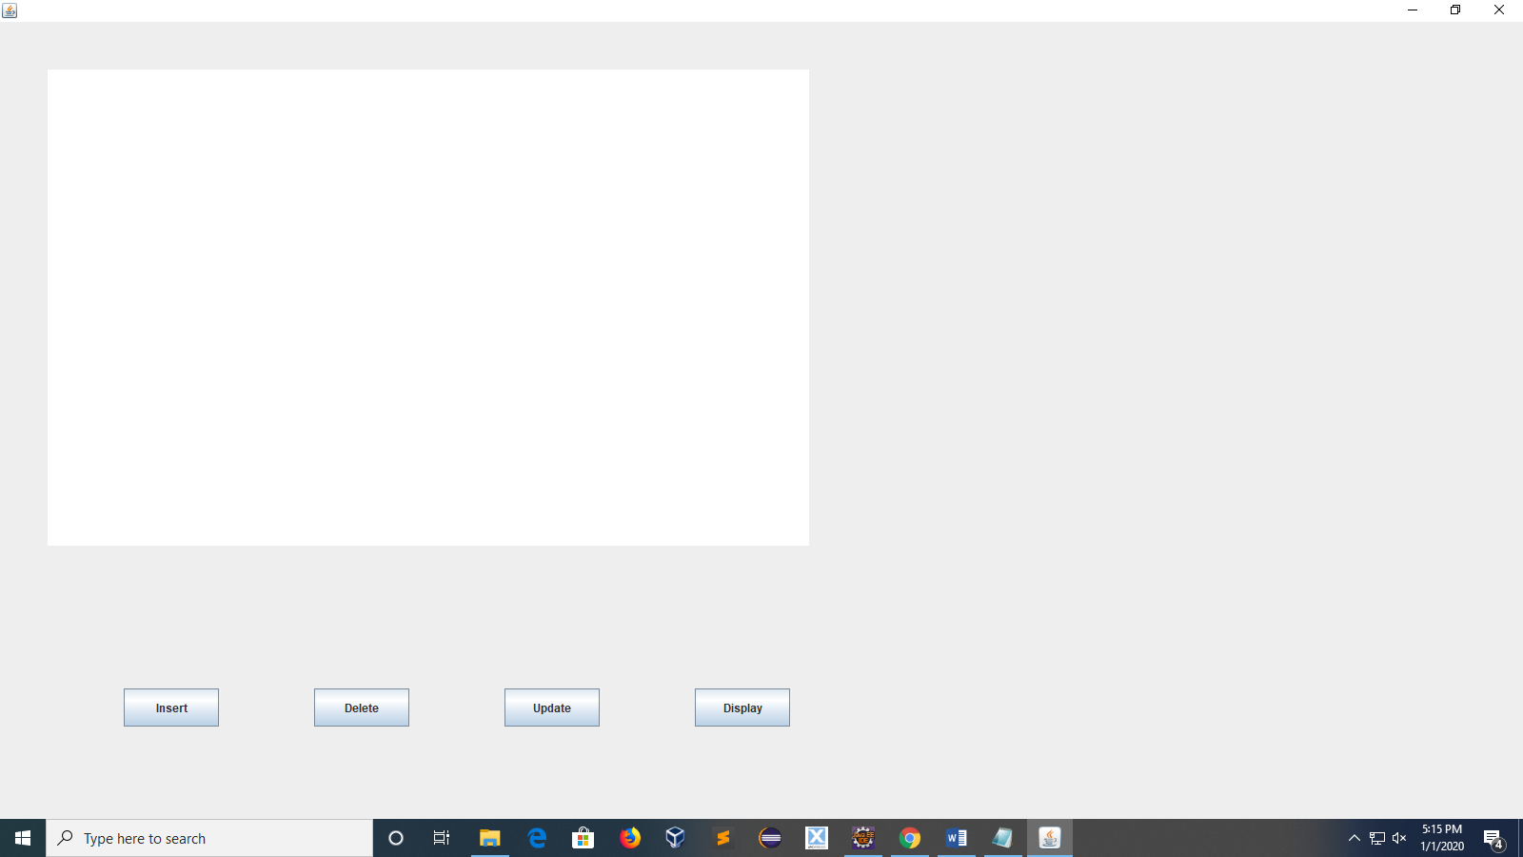

Fig 1 : HOME PAGE

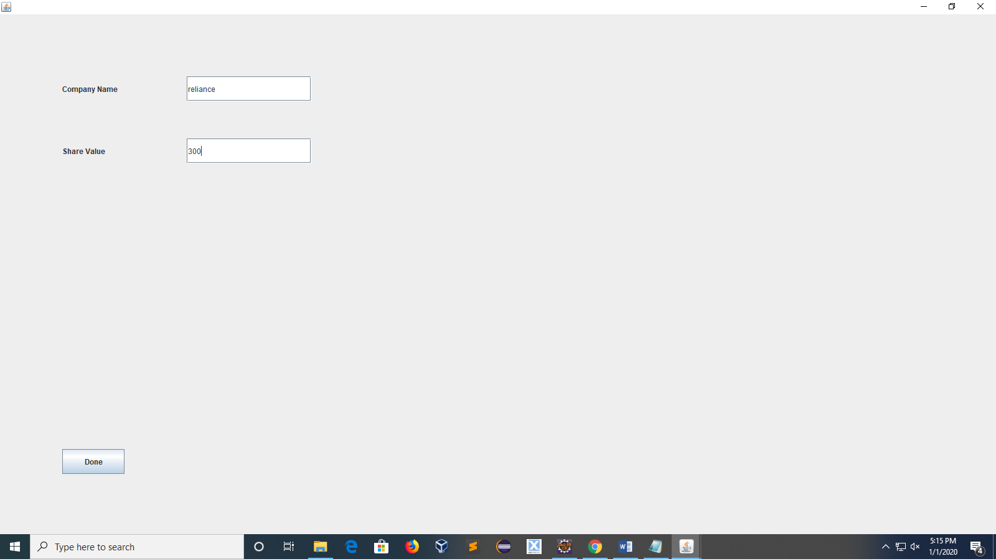

Fig 2 : INSERT PAGE

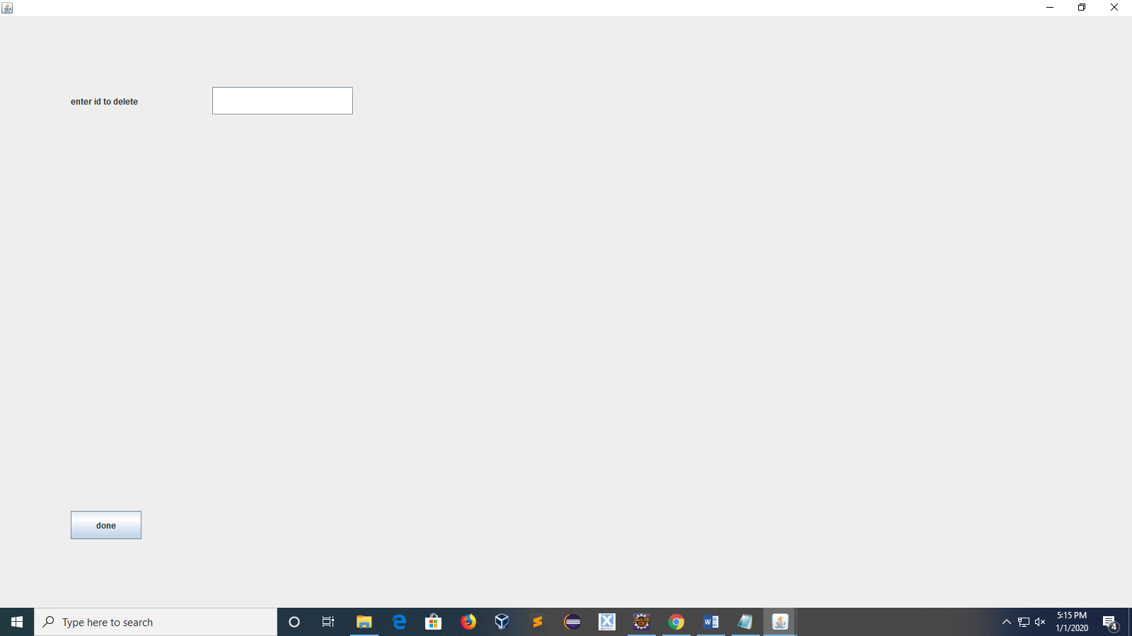

Fig 3: DELETE PAGE

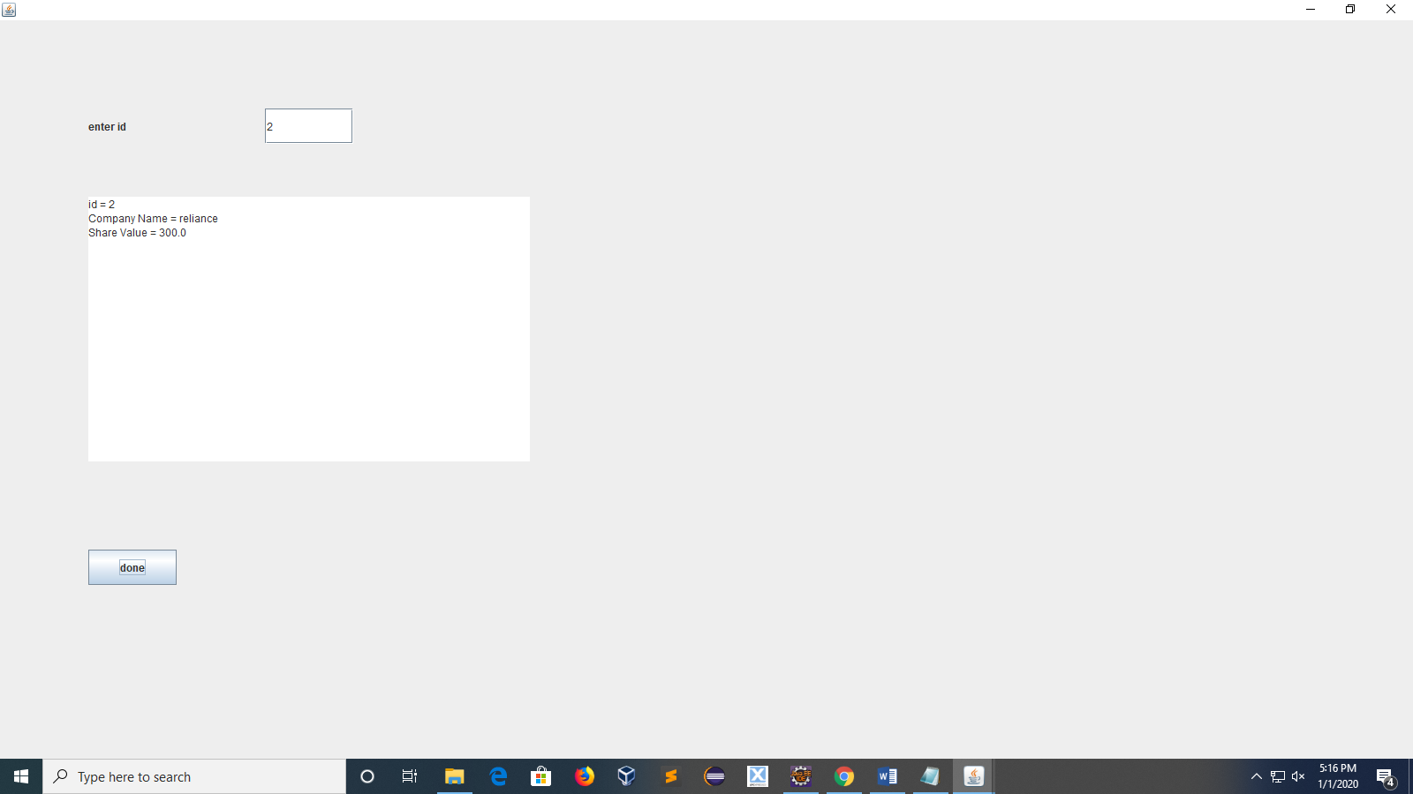

Fig 4 : DISPLAY PAGE

Full Code Available at:

<https://github.com/nandan-nayak/clouddatabaselab/blob/master/swingsql/>