Phase 1 Report: Project Setup and Operational Simulation
  - Trajectory-Aware Reinforcement Learning for Autonomous Tractor–Trailer Reverse Docking
MSML642 Group 20: Nandan Prince and Chris Pedretti
13 November 2026

1. Summary
The project setup is complete. The simulation, the programming environment, and the task environment all run from the main branch of the team repository, and an automated check suite confirms it on every push.
Rubric item | Status | Evidence
Simulation operational | Done | A 2D kinematic simulator and a 3D MuJoCo simulator both run the same vehicle and agree to within 8 mm over a 15 s reverse maneuver (Section 4.3)
Programming setup operational | Done | One-command install; 266 automated tests pass; lint, strict type checking, and continuous integration are green (Section 3)
Environment setup operational | Done | The Gymnasium task TrailerDocking-v0 passes the Gymnasium API checker and completes a collision-free docking episode (Section 4.1)
Evidence of progress | Done | Three recorded animations, four figures, and a script that regenerates all of them (Section 4)
No deviation from the proposed setup | Kept | Same platform, language, methods, and task as the proposal; additions and open items are listed in Section 6
What does not exist yet: no controller has been trained or evaluated. Every rollout shown in this report uses a fixed open-loop command to prove that the simulators and environment work. NMPC and PPO are Phase 2 work.
All numbers in this report were re-measured on 13 November 2026 against main at revision 437c2bc (Windows 11, Python 3.12.0, Gymnasium 1.4.0, MuJoCo 3.17.0, NumPy 2.5.4).
Repository: https://github.com/nandan-prince/RL-based-Autonomous-Tractor-Trailer-Reverse-Docking

2. What the project is
The task is to reverse one tractor with one semitrailer into a known loading bay without hitting the walls or jackknifing. The research question from the proposal is whether a PPO controller that observes the reference path ahead of the trailer can do this reliably, and how it compares with nonlinear model predictive control (NMPC) under varied start poses, trailer lengths, and observation noise.
The proposal committed to this setup, and the repository implements it:
- Platform. A fast custom 2D Gymnasium environment for training and the quantitative comparison, and MuJoCo for the 3D model and demonstration.
- Language and tools. Python 3, Gymnasium, MuJoCo, NumPy, Matplotlib, pytest, YAML configuration, Git and GitHub.
- Control interface. One action: a bounded steering rate, at a fixed reverse speed of 0.2 m/s. Both controllers will use it.
- Pipeline. Reference path, then controller, then safety supervisor, then simulator, as drawn in the proposal.

3. Programming setup

3.1 Installation
The project is an installable Python package with pinned dependency ranges. Setup is two commands from the repository root:
python3 -m venv .venv
.venv/bin/pip install -e '.[dev,mujoco,viz]'

3.2 Repository layout
configs/ Versioned YAML for vehicles, docks, and the Gymnasium task
docs/design/ Frozen vehicle and environment specification, architecture, MuJoCo audit
src/trailer_docking/
core/ Shared state, command, geometry, strict configuration loading
simulators/ kinematic/ (2D) and mujoco/ (3D) behind one simulator protocol
paths/ Reference paths, path-relative errors, preview points
observations/ Controller-facing observation vector
safety/ Collision, jackknife, and command supervision
environments/ Gymnasium task, renderer, keyboard viewer
controllers/ Placeholders for the tracker, NMPC, and PPO
evaluation/ Placeholders for scenarios, metrics, and the rollout runner
tests/ Unit and integration tests
paper/ IEEE-format LaTeX report, maintained alongside the code
research/ Literature index, decision log, open questions
On main this is about 6,000 lines of Python source and 29 test files, built through pull requests from both team members.

3.3 Verification gates
Continuous integration (GitHub Actions) runs six gates on every push and pull request. The last eight runs, including the three most recent merges to main, all passed. The same gates were re-run locally for this report:
Gate | Command | Result
Lint | ruff check src tests | All checks passed
Static types | mypy (strict) | No issues in 31 source files
Tests | pytest --cov | 266 passed in 11 s
Coverage | branch-aware, 85 % required | 91.52 %
Specification conformance | python -m trailer_docking.validation.vehicle_spec | 7 of 7 checks pass
Generated MuJoCo model is current | python -m trailer_docking.simulators.mujoco.builder | Both model files up to date

3.4 One specification for both simulators
Both simulators read the same versioned YAML files, so they cannot drift apart in geometry or limits. The specification document (docs/design/vehicle-and-environment-specification.md) freezes coordinate and sign conventions, the state and command contracts, timing, and the definition of docking success.
Parameter | Value (compact-semitrailer-v1, nominal-dock-v1)
Tractor wheelbase / body | 1.90 m / 2.90 m by 1.00 m
Trailer hitch-to-axle length | 4.00 m nominal; 2.00 m and 5.00 m variants
Steering angle / steering rate limits | 0.50 rad / 0.30 rad/s
Speed / acceleration limits | 0.20 m/s forward and reverse / 0.40 m/s²
Articulation warning / jackknife thresholds | 35° / 45°
Controller period | 0.10 s (5 substeps in 2D, 50 physics steps in MuJoCo)
Bay interior | 1.50 m wide, 6.00 m deep
Docking success | Within 0.10 m and 3° of the target, trailer fully inside the bay, no collision, no jackknife
Each configuration has a SHA-256 fingerprint that the environment reports in every step, so later experiment results can be tied to exact inputs.

4. Evidence that the simulation and environment run
Everything in this section is produced by reports/phase1/make_evidence.py, which only calls the package’s public simulators and environment. Its raw output is saved in reports/phase1/evidence_summary.json.

4.1 2D Gymnasium environment
TrailerDocking-v0 combines the 2D kinematic simulator with a reference path, a 21-element path-relative observation, footprint collision checking, jackknife detection, docking success, a decomposed reward, and a renderer.
- Gymnasium’s own API checker passes.
- The observation is 21 values bounded to [-1, 1]; the action is one normalized steering rate.
- A constant straight reverse from the default start reaches docking success after 486 control steps (48.6 s simulated), with no collision and a final longitudinal error of 0.08 m.
- With uniform random steering from 20 seeded random starts, every episode ended through the safety logic: 14 by collision and 6 by jackknife. This shows that the termination events fire. It is also a first indication that the task is not solved by chance.
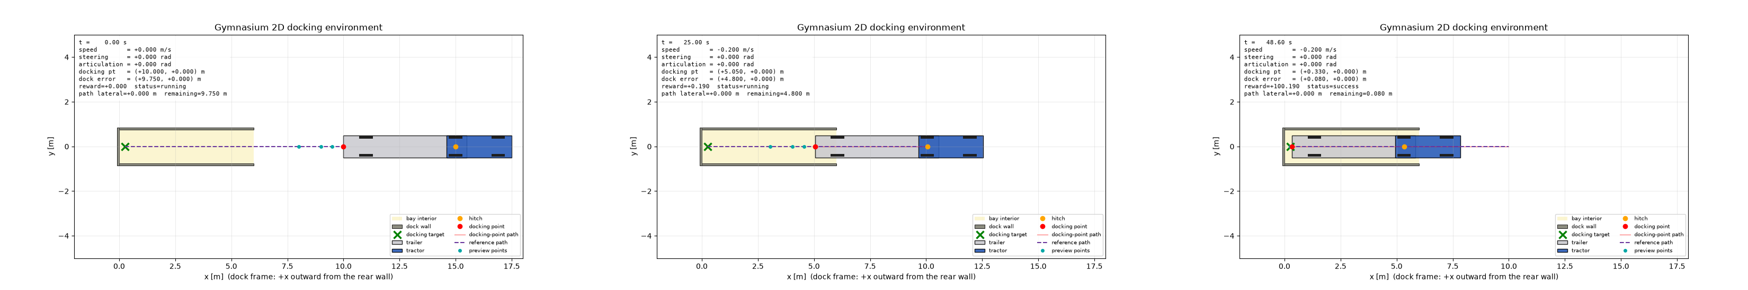
2D Gymnasium environment during the straight-reverse acceptance run: start, midway, and docking success. The overlay shows speed, steering, articulation, docking error, reward, and status.
Animation: figures/gym2d_compact_straight_reverse.gif
A second, separately versioned scenario shows the same environment at full scale: a 14 m trailer in a 200 m by 100 m service-center yard with 20 doors. Its straight-reverse run also reaches docking success, after 325 steps. The viewer accepts keyboard driving in both scenarios.
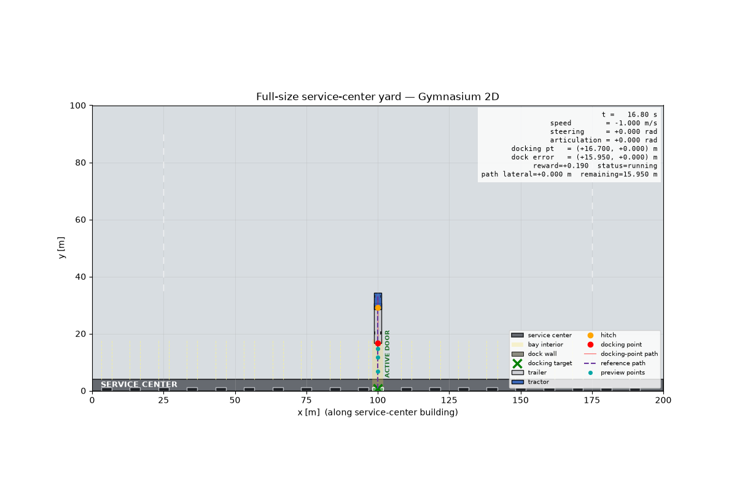
Full-size service-center scenario in the same 2D environment.
Animation: figures/gym2d_service_center_straight_reverse.gif

4.2 3D MuJoCo simulation
The MuJoCo model is generated from the same YAML files: a tractor on a free joint, a trailer on a hitch yaw joint, Ackermann front steering, driven rear wheels, and a walled loading bay (11 bodies, 10 joints, 4 actuators, 2 ms physics step). An adapter exposes the same command and state contract as the 2D simulator.
In the run below, a fixed reverse command backs the vehicle straight into the bay. The trailer touches the rear wall after 503 control steps, and the simulator reports the contact. The trailer stays centered and the articulation stays at zero throughout.
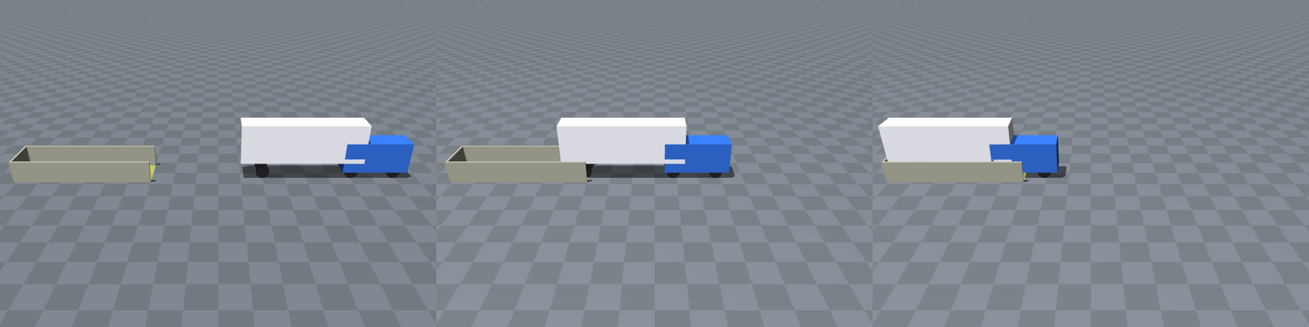
MuJoCo scene during a fixed straight reverse: start, midway, and trailer contact with the bay’s rear wall.
Animation: figures/mujoco_straight_reverse.gif

4.3 The two simulators agree
The same 150 open-loop commands (a 15 s reverse S-maneuver at 0.2 m/s) were sent to both simulators.
Quantity | Largest gap between 2D and MuJoCo
Tractor position | 0.008 m
Tractor heading at the end | 0.0007 rad
Trailer heading at the end | 0.00001 rad
Articulation angle, any time | 0.0009 rad
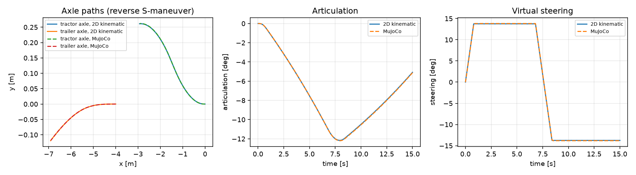
Same open-loop reverse command sequence through the 2D kinematic simulator and MuJoCo.
This is agreement between the two vehicle models at low speed on flat ground. It is not yet evidence that a controller will transfer between them, and it says nothing about fidelity to a real truck.

4.4 Running it live
These commands open the interactive windows (replace .venv/bin/ with .venv\Scripts\ on Windows):
# 2D Gymnasium environment, scripted docking then keyboard driving
.venv/bin/python -m trailer_docking.environments.viewer --demo --speed 4
.venv/bin/python -m trailer_docking.environments.viewer --scenario compact
# MuJoCo 3D and top-down windows driven by one simulation
.venv/bin/python -m trailer_docking.visualization.viewer --mode both --demo --speed 4

5. Progress against the proposal plan
Proposal item | Planned week | Status
Freeze geometry, interfaces, safety thresholds, success criteria | 1 | Done
Validate straight and constant-steering motion | 1 | Done, with timestep-convergence and determinism tests
Collision and jackknife checks | 2 | Done
Fixed reference paths | 2 | Done on main for straight approaches; a curved planner exists on a side branch (Section 6)
Gymnasium environment | 2 | Done
Simple classical controller | 2 | Not started; this is the next gate
PPO training on fixed paths | 3 | Pipeline skeleton on a side branch; no policy has learned to dock
NMPC or fallback baseline | 3 | Not started
First held-out 2D comparison | 3 | Not started
MuJoCo vehicle and dock scene, shared adapter | 4 | Done early
Experiments, analysis, final report | 5 and 6 | Not started; the report scaffold exists under paper/
Supporting work that is also in place: a decision log with 11 recorded decisions, a list of open questions, a literature index of the four core papers, and the experiment-record structure (configs/experiments/, results/) that Phase 2 runs will fill.

6. Deviations and open items
The platform, language, task, control interface, and methods are unchanged from the proposal. The points below are the differences a reader should know about.
- MuJoCo was built in parallel instead of in week 4. This is a schedule change, made to remove the largest integration risk early. Both simulators were built against the same frozen specification.
- A full-size service-center scenario was added. It is a separate, separately fingerprinted configuration for demonstration and manual driving. The compact vehicle remains the default and the research baseline.
- The learning-pipeline skeleton is not on main. Pull request 3 (path planner, PPO training session, docking-test runner, and control UI; 288 tests pass on that branch) was merged into the branch chris/mujoco-3d-environment after that branch had already been merged to main. Meanwhile main gained its own 2D simulator and Gymnasium environment. The two lines now define paths/, safety/collision.py, observations/, and the docking environment differently. They must be reconciled before PPO training starts, keeping main’s validated 2D task and porting the training and UI code onto it. On that branch a 30,000-step PPO run completed as a pipeline check and reached 0 % docking success; it is not an experiment.
- Dependencies for later phases are not yet declared on main. Stable-Baselines3 and PyTorch are declared only on the side branch. CasADi/IPOPT, SciPy, and TensorBoard will be added when NMPC and training are implemented.
- MuJoCo runs the vehicle but not yet the task. Collision, jackknife, and success events are evaluated in the 2D environment only. Running the same task definition on MuJoCo is the remaining parity gate.
- Known design questions, recorded in research/open_questions.md: the 5 m trailer variant cannot satisfy the “fully inside the bay” rule in the 6 m bay; steered front wheels extend about 0.11 m beyond the collision footprint at full lock; and MuJoCo-only tuning values are versioned in code but not included in the configuration fingerprint.
- The LaTeX report was not compiled for this submission, because no LaTeX compiler is installed on the machine used.

7. Next steps for Phase 2
- Reconcile the learning-pipeline branch with main (item 3 above).
- Implement a simple deterministic tracker to validate the closed loop on straight and curved references.
- Implement NMPC with CasADi/IPOPT, or the documented geometric/LQR fallback.
- Train PPO on the 2D environment with a straight-to-curved curriculum.
- Run the held-out 2D comparison with fixed seeds and saved experiment records, then one robustness study.
- Apply the shared task definition to MuJoCo and test controller transfer.

