AWS Application Load Balancer (ALB) — Documentation

1. Introduction to Load Balancer

Definition
A Load Balancer is a networking service that distributes incoming application traffic across multiple backend servers or targets such as:
- EC2 Instances
- Containers
- Lambda Functions
- IP Addresses
The main goal of a Load Balancer is to improve:
- High Availability
- Scalability
- Reliability
- Fault Tolerance
- Application Performance

Real-Time Example
Imagine a supermarket with multiple billing counters.
A staff member standing at the entrance directs customers to different counters depending on availability.
This prevents:
- Overloading a single counter
- Long waiting times
- Service interruptions
A Load Balancer works similarly by distributing client requests among multiple servers.

2. Benefits of Load Balancer
Feature | Description
High Availability | Distributes traffic across multiple servers and Availability Zones
Fault Tolerance | Automatically avoids unhealthy servers
Scalability | Supports increasing traffic loads
Better Performance | Prevents backend server overload
Security | Backend servers remain hidden from public access
Health Monitoring | Continuously checks server health
SSL/TLS Offloading | Handles HTTPS encryption and decryption

3. AWS Elastic Load Balancing Family
AWS provides multiple types of Load Balancers under Elastic Load Balancing (ELB).
Load Balancer Type | OSI Layer | Protocols
Application Load Balancer (ALB) | Layer 7 | HTTP, HTTPS
Network Load Balancer (NLB) | Layer 4 | TCP, UDP, TLS
Gateway Load Balancer (GLB) | Layer 3 | IP Traffic
Note: Classic Load Balancer (CLB) is considered legacy and AWS recommends using ALB or NLB for modern architectures.

4. Application Load Balancer (ALB)

Definition
Application Load Balancer (ALB) operates at:
OSI Layer 7 — Application Layer
ALB can inspect HTTP and HTTPS requests and route traffic depending on:
- URL Path
- Hostname
- Query Strings
- HTTP Headers
- HTTP Methods

5. Features of ALB
Feature | Description
Layer | Layer 7
Protocol Support | HTTP, HTTPS, WebSocket, gRPC
Routing | Content-Based Routing
SSL Termination | Supported
Sticky Sessions | Supported
Health Checks | Supported
Cross-Zone Load Balancing | Enabled by Default
Target Types | EC2, Lambda, ECS, IP

6. ALB Architecture
INTERNET
|
v
+--------------------------+
| Application Load |
| Balancer |
+------------+-------------+
|
-------------------------------------
| | |
v v v
+-----------+ +-----------+ +-----------+
| EC2-App1 | | EC2-App2 | | EC2-App3 |
+-----------+ +-----------+ +-----------+

7. Core Components of ALB
Component | Purpose
Listener | Checks incoming requests on specific ports
Listener Rules | Defines routing conditions
Target Group | Collection of backend servers
Health Checks | Monitors backend health

8. ALB Routing Methods

8.1 Path-Based Routing
Traffic is routed depending on URL paths.

Example
Path | Destination
/app1 | App1 Servers
/app2 | App2 Servers
/api | API Servers

8.2 Host-Based Routing
Traffic is routed using domain names.

Example
Hostname | Destination
app1.example.com | App1 Target Group
app2.example.com | App2 Target Group

8.3 Query String Routing
Routing is performed based on URL query parameters.

Example
Query String | Destination
?platform=mobile | Mobile Backend
?platform=desktop | Desktop Backend

8.4 HTTP Method Routing
Traffic is routed depending on HTTP methods.

Example
HTTP Method | Destination
GET | Read Servers
POST | Write Servers

9. Internet-Facing ALB vs Internal ALB

Internet-Facing ALB
An Internet-Facing ALB:
- Has Public IP addresses
- Is accessible from the Internet
- Uses public subnets

Use Cases
- Public Websites
- Public APIs
- Web Applications

Internal ALB
An Internal ALB:
- Uses private IP addresses
- Is accessible only inside the VPC
- Uses private subnets

Use Cases
- Internal APIs
- Microservices
- Backend Applications

Comparison Table
Feature | Internet-Facing ALB | Internal ALB
IP Type | Public | Private
Accessibility | Internet + VPC | VPC Only
Subnets | Public | Private
Use Case | Public Apps | Internal Services

10. Network Load Balancer (NLB)

Definition
Network Load Balancer operates at:
OSI Layer 4 — Transport Layer
It routes traffic based on:
- IP Address
- TCP/UDP Port
NLB is designed for:
- Ultra High Performance
- Low Latency
- Millions of Requests per Second

11. Features of NLB
Feature | Description
Layer | Layer 4
Protocols | TCP, UDP, TLS
Performance | Extremely High
Static IP | Supported
Elastic IP | Supported
Preserve Client IP | Supported
Health Checks | TCP, HTTP, HTTPS

12. ALB vs NLB
Feature | ALB | NLB
OSI Layer | Layer 7 | Layer 4
Routing | Content-Based | IP + Port Based
Protocols | HTTP/HTTPS | TCP/UDP
Static IP | No | Yes
Elastic IP | No | Yes
Lambda Support | Yes | No
Performance | High | Very High

13. Practical Implementation — ALB Configuration

Objective
To configure an Application Load Balancer with Path-Based Routing using EC2 instances.

14. Architecture Used

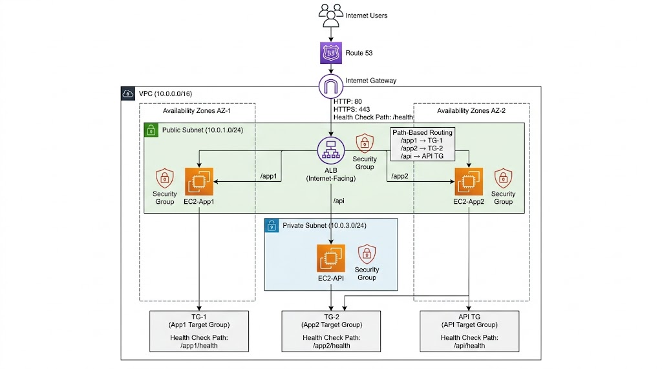

15. Task 1 — Launch EC2-App1 Instance

Objective
Create backend server for /app1.

Configuration
Setting | Value
Instance Name | EC2-App1
AMI | Ubuntu
Instance Type | t2.micro
Subnet | Public-Subnet-1
Security Group | EC2-SG

User Data Script
#!/bin/bash
apt update -y
apt install apache2 -y
systemctl start apache2
systemctl enable apache2

mkdir -p /var/www/html/app1

cat <<EOF > /var/www/html/app1/index.html
<html>
<body style='background-color:#4CAF50; text-align:center;'>
<h1 style='color:white; margin-top:200px;'>
Welcome to APP1
</h1>
<h2 style='color:white;'>
This is EC2-App1 Server
</h2>
</body>
</html>
EOF

16. Task 2 — Launch EC2-App2 Instance

Objective
Create backend server for /app2.

Configuration
Setting | Value
Instance Name | EC2-App2
AMI | Ubuntu
Instance Type | t2.micro
Subnet | Public-Subnet-2
Security Group | EC2-SG

User Data Script
#!/bin/bash
apt update -y
apt install apache2 -y
systemctl start apache2
systemctl enable apache2

mkdir -p /var/www/html/app2

cat <<EOF > /var/www/html/app2/index.html
<html>
<body style='background-color:#2196F3; text-align:center;'>
<h1 style='color:white; margin-top:200px;'>
Welcome to APP2
</h1>
<h2 style='color:white;'>
This is EC2-App2 Server
</h2>
</body>
</html>
EOF

17. Task 3 — Create Target Groups

Target Group 1 — TG-App1
Setting | Value
Target Group Name | TG-App1
Protocol | HTTP
Port | 80
Health Check Path | /app1/index.html
Registered Target | EC2-App1

Target Group 2 — TG-App2
Setting | Value
Target Group Name | TG-App2
Protocol | HTTP
Port | 80
Health Check Path | /app2/index.html
Registered Target | EC2-App2

18. Task 4 — Create Application Load Balancer

Objective
Create an Internet-Facing Application Load Balancer.

Configuration
Setting | Value
Name | My-ALB
Type | Application Load Balancer
Scheme | Internet-Facing
Protocol | HTTP
Port | 80
Security Group | LB-SG
Subnets | Public-Subnet-1 & Public-Subnet-2
Default Action | Forward to TG-App1

19. Task 5 — Configure Path-Based Routing

Rule 1 — App1 Routing
Setting | Value
Path | /app1*
Action | Forward to TG-App1
Priority | 1

Rule 2 — App2 Routing
Setting | Value
Path | /app2*
Action | Forward to TG-App2
Priority | 2

20. Task 6 — Testing ALB

Test URL 1
http://ALB-DNS/app1

Expected Output
- APP1 Page
- Green Screen

Test URL 2
http://ALB-DNS/app2

Expected Output
- APP2 Page
- Blue Screen

21. Host-Based Routing Configuration

Objective
Configure routing using domain names.

Example Rules
Hostname | Target Group
app1.example.com | TG-App1
app2.example.com | TG-App2

22. Query String Routing Configuration

Example Rules
Query Parameter | Target Group
?platform=mobile | TG-Mobile
?platform=desktop | TG-Desktop

23. HTTP Method Routing Configuration

Example Rules
HTTP Method | Target Group
GET | TG-GET
POST | TG-POST

24. Health Checks
ALB continuously monitors backend instances using health checks.
If an instance becomes unhealthy:
- ALB stops forwarding traffic to that server
- Requests are redirected to healthy instances

Health Check Parameters
Parameter | Description
Protocol | HTTP/HTTPS
Path | URL used for health monitoring
Healthy Threshold | Number of successful checks
Unhealthy Threshold | Number of failed checks

25. Security Groups Configuration

ALB Security Group
Allow:
- HTTP (80)
- HTTPS (443)
From:
0.0.0.0/0

EC2 Security Group
Allow traffic only from:
- ALB Security Group
This improves security by preventing direct public access.

26. Advantages of ALB
- Smart Layer 7 Routing
- Path-Based Routing
- Host-Based Routing
- Query String Routing
- SSL Termination
- WebSocket Support
- High Availability
- Auto Scaling Integration
- Better Application Performance

27. Real-World Use Cases
ALB is commonly used in:
- E-Commerce Applications
- Banking Systems
- Enterprise Applications
- SaaS Platforms
- APIs and Microservices
- Healthcare Systems
- Media Streaming Platforms

28. Conclusion
Successfully implemented AWS Application Load Balancer with:
- EC2 Backend Servers
- Target Groups
- Path-Based Routing
- Host-Based Routing
- HTTP Method Routing
- Health Checks
- High Availability Architecture
This architecture provides:
- Scalability
- Reliability
- Better Performance
- Secure Traffic Distribution
- Fault Tolerance
The implementation demonstrates how AWS Application Load Balancer efficiently manages and distributes web traffic across multiple backend servers in a production-style environment.

