AWS Cloud Documentation
On
Networking Fundamentals
Part-2

Introduction
Networking is one of the most important foundations in AWS Cloud. Every AWS service such as EC2, VPC, Load Balancer, Auto Scaling, Route 53, NAT Gateway, and Kubernetes networking depends heavily on networking concepts.
Before learning AWS networking services, it is extremely important to understand the core networking concepts properly. These concepts include:
- IP Addressing
- Network and Host concepts
- IPv4 Classes
- Subnet Masks
- CIDR Notation
- Subnetting
- Broadcast Address
- Network Address
- Public and Private IPs
- AWS VPC Networking Basics

1. What is Networking?
Networking is the process of connecting devices together so they can communicate and exchange data.
Examples of devices in a network:
- Laptop
- Mobile phone
- EC2 instance
- Printer
- Router
- Server
Without networking:
- Devices cannot communicate
- Internet cannot work
- Cloud services cannot interact
Networking is the backbone of cloud computing.

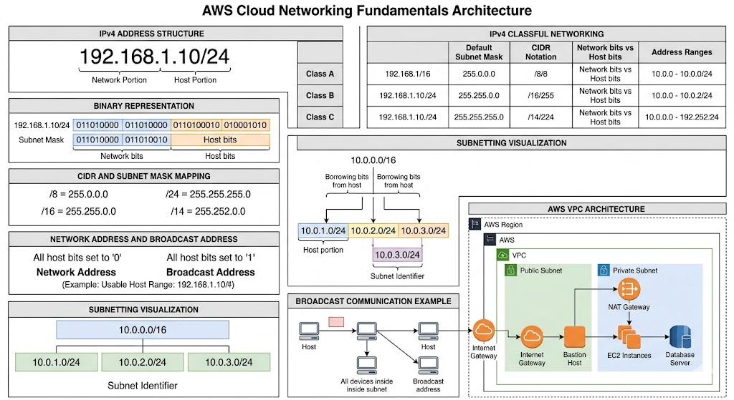

2. What is an IP Address?
An IP Address (Internet Protocol Address) is a unique address assigned to every device in a network.
Purpose of IP Address:
- Identifies devices uniquely
- Allows communication between devices
- Helps routers send data correctly
- Enables internet communication
Example:
192.168.1.10
Just like a home address helps deliver parcels, an IP address helps deliver data packets.

3. IPv4 Address Structure
IPv4 is the most commonly used IP version.
Example IPv4 Address:
192.168.1.10
An IPv4 address contains:
- 4 octets
- Each octet contains 8 bits
- Total = 32 bits
Structure:
8 bits + 8 bits + 8 bits + 8 bits = 32 bits
Each octet ranges from:
0 to 255

4. Binary Representation of IP Addresses
Computers understand only binary values:
0 and 1
Example:
192 = 11000000
So:
192.168.1.10
actually becomes:
11000000.10101000.00000001.00001010

5. Network Portion and Host Portion
Every IP address contains two parts:
Network Portion + Host Portion

Network Portion
Identifies the network.

Host Portion
Identifies the specific device inside that network.
Example:
192.168.1.10
May mean:
- 192.168.1 = network
- 10 = host/device
Meaning:
Device 10 inside network 192.168.1

6. What is a Subnet Mask?
A subnet mask tells the computer:
Which part of IP address is network
Which part is host
Example:
255.255.255.0
Subnet masks work using binary.

Binary Representation
255 = 11111111
0 = 00000000
Thus:
255.255.255.0
becomes:
11111111.11111111.11111111.00000000
Rules:
Binary Value | Meaning
1 | Network bit
0 | Host bit
Therefore:
- First 24 bits = network
- Last 8 bits = host
Thus:
192.168.1 = Network
10 = Host

7. CIDR Notation
CIDR means:
Classless Inter-Domain Routing
CIDR is a short form of subnet mask notation.
Example:
255.255.255.0 = /24
Why?
Because:
11111111.11111111.11111111.00000000
contains:
24 network bits
Thus:
/24
means:
24 bits belong to network

8. CIDR vs Subnet Mask
CIDR and subnet mask represent the same thing.
Both define:
- Number of network bits
- Number of host bits
Examples:
CIDR | Subnet Mask
/8 | 255.0.0.0
/16 | 255.255.0.0
/24 | 255.255.255.0
/14 | 255.252.0.0
CIDR is the modern and shorter representation.

9. Understanding /16, /24 and /14

Example: /16
10.0.0.0/16
Means:
- First 16 bits = network
- Remaining 16 bits = hosts
Binary subnet mask:
11111111.11111111.00000000.00000000
Decimal:
255.255.0.0

Example: /24
10.0.1.0/24
Means:
- First 24 bits = network
- Remaining 8 bits = hosts
Binary:
11111111.11111111.11111111.00000000
Decimal:
255.255.255.0

Example: /14
/14
Means:
- 14 network bits
- 18 host bits
Binary subnet mask:
11111111.11111100.00000000.00000000
Decimal subnet mask:
255.252.0.0

10. Network Address
If all host bits become:
0
then the address becomes:
Network Address
Purpose:
Identifies the entire network
Example:
192.168.1.0/24
Host bits:
00000000
This represents the network itself.
It cannot be assigned to a device.

11. Broadcast Address
If all host bits become:
1
then the address becomes:
Broadcast Address
Purpose:
Send data to ALL devices inside the subnet
Example:
192.168.1.255
This means:
all devices inside network 192.168.1.0/24
Broadcast packets are received by all devices in the subnet.
Broadcast does not cross routers.

12. Usable Host Range
Example:
192.168.1.0/24
Contains:
256 total addresses
But:
- 192.168.1.0 = network address
- 192.168.1.255 = broadcast address
Thus usable devices:
192.168.1.1 to 192.168.1.254

13. Public IP vs Private IP

Public IP
- Accessible from internet
- Globally unique
- Used for internet communication
Example:
13.234.55.10

Private IP
Used for internal communication.
Cannot be directly accessed from internet.
Private IP ranges:

Class A Private
10.0.0.0/8

Class B Private
172.16.0.0 – 172.31.255.255

Class C Private
192.168.0.0/16
AWS VPC uses private IP addressing.

14. IPv4 Classes
Earlier networking used fixed classes.
These were:
- Class A
- Class B
- Class C
Classes divide IP addresses differently between:
- network bits
- host bits

15. Class A Networking

Purpose
Designed for very large organizations.
Examples:
- Governments
- Military
- Huge corporations

Structure
Class A uses:
/8
Meaning:
- First 8 bits = network
- Remaining 24 bits = hosts
Default subnet mask:
255.0.0.0

Example
10.1.2.3
Meaning:
- 10 = network
- 1.2.3 = host

Host Capacity
2^24 - 2 = 16,777,214
usable hosts.

Class A Range
1.0.0.0 → 126.255.255.255
Why?
- First binary bit starts with 0
- 127 reserved for loopback
- 0 reserved for special functions

Loopback Address
127.0.0.1
Means:
This computer itself

16. Why Classful Networking Became a Problem
Classful networking allowed only fixed sizes:
- /8
- /16
- /24
Suppose a company needed:
500 hosts
Class C:
254 hosts
Too small.
Class B:
65,534 hosts
Too large.
Huge wastage of IP addresses occurred.

17. CIDR Replaced Classful Networking
CIDR introduced flexible subnet sizes.
Instead of only:
/8 /16 /24
CIDR allows:
/20 /22 /27 /29
This improved:
- IP utilization
- routing efficiency
- subnet flexibility
Modern networking uses CIDR.

18. What is a Subnet?
Subnet means:
Smaller network inside a larger network
Subnetting divides a large network into multiple smaller networks.
Purpose:
- Better organization
- Better security
- Smaller broadcast domains
- Better performance

19. Subnetting Example
Original network:
10.0.0.0/16
Large network.
Now divide into smaller /24 networks.
Subnets become:
10.0.0.0/24
10.0.1.0/24
10.0.2.0/24
10.0.3.0/24
and so on.
Each subnet contains:
254 usable hosts

20. Borrowing Bits in Subnetting
Subnetting works by:
Borrowing bits from host portion
and converting them into subnet bits
Example:
Original network:
10.0.0.0/16
Structure:
NNNNNNNN.NNNNNNNN.HHHHHHHH.HHHHHHHH
After subnetting into /24:
NNNNNNNN.NNNNNNNN.SSSSSSSS.HHHHHHHH
Where:
- S = subnet bits
- H = remaining host bits

21. AWS VPC Networking Example
Suppose AWS VPC:
10.0.0.0/16
Subnets:
Purpose | Subnet
Public subnet | 10.0.1.0/24
Private subnet | 10.0.2.0/24
Database subnet | 10.0.3.0/24
Each subnet supports:
254 usable IPs

22. Public Subnet vs Private Subnet

Public Subnet
- Has internet access
- Uses Internet Gateway
- Public IPs assigned
Examples:
- Load Balancers
- Bastion Hosts
- Public web servers

Private Subnet
- No direct internet access
- Uses NAT Gateway for outbound internet
- Uses private IPs
Examples:
- Databases
- Backend servers
- Internal applications

23. Bastion Host
A Bastion Host is a secure EC2 instance placed inside a public subnet.
Purpose:
Access private EC2 instances securely
Architecture:
Laptop → Bastion Host → Private EC2
Benefits:
- Better security
- Controlled SSH access
- Protects private servers

24. Broadcast Communication Example
Suppose network:
192.168.1.0/24
Devices:
192.168.1.10
192.168.1.20
192.168.1.30
Broadcast address:
192.168.1.255
If device:
192.168.1.10
sends packet to:
192.168.1.255
then:
- .20 receives it
- .30 receives it
- all devices receive it
This is called broadcast communication.

25. Important Networking Rules

Rule 1
All host bits = 0
→ Network Address

Rule 2
All host bits = 1
→ Broadcast Address

Rule 3
Anything between network and broadcast addresses:
→ Usable host/device IPs

26. Important AWS Networking Concepts Built on These Fundamentals
All advanced AWS networking services use these concepts.
Examples:
- VPC
- Subnets
- Route Tables
- Internet Gateway
- NAT Gateway
- Security Groups
- NACLs
- Load Balancers
- Route 53
- Auto Scaling
- Kubernetes Networking
Understanding networking fundamentals is mandatory for mastering AWS Cloud.

Conclusion
Networking is the core foundation of AWS Cloud.
Before learning advanced cloud services, it is important to clearly understand:
- IP addressing
- Network and host concepts
- Subnet masks
- CIDR notation
- IPv4 classes
- Network address
- Broadcast address
- Subnetting
- Public and private networking
These concepts are directly used in AWS VPC architecture and almost every cloud networking service.

