**Task 1: Data Cleaning & Preprocessing**

**1).Import the dataset and explore basic info (nulls, data types)?**

//program code is done in spyder.

**ANSWER:-**

import pandas as pd

data=pd.read_csv('Titanic.csv')

print(data)

# View top rows

print(data.head())

# Check data types and non-null counts

print(data.info())

# Check for null values

print(data.isnull().sum())

# Basic statistics (optional)

print(data.describe())

OUTPUT IN CONSOLE:-

PassengerId Survived Pclass ... Fare Cabin Embarked

0 1 0 3 ... 7.2500 NaN S

1 2 1 1 ... 71.2833 C85 C

2 3 1 3 ... 7.9250 NaN S

3 4 1 1 ... 53.1000 C123 S

4 5 0 3 ... 8.0500 NaN S

.. ... ... ... ... ... ... ...

886 887 0 2 ... 13.0000 NaN S

887 888 1 1 ... 30.0000 B42 S

888 889 0 3 ... 23.4500 NaN S

889 890 1 1 ... 30.0000 C148 C

890 891 0 3 ... 7.7500 NaN Q

[891 rows x 12 columns]

PassengerId Survived Pclass ... Fare Cabin Embarked

0 1 0 3 ... 7.2500 NaN S

1 2 1 1 ... 71.2833 C85 C

2 3 1 3 ... 7.9250 NaN S

3 4 1 1 ... 53.1000 C123 S

4 5 0 3 ... 8.0500 NaN S

[5 rows x 12 columns]

<class 'pandas.core.frame.DataFrame'>

RangeIndex: 891 entries, 0 to 890

Data columns (total 12 columns):

# Column Non-Null Count Dtype

--- ------ -------------- -----

0 PassengerId 891 non-null int64

1 Survived 891 non-null int64

2 Pclass 891 non-null int64

3 Name 891 non-null object

4 Sex 891 non-null object

5 Age 714 non-null float64

6 SibSp 891 non-null int64

7 Parch 891 non-null int64

8 Ticket 891 non-null object

9 Fare 891 non-null float64

10 Cabin 204 non-null object

11 Embarked 889 non-null object

dtypes: float64(2), int64(5), object(5)

memory usage: 83.7+ KB

None

PassengerId 0

Survived 0

Pclass 0

Name 0

Sex 0

Age 177

SibSp 0

Parch 0

Ticket 0

Fare 0

Cabin 687

Embarked 2

dtype: int64

PassengerId Survived Pclass ... SibSp Parch Fare

count 891.000000 891.000000 891.000000 ... 891.000000 891.000000 891.000000

mean 446.000000 0.383838 2.308642 ... 0.523008 0.381594 32.204208

std 257.353842 0.486592 0.836071 ... 1.102743 0.806057 49.693429

min 1.000000 0.000000 1.000000 ... 0.000000 0.000000 0.000000

25% 223.500000 0.000000 2.000000 ... 0.000000 0.000000 7.910400

50% 446.000000 0.000000 3.000000 ... 0.000000 0.000000 14.454200

75% 668.500000 1.000000 3.000000 ... 1.000000 0.000000 31.000000

max 891.000000 1.000000 3.000000 ... 8.000000 6.000000 512.329200

[8 rows x 7 columns]

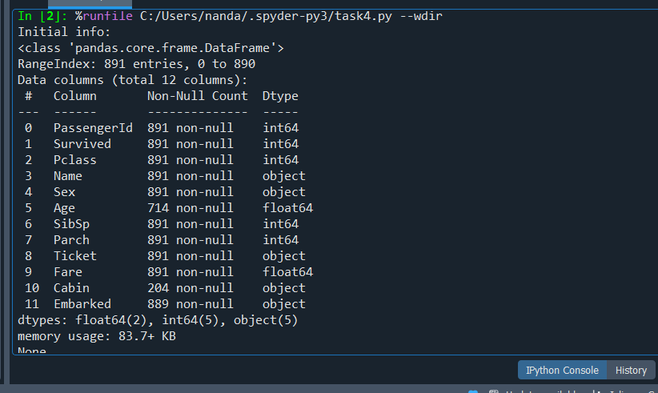

**2)Handle missing values using mean/median/imputation?**

**ANSWER:-**

import pandas as pd

# Load the dataset

df = pd.read_csv("Titanic.csv")

# Check missing values before imputation

print("Missing values before imputation:\n", df.isnull().sum())

# Handle missing values

df['Age'] = df['Age'].fillna(df['Age'].mean())

df['Fare'] = df['Fare'].fillna(df['Fare'].median())

df['Embarked'] = df['Embarked'].fillna(df['Embarked'].mode()[0])

df['Cabin'] = df['Cabin'].fillna('Unknown')

# Check missing values after imputation

print("\nMissing values after imputation:\n", df.isnull().sum())

# Show the filled values from each affected column

print("\nFilled 'Age' column (first 10 rows):\n", df['Age'].head(10))

print("\nFilled 'Fare' column (first 10 rows):\n", df['Fare'].head(10))

print("\nFilled 'Embarked' column (first 10 rows):\n", df['Embarked'].head(10))

print("\nFilled 'Cabin' column (first 10 rows):\n", df['Cabin'].head(10))

**OUTPUT:-**

Missing values before imputation:

PassengerId 0

Survived 0

Pclass 0

Name 0

Sex 0

Age 177

SibSp 0

Parch 0

Ticket 0

Fare 0

Cabin 687

Embarked 2

dtype: int64

Missing values after imputation:

PassengerId 0

Survived 0

Pclass 0

Name 0

Sex 0

Age 0

SibSp 0

Parch 0

Ticket 0

Fare 0

Cabin 0

Embarked 0

dtype: int64

Filled 'Age' column (first 10 rows):

0 22.000000

1 38.000000

2 26.000000

3 35.000000

4 35.000000

5 29.699118

6 54.000000

7 2.000000

8 27.000000

9 14.000000

Name: Age, dtype: float64

Filled 'Fare' column (first 10 rows):

0 7.2500

1 71.2833

2 7.9250

3 53.1000

4 8.0500

5 8.4583

6 51.8625

7 21.0750

8 11.1333

9 30.0708

Name: Fare, dtype: float64

Filled 'Embarked' column (first 10 rows):

0 S

1 C

2 S

3 S

4 S

5 Q

6 S

7 S

8 S

9 C

Name: Embarked, dtype: object

Filled 'Cabin' column (first 10 rows):

0 Unknown

1 C85

2 Unknown

3 C123

4 Unknown

5 Unknown

6 E46

7 Unknown

8 Unknown

9 Unknown

Name: Cabin, dtype: object

**3).Convert categorical features into numerical using encoding?**

**ANSWER:-**

import pandas as pd

# Load the cleaned Titanic dataset

df = pd.read_csv("Titanic.csv")

# Fill missing values as done before

df['Age'] = df['Age'].fillna(df['Age'].mean())

df['Fare'] = df['Fare'].fillna(df['Fare'].median())

df['Embarked'] = df['Embarked'].fillna(df['Embarked'].mode()[0])

df['Cabin'] = df['Cabin'].fillna('Unknown')

# Encode 'Sex' using label encoding: male=1, female=0

df['Sex'] = df['Sex'].map({'male': 1, 'female': 0})

# Encode 'Embarked' using one-hot encoding

df = pd.get_dummies(df, columns=['Embarked'], prefix='Embarked')

# Optional: simplify 'Cabin' to just deck letter (e.g., 'C85' → 'C')

df['Cabin'] = df['Cabin'].apply(lambda x: x[0] if x != 'Unknown' else 'U')

df = pd.get_dummies(df, columns=['Cabin'], prefix='Cabin')

# Drop non-useful or text-heavy columns (optional)

df.drop(['Name', 'Ticket'], axis=1, inplace=True)

# Display the head of the encoded DataFrame

print(df.head())

**OUTPUT:-**

PassengerId Survived Pclass Sex ... Cabin_F Cabin_G Cabin_T Cabin_U

0 1 0 3 1 ... False False False True

1 2 1 1 0 ... False False False False

2 3 1 3 0 ... False False False True

3 4 1 1 0 ... False False False False

4 5 0 3 1 ... False False False True

[5 rows x 20 columns]

**4).Normalize/standardize the numerical features?**

**ANSWER:-**

import pandas as pd

import numpy as np

# Step 1: Load the dataset

df = pd.read_csv("Titanic.csv")

# Step 2: Basic info

print("Initial info:")

print(df.info())

print("\nMissing values before imputation:\n", df.isnull().sum())

# Step 3: Handle missing values

df['Age'] = df['Age'].fillna(df['Age'].mean()) # Use mean for Age

df['Fare'] = df['Fare'].fillna(df['Fare'].median()) # Use median for Fare

df['Embarked'] = df['Embarked'].fillna(df['Embarked'].mode()[0]) # Use mode for Embarked

df['Cabin'] = df['Cabin'].fillna('Unknown') # Fill Cabin with 'Unknown'

# Step 4: Check missing values again

print("\nMissing values after imputation:\n", df.isnull().sum())

# Step 5: Encode categorical features

df['Sex'] = df['Sex'].map({'male': 0, 'female': 1})

df['Embarked'] = df['Embarked'].map({'S': 0, 'C': 1, 'Q': 2})

# You can drop columns like Name, Ticket, Cabin if not using them

df = df.drop(columns=['Name', 'Ticket', 'Cabin'])

# Step 6: Normalize numerical features manually (Min-Max Scaling)

numerical_cols = ['Age', 'Fare', 'SibSp', 'Parch']

for col in numerical_cols:

df[col] = (df[col] - df[col].min()) / (df[col].max() - df[col].min())

# Step 7: Show final dataset preview

print("\nFinal dataset preview:\n")

print(df.head())

**OUTPUT:-**

Initial info:

<class 'pandas.core.frame.DataFrame'>

RangeIndex: 891 entries, 0 to 890

Data columns (total 12 columns):

# Column Non-Null Count Dtype

--- ------ -------------- -----

0 PassengerId 891 non-null int64

1 Survived 891 non-null int64

2 Pclass 891 non-null int64

3 Name 891 non-null object

4 Sex 891 non-null object

5 Age 714 non-null float64

6 SibSp 891 non-null int64

7 Parch 891 non-null int64

8 Ticket 891 non-null object

9 Fare 891 non-null float64

10 Cabin 204 non-null object

11 Embarked 889 non-null object

dtypes: float64(2), int64(5), object(5)

memory usage: 83.7+ KB

None

Missing values before imputation:

PassengerId 0

Survived 0

Pclass 0

Name 0

Sex 0

Age 177

SibSp 0

Parch 0

Ticket 0

Fare 0

Cabin 687

Embarked 2

dtype: int64

Missing values after imputation:

PassengerId 0

Survived 0

Pclass 0

Name 0

Sex 0

Age 0

SibSp 0

Parch 0

Ticket 0

Fare 0

Cabin 0

Embarked 0

dtype: int64

Final dataset preview:

PassengerId Survived Pclass Sex ... SibSp Parch Fare Embarked

0 1 0 3 0 ... 0.125 0.0 0.014151 0

1 2 1 1 1 ... 0.125 0.0 0.139136 1

2 3 1 3 1 ... 0.000 0.0 0.015469 0

3 4 1 1 1 ... 0.125 0.0 0.103644 0

4 5 0 3 0 ... 0.000 0.0 0.015713 0

[5 rows x 9 columns]

**5)Visualize outliers using boxplots and remove them?**

**ANSWER:-**

import pandas as pd

import numpy as np

import matplotlib.pyplot as plt

# Load dataset

df = pd.read_csv("Titanic.csv")

# Handle missing values

df['Age'] = df['Age'].fillna(df['Age'].mean())

df['Fare'] = df['Fare'].fillna(df['Fare'].median())

df['Embarked'] = df['Embarked'].fillna(df['Embarked'].mode()[0])

df['Cabin'] = df['Cabin'].fillna('Unknown')

# Encode categorical variables

df['Sex'] = df['Sex'].map({'male': 0, 'female': 1})

df['Embarked'] = df['Embarked'].map({'S': 0, 'C': 1, 'Q': 2})

# Drop unnecessary columns

df = df.drop(columns=['Name', 'Ticket', 'Cabin'])

# Plot boxplots using matplotlib

numeric_cols = ['Age', 'Fare', 'SibSp', 'Parch']

plt.figure(figsize=(12, 6))

for i, col in enumerate(numeric_cols):

plt.subplot(2, 2, i+1)

plt.boxplot(df[col])

plt.title(f'Boxplot of {col}')

plt.ylabel(col)

plt.tight_layout()

plt.show()

# Function to remove outliers using IQR

def remove_outliers_iqr(dataframe, column):

Q1 = dataframe[column].quantile(0.25)

Q3 = dataframe[column].quantile(0.75)

IQR = Q3 - Q1

lower_limit = Q1 - 1.5 * IQR

upper_limit = Q3 + 1.5 * IQR

return dataframe[(dataframe[column] >= lower_limit) & (dataframe[column] <= upper_limit)]

# Remove outliers from each numerical column

for col in numeric_cols:

df = remove_outliers_iqr(df, col)

# Output cleaned data shape and preview

print("\nShape after outlier removal:", df.shape)

print("\nPreview of cleaned data:\n")

print(df.head())

**OUTPUT:-**

Shape after outlier removal: (577, 9)

Preview of cleaned data:

PassengerId Survived Pclass Sex ... SibSp Parch Fare Embarked

0 1 0 3 0 ... 1 0 7.2500 0

2 3 1 3 1 ... 0 0 7.9250 0

3 4 1 1 1 ... 1 0 53.1000 0

4 5 0 3 0 ... 0 0 8.0500 0

5 6 0 3 0 ... 0 0 8.4583 2

[5 rows x 9 columns]

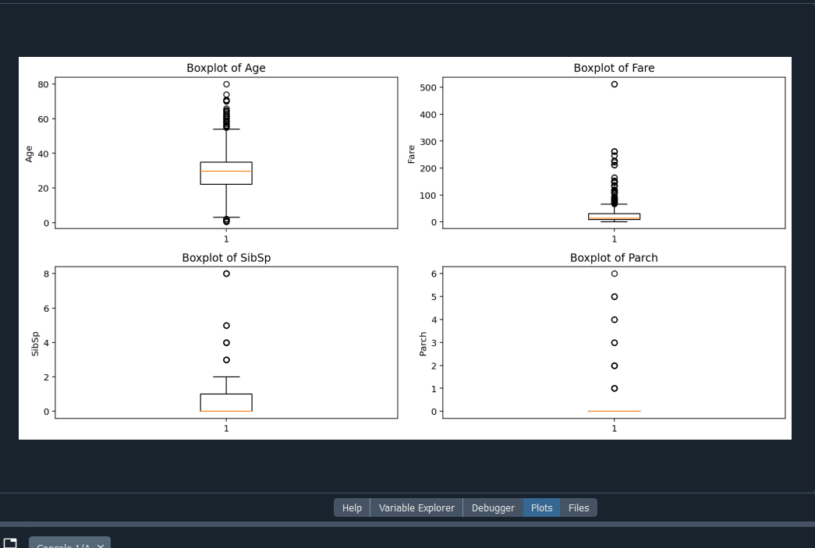

Some screenshots of the tasks

