Blogger Locale: A Semantic Search Based Application
Yaganti Ashok, Nandanamudi Jyothikiran, Pullela Tejaswi, Kadari Pratap Rao

Abstract— Semantic search is a technique used for searching data in which a search query aims to determine the intent and contextual meaning of the words that a person is using for search. It improves search accuracy by understanding the need of a person and generate more relevant results. Here in this paper we introduced semantic based search in a blog where we used NLPs provide by machine learning to improve the results and we used LDA for topic classification and Naive Bayes modelling in developing an ontology. We finally ran SparkQL query to determine the relational occurrences of the search item with the available topic classifications and categories it belong.
Keywords— Semantic search, latent Dirichlet allocation (LDA), Naive Bayes, Ontology

Introduction
Blogger Locale is an online blog which provides a smart way of posting articles, promotions, questions and all types of software related enquiries. Latest technological improvements, new ideas can be shared with different people. People can get aware of social issues; new languages can be others.
Human right groups, NGOs needs a medium to interact with the people to create social awareness of a social cause, our bog will help them to reach huge number of people online. One can use our blog to communicate with their friends and families. People will use this to have fun and to be creative. Our main objective is to make it more user friendly by inclusion of some interesting NLPs which will help the people to raise the questions from the already available ones. People can filter they needs based on the tags we provide.
In this paper, we demonstrated the usage of machine learning algorithms to narrow down the search for a post in a blog.

Related Work

Semantic Search Engine
The Semantic Web is an extension of the current Web which allows to described in terms of well-defined vocabularies that can be read and understand by people and computers. The W3C standard called Resource Description framework is used to describe the information on the Semantic Web. People and computers can use current websites to locate information on the semantic web. Semantic Web infrastructure uses a most significant concept called Ontology. For representing ontologies, the two main W3C standards that we can use are RDF(S) (Resource Description Framework/Schema) and OWL (Web Ontology Languages). The Semantic Web will support more efficient integration, discovery, automation, and reuse of data and provide support for interoperability, the current web technologies cannot solve this problem.

The current web technologies cannot solve the problem of interoperability and it can be solved by using Semantic Web and it is more efficient discovery, automation and integrated solution. For answering the queries most of the search engines use keywords to search. The search engines usually look in web pages for the required information. By using the advanced algorithms, searching unnecessary pages can be avoided.

The search engines develop state-of algorithms which helps in answering topic wise queries efficiently and effectively. But, due to dependence on the data available on the web pages, they cannot answer intelligent queries asked by the user. But by using the much researched algorithms, the accuracy can be improved for these queries. With just keyword based search, the results are just form blogs or may be from other discussion boards. But, the user does not find them to be truth as he doesn’t trust the blog etc.

To overcome this problem in search engines to retrieve relevant and meaningful information more accurately and intelligently, semantic web technology deals with a machine learning algorithms in a greater role. By using the Intelligent semantic technology approximate results to the actual can be found out by search engines. By classifying the post into few main categories, we can review their characteristics respectively. In addition, the issues within the reviewed intelligent semantic search methods and the search engines are analyzed and concluded based on perspectives.

The main motivation is from the present available blogs which lags in providing a better of search engine. Our main objective is to limit the search results to compare with the requested post in a blog. It should
be compatible with all platforms and should be mobile friendly. Identifying the topic to which the search tags are related to using LDA, Naive Bayes. Usage of available API’s to make the blog interesting as well as place where the user can search using different engines.

Proposed Plan

We decided to use and LDA and Naive Bayes for categorization and training the model on the data sets available. When the user submits a post we used machine learning algorithms to extract raw data by implementing NER, POS and the TFIDF to identify the top frequency word and we saved these words as tags and used WordNet to find the synonyms which can be used to identify the post the user is looking for while he is searching for one.

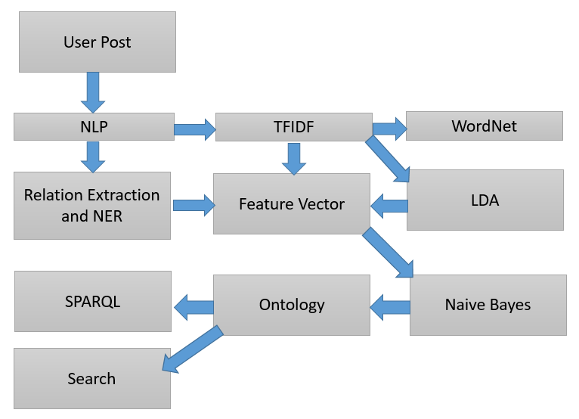
Fig.1 Work Flow Model

For extracting the triples and relations, after doing TFIDF, we extracted them as feature vector and trained our Naive Bayes model on the data set of post and compared with LDA prediction and final created an ontology out of that we ran SparQL query on the ontology created using Jena Fuseki and we found almost 6000 triples with a few lines of post.

LDA and Naïve Bayes apprach
The estimation of posterior P(class|x) can be done by LDA and Naïve Bayes (NB) are linear classifiers which comes under the category of generative models. LDA assumes Gaussian class-conditional density models. It also assumes equal covariance’s. NB assumes variables to be independent.
The Gaussian NB classifier (Mitchell, 1997; Mitchell et al., 2004) models the probability density which is conditional of the response patterns given a stimulus class as a Gaussian distribution given by a diagonal covariance matrix. The conditional probability P(x|Ci) is modeled as a univariate Gaussian which is of response amplitude x given that the stimulus is of class Ci. The variance and the main of the Gaussian are estimated from the training patterns. A test pattern x is classified as the class Ci whose posterior probability is maximal.
LDA is closely related to NB in that both classifiers assume Gaussian within-class distributions. However, NB relies on a less flexible in that it assumes zero off-diagonal covariance
Naive Bayes classifiers are a popular choice for classification problems. There are many reasons for this, including:
- widespread awareness after the success of spam filters
- Easy to understand and put on the paper.
- The classifier model can be built fast.
- The model can be modified with new training data without having to rebuild the model
However, they are 'naive' - i.e. they assume the features are independent - this contrasts with other classifiers such as Maximum Entropy classifiers

Ontolgy Learning

Ontology is a base for the semantic Web and machine learning in AI and is the future of web revolution.. The ontology can help the information sharing and knowledge management more effectively and efficiently. Ontology can provide a semantic foundation of the digital content for the machine. The ontology aims to provide the knowledge about for the developer and computer which include the domain and relation. And it can define the attribute, function, constraints, and axioms for an item, then it can help the computer to manage and learn the knowledge easily.

With the ontology method develop rapidly, the tools for develop and manage the ontology became requirement. The fundamental and needful function for those tools is knowledge elicitation, ontology retrieval, ontology editing, ontology validation, collaborative development and ontology transformation and presentation.

With those tools, ontology learning always has a framework, which include the information extraction, discovery of ontology, and ontology organization. The ontology extraction is pre-processing and recognize information from all the kinds of data, the ontology discovery is using the extracted information to discovery the concepts and relations, and the ontology organization means the seeking the concepts and relation via the clustering synonymous terms and their relation, deriving inverse relation, discovering local centers of concepts and building higher-level ontologies.
The domains in the ontology also have a lot of classes, there are some popular classification scheme for the domains and it’s useful for the ontology learning such as established vs. under-developed domains, emerging vs. conventional domains, technology-heavy vs. technology-light domains, and self-contained vs. interdisciplinary domains.

With those steps, we can learn and use the ontology, then it can help us to transform information from the Webpages, papers, reports, books and articles to the knowledge we can use. And the ontology is advantageous to searching and filter the related information, and it’s also useful for the machine learning.

With the ontology studding, we not only learned how to use the ontology to seek and extract the information we needed, but also know that the human and machine and understand each other, and the relations and domains are very important for an item. It can help us and the machine cognize and learn one thing clearly and accurately. And we can use ontology to build the knowledge framework and database.

Implementation
The Named Entity recognition module was run to return the specific naming conventions. The knowledge graph is extracted based on this and we can show the interlinking of an article through this. The conventional data format is used to show how the data can be superimposed can be seen as the manner for showing the format and class to which it belongs.
Fig.1 shows the procedure we have been followed in implementing the semantic search as per the given inputs in the search fields. We the user submits a post we read the post as RDDs and then did machine learning algorithms such as tokenization, lemmatization, POS and NER (Name Entity Recognition) and extracted feature vectors while saving to the database we did TFIDF (Term Frequency and Inverse Document Frequency) to find the top frequency word in the post and saved those words as tags which are used while the user is searching for a post. While the user enters a text in the search box those words are searched among the tags saved as well as synonyms are found to the text entered using WordNet and these synonyms are also used in finding the post in the data base.
After inserting the post, LDA and Naive Bayes has been calculated and then from the extracted output by comparison of LDA and Naive Bayes, Ontology has been created. The ontology contains all the triples in it along with the recently added post. For a sample data set of 50 post we found almost 6000 triple in the ontology. From the ontology extracted we can measure the true relationship of each entity with any other entity by running a SparQL query on the ontology created.

Type | URL
Github | https://github.com/nandanamudi/KDM-Summer2016-BlogSearch
Youtube | https://youtu.be/ZdQ8Drjf910

Table 1 Github Repository and Youtube Video URL.

The Github URL shows the project increments in 3 phases we developed and the yotutube URL shows the overall working procedure of the project developed with all the entities explained.

Results And Evaluation

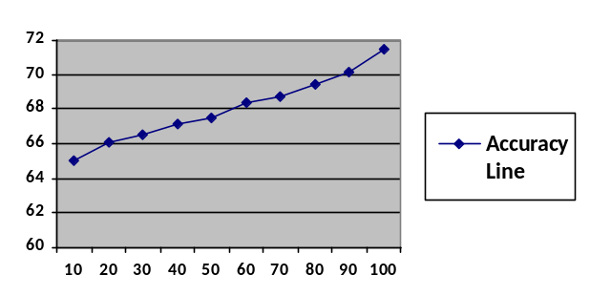
Fig.2 Accuracy line with the increase of data sets.

After comparing the actual expected versus the actual results, the results proved to be of 60 percent accurate. In terms of categorization we achieved 80 percent accuracy by using Naive Bayes training model and LDA

Fig.2 Shows the accuracy with the increase of data sets. Our experiment with the data sets proved the with the increase of data sets there is a difference in the accuracy levels. With less data sets the system worked less efficiently and has provided best results with the increase of data sets. But with the increase of data sets time taken to process the given search query took long time when compared to the processing with less data sets.

We have categorized the data sets into ten categorizations as per the available data and when we did our experiment on these data set categorizations in finding a post to which particular categorization does it belong we almost achieved 85 to 90 percent accuracy.

In Fig.2, we considered datasets on X-axis and accuracy in terms of percentage on Y-axis. As per the results the graphs depict that for the data sets of size 10 the accuracy is 74 percent approximately. Whereas
with the increase of data sets, the accuracy line has steeped toward higher percentages. At the size of 100 the accuracy has increase to almost 71.5 percent approximately.

With the current model, the accuracy can still be improved a lot by considering all the options available.

Conclusion

Blogger Locale is a successfully developed approach in which we implemented a semantic based search engine for searching a post. We used Spark natural language processing with learning model with ontology.
Our approach is consistent, but with the better data sets from the web the accuracy can be still improved. Of course, the results proved to be consistent the improvement of accuracy is still needed by understanding the needs of the user. As we have used the tags from the words extracted from the TFIDF and the usage of WordNet 2.0 for finding the synonyms while searching a post improved the accuracy and the time taken for searching a post has been decreased.
There is still of lot of work needed to improve the accuracy as expected. The Naive Bayes approached limited the accuracy to a certain extent. With other approaches like K-means clustering the categorization and semantic search accuracy can be improved.

Future Work

The Future works a lot of extensions to the present approach introduced in this paper. The Ontology learning has not been concentrated much which forms a major part of the future work. The dynamic ontology from the data sets and linking the input data to the ontology will act as a major role in the extended work.
Extracting the data or the searching a query using a SparQL query will be introduced in the future work to this paper. Categorization of data sets by using K-Means clustering and predicting using the LDA combination will be studied. The study related to improvement of accuracy will be a part of future Work.
Also, we are still working on how find a nice way to remove the supervision of the data set. The problem is that if we pursue more concrete, the data appears less precise; if we pursue more precise, the data appears less concrete. Therefore, it is a very interesting topic that worth to put research efforts on, which will lead machine learning and knowledge management into another level.

References
[1] D. Cohn and T. Hofmann. The missing link- A probabilistic model of document content and hypertext connectivity. In Advances in Neural Information Processing
Systems 13, 2001.

[2] P.J. Green and S. Richardson. Modelling heterogeneity with and without the Dirichlet process. Technical Report, University of Bristol, 1998.

[3] T. Hofmann. Probabilistic latent semantic indexing. Proceedings of the Twenty-Second Annual International SIGIR Conference, 1999.

[4] T. J. Jiang, J. B. Kadane, and J. M. Dickey. Computation of Carlson's multiple hypergeometric functions r for Bayesian applications. Journal of Computational and Graphical Statistics, 1:231- 251 , 1992.

[5] M. I. Jordan, Z. Ghahramani, T. S. Jaakkola, and L. K. Saul. Introduction to variational methods for graphical models. Machine Learning, 37:183- 233, 1999.

[6] K. Nigam, A. Mccallum, S. Thrun, and T. Mitchell. Text classification from labeled and unlabeled documents using EM. Machine Learning, 39(2/3):103- 134, 2000.

[7] A. Popescul, L. H. Ungar, D. M. Pennock, and S. Lawrence. Probabilistic models for unified collaborative and content-based recommendation in sparse-data environments.
In Uncertainty in Artificial Intelligence, Proceedings of the Seventeenth Conference,
2001

[8] Thomas M. Cover and Joy A. Thomas. Elements of Information Theory. John Wiley, 1991.

[9] M. Craven, D. DiPasquo, D. Freitag, A. McCallum, T. Mitchell, K. Nigam, and S. Slattery. Learning to extract symbolic knowledge from the World Wide Web. In AAAI-98, 1998.

[10] P. Domingos and M. Pazzani. On the optimality of the simple Bayesian classifier under zero-one loss. Machine Learning, 29:103–130, 1997.

[11] Nir Friedman, Dan Geiger, and Moises Goldszmidt. Bayesian network classifiers. Machine Learning, 29:131– 163, 1997. Jerome H. Friedman. On bias, variance, 0/1 - loss, and the curse-of-dimensionality. Data Mining and Knowledge Discovery, 1:55–77, 1997.

[12] Louise Guthrie and Elbert Walker. Document classification by machine: Theory and practice. In Proceedings of COLING-94, 1994.

[13] Thorsten Joachims. A probabilistic analysis of the Rocchio algorithm with TFIDF for text categorization. In ICML- 97, 1997.

[14] Booch, G., Rumbaugh, J. and Jacobson, I. (1997). The Unified Modeling Language user guide: Addison-Wesley.

[15] Brachman, R.J., McGuinness, D.L., Patel-Schneider, P.F., Resnick, L.A. and Borgida, A. (1991). Living with CLASSIC: When and how to use KL-ONE-like language. Principles of Semantic Networks. J. F. Sowa, editor, Morgan Kaufmann: 401-456.

[16] Brickley, D. and Guha, R.V. (1999). Resource Description Framework (RDF) Schema Specification. Proposed Recommendation, World Wide Web Consortium: http://www.w3.org/TR/PR-rdf-schema.

[17] Chimaera (2000). Chimaera Ontology Environment. www.ksl.stanford.edu/software/chimaera

[18] Duineveld, A.J., Stoter, R., Weiden, M.R., Kenepa, B. and Benjamins, V.R. (2000). WonderTools? A comparative study of ontological engineering tools. International Journal of Human-Computer Studies 52(6): 1111-1133.

[19]Farquhar, A. (1997). Ontolingua tutorial. http://ksl-web.stanford.edu/people/axf/tutorial.pdf

[20] Gomez-Perez, A. (1998). Knowledge sharing and reuse. Handbook of Applied Expert Systems. Liebowitz, editor, CRC Press.

