**Name: Nandani Patel**

**Department:Dotnet**

**Assignment-3**

1. **Write a SQL query to find Employees who have the biggest salary in their Department.**

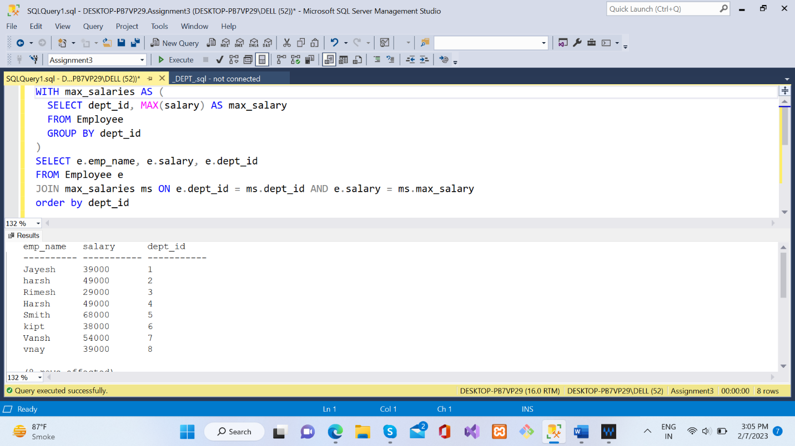

1. **Write a SQL query to find Departments that have less than 3 people in it.**

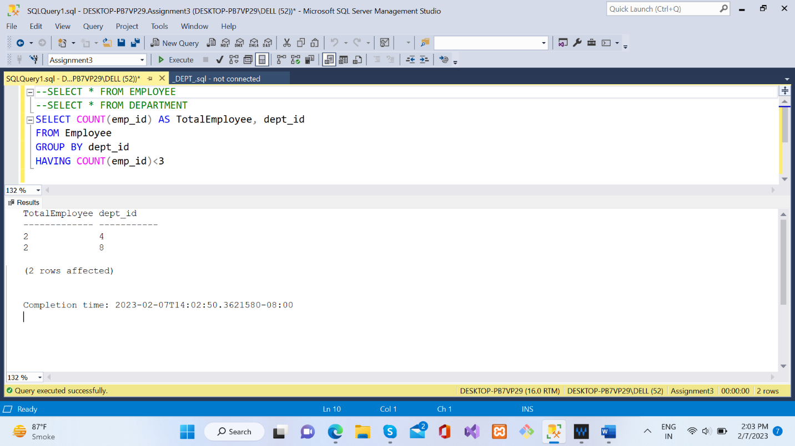

1. **Write a SQL query to find All Department along with the number of people there.**

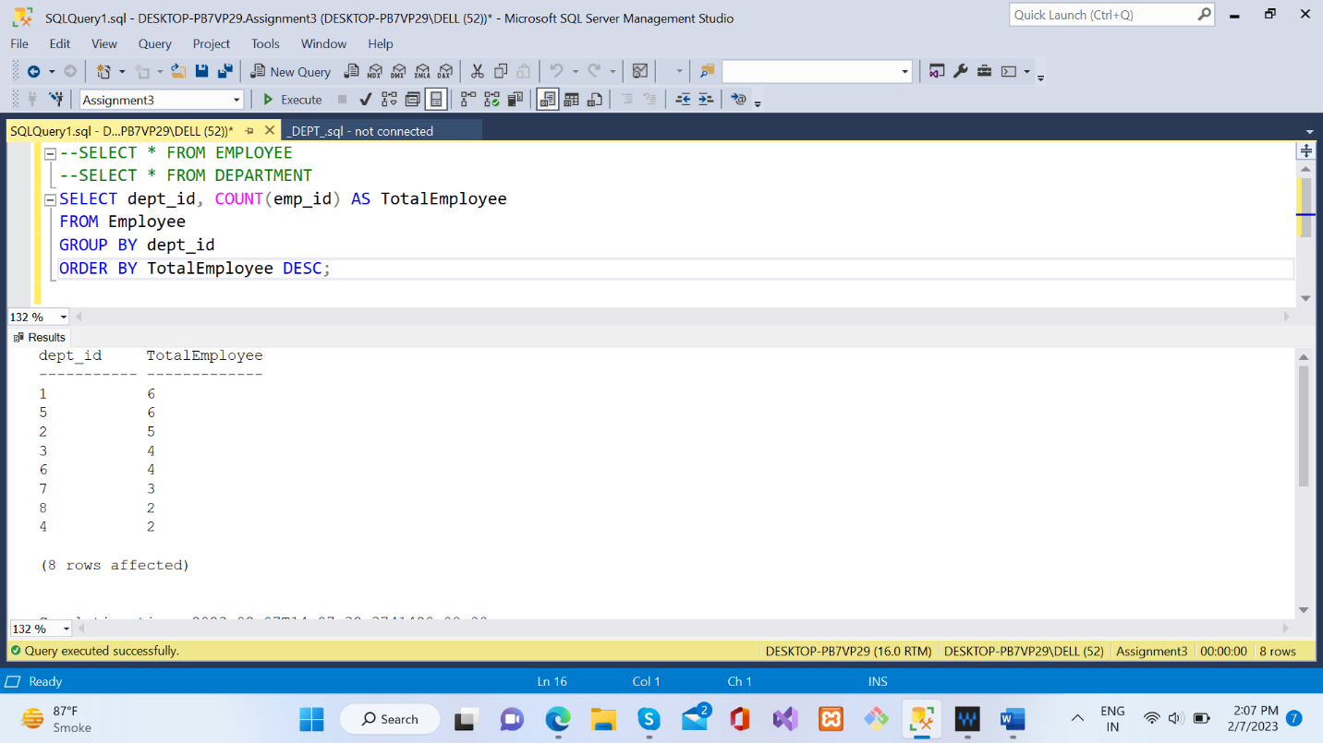

1. **Write a SQL query to find All Department along with the total salary there.**

