**Name: Nandani Patel**

**Department: Dotnet**

**Assignment:1**

1. **Write a query to get a Product list (id, name, unit price) where current products cost less than $20.**

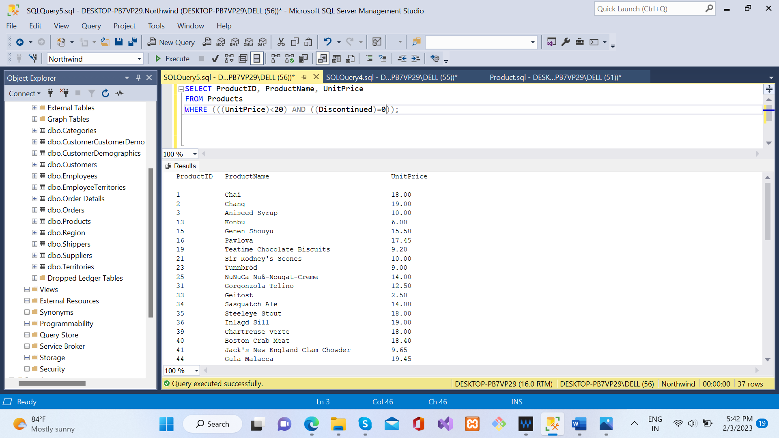

1. **Write a query to get Product list (id, name, unit price) where products cost between $15 and $25.**

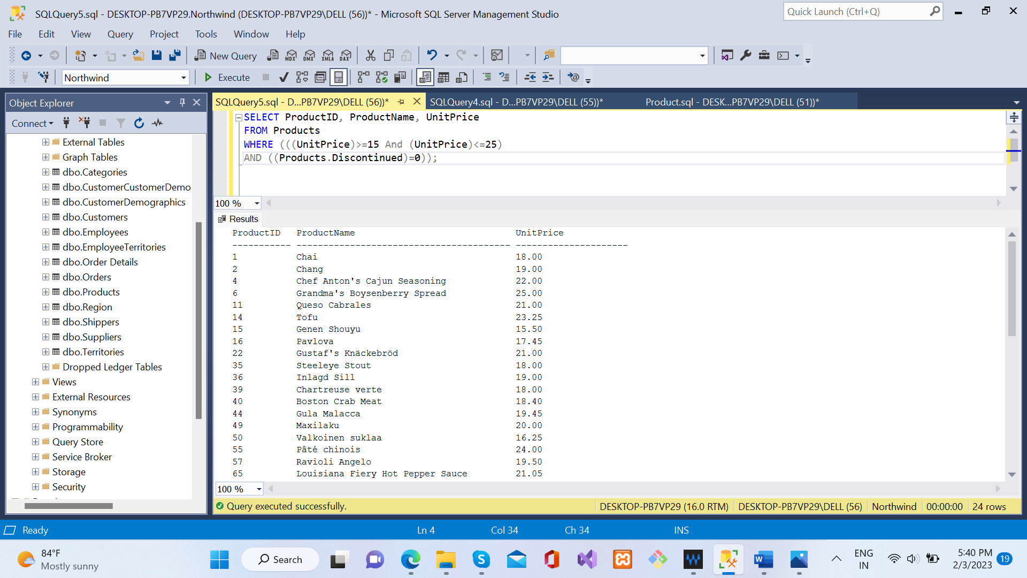

1. **Write a query to get Product list (name, unit price) of above average price.**

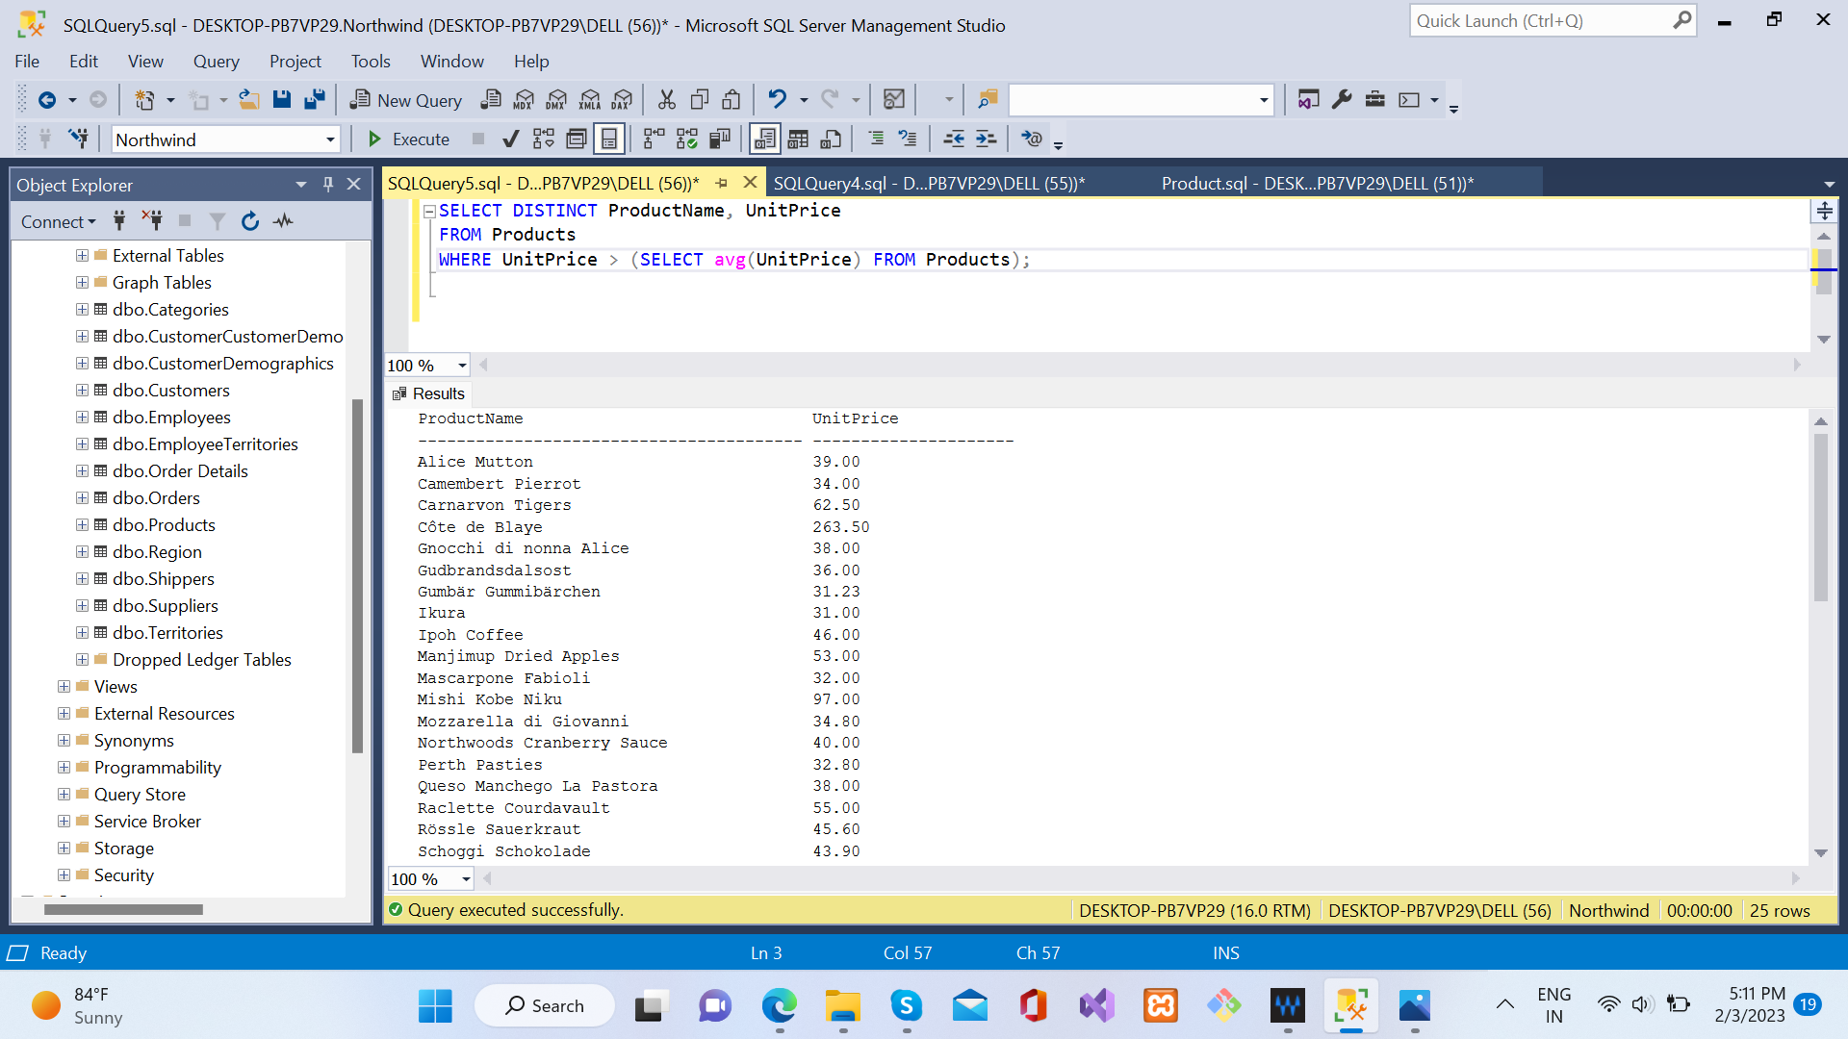

1. **Write a query to get Product list (name, unit price) of ten most expensive products.**

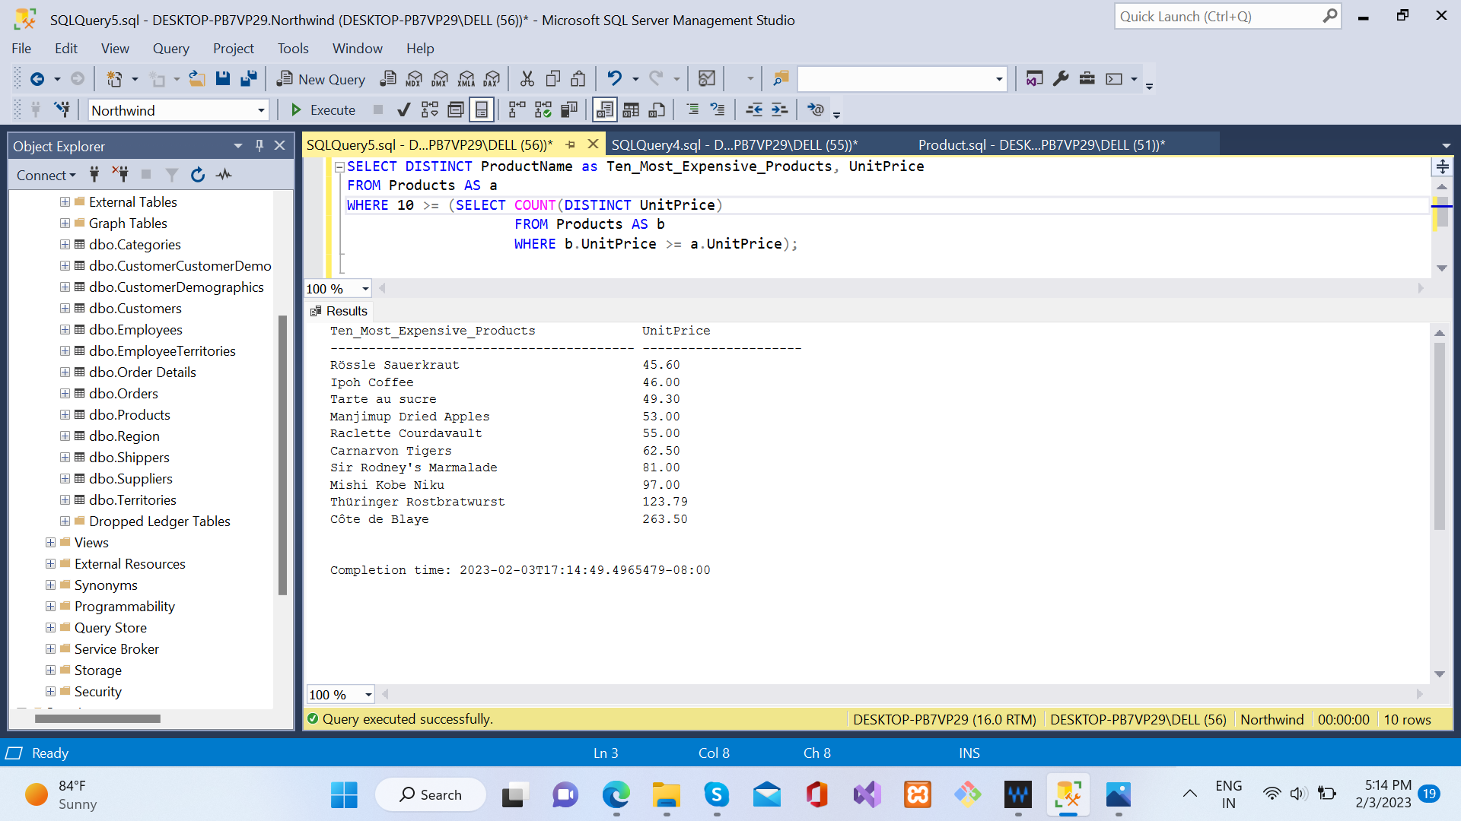

1. **Write a query to count current and discontinued products.**

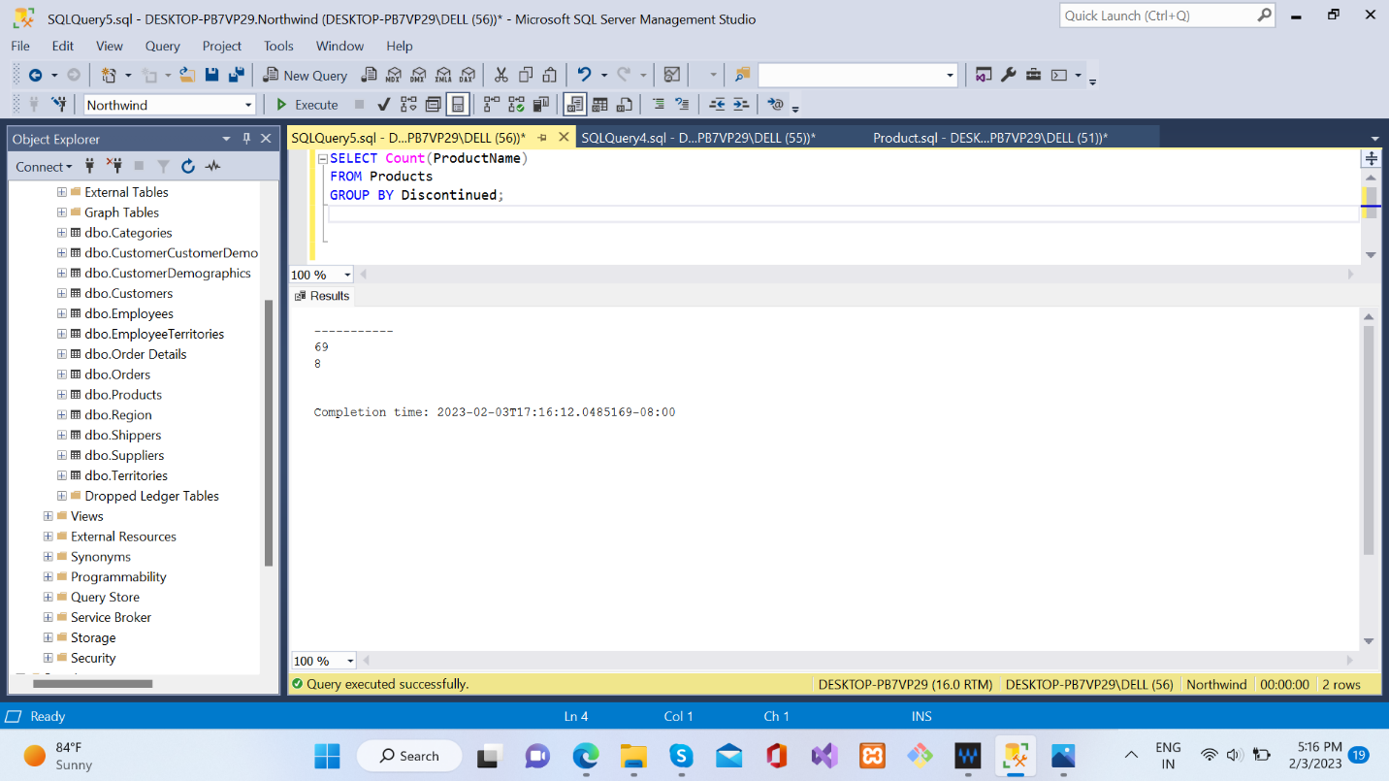

1. **Write a query to get Product list (name, units on order, units in stock) of stock is less than the quantity on order.**

