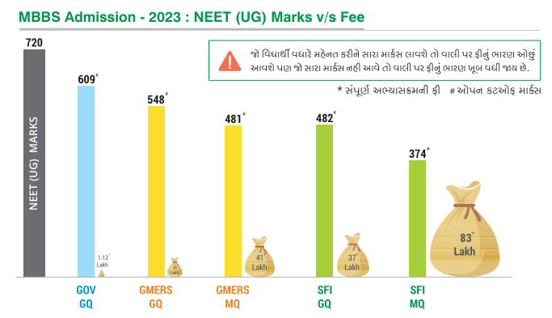

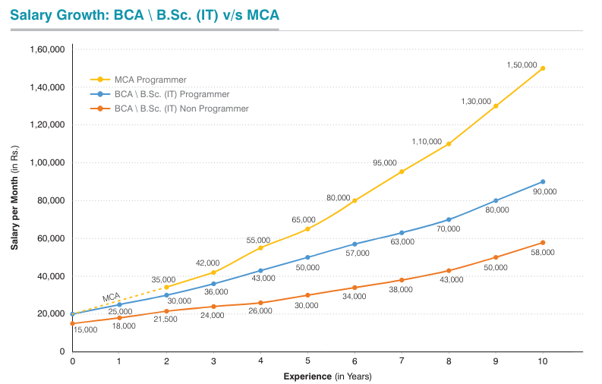

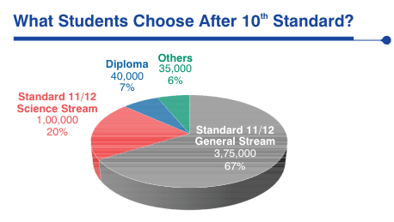

1. Draw above charts.
2. Keep header of every page as the name of chart.
3. Insert watermark as Darshan University.
4. Insert 4th page and draw a flow chart of C program to display whether number is positive or negative.
5. Insert signature line, Date, and time at the end of 4th page and it should be right aligned.
6. Insert page border in every page of light blue coloured.