**Writing a 10,20,50,100,200 MB of data into AWS S3 bucket**

**and checking writing performance**

1. **Writing 10 MB of data and capturing the performance of time duration result.**

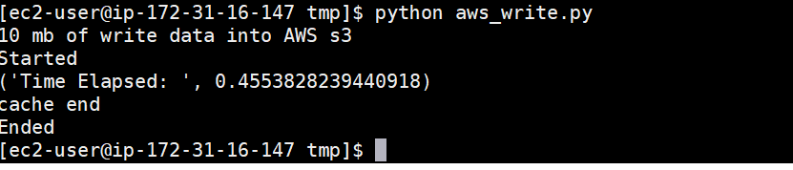

1. **Writing 20 MB of data and capturing the performance of time duration result.**

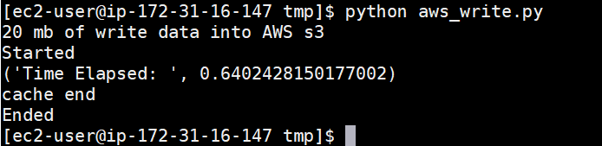

1. **Writing 50 MB of data and capturing the performance of time duration result.**

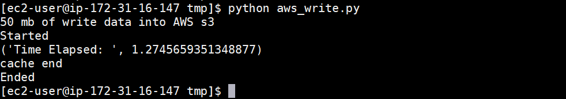

1. **Writing 100 MB of data and capturing the performance of time duration result.**

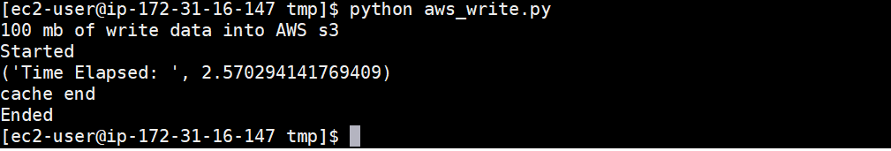

1. **Writing 200 MB of data and capturing the performance of time duration result.**

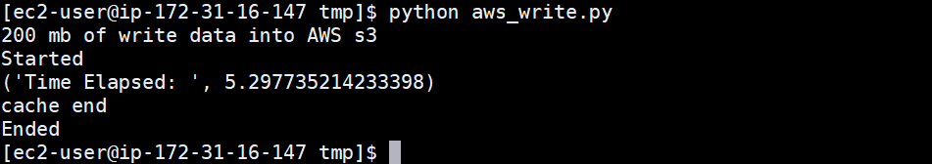

**Writing a 10,20,50,100,200 MB of data into redis memory cache**

**and checking writing performance**

1. **Writing 10 MB of data and capturing the performance of time duration result.**

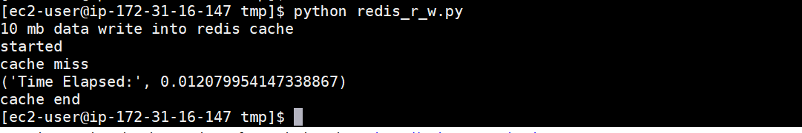

1. **Writing 20 MB of data and capturing the performance of time duration result.**

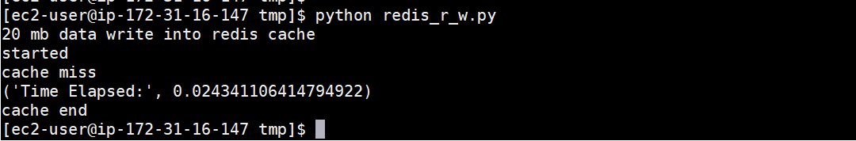

1. **Writing 50 MB of data and capturing the performance of time duration result.**

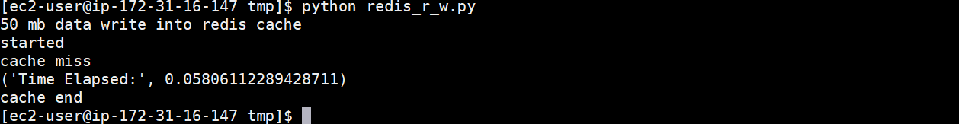

1. **Writing 100 MB of data and capturing the performance of time duration result.**

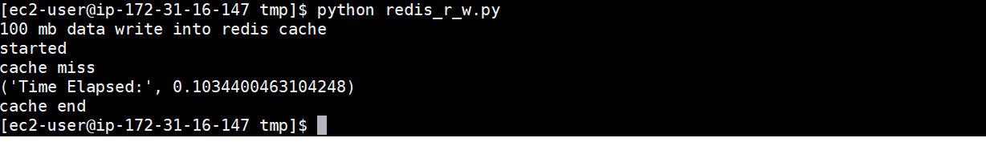

1. **Writing 200 MB of data and capturing the performance of time duration result.**

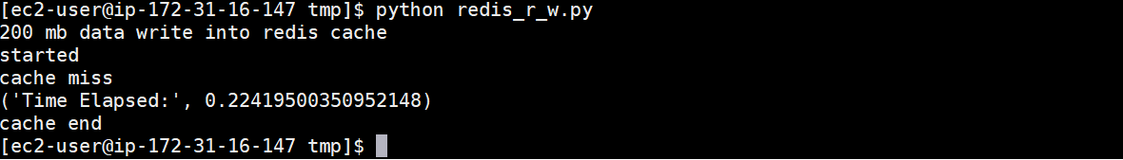

**Writing a 10,20,50,100,200 MB of data into Hadoop(HDFS)**

**and checking writing performance**

1. **writing 10 MB of data and capturing the performance of time duration result.**

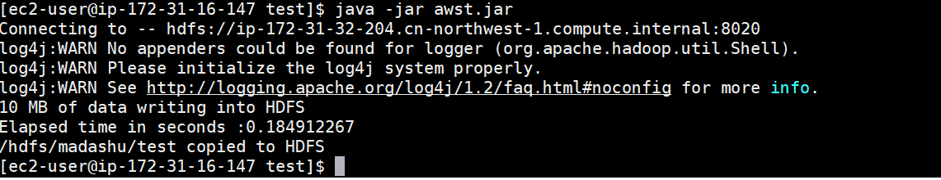

1. **writing 20 MB of data and capturing the performance of time duration result.**

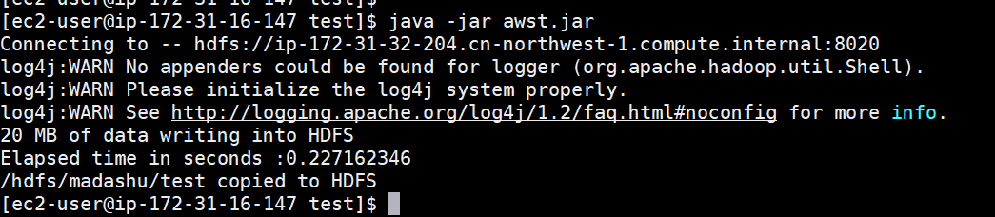

1. **writing 50 MB of data and capturing the performance of time duration result.**

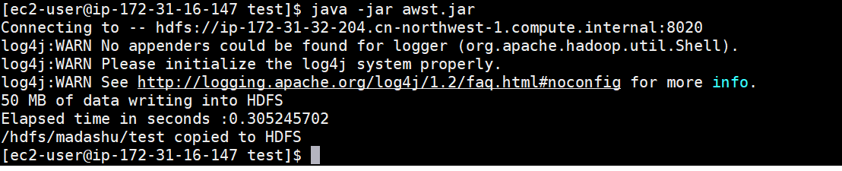

1. **writing 100 MB of data and capturing the performance of time duration result.**

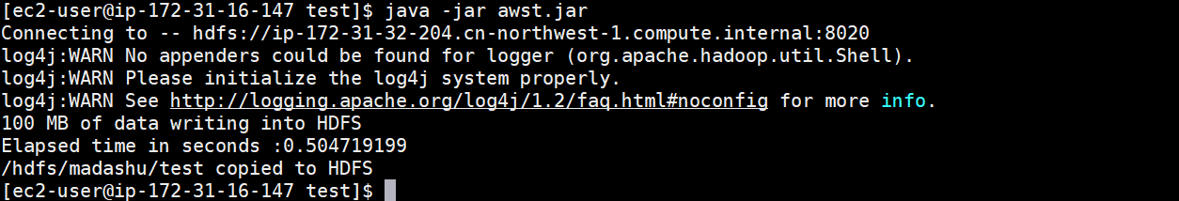

1. **writing 200 MB of data and capturing the performance of time duration result.**

