Hadoop FS using Read & Write

1st time Run Result:

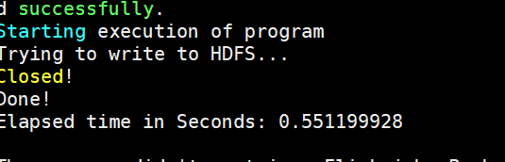

2nd time Run Result:

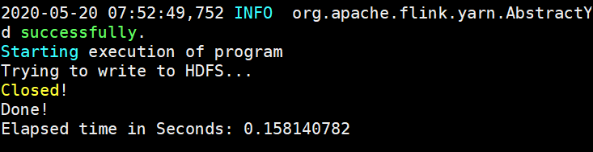

Hadoop Write Code:

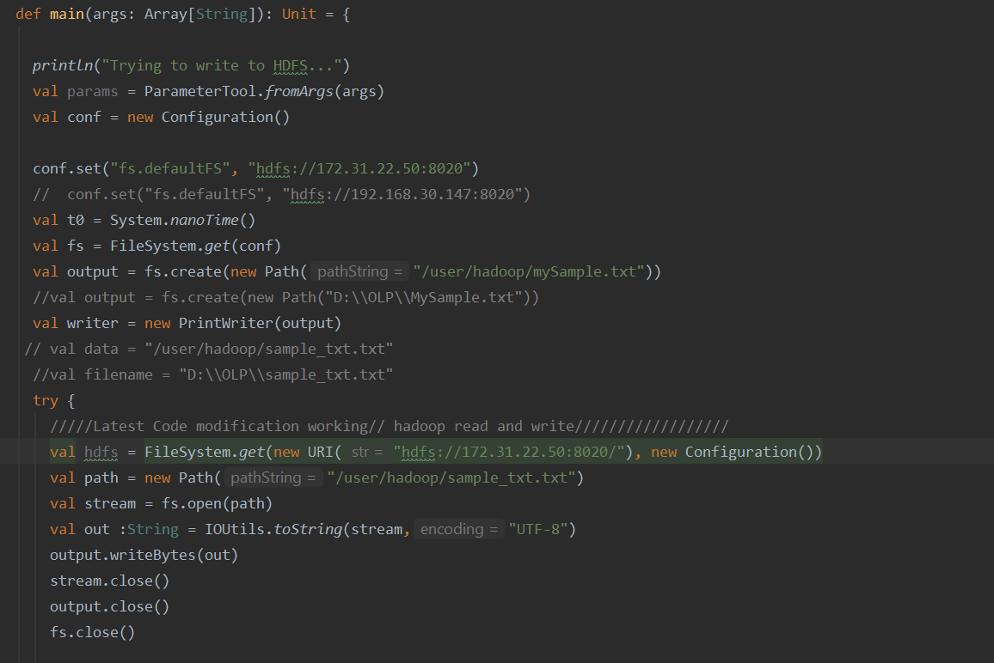

Write data into S3 Bucket:

1st time:

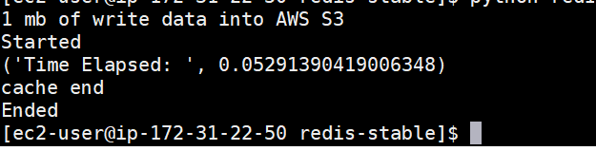

2nd time:

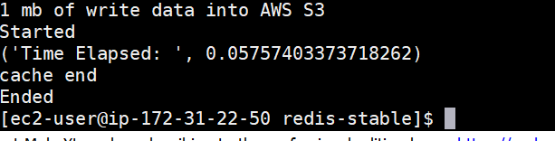

S3 Bucket write Code:

