**VIEW IN BROWSER USING GOOGLE CHROME!**

**TECHNOLOGIES USED:**

**Development Environment:** Visual Studio

**Programming Language(s):** C#, CSS, HTML, JavaScript

**Framework:** .NET 8.0 **(back-end)** Bootstrap **(front-end)**

**Database:** SQL Server

**Version Control:** GitHub

**GITHUB LINK:**

<https://github.com/nande19/PhoneBook-.git>

**Build Tools and Package Managers:** NuGet

**DOWNLOAD + INSTALLATION + SETUP:**

**ONCE YOU HAVE DOWNLOADED THE ZIPPED FOLDER:**

1. Right **click** on the downloaded **folder** (“**Nande Mzantsi**”) in your **File Explorer**
2. **Click** on “**Extract all**”
3. Once all the files have been extracted, **click** on the folder and open the “**PhoneBook Application.sln**” solution in **Visual Studio**.
4. Once that solution is open, **open** your “**Solution Explorer**”.
5. **Click** on the “**appsettings.json**” file.
6. **Change** **line 10** which is the Connection String titled “**PhoneBookPortal**” from this;

**"PhoneBookPortal": "Server=LAPTOP-PIF45UTQ;Database=DbPhoneBook;Trusted_Connection=True;TrustServerCertificate=True"**

**TO THIS**

**"PhoneBookPortal": "Server=(localdb)****\\mssqllocaldb;Database=DbPhoneBook;Trusted_Connection=True;TrustServerCertificate=True****"**

1. Once that is changed, **click** on the **Tools** tab at the **top of the screen**
2. **Select/Hover** over “**NuGet Package Manager**”
3. **Click** on “**Package Manager Console**”
4. Once the console is open, **write** the follow command [ **Update-Database** ]
5. Once it is done updating, there will be a text at the bottom that says “**done.**”. That **indicates** the **completion** of our setup.

**RUNNING THE APPLICATION:**

1. At the **top of the screen** there is a **green triangle** (which will be used to start the application) with a dropdown. Before starting the application, please **ensure** that you have **selected https**.

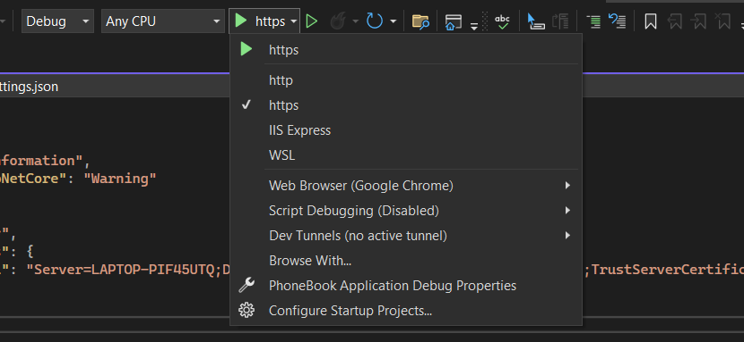

1. **Click** on the **green triangle** to **start** the application.
2. You will immediately be directed to the “**Home**” page

1. Once you’re on the “Home” page, **click** on the “**Add Contacts**” tab where you will be directed to the “**Add Contact**” where you can add your contacts.

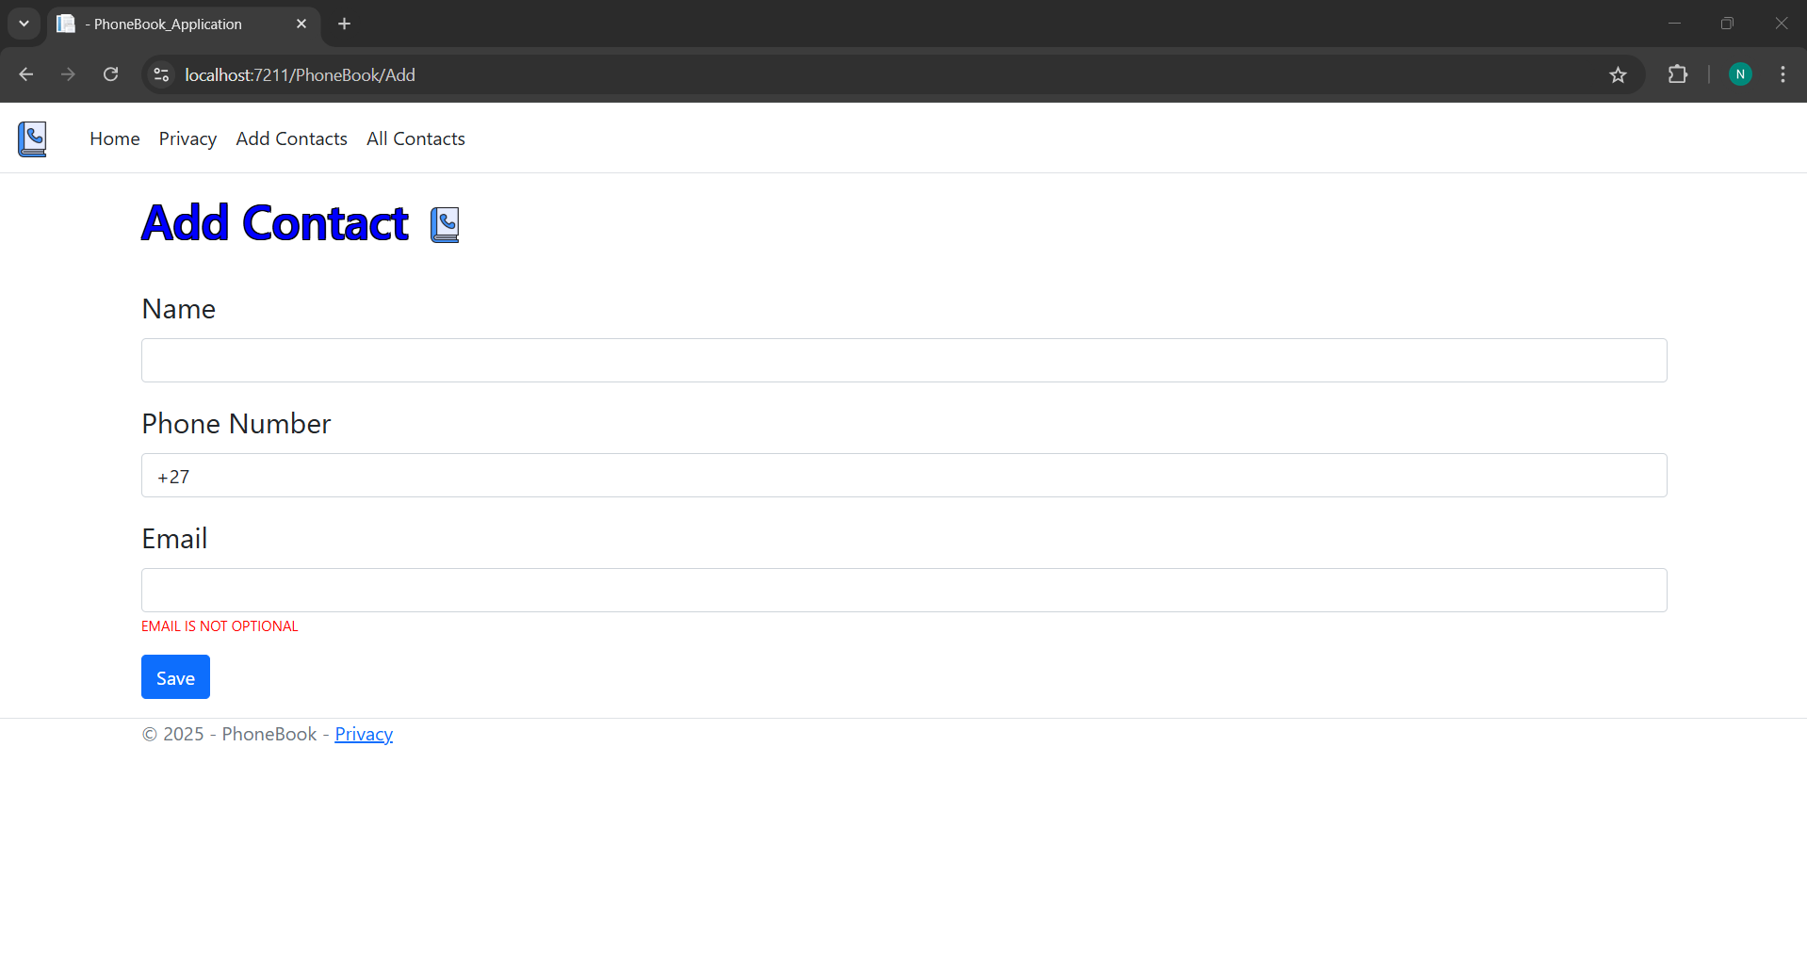

1. **Enter** all the **details** you wish to enter and then **click** the “**Save**” button which will validate the data you have entered and then take you to the next page if you have met the requirements

1. Once the contact has been saved you will be **notified**, and you will be able to **view** the **contacts** you have previously entered. If you wish to **enter more** contacts, **click** the “**Add New Contact**” button.

1. **Click** the “**Update**” button **to update any information** you feel you have entered incorrectly
2. Here you can edit the information, **click** the “**Save**” button when you are done, **click** the “**Back**” button if you no longer wish to make any changes, it will take you back to the table.A screenshot of a computer

   Description automatically generated

1. Once you have **clicked** on the “**Save**” button to update the contact information, the table will automatically update the contact details.

1. If you feel like **deleting** a contact, **click** the “**Update**” button which will show you the contact information with the “Delete” button at the bottom of the screen.

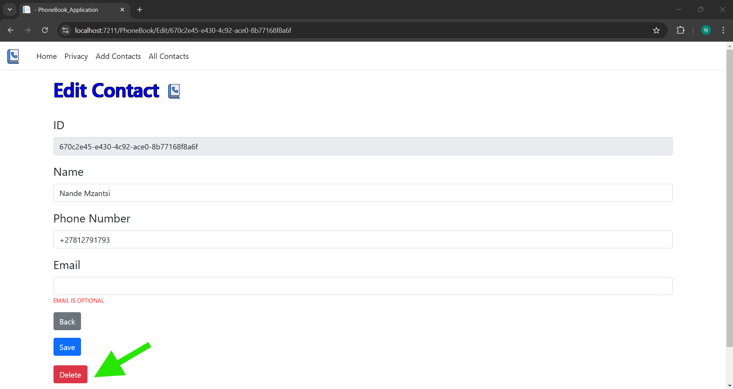

1. Once you have **clicked** the “**Delete**” button you will be **notified** that you have deleted the contact **successfully**

1. You can also **search** for contacts by **typing** the **contacts name or phone number** and

then **clicking** the “**Search**” button

The “**Clear**” button is used to **reset** **the search**

**DO NOT STOP RUNNING THE APPLICATION, CONTINUE SCROLL FOR THE RESPONSIVENESS**

**CHECKING THE RESPONSIVENESS ON ALL DEVICES:**

1. Whilst the **website** is still **running** on chrome, **click** the **three dots** in the top right **corner**.

1. **Click/Hover** on more “**Tools”**

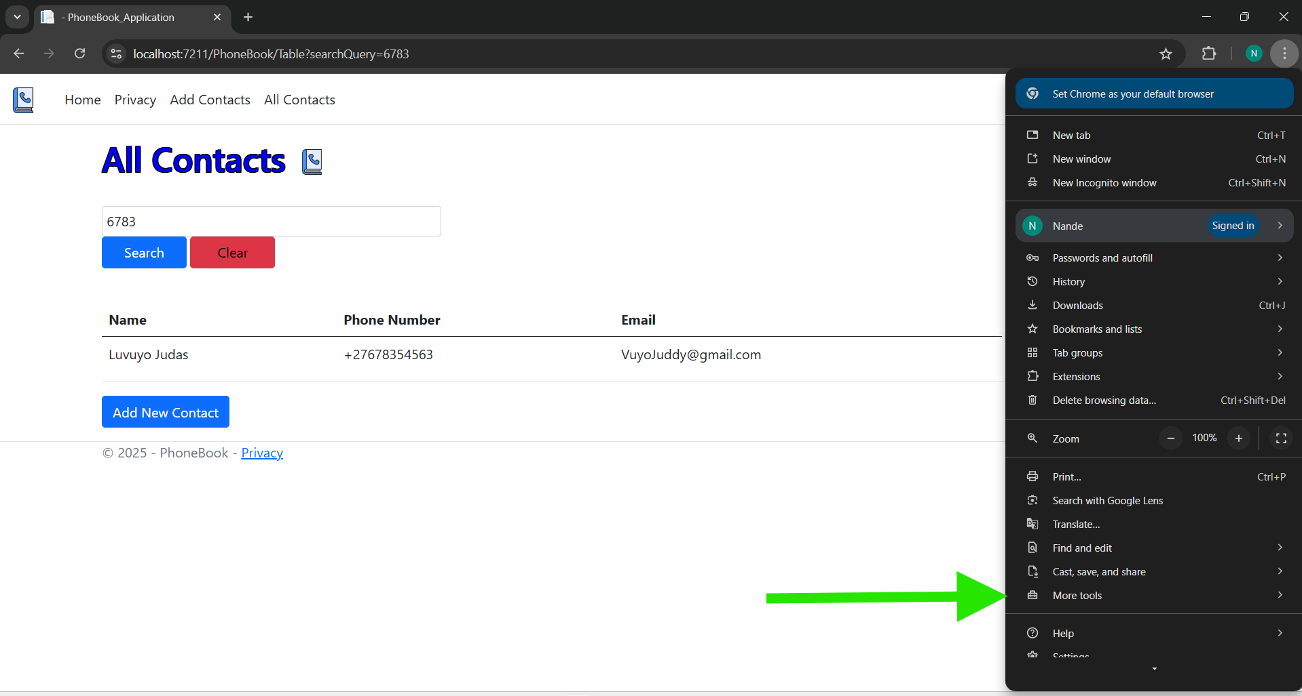

1. **Click** on “**Developer tools”** which is found at the **bottom** A screenshot of a computer

   Description automatically generated
2. You should see device emulation option, **click** on the **button**

1. The layout will change after clicking that button

1. If you want it to be for a **specific phone**, **click** this **dropdown** and **select.**

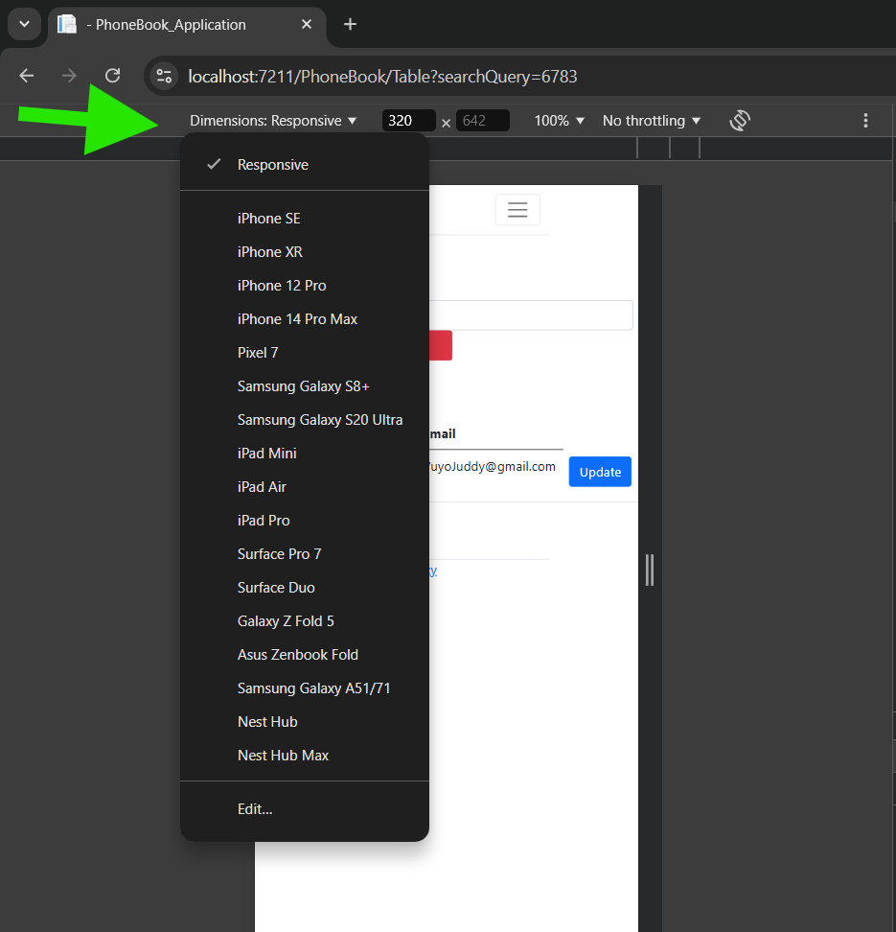

***Thank you for running my phonebook app, I hope you enjoyed the experience!***